 | World Telecommunication Development Conference 2025 (WTDC-25)  Baku, Republic of Azerbaijan, 17–28 November 2025 |  | 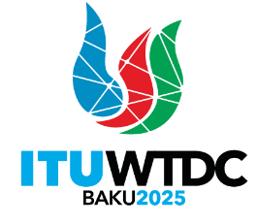
PLENARY MEETING |  | Revision 9 to  Document WTDC-25/DT/1-E
 |  | 27 November 2025
 |  | English only
Director, Telecommunication Development Bureau
WTDC-25 Time Management Plan

_

