 | World Telecommunication Development Conference 2025 (WTDC-25)  Baku, Republic of Azerbaijan, 17–28 November 2025 |  | 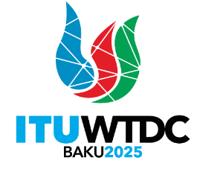
PLENARY MEETING |  | Document WTDC-25/DT/1(Rev.2)-E
 |  | 17 November 2025
 |  | English only
Director, Telecommunication Development Bureau
WTDC-25 draft Time Management Plan

________________

