 | World Telecommunication Development Conference 2025 (WTDC-25)  Baku, Republic of Azerbaijan, 17–28 November 2025 |  | 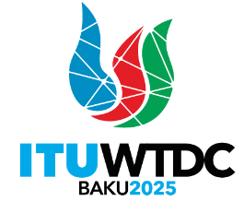
PLENARY MEETING |  | Document WTDC-25/17(Rev.1)-E
 |  | 10 November 2025
 |  | Original: English
Director, Telecommunication Development Bureau
REPORT ON DIGITAL SKILLS DEVELOPMENT
Priority area: - Action Plan, Regional Initiatives and ITU-D Study Group Questions
- ITU-D Resolutions and Recommendations
Summary:
This document provides an overview of the work undertaken by the Telecommunication Development Bureau (BDT) since WTDC-22 related to digital skills and capacity development. It includes training activities carried out through the ITU Academy and its ITU Academy training centres (ATC) programme, the digital transformation centre initiative, as well as research and policy work related to digital skills.
Expected results:
WTDC-25 is invited to note this document.
References:
WTDC Resolutions 37, 40, 73, 87 (Rev. Kigali, 2022)

Introduction
This document provides an overview of the work undertaken by BDT since WTDC-22 related to digital skills and capacity development. It includes training activities carried out through the ITU Academy and the ITU Academy training centres (ATC) programme, the digital transformation centre initiative, as well as research and policy work related to digital skills. It highlights the impact these activities have achieved in terms of strengthening digital capacities across the ITU membership and contributing to closing the digital divide through digital literacy training in remote and underserved communities. The work has been carried out in close collaboration with partners from a range of different stakeholder groups.
ITU Academy
The ITU Academy portal is the main gateway to ITU capacity development and training activities. It offers ICT professionals and policy-makers access to capacity development opportunities using various methodologies and tailored to different learning styles, such as online instructor-led, self-paced, or face-to-face courses. Its comprehensive training catalogue covers a large array of topics relevant to the ITU membership, such as artificial intelligence, cybersecurity, e-waste, spectrum management, digital transformation, satellite communications, emergency telecommunication, data governance, ICT measurement, policy and regulation, wireless and fixed broadband and others. The platform plays a central role in promoting digital capacity development, which is key to ensuring inclusive and secure telecommunications/ICTs for sustainable development – one of the core priorities for the ITU-D as outlined in the Kigali Action Plan.
Over the past years, the ITU Academy has experienced strong growth (see Chart 1). Between 2023 and 2025, the ITU Academy nearly doubled its community, expanding from 35 000 to 75 000 registered users. Today, over 80 per cent of participants come from developing countries, and the share of women among new users has risen to 40 per cent, almost twice the level recorded in 2019. During this period, over 400 courses were delivered, with 70 per cent online, enabling scale and accessibility, and the remainder face-to-face courses, enabling intensive exchange among participants. Completion rates have consistently exceeded industry benchmarks, rising from 68 per cent for face-to-face courses and 28 per cent for online courses in 2023, to 90 per cent and 45 per cent, respectively, in 2025. These gains reflect sustained efforts to enhance the quality of courses and strengthen engagement with learners. In total, more than 15 000 certifications were issued, recognizing participant achievements and providing them with credentials to advance their careers.
Chart 1: ITU Academy registrations
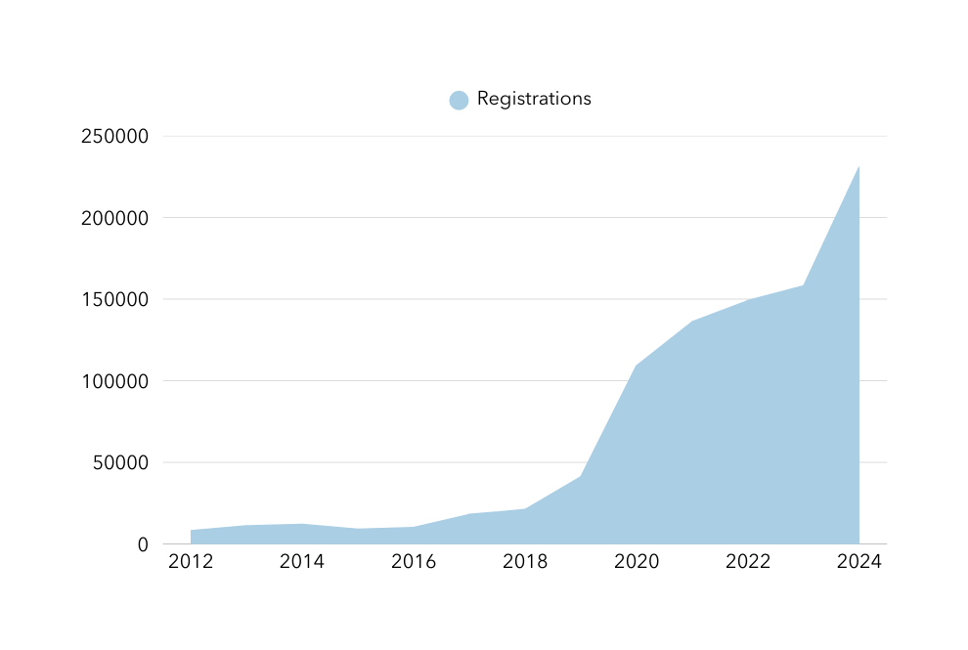
The ITU Academy catalogue is in constant evolution alongside the fast-moving technology landscape, with new courses added on artificial intelligence, quantum technologies, data governance, and other emerging topics. ITU Academy courses provide practical knowledge that participants can apply directly in their institutions as well as non-technical skills, such as teamwork and collaboration across groups, sectors, organizations, and countries.
Participants consistently report over 90 per cent satisfaction rates, but the real measure of success lies in concrete and verifiable results. Post-training assessments, collected since 2024, show a notable increase in the skills of the participants, who reported a higher level of proficiency after completing the course, as well as a high application of the knowledge gained from the training, in their current jobs.
These outcomes translate into real-world change: alumni have, for example, strengthened national cybersecurity monitoring systems, aligned internal processes with new data protection laws, contributed to drafting e-waste regulations, and developed broadband strategies for underserved areas. Many also go on to mentor colleagues, run internal workshops, or revise institutional frameworks, multiplying the benefits well beyond the individual learner.
Finally, over this period, the ITU Academy has undergone a major technical and design transformation to deliver a smoother, more intuitive, and data-driven learning experience. A refreshed platform interface now offers clearer navigation, and many processes have been automated, from course setup to certification, reducing administrative workload and speeding up delivery.
As a result, the ITU Academy platform enables faster course launches, greater consistency across regions, and stronger integration with tools such as digital credentials or the automatic translation of the platform into all six official UN languages, powered by an internally designed ITU tool.
Finally, expanded data analytics through Power BI dashboards track enrolments, completion rates, and learner feedback, supporting evidence-based decision-making and continuous improvement. Together, these advances have made the ITU Academy more accessible, efficient, and connected, a platform that not only delivers high-quality learning but also strengthens the ITU global capacity development impact.
ITU Academy training centres
In 2023, ITU launched the ITU Academy training centres (ATC) programme, following the outcomes of WTDC-22 where ITU membership adopted the revised Resolution 73. These ITU training centres are internationally recognized institutions that offer high-quality training to intermediate and senior personnel, with a strong focus on the needs of developing countries. These ITU core capacity development partners deliver nearly 40 per cent of all courses on the ITU Academy platform, with the remainder being organized by ITU, and other partners. This network anchors the ITU Academy in a diverse ecosystem that combines global reach with regional expertise. ATCs deliver courses on the most important topics identified by ITU membership, including policy and regulation, network infrastructure, spectrum management, cybersecurity, emerging technologies, digital inclusion, and digital services.
Since the launch of the programme in January 2023 until August 2025, 146 courses were implemented by the 14 centres, with 3 500 participants receiving course certificates. The majority of course participants are from public sector entities (ministries, regulatory authorities) and telecommunication entities, followed by academic institutions, the private sector and other organizations. Participants come from all ITU Member States, with 81 per cent from developing countries and the majority from Africa (see Chart 2).
Chart 2: ITU Academy training centres course participants, by region
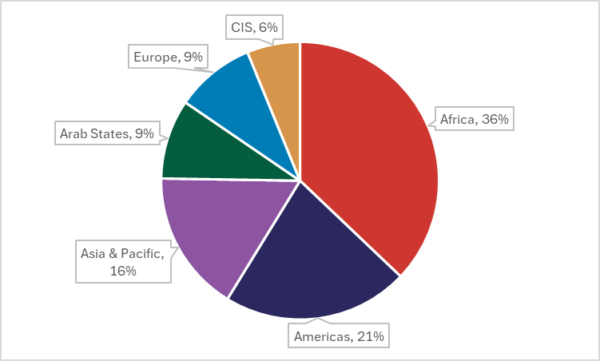
All ATC courses are delivered through the ITU Academy platform. Information about these courses, including the full catalogue, as well as on the ITU ATC programme itself, is available on the ITU Academy website. In terms of the delivery modality, 83 per cent of the ATC training courses are offered via an online, instructor-led methodology, which helps support the global outreach of the programme.
BDT has organized several training sessions aimed at the instructors of the ATCs. These focused on how to conduct engaging instructor-led training (both in online and face-to-face environments), how to increase the range of tools used in order to deliver more interactive training, as well as how to optimize session design. The goal of the initiative was to impact the quality of the training courses by improving facilitation, delivery skills and by allowing for exchanges of best practices among the participating institutions.
As part of the programme cycle, annual meetings have been organized with the participating institutions on a yearly basis, both online and face-to-face. In 2023, the first annual ATC meeting took place in Geneva, Switzerland in October, followed one year later by the 2024 meeting in Manama, the Kingdom of Bahrain. The most recent annual ATC meeting took place in June 2025 in Santo Domingo, Dominican Republic. It brought together 17 delegates from the 14 ATCs representing partner institutions from the Arab Republic of Egypt, Jamaica/Barbados, Federative Republic of Brazil, Federative Republic of Nigeria, Kingdom of the Netherlands, People's Republic of China, Peru, Republic of Estonia, Republic of India, Republic of Kenya, Republic of Lithuania, Republic of Mauritius, Republic of Poland, and Republic of South Africa. During the meeting, participants focused on analysing the ATC programme implementation to date, and on how to build on lessons learned regarding training course organization and management. The meeting also provided updates on the ITU Academy revised guidelines and upcoming features, and discussed the training evaluation framework and learner feedback, as well as consolidating links between participating institutions to encourage networking and collaboration projects. The annual meeting was held in conjunction with the Global Digital Transformation Centres (DTC) Workshop and was hosted by the Centros Tecnológicos Comunitarios (CTC), in collaboration with the Instituto Dominicano de las Telecomunicaciones (INDOTEL).
Capacity development project
Funded by the Global Gateway initiative of the European Union over a period of four years, ITU, in collaboration with the United Nations Development Programme (UNDP), started implementation of the project “Capacity Development for Digital Transformation” at the end of 2023. The project supports the delivery of training to policy-makers and government officials globally through the ITU Academy platform and aims to train at least 5 000 participants on 18 foundational topics related to digital technologies. The training courses are delivered by ITU, and in partnership with the ATC, as well as other United Nations partners including the United Nations Educational, Scientific and Cultural Organization (UNESCO), the International Labour Organization (ILO) and the Office of the High Commissioner for Human Rights (OHCHR).
Since the beginning of the project, a total of 51 face-to-face and online courses were completed, and an additional 10 courses by the end of 2025. Almost 3 000 participants, coming from 115 (mostly developing) countries, were trained, with a participant satisfaction rate of 96 per cent. Courses were delivered under the 18 topics specified in the project, with a total number of 7 702 applicants.
School connectivity project
Through the project “Capacity development to accelerate school connectivity in collaboration with the Giga Initiative”, which was launched in 2024, BDT supports Member State school connectivity efforts by providing tailored training courses through the ITU Academy. The training courses cover the entire school connectivity journey from early inception and planning to infrastructure mapping and modelling, financing and procurement, technical implementation and connectivity monitoring, drawing upon ITU expertise in ICT connectivity and enabling environments. Courses are offered both in-person at the Giga Connectivity Centre in Geneva, and online through instructor-led, self-paced, and blended approaches. To implement the project, BDT works closely with the ITU General Secretariat as well as with United Nations International Children's Emergency Fund (UNICEF), the ITU Giga initiative partner.
Digital transformation centre initiative
The Digital Transformation Centres (DTC) Initiative was launched in September 2019 by ITU in partnership with Cisco, with the objective of supporting countries to strengthen the digital capacities of citizens, particularly those in rural and the underserved communities. The initiative operates through a global network of national institutions, the digital transformation centres (DTCs), which have a mandate to deliver digital skills programmes in their countries. The DTCs operate nationally and demonstrate proven capacity, infrastructure and experience to implement basic and intermediate level training.
The number of DTCs has grown to 14 in total, covering the Africa, Americas, Arab States, and Asia-Pacific regions (see Chart 3). Since the start of the DTC initiative in 2020 until the end of June 2025, over 610 000 (53% female) participants have been provided with basic and intermediate digital skills training (see Chart 4).
Chart 3: Digital transformation centres (DTC) countries
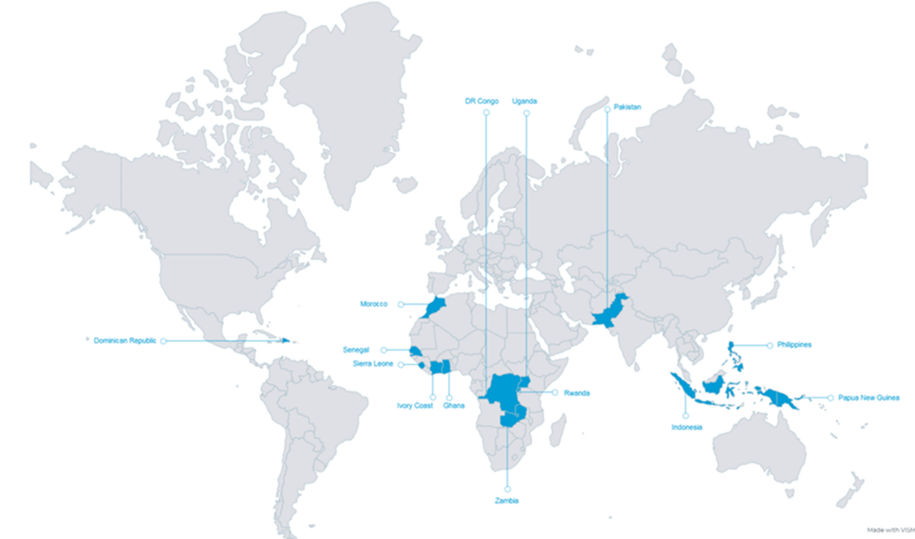
Note: The designations employed and presentation of material in this publication, including maps, do not imply the expression of any opinion whatsoever on the part of ITU concerning the legal status of any country, territory, city or area, or concerning the delimitations of its frontiers or boundaries.

Chart 4: DTC course participants by gender

Beyond achieving gender parity in overall reach, it is important to highlight that training delivered through the initiative has grown in underserved and rural communities served by the DTCs. This includes students, persons with disabilities—particularly those with visual impairments—youth, as well as micro, small and medium enterprises. Additionally, trainers and teachers received capacity-building support to ensure the delivery of high-quality training within these communities.
The number and type of partner joining the initiative has continued to grow with more organizations expected to join. In addition to initial training content partners, Cisco and Hewlett-Packard, the initiative welcomed a new training content partner, ST Microelectronics Foundation, which has brought several training courses to complement the existing training content, including "Introduction to Computer Basics for Persons with Visual Impairments'' (ICBVI), ''Tablets for Seniors'', among others. Currently, five DTCs are delivering the ICBVI training (Ghana, Islamic Republic of Pakistan, Republic of Senegal, Sierra Leone, and Republic of Uganda), with more DTCs expected to be fully trained to deliver the ICBVI training course.
ITU continues to strengthen its collaboration with current partners of the initiative. Telecommunication companies have become partners, namely Indosat Ooredoo Hutchison (Indonesia), Philippine Long Distance Telephone Company (PLDT), and Airtel (Africa) to support the work and capacity development interventions of DTCs.
Under the initiative, ITU and Cisco facilitate networking opportunities for DTCs by organizing face-to-face workshops and virtual meetings every year. These meetings contribute to strengthening the global DTC network and provide a platform to discuss implementation, review progress and achievements made, and explore new ideas to support the work of the DTCs. In 2023 and 2024, Global DTC Workshops were respectively hosted by the Department of Information and Communication Technology (the DTC in the Republic of the Philippines) and the ICT Training and Development Center under the Ministry of Communications and Informatics (the DTC in Indonesia) in collaboration with Indosat Ooredoo Hutchison. These regular meetings serve as an opportunity for DTCs to regularly engage with each other and to further strengthen the DTC community.
In 2025, the DTC workshop was hosted by the Centros Tecnológicos Comunitarios (CTC) the DTC in the Dominican Republic, in collaboration with the Instituto Dominicano de las Telecomunicaciones (INDOTEL). It was held in conjunction with the annual meeting of the ITU Academy training centres (ATCs) with the objective of encouraging collaborations within the DTC-ATC network, share best practices to ensure a continued quality of training offer, and support the work of these capacity development programmes.
DTC projects
The Government of Norway and ITU supported the DTC initiative through two projects Boosting Digital Skills through Digital Transformation Centres phase 1 from 2021 to 2023 and phase 2 from 2024 to 2025.
The first project supported DTC activities, in particular in Ghana, providing training to over 22 000 people (68% female) by the end of the project. The DTC in Ghana exceeded almost every target set for the project and impacted the lives of people across all 16 regions of the country. Notable achievements under this project include supporting 155 Community ICT Centres (CICs) and school cyberlabs to implement digital skills training, renovating 5 CICs and equipping 10 CICs with computers and accessories, the establishment of 31 Coding Clubs, and the training of 220 instructors in Ghana. An impact study conducted at the close of the project showed that almost 82 per cent of beneficiaries self-reported experiencing improved wellbeing and livelihoods as a direct result of their participation in the training. Other observed impacts included the reduction of regional disparities in access to digital skills training, improved interest of school children, especially young girls, in science, technology, engineering and mathematics, and improved capacity of local ICT training centres. The project documentary, developed at its conclusion, details the impacts on beneficiaries and their experiences.
In addition to Ghana, the project supported other DTCs scale their capacity development interventions. ITU organized training of master trainers through Cisco and HP LIFE training courses for representatives from all DTCs. By the end of the project, DTCs in nine countries received support to build training capacity in their countries through train-the-trainer programmes and four DTCs received support for the delivery of basic and intermediate digital skills training in rural and underserved communities.
The second project aimed at strengthening the DTC initiative. DTCs are supported in the delivery of both basic and intermediate digital skills training, while also strengthening their long-term capacity through train-the-trainers programmes to ensure consistent, high-quality face-to-face training. Additionally, a training impact methodology has been piloted and made available to DTCs to help them evaluate the impact of their activities under the DTC Initiative. Furthermore, the project is in the process of equipping three local ICT training centres in the Republic of Uganda and three in the Republic of Zambia with new equipment including computers, printers, and projectors, with delivery expected by the end of 2025.
Highlights from the two DTC projects include the following (as of September 2025):
- All DTCs have been supported to implement training, including training of trainers, outreach activities and/or equipping centres through the two projects.
- DTCs in the Dominican Republic, Ghana, Kingdom of Morocco, Pakistan, Philippines, Republic of Rwanda, Senegal, Republic of Côte d'Ivoire, Sierra Leone, Uganda, and Zambia received support to train underserved communities on basic and intermediate digital skills.
- DTCs in Ghana, Pakistan, Senegal, Uganda, and Zambia were supported in community outreach activities to create greater awareness of the importance of digital skills, including for persons with visual impairments.
- ITU and DTC initiative partners supported DTCs in Côte d’Ivoire, Democratic Republic of Congo, Dominican Republic, Ghana, Indonesia, Pakistan, Papua New Guinea, Philippines, Senegal, Sierra Leone, and Uganda in building their institutional capacities through train-the-trainer interventions, reaching 919 trainers (38% female).
- Through the partnership with ST Microelectronics Foundation, training content is available to DTCs to train persons with visual impairments through the Introduction to Computer Basics for Visually Impaired Persons (ICBVI) training course. The DTC in Ghana has trained over 70 trainers and subsequently delivered training to almost 600 persons with visual impairments (47% female). The DTC in Pakistan was supported to train visually impaired trainers along with sighted trainers. In April 2025, the DTC in Uganda started implementing the ICBVI programme with a train-the-trainer activity for visually impaired and sighted trainers. A total of four DTCs have completed the ICBVI training through this partnership.
Digital Skills Forum
The ITU Digital Skills Forum is a core global event for the ITU membership and other stakeholders where the most pressing needs are discussed with the aim of achieving universal digital skills, and close the global digital skills gap.
The ITU Digital Skills Forum 2024 took place in Manama, Bahrain, from 17 to 19 September 2024. It was organized by ITU and hosted by the Telecommunications Regulatory Authority (TRA) of the Kingdom of Bahrain.
Under the theme “Developing skills for digital transformation” the Forum brought together over 700 participants from 66 countries, comprising physical and remote participation, from public and private organizations, universities and research institutions, and other regional and international organizations. The Forum was preceded by the ITU Academy training centres (ATC) annual meeting.
Participants discussed key pertinent issues related to:
- Bridging the digital skills divide.
- National digital skills frameworks for policy-making.
- Digital skills for jobs.
- Industry perspective on skills needs.
- Digital innovators and entrepreneurs.
- Skills for a safe and secure use of digital technologies and online information.
- Skills for the green and digital transition.
- Future skills requirements in the age of emerging technologies.
At the end of the meeting, the key outcomes of the Forum, along with recommendations on how to tackle the emerging skills gap, were presented by the Chair.
Further information, including the agenda, the presentation slides, highlights, media information, videos and photos, the Chair’s Summary Report and the Final Report of the Digital Skills Forum, are available at: https://www.itu.int/itu-d/meetings/digital-skills-forum/.
Digital Skills Toolkit
The ITU Digital Skills Toolkit 2024 was launched on 17 September, at the Digital Skills Forum 2024. The toolkit offers a comprehensive, step-by-step guide to support the ITU membership to create effective national digital skills strategies and policies. This practical resource offers actionable insights and examples, making it a valuable tool for countries at all stages of digital development.
The publication is divided into three parts:
- Part 1 focuses on understanding digital skills, covering digital skills frameworks and the evolving importance of these skills for digital inclusion and economic growth.
- Part 2 provides a detailed roadmap for creating a national digital skills strategy: integrating digital skills into broader digital transformation efforts, assessing needs, engaging stakeholders, creating strategies for digital skills development of both citizens and the workforce and monitoring implementation.
- Part 3 offers examples of digital skills strategies and programmes from around the world, serving as an inspiration to countries developing or updating their own strategies.
Designed for use by policy-makers and other stakeholders, such as partners in the private sector, non-governmental organizations and academia, the toolkit builds on the previous edition published in 2018. It has been thoroughly reviewed and updated to reflect developments in digital transformation since then.
Digital Skills Campaign
ITU continues to lead the Digital Skills Campaign in partnership with ILO. Launched in 2016 as one of the thematic priorities under the ILO Global Initiative on Decent Jobs for Youth, it seeks to equip young people with the skills needed to work in the digital age. In 2021, the campaign targets were revised from commitments to train 5 million young people to training 25 million by the end of 2030.
All commitments focus on job-ready, transferable digital skills, a combination of technical and soft skills that are aligned with national and global market demand. Training includes work experience (e.g. internships and project-based learning) and job placement services to maximize employment outcomes and maintain close relations with employers. As part of the campaign, ITU disseminates best practices and guidelines through knowledge products such as the Digital Skills Toolkit and the Digital Skills Assessment Guidebook.
In June 2023, ITU and ILO convened a meeting of the campaign partners as well as potential partners to exchange knowledge, share best practices and identify synergies. The meeting also provided an opportunity to review progress made and identify innovative ideas to accelerate progress. The meeting brought together representatives from partners of the Digital Skills Campaign as well as partners of the Decent Jobs for Youth Initiative, engaged in capacity and skills development activities for youth.
As of March 2025, the campaign had received commitments to train more than 23 million young people with digital skills by 2030. The 19 partners who made commitments under this initiative are from a range of sectors including government, development banks, non-governmental organizations, United Nations agencies and the private sector.
Group on Capacity Building Initiatives
BDT maintains and supports the work of the Group on Capacity Building Initiatives (GCBI), which was established pursuant to Resolution 40 adopted by the WTDC-10, and revised at WTDC-22, to advise the Director of the BDT on matters related to capacity building.
The group, which comprises two members from each region, meets annually to discuss pertinent topics related to digital skills development and undertakes work that provides inputs to ITU-D work in this field.
In 2023-2025, the focus of GCBI activities included:
- providing inputs to the revision of the ITU Digital Skills Toolkit;
- reviewing the ITU/BDT training needs assessment questionnaire;
- conducting desk research on national digital skills strategies;
- promotion and scaling of ITU capacity development activities in the regions.
The work of the group is reported by the GCBI Chair to the annual meetings of TDAG.
________________

See the impact story and project documentary
Updates on the latest activities conducted by the DTCs are available on the DTC news webpage.
More information on these digital literacy programmes is available in the following impact stories: “Empowering indigenous people in the Philippines through digital literacy programmes" and “Driving digital empowerment in the Dominican Republic through the DTC Initiative”.

