 | World Telecommunication Development Conference 2025 (WTDC-25)  Baku, Republic of Azerbaijan, 17–28 November 2025 |  | 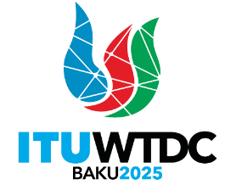
PLENARY MEETING |  | Document WTDC-25/12-E
 |  | 30 September 2025
 |  | Original: English
Chair, ITU-D Study Group 2
Report on ITU-D Study Group 2 activities for the eighth study period between WTDC-22 and WTDC-25
Priority area: Study Group Questions
Summary:
This report summarizes the activities carried out by Study Group 2 for the eighth study period.
Expected results:
WTDC-25 is invited to note this document.
References:
TDAG-23/6 (2023), TDAG-24/6 (2024), TDAG-25/7 (2025), 2/REP/8 (2022), 2/REP/9 (2023), 2/REP/17 (2024), 2/REP/25 (2025)

Introduction
The report covers the eighth study period for ITU-D Study Group 2. SG2 concluded its work at its fourth and final meeting held in Geneva from 5 to 9 May 2025, approving output reports for all seven Questions. The study period 2022-2025 for SG2 concluded to-date with:
- 2 interim deliverables:
  - Cybersecurity assurance practices (by Question 3/2), published in 2024
  - 5G cybersecurity (by Question 3/2) published in 2025
- 4 annual Study Group meetings from 2022 to 2025
- 2 annual Rapporteur Group Question (RGQ) level meetings in 2023 and 2024
- Video interviews by 2 (co-)rapporteurs of interim deliverables
- 17 workshops and other events held in conjunction with the rapporteur group meetings
A Regional Workshop on Increasing Consumer Awareness held on 18-20 June 2024 in Brasilia and hosted by ANATEL, in collaboration with ITU-D SG1 and ITU Regional Office for Americas
- 113 incoming liaison statements (SG2 and Rapporteur Group Question level)
- 27 outgoing liaison statements (SG2 and RGQ level)
- 482 unique contributions (membership, SG2 management and ITU) received
- 269 participants at most for a SG2 plenary level meeting (first meeting in 2022)
- 45% female participation at most for a SG2 plenary level meeting (second meeting in 2023)
- 221 participants at most for Rapporteur Group Question level meeting (second meeting in 2024)
- 38% female participation at most for Rapporteur Group Question level meeting (second meeting in 2024)
- SG2 Management team contributed in ITU work including representations in various events.

Mandate and outcomes
Study Group 2 (SG2) was established in accordance with WTDC Resolution 2 (Rev. Kigali, 2022) to study Questions and issues relating to digital transformation. The Group is responsible for seven substantive topics to study the use and impact of ICTs in the areas of: 1) smart sustainable cities and communities, 2) e-services and applications, 3) cybersecurity, 4) conformance and interoperability, counterfeit of ICT equipment and theft of mobile devices, 5) adoption of telecommunications/ICTs and improving digital skills, 6) environment, and 7) human exposure to electromagnetic fields. SG2 takes also into account the work of other ITU Sectors and relevant organizations, and the priorities of developing countries in fulfilling its mandate.
The formal titles of the Study Group 2 Questions are as follows:
Question 1/2: Smart sustainable cities and communities
Question 2/2: Enabling technologies for e-services and applications, including e-health and e--education
Question 3/2: Securing information and communication networks: Best practices for developing a culture of cybersecurity
Question 4/2: Telecommunication/ICT equipment: Conformance and interoperability, combating counterfeiting and theft of mobile devices
Question 5/2: Adoption of telecommunications/ICTs and improving digital skills
Question 6/2: ICTs for the environment
Question 7/2: Strategies and policies concerning human exposure to electromagnetic fields​
The definitions of the Questions, which include, inter alia, the statement of the problem, the description of the expected output, the initial work plan with the required timing for the output, etc., are available on the Study Group 2 website in Document 2/2.
SG2 concluded its work at its fourth and final meeting held from 5 to 9 May 2025, approving output reports for all seven study Questions.

Study Group 2 management
WTDC-22 designated the SG2 leadership for the eighth study period (2022-2025): Mr Fadel Digham (Egypt) served as Chair; he was ably assisted by the following Vice-Chairs:
Mr Abdelaziz Alzarooni (United Arab Emirates) (ARB)
Ms Zainab Ardo (Nigeria) (AFR)
Mr Javokhir Aripov (Uzbekistan) (CIS)
Ms Carmen Madalina Clapon (Romania) (EUR)
Mr Mushfig Guluyev (Azerbaijan) (CIS)
Mr Hideo Imanaka (Japan) (ASP)
Ms Mina Seonmin Jun (Republic of Korea) (ASP)
Mr Mohamed Lamine Minthe (Guinea) (AFR)
Mr Víctor Antonio Martínez Sánchez (Paraguay) (AMS)
Mr Tongning Wu (China) (ASP)
Mr Dominique Würges (France) (EUR)
Stepped down during this study period:
Ms Alina Modan (Romania) (EUR)
Mr Diyor Rajabov (Uzbekistan) (CIS)
The list of appointed Chair, Vice-Chairs, Rapporteurs and Vice-Rapporteurs of ITU-D Study Group 2 Questions and their participation during this study period can be found in Annex 1.

Participation and documents (2022-2025)

Participants
An aggregate number of 1252 participants attended SG2 and Rapporteur Group meetings during this study period. Table 1 details the number of participants and represented countries during each SG2 event of the study period. Each SG2 event gathered about 209 participants from 54 countries on average per meeting.
Table 1: Participation to SG2 and rapporteur group meetings during the study period
Figure 1 provides the evolution of the number of participants since the previous study period. The number of participants significantly increased during this study period compared to the previous one (aggregate: 1003, average: 125 per meeting), which is in big part due to the increased number of remote participants since COVID-19. The numbers in 2022 and 2025 are lower than in 2023 and 2024, because no separate rapporteur group meetings were organized due to WTDCs.
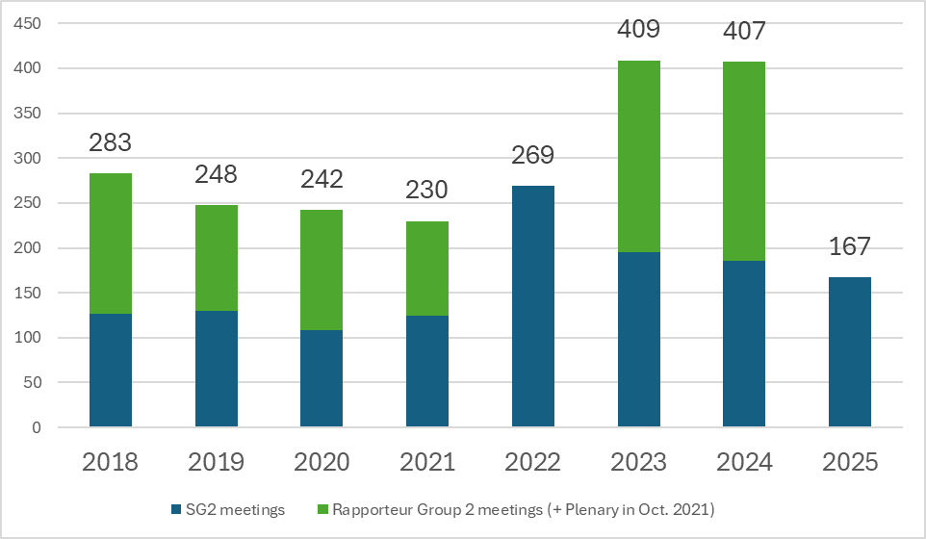
Figure 1: Evolution of the number of SG2 participants per year (2018-2025)
Figure 2 provides the evolution of participation rate of women from the previous study period. The percentage of women participants stood at an average of 40% per meeting, which is higher than during the previous study period (average of 32% per meeting).

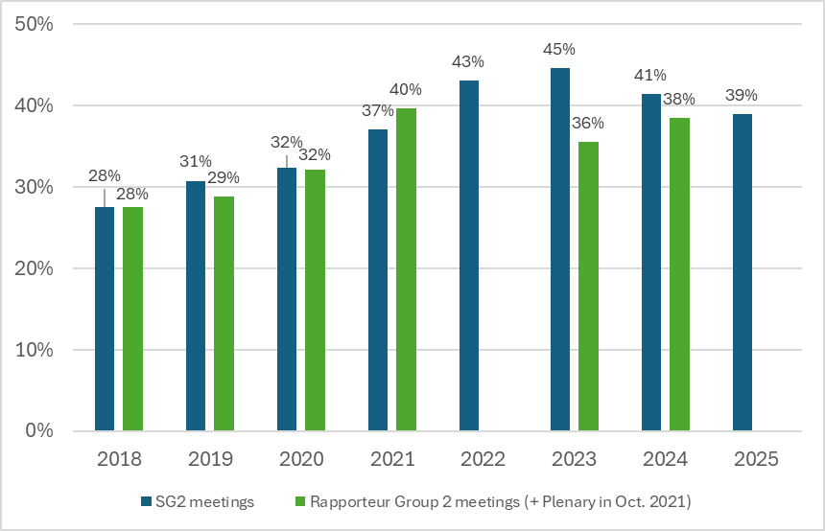
Figure 2: Evolution of participation rate of women (2018-2025)
Figure 3 provides the regional distribution of all participants. The majority of participants were from the African and Asia and Pacific regions, followed by the Americas, Europe, Arab States and CIS. The distribution is similar to the previous study period with small changes (biggest increase from Africa at +6%), and biggest reduction from the Americas at -4%).
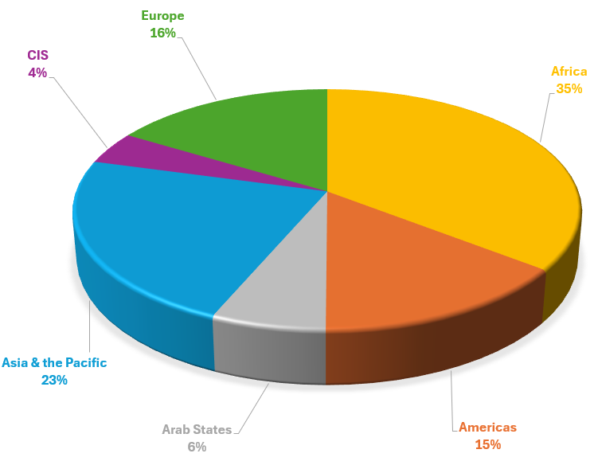
Figure 3: Distribution of Study Group 2 participants per region
Figure 4 shows the distribution of participants by membership type. Like in the previous study period, the majority of participants were from Member States, followed by Sector Members. Academia and ITU-D Associate member participants remained to less than 5%.
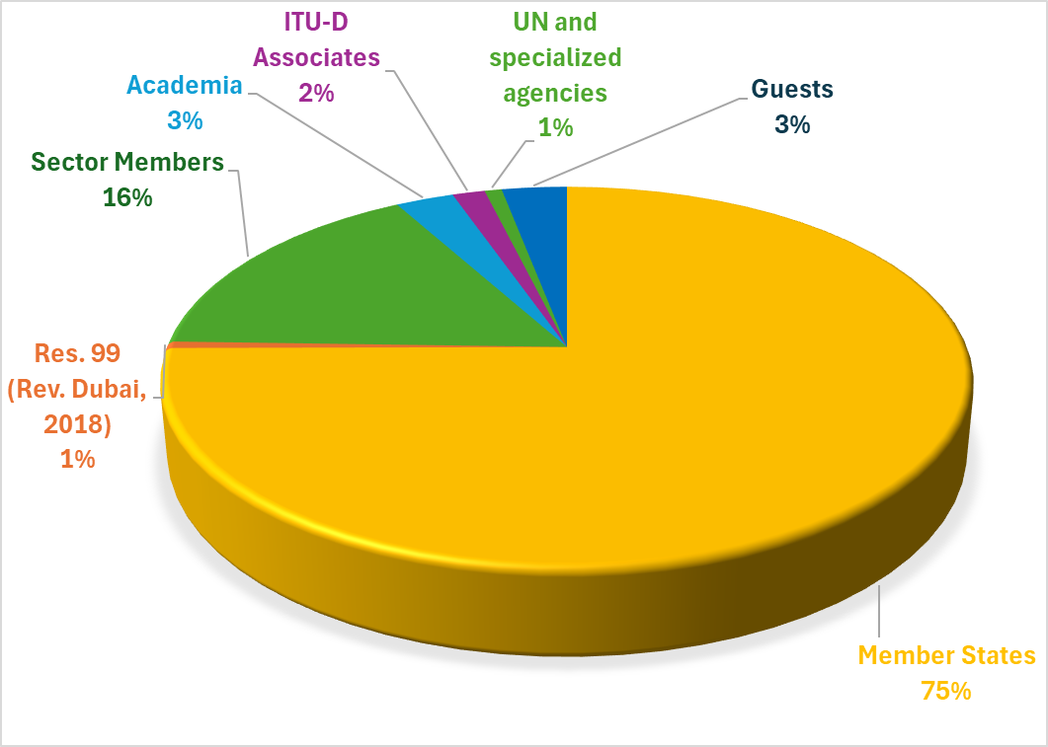
Figure 4: Distribution of Study Group 2 participants per membership type

Documents
Study Group 2 considered a total of 689 documents during this study period, 482 of which were contributions. A deeper analysis of the contributions shows that 353 of them were submitted by the membership, while the remaining 129 contributions came from the SG2 management team members (Chair, Vice-Chairs, Rapporteurs, Vice-Rapporteurs and Coordinators) while performing their duties, and from ITU (BDT including BDT Focal Points, other BDT staff and the Study Group Secretariat, as well as the other ITU Sectors and the General Secretariat). Table 2 lists the different documents during this study period.
Documents for SG2 meetings and Rapporteur Group meetings | 2022 | 2023 | 2024 | 2025 | Study period
Contributions  - From members  - From SG management + ITU | 56 | 163 | 207 | 54 | 482  353  129
Incoming liaison statements | 34 | 36 | 34 | 9 | 113
Outgoing liaison statements | 7 | 10 | 5 | 5 | 27
Meeting and progress reports | 8 | 22 | 22 | 15 | 67
Total documents | 105 | 231 | 268 | 83 | 689
Table 2: Documents considered by SG2 during the study period (2022–2025)
Figure 5 provides the evolution of the number of documents since the previous study period. The number of documents is lower during this study period compared to the previous one (aggregate: 921, average: 115 per meeting), which is partly due to a shorter period with less meetings. However, the number of documents received on average per meeting are identical at 115 documents per meeting.
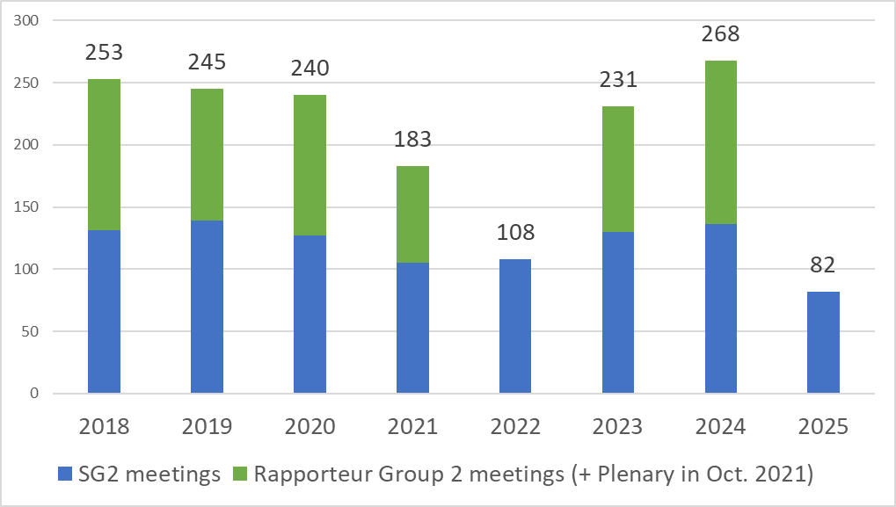
Figure 5: Evolution of the number of SG2 documents (2018-2025)
Figure 6 provides a regional analysis of the contributions from members. The majority of the contributions come from the Africa and Asia & Pacific regions, followed by the Americas, Europe, Arab States and CIS. Compared to the previous study period, the distribution for each region varied from -7% (Europe) to +9% (Africa).
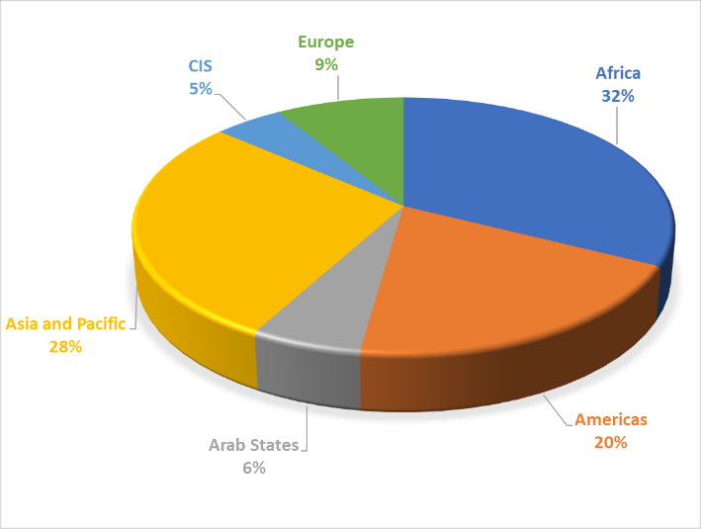
Figure 6: Regional distribution of contributions submitted by the membership to Study Group 2
Table 3 illustrates the number of written contributions received by each Question to complete its deliverables for the study period. The three Questions (excluding contributions to All Questions – “QAll/2” – which were for the SG2 plenary) receiving the highest number are Question 5/2 (area: digital skills) with 100, followed by Question 2/2 (area: e-services and applications) with 98, then Question 3/2 (area: cybersecurity) with 96. The last column provides the number of contributions received by each Question during the previous study period (2018-2021). The Questions received less contributions compared to the previous study period, due again to the shorter study period with less meetings held. Question 5/2 (area: digital skills) started from this study period, so no comparison is available. It should also be noted that all rapporteur groups organized workshops and webinars (see Section 3) during this study period, the results of which were also used as inputs to support and complement the development of their output reports.
Contributions received for annual SG2 and rapporteur group meetings | 2022 | 2023 | 2024 | 2025 | Total  (2022-2025) | Total  (2018-2021)
Q1/2 | 7 | 24 | 26 | 6 | 63 | 125
Q2/2 | 13 | 40 | 35 | 7 | 98 | 104
Q3/2 | 10 | 33 | 44 | 9 | 96 | 106
Q4/2 | 5 | 9 | 15 | 4 | 33 | 74
Q5/2 | 9 | 34 | 49 | 8 | 100 | N/A
Q6/2 | 10 | 11 | 24 | 6 | 51 | 65
Q7/2 | 5 | 21 | 26 | 2 | 54 | 88
QAll/2 (for SG2 plenary) | 16 | 14 | 15 | 19 | 67 | 116
Total | 78 | 189 | 234 | 61 | 562 | 769
Table 3: Number of contributions received per Study Group 2 Question
Figure 7 illustrates the distribution of contributions per source type. Similar to the previous study period, Member States remained the highest contributor across all Questions, with more contributions submitted to Questions 3/2 (area: cybersecurity) and 5/2 (area: digital skills). Sector members (which include regional/international organizations) followed suit with more contributions submitted to Questions 2/2 (area: e-services and applications) and 5/2 (area: digital skills). Sector Members’ contributions remained at good numbers, except for Questions 4/2 (area: C&I, combating counterfeiting and theft of mobile devices) and 6/2 (area: environment). More contributions from Academia and Associates remain desirable, with nevertheless more contributions from Associates in Question 4/2.
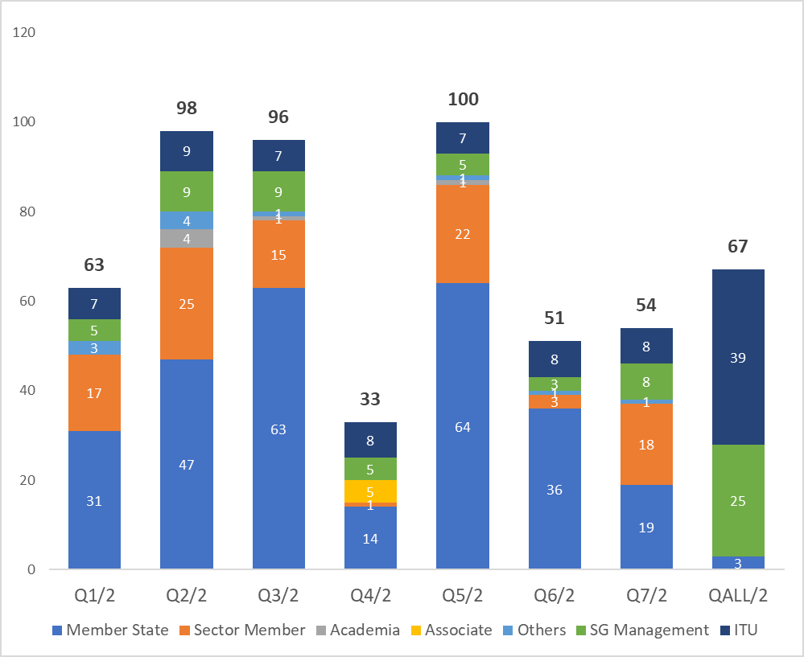
Figure 7: Contributions received for Study Group 2 per Question and source type

Meetings

Management team meetings
During this study period, four annual Study Group 2 management team meetings with the Chair, Vice-Chairs, (Co-)Rapporteurs, Vice-Rapporteurs and BDT Focal Points were held on the day before each annual Study Group 2 meeting, in order to prepare for the meeting, approve the time-management plan, review the progress of each Question under study, discuss planned and on-going activities and come up with proposals on further improvements to the functioning of the study groups.
In addition, 17 additional meetings (two of which jointly with SG1) between the SG2 Chair and management team members concerned were held to prepare for workshops and information sessions, review the progress of interim and final deliverables, and coordinate on other topics of interest in preparation for the next WTDC (e.g. future study Questions). Before the deadline of submission of the final reports, the SG2 Chair had a separate meeting with each Question management team to review in detail their draft final reports and provide guidance to improve them.
Coordinators were appointed to facilitate the coordination on key topics. A list of these topics and names of the coordinators can be found in Annex 2 to this report.
Finally, the seven Rapporteur Groups held management team meetings at their own level to ensure coordination and fulfil their Question mandates.

Study Group 2 meetings
During the course of the study period, Study Group 2 met six times. Four annual meetings were held in December 2022, October-November 2023, November 2024 and May 2025. The Rapporteur Groups met in total six times during this study period, both during each annual Study Group meeting and separately in May-June 2023 and April-May 2024.
Annex 3 presents the dates of the Study Group and Rapporteur Group meetings held during this study period. A substantial amount of the work was also carried out electronically and by correspondence in between the physical meetings.

First annual SG2 meeting
The meeting was held in Geneva from 5 to 9 December 2022. The meeting took the following main actions and decisions:
- Reviewed the main outcomes from the previous 2018-2021 study period, SG2 work plan and expectations for the 2022-2025 study period;
- Appointed new (Co-)Rapporteurs and Vice-Rapporteurs to lead the Questions under study;
- Assigned coordinators (mostly Vice-Chairs) for specific topics of interest;
- Developed draft work plans and tables of contents for each Question to start the work;
- Organized an onboarding session which provided an overview of the study groups and information to help them getting involved in the activities of the study groups (presentation);
- Explored several topics for future collaboration, including with other ITU Sectors, WTDC Resolution 9 (Rev. Kigali, 2022), as well as synergies on statistics activities and BDT projects.
The report of this meeting is available in Document 2/REP/8.

Second annual SG2 meeting
The meeting was held in Geneva from 30 October to 3 November 2023, and took the following main actions:
- Appointed 1 Vice-Chair (Europe region), 3 Co-Rapporteurs and 1 Vice-Rapporteur to reinforce the management teams, after the previous role bearers stepped down due to career movements;
- Approved an interim deliverable from Question 3/2 (“Cybersecurity assurance practices”). This interim deliverable examines the global landscape of cybersecurity assurance across various domains (IoT, telecoms, etc.) by presenting a diverse range of ongoing practices and perspectives from around the world;
- Developed and stabilized mappings between ITU-D Questions and with other ITU Sectors;
- Held two information sessions: the first one to showcase the new interim deliverable on cybersecurity assurance practices (programme, report (see Annex 5)), and the second one to present selected ITU projects related to digital transformation and their impacts in the field (programme, report (see Annex 6)).
- Held an informal discussion on youth engagement was also held between some youth members and the SG2 management teams, in order to explore how young participants could become more involved in the work of study groups.
- Continued to explore several topics for future collaboration, in particular with the TSAG rapporteur group on sustainable digital transformation (RG-DT), to which a response liaison statement was sent to inform about the activities of SG2.
The report of this meeting is available in Document 2/REP/9.

Third annual SG2 meeting
The meeting was held in Geneva from 11 to 15 November 2024. The meeting took the following main actions and decisions:
- Appointed 1 Vice-Chair (CIS region), 1 Co-Rapporteur and 6 Vice-Rapporteurs to reinforce the management teams, after the previous role bearers stepped down due to career movements;
- Approved an interim deliverable from Question 3/2 (“5G cybersecurity”). This interim deliverable aims to share reflections and good practices on securing 5G networks to assist ITU membership in implementing cybersecurity measures in their national contexts;
- Reviewed in detail the draft output reports from the seven rapporteur groups, with comments to assist in their finalization and submission for approval;
- Continued to explore several topics for future collaboration, in particular with the Industry Advisory Group on Development Issues and Private Sector Chief Regulatory Officers (IAGDI-CRO), with which SG2 agreed to collaborate in order to organize a tech talk on the theme of digital transformation;
- Reviewed the proposed questions of the end-of-cycle survey (joint with SG1), traditionally done in accordance with WTDC Resolution 1.
The report of this meeting is available in Document 2/REP/17.

Fourth annual SG2 meeting
The meeting was held in Geneva from 5 to 9 May 2025. The meeting took the following main actions and decisions:
- Approved the output reports on the seven SG2 study Questions for the study period;
- Appointed a new Vice-Rapporteur for Question 7/2, following the previous role bearer stepping down due to a career movement;
- Consolidated the views on new ideas related to the topics of current study Questions;
- Reviewed two draft guidelines for composing rapporteur teams and on better use of ITU-D study group products (see Section 4.1 for more information), in collaboration with ITU-D Study Group 1;
- Reviewed a compilation document of reported case studies and practices, represented individually or reflected in the final reports. While this document was not agreed upon as an outcome report, given current procedures, it may serve as a basis for further development to have outcomes at the SG level in the future, in coordination with the rapporteur groups;
- Reviewed the results of the end-of-cycle survey (see Section 6 for more information);
- Reviewed areas of relevance to ITU-D activities, including implementation of WTDC Resolution 9, activities on statistics, collaboration with other ITU Sectors and the ITU Coordination Committee for Terminology (ITU CCT);
- Reviewed the outcomes of the tech talk on digital transformation organized by IAGDI-CRO in collaboration with SG2. The tech talk covered several topics which may serve as useful inputs for shaping future study Questions.
The report of this meeting is available in Document 2/REP/25.

Summary of the key results achieved

Question 1/2 – Smart sustainable cities and communities
The approved Output Report on Question 1/2 can be found in Document 2/358.
The Rapporteur Group on Question 1/2 also organized the following workshops:
- Workshop on digital public infrastructure and shared services for smart sustainable government, cities and communities, held on 25 May 2023 (programme, report (Annex 4));
- Workshop on digital smart city/community policies and business models to ensure stakeholder involvement and yield sustainable development, held on 30 April 2024 (programme, report (Annex 3)).
Topics for the next study period were proposed, including:
- The development of mechanisms and tools for evaluating smart cities and communities,
- Economic models for the harmonious development of smart cities and communities, and
- Best practices and guidelines for an appropriate legal framework in building smart cities and choosing/providing smart services and applications.
An updated draft terms of reference for Question 1/2 is available in Document TDAG-WG-futureSGQ/48.

Question 2/2 – Enabling technologies for e-services and applications, including e-health and e-education
The approved Output Report on Question 2/2 can be found in Document 2/359.
The Rapporteur Group on Question 2/2 also organized the following workshops:
- Workshop on adoption of new digital technology for e-health, e-learning and other e-services, held on 30 May 2023 (programme, report (Annex 5));
- Workshop on best practice models and enabling technology for digital transformation in e-health, e-education, and other e-applications, held on 29 April 2024 (programme, report (Annex 4));
Topics for the next study period were proposed, including impact of artificial intelligence (AI) technologies in support of e-services and applications.
An updated draft terms of reference for Question 2/2 is available in Document TDAG-WG-futureSGQ/48.

Question 3/2 – Securing information and communication networks: Best practices for developing a culture of cybersecurity
The approved Output Report on Question 3/2 can be found in Document 2/360.
The following interim deliverables on Question 3/2 were approved for release:
Cybersecurity assurance practices (interim deliverable 2023, link). A dedicated panel session presented the key findings of this deliverable (programme, report (Annex 5)).
5G cybersecurity (interim deliverable 2024, link).
The Rapporteur Group on Question 3/2 also organized the following workshops:
- Workshop on cybersecurity assurance practices, held on 23 May 2023 (programme, report (Annex 4));
- Workshop on 5G cybersecurity, held on 2 May 2024 (programme, report (Annex 4)).
Topics for the next study period were proposed on how to promote cybersecurity and cyber resilience for the telecommunications/ICTs sector, including:
- Cybersecurity public policies and regulations that applies to the telecommunications/ICTs sector, including obligations and assurance practices.
- Specific measures, initiatives and projects to improve the cybersecurity and cyber resilience of small and medium telecommunications service providers.
- How ITU membership is addressing the cybersecurity challenges and opportunities of the new and emerging telecommunications/ICT technologies and services in the sector.
An updated draft terms of reference for Question 3/2 is available in Document TDAG-WG-futureSGQ/48.

Question 4/2 – Telecommunication/ICT equipment: Conformance and interoperability, combating counterfeiting and theft of mobile devices
The approved Output Report on Question 4/2 can be found in Document 2/361.
The Rapporteur Group on Question 4/2 also organized the following workshops:
- Workshop on conformance and interoperability challenges for digital transformation, held on 2 June 2023 (programme, report (Annex 4));
- Workshop on techniques designed to promote harmonization of conformance and interoperability (C&I) regimes, held on 10 May 2024 (programme, report (Annex 3)).
Topics for the next study period were proposed, for example establishing collaborative platforms for C&I, establishing centralized databases to combat counterfeit of ICT equipment, and establishing harmonized legal frameworks to combat theft of mobile devices. More information can be found in Document TDAG-WG-futureSGQ/48.

Question 5/2 – Adoption of telecommunications/ICTs and improving digital skills
The approved Output Report on Question 5/2 can be found in Document 2/362.
The Rapporteur Group on Question 5/2 also organized the following workshops:
- Workshop on adoption of ICTs and digital skills development, held on 1 June 2023 (programme, report (Annex 3));
- Workshop on digital skills development: policies, strategies, and national experiences for a better future, held on 8 May 2024 (programme, report (Annex 4));
Regarding future topics, considering that this study area was introduced for the first time during this study period, it was considered that all items included in the current terms of reference of this Question were not fully explored and need further studies.

Question 6/2 – ICTs for the environment
The approved Output Report on Question 6/2 can be found in Document 2/363.
The Rapporteur Group on Question 6/2 also organized the following workshops:
- Workshop on green ICT and emerging technologies towards climate change mitigation, held on 29 May 2023 (programme, report (Annex 4));
- Workshop on circular economy considerations and new technologies for combatting climate change, held on 6 May 2024 (programme, report (Annex 4)).
Topics for the next study period were proposed, including:
- The role of ICTs and cutting-edge intelligent technologies like AI in reducing climate change-related disasters like flash floods and large-scale fires (in collaboration with Q3/1),
- The role of ICTs in monitoring and protecting biodiversity worldwide and, in particular, in biodiversity hotspots where the variety and richness of ecosystems is particularly high.
An updated draft terms of reference for Question 6/2 is available in Document TDAG-WG-futureSGQ/48.

Question 7/2 – Strategies and policies concerning human exposure to electromagnetic fields
The approved Output Report on Question 7/2 can be found in Document 2/364.
The Rapporteur Group on Question 7/2 also organized the following workshops:
- Workshop on international, regional and national policies concerning human exposure to electromagnetic fields (EMFs), held on 25 May 2023 (programme, report (Annex 4));
- Workshop on recent developments relevant to EMF policy formulation, held on 8 May 2024 (programme, report (Annex 5)).
The following topics for the next study period were proposed at this stage: 5G EMF, EMF in low-altitude airspace and drone, AI in EMF evaluation, EMF in smart wearable devices
An updated draft terms of reference for Question 7/2 is available in Document TDAG-WG-futureSGQ/48.

Collaboration with other groups

ITU-D study Questions and ITU-D study groups
Synergies between Question in SG2, and with SG1 were continuously sought.
A joint Q6/1 and Q3/2 workshop on Increasing Consumer Awareness was held from 18 to 20 June 2024 in Brasilia, hosted by ANATEL in collaboration with the ITU Regional Office for Americas.
Four joint SG1 and SG2 management team meetings were held on the Sunday before start of SG2 annual meetings under the chairmanship of the BDT Director. These meetings ensured coordination and collaborative work between the two ITU-D study groups.
Two draft guiding documents were prepared in collaboration with SG1 on the following items that require a joint reflection to make study group work more efficient and effective:
- Guidelines for submitting candidatures for positions of rapporteurs and vice-rapporteurs and for evaluating the candidates
- Guidelines to address challenges that impact on the effective use of ITU-D study group products.
These documents are currently work in progress and are available in Document 2/403 and in Annexes 4 and 5 of this report. They are shared with TDAG for information and guidance as appropriate.

Collaboration with the TDAG Working Group on future Study Group Questions
An important collaboration in preparation for the next WTDC has been with the TDAG Working Group on future Study Group Questions (TDAG-WG-futureSGQ). For this purpose, SG2 assigned Vice-Chair Mr Abdelaziz Alzarooni (United Arab Emirates), succeeded by Vice-Chair Mr Victor Martinez (Paraguay) from 2025, to ensure coordination on future study Questions. Mr Ahmad Reza Sharafat, Chair of the TDAG-WG-futureSGQ, was also regularly invited in study group meetings to ensure that the study group receives regular updates and provides meaningful inputs to this TDAG WG.
Following coordination between the Coordinator and the SG2 (Co-)Rapporteurs, preliminary views on possible new items for future study Questions were submitted to the TDAG WG for consideration.
Documents for more information:
- Web page of the TDAG-WG-futureSGQ: link
- Preliminary views on future SG2 Questions: TDAG-WG-futureSGQ/22.
- Updated views on future SG2 Questions: TDAG-WG-futureSGQ/48.

Mapping of activities between ITU-D study Questions and with other ITU sectors
During this study period, mapping of activities with other ITU sectors were maintained in order to identify potential areas of common interest, facilitate coordination and further strengthen collaboration. SG2 assigned two management team members as coordinators to facilitate development and exchange of these mapping tables: Mr Arseny Plossky (Russian Federation), Rapporteur for Question 4/1, and Mr Haim Mazar (Israel), Co-Rapporteur for Question 7/2.
The inter-sector mapping tables were updated from the previous study period in order to take into account the evolution of activities in the three ITU Sectors. All documents related to inter-sector mappings continued to be maintained as living documents in a common repository, currently maintained by the Inter-Sector Coordination Group (ISCG) on issues of mutual interest. Further updates will be maintained through coordination between the ISCG and representatives of the three ITU Sectors.
Documents for more information:
- Mapping of ITU-D SG1 and SG2 Questions to ITU-R Working Parties: link
- Mapping of ITU-D SG1 and SG2 Questions to ITU-T Questions: link

WTDC Resolution 9 (Rev. Kigali, 2022)
In an effort to implement WTDC Resolution 9 (Rev. Kigali, 2022), and in particular to fulfil the needs of the developing countries stated therein, SG2 adopted the following approach:
- SG2 assigned two coordinators to ensure continuous update on this topic: Mr Hideo Imanaka (Japan), Vice-Chair of ITU-D SG2, and Mr Haim Mazar (Israel), Co-Rapporteur for Question 7/2;
- Since not all Questions necessarily have linkages with Resolution 9, rapporteur group management teams were requested to review the relevance of their mandates with this Resolution;
- Rapporteur groups were invited to analyse their contributions received and leverage regular information provided by ITU-R (presentations in plenaries, incoming liaison statements) to identify items of relevance for further collaboration.
As a result of this exercise, a mapping table of SG2 contributions received to the types of assistance described in Resolution 9 has been developed and is available in Annex 6. A compilation table with the total numbers of possible topics of interest for each type of assistance described in Resolution 9 can be found in Annex 7.
Documents for more information:
Report from the Chair of SG2 to TDAG (2020): Section 3.2 of TDAG-23/6;
Proposed actions from the Coordinators: 2/161.
Report from the Coordinators (with mapping table): 2/402.

ITU Coordination Committee for Terminology (ITU CCT)
Resolution 154 (Rev. Bucharest, 2022) of the Plenipotentiary Conference on the use of the six official languages of the Union on an equal footing, notes the importance of the work of ITU Coordination Committee for Terminology (CCT), which agrees on and adopts terms and definitions in the field of telecommunications/ICTs across the three ITU Sectors. In accordance with provision 12.3 of WTDC Resolution 1, SG2 assigned Vice-Chair Mr Tongning Wu (China) as an ITU-D representative to the ITU-CCT.
During the 2022-2025 study period, ITU CCT met nine times. The meeting considered liaison statements and contributions with matters concerning terminology and agreed on the updates to the ITU terminology database, especially what is called Part 3 with the Terms, acronyms and definitions.
While no additional term was proposed by SG2 during this study period, some potential candidate terms (e.g. digital security) for possible future proposal were discussed. Several terms and definitions proposed by ITU-R and ITU-T study groups included also general terms that could be used in the context of ITU-D study Questions, such as “AI application/service”, “blockchain”, “digital financial services” and “smartphone”, among others.
All rapporteur groups were invited to discuss any new terms and follow-up through liaison statements with ITU-CCT as appropriate. SG2 participants were regularly invited to stay updated on meeting progress and encouraged them to participate in the ITU-CCT's work to achieve better harmonization of vocabulary across the ITU.
Documents for more information:
- Summary records of ITU-CCT meetings (period 2022-2025): R19-CCV/51 (10 Nov. 2022), CCT/1 (18 April 2023), CCT/37 (26 Sep. 2023), CCT/60 (16 April 2024), CCT/73 (25 June 2024), CCT/87 (17 Sep. 2024), CCT/97 (10 Dec. 2024), CCT/110 (30 Jan. 2025), CCT/137 (11 Mar. 2025).
- Reports from the Coordinator: 2/159 (2023), 2/286 (2024), 2/372 (2025).

Expert Group on ICT Household Indicators (EGH) and Expert Group on Telecommunication/ICT Indicators (EGTI)
In order to implement Resolution 131 (Rev. Bucharest, 2018) of the Plenipotentiary Conference (PP) on Measuring information and communication technologies to build an integrating and inclusive information society, and WTDC Resolution 8 (Rev. Kigali, 2022) on “Collection and dissemination of information and statistics”, SG2 assigned Vice-Chair Ms Mina Seonmin Jun (Rep. of Korea) as Coordinator to explore possible synergies with ITU-D statistics activities in ITU-D, namely the Expert Group on ICT Household Indicators (EGH) and the Expert Group on Telecommunication/ICT Indicators (EGTI).
SG2 received regular updates from the Coordinator on related activities and progress. It noted several topics of interest to its study Questions, such as measurement of ICT skills, OTT and e-waste, as well as the creation of a new subgroup on measuring the use of AI through household surveys. SG2 received also regular complementary updates from BDT on its ongoing project and publications for further consideration and incorporation in the current studies as appropriate.
Documents for more information:
- Reports from the Coordinator: 2/174 (2023), 2/323 (2024).
- Contributions from BDT: 2/57 (2022), 2/168 (2023), 2/292 (2024).

Synergies with BDT projects
With the aim to strengthen synergies between the study groups and BDT initiatives, SG2 assigned Vice-Chairs Ms Zainab Ardo (Nigeria) and Mr Mushfig Guluyev (Azerbaijan) as Coordinators on Synergies of study Questions with ITU actions, such as BDT projects.
To facilitate such synergies, the following activities were held:
- SG2 received regular updates from BDT on its ongoing projects and the introduction of a project dashboard. The contributions presented also a mapping of these projects with the current study Questions, which facilitated the identification of relevant projects for inclusion in current studies.
- SG2 organized an “Information session on BDT projects for digital transformation”, chaired by the two SG2 Coordinators, and which presented some selected ITU projects related to digital transformation and their impacts in the field in more detail.
These initiatives were widely appreciated by the membership, and rapporteur group management teams took these projects and their linkages to study Questions into account for inclusion in their studies.
Documents for more information:
- Contributions from BDT: 2/61 (2022), 2/170 (2023), 2/305 (2024)
- Information session on BDT projects for digital transformation: programme, report (Annex 6).

Engagement of youth and women in the work of ITU-D study groups
In line with WTDC Resolutions 55 and 76 (Rev. Kigali, 2022), and with the aim to organize inclusive and gender-responsive study group meetings, the membership was regularly invited to support and encourage the participation of women and young people in their delegation.
To facilitate their engagement, SG2 assigned Vice-Chair Ms Alina Modan (Romania), succeeded by Vice-Chair Ms Madaline Clapon (Romania) from 2023, as Coordinator. The following actions were namely performed:
- During the first annual meeting of SG2 (2022), several Generation Connect Youth Envoys participated as part of the delegations of their respective countries in the meeting to follow discussions and ongoing issues. They also organized a side-event (intergenerational dialogue) during the meeting week and were provided the opportunity to share their overall impression, along with a few ideas for consideration by the rapporteur groups.
- An informal discussion on youth engagement was organized during the second annual meeting of SG2 (2023) between some youth members and the SG2 management teams, and led by the Coordinator, in order to explore how young participants could become more involved in the work of study groups, while respecting the existing rules and procedures. Several practical ideas were discussed, which the management teams considered for further exploration.
- As a follow-up to this informal discussion, the Coordinator worked with the BDT Digital Inclusion Division and interested rapporteur group management teams to engage three young people either as moderator or speaker during the workshops organized in conjunction with the rapporteur group meetings in April-May 2024.
- BDT and the membership submitted regularly contributions with actions and proposals to promote the engagement of youth and women, and which received support from the meeting participants.
Each of these engagements above provided fresh perspectives that contributed to the work of study Questions.
Documents for more information:
- Report from the Coordinator: 2/288
- Contributions from BDT: 2/60 (2022), 2/160 (2023), 2/178 (2023)
- Contributions from the membership to SG2 plenaries: 2/250 (2024), 2/256 (2024)

Collaboration with WSIS
In order to seek a close alignment between WSIS Process and 2030 Agenda for Sustainable Development as called by the United Nations General Assembly Overall Review on WSIS, and as encouraged by the Council Working Group on WSIS&SDG (CWG-WSIS&SDG) to closely work between ITU study groups and WSIS Secretariat for contribution to the WSIS and SDG Process, the WSIS secretariat was regularly invited to provide updates on the latest activities on the WSIS events and other activities, including the WSIS process, Forum, Stocktaking, Prizes, emphasizing ITU-D study groups' engagement and potential for future collaboration. It highlighted the WSIS process's coordination with UN agencies to implement action lines and advance the Sustainable Development Goals. It also included outcomes from the WSIS Forums, in particular regarding the WSIS+20 review process.
As all study Questions have linkages with WSIS Action Lines, SG2 will continue to seek opportunities for synergies with WSIS by leveraging the collaborations explored and achieved during this study period.
Documents for more information:
- Contributions from the WSIS Secretariat: 2/62 (2022), 2/63 (2022), 2/64 (2022), 2/65 (2022), 2/66 (2022), 2/176 (2023), 2/308 (2024), 2/412 (2025).

Collaborative tools
Collaborative tools to facilitate electronic participation in the work of the ITU-D study groups is evolving. In addition to remote participation services and the webcast in the languages of the respective meeting, mailing lists are made available to participants and management team members.
Microsoft Team channels have been created for use by each Question management team as per their convenience. The automatic captioning and translation in various languages was highly appreciated by the Question management team members, considering that some participants were not able to speak fluently in English.
A contributions repository and dashboard, which facilitates the search of previous contributions and their abstracts, has been introduced and is updated on a regular basis. Automatic document (machine) translation named “ITUTranslate” is available on the TIES protected document management repository whereby contributions, reports and other meeting documents can be translated from one UN official language into another UN official language. All ITU-D study group web pages can also be translated in all UN official languages with the ITUTranslate widget. AI-based interpretation was also tested during the last joint SG1-SG2 and SG2 management team meetings, with positive feedbacks from the participants.
Study group participants were encouraged to explore the tools and to provide any feedback to the secretariat to assist in their improvement.

Results of the survey on the work of ITU-D Study Groups (8th study period, 2022-2025)
In keeping with Section 3.10.5.4 of Resolution 1 (Rev. Kigali, 2022), the ITU-D Study Groups issued a joint survey to help ascertain the extent to which the ITU-D membership, and in particular developing countries, benefit from the outputs of studies.
A draft questionnaire was submitted for comments at the November 2024 meetings of ITU-D Study Groups 1 and 2. The final version of the questionnaire was issued as an online survey to the ITU-D membership (see Document BDT/PPS/CSTG-7) on 8 January 2025 with closing date of 7th February 2025.
The responses received during the joint survey were analysed and a report was presented during the fourth and final meetings of the study groups. The report covered the following sections:
- Section 1: Survey participation statistics, with 74 responses received from all membership types and from the six regions;
- Section 2: General aspects, including participation in ITU-D study groups, intersectoral collaboration and workshops, as well as utilization and effectiveness of ITU-D resources and tools;
- Section 3: ITU-D study group structure and study topics, including awareness and relevance of ITU-D study groups, evaluation of study topics, as well as comments on the structure (e.g. organizational, management teams, Questions);
- Section 4: ITU-D study group work and outputs, including satisfaction and importance levels of current study Questions, usage of study group outputs, alignment with strategic goals and regional initiatives, as well as suggestions for improvement.
The highlights and full version of the report can be found in Document 2/385. The findings of the surveys can be useful for the ITU membership as part of preparations for WTDC-25 particularly the sections relevant to discussions on future of Questions and on working methods of study groups.

Conclusion
Study Group 2 has successfully carried out its mandate because of the hard work, dedication, perseverance, flexibility, and expertise of all the parties concerned: the SG2 Management Team, Vice Chairs, (Co-)Rapporteurs, Vice-Rapporteurs, Focal Points, Secretariat, active contributors, meeting participants, interpreters and translators and all other persons working behind the scene. With strong support from the BDT Director and his staff, the Group has fulfilled its mission.
Annexes

Annex 1: Appointed chair, vice-chairs, rapporteurs and vice-rapporteurs of ITU-D Study Group 2 Questions for the 2022-2025 study period
Table 1A: List of chair and vice-chairs (also available at this web page) and their attendance (O: physical, O^{R}: remote)
 | ITU-D STUDY GROUP 2 | Attendance
 | ITU-D STUDY GROUP 2 | 2022 SG2 | 2023 RGQ2 | 2023 SG2 | 2024 RGQ2 | 2024 SG2 | 2025 SG2
Chair | Mr Fadel Digham (Egypt) | O | O | O | O | O | O
Vice-chairs | Mr Hideo Imanaka (Japan) | O | O | O | O | O | O
Vice-chairs | Ms Mina Seonmin Jun (Republic of Korea) | O | O | O | O^{R} | O | O
Vice-chairs | Mr Tongning Wu (China) | O^{R} | O | O | O | O | O
Vice-chairs | Ms Zainab Ardo (Nigeria) | O | O | O | O^{R} | O^{R} | O
Vice-chairs | Mr Mohamed Lamine Minthe (Guinea) | O | O | O | O | O^{R} | O
Vice-chairs | Mr Víctor Antonio Martínez Sánchez (Paraguay) | O^{R} | O | O | O | O | O
Vice-chairs | Mr Dominique Würges (France) | O | O | O | O^{R} | O^{R} | O^{R}
Vice-chairs | Ms Alina Modan (Romania) | O^{R} |  | (Stepped down in  June 2023)
Vice-chairs | Ms Carmen Madalina Clapon (Romania) | (Not appointed yet) |  | O | O | O | O
Vice-chairs | Mr Javokhir Aripov (Uzbekistan) | (Not appointed yet)
Vice-chairs | Mr Diyor Rajabov (Uzbekistan) | O | O^{R} | O | O^{R} | (Stepped down in September 2024)
Vice-chairs | Mr Mushfig Guluyev (Azerbaijan) | O^{R} | O^{R} | O^{R} | O^{R}
Vice-chairs | Mr Abdelaziz Alzarooni (United Arab Emirates) |  |  | O | O^{R} | O
Table 2A: List of (co-)rapporteurs and vice-rapporteurs (also available at this web page) and their attendance (O: physical, O^{R}: remote)
Question | Role | Name of candidate | Organisation | Country | Region | Attendance
 |  |  |  |  |  | 2022  SG2 | 2023  RGQ2 | 2023 SG2 | 2024 RGQ2 | 2024SG2 | 2025SG2
Question 1/2 | Co-Rapporteur | Mr Yétondji HOUEYETONGNON | Administration | Benin | Africa | (Not appointed yet) |  | O | O | O | O
Question 1/2 | Co-Rapporteur | Mr Javokhir ARIPOV | Administration | Uzbekistan | CIS countries | (Not appointed yet)
Question 1/2 | Co-Rapporteur | Mr Diyor RAJABOV | Administration | Uzbekistan | CIS countries | (Not appointed yet) |  | O | O^{R} | (Stepped down in Sep 2024)
Question 1/2 | Rapporteur | Ms Fifatin Carrelle Lucrèce TOHO | Administration | Benin | Africa |  | (Stepped down in April 2023)
Question 1/2 | Vice-Rapporteur | Mr Mory KOUROUMA | Administration | Guinea | Africa
Question 1/2 | Vice-Rapporteur | Mr Seydou DIARRA | Administration | Mali (Republic of) | Africa | O | O | O
Question 1/2 | Vice-Rapporteur | Ms Mariéme Thiam NDOUR | Administration | Senegal | Africa | O^{R}
Question 1/2 | Vice-Rapporteur | Ms Paulette HERNANDEZ | Administration | United States of America | Americas | O^{R} | O | O | O | O
Question 1/2 | Vice-Rapporteur | Mr Cai CHEN | Administration | China (People's Republic of) | Asia & Pacific |  |  |  | (Stepped down in  March 2024)
Question 1/2 | Vice-Rapporteur | Ms Ying CUI | Administration | China (People's Republic of) | Asia & Pacific | (Not appointed yet) |  |  |  |  | O
Question 1/2 | Vice-Rapporteur | Mr Zhen ZHANG | Administration | China (People's Republic of) | Asia & Pacific |  |  | O |  | O | O
Question 1/2 | Vice-Rapporteur | Mr Hemendra K SHARMA | Administration | India | Asia & Pacific |  | O^{R} | O | O^{R} | O | O^{R}
Question 1/2 | Vice-Rapporteur | Mr Yoshihiro NAKAYAMA | Administration | Japan | Asia & Pacific | O | O | O | O | O | O
Question 1/2 | Vice-Rapporteur | Mr Álvaro NEIRA | Axon Partners Group | Spain | Europe
Question 2/2 | Co-Rapporteur | Mr Isao NAKAJIMA | Administration | Japan | Asia & Pacific | O | O | O | O | O | O
Question 2/2 | Co-Rapporteur | Mr Done-Sik YOO | Administration | Korea (Republic of) | Asia & Pacific | O | O | O | O^{R} | O^{R}
Question 2/2 | Vice-Rapporteur | Mr Osther Rock BADOU | Administration | Benin | Africa | O | O
Question 2/2 | Vice-Rapporteur | Ms Allomo Francine Tania LOGBO | Administration | Côte d'Ivoire | Africa | O^{R} | O | O^{R} | O^{R} | O
Question 2/2 | Vice-Rapporteur | Mr Ibrahima SYLLA | Administration | Guinea | Africa |  |  | O^{R}
Question 2/2 | Vice-Rapporteur | Mr Robert Kwambai CHIRCHIR | Administration | Kenya (Republic of) | Africa | O^{R} | O | O | O | O
Question 2/2 | Vice-Rapporteur | Mr Gregory DOMOND | Administration | Haiti (Republic of) | Americas |  | O | O |  | (Stepped down in  July 2024)
Question 2/2 | Vice-Rapporteur | Ms Alicia TAMBE | Administration | United States of America | Americas | O | O | O | O
Question 2/2 | Vice-Rapporteur | Mr Geraldo NETO | Telecommunications Management Group, Inc | United States of America | Americas | O^{R} | O^{R} | O^{R} |  | O^{R} | O^{R}
Question 2/2 | Vice-Rapporteur | Ms Shan XU | Administration | China (People's Republic of) | Asia & Pacific | O^{R} | O
Question 2/2 | Vice-Rapporteur | Mr Sandeep Kumar GUPTA | Administration | India | Asia & Pacific | (Not appointed yet) |  |  |  | O^{R}
Question 2/2 | Vice-Rapporteur | Mr Mayank MRINAL | Administration | India | Asia & Pacific |  |  |  |  | (Stepped down in  May 2024)
Question 2/2 | Vice-Rapporteur | Mr Arseny PLOSSKY | Administration | Russian Federation | CIS countries | O | O | O | O | O
Question 2/2 | Vice-Rapporteur | Ms Kübra DIRI | Administration | Türkiye | Europe | O^{R}
Question 3/2 | Co- Rapporteur | Ms Vanessa Copetti CRAVO | Administration | Brazil (Federative Republic of) | Americas | O | O | O | O | O | O
Question 3/2 | Co-Rapporteur | Ms Nicole DARABIAN | Administration | United Kingdom of Great Britain and Northern Ireland | Europe | O  (as Vice-Rapporteur) | O  (as Vice-Rapporteur) | O | O | O | O
Question 3/2 | Co-Rapporteur | Ms Jabin VAHORA | Administration | United States of America | Americas | O | O | (Stepped down in October 2023)
Question 3/2 | Vice-Rapporteur | Mr Idrissa DIALLO | Administration | Guinea | Africa | O^{R}
Question 3/2 | Vice-Rapporteur | Mr Rodgers MUMELO | Administration | Kenya (Republic of) | Africa | O^{R} | O | O | O | O | O
Question 3/2 | Vice-Rapporteur | Mr Sidy Mouhamed FALL | Administration | Senegal (Republic of) | Africa | O | O | O | O
Question 3/2 | Vice-Rapporteur | Mr Damnam K. BAGOLIBE | Administration | Togolese Republic | Africa | O^{R} | O^{R} | O
Question 3/2 | Vice-Rapporteur | Ms Kacie YEAROUT | Administration | United States of America | Americas | (Not appointed yet) |  | O | O
Question 3/2 | Vice-Rapporteur | Ms Xinxin WAN | Administration | China (People's Republic of) | Asia & Pacific |  | O^{R} |  | O^{R}
Question 3/2 | Vice-Rapporteur | Mr Prachish KHANNA | Administration | India | Asia & Pacific |  |  |  | O
Question 3/2 | Vice-Rapporteur | Mr Jaesuk YUN | Administration | Korea (Republic of) | Asia & Pacific | O^{R} | O | O^{R} | O^{R} |  | O^{R}
Question 3/2 | Vice-Rapporteur | Mr Teng MA | China International Telecommunication Construction Corporation | China (People’s Republic of) | Asia & Pacific |  | O | O^{R} | O | O | O
Question 3/2 | Vice-Rapporteur | Ms Maria BOLSHAKOVA | Administration | Russian Federation | CIS countries | O | O | O | (Stepped down in  April 2024)
Question 3/2 | Vice-Rapporteur | Ms Uliana STOLIAROVA | Administration | Russian Federation | CIS countries | (Not appointed yet) |  |  |  | O^{R}
Question 3/2 | Vice-Rapporteur | Mr Doğukan Ömer GÜR | Administration | Türkiye | Europe | O^{R} | O^{R} |  | O |  | O^{R}
Question 3/2 | Vice-Rapporteur | Mr Alvaro GARCIA | Axon Partners Group | Spain | Europe | (Not appointed yet) |  |  |  |  | O^{R}
Question 3/2 | Vice-Rapporteur | Mr Samuel TEW | Axon Partners Group | Spain | Europe | O^{R} | O | O^{R} | (Stepped down in  April 2024)
Question 3/2 | Vice-Rapporteur | Mr Daniel BATTY | Access Partnership Ltd | United Kingdom of Great Britain and Northern Ireland | Europe | O^{R} | O^{R} |  | (Stepped down in  April 2024)
Question 3/2 | Vice-Rapporteur | Mr Tommaso DE ZAN | Access Partnership Ltd | United Kingdom of Great Britain and Northern Ireland | Europe | (Not appointed yet) |  |  |  | O^{R}
Question 4/2 | Rapporteur | Mr Ibrahima SYLLA | Administration | Guinea | Africa | O^{R} | O^{R} | O^{R} | O | O^{R} | O
Question 4/2 | Vice-Rapporteur | Ms Awa Koko Valéry Nadège TRAORE Epouse GOUE | Administration | Côte d'Ivoire (Republic of) | Africa | O^{R} | O | O | O^{R} | O | O
Question 4/2 | Vice-Rapporteur | Mr Diao TOURE | Administration | Guinea | Africa
Question 4/2 | Vice-Rapporteur | Mr Serigne Abdou Lahatt SYLLA | Administration | Senegal (Republic of) | Africa | O^{R} | O^{R} | O^{R} | O | O^{R} | O^{R}
Question 4/2 | Vice-Rapporteur | Mr Junzhi YAN | Administration | China (People’s Republic of) | Asia & Pacific | O^{R} |  | O^{R} |  |  | O^{R}
Question 4/2 | Vice-Rapporteur | Mr Jiawei ZANG | Administration | China (People’s Republic of) | Asia & Pacific | O^{R} |  |  | O^{R}
Question 4/2 | Vice-Rapporteur | Mr Kishik PARK | Administration | Korea (Republic of) | Asia & Pacific | O^{R} |  | (Stepped down in October 2024)
Question 4/2 | Vice-Rapporteur | Ms Tharalika LIVERA | Administration | Sri Lanka (Democratic Socialist Republic of) | Asia & Pacific | O |  | O |  |  | O^{R}
Question 4/2 | Vice-Rapporteur | Mr Sergei MELNIK | International Telecommunication Academy | Russian Federation | CIS countries | O^{R} | O | O | O | O | O
Question 4/2 | Vice-Rapporteur | Ms Helen KYEYUNE | Access Partnership Ltd | United Kingdom of Great Britain and Northern Ireland | Europe | O^{R} |  |  |  | (Stepped down in  Sep 2024)
Question 5/2 | Co-Rapporteur | Mr Abdulkarim OLOYEDE | Administration | Nigeria | Africa | O | O | O | O | O | O
Question 5/2 | Co-Rapporteur | Ms Sha WEI | Administration | China (People’s Republic of) | Asia & Pacific | O^{R} | O | O | O^{R} | O^{R} | O^{R}
Question 5/2 | Vice-Rapporteur | Mr Ahmadou Dit Adi CISSE | Administration | Mali (Republic of) | Africa | O | O | O | O | O | O^{R}
Question 5/2 | Vice-Rapporteur | Mr Babou SARR | Administration | Senegal (Republic of) | Africa | O^{R} | O
Question 5/2 | Vice-Rapporteur | Ms Armelle MANKO | RIFEN |  | Africa | O^{R} |  |  | O^{R} | O | O^{R}
Question 5/2 | Vice-Rapporteur | Mr Turhan MULUK | Intel Corporation | United States of America | Americas | O^{R} | O^{R} | O | O^{R} | O^{R} | O^{R}
Question 5/2 | Vice-Rapporteur | Mr Guoqing LI | Administration | China (People’s Republic of) | Asia & Pacific | O^{R} | O |  | O |  | O^{R}
Question 5/2 | Vice-Rapporteur | Mr Labh SINGH | Administration | India | Asia & Pacific |  |  |  |  |  | O^{R}
Question 5/2 | Vice-Rapporteur | Mr N Kishor NARANG | Administration | India | Asia & Pacific
Question 5/2 | Vice-Rapporteur | Ms Niver Bengü KARABACAK | Administration | Türkiye | Europe | O^{R} | O^{R} |  | O | O^{R} | O
Question 6/2 | Rapporteur | Ms Aprajita SHARRMA | Administration | India | Asia & Pacific | O^{R} | O^{R} | O^{R} | O^{R} | O^{R} | O
Question 6/2 | Vice-Rapporteur | Mr Apollinaire BIGIRIMANA | Administration | Burundi | Africa | O | O |  | O | O^{R} | O^{R}
Question 6/2 | Vice-Rapporteur | Ms Gnakri Isabelle Sonia GNABRO Epouse KAKOU | Administration | Côte d'Ivoire (Republic of) | Africa |  | O |  | O^{R} | O^{R} | O
Question 6/2 | Vice-Rapporteur | Mr Thomas Wambua LUTI | Administration | Kenya (Republic of) | Africa | O^{R} | O | O | O^{R} | O^{R} | O
Question 6/2 | Vice-Rapporteur | Mr Issa CAMARA | Administration | Mali (Republic of) | Africa | O | O |  | O | O | O
Question 6/2 | Vice-Rapporteur | Mr Gregory DOMOND | Administration | Haiti (Republic of) | Americas | O | O | O |  | (Stepped down in  July 2024)
Question 6/2 | Vice-Rapporteur | Mr Shang LI | Administration | China (People’s Republic of) | Asia & Pacific | O^{R} | O^{R} | O^{R} | O^{R} | O^{R} | O^{R}
Question 6/2 | Vice-Rapporteur | Mr Yasumitsu TOMIOKA | Administration | Japan | Asia & Pacific | O
Question 6/2 | Vice-Rapporteur | Mr Sang-hun LEE | Administration | Korea (Republic of) | Asia & Pacific | O^{R} | O^{R} | O^{R} | O^{R} | O^{R} | O^{R}
Question 6/2 | Vice-Rapporteur | Mr Jean-Manuel CANET | Administration | France | Europe | (Not appointed yet) |  |  |  |  | O
Question 6/2 | Vice-Rapporteur | Ms Julia NIETSCH | Administration | France | Europe | O^{R} | O^{R} | O^{R} | (Stepped down in May 2024)
Question 6/2 | Vice-Rapporteur | Mr Ethan MUDAVANHU | Access Partnership Ltd | United Kingdom of Great Britain and Northern Ireland | Europe | O^{R} |  | O^{R} | O^{R}
Question 7/2 | Co-Rapporteur | Mr Tongning WU | Administration | China (People's Republic of) | Asia & Pacific | O | O | O | O | O | O
Question 7/2 | Co-Rapporteur | Mr Haim MAZAR | Administration | Israel | Europe | O^{R} | O | O^{R} | O | O^{R} | O^{R}
Question 7/2 | Vice-Rapporteur | Ms Keamogetswe MATOMELA | Administration | Botswana (Republic of) | Africa
Question 7/2 | Vice-Rapporteur | Mr Diarrassouba BAKARY | Administration | Côte d'Ivoire (Republic of) | Africa |  | O |  |  |  | O
Question 7/2 | Vice-Rapporteur | Mr Diao TOURE | Administration | Guinea | Africa
Question 7/2 | Vice-Rapporteur | Ms Aminata Niang DIAGNE | Administration | Senegal (Republic of) | Africa | O | O^{R} | O^{R} | O^{R} |  | O^{R}
Question 7/2 | Vice-Rapporteur | Mr Gregory DOMOND | Administration | Haiti (Republic of) | Americas | O | O | O |  | (Stepped down in  July 2024)
Question 7/2 | Vice-Rapporteur | Mr Wenhua MA | China Institute of Communications | China (People's Republic of) | Asia & Pacific | O^{R} | O^{R} | O | O | O^{R} | O^{R}
Question 7/2 | Vice-Rapporteur | Mehmet Akif ESIN | Administration | Türkiye | Europe | (Not appointed yet) |  |  |  |  | O^{R}
Question 7/2 | Vice-Rapporteur | Mr Hüseyin Avni YAVUZARSLAN | Administration | Türkiye | Europe | O^{R} | O^{R} |  |  |  | (Stepped down in  Jan 2025)

Annex 2: List of ITU-D Study Group coordinators on key topics of interest
Table 3A: List of appointed coordinators
Topic | Responsible person(s)
1. Backup to the SG chair | Mr Dominique WÜRGES (France)
2. Plenary liaison statements | Mr Mohamed Lamine MINTHE (Guinea)
3. Joint activities (annual deliverables, workshops, webinars) | Mr Diyor RAJABOV (Uzbekistan) (until September 2024)
4. Council working groups | Mr Abdelaziz ALZAROONI (UAE)
5. Youth and women engagement | Ms Alina MODAN (Romania) (until June 2023)  Ms Madalina CLAPON (Romania) (from October 2023)
6. Delegate on-boarding (e.g. induction) | Mr Victor Antonio MARTÍNEZ SÁNCHEZ (Paraguay)
7. WTDC Resolution 9 | Mr Hideo IMANAKA (Japan)  Mr Haim MAZAR (ATDI, France)
8. Statistics (EGTI, EGH) | Ms Mina Seonmin JUN (Rep. of Korea)
9. ITU-CCT (Vocabulary) | Mr Tongning WU (China)
10. Inter-sectoral mappings | Mr Haim MAZAR (ATDI, France)  Mr Arseny PLOSSKY (Russian Federation)
11. Synergies of study Questions with ITU actions (e.g. projects) | Ms Zainab ARDO (Nigeria)  Mr Mushfig GULUYEV (Azerbaijan)
12. Dashboard for monitoring Question progress | Q1/2, Q2/2: Mr Diyor RAJABOV (Uzbekistan) (until September 2024)  Q3/2, Q5/2, Q6/2: Mr Dominique WÜRGES (France)  Q4/2, Q7/2: Mr Tongning WU (China)
13. Coordination with TSAG Rapporteur Group on sustainable Digital Transformation (RG-DT) | Mr Mohamed Lamine MINTHE (Guinea)
14. Future study Questions | Mr Abdelaziz ALZAROONI (UAE) (until December 2024)  Mr Victor Antonio MARTÍNEZ SÁNCHEZ (Paraguay) (from January 2025)

Annex 3: ITU-D Study Group 2 meetings and Rapporteur Group meetings (2022-2025)
Table 4A: List of ITU-D Study Group 2 and Rapporteur Group meetings
Study Group / Rapporteur Group meeting | Date and location
Study Group 2 meetings
Fourth meeting of ITU-D Study Group 2 | 5-9 May 2025, Switzerland [Geneva]
Third meeting of ITU-D Study Group 2 | 11-15 November 2024, Switzerland [Geneva]
Second meeting of ITU-D Study Group 2 | 30 Oct – 3 Nov 2023, Switzerland [Geneva]
First meeting of ITU-D Study Group 2 | 5-9 December 2022, Switzerland [Geneva]
Rapporteur Group meetings
Rapporteur Group meetings | 29 April – 10 May 2024, Switzerland [Geneva]
Rapporteur Group meetings | 22 May – 2 June 2023, Switzerland [Geneva]
All associated workshops and webinars are detailed in the ITU-D study groups website on the page dedicated to workshops and other events (see https://www.itu.int/en/ITU-D/Study-Groups/2022-2025/Pages/events_workshops.aspx).

Annex 4: Draft guidelines for composing rapporteur teams
Note: These guidelines were developed by Mr Teddy Woodhouse (United Kingdom).
This document aims to provide a step-based summary of the process to compose rapporteur teams (collectively referring to rapporteurs, co-rapporteurs, and vice rapporteurs).
This document is provided for information only and is not legally binding in any way. It provides guidance only insofar as it remains fully compliant with the ITU Convention and all resolutions of the Plenipotentiary and World Telecommunication Development Conferences, with particular regard to PP Resolution 208 and WTDC Resolution 1.

Summary of Steps
This document structures the process for composing rapporteur teams in seven steps and describes them in chronological order.
Invitation
  - At some point following WTDC, the BDT sends a letter of invitation for nominations to ITU-D members.
Nomination Process
- For a recommended period of at least four weeks, ITU-D members submit nominations via online form.
- During this period, the BDT assures the validity of each nomination received.
- Once the deadline has passed, the BDT identifies overfill for roles for each study Question.
Informal Consultations
- Recommended at least one month before the first SG meeting, members affected by overfill are notified and invited to begin informal consultations.
Team Composition
- At least 12 days before the first SG meeting (per WTDC Res 1 section 4.2.1.1), the Study Group Chairs compose a draft proposal for the rapporteur teams, with consideration to overall team composition and evaluation of individual nominations.
- At first Study Group meeting, the Study Group approves the rapporteur teams in plenary.

Invitation
The BDT should send a letter of invitation for nominations to ITU-D members, associates, and academia. In that letter, it should note:
- Eligibility criteria for valid nominations (in alignment with PP Resolution 208 & WTDC Resolution 1, see below);
- The critical nature of institutional support for individuals to successfully contribute over the years of the study cycle, including time allocations to prepare and attend meetings and to manage the Question’s workload;
- The total number of vice rapporteurs proposed by any administration should be reasonable, so as to observe the principle of equitable distribution of posts among the Member States concerned (in alignment with PP Resolution 208 Annex 3 recital 4);
- The Plenipotentiary Conference’s encouragement to Member States and Sector Members to make efforts to ensure gender-balanced representation in candidatures for leadership roles (per PP Resolution 58 encourages Member States and Sector Members 9) and WTDC’s invitation to Member States to candidatures for rapporteur and vice rapporteur roles in order to support the active involvement of women as well as men (per WTDC Resolution 55 invites Member States and Sector Members 1);
- The objective for each Study Group to compose dedicated, stable rapporteur teams with competent participants who reflect the diversity of ITU-D’s membership;
- Nominations will be evaluated based on each candidate’s experience and ability to participate and their member’s motivation; and
- These guidelines, informed by the ITU Convention, PP Resolution 208, and WTDC Resolution 1, will be used to evaluate nominations in the event of any overfills of each rapporteur team (and an indication on when an overfill occurs, see below).
A copy of these guidelines should be made available on the ITU website.

Nomination Process
ITU-D members shall be provided a clear process for the submission of nominations and a deadline by which nominations must be received.
Upon receipt of a nomination, the BDT should evaluate its eligibility. Namely, that the nomination:
- Is affiliated to a Member State, ITU-D Sector Member, Associate, or Academia (per WTDC Resolution 1, 3.3.1); and
- For rapporteurships, includes information that enables the Study Group to assess the candidate’s expertise, ability to coordinate, and ability to actively participate in ITU-D activities (per WTDC Res 1, 3.3.3) including physical participation in the Study Group meetings (twice per year); or
- For vice rapporteurships, includes information that enables the Study Group to assess the candidate’s expertise and experience related to the study Question (per WTDC Res 1, 3.3.5).
Should a revised, eligible nomination be received by the deadline, the Study Group can consider the nomination. The BDT should make every effort to support each nomination to be complete and eligible: revisions after the deadline to an initial nomination received before the deadline should be considered where at all possible.
Based upon eligible nominations, the BDT should indicate to the Study Group Chairs which rapporteur positions have more than one nomination and which rapporteur teams have more than two nominations for a vice rapporteur position from any one region. Any such instance should be treated as an overfill of the rapporteur team.

Informal Consultations
In the event of an overfill of a rapporteur team, the BDT in coordination with the Study Group Chairs, should notify the affected members of this fact and provide sufficient information and time for informal consultations among them. This notification should include:
- In the context of rapporteurships, a request for the member to reaffirm that they are prepared to allocate sufficient time (estimated at an average of four hours per working week) and budget (the cost of physical participation in two meetings per year, with supporting information from BDT on fellowships) for each affected candidate to participate in their study Question and notice that any candidate not so reaffirmed may be deferred for a vice rapporteurship;
- In the context of vice rapporteurships, a request for the member to reaffirm that they are prepared to allocate sufficient time (estimated at an average of two hours per working week) and budget (with supporting information from BDT on fellowships) for each affected candidate to participate in their study Question;
- A designated period of time for informal consultations that does not extend past one month before the first Study Group meeting of the cycle;
- Information on all of the candidacies that constitute the overfill (in line with the current Web portal of submitted candidacies);
- The objective for the Study Group to compose dedicated, stable rapporteur teams with competent participants who reflect the diversity of ITU-D’s membership, in line with the ITU Convention, PP Resolution 208, and WTDC Resolution 1;
- A reminder that in any persistent overfill after informal consultations will be resolved by the Study Group, using these guidelines and based on each candidate’s experience and ability to participate; and
- A reminder that those not a part of a rapporteur team can and should remain active participants in all of the study Question’s activities.
Based on this notification, members may conduct informal consultations among themselves to aide the process of resolving any overfill. This might include withdrawing or revising one or more nominations with the objective to help facilitate the Study Groups’ composition of rapporteur teams — but the option for any of these actions remains at the discretion of the member.
- Among nominations for rapporteurship, efforts should focus on reducing the number of candidacies, identifying willing co-rapporteurs, and/or reaffirming each candidate’s institutional support (including time) to attend the Study Group meetings physically twice a year.
- Among nominations for vice rapporteurship, efforts should focus on reducing the number of candidacies to no more than two per region per study Question.

Team Composition
In the event that any overfill persists after the period of informal consultations, it remains the responsibility of each of the Study Groups to compose dedicated, stable rapporteur teams with competent participants who reflect the diversity of ITU-D’s membership for each study Question.
Several factors contribute to the composition of a rapporteur team. These include:
- Each candidate has the requisite experience and ability themself and institutional support (including time) from their member to participate actively;
  - In the case of a rapporteur or co-rapporteur candidate, this includes being physically present for both meetings each year;
- The team represents the diversity of the ITU-D’s membership through the individuals’ gender and ability and through members’ membership category and region; and
- The team is of an appropriate number that rapporteurs can effectively lead the work and vice rapporteurs have sufficient opportunity to contribute meaningfully and develop new skills in leadership (in alignment with PP Res 208 resolves 2).
Unless provided by the ITU Convention or a PP or WTDC Resolution, no single factor should disqualify or exclusively characterise any nomination. One example is known:
- WTDC Resolution 1, 3.3.1: An individual can only be a rapporteur or co-rapporteur to a single study Question.
However, a number of factors can contribute to the holistic evaluation of nominations. Ceteris paribus, a nomination should be preferred when:
- The candidate is a Chair or Vice Chair of the Study Group to the relevant study Question (per PP Resolution 208 resolves further 1);
- The candidate is from a country that does not otherwise hold any other rapporteur, co-rapporteur, or vice rapporteur position within the Study Group (in alignment with PP Resolution 208 resolves further 3);
- The candidate has demonstrated experience, within the ITU or elsewhere, concordant with their role’s responsibilities (see Rapporteur’s checklist, WTDC Resolution 1 Annex 5);
- The candidate has demonstrated experience in the ways of working within the ITU at any level and within any part of the Union;
- The candidate has participated in a previous study cycle;
- The candidate has actively participated in a rapporteur, co-rapporteur, or vice rapporteur position in the previous study cycle and is standing for renomination;
- The candidate has been physically present in a previous meeting of the Study Group;
- Financial and time support for the candidate’s nomination has been reaffirmed by the member (where and as appropriate); or
- The candidate contributes to a greater diversity of the rapporteur team, with regard to individuals’ gender and ability and to members’ membership category and region.
Inversely, ceteris paribus, a nomination should be deprioritised when:
- In the context of a vice rapporteur’s renomination, the candidate failed to participate (either physically or remotely) in at least half of all Study Group meetings during the previous study period (in alignment with PP Resolution 208 Annex 3 recital 6);
- The candidate was a rapporteur or co-rapporteur in the previous study cycle and did not physically attend more than one meeting of the study Question;
- The candidate was a rapporteur, co-rapporteur, or vice rapporteur in the previous study cycle and did not submit any written contribution to the study Question over the duration of the study cycle; or
- Financial and time support for the candidate’s nomination has not been reaffirmed by the member (where and as appropriate).
This deprioritisation might include the deferral of a rapporteur or co-rapporteur candidate to a vice rapporteurship, given the critical nature of a (co-)rapporteur’s physical presence to adequately chair the study Question (in line with the Rapporteur’s checklist, WTDC Res 1 Annex 5).
To aide this process of evaluation, the BDT should prepare a report, circulated in an unabridged version only to the Study Group Chairs and Vice Chairs and to members as relates only to their own candidates, that includes, for each candidate:
- An indication if the member’s support for the candidate has been reaffirmed (where and as appropriate);
- The number of study group meetings that the candidate attended in the last cycle, if any; and
- In the context of rapporteurships only, the number of study group meetings that the candidate was recorded as physically present, if any.
Based on this information and with these guidelines, the Study Group Chairs should assemble a draft proposal for each rapporteur team within each Study Group and submit this as a written contribution to the first Study Group meeting. In that effort, they should:
- Give particular consideration to the requirements of competence and equitable geographical distribution as possible and to the need to promote more efficient participation by developing countries (per No. 242 of the ITU Convention, emphasis added);
  - This competence of any candidate should be evaluated based on the information provided by the BDT and supporting information provided by the nominating member;
- Appoint only the number of vice-rapporteurs deemed necessary for the efficient and effective management and functioning of the Question (in alignment with PP Res 208 resolves 2, emphasis added);
- Ensure appropriate representation from developing countries, including the least developed countries, small island developing states, landlocked developing countries and countries with economies in transition (in alignment with PP Resolution 208 Annex 2 recital 1, emphasis added); and
- Utilise the human resources of as broad a range of Member States and Sector Members as possible within the rapporteur team (per PP Resolution 208 Annex 3 recital 2, emphasis added).
Before submission of the draft proposal to the Study Group, it should be shared for consultation with the proposed rapporteurs (and/or co-rapporteurs, if appropriate), as relates only to the study Question for which they are provisionally to lead. The Study Group Chair may revise their draft proposal based on this consultation before submission.
Ultimately, this draft proposal will then need to be adopted by the Study Group at its first meeting, with or without amendments, in accordance with WTDC Res 1 3.3.5. This remains the formal process of appointment for all rapporteurs, co-rapporteurs, and vice rapporteurs.

Annex 5: Draft guidelines on better use of ITU-D Study Group products
Note: These guidelines were developed by Ms Nicola Bennett (Australia) and Mr Hideo Imanaka (Japan).
Purpose of document:
To identify challenges impacting the effective use of ITU-D Study Group products, and propose potential solutions to address these pressure points.
Target ITU-D SG products:
ITU-D Study Group products include:
- Final Reports from each Study Group Question (quadrennial)
- Interim reports from each Study Group Question (annually)
- Workshop reports of each Study Group Question
- Best practice documents, guidelines, seminars, etc.
 | Challenge | Proposed solutions
How to find ITU-D SG products | - Easy access to the products by ITU website navigation  - The current ITU webpage makes it difficult to find information, as the reports/interim deliverables are spread out across multiple webpages.  - Example of duplicate landing pages for reports:  - Best practices being adopted on fit-for-purpose digital regulation tools for consumer protection - ITU (ITU hub) AND Best practices being adopted on fit-for-purpose digital regulation tools for consumer protection (SG publication)  - 1/1 report (ITU hub) AND 1/1 Report (SG publication)  - There is no search function/tag capability on the ITU-D publications webpage to easily find topics of interest.  - Note - there is a search function for the general ITU hub. | - Streamline duplicative webpages on the ITU website (examples provided in the Challenge column).  - Include a search/tag function on the ITU-D Publications webpage and a tag function for the ITU hub, so users can more easily find the reports/topics they need.  - One of the tags should be able to filter Study Group products, to assist members searching for these.  - Reduce the number of hyperlinks to reach Study Group products.  - From one of the ITU-D Study Groups webpages, you need to go through the following links to reach reports: Study Groups > Study Group publications > SG1 > 2021 > 1/1 report  - This could be simplified to: Study Groups > ITU-D publications OR ITU hub > user searches/filters by the Study Group tag > 1/1 report  - All study group final and interim reports to be accessible/searchable by topic and not by study period.
Finding, mapping and sharing information in the Final Reports | - The current length and number of topics covered in the Final Reports makes it difficult to find and use information easily.  - Lack of precise items contributed to Questions - membership inputs can be too vague, resulting in broad and unspecific proposals which do not target specific Questions.  - This can also make it difficult for editors to develop their reports. | - Rethink how the quadrennial Final Reports are developed. Instead of providing lengthy reports covering many subtopics, the Final Reports could comprise of short reports on specific topics (e.g. the length and format of the Best practices being adopted on fit-for-purpose digital regulation tools for consumer protection).  - This new approach to developing the Final Reports could be undertaken through the following steps:  - Study Group Questions select specific topics to deliver 3-4 interim deliverable reports on, based on their Terms of Reference and mapped to the WTDC Action Plan/ITU-D Operational Plan and its KPIs.  - E.g. An interim deliverable report on best practices to improve access to digital services in remote communities would support the ITU-D Priority “Affordable Connectivity” (KPI: Improved access to digital services by people in urban, rural and remote areas and underserved communities) from the Kigali Action Plan.  - Study Group Question meetings address these specific topics, encouraging inputs and running workshops that specifically support the development of interim deliverable reports on these topics.  - Following this method, 3-4 interim deliverable reports are delivered throughout the study cycle, and are the focus of the Study Group teams' efforts.  - These 3-4 interim deliverable reports from each Study Question would be the content of the quadrennial Final Reports presented at WTDC.  - Following this method of focusing on interim deliverable reports, Study Group outputs would be easier to catalogue on the ITU website and disseminate to target audiences, because their subject matter would be clear and concise.
 | - Poor dissemination and lack of visibility of products.  - Products need to be shared more with different stakeholders in the ecosystem.  - Unclear who the target audience is for products. | - The aforementioned reporting approach (3-4 shorter interim deliverable reports per study cycle) would make it easier for Members and ITU staff to share reports with interested parties because the report topics would be more precise.  - Interim deliverable reports and their findings could be shared and discussed at relevant panels/workshops at ITU summits, symposiums, regional development forums, etc., as well as relevant events of other organisations (e.g. at forums of Regional Telecommunications Organisations).  - This could include sharing partial or final outcomes in relevant ITU events where applicable, such as GSR workshops and panels, and at Regional activities and events where applicable.  - Suggest not creating new, standalone workshops, as these would likely attract the usual Study Group participants, rather than a broader audience that attends other ITU summits/events.  - To encourage engagement from a broader target audience, consider that workshop reports should be open to non ITU members.  - Study Group Question ToRs could be enhanced by incorporating text to support relevant action items from WTDC resolutions or other relevant resolutions that support the work of other ITU working groups (for example, the CWG-WSIS & SDG for the period). Subsequently, Study Group deliverables linked to the mapped actionable could be presented to the relevant CWG annually.
Improving Quality of the Final Reports | - Lack of clarity on contribution/input requirements to Study Group discussions.  - Lack of expertise to provide input to Study Group discussions where products are developed.  - Difficult to attract new participants/experts. | - An optional section could be added to the ITU-D Study Group contribution template for contributors to identify the relevant chapter or topic in the question.  - The aforementioned reporting approach (3-4 shorter interim deliverable reports per study cycle) would assist with encouraging more concise contributions and attract specific expertise.  - Meeting invitation letters could include a list of these interim deliverable topics for each Question, and encourage focused contributions to the Study Group meetings that support each interim deliverable.  - This would encourage engagement from relevant experts in the Study Groups, because the topic of discussion/for contribution would be clearly specified and understood.  - Contributors can easily access to draft reports, which are on-going work in Questions, and can search topics to find appropriate target draft for contributions.  - If possible, mentors who can help contributors to improve quality of contributions might be allocated in each Region or in each SG or each topic.
Encouraging wider participation in ITU-D Study Groups to better develop and disseminate products | - Study Group processes are unclear for newcomers (including participation and development of outputs).  - Hard to attract expertise, including academia.  - Lack of women, youth and persons with disabilities participating in Study Group work and the development of products. | - Make information for newcomers more prominent on the ITU-D Study Group webpages and included in invitation and circular letters  - Note that a “briefing for delegates” is available on the Study Groups webpage, but not the ITU-D Study Groups Study Groups webpage.  - The aforementioned reporting approach (3-4 shorter interim deliverable reports per study cycle) would also simplify engagement in Study Groups for newcomers, as a four-year cycle can be difficult to commit to.  - This approach would allow experts to prioritise engagement on specific topics/reports of interest.  - Focusing on the shorter interim deliverable reports may also appeal more to experts/new participants, as a product would be developed in a shorter timeframe.  - Continue encouraging Members to include women, youth and persons with disabilities in their delegations to ITU-D Study Groups.  - Update ITU webpages to have audio index/text to speech capabilities for people who are blind/visually impaired.  - BDT focal points and other BDT staff in BDT HQ divisions to consult with UN Women, ITU Generation Connect, ITU Secretary-General's Youth Advisory Board, and disability organisations (e.g. International Disability Alliance). BDT should share the work of the Study Groups of interest to these groups and seek feedback on how to better engage these organisations/stakeholders in the work of the Study Groups.
Support to Members to implement products | - Implementation of the products, particularly best practices/guidelines.  - Funding for developing countries. | - ITU Regional/Area Offices to share Study Group products, including at relevant ITU summits, symposiums, and development forums.  - Relevant products (e.g. the Best practices being adopted on fit-for-purpose digital regulation tools for consumer protection) should include contact details for the Regional Offices on the last page for Members to reach out to if they are interested in ITU development assistance on the topic discussed.  - Development assistance would be discussed under the scope of ITU’s development projects.  - ITU Regional Offices can organise dialogues/workshops based on the topics of the report at Regional Development Forums, at the request of members.
ITU-D members active in Study Groups as ambassadors to promote (awareness and use) of ITU-D study group products | - The study group products may be benefit other stakeholders in Government, Non-Government organisations, SMEs, private sector and academia who are not members of ITU-D because their core focus is not ICTS – e.g. Ministry of education, Consumer protection NGO, NGO of SMEs, Chamber of Commerce etc | - All active members in Study Groups to identify opportunities in their organisation level network to inform of the study group products.
Existing information referred to
- Responses of SG1 rapporteurs and vice Chairs received in October 2024 on the question: How do we ensure better use of ITU-D Study Groups outputs?
- October 2023 Joint SG1 and SG2 management team meeting
- ITU-D Study Group 1 public hybrid workshops facilitated by BDT Innovation service on 8 and 10 May 2023 (annex to SG1 Chair’s report to TDAG 2023)

Annex 6: Mapping table with possible topics of interest and related developing countries needs in the work of WTDC Resolution 9 (Rev. Kigali, 2022)
ITU-D Question | Title | Source | Contribution | Type of assistance | Reason for mapping | Relevant quotes from the document
Q1/2, Q3/2, Q4/2, Q5/2 | Egypt capacity building centre for African countries (EG-ATRC) | Egypt | 2/329 | 1 | Egypt's EG-ATRC initiative aligns with ITU-D's aim to provide training in spectrum management. | "Frequency spectrum represents one of the vital issues in the continent of Africa, as this scarce resource requires distinct human competencies in order to be able to manage it optimally and benefit from it in a way that reflects positively on the communication services and the Internet."
Q2/2, Q5/2 | Delivering universal meaningful connectivity to enable e-services and applications | International Chamber of Commerce | SG2RGQ/46  + ICC white paper  (page 10) | 10 | A case study in Colombia discusses leveraging shared and unlicensed spectrum resources as a means to enable connectivity in challenging environments, which is relevant to assistance with emerging technologies and approaches in using spectrum. | "leverage shared and unlicensed spectrum resources" and  "a regulatory framework to enable unlicensed, secondary access to vacant TV channels in the UHF band, known as TV White Spaces (TVWS)."
Q3/2 | Brazilian cybersecurity-related policies and regulations | Brazil | SG2RGQ/57 | 10 | The contribution discusses the establishment of cybersecurity procedures and actions in the context of 5G applications, which are part of emerging technologies and approaches in using spectrum efficiently and securely. | "Finally, concerning 5G cybersecurity, the 5G Spectrum Auction Notice, approved in September 2021, established that the bidders had to commit to establish procedures and actions for the promotion of the cybersecurity of the network and telecom services, in accordance with Anatel’s Cybersecurity Regulation which has been previously mentioned."
Q5/2 | Extension of licences and regulatory reforms to improve digital connectivity in Madagascar | Madagascar | SG2RGQ/110 | 1 | The contribution discusses regulatory reforms, including updates to licence categories that foster development of telecommunication infrastructure and services, which aligns with training in regulatory frameworks and spectrum management. | "As part of the reform, other regulatory projects are being elaborated to guide the implementation of the new decree, in particular, draft decrees for the rules for managing and assigning spectrum resources..."
Q5/2 | Encourage collaboration with universities and leading technology schools to strengthen the specific digital skills of young professionals in Côte d'Ivoire | RIFEN | SG2RGQ/158 | 1 | The contribution mentions the need to inform university leaders about technological areas including spectrum management. | “To inform the leaders of these universities about the technological areas covered by the ITU's ATC programme (ICT regulation, network infrastructure, spectrum management, cybersecurity, digital inclusion, digital services, etc.)”
Q7/2 | Human exposure to electromagnetic fields created by radio systems and mobile devices | Central African Republic | 2/129 | 2 | The contribution includes the intention of the Central African Republic to enhance its regulatory framework to ensure compliance with international standards, specifically ITU proposals concerning electromagnetic fields (EMFs) | “The Central African Republic intends to work on the following: − Strengthen regulatory sanctions to ensure compliance with ITU Recommendations on EMFs used by operators; − Implement all ITU Recommendations pertaining to EMFs”
Q7/2 | Benin's experience in protecting populations against the effects of non-ionizing radiation from radio sites | Benin | 2/198 | 1 | The contribution discusses the public's concerns and the need for awareness among both the population and policymakers regarding the health implications of radio-electric sites. This aligns with raising awareness of the importance of effective spectrum management and its impact on public health and safety. | (Translated from French)  “Very early on, like international organizations, Benin began to consider the question of whether the growing proximity between radioelectric sites and homes, would have consequences on the health safety of populations close to the sites.”
Q7/2 | Consumer protection against exposure to electromagnetic waves | Congo (Rep. of) | 2/274 | 10 | The contribution refers to concerns about health effects related to the deployment of new technologies, specifically 5G, which relates to emerging technologies and approaches in using spectrum. | (Translated from French)  “5G and Antenna Densification: With the implementation of 5G, antenna density will increase, which could exacerbate concerns about the health effects of OEMs.”
Q7/2 | Managing human exposure to electromagnetic field radiation from telecommunication base stations | Ghana | SG2RGQ/1 | 10 | The contribution mentions the progression towards millimetre-wave technologies for 5G, which falls under the category of emerging technologies and approaches to the use of spectrum. It also highlights the need for public reassurance on the safety of these new cellular technologies, which is relevant to spectrum management in the context of emerging technologies like 5G. | “More recently, there were widespread rumours and allegations linking the COVID-19 virus to 5G, this had the potential to derail the gains made over the years in communications technology adoption. As Ghana progresses towards millimetre-wave technologies, which will require deployment of more base stations much closer to people, the Government found it instructive to reassure the public of the safety of new cellular technologies.”
Q7/2 | Status and strategies of EMF management and miscommunication in Uganda | Uganda | SG2RGQ/77 | 1 | The document includes information on the need for increased public awareness to build confidence among communities regarding the presence of base station sites, which aligns with raising awareness of national policymakers on the importance of effective spectrum management. | "The public interviews indicated that a person’s level of education has no bearing on uncertainty about the presence of base station sites in their proximity and underscored the need for more awareness to increase confidence among the communities."
Q7/2 | Regulatory decision on limit values for human exposure to electromagnetic fields in Haiti | Haiti | SG2RGQ/122 | 2 | The contribution discusses the adoption of ITU and ICNIRP Guidelines for setting limit values for human exposure to electromagnetic fields, which requires training and dissemination of ITU documentation to ensure that the national regulations are aligned with international standards. | "CONATEL adopts the international Telecommunication Union (ITU) and the International Commission on Non-Ionizing Radiation Protection (ICNIRP) recommendations that are widely used in the world as the reference in this matter."

Annex 7: Compilation table with the total numbers of possible topics of interest and related developing countries needs in the work of WTDC Resolution 9 (Rev. Kigali, 2022)
Topic | Number of related contributions
- Assistance in raising the awareness of national policy-makers as to the importance of effective spectrum management for a country's economic and social development | 5
- Training and dissemination of available ITU documentation | 2
- Assistance in developing methodologies for establishing national tables of frequency allocations and spectrum redeployment
- Assistance in setting up computerized frequency management and monitoring systems
- Economic and financial aspects of spectrum management
- Assistance with preparations for world radiocommunication conferences (WRC) and with follow-up and implementation of WRC decisions
- Assistance with participation in the work of the relevant ITU-R study groups and their working parties
- Transition to digital terrestrial television broadcasting
- Assistance in identifying the most efficient ways to utilize the digital dividend
- Emerging technologies and approaches in using spectrum | 4
- Innovative ways of spectrum licensing
- Assistance with interference caused by devices in derogation of national spectrum allocations
- Assistance in resolving seasonal interference caused by anomalous propagation of radiowaves
Total | 11

________________

See https://www.itu.int/en/ITU-D/Study-Groups/2022-2025/Pages/reference/Ongoing-Work.aspx
Ibid.
See the full list in https://www.itu.int/en/ITU-D/Study-Groups/2022-2025/Pages/events_workshops.aspx.
https://www.itu.int/en/ITU-D/Regional-Presence/Americas/Pages/EVENTS/2024/cons-awa-2024.aspx
Changes in study group management are requested by the entity when the person concerned undergoes a career movement.
This figure does not include participants from the informal SG2 rapporteur group meeting and from the joint SG1 and SG2 meeting, which were both held in 2021.
This figure does not include documents from the informal SG2 rapporteur group meeting and from the joint SG1 and SG2 meeting, both held in 2021.
This study period held 6 meetings, while the previous study period held 8 meetings (and 10 meetings if the informal SG2 rapporteur group meeting and the joint SG1-SG2 meeting are also counted in).
Some contributions were counted more than once if allocated to more than one Question.
These meetings were held at the following dates in 2025: 1) 27 January with Q6/2, 2) 29 January with Q4/2, 3) 10 February with Q1/2, 4) 10 February with Q3/2, 5) 13 February with Q7/2, 6) 20 February with Q2/2, and 7) 26 February with Q5/2.
See https://www.itu.int/en/ITU-D/Study-Groups/2022-2025/Pages/reference/Ongoing-Work.aspx
https://www.itu.int/en/ITU-D/Regional-Presence/Americas/Pages/EVENTS/2024/cons-awa-2024.aspx
While several other contributions on youth on women were submitted to various study Questions, they are omitted here for simplicity.
See “Outcome document of the high-level meeting of the General Assembly on the overall review of the implementation of the outcomes of the World Summit on the Information Society”, Res. A/70/125.
The contributions repository & dashboard can be found here.
https://translate.itu.int/documents.
The word ‘region’ here is concordant with the definition from WTDC Resolution 31.
For the avoidance of doubt, no member is required to take any of these mentioned actions: it remains the right of any member to submit nominations and to maintain them unchanged through this period of informal consultations.
This the order of items on this list does not assume any ranking between the items of this list.
This the order of items on this list does not assume any ranking between the items of this list.
This includes editing chapters of text within the final report, any interim deliverable, and/or meeting reports.

