 | World Telecommunication Development Conference 2025 (WTDC-25)  Baku, Republic of Azerbaijan, 17–28 November 2025 |  | 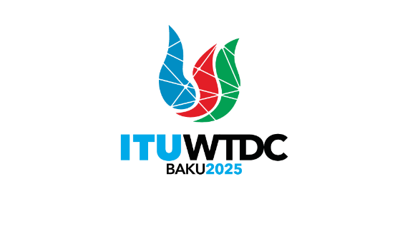
PLENARY MEETING |  | Document WTDC-25/5-E
 |  | 30 September 2025
 |  | Original: English
Secretary-General
Budget of the 2025 World Telecommunication Development Conference
Priority area: N/A
Summary:
The budget of the World Telecommunication Development Conference (WTDC-25) for the biennium 2024-2025, as approved by the Council at its 2023 session by its Resolution 1417, is annexed hereto for the information of the Budget Control Committee.
Expected results:
WTDC is invited to note this report and provide guidance as deemed appropriate.
References:
ITU Council Resolution 1417

Budget of the World Telecommunication Development Conference (WTDC-2025)

Item | Amount in CHF (000)
Staff costs | 605
Other staff costs | 9
Travel on duty | 231
Contractual services | 38
Material and supplies | 14
Public and internal service utilities | 2
Miscellaneous | 1
Sub-total | 900
Translation (4,400 pages) | 701
Text processing (4,400 pages) | 255
Documentation | 956
TOTAL | 1’856
_______________

