 | World Telecommunication Development Conference 2025 (WTDC-25)  Baku, Republic of Azerbaijan, 17–28 November 2025 |  | 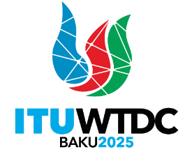
 |  | Document WTDC-25/2(Ann.3)-E
 |  | 14 November 2025
 |  | Original: English
Director, Telecommunication Development Bureau
dashboards
operational plan & WTDC-22 Resolutions and regional initiatives
Summary:
This document presents two interactive dashboards (1) an overview of the ITU-D Operational Plan (OP) including both budget implementation and Results-Based Management performance across the six regions and on a multi-regional scale, and (2) the contribution of OP activities and ITU-D projects to the implementation of WTDC-22 resolutions and regional initiatives.
Action required:
WTDC is invited to note the dashboards and comment as deemed necessary.
References:
WTDC-25 Document 2: Reporting on the implementation of the Kigali Action Plan (KAP)
Document WTDC-25/2(Ann.1) – Mapping of contribution of ITU-D Projects to the implementation of WTDC-22 Regional Initiatives
Document WTDC-25/2(Ann.2) – Contribution of OP Activities and ITU-D Projects to the implementation of WTDC-22 Resolutions

Introduction
The dashboards summarizing the implementation of OP budget and RBM framework for the execution of the Kigali Action Plan as well as the WTDC-22 resolutions and regional initiatives are accessible via a Ties protected account on the following link: Dashboards
The reporting tools highlights BDT’s commitment to upholding accountability, transparency and efficiency throughout its activities and processes.
WTDC is invited to note the dashboards and provide guidance as deemed necessary.
_______________

