 | World Telecommunication Development Conference 2025 (WTDC-25)  Baku, Republic of Azerbaijan, 17–28 November 2025 |  | 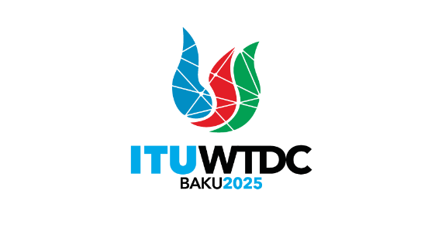
PLENARY MEETING |  | Document WTDC-25/1-E
 |  | 30 September 2025
 |  | Original: English
Director, Telecommunication Development Bureau
Draft Agenda of the World Telecommunication Development Conference (WTDC)

I. Report on the implementation of the ITU-D Action Plan
1. Update on the WTDC-22 Kigali Action Plan (including the Regional Initiatives)
2. Report of the Telecommunication Development Advisory Group
3. Report of Study Groups
4. Report on the implementation of outcomes of other ITU Conferences, Assemblies and meetings related to ITU-D work:
a. Plenipotentiary Conference (PP-22)
b. Radiocommunication Assembly (RA-23)/World Radiocommunication Conference (WRC-23)
c. World Telecommunication Standardization Assembly (WTSA-24)

II. Policy and strategy for digital transformation
5. Ministerial and Industry leaders’ roundtables and policy statements

III. ITU-D work plan for 2026-2029
6. Outcomes of Regional Preparatory Meetings for WTDC
7. ITU-D contribution to the ITU Strategic Plan for 2028-2031
8. ITU-D Priorities
9. ITU-D Action Plan for the following cycle
10. WTDC Declaration
11. Telecommunication Development Advisory Group
a. Authorization for the Telecommunication Development Advisory Group to act between world telecommunication development conferences (Resolution 24, Rev. Dubai, 2014)
b. Structure and working methods
12. Study Groups
a. Study Questions
b. Structure and working methods
13. Regional Initiatives
14. Resolutions and recommendations
________________

