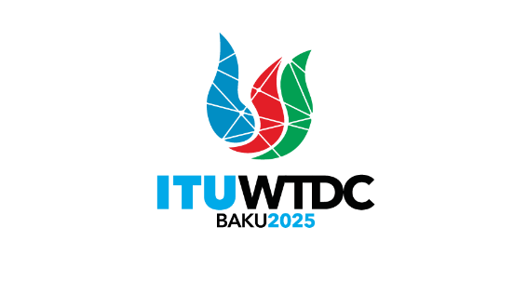 | Telecommunication Development  Advisory Group (TDAG)  32nd Meeting, Geneva, Switzerland, 12-16 May 2025 |  | 
 |  | Document TDAG-25/TD/6-E
 |  | 16 May 2025
 |  | English only
Chair, Telecommunication Development Advisory Group (TDAG)
Reply Liaison statement to Inter-Sector Coordination Group (ISCG)
on issues of mutual interest
Summary:
This liaison statement contains a reply to liaison statement to TDAG on Draft guidelines on the management of fully virtual and physical meetings with remote participation.
Action required:
TDAG is invited to approve this liaison statement.
References:
n/a

 |  | Telecommunication Development  Advisory Group (TDAG)  32nd Meeting, Geneva, Switzerland, 12-16 May 2025 |  |  |  | 
 |  |  |  |  | TDAG-25 – LS 5
 |  |  |  |  | 16 May 2025
 |  |  |  |  | English only
Chair, Telecommunication Development Advisory Group (TDAG)
Reply Liaison statement to Inter-Sector Coordination Group (ISCG)
on issues of mutual interest
For action to: |  |  | ISCG
For information to: |  |  | --
Deadline: |  |  | n/a
Contact: | Name/Organization/Entity: |  |  | Ms Roxanne McElvane Webber, Chair of TDAG
 | Phone number: |  |  | +1 202 418 1489
 | E-mail: |  |  | roxanne.webber@fcc.gov
Contact: | Name/Organization/Entity: |  |  | Ms Archana Gulati, Deputy to the Director, Telecommunication Development Bureau
 | Phone number: |  |  | +41 22 730 6475
 | E-mail: |  |  | archana.gulati@itu.int
Summary:
This liaison statement contains a reply to liaison statement to TDAG on Draft guidelines on the management of fully virtual and physical meetings with remote participation.
TDAG would like to thank the ISCG for the incoming liaison statement and noted with appreciation its contents. The discussions at the 32nd session of the TDAG highlighted the importance of the guidelines on the management of fully virtual and physical meetings with remote participation. The TDAG members expressed their views on the alignment of existing guidelines with the draft guidelines presented by the Inter-Sector Coordination Group (ISCG) on issues of mutual interest.
The TDAG noted the comprehensive nature of the guidelines and the need for effective coordination among the Advisory Groups to ensure consistency and avoid discrepancies. The discussions also emphasized the significance of remote participation in enhancing inclusivity and accessibility for all members, particularly those from developing countries.
Furthermore, the TDAG acknowledged the multi-country proposal related to remote participation at the WTDC, as mentioned in Document TDAG-25/54. The proposal underscored the necessity for practical and logistical arrangements to facilitate remote participation, ensuring that all members can contribute effectively to the conference proceedings. The membership is keen to have remote participation, especially during WTDC-25, and the Secretariat confirmed its preparations with the host country of the WTDC-25 for technical infrastructure that would allow a satisfactory level of remote participation during the Conference.
In conclusion, TDAG appreciates the efforts of the ISCG and the collaborating groups in developing these guidelines and looks forward to continued collaboration to refine and implement them effectively.
________________

