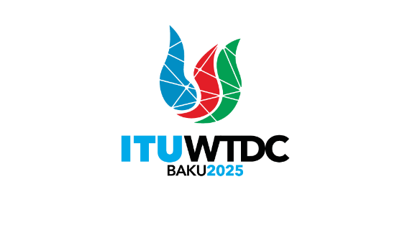 | Telecommunication Development  Advisory Group (TDAG)  32nd Meeting, Geneva, Switzerland, 12-16 May 2025 |  | 
 |  | Document TDAG-25/60-E
 |  | 14 May 2025
 |  | English only
Director, Telecommunication Development Bureau
Use of all the official languages on an equal footing in ITU-D
Abstract:
This document provides an overview of the BDT efforts on the use of all official languages on an equal footing. It presents actions aimed at improving the webpage experience with the transition on WordPress and the usage of artificial intelligence for machine based translation and interpretation.
Action required:
TDAG is invited to note the document and provide guidance as deemed appropriate.
References:
Resolution 154 (Rev. Bucharest, 2022) of the Plenipotentiary Conference (PP-22)
Resolution 1 (Rev. Kigali, 2022) of the World Telecommunication Development Conference (WTDC-22)
ITU Council Resolution 1386 (C17, last amended C24)
Council Resolution 1372 (C15, last amended C24)

- Introduction
The 2022 ITU Plenipotentiary (PP-22) in its Resolution 154 (Rev. Bucharest, 2022) addresses the use of the six official languages of the Union. This resolution calls on the ITU to continue to take all necessary measures to ensure the use of the six official languages of the Union on an equal footing and to provide interpretation and the translation of ITU documentation while noting that some work in ITU (for example working parties, regional conferences) might not require the use of all official languages.
Resolution 154 (Rev. Bucharest, 2022) instructs the Secretary-General, in close collaboration with the Directors of the Bureaux, to present an annual report to the Council and to the Council Working Group on Languages (CWG-Lang). ITU presented to Council 2024 a report on the use of the six languages of the Union on an equal footing. Council noted the report in Document C24/12, adopted the revision of Council Resolution 1386 (C17, last amended C24) and the revision of Council Resolution 1372 (C15, last amended C24), and endorsed the updated guide to current and future practices in the implementation of multilingualism at ITU contained in its Annex C.
Resolution 154 (Rev. Bucharest, 2022) also instructs the Sector Advisory Groups to review annually the use of all official languages of the Union on an equal footing in ITU publications and on ITU websites.
The Report on the implementation of the guide to current and future practices in multilingualism (Doc. 3, CWG-LANG16-C) provides guidelines on the ongoing implementation of the strategies outlines in the guide to multilingualism, including data on the use of ITU Translate for webpages and documents.
- BDT’s efforts on the use of all the official languages
BDT has significantly moved its webpages to WordPress. The continued migration to WordPress has picked up pace with the new ITU website Project to be implemented by 2026. This new ITU website is planned to be implemented next year in the fourth quarter of 2026 so as to be ready for the PP-26. The BDT is closely involved in the different phases at the inter-sectorial level.
Currently, all languages are supported on the ITU-D website, and they benefit from machine translation. The BDT, in close collaboration with the translation services, has been leading the change to the ITU web translation procedures in order to ensure the quality of the translation. To this end, internal arrangements have been made to ensure the translation quality for the upcoming WTDC-25.
Since the last TDAG, in 2024, the following ITU-D websites have been migrated to the current official ITU WordPress and benefit of the machine translation: Partnerships website, ITU-D Membership website, and the ITU-D Projects website.
The World Telecommunication Development Conference WTDC-25 (and its Regional Preparatory Meetings) is the first WTDC website to be developed using WordPress, to benefit from machine translation and post translation quality control by BDT colleagues and translators.
Furthermore, WTDC Resolution 1 (Rev. Kigali, 2022) addresses the usage of the six official languages on an equal footing, on sections 3.5.8, 3.5.9, 3.8.5, and 4.4.2. For TDAG and ITU-D Study Groups, BDT offers human interpretation during meetings, and human translation for documents submitted within the deadline as prescribed in WTDC Resolution 1. ITUtranslate, a machine-based translation is available at all times for accessing contributions in any official language of the Union. The ITU-D Study Group website has a mix of human translation and machine-based translation (ITU translate widget).
BDT has also tested AI based interpretation for ITU-D Study Groups management team meetings held on 27 April and 4 May 2025. BDT will also continue to explore testing of AI especially for meetings that currently have no human interpretation provision.
- Conclusions
BDT is committed to continue to regularly provide TDAG with information on the status of the use of all the official languages of the Union on an equal footing in ITU-D websites and ensure the use of the six official languages of the Union.
________________

