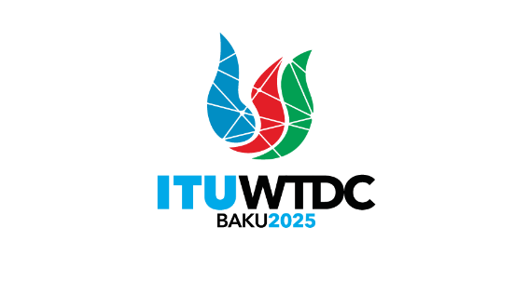 | Telecommunication Development  Advisory Group (TDAG)  32nd Meeting, Geneva, Switzerland, 12-16 May 2025 |  | 
 |  | Document TDAG-25/34-E
 |  | 25 February 2025
 |  | English only
Inter-Sector Coordination Group (ISCG) on issues of mutual interest
Incoming LS – Liaison statement on draft guidelines on the management of fully virtual and physical meetings with remote participation
Summary:
The attached is a liaison statement received for action and comment from Inter-Sector Coordination Group (ISCG) on issues of mutual interest on draft guidelines on the management of fully virtual and physical meetings with remote participation.
Action required:
TDAG is invited to note this document and provide guidance as deemed appropriate.

12 February 2025
English only

Inter-Sector Coordination Group (ISCG)
on issues of mutual interest
Geneva, 12 February 2025

LIAISON STATEMENT
Source: | ISCG
Title: | Draft guidelines on the management of fully virtual and physical meetings with remote participation
Purpose: | Action
For action to: RAG, TSAG, TDAG
For comment to: RAG, TSAG, TDAG
For information to: -
Approval: ISCG Meeting (Geneva, 12 February 2025)
Deadline: N/A
Contact: Fabio Bigi E-mail: fabio.bigi@virgilio.it
ISCG Chair E-mail: iscg@itu.int
(Italy)
Contact: Philip Rushton E-mail: philrushton@rcc-uk.uk
ISCG Coordinator
(United Kingdom)

Keywords: | Inter-Sectoral coordination; ISCG, Remote participation.
Abstract: | The ISCG has noted the output of the Correspondence Group of the CWG-FHR task on guidelines for remote participation and brings it to the attention of the sector advisory groups
The Inter-Sector Coordination Group (ISCG) on issues of mutual interest would like to present to the attention of the Radiocommunication Advisory Groups (RAG), the Telecommunication Standardization Advisory Group (TSAG) and the Telecommunication Development Advisory Group (TDAG) the Draft guidelines on the management of fully virtual and physical meetings with remote participation at ITU, in line with the implementation of Resolution 167 (Rev. Bucharest, 2022).
These guidelines were developed by a Correspondence Group created by the Council Working Group on Financial and Human Resources (CWG-FHR), and are presented here for your information.
The ISCG kindly requests the RAG, TDAG, and TSAG to provide their views on the alignment of their existing guidelines with the attached guidelines. Additionally, we would appreciate it if you could identify any discrepancies, if present.
Looking forward to receiving your feedback, the ISCG thanks the sector advisory groups, RAG, TSAG and TDAG, for its collaboration and contributions.
_______________

