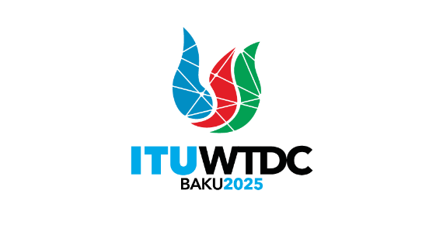 | Telecommunication Development  Advisory Group (TDAG)  32nd Meeting, Geneva, Switzerland, 12-16 May 2025 |  | 
 |  | Document TDAG-25/30-E
 |  | 9 August 2024
 |  | English only
Telecommunication Standardization Advisory Group (TSAG)
Incoming LS – Liaison Statement on A-Series Supplement 7
“WTSA preparation guideline on Resolutions” [to ISCG, TDAG, RAG]
Summary:
The attached is a liaison statement received for information from Telecommunication Standardization Advisory Group (TSAG) on A-Series Supplement 7 “WTSA preparation guideline on Resolutions”.
Action required:
TDAG is invited to note this document and provide guidance as deemed appropriate.

 | INTERNATIONAL TELECOMMUNICATION UNION  TELECOMMUNICATION  STANDARDIZATION SECTOR  STUDY PERIOD 2022-2024 |  |  |  | TSAG-LS51
 |  |  |  |  | TSAG
 |  |  |  |  | Original: English
Question(s): |  | RG-WTSA |  |  | Geneva, 29 July – 2 August 2024
LS
Source: |  | Telecommunication Standardization Advisory Group (TSAG)
Title: |  | LS on A-Series Supplement 7 "WTSA preparation guideline on Resolutions" [to ISCG, TDAG, RAG]
LIAISON STATEMENT
For action to: |  |  | ISCG
For information to: |  |  | RAG, TDAG
Approval: |  |  | TSAG meeting (Geneva, 2 August 2024)
Deadline: |  |  | –
Contact: |  | Mr Mihail Ion  Romania, WP1 chairman |  | E-mail: mihail.ion@ancom.ro
Contact: |  | Fang Li  CAICT, MIIT, China  Rapporteur, TSAG RG-WTSA |  | E-mail: lifang@caict.ac.cn

Abstract: | This liaison statement informs ISCG (cc RAG and TSAG) of agreed A-Series Supplement 7 (ex A.SupWTSAGL) "WTSA preparation guideline on Resolutions" for information, and requests ISCG to study effective mechanisms to streamline ITU Resolutions of ITU Conferences and Assemblies.
TSAG thanks ISCG for your liaison reply (ISCG-LS7) LS/r on draft analysis of operational parts of WTSA/PP/WTDC/Council/ITU-R Resolutions.
TSAG is pleased to inform you that TSAG July/Aug 2024 meeting approved A.SupWTSAGL "WTSA preparation guideline on Resolutions" in TSAG-TD612R3.
TSAG highlighted again the importance of streamlining ITU Resolutions and recognized discussions and efforts of TSAG, TDAG and ISCG to develop guidelines on streamlining ITU Resolutions over several past cycles. TSAG noted serious concerns shared by TSAG delegates on the substantial overhead caused by inflation of Resolutions among ITU high level Conferences and Assemblies, and regrets that little streamlining progress has been achieved in putting TSAG, TDAG and ISCG guidelines into practice.
Recognizing streamlining of ITU Resolutions cross all ITU Sectors needs highest level of consensus and commitment of ITU Membership, pursuit to PP Resolution 191, TSAG would like to escalate this issue common to all ITU Sectors to ISCG, to invite ITU membership to make proposals to ITU Council and Plenipotentiary Conference on effective mechanisms to streamline ITU Resolutions of ITU Conferences and Assemblies.
Annex (1):
1. A-Series Suppl. 7 (2024) "WTSA preparation guideline on Resolutions" (Prepublication draft)
_______________

