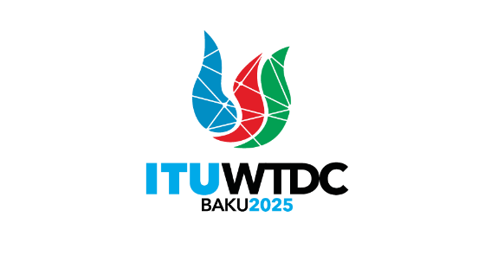 | Telecommunication Development  Advisory Group (TDAG)  32nd Meeting, Geneva, Switzerland, 12-16 May 2025 |  | 
 |  | Document TDAG-25/21-E
 |  | 31 March 2024
 |  | Original: English
Chair, TDAG-WG-ITUDP
Report on progress of the TDAG Working Group on the ITU-D Priorities
Summary:
The document contains a summary of discussions and an update on progress of the Group.
Action required:
For information.
References:
- Terms of Reference of TDAG-WG-ITUDP (TDAG-24/DT/5)
- Report of the first meeting of the TDAG Working Group on the ITU-D Priorities (TDAG-WG-ITUDP/3)
- Report of the second meeting of the TDAG Working Group on the ITU-D Priorities (TDAG-WG-ITUDP/6)
- Report of the third meeting of the TDAG Working Group on the ITU-D Priorities (TDAG-WG-ITUDP/8)

- Introduction
The TDAG Working Group on ITU-D Priorities (TDAG-WG-ITUDP) was established by TDAG with the following Terms of Reference:
- Review the current ITU-D Priorities and related enablers set at WTDC-22, proposals to WTDC-25 including on regional initiatives, ITU-D study Questions, as well as outcomes of the Regional Preparatory Meetings for WTDC-25, the 2030 Sustainable Development Goals and the relevant WSIS Action Lines for which ITU has lead responsibility and subsequently develop proposals for the new ITU-D Priorities;
- Review the status of implementation and impact of the ITU Strategic Plan 2024-2027 relating to ITU-D and prepare proposals for the draft new ITU-D contribution to the ITU Strategic Plan for the next period (2028-2031);
- Review the status of implementation and impact of the Kigali Action Plan (KAP) including its links with the Operational Plan and develop proposals for the next WTDC Action Plan;
- Review the status of implementation and impact of the four-year rolling Operational Plan, identify areas of improvement, and develop recommendations for the Draft Operational Plan; and
- Submit the report to TDAG.
Mr Christopher Kemei from Kenya was appointed as Chair, with Mr Ahmad Sharafat from Iran and Ms Blanca Gonzalez from Spain serving as Vice-Chairs.
At the extraordinary TDAG held the 23 January 2025, Mr Kemei stepped down as Chair of the group and Ms Inga Rimkevičienė, from Lithuania was appointed as new Chair.
TDAG-WG-ITUDP held its first meeting on 4 September 2024, the second meeting on 4 December 2024 and the third meeting the 26 March 2025. The Reports of the meetings are available on the Website of TDAG-WG-ITUDP.
- Approach taken and progress made
At the time the 1st meeting was held, no written contributions had been received and therefore very minimal discussions took place. In view of this and for purposes of stimulating contributions and discussions in the subsequent meetings, the group agreed that the Chair, in consultation with the secretariat could develop a contribution for such purposes.
During the second meeting, a Chair’s proposal was presented to the group.
At the third meeting the Chair proposed to carry on the work on the revision of the current priorities based on a note that she submitted prior to the 26 March meeting.
The meeting agreed to:
- Use the current priorities of the Kigali Action Plan as baseline for discussion on the elaboration of the new priorities. The priorities are:
  - Affordable Connectivity;
  - Digital Transformation;
  - Enabling Policy and Regulatory Environment;
  - Resource Mobilization and International Cooperation;
  - Inclusive and secure telecommunications/ICTs for sustainable development
- Adopt the proposal from the Chair on the structure of the Baku Action Plan to guide the drafting process
- Key Dates and Next Steps
The fourth meeting of TDAG-WG-ITUDP will be held the 1st May 2025. There will also be a possibility for a physical meeting during TDAG-25 to wrap up the discussions of the Group.
In addition, the TDAG-WG-ITUDP Chair will provide reports on progress of the work of the Group to the upcoming Regional Preparatory Meetings (RPMs) in the lead up to WTDC-25.
The final deliverable of the TDAG-WG-ITUDP will be submitted for further consideration to the 2025 TDAG and possible submission as input to WTDC-25 where it will be finalized and the final Baku Action Plan adopted.

References:
TDAG-WG-ITUDP/DT/3
________________

