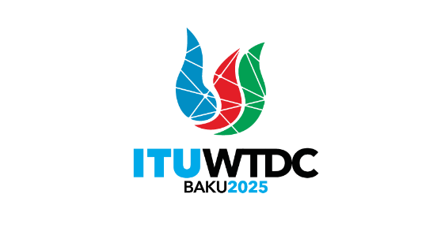 | Telecommunication Development  Advisory Group (TDAG)  32nd Meeting, Geneva, Switzerland, 12-16 May 2025 |  | 
 |  | DocumentTDAG-25/19(Rev.1)-E
 |  | 9 May 2025
 |  | Original: English
Chair, TDAG-WG-futureSGQ
Report on the TDAG Working Group on Future of Study Group Questions
(TDAG-WG-futureSGQ)
Summary:
This document presents the report on the TDAG Working Group on the future of Study Group Questions (TDAG-WG-futureSGQ).
This revised version provides updates from the meeting of TDAG-WG-futureSGQ held on 16 April 2025. This version includes a section on all proposals received and an annex 3 which is a consolidated document proposed for use as a base document at WTDC-25 instead of annex 1 and 2 of WTDC Resolution 2 (Rev. Kigali, 2022) and its related terms of reference of Study Group Questions.
This revised version may not be available in all official languages of the Union. It can be translated using ITU translate https://translate.itu.int/documents - please click on this link to initiate the translation.
Action required:
TDAG is invited to consider this document and provide guidance as deemed appropriate.
References:
- WTDC Resolution 2 (Rev. Kigali, 2022)

- Introduction
At the 31st meeting of TDAG held in Geneva from 20-23 May 2024, the first progress report of TDAG Working Group on the future of Study Group Questions (document TDAG-24/25) was presented. The document shared the report of the first meeting of the TDAG Working Group on the future of Study Group Questions (TDAG-WG-futureSGQ) which included a proposed composition of the working group, a background document, a proposed the terms of reference for the working group and a proposed calendar of future fully online meetings.
Following the approval of the terms of reference at the TDAG meeting of May 2024, the TDAG-WG-futureSGQ held its second and third two fully online meetings on 3 September 2024 and 3 December 2024, respectively. At the December meeting, an additional meeting prior to the final one on 4 March 2025, was agreed. The fourth meeting was held on 21 January 2025 and the sixth meeting was held on 16 April 2025. A final meeting is planned on 13 and 15 May 2025, in conjunction with TDAG-25 in Geneva.
A progress report (document TDAG-Extra/4) on the work of TDAG-WG-futureSGQ was presented at the Extra-ordinary meeting of the TDAG held on 25 January 2025, as well as at all the WTDC-25 Regional Preparatory Meetings.
This document shares the outcomes of the work of TDAG-WG-futureSGQ.
- Management team
The appointed vice-Chairs of the TDAG-WG-futureSGQ namely Ms Regina Fleur Assoumou-Bessou (Côte d’Ivoire), and Mr Fadel Digham (Egypt) as well as the appointed study group coordinators namely Mr Roberto Hirayama (Brazil) for ITU-D Study Group 1 (SG1) and Mr Victor Martinez (Paraguay) for ITU-D Study Group 2 (SG2), provided their constant support to the Chair.
Regional Focal points were identified as indicated at annex 1.
- Approved terms of reference of TDAG-WG-futureSGQ
- To act as a single platform for focused discussions on future ITU-D study Questions, and to assist ITU membership in their preparations for the next WTDC by proposing specific changes to Resolution 2 (Rev. Kigali, 2022) on the scope of ITU-D study Questions, their number, titles, and terms of reference, taking into consideration the evolution of ICTs, priorities of ITU membership, as well as current and past activities/outcomes of ITU-D study groups.
- To align, as far as possible, the proposed study Questions to BDT priorities, proposed regional initiatives, the 2030 Sustainable Development Goals and WSIS Action Lines (C2, C5 and C6) for which ITU has lead responsibility.
- To research and acquire views of ITU membership through relevant channels including surveys, contributions and meetings.
- To liaise with ITU-D Study Groups through the appointed ITU-D Study Groups 1 and 2 coordinators for the future of study Questions. The coordinators may, inter alia, upon the request of the ITU membership, assist them to prepare contributions on Future of Questions.
- To submit regular updates to TDAG.
- Meeting outcomes
Meetings Report | Outcomes
1st meeting held on 4 March 2024 | - Agreement on management team and terms of reference  - Agreement on future meeting dates  - Review of background paper for developing future study Questions  Meeting Report is Document TDAG-WG-futureSGQ/6  The outcomes were reported to TDAG-24.
2nd meeting held on 3 September 2024 | - Agreement on the content of the online consultation form as well as on launch and closing dates  Meeting Report is Document TDAG-WG-futureSGQ/10
3rd meeting held on 3 December 2024 | - Presentation of results of the online consultation  - Review of two contributions from members (ATU, SG1)  - Agreement for Chair to prepare a draft revision of extracts from annexes 1 and 2 of WTDC Resolution 2 (Rev. Kigali, 2022) including the terms of reference of study Questions. The revision (first draft consolidated document) will use inputs from the online consultation results, the contributions reviewed and the discussions held at the meeting.  Meeting Report is Document TDAG-WG-futureSGQ/16
4th meeting held on 21 January 2025 | - Review of the first draft consolidated document TDAG-WG-futureSGQ/23  - Review of contributions from members (APT, UK et al., China, SG1, SG2)  - Agreement to update the first draft consolidated document using inputs from the contributions reviewed, the discussions held at the meetings and further consultations as agreed at the meeting.  Meeting Report is Document TDAG-WG-futureSGQ/25
5th meeting held on 4 March 2025 | - Review of the second draft consolidated document TDAG-WG-futureSGQ/29  - Review of five contributions from members (ATU, China, Egypt, IAGDI-CRO, SG1)  - Agreement to update the second draft consolidated document using inputs from the contributions reviewed, the discussions held at the meetings and further consultations as agreed at the meeting.  Meeting Report is TDAG-WG-futureSGQ/34
6th meeting held on 16 April 2025 | - Review of the third draft consolidated document TDAG-WG-futureSGQ/38  - Review of three contributions from members (APT,RCC Russian Federation)  - Agreement to update the third draft consolidated document using inputs from the contributions reviewed, the discussions held at the meetings and further consultations as agreed at the meeting. The updated document is TDAG-WG-futureSGQ/43  Meeting Report is TDAG-WG-futureSGQ/41
Annex 2 provides a summary of the meetings held after TDAG-24.
- Proposals received in the form of contributions to TDAG-WG-futureSGQ meetings
- Documents TDAG-WG-futureSGQ/14 and TDAG-WG-futureSGQ/27 (Rev.1)from African Telecommunication Union (ATU) with the views of African countries on specific topics, which aligns with consolidated proposal of the TDAG-WG-futureSGQ to keep the number of Study Groups to 2 and to have 10 study Questions in total.
- Documents TDAG-WG-futureSGQ/18 and TDAG-WG-futureSGQ/36 from Asia-Pacific Community (APT) shares the views of the Asia-Pacific Community (APT) to keep the number of Study Groups to 2 and to have 10 study Questions in total and aligns with the consolidated proposal of the TDAG-WG-futureSGQ.
- Document TDAG-WG-futureSGQ/19 from Kenya, UK, GDPI, GSMA and Spain proposes a new study Question on device affordability, with draft ToRs.
- Documents TDAG-WG-futureSGQ/20 and TDAG-WG-futureSGQ/30 from China (People’s Republic of) propose a new study Question on applying artificial intelligence in digital transformation together with draft ToRs.
- Documents TDAG-WG-futureSGQ/12 , TDAG-WG-futureSGQ/21 and TDAG-WG-futureSGQ/28 from the Study Group 1 (SG1) Coordinator, provide the revised ToRs of ITU-D SG1 Questions integrated into the consolidated proposal of the TDAG-WG-futureSGQ.
- Document TDAG-WG-futureSGQ/22 from the Study Group 2 (SG2) Coordinator, shares the initial thoughts on new and revised study items for Study Group 2 Questions integrated into the consolidated proposal of the TDAG-WG-futureSGQ.
- Document TDAG-WG-futureSGQ/31 from the Industry Advisory Group on Development Issues and Private Sector Chief Regulatory Officers (IAGDI-CRO) shares information on potential hot topics in future Study Question identified from the outcomes of two Tech Talks on the topic of the current titles of SG1 and SG2.
- Document TDAG-WG-futureSGQ/32 from Egypt proposes the bases and guidelines for proposing future Questions, and comments on the consolidated proposal of the TDAG-WG-futureSGQ.
- Document TDAG-WG-futureSGQ/37 from the Regional Commonwealth in the field of Communications (RCC) shares view on the number of study groups and on study group Questions for 2026-2029. The views are backed by the analysis of the current structure, including the mapping of Questions’ topics and mapping of received contributions.
- Document TDAG-WG-futureSGQ/39 from the Russian Federation provided updates to the revised terms of reference of Question 7/1.
- Final consolidated document
After the extensive consultations held, please find at annex 3, a final consolidated document proposed for use as a base document at WTDC-25 instead of annex 1 and 2 of WTDC Resolution 2 (Rev. Kigali, 2022) and its related terms of reference of Study Group Questions.
This final consolidated is a guide for consideration by all members who will be submitting contributions at WTDC-25 for annex 1 and annex 2 extracts of WTDC Resolution 2 (Rev. Kigali, 2022) including the terms of reference of Study Group Questions.
The main elements proposed are:
- 2 Study Groups maintained with a shorter revised title for SG1.
- 5 Study Questions for each Study Group to reduce topic/contribution overlaps and enhance efficient use of resources. With this proposal, a set of Rapporteur Group meetings can fit in one week and back-to-back SG1 and SG2 Rapporteur Groups meetings could be then reduced to 2 weeks long instead of 4 weeks.
- The terms of reference of all study Questions proposed have integrated the revisions of terms of references shared by SG1 and SG2 Coordinators after consulting the current (co)rapporteurs of each study Question.

Annex 1: Regional Focal Points
Mr Mohammad Khalil-Ur-Rahman (Bangladesh) for APT (Asia-Pacific)
Ms Caecilia Nyamutswa (Zimbabwe) for ATU (Africa)
Ms Madalina Clapon (Romania) and Mr Teddy Woodhouse (United Kingdom) for CEPT (Europe)
Mr Roberto Hirayama (Brazil) for CITEL (Americas)
Mr Belkassem Makhlouf (LAS) for LAS (Arab States)
Mr Arseny Plossky (Russian Federation) for RCC (CIS regions)

Annex 2: Summary of meetings held after TDAG-24
- The second fully online meeting of the TDAG-WG-futureSGQ held on 3 September 2024
The information shared below is from the report of the second meeting of TDAG-WG-futureSGQ (document TDAG-WG-futureSGQ/10).
The focus of the meeting was to review and agree on the content of the online consultation form (questionnaire) developed to gather views from all interested members subscribed to the TDAG and TDAG-WG-futureSGQ’s mailing lists.
The consultation form was structured into the following sections:
- Section 1 (“Current study Questions”) included general queries to respondents about their knowledge of the current structure of the ITU-D Study Groups, as well as which Study Questions in the current study period were important to them.
- Section 2 (“Number of Questions”) enquired on the number of Study Questions to consider in the next study period with a deeper dive in Questions to merge or discontinue.
- Section 3 (“New topics”) focused on identifying emerging topics to be addressed in the upcoming study period, with an emphasis on providing guidelines, best practices, and experience sharing for developing countries.
- Section 4 (“Cross-cutting topics”) probed on cross-cutting topics to be addressed in a separate study Question or across multiple study Questions.
The meeting agreed that the consultation form would be updated as per discussions held at the meeting and shared on 17 September 2024, with deadline for responses set to 1 October 2024. The results would be made available (as a contribution to the next meeting) by end of October 2024 to guide inputs from the membership for the next meeting of TDAG-WG-futureSGQ, scheduled on 3 December 2024, and to assist regional groups in preparing for WTDC-25.
- The third fully online meeting of the TDAG-WG-futureSGQ held on 3 December 2024
The information shared below is from the report of the third meeting of TDAG-WG-futureSGQ (document TDAG-WG-futureSGQ/16).
The results of the online consultation were presented as per the image below. These are for use by all in preparing contributions for submission to future TDAG-WG-futureSGQ meetings.
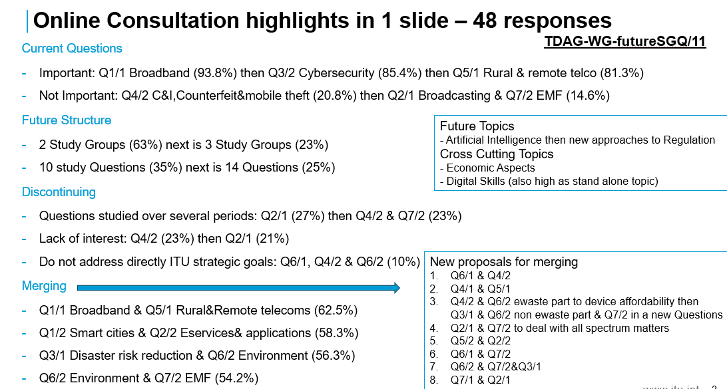
A contribution from the African Telecommunication Union (ATU) and a contribution on the initial views of Rapporteurs and co-Rapporteurs of Study Group 1 were received and discussed.
The meeting agreed that:
- The Chair will prepare a draft revision of extracts of Resolution 2 annexes including the terms of reference of Study Questions, for discussion in the next meeting. This document will consider the online consultation results, the contributions received as well as the views shared at the meeting. It will aim to engage the widest possible set of contributions/views received formally and informally. This document will be a contribution to the next TDAG-WG-futureSGQ meeting.
- The BDT secretariat will be tasked to request focal points from RTOs for the TDAG-WG-futureSGQ who will submit and present inputs of RTOs to the next TDAG-WG-futureSGQ.
- An additional e-meeting will be held in January- February 2025 period after further consultation with BDT secretariat, BDT Director and TDAG Chair.
- The fourth fully online meeting of the TDAG-WG-futureSGQ held on 21 January 2025
The information shared below is from the report of the fourth meeting of TDAG-WG-futureSGQ (document TDAG-WG-futureSGQ/25). This meeting was attended by over 80 participants.
Six contributions as listed below, were received, presented and extensively discussed:
- Document TDAG-WG-futureSGQ/18 from Asia-Pacific Community (APT)shared the views of the Asia-Pacific Community (APT) which aligns with proposal of the TDAG-WG-futureSGQ.
- A proposal for a new Question on Device Affordability/Availability
- A proposal for a new Question on Application of Artificial Intelligence
- The initial views of Rapporteurs and co-Rapporteurs of Study Group 2.
- The revised terms of reference of most of the Study Group 1 Questions.
- Document TDAG-WG-futureSGQ/23 which is the draft revision of extracts of Resolution 2 annexes including the terms of reference of Study Questions prepared by the Chair, as agreed in the previous meeting.
The meeting agreed that:
- Document TDAG-WG-futureSGQ/23 be updated to incorporate inputs from the contributions received and from discussions at the meeting. The final version of the document is planned to be shared as a deliverable of the TDAG-WG-futureSGQ.
- The two proposals for new Questions be reviewed collaboratively by the authors and participants who shared views on them at the meeting. The reviewed proposals would be presented at the next meeting and integrated into a revised version of document TDAG-WG-futureSGQ/23.
- The fifth fully online meeting of the TDAG-WG-futureSGQ held on 4 March 2025
The information shared below is from the report of the fifth meeting of TDAG-WG-futureSGQ (document TDAG-WG-futureSGQ/34). This meeting was attended by over 80 participants.
Six contributions as listed below, were received, presented and extensively discussed:
- Reports from the Industry Advisory Group on Development Issues and Private Sector Chief Regulatory Officers (IAGDI-CRO) on two tech talks organized on the themes of the two ITU-D study groups. They discussed on topics which may serve as inputs for future study Questions.
- Updated views from the African Telecommunication Union (ATU) on new topics (device affordability/availability and application of artificial intelligence), on number of study groups and on the draft proposal of the deliverable of TDAG-WG-futureSGQ.
- Completed compilation of terms of reference for ITU-D Study Group 1 (SG1) Questions, provided by the SG1 Vice-Chair and Coordinator on future study Questions on behalf of the SG1 (co-)rapporteurs.
- Updated proposal from China for a new Question on application of artificial intelligence (AI), following comments and offline discussions since the previous meeting.
- Proposal from Egypt on bases and guidelines for proposing future Questions, and comments on the draft proposal of the deliverable of TDAG-WG-futureSGQ.
- Document TDAG-WG-futureSGQ/29 which is the second draft revision of extracts of Resolution 2 annexes including the terms of reference of Study Questions prepared by the Chair, following contributions, comments and offline discussions since the previous meeting.
The meeting agreed to:
- uphold the current two study groups. Discussion of a possible third study group was recognized, but was considered outside the scope of the two study groups and would need to be discussed as a separate topic.
- have five study Questions in each of the two study groups.
- merge the Q1/1 (broadband) and Q5/1 (rural and remote areas) of the current study period.
- agree on focus for Q4/1 (economic aspects).
- include the new topic on AI into an existing study Question.
Further discussions were needed to achieve consensus on the following points:
- where to fit the new topic on device availability & affordability.
- whether some specific Questions (including Q6/1 with Q4/2 or Q5/2, Q7/1 with Q5/2, Q1/2 with Q2/2, Q4/2 C&I with Q6/2 and Q7/2) should be merged or not, and in which study group they should be studied (including Q3/1 and Q3/2)¹.
- whether some standalone or merged Questions (including Q1/1 merged with Q5/1, Q2/1)¹ should extend their scope to become more attractive.
- The sixth fully online meeting of the TDAG-WG-futureSGQ held on 16 April 2025
The information shared below is from the report of the sixth meeting of TDAG-WG-futureSGQ (document TDAG-WG-futureSGQ/41). This meeting was attended by over 60 participants.
Four contributions as listed below, were received, presented and extensively discussed:
- Aligned views of the Asia-Pacific Telecommunity (APT) on study Questions for the 2025-2029 study period, as discussed at the 3rd meeting of the APT Preparatory Group for WTDC-25 held from 17 to 18 March 2025 in Bangkok, Thailand.
- Views of the Regional Commonwealth in the field of Communications (RCC) on the structure that is the number of study groups and on study group Questions for 2026-2029. The views are backed by the analysis of the current structure, including the mapping of Questions’ topics and mapping of received contributions.
- Proposed updates by the Russian Federation, on the revised terms of reference of Question 7/1 previously submitted by SG1 Coordinator to the TDAG-WG-futureSGQ which were prepared by co-Rapporteurs of Question 7/1
- The third draft revision of extracts of Resolution 2 annexes including the terms of reference of Study Questions prepared by the Chair, following contributions, comments and offline discussions since the previous meeting.
The meeting agreed that
- The RCC be invited to reconsider its contribution based on the comments received during the meeting, and to propose revised/new options to be considered at the next meeting.
- A revision to the title for proposed Question A/1
- The use of the word to “users’ terminals/devices instead of “users’ terminals”
- The proposal from the Russian Federation on Q7/1 terms of references, be included as far as possible in the updated revision of document TDAG-WG-futureSGQ/38 under Question B/1.
- An updated revision of documentTDAG-WG-futureSGQ/38 (this is document TDAG-WG-futureSGQ/43) with tracked changes and without tracked changes be made available. This document will take into consideration all contributions and comments received.
- A final meeting in conjunction with TDAG-25 to be held in Geneva in May 2025.

Annex3: Consolidated document proposed for use as a base document
Please see the documents annexed in two versions:
- with revision marks
- without revision marks
_______________

The Question numbers refer to the Questions of the 2022-2025 study period: link

