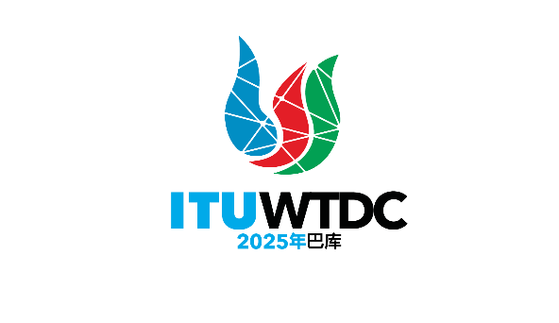 | 电信发展顾问组（TDAG）  第32次会议，2025年5月12-16日，瑞士日内瓦 |  | 
 |  | 文件 TDAG-25/19(Rev.1)-C
 |  | 2025年5月9日
 |  | 原文：英文
TDAG-WG-futureSGQ主席
TDAG未来研究组课题工作组（TDAG-WG-futureSQ）的报告
概要：
本文件载有TDAG未来研究组课题工作组（TDAG-WG-future SGQ）的报告。
本修订版提供了2025年4月16日举行的TDAG-WG-futureSGQ会议的最新情况。这一版本纳入了一个关于收到的所有提案的章节和一份附件3，该附件3是一份综合文件，建议用作WTDC-25的基础文件，以取代WTDC第2号决议（2022年，基加利，修订版）附件1和2及其相关的研究组课题职权范围。
需采取的行动：
请TDAG审议本文件，并酌情提供指导。
参考文件：
– WTDC第2号决议（2022年，基加利，修订版）

1 引言
2024年5月20-23日在日内瓦举行的TDAG第31次会议介绍了TDAG未来研究组课题工作组的第一份进展报告（TDAG-24/25号文件）。该文件分享了TDAG未来研究组课题工作组（TDAG-WG-futureSGQ）第一次会议的报告，其中包括工作组的拟议构成、背景文件、工作组的拟议职责范围以及未来纯线上会议的拟议会议日历。
在2024年5月的TDAG会议批准其职责范围后，TDAG-WG-futureSGQ分别于2024年9月3日和2024年12月3日举行了第二次和第三次纯线上会议。12月的会议同意在2025年3月4日最后一次会议之前再举行一次会议。第四次会议于2025年1月21日举行，第六次会议于2025年4月16日举行。最后一次会议计划于2025年5月13日和15日与TDAG-25在日内瓦同期举行。
在2025年1月25日举行的TDAG特别会议以及所有WTDC-25区域筹备会议上介绍了TDAG-WG-futureSGQ工作的进展报告（TDAG-Extra/4号文件）。
本文件分享了TDAG-WG-futureSGQ的工作成果。

2 管理班子
TDAG-WG-futureSGQ任命的副主席Regina Fleur Assoumou-Bessou女士（科特迪瓦）和Fadel Digham先生（埃及）、以及指定的ITU-D第1研究组（SG1）的协调人Roberto Hirayama先生（巴西）和ITU-D第2研究组（SG2）的协调员Victor Martinez先生（巴拉圭），为主席提供了不懈的支持。
区域联系人已确定，见附件1。

3 经批准的TDAG-WG-futureSGQ的职责范围
1) 作为就ITU-D未来研究课题进行集中讨论的单一平台，并就ITU-D研究课题的范围、编号、标题和职责范围对第2号决议（2022年，基加利，修订版）提出具体修改建议以协助国际电联成员筹备下届WTDC，同时考虑到信息通信技术的发展、国际电联成员的工作重点以及ITU-D研究组当前和过去的活动/成果。
2) 尽可能将拟议研究课题与电信发展局工作重点、拟议区域性举措、国际电联牵头负责的2030年可持续发展目标和WSIS行动方面（C2、C5和C6）统一起来。
3) 通过调查、文稿和会议等相关渠道开展研究并了解国际电联成员的意见。
4) 通过指定的ITU-D第1和第2研究组协调人就研究课题的未来与ITU-D各研究组进行联络。协调人可应国际电联成员的要求，协助其准备有关课题未来的文稿。
5) 定期向TDAG提交最新情况。

4 会议成果
会议报告 | 成果
2024年3月4日举行的  第1次会议 | – 就管理班子和职责范围达成一致  – 就未来会议日期达成一致；  – 审议背景文件，以制定未来的研究课题  会议报告见TDAG-WG-futureSGQ/6号文件  成果已向TDAG-24报告。
2024年9月3日举行的  第2次会议 | – 就在线磋商表的内容以及启动和截止日期达成一致  会议报告见TDAG-WG-futureSGQ/10号文件。
2024年12月3日举行的  第3次会议 | – 介绍在线磋商结果  – 审议成员提交的两份文稿（ATU、SG1）  – 同意主席起草WTDC第2号决议（2022年，基加利，修订版）附件1和附件2摘录的修订草案，其中包括研究课题的职责范围。修订案（综合文件草案初稿）将采用在线磋商结果、经审议的文稿和会议讨论的输入意见。  会议报告见TDAG-WG-futureSGQ/16号文件
2025年1月21日举行的  第4次会议 | – 审议TDAG-WG-futureSGQ/23号综合文件草案初稿  – 审议成员提交的文稿（APT、英国等、中国、SG1、SG2）  – 同意利用来自所审议文稿、会议上进行的讨论以及会议商定的进一步磋商的输入意见来更新综合文件草案初稿。  会议报告见TDAG-WG-futureSGQ/25号文件
2025年3月4日举行的  第5次会议 | – 审议TDAG-WG-futureSGQ/29号综合文件第二稿草案  – 审议成员提交的五份文稿（ATU、中国、埃及、IAGDI-CRO、  第1研究组）  – 同意利用来自所审议文稿、会议上进行的讨论以及会议商定的进一步磋商的输入意见来更新综合文件第二稿草案。  会议报告见TDAG-WG-futureSGQ/34
2025年4月16日举行的  第6次会议 | – 审议TDAG-WG-futureSGQ/38号综合文件第三稿草案  – 审议成员提交的三份文稿（APT、RCC、俄罗斯联邦）  – 同意使用所审议文稿、会议进行的讨论以及会议上一致认可的进一步磋商意见对综合文件第三稿草案进行更新。更新后的文件为TDAG-WG-futureSGQ/43  会议报告见TDAG-WG-futureSGQ/41
附件2提供了TDAG-24之后举行的会议的摘要。

5 以提交TDAG-WG-futureSGQ会议的文稿形式收到的提案
a) 非洲电信联盟（ATU）提交的TDAG-WG-futureSGQ/14号文件和TDAG-WG-futureSGQ/27 (Rev.1)号文件涉及非洲国家对具体议题的看法，与TDAG-WG-futureSGQ的综合提案相一致，即将研究组数量保持在2个，总共有10个研究课题。
b) 亚太共同体（APT）提交的TDAG-WG-futureSGQ/18号文件和TDAG-WG-futureSGQ/36号文件分享了亚太共同体（APT）的观点，即将研究组的数量保持在2个，共有10个研究课题，并与TDAG-WG- futureSGQ的综合提案保持一致。
c) 肯尼亚、英国、GDPI、GSMA和西班牙提交的TDAG-WG-futureSGQ/19号文件提出了一个关于设备价格可承受性的新研究课题以及职责范围草案。
d) 中华人民共和国提交的TDAG-WG-futureSGQ/20号文件和TDAG-WG-futureSGQ/30号文件提出了一个关于在数字化转型中应用人工智能的新研究课题以及职责范围草案。
e) 第1研究组（SG1）协调员提交的TDAG-WG-futureSGQ/12号文件、TDAG-WG-futureSGQ/21号文件和TDAG-WG-futureSGQ/28号文件提供了纳入TDAG-WG-futureSGQ综合提案的ITU-D SG1课题经修订的职责范围。
f) 第2研究组（SG2）协调员提交的TDAG-WG-futureSGQ/22号文件，分享了对纳入TDAG-WG-futureSGQ综合提案的第2研究组课题新的和经修订的研究项目的初步想法。
g) 发展问题行业顾问组和私营部门首席监管官（IAGDI-CRO）提交的TDAG-WG-futureSGQ/31号文件分享了根据两次关于第1研究组和第2研究组当前标题的技术讲座成果所确定的未来研究课题中的潜在热点话题的信息。
h) 埃及提交的TDAG-WG-futureSGQ/32号文件建议了提出未来课题的基础和导则，并对TDAG-WG-futureSGQ综合提案提出了评论意见。
i) 区域通信联合体（RCC）提交的TDAG-WG-futureSGQ/37号文件分享了有关2026-2029年研究组数量和研究组课题的观点。这些观点得到了对当前结构的分析的支持，包括课题主题的对照和收到文稿的对照。
j) 俄罗斯联邦提交的TDAG-WG-futureSGQ/39号文件提供了经修订的第7/1号课题职责范围的最新情况。

6 最后综合文件
经过广泛磋商，提议将附件3中所载之最后综合文件作为WTDC-25的基础文件，以取代WTDC第2号决议（2022年，基加利，修订版）的附件1和2及其相关的研究组课题的职责范围。
这份最后综合文件是一份指南，供将在WTDC-25上就WTDC第2号决议（2022年，基加利，修订版）的附件1和附件2摘录（包括研究组课题的职责范围）提交文稿的所有成员审议。
拟议的要点有：
– 保留2个研究组，但修订缩短第1研究组的标题。
– 每个研究组有5个研究课题，以减少议题/文稿的重叠，提高资源的有效利用。通过这一建议，一组报告人组会议可以安排在一周内举行，然后第1研究组和第2研究组报告人组的背靠背会议可缩短为两周，而不是4周。
– 所有拟议研究课题的职责范围均纳入了第1研究组和第2研究组协调人在咨询每个研究课题现任（共同）报告人后分享的修订版职责范围。

Annex 1: Regional Focal Points
Mr Mohammad Khalil-Ur-Rahman (Bangladesh) for APT (Asia-Pacific)
Ms Caecilia Nyamutswa (Zimbabwe) for ATU (Africa)
Ms Madalina Clapon (Romania) and Mr Teddy Woodhouse (United Kingdom) for CEPT (Europe)
Mr Roberto Hirayama (Brazil) for CITEL (Americas)
Mr Belkassem Makhlouf (LAS) for LAS (Arab States)
Mr Arseny Plossky (Russian Federation) for RCC (CIS regions)

Annex 2: Summary of meetings held after TDAG-24
- The second fully online meeting of the TDAG-WG-futureSGQ held on 3 September 2024
The information shared below is from the report of the second meeting of TDAG-WG-futureSGQ (document TDAG-WG-futureSGQ/10).
The focus of the meeting was to review and agree on the content of the online consultation form (questionnaire) developed to gather views from all interested members subscribed to the TDAG and TDAG-WG-futureSGQ’s mailing lists.
The consultation form was structured into the following sections:
- Section 1 (“Current study Questions”) included general queries to respondents about their knowledge of the current structure of the ITU-D Study Groups, as well as which Study Questions in the current study period were important to them.
- Section 2 (“Number of Questions”) enquired on the number of Study Questions to consider in the next study period with a deeper dive in Questions to merge or discontinue.
- Section 3 (“New topics”) focused on identifying emerging topics to be addressed in the upcoming study period, with an emphasis on providing guidelines, best practices, and experience sharing for developing countries.
- Section 4 (“Cross-cutting topics”) probed on cross-cutting topics to be addressed in a separate study Question or across multiple study Questions.
The meeting agreed that the consultation form would be updated as per discussions held at the meeting and shared on 17 September 2024, with deadline for responses set to 1 October 2024. The results would be made available (as a contribution to the next meeting) by end of October 2024 to guide inputs from the membership for the next meeting of TDAG-WG-futureSGQ, scheduled on 3 December 2024, and to assist regional groups in preparing for WTDC-25.
- The third fully online meeting of the TDAG-WG-futureSGQ held on 3 December 2024
The information shared below is from the report of the third meeting of TDAG-WG-futureSGQ (document TDAG-WG-futureSGQ/16).
The results of the online consultation were presented as per the image below. These are for use by all in preparing contributions for submission to future TDAG-WG-futureSGQ meetings.
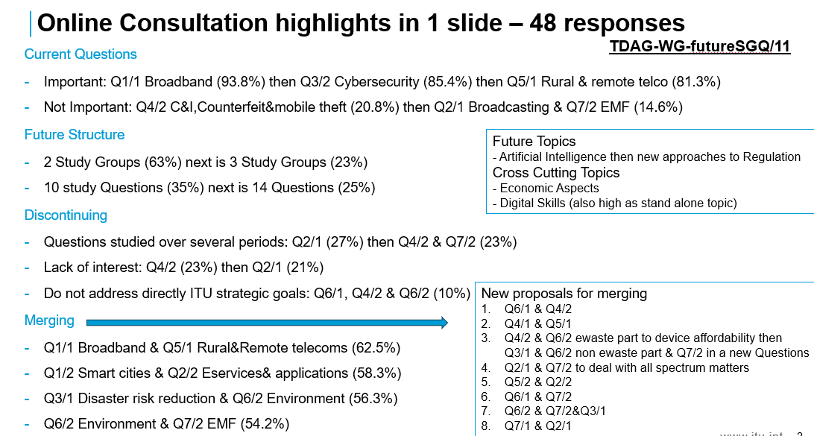
A contribution from the African Telecommunication Union (ATU) and a contribution on the initial views of Rapporteurs and co-Rapporteurs of Study Group 1 were received and discussed.
The meeting agreed that:
- The Chair will prepare a draft revision of extracts of Resolution 2 annexes including the terms of reference of Study Questions, for discussion in the next meeting. This document will consider the online consultation results, the contributions received as well as the views shared at the meeting. It will aim to engage the widest possible set of contributions/views received formally and informally. This document will be a contribution to the next TDAG-WG-futureSGQ meeting.
- The BDT secretariat will be tasked to request focal points from RTOs for the TDAG-WG-futureSGQ who will submit and present inputs of RTOs to the next TDAG-WG-futureSGQ.
- An additional e-meeting will be held in January- February 2025 period after further consultation with BDT secretariat, BDT Director and TDAG Chair.
- The fourth fully online meeting of the TDAG-WG-futureSGQ held on 21 January 2025
The information shared below is from the report of the fourth meeting of TDAG-WG-futureSGQ (document TDAG-WG-futureSGQ/25). This meeting was attended by over 80 participants.
Six contributions as listed below, were received, presented and extensively discussed:
- Document TDAG-WG-futureSGQ/18 from Asia-Pacific Community (APT)shared the views of the Asia-Pacific Community (APT) which aligns with proposal of the TDAG-WG-futureSGQ.
- A proposal for a new Question on Device Affordability/Availability
- A proposal for a new Question on Application of Artificial Intelligence
- The initial views of Rapporteurs and co-Rapporteurs of Study Group 2.
- The revised terms of reference of most of the Study Group 1 Questions.
- Document TDAG-WG-futureSGQ/23 which is the draft revision of extracts of Resolution 2 annexes including the terms of reference of Study Questions prepared by the Chair, as agreed in the previous meeting.
The meeting agreed that:
- Document TDAG-WG-futureSGQ/23 be updated to incorporate inputs from the contributions received and from discussions at the meeting. The final version of the document is planned to be shared as a deliverable of the TDAG-WG-futureSGQ.
- The two proposals for new Questions be reviewed collaboratively by the authors and participants who shared views on them at the meeting. The reviewed proposals would be presented at the next meeting and integrated into a revised version of document TDAG-WG-futureSGQ/23.
- The fifth fully online meeting of the TDAG-WG-futureSGQ held on 4 March 2025
The information shared below is from the report of the fifth meeting of TDAG-WG-futureSGQ (document TDAG-WG-futureSGQ/34). This meeting was attended by over 80 participants.
Six contributions as listed below, were received, presented and extensively discussed:
- Reports from the Industry Advisory Group on Development Issues and Private Sector Chief Regulatory Officers (IAGDI-CRO) on two tech talks organized on the themes of the two ITU-D study groups. They discussed on topics which may serve as inputs for future study Questions.
- Updated views from the African Telecommunication Union (ATU) on new topics (device affordability/availability and application of artificial intelligence), on number of study groups and on the draft proposal of the deliverable of TDAG-WG-futureSGQ.
- Completed compilation of terms of reference for ITU-D Study Group 1 (SG1) Questions, provided by the SG1 Vice-Chair and Coordinator on future study Questions on behalf of the SG1 (co-)rapporteurs.
- Updated proposal from China for a new Question on application of artificial intelligence (AI), following comments and offline discussions since the previous meeting.
- Proposal from Egypt on bases and guidelines for proposing future Questions, and comments on the draft proposal of the deliverable of TDAG-WG-futureSGQ.
- Document TDAG-WG-futureSGQ/29 which is the second draft revision of extracts of Resolution 2 annexes including the terms of reference of Study Questions prepared by the Chair, following contributions, comments and offline discussions since the previous meeting.
The meeting agreed to:
- uphold the current two study groups. Discussion of a possible third study group was recognized, but was considered outside the scope of the two study groups and would need to be discussed as a separate topic.
- have five study Questions in each of the two study groups.
- merge the Q1/1 (broadband) and Q5/1 (rural and remote areas) of the current study period.
- agree on focus for Q4/1 (economic aspects).
- include the new topic on AI into an existing study Question.
Further discussions were needed to achieve consensus on the following points:
- where to fit the new topic on device availability & affordability.
- whether some specific Questions (including Q6/1 with Q4/2 or Q5/2, Q7/1 with Q5/2, Q1/2 with Q2/2, Q4/2 C&I with Q6/2 and Q7/2) should be merged or not, and in which study group they should be studied (including Q3/1 and Q3/2)¹.
- whether some standalone or merged Questions (including Q1/1 merged with Q5/1, Q2/1)¹ should extend their scope to become more attractive.
- The sixth fully online meeting of the TDAG-WG-futureSGQ held on 16 April 2025
The information shared below is from the report of the sixth meeting of TDAG-WG-futureSGQ (document TDAG-WG-futureSGQ/41). This meeting was attended by over 60 participants.
Four contributions as listed below, were received, presented and extensively discussed:
- Aligned views of the Asia-Pacific Telecommunity (APT) on study Questions for the 2025-2029 study period, as discussed at the 3rd meeting of the APT Preparatory Group for WTDC-25 held from 17 to 18 March 2025 in Bangkok, Thailand.
- Views of the Regional Commonwealth in the field of Communications (RCC) on the structure that is the number of study groups and on study group Questions for 2026-2029. The views are backed by the analysis of the current structure, including the mapping of Questions’ topics and mapping of received contributions.
- Proposed updates by the Russian Federation, on the revised terms of reference of Question 7/1 previously submitted by SG1 Coordinator to the TDAG-WG-futureSGQ which were prepared by co-Rapporteurs of Question 7/1
- The third draft revision of extracts of Resolution 2 annexes including the terms of reference of Study Questions prepared by the Chair, following contributions, comments and offline discussions since the previous meeting.
The meeting agreed that
- The RCC be invited to reconsider its contribution based on the comments received during the meeting, and to propose revised/new options to be considered at the next meeting.
- A revision to the title for proposed Question A/1
- The use of the word to “users’ terminals/devices instead of “users’ terminals”
- The proposal from the Russian Federation on Q7/1 terms of references, be included as far as possible in the updated revision of document TDAG-WG-futureSGQ/38 under Question B/1.
- An updated revision of documentTDAG-WG-futureSGQ/38 (this is document TDAG-WG-futureSGQ/43) with tracked changes and without tracked changes be made available. This document will take into consideration all contributions and comments received.
- A final meeting in conjunction with TDAG-25 to be held in Geneva in May 2025.

Annex3: Consolidated document proposed for use as a base document
Please see the documents annexed in two versions:
- with revision marks
- without revision marks
_______________

The Question numbers refer to the Questions of the 2022-2025 study period: link

