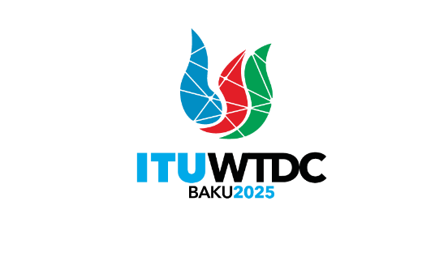 | Telecommunication Development  Advisory Group (TDAG)  32nd Meeting, Geneva, Switzerland, 12-16 May 2025 |  | 
 |  | Document TDAG-25/17-E
 |  | 1 April 2025
 |  | Original: English
Director, Telecommunication Development Bureau
Draft structure of the World Telecommunication Development Conference 2025
Summary:
This document presents the draft structure of the World Telecommunication Development Conference 2025 (WTDC-25).
Action required:
TDAG is invited to note this document and provide guidance as deemed appropriate.
References:
General Rules of conferences, assemblies and meetings of the Union and Resolution 1 (Rev. Kigali, 2022)

Draft Structure of the
World Telecommunication Development Conference 2025 (WTDC-25)

Meeting of heads of delegation
Terms of reference: in accordance with No. 49 of the General Rules of conferences, assemblies and meetings of the Union, the inaugural meeting of the conference shall be preceded by a meeting of heads of delegation. At this meeting, the heads of delegation shall prepare the agenda for the first plenary meeting and make proposals for the organization, chairmanships and vice-chairmanships of the conference, its committees and, as appropriate, working group(s) of the Plenary.
During WTDC, the heads of delegation shall meet to consider the proposals concerning the work programme and the constitution of study groups, and to draw up proposals concerning the designation of chairmen and vice-chairmen of study groups, TDAG and any other groups established by WTDC.

Committee 1: Steering Committee
Terms of reference: to coordinate all matters connected with the smooth execution of work and to plan the order and number of meetings, avoiding overlapping wherever possible in view of the limited number of members of some delegations.
This committee is composed of the Chair, and the Vice-Chairs of the conference and the Chairs and Vice-Chairs of the committees and working group(s) of the Plenary.

Committee 2: Budget Control
Terms of reference: to determine the organization and facilities available to the delegates, to examine and approve the accounts for expenditure incurred throughout the duration of the conference and to report to the plenary meeting on the estimated total expenses of the conference, and the estimated financial needs of ITU Telecommunication Development Sector (ITU-D) up to the next World Telecommunication Development Conference (WTDC) and the costs entailed by the execution of the decisions taken by the Conference.

Committee 3: Objectives
Terms of reference: to review and approve the agenda and make proposals for the organization of work; to review and approve the outputs and outcomes for the objectives; to review and agree on the related study group questions and related regional Initiatives and establish appropriate guidelines for their implementation; to review and agree on relevant resolutions; and to ensure that the output is in accordance with a results-based management approach aiming to improve management effectiveness and accountability.

Committee 4: ITU-D Working Methods
Terms of reference: to review and approve the agenda and make proposals for the organization of work; to examine proposals and contributions relating to cooperation among members; to evaluate the working methods and functioning of the ITU-D study groups and Telecommunication Development Advisory Group (TDAG); to assess and identify options for maximizing programme delivery and to approve appropriate changes thereto with a view to strengthening the synergies between study group questions, programmes and regional initiatives; and to submit to the plenary meeting reports, including proposals on the ITU-D working methods for implementation of the ITU-D work programme, on the basis of TDAG and study group reports submitted to the conference and the proposals of ITU Member States, ITU-D Sector Members and Academia.

Committee 5: Editorial Committee
Terms of reference: to perfect the wording of texts arising from WTDC deliberations, such as resolutions, without altering the sense and substance, and align the texts in the official languages of the Union, with a view to their submission for approval to the plenary meetings.
Furthermore, it is suggested to set up Working Group of the Plenary as follows:
Working Group of Plenary: ITU-D contribution to the ITU Strategic Plan 2028-2032 and WTDC Declaration
Terms of reference: to draw up a draft WTDC Declaration and the input of the ITU-D Sector to the Union’s strategic plan to be adopted at the next Plenipotentiary Conference.

Explanatory note
In accordance with No. 63 of the General Rules of conferences, assemblies and meetings of the Union, the plenary meeting of the World Telecommunication Development Conference may set up committees to consider matters referred to the conference.
_______________

The creation of the Working Group of Plenary will depend on the progress during the preparatory process in relation to the ITU-D contribution to the ITU Strategic Plan and the WTDC Declaration.

