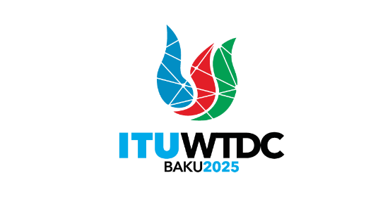 | Telecommunication Development  Advisory Group (TDAG)  32nd Meeting, Geneva, Switzerland, 12-16 May 2025 |  | 
 |  | Document TDAG-25/14-E
 |  | 24 March 2025
 |  | Original: English
Director, Telecommunication Development Bureau
Report on the organization of the Youth Celebration in shaping the future of Digital Development: Hearing Voices of Tomorrow in the lead
to the World Development Conference 2025 (WTDC-25)
Summary:
Considering BDT’s mandate to lead meaningful youth engagement in digital development, preparations for a one-day event is ongoing closely with the host country of WTDC-25 to celebrate youth, expose them to digital age technologies and highlight the importance of youth empowerment in digital development.
Action required:
TDAG is invited to note this document.
References:
Document TDAG-24/30
Resolution 76 (Rev. Kigali, 2022) of the World Telecommunication Development Conference (complemented by WTDC Resolutions 11, 37, 45, 46, 55, 58, 67)
Resolution 198 (Rev. Bucharest, 2022) of the Plenipotentiary Conference (complemented by PP Resolutions 70, 175, 179, 184)

- Background
Aligned with BDT’s mandate and commitment to meaningful youth engagement, and in close coordination with the host country of the World Telecommunication Development Conference (WTDC-25), preparations are underway for a one-day Global Youth Celebration preceding WTDC-25.
Originally planned as a complementary event following the Global Youth Summit held in Varadero, Cuba, in March 2025, this celebration has evolved into a concise yet impactful gathering. Its primary objective is to highlight youth contributions and further enhance their active participation in shaping global digital policies and development agendas.
- Overview
The Global Youth Celebration will recognize and amplify the critical role of youth in digital development through a carefully curated series of intergenerational dialogues, inspiring talks, and targeted activities. Youth participants will benefit from unique opportunities to directly engage with policymakers, decision-makers, and prominent stakeholders participating in WTDC-25. The event aims to bridge generational insights, fostering a collaborative environment that underscores youth as essential partners in digital transformation.
To further enrich this experience, specialized activities, including insightful visits to significant technological sites, such as space facilities, are planned to enhance youths' practical understanding of advanced digital technologies.
- Coordination and Implementation
Preparations are currently being coordinated closely with the host country of WTDC-25 to ensure seamless integration of activities and optimal impact for all participants with a focus on high-impact activities and robust networking opportunities.
This celebration event will not produce a formal outcome document but instead seeks to energize WTDC-25 with the dynamic perspectives of youth. This event will clearly demonstrate ITU’s ongoing commitment to empowering the next generation of digital leaders and solidify youth voices within the global telecommunications and digital development agenda.
_______________

