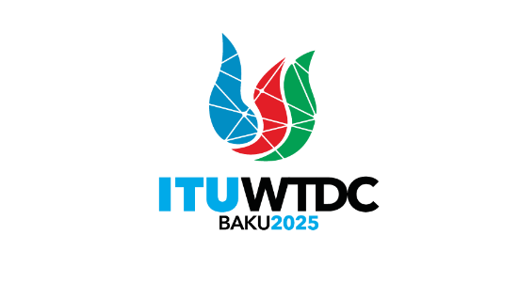 | Telecommunication Development  Advisory Group (TDAG)  32nd Meeting, Geneva, Switzerland, 12-16 May 2025 |  | 
 |  | Document TDAG-25/13-E
 |  | 1 April 2025
 |  | Original: English
Secretary-General
Draft Agenda of the World Telecommunication Development Conference (WTDC)
Summary:
The ITU Council-2024, noting that WTDC-25 is scheduled to be held in the last quarter of 2025, in accordance with Resolution 77 (Rev. Bucharest, 2022) of the Plenipotentiary Conference on Scheduling and duration of conferences, forums, assemblies and Council sessions of the Union (2023-2027), decided that, subject to the concurrence of the majority of the Member States of the Union, the next World Telecommunication Development Conference (WTDC-25) will take place in Baku, Republic of Azerbaijan, from 17 to 28 November 2025.
Action required:
TDAG is invited to note this document and provide guidance as deemed appropriate.
References:
ITU-SG CL Contribution 30

Draft agenda of the 2025 World Telecommunication
Development Conference (WTDC-25)

I. Report on the implementation of the ITU-D Action Plans
1. Update on global digital transformation and reporting on the implementation of the WTDC-17 Buenos Aires Action Plan and the WTDC-22 Kigali Action Plan (including the Regional Initiatives), contribution to the implementation of the WSIS Plan of Action and the Sustainable Development Goals (SDGs)
2. Report of the Telecommunication Development Advisory Group
3. Report of Study Groups
4. Report on the implementation of outcomes of other ITU Conferences, Assemblies and meetings related to ITU-D work:
a. Plenipotentiary Conference (PP-22)
b. Radiocommunication Assembly (RA-23)/World Radiocommunication Conference (WRC-23)
c. World Telecommunication Standardization Assembly (WTSA-24)

II. Policy and strategy for digital transformation
5. Ministerial and Industry leaders’ roundtables and policy statements

III. ITU-D work plan for 2026-2029
6. Outcomes of Regional Preparatory Meetings for WTDC
7. ITU-D contribution to the ITU Strategic Plan for 2028-2031
8. ITU-D Priorities
9. ITU-D Action Plan for the following cycle
10. WTDC Declaration
11. Telecommunication Development Advisory Group
a. Authorization for the Telecommunication Development Advisory Group to act between world telecommunication development conferences (Resolution 24, Rev. Dubai, 2014)
b. Structure and working methods
12. Study Groups
a. Study Questions
b. Structure and working methods
13. Regional Initiatives
14. Resolutions and recommendations
_______________

