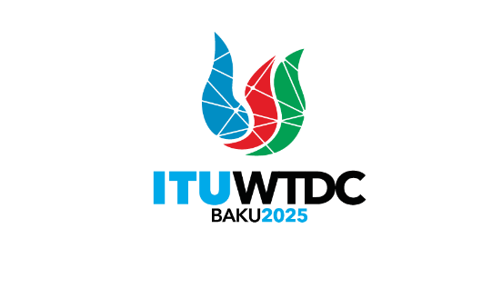 | Telecommunication Development  Advisory Group (TDAG)  32nd Meeting, Geneva, Switzerland, 12-16 May 2025 |  | 
 |  | Document TDAG-25/12-E
 |  | 2 April 2025
 |  | Original: English
Director, Telecommunication Development Bureau
Preparations for the World Telecommunication Development Conference
Summary:
This document covers the preparations so far for the organization of the World Telecommunication Development Conference 2025 (WTDC) that is scheduled to take place in Baku, Azerbaijan, from 17 to 28 November 2025.
Action required:
TDAG is invited to note this document and provide guidance as deemed appropriate.
References:
N/A

- Background
1.1 No. 141 of the ITU Constitution provides that there shall be a World Telecommunication Development Conference (WTDC) between two Plenipotentiary Conferences.
1.2 Resolution 111 (Rev. Busan, 2014) calls on the Union and its Member States to make every effort, as far as practicable, to ensure that the planned period of any ITU conference does not conflict with what may be considered a major religious period by a Member State.
1.3 On 15 March 2024, the ITU Secretary-General received an invitation from the Government of the Republic of Azerbaijan. Following exchanges with the BDT Director, the Minister of Digital Development and Transport has confirmed in a letter dated 3 April 2024 their intention to host the conference in Baku, at the end of November 2025. In a follow-up letter dated 26 April 2024, the period from 17 to 28 November 2025 was proposed (see Annex 1 of Document C24/30).
1.4 A draft agenda for the forthcoming WTDC-25 was presented in Annex 3 of Document C24/30 for approval by the Council subject to the concurrence of the majority of the Member States of the Union.
1.5 The draft agenda is submitted to the Telecommunication Development Advisory Group (TDAG) (12-16 May 2025) for discussion and endorsement. A revised version might be submitted after TDAG to the Council.
- Place, duration, dates, and venue for WTDC
  - The Council has adopted, at its 2024 Session, with the concurrence of the majority of Member States of the Union, Decision 637 on the precise place and exact dates of the World Telecommunication Development Conference (WTDC-25), which provides that the WTDC-25 will take place in Baku, Republic of Azerbaijan, from 17 to 28 November 2025 (see Annex B) and the approval of the draft Agenda of the WTDC-25 (see Annex C);
  - In September 2024, following consultation by correspondence, carried out by Circular Letter No. 24/38 of 24 June 2024 relating to the precise place, exact dates and draft Agenda of WTDC-25, the agreement of the required majority of the Member States of ITU was received, in accordance with CV 47 of the ITU Convention.
  - It is envisaged that a Youth Celebration will be held on 16 November 2025, just prior to WTDC, also in Baku.
- Preparations for the Conference
  - A first site visit took place from 10-14 February 2025 by an ITU team to visit potential venues to hold the events, and to visit the potential hotels where participants and ITU staff will be staying.
  - The signing ceremony of the Host Country Agreement between Azerbaijan and ITU relating to the holding, organizing and financing of WTDC is yet to be organised.
- Preparatory process
4.1 As per Resolution 31 (Rev. Kigali, 2022), six Regional Preparatory Meetings (RPMs) were organized in each of the six regions, as follows:
Region | Dates | City and Host country | Output documents
RPM-ARB | 4-5 February 2025 | Amman, Jordan | Report
RPM-EUR | 25-26 February 2025 | Budapest, Hungary | Report
RPM-ASP | 20-21 March 2025 | Bangkok, Thailand | Report
RPM-AMS | 1-2 April 2025 | Asuncion, Paraguay | n/a at the time of preparation of this document
RPM-AFR | 8-9 April 2025 | Nairobi, Kenya | n/a at the time of preparation of this document
RPM-CIS | 24-25 April 2025 | Bishkek, Kyrgyzstan | n/a at the time of preparation of this document
The RPMs engaged the membership in each region in the WTDC process, to encourage regional coordination before the conference. RPMs also sought to identify regional topics of interest and challenges that need to be addressed to foster the development of telecommunications/ICTs, and help Member States and Sector Members set common priorities.
4.2 An RPM Coordination Meeting will be held physically on 12 May 2025 to examine the reports of the six RPMs, and to submit a consolidated report to TDAG, in accordance with WTDC Resolution 31 (Rev. Kigali, 2022).
4.3 Based on established practice, TDAG-25 is expected to endorse holding of two Inter-Regional Meetings (IRMs) which are scheduled as follows to prepare for WTDC:
IRM-1 | 14-15 July 2025 (virtual)
IRM-2 | 29-30 September 2025 (virtual)
IRMs are open to all ITU-D membership. Member States are encouraged to include in their delegations, representatives from regulators, policymakers, civil society, academia, Internet technical community, youth, gender equality organizations, and others.
IRM agendas are built around key discussions taking place during RPMs, and may include proposals from Member States, Sector Members, Regional Telecommunication Organizations (RTOs), BDT and other stakeholders. Discussions focus on key topics that require coordination and consensus between the different regions.
Following TDAG’s recommendations, the Chair-designate of WTDC will be appointed to chair the two IRMs, and six vice-chairs are to be appointed, one nominated by each of the respective RTOs. Each RTO will also be invited to identify the representative(s) of their choice to speak on behalf of their region.
_______________

