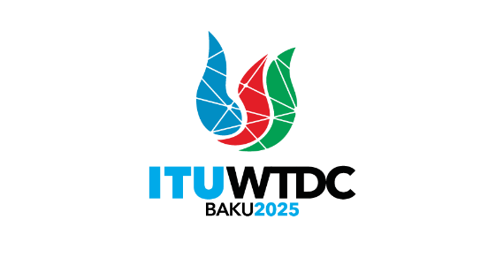 | Telecommunication Development  Advisory Group (TDAG)  32nd Meeting, Geneva, Switzerland, 12-16 May 2025 |  | 
 |  | Document TDAG-25/11-E
 |  | 31 March 2025
 |  | Original: English
Chair, Group on Capacity Building Initiatives (GCBI)
Report on the work of the Group on Capacity Building Initiatives (GCBI) to TDAG
Summary:
This document covers the work undertaken by the Group on Capacity Building Initiatives (GCBI). The group was established pursuant to Resolution 40 which was adopted by the World Telecommunication Development Conference 2010 (WTDC-10), and revised at WTDC-22, to advise the Director of the Telecommunication Development Bureau (BDT) on matters related to capacity building.
Action required:
TDAG is invited to note this document and provide guidance as deemed appropriate.
References:
WTDC Resolution 40 (Rev. Kigali, 2022), on the Group on Capacity Building Initiatives
WTDC Resolution 73 (Rev. Kigali, 2022), on ITU Academy Training Centres

The Group on Capacity Building Initiatives (GCBI) was established pursuant to Resolution 40 which was adopted by the World Telecommunication Development Conference 2010 (WTDC-10), and revised at WTDC-22, to advise the Director of the Telecommunication Development Bureau (BDT) on matters related to capacity building.
Report on GCBI Work since the last meeting (16-18 April 2024)
Since the last meeting of the GCBI held in April 2024, the Group has focused on the following activities:
- Providing inputs to the revision of the ITU Digital Skills Toolkit.
- Reviewing the ITU/BDT training needs assessment questionnaire.
- Conducting desk research on national digital skills strategies.
Providing inputs to the ITU Digital Skills Toolkit
The ITU Digital Skills Toolkit was revised in 2024. GCBI members were consulted during the review process and provided valuable inputs on the structure and content of the Toolkit. The revised Digital Skills Toolkit was launched in September 2024 during the ITU Digital Skills Forum. It provides policy-makers and other stakeholders with practical information, examples, and step-by-step guidance to develop a national digital skills strategy.
Reviewing the ITU/BDT training needs assessment questionnaire
The BDT has been using a "Training Needs Assessment (TNA) questionnaire" to collect regularly feedback from Member States on priority capacity development needs. In preparation for the TNA 2025, GCBI members agreed to provide valuable insights to enhance the questionnaire's quality and efficiency. Specific areas of feedback included:
An evaluation of the questions: ensuring they are well-formulated, identifying any redundancies or ambiguities.
- Suggestions for additional relevant questions.
- Identification of potential course topics that may be missing, with a focus on regional relevance.
- Broader recommendations to improve the overall process and efficiency.
The reviews and suggestions were submitted by GCBI members to the Chair, who compiled a global consolidated list of inputs. These inputs will be discussed at the GCBI meeting scheduled for 16-17 April 2025.
Research on digital skills strategies
The objective of this desk research was to create a comprehensive overview of the adoption and deployment status of digital skills development strategies across different ITU regions, to support the BDT work in this field. To achieve this, each GCBI member, in coordination with the other representative from representative from their region, compiled:
- A list of countries in their respective region that have adopted and announced national strategies or roadmaps for digital skills development, including key pillars and objectives.
- A list of national and global stakeholders involved in the development and implementation of these strategies. A compiled table on this research was prepared by the Chair and will be reviewed in further detail at the next GCBI meeting.
Report on the GCBI meeting held on 16-17 April 2025
To be provided after the meeting.
________________

