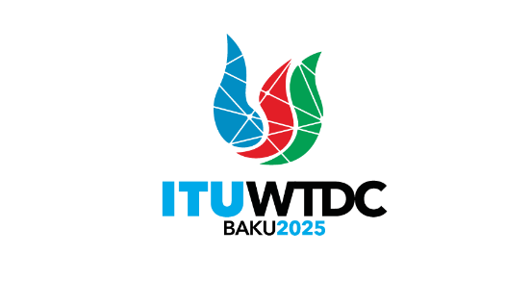 | Telecommunication Development  Advisory Group (TDAG)  32nd Meeting, Geneva, Switzerland, 12-16 May 2025 |  | 
 |  | Document TDAG-25/4-E
 |  | 3 April 2025
 |  | Original: English
Director, Telecommunication Development Bureau
ITU-D Operational Plan 2025
Summary:
This document presents an overview of the activities currently deployed under the 2025 ITU-D Operational Plan both regionally and globally in accordance with the ITU-D Priorities and Enablers.
The document outlines the allocation of funds for each ITU-D region and multi-regionally as well for each ITU-D Priority and Enabler.
Action required:
TDAG is invited to note this document and provide guidance as deemed appropriate.
References:
WTDC-22 Kigali Action Plan
Document TDAG-31/12 – ITU-D Operational Plan 2024

Introduction
The ITU-D Operational Plan (OP) for 2025 is aligned with the structure of the strategic plan for the Union for 2024-2027. The structure follows Kigali Action Plan (KAP), outlining the ITU-D Priorities and Enablers, and their corresponding outcomes, products and services as well as the performance indicators to measure their achievement level produced by the activities of the Sector.
The planning process for OP-25 follows the same principle as OP-24, which involved defining the framework for planning activities, ensuring alignment with KAP and overall coherence. The activities proposed under OP-25 underwent thorough consultation with Member States and align with the priorities of each region

Allocation of funds by beneficiary region
Currently, a total of one hundred and thirty-five (135) activities are being deployed globally and across regions. Similarly to OP-24, slightly more than half of the OP-25 budget (57 percent) has been directed towards outputs with a global focus and multi-region activities, which are expected to generate broad impact and leverage operational efficiencies. Approximately 7 percent of the budget has been equally allocated among the outputs benefiting all six regions of ITU.
To enhance implementation, synergies continue to be sought among the regional outputs, as well as between regional and global initiatives, in collaboration with the Radiocommunication and the Standardization Bureaux as well as the General Secretariat. Further, partnerships with national, regional, and global entities, along with projects executed by BDT, continue to amplify the impact of KAP implementation in the regions and at the global level.

Figure 1: Overview of OP-25 fund allocation by beneficiary region
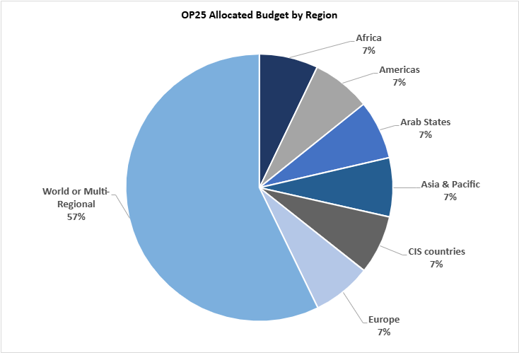
Figure 2: Overview of OP-25 funds allocated by ITU-D Priorities and Enablers (in CHF)
ITU-D Priorities and Enablers | Budget 2025 (CHF) | Budget %
E5 - Excellence in human resources and organizational innovation | 250,000 | 6.3%
E4 - Commitment to environmental sustainability | 120,500 | 3.1%
E3 - Diversity and inclusion | 341,410 | 8.7%
E2 - Regional presence | 111,900 | 2.8%
E1 - Membership-driven | 14,500 | 0.4%
P5/E6/E7 - Resource mobilization, partnerships and international cooperation | 651,500 | 16.5%
P4 - Inclusive and secure telecommunications/ICTs for sustainable development | 476,350 | 12.1%
P3 - Enabling policy and regulatory environment | 987,400 | 25.0%
P2 - Digital transformation | 424,740 | 10.8%
P1 - Affordable connectivity | 569,700 | 14.4%

Conclusion
TDAG is invited to take note of this document and provide guidance and advice on ways to continue delivering impact globally and across regions while ensuring alignment with the outcomes set as per the Kigali Action Plan.
_______________

