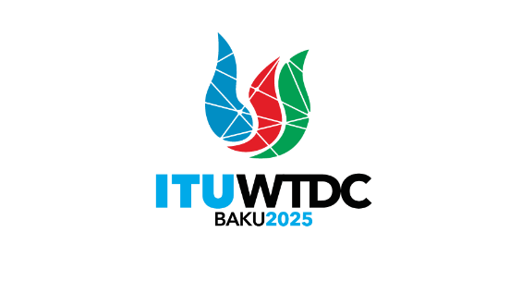 | Telecommunication Development  Advisory Group (TDAG)  32nd Meeting, Geneva, Switzerland, 12-16 May 2025 |  | 
 |  | Document TDAG-25/3(Ann.1)-E
 |  | 5 May 2025
 |  | English only
Director, Telecommunication Development Bureau
Regional Initiatives: Dashboard
Summary:
This document presents an overview of the ITU Regional Initiatives (RI) through interactive dashboards, including the activities and outputs deployed across the six regions.
Action required:
TDAG is invited to note the dashboards and comment as deemed necessary.
References:
- TDAG-25 Document 3: Report on the Regional Initiatives: Implementation and Mapping of Projects with RI
- Document TDAG-25/INF/3 - Mapping of Projects with RI

Introduction
The dashboard presents an overview of the activities undertaken as well as the products and services delivered in each of the ITU’s six regions to support the implementation of the Regional Initiatives, in alignment with the ITU-D priorities and enablers as per the Kigali Action Plan, as well as the ITU strategic plan.
The dashboard is accessible via a Ties protected account on the following link: Reginal Initiatives Dashboard
TDAG is invited to note the dashboards and comment as deemed necessary.
_______________

