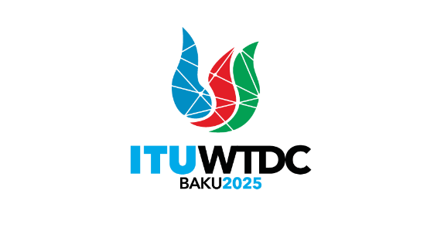 | Telecommunication Development  Advisory Group (TDAG)  32nd Meeting, Geneva, Switzerland, 12-16 May 2025 |  | 
 |  | Document TDAG-25/2(Ann.1)-E
 |  | 5 May 2025
 |  | English only
Director, Telecommunication Development Bureau
ITU-D Operational Plan Dashboards
Summary:
This document presents an overview of the ITU-D Operational Plan (OP) through interactive dashboards, including both budget implementation and Results-Based Management performance across the six regions and on a multi-regional scale.
Action required:
TDAG is invited to note the dashboards and comment as deemed necessary.
References:
TDAG-25 Document 2: Reporting on the implementation of the Kigali Action Plan (KAP)

Introduction
The dashboard summarizing the implementation of OP budget and RBM framework for the execution of the Kigali Action Plan is accessible via a Ties protected account on the following link: ITU-D Operational Plan Implementation Dashboard.
The reporting tool highlights BDT’s commitment to upholding accountability, transparency and efficiency throughout its activities and processes.
In an effort to continually refine and tailor the dashboards to better meet the needs of ITU-D Members, a brief survey has been integrated into the Dashboard webpage, inviting members to provide feedback.
TDAG is invited to note the dashboards and provide guidance as deemed necessary.
_______________

