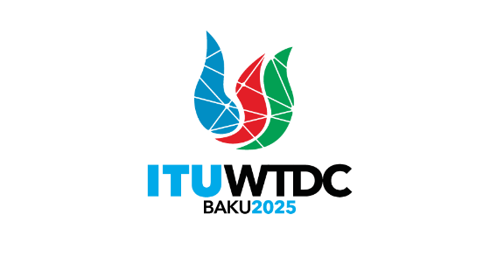 | Telecommunication Development  Advisory Group (TDAG)  32nd Meeting, Geneva, Switzerland, 12-16 May 2025 |  | 
 |  | Document TDAG-25/1-E
 |  | 10 February 2025
 |  | Original: English
Director, Telecommunication Development Bureau
Draft agenda

1. Address by the Secretary-General
2. Address by other Elected Officials
3. Address by the Director of the Telecommunication Development Bureau
4. Opening remarks by the Chair of TDAG
5. Adoption of the agenda and time management plan
6. Reporting on the implementation of the ITU-D Action Plan
6.1 Implementation of the Kigali Action Plan (KAP)
Report on the Regional Initiatives
6.2 Operational Plan 2025 (OP-25)
6.3 ITU-D Projects
6.4 Study Group Activities
6.5 Membership, Partnerships, Private Sector-related matters
6.6 Report by the Chair of the Group on Capacity Building Initiatives (GCBI)
7. Preparations for WTDC-25
7.1 Update on the preparations for WTDC-25
7.2 Report of the Regional Preparatory Meetings (RPMs) Coordination Meeting
7.3 Structure of WTDC-25
7.4 Report by the TDAG Working Group on the Declaration (TDAG-WG-DEC)
7.5 Report by the TDAG Working Group on the Future of Study Group Questions (TDAG-WG-futureSQ)
7.6 Report by the TDAG Working Group on Streamlining Resolutions (TDAG-WG-SR)
7.7 Report by the TDAG Working Group on the ITU-D Priorities (TDAG-WG-ITUDP)
8. Global Youth Summit
9. Collaboration with the other Sectors
10. Outcomes of RA-23 and WRC-23: Updates relevant to the work of ITU-D
11. Outcomes of WTSA-24: Updates relevant to the work of ITU-D
12. Contribution to the work of the Expert Group on the International Telecommunication Regulations (EG-ITR)
13. Calendar of ITU-D events
14. Any other business
_______________

