|  |  |
| --- | --- |
| **Telecommunication Development Advisory Group (TDAG)**  **31st Meeting, Geneva, Switzerland, 20-23 May 2024** |  |
|  |  |
|  | **Document** **TDAG-2****4/35-E** |
|  | **30 April 2024** |
|  | **English only** |
| Cisco Systems, Inc. (United States of America) | |
| Bridging the digital divide through the Digital Transformation Centre Initiative | |
|  | |
| **Summary:**  This document provides an overview of the Digital Transformation Centres Initiative (DTCI) and highlights its achievements and continued relevance. This flagship Initiative was launched by the International Telecommunication Union (ITU) and Cisco in 2019 to bridge the digital divide and close the digital skills gap. The DTCI aims to boost digital skills among underserved groups and rural communities, with Digital Transformation Centres (DTCs) delivering basic and intermediate digital skills training. These centres also work to strengthen their institutional capacities to design and implement digital skills programmes, through train-the-trainer activities, to ensure scalability and self-sustainability in digital skills development.  **Action required:**  TDAG is invited to note the document and to support the call for engagement, commitment and continued support to the DTC Initiative by the BDT, the ITU-D membership as well as other partners.  **References:**  WTDC-22 Resolution 37 (Rev. Kigali, 2022)  WTDC-22 Resolution 40 (Rev. Kigali, 2022)  WTDC-22 Resolution 55 (Rev. Kigali, 2022) | |

# Introduction

* 1. **The DTC Initiative at a glance**

The Digital Transformation Centres Initiative (DTCI) was launched in September 2019 by ITU, in partnership with Cisco, with the objective of supporting countries to strengthen digital capacities at basic and intermediate levels. The Initiative targets citizens mainly from rural and underserved communities with low or no digital skills.

Importantly, the Initiative aims to support progress towards the following **SDGs** by 2030:

The Digital Transformation Centres (DTCs) are national institutions with a mandate to deliver digital skills programmes in their countries, and with proven capacity, infrastructure, expertise, and experience to run training at basic and intermediate levels and operating nationally. By joining the Initiative, DTCs become part of a global network of local institutions selected to strengthen digital capacities of citizens, particularly in rural and underserved communities.

The DTC network now comprises 14 centres across four regions (Africa, Americas, the Arab States and Asia and the Pacific) who have committed to engage as active partners in the Initiative.

This document reflects on the progress made and impact achieved, five years into the Initiative. Through the efforts and contributions of the DTCI community (ITU, Cisco, the DTCs and DTCI partners), more than 300,000 (54% female) course participants were equipped with basic and intermediate digital skills training since the inception of the Initiative. The DTC network continues to expand, with 14 DTCs to date. Various organisations consisting of training content providers, NGOs, and telecommunication companies have joined the Initiative as partners and committed to supporting the work of the DTCs on the ground. The Government of Norway, through its Norwegian Agency for Development Cooperation (Norad) has financially supported the DTCI since 2021.

As the founding partner of the Initiative, Cisco reiterates its continued commitment to enhancing digital skills, enabling digital inclusion, and addressing global disparities. The company aligns its purpose with the Initiative, aiming to "Power an Inclusive Future for All”. Considering the mandate of the DTCI as well as its significant potential to accelerate the uptake of digital skills globally and bridge the digital divide, the document calls for an increased resource mobilisation and engagement from key stakeholders to further support the operations and expansion of the Initiative, and enhance digital literacy among communities.

* 1. **Activities under the Initiative**

The primary function of the DTCs is to:

* Deliver basic digital skills training to enhance digital literacy and foster uptake of digital tools among those at the bottom of the social pyramid.
* Deliver intermediate digital skills training to provide users with job-ready skills, improve workplace efficiency and enhance chances of employability.
* Conduct train-the-trainer programmes on digital skills to ensure scalability and self-sustainability in digital skills capacity development.
* Train SMEs in the field of digital technologies, innovation and entrepreneurship.

By joining the Initiative, DTCs can access training materials, knowledge products and online platforms developed by ITU, Cisco and other partners of the Initiative. The Initiative also provides them with opportunities to build their institutional capacities through train-the-trainer programmes. Through project funding provided by external donors (notably the Norwegian Agency for Development Cooperation, Norad), ITU has been able to financially support DTC training activities across the network and therefore increase outreach and impact.

DTCs can benefit from the support of DTCI partners at national, regional and global levels, as well as from networking opportunities through the global network of DTCs.

* 1. **Impact achieved to date**

1. In response to the COVID-19 pandemic, DTC trainers were provided with tools and skills on how to conduct remote teaching. The train-the-trainer online courses were offered in collaboration with Cisco, free of charge.
2. As of February 2024, more than 300,000 course participants were trained by the DTCs in basic and intermediate digital skills, under the Initiative. The share of female participants represents 54 per cent of the total course participants trained.
3. In 2020, the DTC project “Boosting Digital Skills through the Digital Transformation Centres” was launched as a partnership between ITU and the Norwegian Agency for Development Cooperation (Norad). This project supports the activities implemented under the DTC Initiative, particularly activities aimed at scaling the delivery of digital skills training – and hence digital literacy - in local communities and among marginalised groups. While a major focus of the project is to support the DTC activities in Ghana, the project supports the rolling out of the Initiative at large.
4. A second phase of the project started at the beginning of 2024 with additional funding from Norad and ITU. This project will continue to support DTCs to scale the delivery of basic and intermediate digital skills, with a particular focus on women, youth, school children, and persons with disabilities.
5. New partners were engaged to support the Initiative and the work of the DTCs: HP, Digital Skills Foundation, STMicroelectronics Foundation, Indosat and Airtel.
6. ITU and DTCI partners provided financial support to eight DTCs in conducting train-the-trainer activities and one DTC to conduct stakeholder engagement workshops, reaching 743 trainers in total.
7. High-quality and targeted training materials are made available to the DTCs, through the contributions of Cisco and other DTCI partners.
8. ITU and Cisco facilitated networking opportunities for the DTCs by organising face-to-face workshops and virtual meetings every year. These meetings contribute to strengthening the global DTC network and provide a platform to discuss the implementation of the Initiative, review the progress and achievements made, and explore new ideas to support the work of the DTCs.
9. In addition, the Initiative is focusing on strengthening the infrastructural support within the DTC countries by inviting local partners to join the initiative in their respective DTC countries. Local partners are providing connectivity, devices, mentorship and support to the DTCs with their own digital skills initiatives and CSR programmes. Local partner support is gaining momentum, with several large local partners joining the initiative.
10. Finally, in light of the Safer Internet Day 2024, the DTCs have promoted an introductory cybersecurity course to boost awareness about safe and respectful online behaviour. This initiative reached 4236 additional learners in a month in DTC countries.

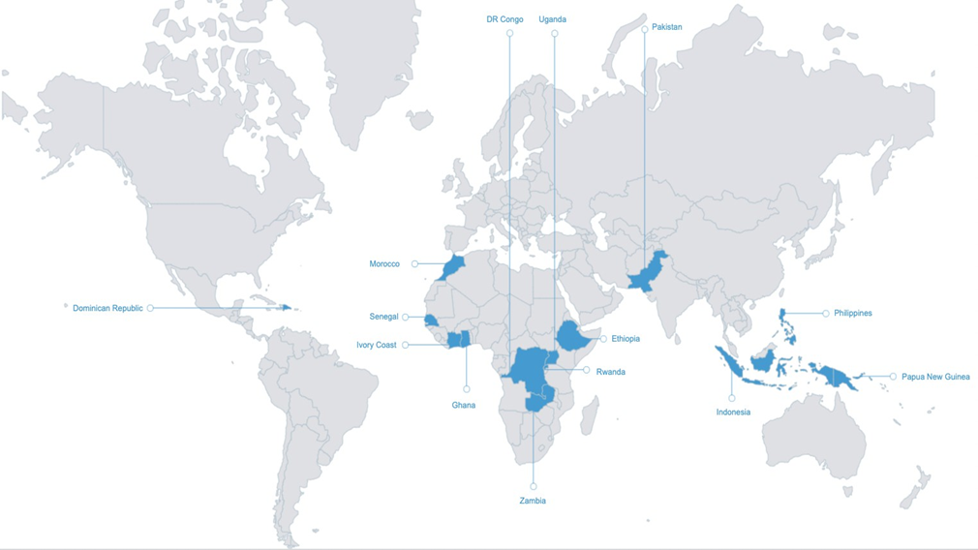

*An overview of the countries that are currently hosting a DTC*

# Call for engagement, commitment and continued support

The DTCI has proven to be a successful instrument in reducing the digital divide by imparting basic and intermediate digital skills training interventions. With proper resources and scaling, it has the potential to make a direct impact on the lives of people and communities around the world, and multiply the impact and benefits achieved to date. It is vital for ITU to continue supporting the DTCs as well as future ones. We therefore also call upon Member States to join the initiative and our efforts to narrow the digital divide.

Cisco remains committed to the Initiative's objectives, reinforcing its dedication to enhancing digital skills, promoting digital inclusion, and addressing global disparities. The DTCI speaks to and aligns with our Cisco purpose to "Power an Inclusive Future for All”. Cisco reiterates its intention to leverage existing platforms, events and channels, such as campaigns, as an opportunity to raise awareness on the DTCI and promote its work, as well as to engage key stakeholders to strengthen the Initiative’s reach and mission.

A recommended action is therefore for the BDT, together with Cisco and the support of the ITU-D Membership and other partners, to focus on further expanding the Digital Transformation Centres Initiative in developing countries by mobilizing the required resources, which will contribute significantly to achieving the Initiative's overarching goals and fostering global digital inclusivity.

_______________