|  |  |
| --- | --- |
| **Telecommunication Development Advisory Group (TDAG)**  **31st Meeting, Geneva, Switzerland, 20-23 May 2024** |  |
|  |  |
|  | **Document** **TDAG-2****4/23-E** |
|  | **29 April 2024** |
|  | **Original:** **English** |
| Director, Telecommunication Development Bureau | |
| Preparations for the 2025 World Telecommunication  Development Conference (WTDC-25) | |
|  | |
| **Summary:**  This document covers the preparations so far for the organization of the World Telecommunication Development Conference 2025 (WTDC-25) that is scheduled to take place in Baku, Azerbaijan, on 17-28 November 2025.  **Action required:**  TDAG is invited to note this document and provide guidance as deemed necessary.  **References:**  N/A | |

1. **Background**
   1. No. 141 of the ITU Constitution stipulates that there shall be a World Telecommunication Development Conference (WTDC) between two Plenipotentiary Conferences.
   2. Resolution 77 (Rev. Bucharest, 2022) resolves to hold the WTDC in the last quarter of 2025.
   3. WTDC Resolution 31 (Rev. Kigali, 2022) expresses the firm convictionthat the coordination of preparations at regional level for the six regions of the ITU Telecommunication Development Sector (ITU-D) are of great benefit to Member States.
2. **Place, duration, dates, and venue for WTDC**
   1. During the 2022 Plenipotentiary Conference (PP-22), the Government of Thailand sent a letter to ITU indicating its interest to host WTDC-25 in Bangkok. This letter was published as [document PP-22/136](https://www.itu.int/md/meetingdoc.asp?lang=en&parent=S22-PP-C-0136).
   2. The Government of Thailand sent a letter on 7 December 2023 indicating that it was unfortunately unable to host the conference as previously indicated.
   3. ITU sent [letter CL-23/51](https://www.itu.int/md/S23-SG-CIR-0051/en) to all Member States of the Union on 19 December informing them of the situation with the hosting of WTDC-25 and inviting interested countries to contact the Secretary-General.
   4. Further to this circular letter, Australia, Jordan, Oman, Azerbaijan, Egypt and Indonesia expressed their interest to ITU in order to obtain information on the requirements and cost to host the Development Conference. BDT provided the requested information and requested that the decision by the various Member State Administrations be communicated by 31 March 2024.
   5. In the meantime, a booking was made at CICG in Geneva for 1-12 December 2025, which needs to be confirmed by 14 June.
   6. On 15 March 2024, letter 3-27/2-1902/2024, was received from Azerbaijan submitting its candidacy to host WTDC-25 (please see **Annex 1**).
   7. On 22 March 2024, the BDT Director replied to the Administration of Azerbaijan with letter BDT/DDR/12554 (please see **Annex 2**), and Azerbaijan replied to this letter on 3 April 2024 confirming its hosting proposal in Baku, for the end of November 2025 with letter 3-24/2-2278/2024 (**Annex 3**).
   8. In a further letter referenced 3-27/2-2991/2024 and dated 26 April 2024, Azerbaijan indicated the exact dates proposed: 17-28 November 2025 (**Annex 4**).
   9. A document is being submitted to TDAG-24 containing the draft agenda proposed for WTDC-25, for TDAG’s endorsement (document [TDAG-24/24](https://www.itu.int/md/D22-TDAG31-C-0024/en)).
   10. A document with the above place and dates, as well as with the draft agenda is being submitted to the 2024 session of Council for its approval ([document C-24/30](https://www.itu.int/md/meetingdoc.asp?lang=en&parent=S24-CL-C-0030))
3. **Preparations for the Conference**
   1. Negotiations with Azerbaijan on the host country agreement will start shortly.
4. **Preparatory process**
   1. As per Resolution 31, six **Regional Preparatory Meetings (RPMs)** are being organized in each of the six regions, back-to-back with a one-day Regional Development Forum (RDF).

RPMs seek to engage the membership in each region in the WTDC process, to encourage regional coordination before the conference. RPMs also aim to identify regional topics of interest and challenges that need to be addressed to foster the development of telecommunications/ICTs and help Member States and Sector Members set common priorities.

The dates for the RDF and RPMs in each region are as follows:

|  |  |  |
| --- | --- | --- |
| **Region** | **Dates proposed by BDT** | **Host country** |
| ARB | 3-5 February (tbc) |  |
| EUR | 24-26 February |  |
| ASP | 17-19 March (tbc) |  |
| AMS | 31 March-2 April (tbc) | To be determined |
| AFR | 7-11 April (tbc) |  |
| CIS | 23-24 April (tbc) |  |

* 1. An **RPM Coordination Meeting** will be held on 12 May 2025, also in accordance with Resolution 31, back-to-back with the Telecommunication Development Advisory Group (TDAG), which is scheduled for 12-16 May 2025, in ITU headquarters, in Geneva.
  2. Based on well-accepted practice during the 2017-2022 cycle and further to the good feedback from membership, two **Inter-Regional Meetings (IRMs)** to prepare for WTDC-25 are scheduled to take place as follows:

|  |  |
| --- | --- |
| IRM-1 | 14-15 July 2025, Geneva, Switzerland |
| IRM-2 | 29-30 September 2025, Geneva, Switzerland |

IRMs are open to all ITU-D membership. Member States are encouraged to include in their delegations, representatives from regulators, policy-makers, civil society, academia, Internet technical community, youth, gender equality organizations, and others.

IRM agendas are built around key discussions taking place during RPMs, and may include proposals from Member States, Sector Members, Regional Telecommunication Organizations (RTOs), BDT and other stakeholders. Discussions focus on key topics that require coordination and consensus between the different regions.

* 1. At its 2023 meeting, TDAG created two working groups to start the preparations for WTDC-25:
* **TDAG Working Group on the future of Study Group Questions (**[**TDAG-WG-futureSGQ**](https://www.itu.int/en/ITU-D/Conferences/TDAG/Pages/2024/TDAG_WG_futureSGQ.aspx)**)**, chaired by Dr Ahmad R. Sharafat (Iran). The Group held its first meeting on 4 March and agreed the Terms of Reference, which will be submitted to TDAG-24 for approval. The Group has also agreed a calendar of meetings to advance its work. Document [TDAG-24/25](https://www.itu.int/md/meetingdoc.asp?lang=en&parent=D22-TDAG31-C-0025) with the progress of the work is presented to the 2024 TDAG.
* **TDAG Working Group on Streamlining Resolutions (**[**TDAG-WG-StreamRes**](https://www.itu.int/en/ITU-D/Conferences/TDAG/Pages/2024/TDAG_WG_SR.aspx)**)**, chaired by Ms Andrea Grippa (Brazil). The Group held its first meeting on 18 April where it agreed its Terms of Reference and calendar of meetings. The ToRs will be submitted to TDAG-24 for approval. Document [TDAG-24/19](https://www.itu.int/md/meetingdoc.asp?lang=en&parent=D22-TDAG31-C-0019) with the progress of the work is presented to the 2024 TDAG meeting.
  1. In addition to the above, TDAG may decide to create additional groups.

Annex 1

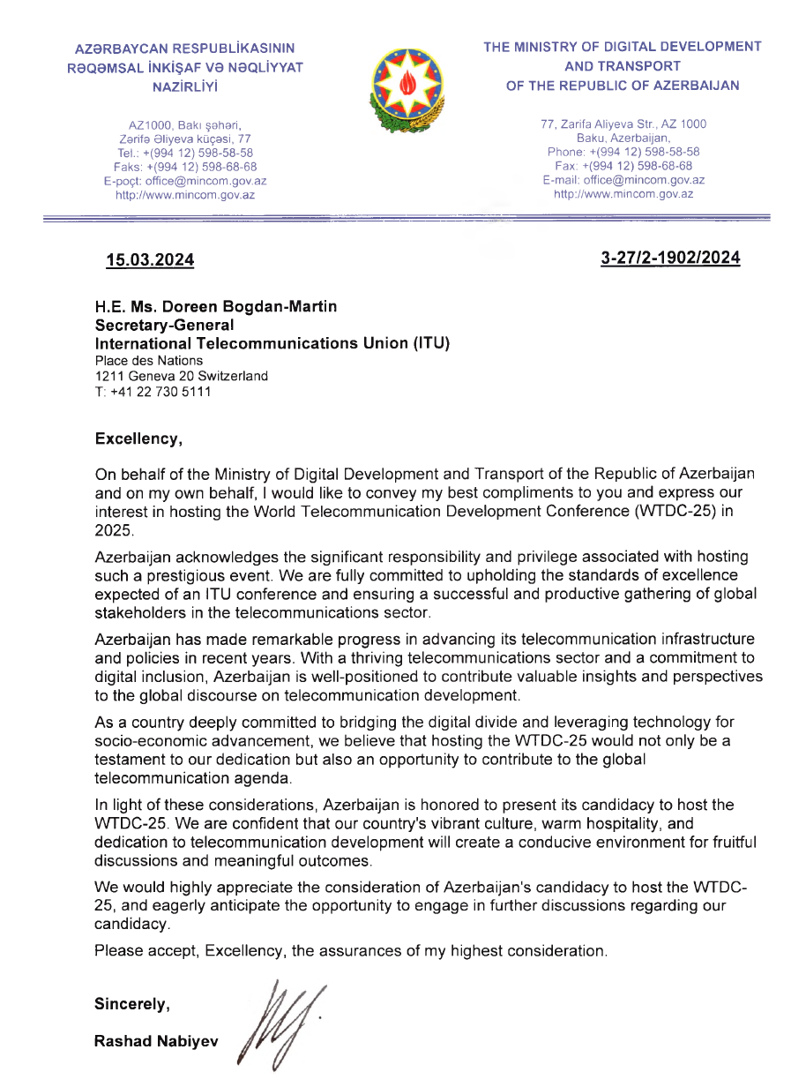

Annex 2

Annex 3

Annex 4

_______________