|  |  |
| --- | --- |
| **Telecommunication Development Advisory Group (TDAG)**  **31st Meeting, Geneva, Switzerland, 20-23 May 2024** |  |
|  |  |
|  | **Document** **TDAG-2****4/8-E** |
|  | **8 April 2024** |
|  | **Original:** **English** |
| Director, Telecommunication Development Bureau | |
| ITU-D Sector Members, Associates and Academia | |
|  | |
| **Summary:**  This document provides an overview of the ITU-D membership evolution in 2022-2023, and up to February 2024. It also recommends actions aimed at continued strengthening of efforts to recruit and retain more members in accordance with the outcomes of the World Telecommunication Development Conference of 2022 (WTDC-22) and the Plenipotentiary Conference of 2022 (PP-22). ITU-D membership includes Sector Members, Associates and Academia[1].  **Action required:**  TDAG is invited to note the document and provide guidance as deemed appropriate.  **References:**  WTDC Resolution 71 (Rev. Kigali, 2022);  Resolutions 169, 205 and 209 (Rev. Bucharest, 2022) of the Plenipotentiary Conference. | |

1. **Background**

The World Telecommunication Development Conference in 2022 (WTDC-22) revised and adopted Resolution 71 (Rev. Kigali, 2022[2]) to promote active involvement of current Sector Members, Associates and Academia in ITU-D activities, including participation in the work of ITU-D study groups and to attract new members from the public, private and academic sectors.

Resolution 71 brought more focus to the strengthening of cooperation between Member States, Sector Members, Associates and Academia of ITU-D, with its instruction to BDT to work closely with ITU-D Sector Members, Associates, and Academia for their participation in the successful implementation of the Kigali Action Plan, and in order to continue to organize meetings for high-level industry executives e.g. the Industry Advisory Group for Development Issues and Private Sector Chief Regulatory Officers’ (IAGDI-CRO) meeting.

1. **ITU-D membership evolution**

**Chart 1** below illustrates the ITU-D membership evolution (Sector Members, Associates and Academia). The chart shows the absolute number of ITU-D Sector Members, Associates and Academia by December 2022, December 2023, and by June 2024 (projection).

* 1. **ITU-D Sector Members and Associates**

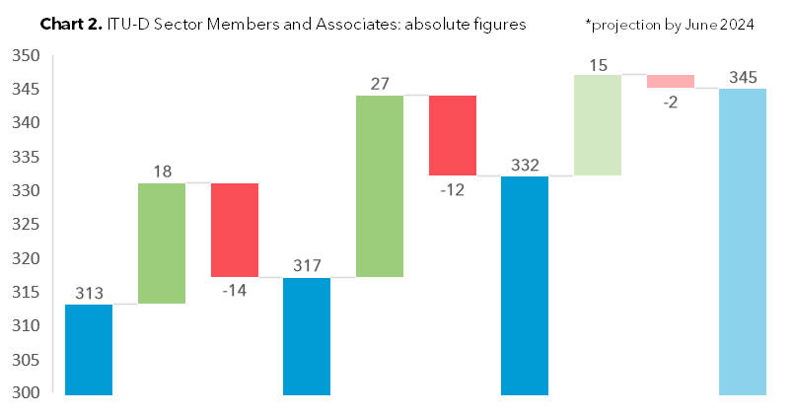

2021

2022

2023

2024*

Growth

Loss

Total

**Chart 2** details ITU-D Sector Members and Associates sustained growth in 2022 and 2023, reflecting the **gains** and **losses** in Sector Members and Associates for both years. It also shows the projected numbers by June 2024 based on accounts to be activated.

By December 2023, ITU-D attracted a total of **twenty-seven new Members*,*** compared to eighteen in 2022. The year 2023 shows a 50% increase in the total number of new members.

By the end of February 2024, ITU-D had already secured **eight new Members** and is expecting the activation of **seven additional** **Members** by June 2024.

Furthermore in 2023, the total of denunciations and exclusions was further **reduced** **to twelve members** due to mergers, review of business strategy, non-settlement of fees or undisclosed reasons. Additionally, two denunciations are expected to take effect by June 2024.

The sustained growth of ITU-D membership stems from strengthening outreach efforts through several streams of actions such as: bringing guests/observers to in-house thematic events; leveraging the partnership value proposition into existing and newly launched ITU-D initiatives into a membership and partnership single benefit package.

Finally, intensified use of data-driven tools and dashboards enabled targeting of membership accounts at risk, and follow-up actions for higher level awareness and re-engagement resulting in increased retention of members and net membership growth.

The lists of membership movement in 2023 (new members and losses) and expected projection by June 2024 can found in Document [TDAG-24/INF/2](https://www.itu.int/md/D22-TDAG31-INF-0002/).

* 1. **Exemption of fees requests**

BDT continued to review requests for exemption of fees in accordance with No. 476 of the Convention and as per ITU Council criteria which can be found [here](https://www.itu.int/hub/membership/our-members/exempted-entities/exemption-criteria/). ITU Council, at its 2023 July Session approved **four** organizations to join ITU-D as exempted members:

* Arab League Educational, Cultural and Scientific Organization (ALECSO)
* Communications Regulators Association of Southern Africa (CRASA)
* Global Impact (Global Digital Inclusion Partnership)
* World Federation of Engineering Organization (WFEO)
  1. **Pending Approvals**

By February 2024, **nine** **entities** were **pending clearance** from their **respective administrations** based on date of ITU’s communication. We would like to thank the Administrations of the private sector entities who we understand are paying due attention to the requests submitted to them to review ITU-D membership requests, and look forward to receiving their approvals or decisions.

|  |  |  |
| --- | --- | --- |
| COUNTRY | ENTITY NAME | MEMBERSHIP TYPE |
| Kenya | Adanian Labs | Sector Member |
| Nigeria | M-kel Networks Limited | Sector Member |
| Angola | ELENGEAFRIKA | Sector Member |
| Yemen | Yemen Mobile | Sector Member |
| Uganda | Lubcom Tech. Solutions Limited | Associate |
| Papua New Guinea | South Pacific Systems Private Limited | Sector Member |
| Yemen | National Foundation for Development and Humanitarian Response (NFDHR) | Associate |
| Malawi | Fatha Hi-Tech Ltd | Sector Member |
| Venezuela (Bolivarian Republic of) | TELECOMUNICACIONES GRAN CARIBE, S.A. | Sector Member |

* 1. **Academia affiliation[3]**

Total

Growth

Loss

2021

2023

2022

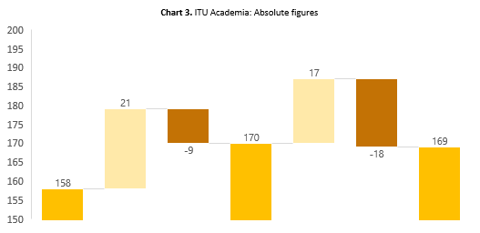

**Chart 3** details the gains and losses of Academia affiliation in 2022 and 2023. Whilst 2022 showed relevant growth, 2023 saw a higher number of losses. Academia can participate in the work of the three Sectors with one single fee, being able to contribute to Study Groups in all the Sectors. Nevertheless, it has reported difficulty to sustain affiliation for an extended period due to budgetary limitations.

To compensate for losses, strong outreach efforts are continuously being made, including by organizing visits and briefings with Members States interested in promoting and supporting academia membership. The ITU-wide Academia benefits have been updated on the webpage and a dedicated Academia benefits page is under construction.

With regards to specific engagement with the ITU-D, collaborative arrangements with Academia (both members and not members) have been piloted to develop studies and joint research. Furthermore, ITU Academy continues to provide partnership opportunities with Academia to deliver ITU’s training programs or joint delivery of specific courses. More details on opportunities and current engagement for replication with ITU affiliated Academia and non-affiliated Academia can be found in Annex 1.

1. **Engagement, retention, promotion, and outreach**

* BDT carried out several actions aimed at reinforcing **outreach and engagement efforts** through promotional campaigns and targeted outreach to wider audiences in global tech exhibitions. BDT also focused on converting existing platforms within the ITU-D products and services portfolio into effective membership outreach channels. An increased number of briefing sessions were held with thematic experts and ITU-D Membership (physically and virtually) throughout 2023, bringing higher awareness of areas for engagement.
* In particular, the **Industry Advisory Group on Development Issues and the Private Sector Chief Regulatory Officers (IAGDI-CRO)** meeting was held during the Global Symposium for Regulators (GSR-23) in Sharm-El-Sheikh, Egypt. The interest and commitment of ITU-D Sector members is shown by a record number of participants, and higher number of industry and private sector contributions to the GSR Best Practice Guidelines consultation process. The meeting’s [Outcome Statement](https://www.itu.int/en/ITU-D/Conferences/CRO/Documents/Outcome%20statement%20IAGDI-CRO.pdf) and the Chair’s Report can be found [here](https://www.itu.int/en/ITU-D/Conferences/CRO/Documents/CHAIRMAN%27S%20REPORT%20D3.pdf). The next IAGDI-CRO meeting will take place on **2 July 2024,** in Kampala, Uganda during GSR-24.
* **The Know Your Members Series** will continue to serve as a platform for consultations with management and knowledge exchange amongst ITU-D members and ITU staff. Additionally, the **Tech Talks Series** will provide ITU-D Members with an opportunity to present their technology trends and innovative approaches and share their best practices in the application and use of these technologies for digital development.
* Enhanced recognition of ITU-D membership through ITU-D members’ **Testimonials** where high level representatives promote the value of the ITU-D membership, serves both as recognition to our members and to attract new prospects.
* The **Partner2Connect Digital Coalition**[4] attracts a high number of pledges from ITU-D membership. The Regional Development Forums sessions recognized these commitments and focused on translating those into tangible actions towards meaningful connectivity.

1. **Tools and processes enhancements in 2024**

BDT continues to enhance tools and processes to attract and retain new members:

* **Process review and re-alignment** leveraging modern data methods and streamlining internal processes, and enhanced use of revamped tools.
* **Harmonizing onboarding experience** through the development of a new Welcome Kit for more effective onboarding of new members and expanded awareness of collaboration opportunities with ITU-D.

1. **New ITU-D membership website** for a seamless membership experience with refreshed content, better reflection of benefits, and streamlined application processes to persuade visitors to join as members.
2. **Conclusions**

BDT is determined to:

1. Increase the engagement with ITU-D membership in the implementation of the Kigali Action Plan through briefing sessions and official missions, and by demonstrating value and establishing partnerships that unlock resources for the financing of high-impact projects and initiatives.
2. Target non-active ITU-D Members to enhance their level of engagement in the activities of ITU-D, including events such as: ITU-D study groups, the Global Symposium for Regulators, Regional Development Forums, etc.
3. Continue to collect insights and feedback from ITU-D Members and Academia regarding improvement of tools, processes, and services.
4. **Call for Support**

Member States are invited to engage and promote, with their domestic private sector, industry, and universities, the benefits of joining the work of ITU-D. Member States are encouraged to complete due diligence of new applications in a timely manner so that applying entities can remain motivated to complete the affiliation process.

_______________

1. Refers to Resolution 169 (Guadalajara, 2010) of the Plenipotentiary Conference, which enabled the new category of Academia to participate in the work of ITU.
2. Resolution 71 (Rev. Kigali, 2022), “Strengthening cooperation between Member States, Sector Members, Associates and Academia of the ITU Telecommunication Development Sector and the evolving role of the private sector in the ITU Telecommunication Development Sector”.
3. Academia members participate in the work of all three ITU Sectors, including their advisory groups. They also participate in other global and regional conferences, workshops, and activities of the Union, apart from plenipotentiary conferences, world radiocommunication conferences, world conferences on international telecommunications and the ITU Council, in conformity with the rules of procedure of the respective Sectors.
4. As of February 2024, there are 170 pledges with an estimated value of more than USD 25 billion from ITU-D Sector Membership including regional and international organizations and the private sector.