Telecommunication Development  Advisory Group (TDAG)  31st Meeting, Geneva, Switzerland, 20-23 May 2024 | 
 | Document TDAG-24/5-E
 | 22 March 2024
 | Original: English
Chair, ITU-D Study Group 1
ITU-D Study Group 1 – Activities and progress
Summary:
This report presents to TDAG the current status of ITU-D Study Group 1 (SG1). It provides information on the outcomes of the second annual meeting of SG1 for the 2022-2025 study period which was held from 23 to 27 October 2023.
It should be noted that the Rapporteur Groups for all seven SG1 Questions are progressing well towards WTDC expected outputs. A highlight from the recent meeting is the approval and subsequent publication of the interim deliverable related to the work of ITU-D SG1 Question 6/1 titled “Best practices being adopted on fit-for-purpose digital regulation tools for consumer protection”.
A revised version of this document will be submitted to reflect the outcomes of the Rapporteur Group meetings to be held from 15 to 26 April 2024.
Action required:
TDAG is invited to note this document and provide guidance as deemed appropriate.
References:
WTDC Resolution 2 (Rev. Kigali, 2022), WTDC Resolution 1 (Rev. Kigali, 2022), 1/REP/9 (2023)

Highlights
ITU-D Study Group 1 (SG1) examines issues relating to an enabling environment for meaningful connectivity through 7 study Questions focusing on broadband deployment, broadcasting new services, emergency telecommunications, economics of ICTs, rural and remote connectivity, consumer protection and ICTs for persons with disabilities.
Highlights from the second annual meeting of SG1 held from 23 to 27 October 2023 include:
- 224 participants (45% women delegates) including 175 delegates from 59 Member States;
- Appointment of 1 vice-chair and 2 vice-rapporteurs;
- 155 documents to advance the work for the 2022-2025 study period;
- 8 outgoing liaison statements were agreed and dispatched;
- 13 fellowships were granted;
- 5 draft output reports of study Questions were presented and discussed;
- approval of the first ITU-D SG1 interim deliverable related to the work of ITU-D SG1 Question 6/1 on “Best practices being adopted on fit-for-purpose digital regulation tools for consumer protection”;
- a spotlight session on the Digital Regulation Network was held as part of the opening plenary;
- the mapping work ITU-D SG1 and SG2 Questions of interest to work items and Questions in ITU-T study groups, was completed;
- proposals for 3 standalone workshops namely by Question 2/1, Question 3/1 and Question 7/1 at the April 2024 Rapporteur Group meetings was agreed to;
- a proposal for a joint ITU-D Q4/1 and Q6/1 workshop on personal data usage regulatory and economic aspects at the April 2024 Rapporteur was agreed to;
- a proposal for a joint ITU-D Q1/1, Q3/1 and Q4/1 workshop on Transformative Satellite connectivity at the April 2024 Rapporteur Group meetings was agreed to;
- a proposal for a joint ITU-D Q6/1 and Q3/2 workshop on Consumer Awareness in June 2024 hosted by ANATEL and the ITU Regional Office for Americas was agreed to;
- 2 ITU-D SG1 management team meetings, a joint ITU-D SG1 and SG2 management team meeting and several Question management team meetings were held in Geneva between 22 and 28 October 2023.

ITU-D Study Group 1

Scope of work
Study Group 1 (SG1) was established in accordance with Resolution 2 (Rev. Kigali, 2022) to examine, through 7 study Questions adopted by the ITU membership at the World Telecommunication Development Conference 2022 (WTDC-22), issues relating to an enabling environment for meaningful connectivity. Annex 1 to this resolution defines the scope of SG1 and Annex 2 list the study Questions. Part V of the WTDC-22 Final Report provides details of each ITU-D Study Questions and their terms of reference.

Management team
WTDC-22 designated the SG1 leadership for the eighth cycle (2022-2025): Ms Regina Fleur Assoumou Bessou (Côte d’Ivoire) was appointed as Chair; and eleven vice-chairs were appointed.
At the second annual meeting of SG1 in October 2023, Mr Ali Rasheed Hamad Al-Hamad (Kuwait) was appointed as vice-chair to replace Ms Sameera Belal Momen Mohammad. Mr Saeed Addow Himmaida Mohammed (Sudan) was appointed as a new vice-rapporteur for Question 2/1, and Ms Rozaidawati Zainum Aznam (Malaysia) as vice-rapporteur for Question 1/1 to replace Ms Syahniza Shah. The contribution of Ms Sameera Belal Momen Mohammad (Kuwait) as vice-chair for SG1, was noted with great appreciation.
The list of all candidatures received can be found online at the following link: https://www.itu.int/en/ITU-D/Study-Groups/2022-2025/Pages/candidates.aspx, and the rapporteurs and vice-rapporteurs of each Question can be found at Annex 1.
The complete Question management teams including with BDT focal points is available online at https://www.itu.int/net4/ITU-D/CDS/sg/rapporteurs.asp?lg=1&sp=2022.

Working methods

The working methods for ITU-D Study Group 1 are defined in Resolution 1 (Rev. Kigali, 2022), primarily in Sections 3, 4, 5,6 and 9 and include:
- Enhanced role of vice-chairs as coordinators: The updated list of coordinators is at Annex 2 of this report. Coordinators were primarily the vice-chairs of SG1 assigned following an expression of interest. When a role could not be filled by any SG1 vice-chair, additional members, such as rapporteurs and vice-rapporteurs, were invited to fill the role;
- TDAG to be made aware of non-attendance of study group chairs, vice-chairs, rapporteurs and vice-rapporteurs, and actions taken to encourage their participation and engagement in their roles. This aspect was discussed at the SG1 management meetings and joint SG management meetings held in October 2023. Attendance information is shared in this report in the last the columns of the tables at Annex 1.

Strategy and Workplan
In order for SG1 to reach its expected results for the 2022-2025 study period, in accordance with the scope of work as defined in Resolution 2 (Rev. Kigali, 2022) “Establishment of study groups”, the continuity of the SG1 Chairperson’s vision of more interaction, innovation and implementation is achieved by:
- a smart SG1 workplan for efficiency actions within the shortened timeline of this study period;
- quality evidence-based content as inputs to the work of SG1, with the effective engagement of experts in the management team, active collaborators and meeting participants, to analyse and process these inputs into quality timely outputs;
- optimizing resources by continued and focused synergies for collaboration between study questions, study groups within ITU-D and in other sectors; with BDT projects, regional initiatives, ITU and ITU partners’ actions;
- involving study groups experts from membership in the work of BDT and ITU to serve membership;
- inclusion of experts from membership namely persons with disabilities, women and youth in the work of SG1.
The second annual meeting of SG1 noted the continued use of the SG1 work plan which was approved at the first meeting in 2022, with updated meeting dates for the third meeting in 2024 (Annex 3 to this report).

3. Overview of the work of ITU-D Study Group 1
  - Second Study Group 1 meeting for the study period (23 to 27 October 2022)
The second meeting of SG1 following WTDC-22 took place from 23 to 27 October 2022, with 224 participants (includes 122 remote participants). Of these, 175 were delegates representing 59 Member States ((1/ADM/43+Annex). 45% of participants were women delegates and 13 fellowships were granted. 155 contributions were reviewed, including 16 liaison statements. Statistics summarizing preliminary participation by region, contributions by Question, and other data may be found in (1/ADM/25 + Annex). Webcast, live captioning and interactive, multilingual remote participation were provided. All meeting documents can be downloaded from the meeting website (TIES access is required). Webcast archives are available here.
Figure 1 : participants at the second annual meeting of SG1
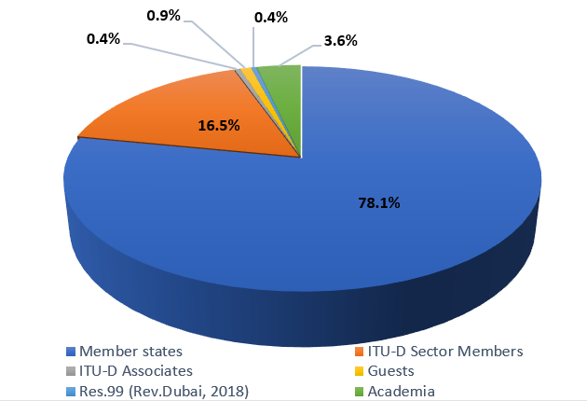
Figure 2 : contributions received by region for second annual meeting of SG1
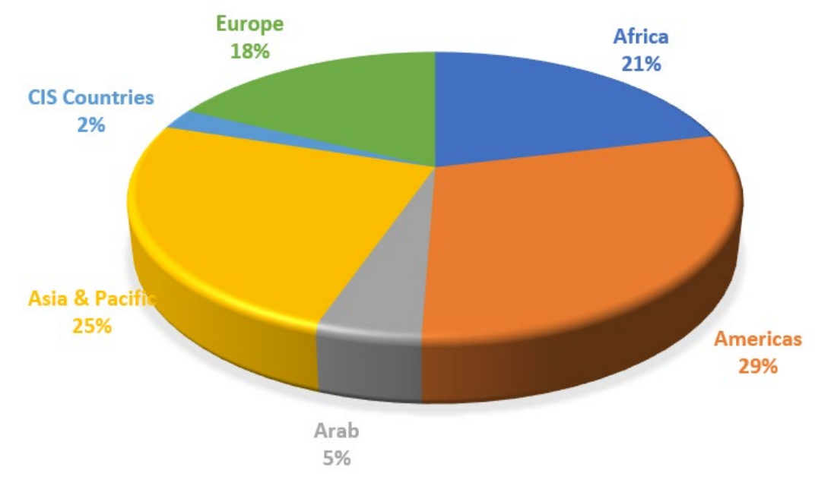
In his opening remarks, the BDT Director, Dr Cosmas Luckyson Zavazava shared his vision of BDT4Impact - to go beyond access and ensure that connectivity is meaningful, affordable supported by the necessary digital skills. He acknowledged the innovative approaches initiated at the Rapporteur Group meetings and workshops held in May 2023 that generated useful content to advance SG1 work. He shared 4 strategic questions for everyone present to consider in order to maximise SG1’s operational impact.
In her opening remarks, the SG1 Chair, Ms Fleur Regina Assoumou-Bessou (Côte d’Ivoire), emphasised the efficiencies and collaborations that result from joint workshops, joint deliverables, which rapporteur groups have committed to producing. She invited all members at the meeting to put all outputs of the study group to good use in their countries and promote further use by all.
Ms Fleur Regina Assoumou-Bessou (Côte d’Ivoire), was joined by Study Group 1 (SG1) vice-chairs in the room: Mr Roberto Mitsuake Hirayama (Brazil), Ms Memiko Otsuki (Japan), Mr Sangwon Ko (Republic of Korea), Mr Amah Vinyo Capo (Togo), Mr Mehmet Alper Tekin (Türkiye) and Ms Caecilia Nyamutswa (Zimbabwe). Mr Sunil Singhal (India) and Mr George Anthony Giannoumis (Norway) were attending online.
A spotlight session provided insight to all participants on the Digital Regulation Network initiative launched at GSR 2023 for further reflection within SG1 on how to leverage on this initiative as well as provide support to it.
The meeting considered the positive progress reports (from November 2022 to October 2023) shared by the Rapporteurs. The meeting approved the reports of the Question meetings held from 23 to 27 October, which included updated work plans and table of contents for the final reports as well as outgoing liaison statements, where applicable. The workshops being planned (as per the workplans) for April 2024 include:
- a joint workshop of Q1/1, Q3/1 and Q5/1 on transformative satellite connectivity;
- a joint workshop of Q4/1 and Q6/1 on personal data usage regulatory and economic aspects;
- a workshop of Q2/1 and one workshop of Q3/1.
The first interim deliverable was approved. It is prepared by the Question 6/1 management team and is titled “Best practices being adopted on fit-for-purpose digital regulation tools for consumer protection”. The approved document has been processed into a publication format agreed and was issued in February 2024 as a free online publication in all UN languages for access by all. The publication is completed by a video interview of co-authors.
Following the appointment of SG1 Coordinators (see annex 2) as per WTDC-22 Resolution 1, they have been carrying out their responsibilities and shared an update at the second annual meeting of SG1 as per documents 1/260* (presentation slides). This information was reinforced with the updates provided on items of collaboration by TSB and BR colleagues, the WSIS team as well as the ICT data and analytics division (IDA) of BDT, the projects being managed by BDT and recent BDT action regarding youth and gender.
- Collaboration and coordination with ITU-D Study Group 2 and the other Sectors on matters of shared interest

Coordination with ITU-D Study Group 2
Synergies between SG1 and SG2 are continuously sought. Joint workshops is an approach that pools expertise together, optimizes costs and strengthens collaboration. In addition to joint workshops planned between SG1 Questions, a joint Q6/1 and Q3/2 workshop is planned for June 2024 hosted by ANATEL in collaboration with ITU Regional Office for Americas. A cross cutting workshop is also planned on the day of Girls in ICT Celebration, 25 April 2024.

Inter-Sectoral Coordination
At the second SG1 meeting, as per tradition, updates shared by TSB and BR were appreciated for identifying synergies and areas of potential future collaboration at specific study group Question, Working Party and Resolution levels.
To facilitate coordination and further strengthen collaboration with the study groups in the other Sectors, a revised mapping of ITU-D SG1 and SG2 Questions of interest to Questions in ITU-T study group is available on the website of the Inter-Sector Coordination Group (ISCG). The matrix of mapping between ITU-D SG1 and SG2 Questions and ITU-R working parties is expected to be updated with post WRC outcomes. These mappings allow rapporteur groups to relate their specific work items to that undertaken in the other ITU Sectors to facilitate cross-referencing of existing Recommendations, directing liaison statements to the right groups, and identifying experts and sharing expertise on related topics e.g. through jointly organized workshops. This work effort was undertaken by the assigned coordinators (see Annex 2) in charge of inter-sectoral coordination.
8 outgoing liaison statements were approved at the second SG1 meeting to continue the valuable exchange whereby SG1 is apprised of latest documents from other sectors and collaborating organisations, and SG1 in turn, informs and seeks feedback as needed on its work in progress.
As part of a continued collaboration of the three bureaus of ITU, a workshop on “The Future of Television for the Americas”, led by ITU-T SG9 in collaboration with ITU-T SG16, ITU-R SG6 and ITU-D Question 2/1, was organised.

Involvement and contribution of ITU-D study groups toward the implementation of WTDC Resolution 9 (Rev. Kigali, 2022)
In order to implement WTDC Resolution 9 in collaboration with ITU-R, it is noted that
SG1 and SG2 coordinators for Resolution 9 are working together in line with document 1/197 which was discussed in the October 2023 rapporteur group meetings for Q1/1, Q3/1, Q4/1, Q5/1, Q1/2, Q2/2, Q7/2. It was agreed that information related to spectrum management received through contributions will be mapped to the list of topics from the Annex 1 of WTDC Resolution 9 and will be submitted to TDAG and to the Directors of BDT and BR, for their consideration, as appropriate. To this effect, a template has been shared with these Questions for them to complete and submit to the coordinators for onward submission. The compilation is at Annex 4 together with guidelines proposed in document 1/197.

ITU Coordination Committee for Terminology (ITU CCT)
In accordance with provision 12.3 of Resolution 1, a vice-chair of SG1 was appointed (see Annex 2) as an ITU-D representative to the ITU Coordination Committee for Terminology (ITU-CCT). In 2023 three virtual CCT meetings were held on 18 April 2023, 21 July 2023 and 26 September 2023. Each meeting considers liaison statements and contributions on matters concerning terminology issues and agrees on updates to the ITU terminology database. ITU-D SG1 in its work must be aware of the ITU terminology database and its usefulness when preparing reports and other deliverables. SG1 will continue to regularly follow relevant discussions with the rapporteur groups and the appointed SG1 representative to ITU CCT.

WSIS
Regular updates are received at SG1 meetings on the various activities undertaken by the General Secretariat related to WSIS, including the WSIS Forum outcomes, the next WSIS Forum preparations, WSIS Stocktaking and WSIS Prizes. As most study Questions have linkages with WSIS Action Lines, SG1 through its HQ focal points, will continue work with WSIS. WSIS prizes winners who are ITU-D Members, are invited to submit contributions to relevant SG1 Questions.

Expert Group on ICT Household Indicators and Expert Group on Telecommunication/ICT Indicators
The importance of evidence through reliable statistical data and analytics is key to produce quality SG1 outputs. The update provided at the second SG1 meeting on ITU-D’s statistical products and activities in 2023 included timely clarifications on the ICT Development Index (IDI). The ongoing work of EGTI and EGH on topics that are of interest to the SG1 Questions, is being followed up by the SG1 coordinators assigned on matters related to statistics (Annex 2). Satellite-based broadband Internet measurement and Measuring middle-mile connectivity are two topics flagged for future work at EGTI level, which would be of interest to SG1.

BDT Projects and actions
Enhancing coordination and focusing on active collaboration with all relevant BDT global and regional event organisers, project managers and capacity building colleagues for optimizing experts resources from study group management teams, is a continuous process.
An update on BDT projects with mapping to ITU-D study Questions, was shared in the second SG meeting of October 2023 to allow Question management teams and rapporteur groups to identify specific projects of interest. SG1 assigned coordinators (see Annex 2) shared proposals to leverage on BDT projects collaboration starting with PRIDA updates shared at the second SG meeting.

Youth and Gender mainstreaming
Two contributions were reviewed at the second annual meeting of SG1 namely incorporating a youth-centric perspective in ITU-D's efforts to foster an inclusive digital society, economy, and environment, and on BDT actions to promote gender equality and women's inclusion in the digital sector. It is proposed that all final output reports have a section on youth and women mainstreaming actions pertaining to the study Question.
- Collaborative tools
Similar to the previous study period, usage of collaborative tools to facilitate collaborators’ electronic participation in the work of the ITU-D study groups, will continue. In addition to remote participation services and the webcast in the languages of the respective meeting, mailing lists are made available to participants and management team members. MS teams have been created for use by each Question management team as per their convenience. The automatic captioning in various languages highly appreciated by the Question management team members as it improves accessibility and exchanges during the e-meetings.
The contributions repository & dashboard, which facilitates the search of previous contributions and their abstracts, is updated. Study group participants were encouraged to explore the tools and to provide any feedback to the secretariat to assist in their improvement.
Automatic document (machine) translation names “ITU Translate” is available on the ties protected document management repository where by contributions, reports and other meeting documents can be translated from one UN official language into another UN official language by the reader.
All ITU-D study Group website pages, as is the case for all BDT webpages, are available in all UN official languages.
- Conclusion and way forward
The ITU-D SG1 work is continuing as planned. It is expected that updated draft output reports for all 7 Questions and additional interim deliverables will be shared at the next ITU-D SG1 meeting to be held from 4 to 8 November 2024 in Geneva.

Annex 1: Appointed Chair, Vice-Chair and Rapporteurs and Vice-Rapporteurs of ITU-D Study Group 1 Questions for the 2022-2025 period with attendance information
List of chair and vice-chair is also available here
List of rapporteurs, vice-rapporteur and BDT focal points is available here
 | ITU-D STUDY GROUP 1 | Study Group 1 Meeting 2022 | Rapporteur Group Meeting 2023 | Study Group 1 Meeting 2023
Chair | Ms Regina Fleur Assoumou BESSOU (Côte d’Ivoire) | Present | Present | Present
Vice-Chairs | Ms Caecilia NYAMUTSWA (Zimbabwe) | Present | Remote | Present
 | Mr Amah Vinyo CAPO (Togo) | Present | Present | Present
 | Mr Roberto Mitsuake HIRAYAMA (Brazil) | Present | Present | Present
 | Ms Sameera Belal Momen MOHAMMAD /Mr Ali Rasheed Hamad AL-HAMAD (Kuwait) from Oct 2023 | Present | Absent | Remote
 | Mr Sunil SINGHAL (India) | Present | Present | Remote
 | Mr Memiko OTSUKI (Japan) | Present | Present | Present
 | Mr Sangwon KO (Republic of Korea) | Present | Present | Present
 | Ms Khayala PASHAZADA (Azerbaijan) | Remote | Absent | Absent
 | Ms Umida MUSAEVA (Uzbekistan) | Present | Absent | Absent
 | Mr George Anthony GIANNOUMIS (Norway) | Remote | Present | Remote
 | Mr Mehmet Alper TEKIN (Türkiye) | Present | Remote | Present

List of (Co)Rapporteurs and Vice-Rapporteurs
Question | Role | Name of candidate | Organisation | Country | Region | SG1  2022 | RG  2023 | SG1 2023
Question 1/1 | Rapporteur | Mr Ahmed GAD | Administration | Egypt (Arab Republic of) | Arab States | Present | Present | Present
Question 1/1 | Vice-Rapporteur | Ms Keamogetswe MATOMELA | Administration | Botswana (Republic of) | Africa | Remote | Absent | Absent
Question 1/1 | Vice-Rapporteur | Ms Emma Ann OTIENO | Administration | Kenya (Republic of) | Africa | Present | Present | Present
Question 1/1 | Vice-Rapporteur | Mr Issiaka ALHABIBOU | Administration | Mali (Republic of) | Africa | Present | Present | Present
Question 1/1 | Vice-Rapporteur | Mr Christopher HEMMERLEIN | Administration | United States of America | Americas | Present | Present | Present
Question 1/1 | Vice-Rapporteur | Mr Turhan MULUK | Intel Corporation | United States of America | Americas | Remote | Remote | Present
Question 1/1 | Vice-Rapporteur | Mr Bharat B BHATIA | Administration | India (Republic of) | Asia & Pacific | Remote | Absent | Absent
Question 1/1 | Vice-Rapporteur | Ms Syahniza Md. SHAH /Ms Rozaidawati Zainum Aznal (from Oct 2023) | Administration | Malaysia | Asia & Pacific | Present | Present | Present
Question 1/1 | Vice-Rapporteur | Ms Ziqi ZHANG | Administration | China (People's Republic of) | Asia & Pacific | Remote | Remote | Present
Question 1/1 | Vice-Rapporteur | Ms Uliana STOLIAROVA | Administration | Russian Federation | CIS Countries | Present | Remote | Remote
Question 1/1 | Vice-Rapporteur | Ms Nataša KUZMANOVIĆ | Administration | Bosnia and Herzegovina | Europe | Present | Present | Present
Question 1/1 | Vice-Rapporteur | Mr Ugur KAYDAN | Administration | Türkiye | Europe | Absent | Absent | Remote
Question 1/1 | Vice-Rapporteur | Mr Jesús CARBALLAL | Axon Partners Group | Spain | Europe | Remote | Absent | Absent
Question 1/1 | Vice-Rapporteur | Mr Juan PEIRANO | Internet Society | United Kingdom of Great Britain and Northern Ireland | Europe | Absent | Present | Remote
Question 1/1 | Vice-Rapporteur | Ms Gevher Nesibe TURAL TOK | Türk Telekom | Türkiye | Europe | Absent | Absent | Absent
Question 2/1 | Co-Rapporteur | Mr Roberto Mitsuake HIRAYAMA | Administration | Brazil (Federative Republic of) | Americas | Present | Present | Present
Question 2/1 | Co-Rapporteur | Mr Stanislas KANVOLI | Administration | Côte d'Ivoire (Republic of) | Africa | Remote | Remote | Present
Question 2/1 | Vice-Rapporteur | Ms Therese KOIVOGUI | Administration | Guinea | Africa | Remote | Present | Remote
Question 2/1 | Vice-Rapporteur | Mr Malick NDIAYE | Administration | Senegal (Republic of) | Africa | Remote | Present | Present
Question 2/1 | Vice-Rapporteur | Mr Jean Marie MAIGNAN | Administration | Haiti | Americas | Absent | Absent | Present
Question 2/1 | Vice-Rapporteur | Mr Luyu ZHAO | China Institute of Communications (CIC) | China (People's Republic of) | Asia & Pacific | Remote | Remote | Absent
Question 2/1 | Vice-Rapporteur | Ms Nataša KUZMANOVIĆ | Administration | Bosnia and Herzegovina | Europe | Present | Present | Present
Question 2/1 | Vice-Rapporteur | Mr Saeed Addow HIMMAIDA MOHAMMED (from Oct 2023) | Administration | Sudan | Arab States | NA | NA | Absent
Question 3/1 | Co- Rapporteur | Mr Serigne Abdou Lahatt SYLLA | Administration | Senegal (Republic of) | Africa | Remote | Present | Present
Question 3/1 | Co-Rapporteur | Ms Alison BALZER | Administration | United States of America | Americas | Present | Present | Present
Question 3/1 | Vice-Rapporteur | Ms Ruth KARIUKI | Administration | Kenya (Republic of) | Africa | Remote | Present | Present
Question 3/1 | Vice-Rapporteur | Mr N'guessan Tchissou Jean Roger KOFFI | Administration | Côte d'Ivoire (Republic of) | Africa | Present | Present | Present
Question 3/1 | Vice-Rapporteur | Mr Giquel Thérance SASSA | Ecole Nationale Supérieure des Postes, Télécommunications et TIC (SUP'PTIC) | Cameroon | Africa | Absent | Present | Absent
Question 3/1 | Vice-Rapporteur | Mr Edva ALTEMAR | Administration | Haiti | Americas | Absent | Present | Present
Question 3/1 | Vice-Rapporteur | Mr Abdelwaheb GALIZRA | Administration | Algeria (People's Democratic Republic of) | Arab States | Remote | Present | Remote
Question 3/1 | Vice-Rapporteur | Mr Hideo IMANAKA | Administration | Japan | Asia & Pacific | Present | Present | Present
Question 3/1 | Vice-Rapporteur | Ms Jingli WANG | Administration | China (People's Republic of) | Asia & Pacific | Remote | Remote | Present
Question 3/1 | Vice-Rapporteur | Ms Muberra BINGOL | Administration | Türkiye | Europe | Remote | Present | Present
Question 3/1 | Vice-Rapporteur | Mr Gökhan TOK | Access Partnership Ltd | United Kingdom of Great Britain and Northern Ireland | Europe | Present | Remote | Absent
Question 4/1 | Rapporteur | Mr Arseny PLOSSKY | Administration | Russian Federation | CIS countries | Present | Present | Present
Question 4/1 | Vice-Rapporteur | Mr Denis R VILLALOBOS ARAYA | Administration | Costa Rica | Americas | Absent | Absent | Absent
Question 4/1 | Vice-Rapporteur | Mr Yan CHEN | Beijing University of Posts and Telecommunications | China (People's Republic of) | Asia & Pacific | Absent | Remote | Remote
Question 4/1 | Vice-Rapporteur | Ms Diago DIOUF FATI | Administration | Senegal (Republic of) | Africa | Present | Remote | Absent
Question 4/1 | Vice-Rapporteur | Mr Talent MUNYARADZI | Administration | Zimbabwe (Republic of) | Africa | Present | Absent | Present
Question 4/1 | Vice-Rapporteur | Mr Tyler CROWE | Administration | United States of America | Americas | Present | Present | Present
Question 4/1 | Vice-Rapporteur | Mr Wesam M. SEDIK | Administration | Egypt | Arab States | Present | Present | Present
Question 4/1 | Vice-Rapporteur | Mr Xiaoyu LIU | Administration | China (People's Republic of) | Asia & Pacific | Remote | Remote | Remote
Question 4/1 | Vice-Rapporteur | Ms Memiko OTSUKI | Administration | Japan | Asia & Pacific | Present | Remote | Present
Question 4/1 | Vice-Rapporteur | Mr Recep DURAN | Administration | Türkiye | Europe | Remote | Remote | Remote
Question 4/1 | Vice-Rapporteur | Mr Emanuele GIOVANNETTI | Anglia Ruskin University | United Kingdom | Europe | Remote | Present | Remote
Question 4/1 | Vice-Rapporteur | Mr Mustafa GÖKHAN ACAR | Türk Telekom | Türkiye | Europe | Remote | Absent | Absent
Question 4/1 | Vice-Rapporteur | Mr Jorge MARTÍNEZ | Axon Partners Group | Spain | Europe | Remote | Present | Remote
Question 4/1 | Vice-Rapporteur | Mr Sidy DIOP | Deloitte | France | Europe | Remote | Remote | Present
Question 5/1 | Co-Rapporteur | Ms Caecilia NYAMUTSWA | Administration | Zimbabwe | Africa | Present | Remote | Present
Question 5/1 | Co-Rapporteur | Mr Ja Heung KOO | Administration | Korea (Rep. of) | Asia & Pacific | Present | Remote | Remote
Question 5/1 | Vice-Rapporteur | Mr Babou SARR | Administration | Senegal | Africa | Present | Absent | Absent
Question 5/1 | Vice-Rapporteur | Mr Mahalmadane Sidi TOURE | Administration | Mali (Republic of) | Africa | Present | Present | Present
Question 5/1 | Vice-Rapporteur | Mr Edva ALTEMAR | Administration | Haiti | Americas | Present | Present | Present
Question 5/1 | Vice-Rapporteur | Mr Christopher HEMMERLEIN | Administration | United States of America | Americas | Present | Present | Present
Question 5/1 | Vice-Rapporteur | Mr Turhan MULUK | Intel Corporation | United States of America | Americas | Remote | Remote | Present
Question 5/1 | Vice-Rapporteur | Ms Runzhu CHEN | Administration | China (People's Republic of) | Asia & Pacific | Remote | Absent | Present
Question 5/1 | Vice-Rapporteur | Mr Ashi KAPOOR | Administration | India (Republic of) | Asia & Pacific | Remote | Remote | Remote
Question 5/1 | Vice-Rapporteur | Ms Julia NIETSCH | Administration | France | Europe | Remote | Remote | Present
Question 5/1 | Vice-Rapporteur | Mr Yusuf Korhan SELEK | Administration | Türkiye | Europe | Remote | Remote | Remote
Question 5/1 | Vice-Rapporteur | Mr Anthony Virgil ADOPO | Deloitte | France | Europe | Remote | Present | Remote
Question 5/1 | Vice-Rapporteur | Mr Shiv BAKHSHI | Ericsson | Sweden | Europe | Present | Present | Remote
Question 5/1 | Vice-Rapporteur | Ms Paulina PASTOR | Axon Partners Group | Spain | Europe | Absent | Remote | Remote
Question 6/1 | Co-Rapporteur | Ms Cristiana CAMARATE | Administration | Brazil (Federative Republic of) | Americas | Remote | Present | Present
Question 6/1 | Co-Rapporteur | Ms Wei PEI | China Institute of Communications (CIC) | China (People's Republic of) | Asia & Pacific | Remote | Present | Absent
Question 6/1 | Vice-Rapporteur | Ms Caroline Kathure MURIANKI | Administration | Kenya (Republic of) | Africa | Remote | Present | Present
Question 6/1 | Vice-Rapporteur | Mr Issouf SOULAMA | Administration | Burkina Faso | Africa | Remote | Present | Absent
Question 6/1 | Vice-Rapporteur | Ms Hadiza KACHALLAH | Administration | Nigeria (Federal Republic of) | Africa | Present | Present | Present
Question 6/1 | Vice-Rapporteur | Ms Anne Chantal NGONDJI | Ecole Nationale Supérieure des Postes, Télécommunications et TIC (SUP'PTIC) | Cameroon | Africa | Remote | Present | Remote
Question 6/1 | Vice-Rapporteur | Mr Jesús Coquis ROMERO | Administration | Mexico | Americas | Remote | Present | Absent
Question 6/1 | Vice-Rapporteur | Ms Hayun KANG | Administration | Korea (Rep. of) | Asia & Pacific | Remote | Present | Remote
Question 6/1 | Vice-Rapporteur | Ms Lin LIN | Administration | China (People's Republic of) | Asia & Pacific | Remote | Remote | Present
Question 6/1 | Vice-Rapporteur | Ms Tharalika LIVERA | Administration | Sri Lanka (Democratic Socialist Republic of) | Asia & Pacific | Remote | Absent | Present
Question 6/1 | Vice-Rapporteur | Mr Osman SAHIN | Administration | Türkiye | Europe | Remote | Present | Present
Question 6/1 | Vice-Rapporteur | Mr Carlo AGDAMAG | Access Partnership Ltd | United Kingdom of Great Britain and Northern Ireland | Europe | Remote | Remote | Absent
Question 7/1 | Co-Rapporteur | Ms Amela Odobašić | Administration | Bosnia and Herzegovina | Europe | Present | Present | Present
Question 7/1 | Co-Rapporteur | Ms Mina Seonmin JUN | Administration | Korea (Rep. of) | Asia & Pacific | Present | Present | Present
Question 7/1 | Vice-Rapporteur | Ms Mariéme Thiam NDOUR | Administration | Senegal (Republic of) | Africa | Absent | Absent | Absent
Question 7/1 | Vice-Rapporteur | Mr Kadiri OURO-AGORO | Administration | Togolese Republic | Africa | Absent | Present | Absent
Question 7/1 | Vice-Rapporteur | Mr Gragba SEVERIN | Administration | Côte d'Ivoire (Republic of) | Africa | Remote | Present | Present
Question 7/1 | Vice-Rapporteur | Ms Ileana Gama BENÍTEZ | Administration | Mexico | Americas | Present | Absent | Present
Question 7/1 | Vice-Rapporteur | Mr Kun YANG | Administration | China (People's Republic of) | Asia & Pacific | Remote | Remote | Absent
Question 7/1 | Vice-Rapporteur | Mr Mitsuji MATSUMOTO | Administration | Japan | Asia & Pacific | Remote | Remote | Present

Annex 2: List of coordinators
Topic | Coordinators (vice-chairs or rapporteurs)
1. Backup to the SG chair | Ms Caecilia NYAMUTSWA (vice-chair and Q5/1 co-rapporteur, Zimbabwe)  Mr Roberto HIRAYAMA (vice-chair and Q2/1 co-rapporteur, Brazil)
2. Plenary liaison statements | Mr Sangwon KO (vice-chair, Rep of Korea)  Mr Memiko OTSUKI (vice-chair, Japan)  Mr Mehmet Alper TEKIN (vice-chair, Türkiye)
3. Joint activities (annual deliverables, workshops, webinars) | Ms Caecilia NYAMUTSWA (vice-chair and Q5/1 co-rapporteur, Zimbabwe)  Mr Sunil Kumar SINGHAL (vice-chair, India)
4. Council working groups | Ms Memiko OTSUKI (vice-chair, Japan)
5. Youth and women engagement | Mr George Anthony GIANNOUMIS (vice-chair, Norway)  Ms Umida MUSAEVA (vice-chair, Uzbekistan)
6. Delegate on-boarding (e.g. induction) | Ms Caecilia NYAMUTSWA (vice-chair and Q5/1 co-rapporteur, Zimbabwe)  Mr Roberto HIRAYAMA (vice-chair and Q2/1 co-rapporteur, Brazil)
7. WTDC Resolution 9 | Mr Sunil Kumar SINGHAL (vice-chair, India)  Mr Roberto HIRAYAMA (vice-chair and Q2/1 co-rapporteur, Brazil )
8. Statistics (EGTI, EGH) | Mr Sangwon KO (vice-chair, Rep of Korea)  Mr Mehmet Alper TEKIN (vice-chair, Türkiye)
9. ITU-CCT (Vocabulary) | Mr Ali Rasheed Hamad AL-HAMAD ( (vice-chair, Kuwait)
10. Inter-sectoral mappings | Mr Arseny PLOSSKY (Q4/1 rapporteur, Russian Federation)
11. Synergies of study Questions with ITU actions (e.g. projects) | Ms Khayala A. PASHAZADE (vice-chair, Azerbaijan)  Mr Sunil Kumar SINGHAL (vice-chair, India)
12. Dashboard for monitoring Question progress | Mr Mehmet Alper TEKIN (vice-chair, Türkiye)
13. Working methods (amendments to WTDC Res. 1) | Mr Amah Vinyo CAPO (vice-chair, Togo)
14. Future Study Questions | Mr Roberto HIRAYAMA (vice-chair and Q2/1 co-rapporteur, Brazil)
15. Synergies of future study Questions with regional preparatory processes | Mr Roberto HIRAYAMA (vice-chair and Q2/1 co-rapporteur, Brazil)
16. Streamlining of WTDC Resolutions | Mr Roberto HIRAYAMA (vice-chair and Q2/1 co-rapporteur, Brazil)
Note: The table above will be updated in due course to complete the items with TBD.

Annex 3: Work plan of ITU-D Study Group 1
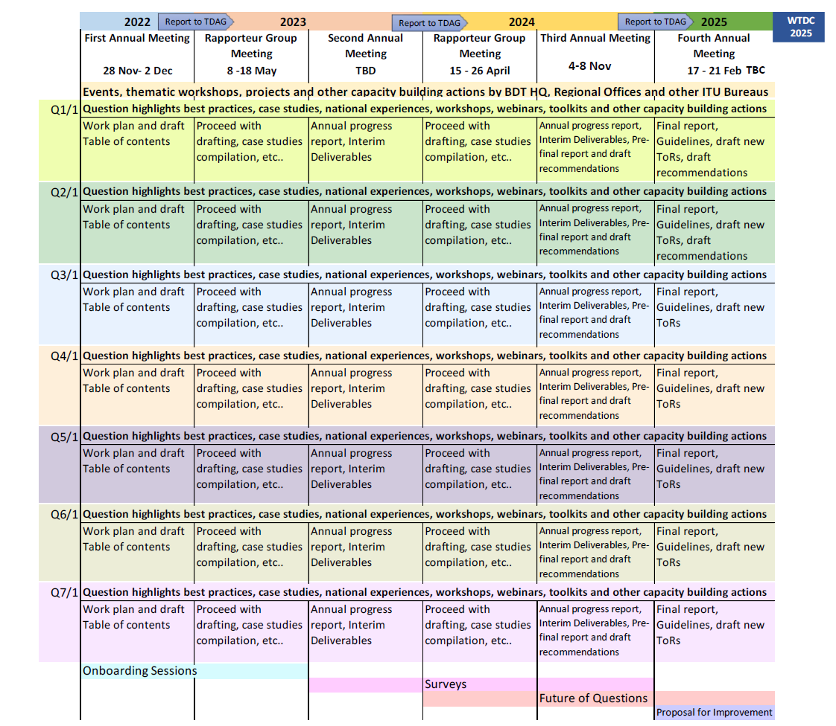

Annex 4: Contribution of ITU-D SG1 toward the implementation of WTDC Resolution 9 (Rev. Kigali, 2022)

________________

Meaningful connectivity is a level of connectivity that allows users to have a safe, satisfying, enriching and productive online experience at an affordable cost.
Member states delegates only
Includes 132 contributions for action and 16 incoming liaison statements. Excludes 6 temporary documents.
The WTDC-22 Final Report is available here.
https://www.itu.int/net4/ITU-D/CDS/sg/blkmeetings.asp?lg=1&sp=2022&blk=28245
https://www.itu.int/itu-d/sites/ra-network/
https://www.itu.int/hub/publication/d-stg-sg01-06-3-2023/
https://www.itu.int/md/D22-SG01-C-0260
https://www.itu.int/en/ITU-T/Workshops-and-Seminars/2023/1117/Pages/default.aspx
The contributions repository & dashboard for the previous study period (2018-2022) can be found here.
https://translate.itu.int/documents
See Document 1/ADM/1(Rev.3) for more information.

