Telecommunication Development  Advisory Group (TDAG)  30th Meeting, Geneva, Switzerland, 19-23 June 2023 | 
 | Document TDAG-23/33-E
 | 1 June 2023
 | Original: English
Hungary
Frequency management supporting system (STIR)
Summary:
STIR is a frequency management supporting IT system developed by the National Media- and Infocommunications Authority, Hungary (NMHH), which provides a user friendly access and software based management to the NFFF (Decree No. 7/2015 (XI. 13.) NMHH on the national frequency allocation and the rules of using frequency bands). NMHH stands ready to provide additional information and work together with countries that might find the system interesting and possibly being deployed at their end.
Action required:
TDAG is invited to endorse the proposal in this document.
References:
n/a

STIR is a frequency management supporting IT system developed by the National Media- and Infocommunications Authority, Hungary (NMHH), which provides a user friendly access and software based management to the NFFF (Decree No. 7/2015 (XI. 13.) NMHH on the national frequency allocation and the rules of using frequency bands).
The software widely supports the experts to create, edit, display, translate, search, select, generate, download or publish easily and effectively such a large and complex legal document as the NFFF, which contains about 600 pages with huge amount of data and quite complex tables (around 400 pages) with difficult relationships between them. The tool helps the experts to complete different analyses or compare data regarding the use of different frequency bands and corresponding technical data according to different criteria through processing the frequency management information available in the system. The tool is capable to receive from or send information to other systems such as EFIS (ECO Frequency Information System). The system used by the STIR is bilingual: Hungarian and English (both the data and the user interface).
All data in the STIR, which can be listed (such as radio services, applications, documents, footnotes, abbreviations, etc.) is called master data and the significant majority of the NFFF is generated from them.
The STIR consists of two subsystems: the Public STIR and the Private STIR which are two separate HTML-based interface.
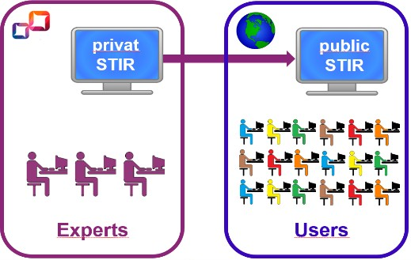
Public STIR is designed both for internal and external users all over the World. They can view the whole content of the Hungarian decree in force in electronic format, and they can use all IT tools built in such as display, search, selection, download, etc. of the allocation, applications, documents referred to and also other parts of the decree. Graphic NTFA (National Table of Frequency Allocations) is also available even in placard format which shows the whole Hungarian frequency allocation with colour codes and explanations. Access to the public stir is free for anybody (stir.nmhh.hu).
Private STIR is designed only for experts responsible for the maintenance of the content in the STIR. They regularly upload the currently endorsed NFFF in to the system and check the data accuracy as the NFFF is the official legal regulation on the Hungarian frequency management. Here the experts modify the additional information (such as definitions, explanatory fields, translation, etc.) to the NFFF data and also the master data if it is a need. The pairing of application terminology with NFFF terminology is also made by the dedicated frequency management experts which gives possibility to generate a special HTML file on Hungarian frequency management information and automatic upload it into the EFIS system.
Important to note that STIR was developed specifically to deal with Hungarian legal regulation, but all information and development experience is available on how to create a similar IT system dealing with legal regulation on the frequency management of other countries.
NMHH stands ready to provide additional information and work together with countries that might find the system interesting and possibly being deployed at their end.
________________

