Telecommunication Development  Advisory Group (TDAG)  30th Meeting, Geneva, Switzerland, 19-23 June 2023 | 
 | Revision 2 to
 | Document TDAG-23/15-E
 | 16 June 2023
 | Original: English
Director, Telecommunication Development Bureau
Outcomes of the World Telecommunication Development
Conference 2022 (WTDC-22)
Summary:
The 2022 ITU World Telecommunication Development Conference (WTDC-22) was convened in Kigali, Rwanda from 6 to 16 June 2022.
WTDC-22 produced several outputs, including the Kigali Action Plan (KAP) for the period 2023-2027, 28 Regional Initiatives applicable for the period 2023-2025, new Study Group Questions for the period 2022-2025, as well as four new resolutions.
Although the outputs were developed and agreed at the same time, the work cycle dates for each output is different.
In summary, the implications of the above outlined situation is:
- Study Group questions – for the period 2022 to 2025, work started immediately after WTDC-22 and continues until presentation of the report at WTDC-25.
- Regional Initiatives – for the period 2023 to 2025, work starts at the beginning of the year after WTDC-22, and continues until the end of the year after WTDC-25.
- New resolutions and amendments of existing resolutions take effect from the end of WTDC-22, and continue until they are amended or suppressed.
- Appointment of TDAG and Study Group leadership Chairmen and Vice-Chairmen takes effect from the time of appointment, until new appointments are made at WTDC-25.
The purpose of this report is to update TDAG on the outcomes of the WTDC-22, to note the work cycle established for WTDC-22 outputs, and seek any guidance from TDAG on the way forward.
Action required:
TDAG is invited to note this report and to consider and provide guidance on the work cycles for the Kigali Action Plan, Regional Initiatives and Study Group Questions established at WTDC-22.

References:
WTDC-22, Final Report

1. Introduction
1.1 The eighth World Telecommunication Development Conference (WTDC-22) of the International Telecommunication Union (ITU), held from 6 to 16 June 2022 in Kigali, Rwanda, was a landmark event aimed at bringing affordable, meaningful connectivity to the estimated 2.7 billion people around the world who still lack an Internet connection.
1.2 Convened under the theme: Connecting the unconnected to achieve sustainable development, WTDC-22 was attended by 2 152 participants (1 304 in-person and 848 joining online). Participants were from 150 Member States (with 127 countries on site and 23 joining remotely), 96 Sector Members of the ITU Telecommunication Development Sector (ITU-D), 37 Academia, and observers under Resolution 99 of the Plenipotentiary Conference and the United Nations and its specialized agencies.
1.3 WTDC-22 produced the following key outputs:
- The Kigali Declaration, which highlights the main conclusions and priorities established by the conference and reinforces the political support for the ITU development mission and strategic goals.
- The Kigali Action Plan, a comprehensive package that will promote the equitable and sustainable development of telecommunication/ICT networks and services for the period from 2023 - 2027.
- Regional Initiatives for Africa, the Americas, the Arab States, Asia and the Pacific, the Commonwealth of Independent States (CIS) and Europe. Regional initiatives are intended to identify principal telecommunication/ICT priority areas of concern to a region, which are then addressed through partnerships and resource mobilization to implement projects that are part of the ITU-D action plan.
- 4 new resolutions, and 40 revised resolutions.
- New and revised ITU-D study Questions to be studied during the period 2022-2025.
- WTDC-22 appointed the Bureau of the Telecommunication Development Advisory Group (TDAG), comprising the Chairman and Vice-Chairmen of TDAG and the Chairmen of ITU-D Study Groups for the period 2022-2025.
- WTDC-22 appointed management teams of ITU-D Study Groups, comprising the Chairman and Vice-Chairmen of each Study Group.
2. Analysis of Outcomes
2.1 The timelines for the various activities approved by WTDC-22, are impacted by the need for ITU-D outputs to be aligned with the work cycle for the sector, and to align as necessary with the ITU Strategic Planning process.
Kigali Action Plan 2023 - 2027: Strategic Plan alignment ensures that ITU-D objectives and priorities align with the overall ITU Strategic objectives thereby furthering the achievement of ITU’s mandate, and that the necessary financial and other resources needed for implementation are allocated within the appropriate period. For this reason, the KAP, approved at WTDC-22, was developed for the period 2023-2027 so that its ending would be aligned with the ITU Strategic Plan approved at PP-22 (i.e. the ITU Strategic Plan 2024-2027). Future WTDC outputs should align fully with the corresponding ITU strategic plans.
Regional Initiatives: While Regional Initiatives set priorities for each region within the mandate of ITU, they are not specifically dependent on ITU or ITU-D priorities for a specific planning period. Further, direct efforts toward Regional Initiatives are funded by multi-year projects and/or extrabudgetary funding, and therefore are less dependent on the ITU Financial Plan for a specific period. Accordingly, Regional Initiatives take effect immediately from the year following the WTDC until the end of the next WTDC year, in this case, the Regional Initiatives set at WTDC-22, will be for the period 2023 – 2025.
Study Questions: In accordance with WTDC Resolution 2 (Rev. Kigali 2022), the ITU Study cycle runs from WTDC when the questions are approved, to the subsequent WTDC when the revised set of Questions, scope and titles of the study Groups are discussed and approved. Accordingly, WTDC-22 approved Study Questions for the period 2022–2025 and appointed Study Group chairmen and vice-chairmen for the same period.
Resolutions: Resolutions, decisions and appointments take effect as soon as they are decided, or in accordance with any specific stated terms. The resolutions are mainstreamed into the work of ITU-D through the Operational Plan and Project implementation.
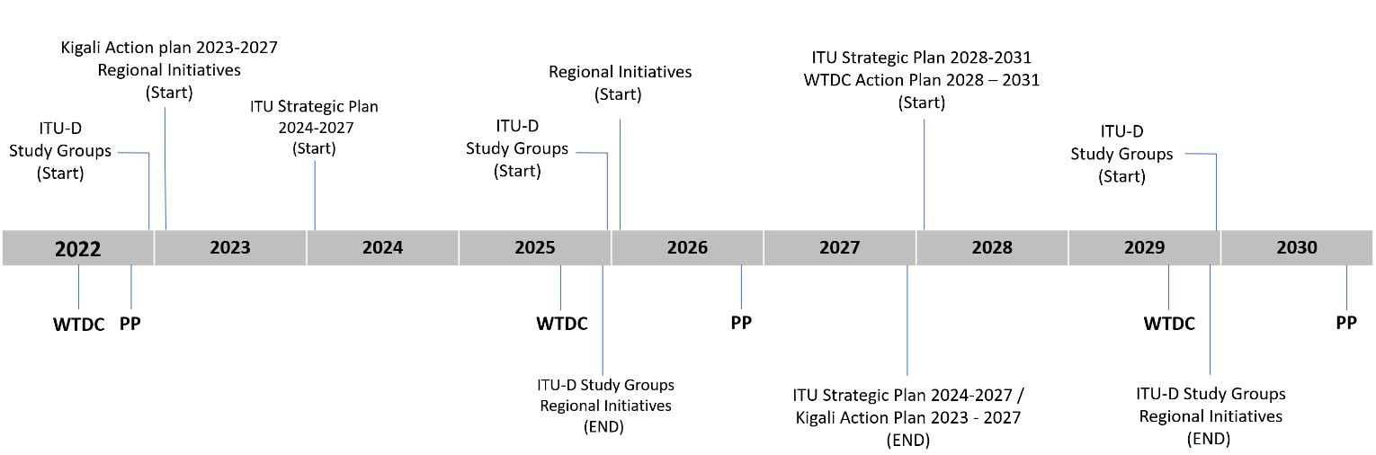
3. The Kigali Action Plan (KAP)
3.1 The KAP follows an RBM framework based on the ITU-D priorities identified as key work areas that will support the achievement of the ITU strategic plan for 2024-2027. Figure 1 shows the structure of the KAP and its contribution to the ITU strategic plan.
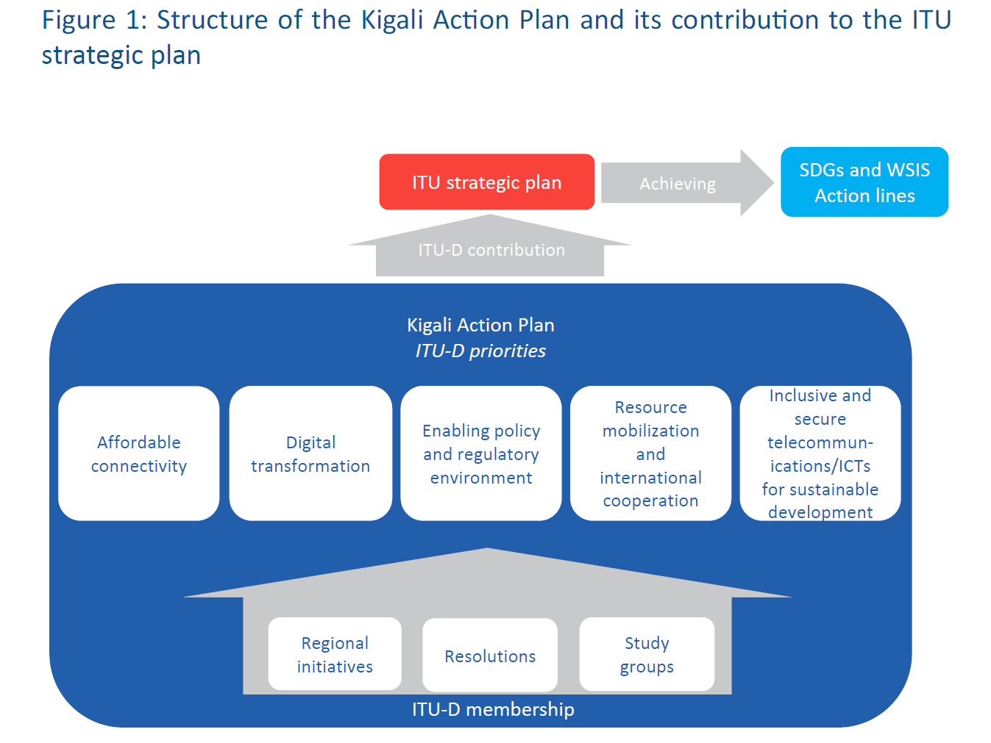
3.2 The KAP is made up of ITU-D Priorities, delivered through a range of key offerings (products and services) and enablers. In order to ensure coherence with ITU’s mandate and other key processes and initiatives, these are clearly linked to specific ITU resolutions, WSIS action lines and SDGs.
3.3 ITU-D Priorities
The five priorities for the Development Sector are as follows:
Affordable connectivity
The focus of this priority is on the use of modern, available, secure, accessible and affordable connectivity through deployment of telecommunication/ICT infrastructure and services for bridging the digital divides.
Digital transformation
The focus of this priority is on (1) the development and use of telecommunications/ICTs, as well as applications and services, to close the digital divide and empower people and societies for sustainable development; (2) support to the ITU-D membership in fostering digital transformation through ICT entrepreneurship and increased ICT innovation in the ICT ecosystem, while encouraging the empowerment of grassroots stakeholders and creating new opportunities for them in the telecommunication/ICT sector.
Enabling policy and regulatory environment
The focus of this priority is on fostering an enabling policy and regulatory environment conducive to sustainable telecommunication/ICT development that encourages investment in infrastructure and ICTs and increased adoption of telecommunications/ICTs.
Resource mobilization and international cooperation
The focus of this priority is on mobilizing and attracting resources and fostering international cooperation on telecommunication/ICT development issues. This priority is also cross-cutting, providing resources and fostering international cooperation to deliver relevant global outcomes.
Inclusive and secure telecommunications/ICTs for sustainable development
The focus of this priority is on providing support for Member States to achieve secure telecommunications/ICTs for digital development for all.
3.4 Products and Services
To achieve the outcomes under the thematic priorities, ITU-D deploys a range of products and services for its members, United Nations agencies and other stakeholders. The KAP provides a list of these products and services but that list is not exhaustive, and additional products and services may be developed for each outcome and KPI in order to ensure the priority has the corresponding action framework. The products and services fall within the following broad categories:
- Development of policy frameworks and knowledge products
- Provision of data and statistics
- Capacity development
- Provision of technical assistance
- Convening Platforms
3.5 Enablers
ITU-D will deliver the action plan through several “enablers” defined in the KAP. Enablers are the ways of working that allow BDT to deliver on its goals and priorities more effectively and efficiently. They reflect ITU's values of efficiency, transparency and accountability, openness, universality and neutrality, and being people-centred, service-oriented and results-based, and leverage its key strengths and address its weaknesses so that it can support its membership. The enablers defined in the KAP are as follows:
- Membership-driven
- Regional presence
- Diversity and inclusion
- Commitment to environmental sustainability
- Partnerships and international cooperation
- Resource mobilization
- Excellence in human resources and organizational innovation
3.6 Linkages
An important objective of the KAP is to ensure that the ITU-D continues to deliver on its contribution to the ITU Strategic Plan, the UN Sustainable Development Goals, WSIS action lines, as well as the applicable ITU resolutions, Regional Initiatives and ITU-D Study Questions. Accordingly, the action plan while being organized along the ITU-D priorities, provides information on, and ensures linkages between, the corresponding product and service offerings, enablers, key outputs, expected results and KPIs.
The linkages between these elements are displayed in Figure 2 below.
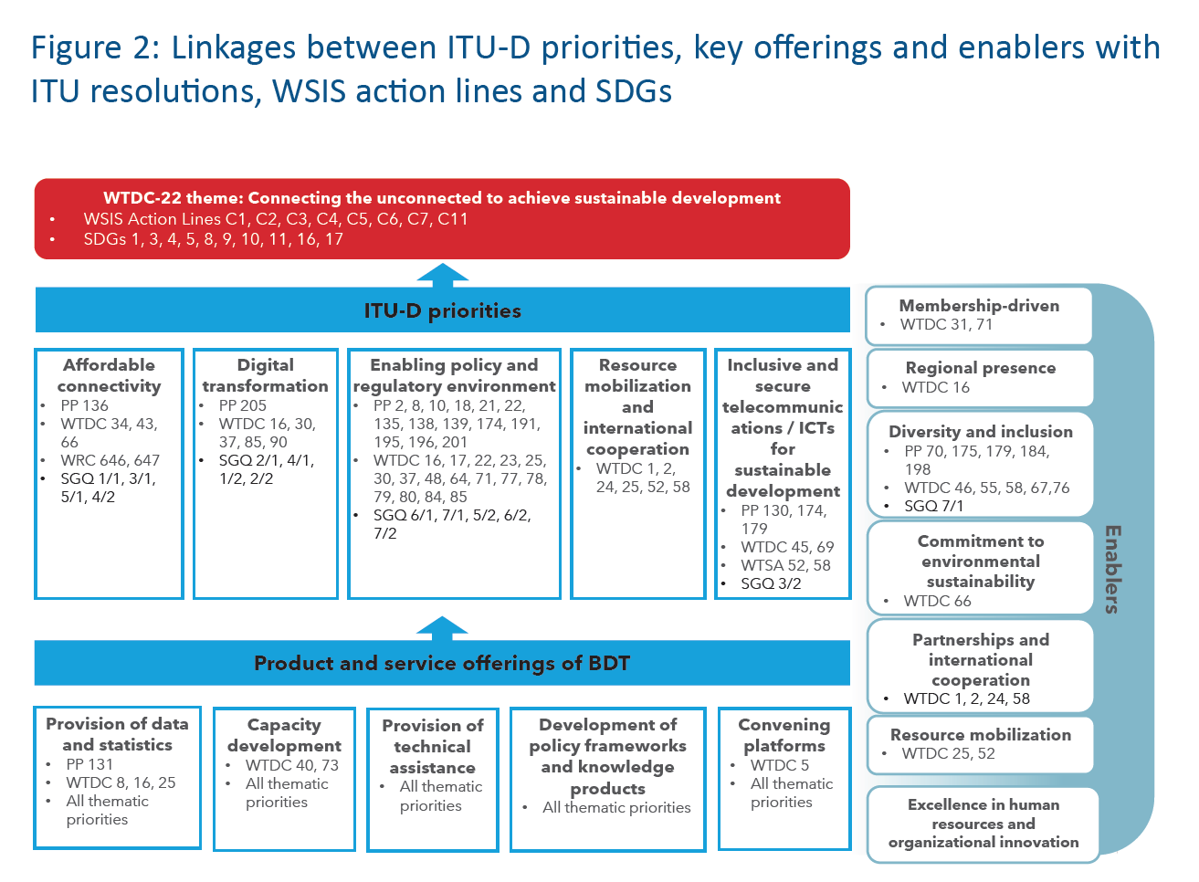
4. Regional Initiatives
The work of ITU-D is coordinated across six regions which organise ITU-D’s membership in Africa, the Americas, the Arab States, Asia and the Pacific, CIS and Europe. During the preparatory process for WTDC-22, each region develops specific initiatives for ITU-D within the region, and WTDC-22 endorses those priorities as Regional Initiatives which are a key deliverable for the ITU-D sector during the coming period.
WTDC-22 endorsed a total of 28 Regional Initiatives, across the six regions, as follows:
Africa Region
- AFR1: Supporting digital transformation to usher in a rapid transition to a digital economy while accelerating innovation in Africa
- AFR2: Implementation and expansion of broadband infrastructures, connectivity and emerging technologies
- AFR3: Building trust, safety and security in the use of telecommunications/information and communication technologies and protection of personal data
- AFR4: Fostering emerging technologies and innovation ecosystems
Americas Region
- AMS1: Deployment of modern, resilient, secure and sustainable telecommunication/information and communication technology infrastructure
- AMS2: Enhancement and expansion of digital-literacy, digital-skills and digital-inclusion programmes, especially among vulnerable populations
- AMS3: Effective support for digital transformation and innovation ecosystems through scalable, funded and sustainable connectivity projects
- AMS4: Development of enabling policy and regulatory environments to connect the unconnected through accessible and affordable telecommunications/information and communication technologies that support achievement of the Sustainable Development Goals and progress towards the digital economy
Arab States Region
- ARB1: Sustainable digital economy through digital transformation
- ARB2: Enhancing confidence, security and privacy in the use of telecommunications/information and communication technologies in the era of new and emerging digital technologies
- ARB3: Developing digital infrastructure for smart sustainable cities and communities
- ARB4: Building capacities and encouraging digital innovation, entrepreneurship and future foresight
- ARB5: Developing means of digital regulation
Asia and the Pacific Region
- ASP1: Addressing special needs of least developed countries, small island developing states, including Pacific island countries, and landlocked developing countries
- ASP2: Harnessing information and communication technologies to support the digital economy and inclusive digital societies
- ASP3: Fostering development of infrastructure to enhance digital connectivity and connecting the unconnected
- ASP4: Enabling policy and regulatory environments to accelerate digital transformation
- ASP5: Contributing to a secure and resilient information and communication technology environment
CIS Region
- CIS1: Developing infrastructure to promote innovation and partnerships in the introduction of new technologies – the Internet of Things, including the industrial Internet, smart cities and communities, 5G/IMT-2020 and next-generation NET-2030 communication networks, quantum technologies, artificial intelligence, digital health, digital skills and environmental protection
- CIS2: Cybersecurity and personal data protection
- CIS3: Creating an enabling legal and regulatory environment to accelerate digital transformation
- СIS4: Digital skills and information and communication technology accessibility for the public, in particular for persons with disabilities
- CIS5: Development of smart cities and communities
Europe Region
- EUR1: Digital infrastructure development
- EUR2: Digital transformation for resilience
- EUR3: Digital inclusion and skills development
- EUR4: Trust and confidence in the use of telecommunications/information and communication technologies
- EUR5: Digital innovation ecosystems
The RI’s provide further specificity for the high-level priorities of ITU-D, within the context of ITU’s overall Strategic Priorities. Detailed descriptions of the expected outcomes to be achieved under each RI were defined by the regions and endorsed by WTDC-22, and these provide a further layer of focus for ITU-D’s work in the applicable region.
5. ITU-D Study Group Questions
WTDC-22 revised existing ITU-D Study Questions, and developed a new question, resulting in a total of fourteen (14) Study Questions for the period 2022-2025. Study Group 1 Questions fall under the scope of ''enabling environment for meaningful connectivity'', while those of Study Group 2 fall under “digital transformation”, as set out in the tables below.
Study Group 1
New number | Title | Origin
Q1/1 | Strategies and policies for the deployment of broadband in developing countries | Continuation of Question 1/1 with additional new topics
Q2/1 | Strategies, policies, regulations and methods of migration to and adoption of digital technologies for broadcasting, including to provide new services for various environments | Continuation of Question 2/1 under a revised title and updated topics
Q3/1* | The use of telecommunications/ICTs for disaster risk reduction and management | Formerly Question 5/2 of Study Group 2 continued with updated topics
Q4/1 | Economic aspects of national telecommunications/ICTs | Continuation of Question 4/1 under a shortened title with updated topics
Q5/1 | Telecommunications/ICTs for rural and remote areas | Continuation of Question 5/1 under a shortened title with updated topics
Q6/1 | Consumer information, protection and rights | Continuation of Question 6/1 under a shortened title with updated topics
Q7/1 | Telecommunication/ICT accessibility to enable inclusive communication, especially for persons with disabilities | Continuation of Question 7/1 under a revised title with updated topics
Study Group 2
New number | Title | Origin
Q1/2 | Smart sustainable cities and communities | Continuation of Question 1/2 under a shortened title with updated topics
Q2/2 | Enabling technologies for e-services and applications, including e-health and e-education | Continuation of Question 2/2 expanded to cover more topics
Q3/2 | Securing information and communication networks: Best practices for developing a culture of cybersecurity | Continuation of Question 3/2with updated topics
Q4/2 | Telecommunication/ICT equipment: Conformance and interoperability, combating counterfeiting and theft of mobile devices | Continuation of Question 4/2 under a shortened title with updated topics
Q5/2* | Adoption of telecommunications/ICTs and improving digital skills | New Question
Q6/2 | ICTs for the environment | Continuation of Question 6/2 under a shortened title with updated topics
Q7/2 | Strategies and policies concerning human exposure to electromagnetic fields | Continuation of Question
6. WTDC-22 Resolutions
WTDC-22 revised 40 existing WTDC resolutions ensuring that the focus of ITU-D continued to reflect the needs of ITU membership. The Conference also produced four (4) new resolutions, on the following topics:
- Resolution 87 (Kigali, 2022): Connecting every school to the Internet and every young person to information and communication technology services aims to ensure that every school is connected to the Internet through the joint ITU-UNICEF Giga initiative.
- Resolution 88 (Kigali, 2022): The ITU Partner2Connect Digital Coalition formalizes the Partner2Connect Digital Coalition as the primary platform to foster new partnerships around meaningful connectivity and digital transformation globally, focusing on, but not limited to, the hardest-to-connect communities.
- Resolution 89 (Kigali, 2022): Digital transformation for sustainable development aims to drive efforts to advance digital transformation for sustainable development, recognizing the enormous potential that ICTs have to create positive, meaningful and lasting change. The Directors of the Radiocommunication Bureau, the Telecommunication Standardization Bureau and the Telecommunication Development Bureau are invited to collaborate actively to fulfil the needs addressed by this resolution in areas of mutual interest related to digital-transformation technologies, within the framework of the ''One ITU'' approach and enhancing coordination among the three Sectors.
- Resolution 90 (Kigali, 2022): Fostering telecommunication/ICT-centric entrepreneurship and digital innovation ecosystems for sustainable digital development seeks to create a thriving environment for entrepreneurship and digital innovation ecosystems to help accelerate the achievement of the United Nations Sustainable Development Goals.
7. Telecommunication Development Advisory Group (TDAG)
The TDAG bureau comprises the chairman and the vice-chairmen of TDAG, as well as the chairmen of ITU-D study groups. WTDC-22 appointed the TDAG chairman and vice-chairmen, as follows:
Chairman: Ms Roxanne McElvane Webber (United States)
Vice-chairmen:
Ms Regina Fleur Assoumou Bessou (Chairman, Study Group 1)
Mr Fadel Digham (Chairman, Study Group 2)
Mr Christopher Kemei (Kenya)
Mr Abdulkarim Oloyede (Nigeria)
Ms Agustina Brizio (Argentina)
Ms Andrea Mamprim Grippa (Brazil)
Mr Ahmed Abdel Aziz Gad (Egypt)
Ms Shahad Albalawi (Saudi Arabia)
Ms Ke Wang (China)
Mr Ahmad R. Sharafat (Islamic Republic of Iran)
Mr Orozobek Zhazybaevich Kayikov (Kyrgyzstan)
Ms Inga Rimkevičienė (Lithuania)
Ms Blanca González (Spain)
8. ITU-D Study Groups
WTDC-22 appointed the chairmen and vice-chairmen to the management teams of ITU-D Study Group 1 and Study Group 2. The management teams also include rapporteurs and vice-rapporteurs, and BDT focal points for each study question, to ensure that the work is effectively directed, conducted and reported during the study period. They are appointed after WTDC.
Study Group 1
Chairman: Ms Regina Fleur Assoumou Bessou (Côte d'Ivoire)
Vice-Chairmen:
Mr Sangwon Ko (Republic of Korea)
Ms Memiko Otsuki (Japan)
Mr Sunil Singhal (India)
Ms Caecilia Nyamutswa (Zimbabwe)
Mr Amah Vinyo Capo (Togo)
Mr Roberto Mitsuake Hirayama (Brazil)
Mr Mehmet Alper Tekin (Türkiye)
Mr Anthony Giannoumis (Norway)
Ms Umida Musaeva (Uzbekistan)
Mr Khayala Pashazade (Azerbaijan)
Ms Sameera Belal Momen Mohammad (Kuwait)
Study Group 2
Chairman: Mr Fadel Digham (Egypt)
Vice-Chairmen:
Mr Hideo Imanaka (Japan)
Ms Mina Seonmin Jun (Republic of Korea)
Mr Tongning Wu (China)
Ms Zainab Ardo (Nigeria)
Mr Mohamed Lamine Minthe (Guinea)
Mr Víctor Antonio Martínez Sánchez (Paraguay)
Mr Dominique Würges (France)
Ms Alina Modan (Romania)
Mr Diyor Rajabov (Uzbekistan)
Mr Mushfig Guluyev (Azerbaijan)
Mr Abdelaziz Alzarooni (United Arab Emirates)
_______________

