Telecommunication Development  Advisory Group (TDAG)  30th Meeting, Geneva, Switzerland, 19-23 June 2023 | 
 | Annex 1 to
 | Document TDAG-23/2(Add.2)-E
 | 22 May 2023
 | Original: English
Director, Telecommunication Development Bureau
Moving towards a “BDT4IMPACT” –
Report from the BDT Senior Management Retreat 2023
Summary:
The document contains the report from the Senior Management Retreat of the ITU Telecommunication Development Bureau (BDT) held at the Geneva Hilton Hotel on 7-9 February 2023. The retreat led by the Director, Dr Cosmas Luckyson Zavazava, served as a platform to align the operational strategy for the work of the Bureau over the current implementation cycle 2023-2026 to the outcomes and guidance of the 2022 World Telecommunication Development Conference (WTDC-22) in Kigali and the 2022 ITU Plenipotentiary Conference (PP-22) in Bucharest. One of the outcomes of the retreat was the ITU-D Operational Plan 2023.
Action required:
TDAG is invited to note this document.
References:
Document 2, TDAG-23
WTDC-22 Kigali Action Plan

Introduction
The Senior Management Retreat of the ITU Telecommunication Development Bureau (BDT) led by the Director, Dr Cosmas Luckyson Zavazava, was held at the Geneva Hilton Hotel on 7-9 February 2023, following the 2022 World Telecommunication Development Conference (WTDC-22) in Kigali and the 2022 ITU Plenipotentiary Conference (PP-22) in Bucharest. The retreat provided an opportunity for the new leadership to steer a constructive discussion on future plans and implementation challenges, and align the BDT team with the Kigali Action Plan drawn by ITU-D Members to foster meaningful universal connectivity and sustainable digital transformation around the world in the period 2022-2025.
The retreat brought together BDT senior management (P5 level and above) from ITU area and regional offices and Headquarters. ITU Elected Officials (the Secretary-General, the Deputy Secretary-General, the Director, Radiocommunication Bureau and the Director, Telecommunication Standardization Bureau) had the opportunity to address the retreat and present their visions for collaborative work with BDT. Key focal points from the finance, human resources, procurement and legal departments joined the dedicated thematic sessions to share their insights, exchange ideas with BDT senior management and engage in reinforced collaboration with BDT.

The introductory sessions of the retreat were designed around the themes of team building, leadership and work-life balance. The main sessions focused on creating a forward-looking, development-oriented and outcome-led 2023 BDT Operational plan fit to deliver impactful results and fully coherent with BDT project implementation. The retreat also tackled innovation, communication and operational excellence as foundations of ‘BDT for Impact’ (BDT4Impact).

Towards a ‘BDT for Impact’
BDT senior management is committed to creating a ‘BDT for Impact’ (BDT4Impact) and in order to succeed, all staff must be equipped with the skills, insights and tools to effectively lead, manage, and coordinate the delivery of quality services, products and projects. The retreat allowed refining operational strategies and working methods across teams and emphasized the importance of internal and external collaboration to ensure that BDT delivers results improving the lives of people through digital development.

Director’s Vision
During the first BDT Townhall meeting held on 25 January 2023, the BDT Director shared with all staff his vision of BDT4Impact: a BDT that delivers on its mandate and positively impacts people's lives through digital development. This vision and its pillars are illustrated in Figure 1 below.
Figure 1: BDT4Impact
Vision of BDT4Impact  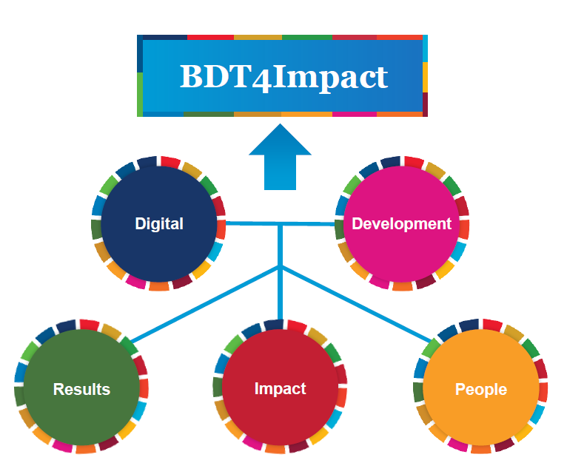 | Pillars of BDT4Impact  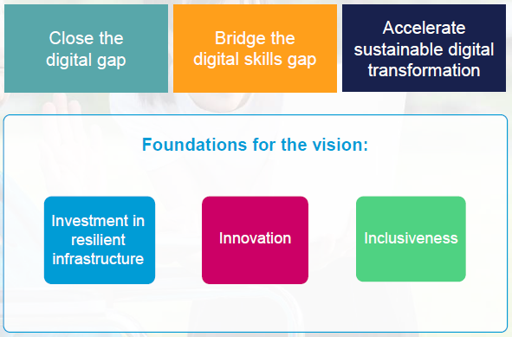

Leadership
Leadership development is a critical priority for BDT. Positive leadership is a fundamental part of BDT Director’s strategy ‘Leading for Impact’ towards fulfilling the Bureau’s mandate (see Figure 2).
During the leadership session led by a professional life coach, senior management was reminded of the importance of leadership behaviors which role-model organizational values. The session informed about modern leadership practices and lessons learnt from other organizations. Discussions allowed aligning participants’ understanding of key principles of leadership and identified critical skills needed to achieve impact.
BDT management committed to nurturing high-quality leadership at all levels, champion positive change in BDT and deliver results to improve people’s lives through digital development. The leadership session thus set the ground for the following discussions on strategic planning and implementation.
Figure 2: Leadership skills
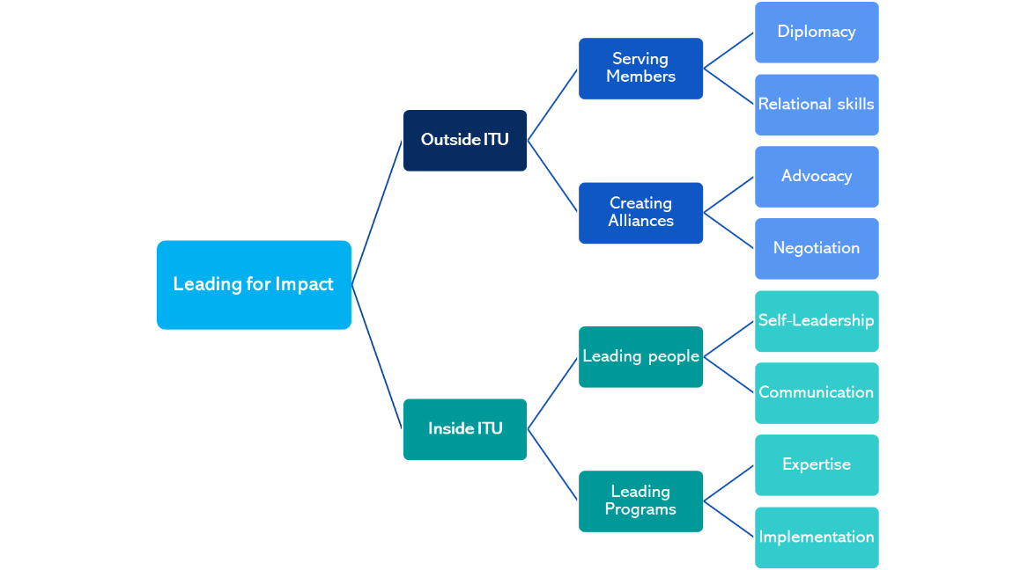

Operational Plan 2023 (OP-23)
The overall strategy for OP-23 is built around the coherence, integration and efficiencies of individual actions along with their strong link to the Kigali Action Plan, ITU-D Resolutions as well as to the ITU Strategic Goals (see Figure 3). Collaboration across ITU-D Priorities and regions is key to enhancing the efficiency of BDT products and services and their impact to beneficiary countries, government agencies, national stakeholders and communities.
A set of interactive panel discussions allowed to refine, streamline and harmonize OP-23 proposals to maximize synergies between global and regional actions and ultimately, BDT’s impact on the ground. In addition, a detailed review was carried out by the retreat participants to analyze activities and their rationale, membership focus and delivery mechanisms. The review was geared towards avoiding fragmentation of efforts, pooling resources, bridging silos and allowing for better monitoring and evaluation of activities.
Figure 3: Fusion of BDT Impact Vision with Kigali Action Plan
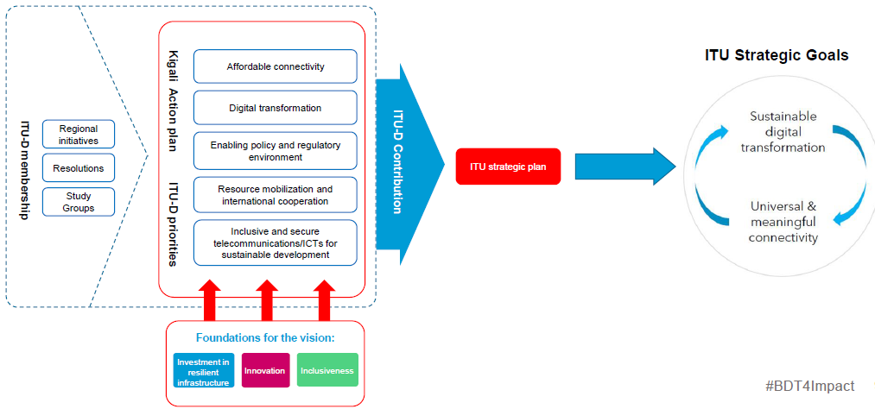
A set of framing questions led the collective reflection on OP-23 proposals to ensure that they are robust enough to succeed and make the best use of BDT’s resources:
- Can proposed actions be covered by projects (rather than OP)?
- Could costs of Short-Term Staff supporting ITU-D Priorities and Enablers be covered by non-OP sources, such as staff on loan or by partners?
- Can BDT staff carry out some actions internally rather than by external experts (SSAs)?
- Could individual regional efforts be packaged as multi-region efforts?
- Could an existing global activity deliver similar value at a more efficient cost?
- Is this the highest-value impact for the estimated cost?
Discussions also focused on the proportionate use of strategic options for delivering on BDT’s mandate, from building internal expertise in key new areas (including in regional and areas offices) and synergizing with other ITU Bureaus to tapping into external expertise on demand. Another important vehicle of the implementation of the Kigali Action Plan remains engaging with UN and other partners, including through using OP as seed funds for projects and partnership activities.
The OP-23 discussions also allowed identifying concrete actions towards improving BDT tools, processes and practices to ensure smooth and timely delivery of BDT activities.

Project Implementation
BDT has, in recent years, mobilized a large volume of resources to support project implementation in countries. The rate of expenditure, however, does not always match available project funds, resulting in low levels of cost recovery from projects (measured in AOS amounts) and the accumulation of unspent funds (Figure 4).
During the dedicated session, BDT senior management brainstormed on ways to accelerate project implementation, overcome challenges and identify possible solutions to maximize the impact of BDT-led projects. The discussions identified recurring challenges in key areas such as recruitment, budget tracking and procurement as well as internal processes and activity planning.
BDT participants and representatives from the General Secretariat support departments relevant to project implementation (in particular, human resources, finance, procurement and legal) discussed possible solutions to accelerate the rolling out of project activities, thus maximizing the impact of BDT projects and raising the profile of the Union as a successful digital transformation implementation partner. The discussions allowed identifying a set of concrete improvements to projects support services – either new ways of working with internal stakeholders or practical arrangements under the existing rules – to remedy the current situation and keep project implementation on track while maintaining the reputation of ITU and ensuring BDT future ability to raise funds. Some of the identified improvements are:
- Improving the planning of project-related activities
- Clarifying roles and ensuring appropriate Delegation of Authority at all levels
- Widening the options for project support services such as recruitment and procurement by leveraging UN system offer (e.g., outsourcing to UN service centers, UN-to-UN agreements, and Service Level Agreements)
- Fully automating internal processes (e.g., donor reports) and connecting internal IT systems (e.g., of human resources, finance and procurement) to ensure accurate real-time information and tracking of requests
- Regularly revising internal rules and regulations based on experience and feedback from implementation players (e.g., with regards to procurement, recruitment modalities and timelines)
- Improving internal communication
- Reinforcing project management practices and culture in BDT
BDT management also identified some guiding principles for improving the coherence of BDT project delivery and OP-23, and strengthening project design and implementation to ensure meaningful, timely and efficient results.
Figure 4: Resources signed in projects signed vs funds disbursed (USD)

Innovation
BDT leadership recognizes the critical role of innovation in accelerating digital development and making digital transformation more sustainable and inclusive. The retreat provided the opportunity to brainstorm on a strategy to enhance BDT delivery in core areas through the newly launched Innovation and Entrepreneurship Alliance for Digital Development. The Alliance offers a new framework as an enabler to bridge the digital innovation gap (see Figure 5). It aims to fast-track five strategic objectives and accelerate the journey towards an innovation-driven digital economy:
- trends research readiness
- open technology innovation
- entrepreneurship and SMEs growth
- policy experimentation and
- unlocking the potential of digital ecosystems initiatives.
Through partnerships with governments, private sector, United Nations Agencies and academia, the Alliance will build local innovation and entrepreneurship capabilities.
The Alliance will enable transformational projects fostering digital innovation and entrepreneurship for national, regional and global impact.
Figure 5: Main vehicles of the Innovation and Entrepreneurship Alliance for Digital Development
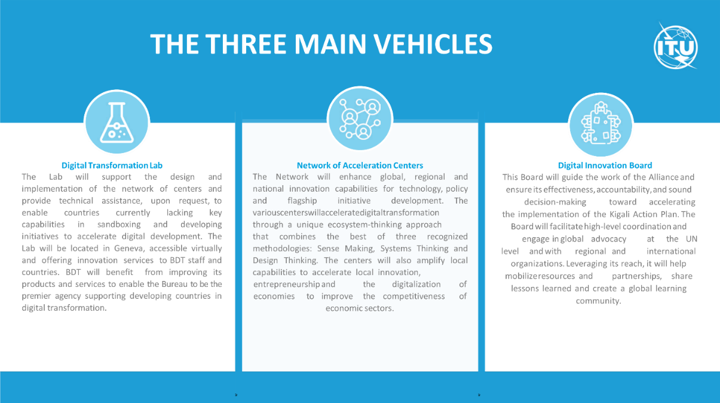

Communications
Communication is a strategic activity supporting BDT’s work across Priorities and Enablers. A new ‘Communication4Impact’ strategy has been introduced in 2023 (see Figure 6) to raise the visibility of BDT delivery. During the dedicated session, BDT senior management created stories based on existing projects and activities to showcase the impact of BDT’s work. The group identified engagement mechanisms of both internal and external stakeholders as well as concrete tactics for informing ITU membership and engaging external audiences.
The BDT Communications team will work with BDT staff to promote those stories through various communications channels over the coming year.
Figure 6: BDT Communication for Impact
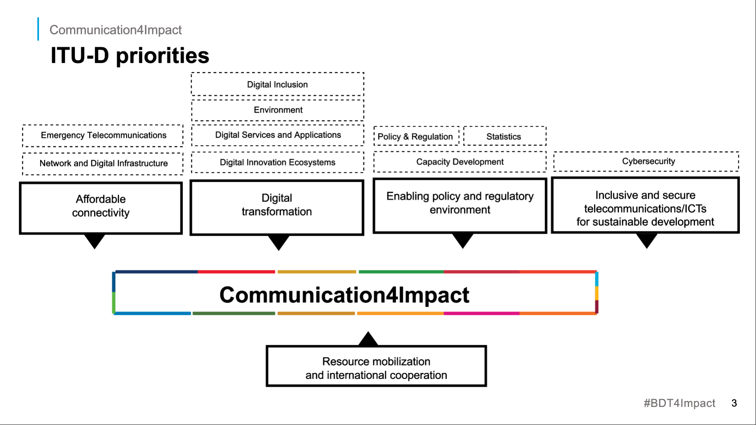

BDT Culture

Work-life Balance
The BDT Director is committed to building a supportive work culture driven by the holistic well-being of staff. A dedicated session led by a professional life coach provided academic insights and practical tips to finding work-life balance to improve staff productivity at work while stimulating a fulfilling life outside of work. Participants discussed effective ways to achieve a sustainable work-life balance in their respective teams and maintain a thriving workplace in BDT. Setting clear boundaries and creating a strong social support network at work can help staff to balance their many duties successfully.

Team Building
Interactive team building activities were carried on each day of the retreat underpinned by lessons on issues of relevance to BDT, including the foundational values of the United Nations, ITU Thematic Priorities, problem solving and project management. The activities contributed to reinforcing the BDT team spirit and human relationships.

Get-together with the ITU Elected Officials
ITU Elected Officials paid a visit to the BDT retreat to share their priorities for the new cycle and discuss with BDT senior management key issues of relevance for all Sectors, such as:
- The financial stability of the Union
- Organizational and operational excellence
- ITU thought leadership, especially in universal meaningful connectivity, digital infrastructures, cybersecurity and space issues
- The OneITU concept and strengthening of collaboration between BDT and the other sectors, especially in the area of radio spectrum, space communications, Artificial Intelligence, and more generally in capacity building initiatives and assistance to ITU membership
- Partnerships and collaboration with the UN system, such as with the Resident Coordinators system in the regions and
- Industry engagement in the work of the Union.

Preparing for the transition to the new HQ building
Noting the progress on the preparations for the transition period to the new ITU Headquarters building, BDT senior management received guidance on workspace arrangements for focused work and meetings, flexible working methods and the foreseen schedule of internal reallocation.

Next steps
The retreat offered an opportunity for BDT senior management to discuss strategic and operational priorities in accordance with the Kigali Action Plan and the ‘BDT4Impact’ vision.
BDT senior management will continue efforts towards:
- Implementing the Kigali Action Plan and the BDT4Impact vision to improve the lives of people everywhere through digital development;
- Supporting staff work- life balance while maintaining a thriving, highly-efficient and inclusive BDT workplace;
- Nurturing a culture of result-oriented leadership at all levels;
- Creating a harmonious and member-driven operational plan with impactful results;
- Increasing the coherence in the implementation of ITU projects, the BDT Operational Plan activities, regional initiatives and WTDC Resolutions.
_______________

