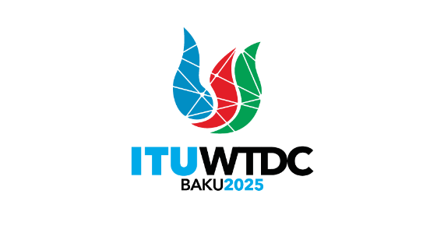 | TDAG Working Group on Streamlining Resolutions (TDAG-WG-StreamRes)  5th Meeting, Virtual, 26 March 2025 |  | 
 |  | Document TDAG-WG-SR/20(Rev.1)-E
 |  | 21 March 2025
 |  | English only
Chair, TDAG-WG-SR
Draft agenda

 | Items | Documents
 | Approval of the agenda | TDAG-WG-SR/20(Rev.1)
 | Contributions submitted to TDAG-WG-SR | TDAG-WG-SR/22 (Future Meetings)  TDAG-WG-SR/21 (Proposed Amendment of WTDC Resolution 20 - Contribution from Ghana)  Contributions from the Russian Federation:  TDAG-WG-SR/23 (Draft New Resolution Promoting the development and implementation of metaverse)  TDAG-WG-SR/24 (Draft Resolution 11 (Rev. Kigali, 2022) - Telecommunication/information and communication technology services in rural, isolated and poorly served areas)  TDAG-WG-SR/25 (Draft Resolution 24 (Rev. Kigali, 2022) - Authorization for the Telecommunication Development Advisory Group to act between World Telecommunication Development Conferences)  TDAG-WG-SR/26 (Draft Resolution 58 (Rev. Kigali, 2022) - Telecommunication/information and communication technology accessibility for persons with disabilities and persons with specific needs)  TDAG-WG-SR/27 (Draft Resolution 1 (Rev. Kigali, 2022) - Rules of procedure of the ITU Telecommunication Development Sector)  TDAG-WG-SR/28 (Draft Resolution 31 (Rev. Kigali, 2022) - Regional preparations for world telecommunication development conferences)  TDAG-WG-SR/29 (Draft Resolution 59 (Rev. Kigali, 2022) - Strengthening coordination and cooperation among the three ITU Sectors on matters of mutual interest)
 | Any other business

________________

