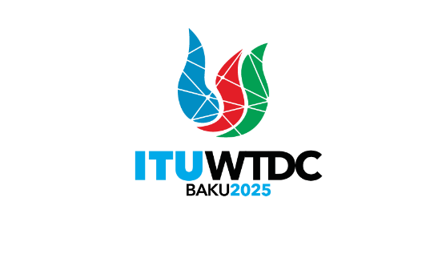 | TDAG Working Group on the future of Study Group Questions (TDAG-WG-futureSGQ)  7th Meeting, 13 & 15 May 2025 |  | 
 |  | Document TDAG-WG-futureSGQ/42(Rev.2)-E
 |  | 13 May 2025
 |  | English only
Chair, TDAG-WG-futureSGQ
Draft agenda

 | Items | Documents
 | Approval of the agenda | TDAG-WG-futureSGQ/42(Rev.2)
 | Review of the report of the fourth meeting held on 21 January 2025 | TDAG-WG-futureSGQ/41
 | Contributions submitted to TDAG-WG-futureSGQ | TDAG-WG-futureSGQ/44 (contribution Portugal)  TDAG-WG-futureSGQ/45 (contribution from APT)  TDAG-WG-futureSGQ/46 (contribution from League of Arab States)  TDAG-WG-futureSGQ/47 (vice-Chair, Study Group 1)  TDAG-WG-futureSGQ/48 (vice-Chair, Study Group 2)  TDAG-WG-futureSGQ/49 (contribution, ATU)  TDAG-WG-futureSGQ/43 (revised draft proposal of the deliverable of TDAG-WG-futureSGQ by the Chair)
 | Any other business
_______________

