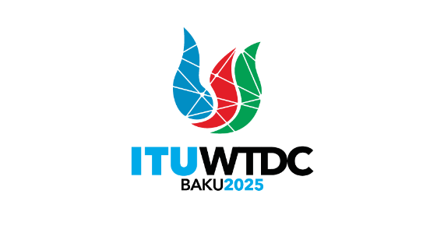 | TDAG Working Group on the future of Study Group Questions (TDAG-WG-futureSGQ)  6th Meeting, Virtual, 16 April 2025 |  | 
 |  | Document TDAG-WG-futureSGQ/35(Rev.1)-E
 |  | 15 April 2025
 |  | English only
Chair, TDAG-WG-futureSGQ
Draft agenda

 | Items | Documents
 | Approval of the agenda | TDAG-WG-futureSGQ/35
 | Review of the report of the fourth meeting held on 21 January 2025 | TDAG-WG-futureSGQ/34
 | Contributions submitted to TDAG-WG-futureSGQ | TDAG-WG-futureSGQ/36 (contribution APT)  TDAG-WG-futureSGQ/37 (contribution from RCC)  TDAG-WG-futureSGQ/39 (contribution from Russian Federation)  TDAG-WG-futureSGQ/38 (revised draft proposal of the deliverable of TDAG-WG-futureSGQ by the Chair)
 | Any other business
_______________

