TDAG Working Group  on the future of Study Group Questions  (TDAG-WG-futureSGQ)  3rd Meeting, Virtual, 3 December 2024 |  | 
 | Document TDAG-WG-futureSGQ/16-E
 | 12 December 2024
 | English only
Chair, TDAG-WG-futureSGQ
Report of the third meeting of the TDAG working group
on the future of Study Group Questions

Opening of the meeting and welcome remarks
Dr Ahmad Sharafat (Iran (Islamic Republic of)), Chair of the TDAG Working Group on the future of Study Group Questions (TDAG-WG-futureSGQ) welcomed all present (see list of participant TDAG-WG-futureSGQ/15) for the third meeting of this TDAG Working Group.
He acknowledged the presence of Dr Cosmas Luckyson Zavazava, Director of the BDT, who extended greetings to the participants and wished them successful outcomes for the meeting. The Chair also acknowledged the presence of Ms Roxanne McElvane Webber (Unites States), Chair of TDAG, who also wished the meeting well. Dr Fadel Digham (Egypt), Chair of ITU-D Study Group 2 and vice Chair of TDAG-WG-futureSGQ noted the important work of the working group and wished for good outcomes.
- Approval of the agenda
The agenda was presented in Document TDAG-WG-futureSGQ/13 (Rev.1) with some changes in the order of presentation of contributions received.The agenda was approved without comments.
- Contributions submitted to TDAG-WG-futureSGQ
Document TDAG-WG-futureSGQ/14 from African Telecommunication Union (ATU) was introduced by Ms Caecilia Nyamustwa (Zimbabwe) in her capacity as Chair of WG2 for WTDC-25 preparations at ATU. She indicated that a second contribution will be provided at the next TDAG-WG-futureSGQ meeting which will share revisions to terms of references (ToRs) of study Questions. The current contribution proposed (1) to maintain the number of Study Groups as it is, (2) to include as future study areas, within Questions, Artificial Intelligence, Airborne platforms, the Metaverse and new regulatory approaches (3) to supplement current Questions. Mr Teddy Woodhouse (United Kingdom) requested more information on whether topics of Study Group 2 are to be kept or the current study Questions. Ms Nyamutswa (Zimbabwe) explained that views came out strongly not to merge current Questions while new topics would be proposed and included in the second contribution of ATU which will be submitted in the future TDAG-WG-futureSGQ. The Chair shared his understanding that the contribution is an initial input on ATU’s work in progress, and the door is not closed for reconsidering the positions taken in this contribution. Ms Nyamustwa (Zimbabwe) confirmed that the Chair’s understanding is correct. The TDAG Chair said that not having a topic in the title of a study Question does not mean that the topic will not be studied. The topic would still be part of a Question and be studied. She requested all to consider for each study Question “Is this study Question the best way, or the only way to tackle the topic concerned ?” She stressed on bringing innovation and freshness to the study Questions and to finding an optimal way to bring information to members when a topic is not mentioned in the title of a study Question. This would include workshops, webinars and interim deliverable on the topic. The Chair added that there were indeed cases where workshops had higher attendance than actual study group meetings. He urged all to consider opening the door to new frontiers for Questions on new topics as ICTs is evolving at an accelerating pace and Questions need to embrace them in a coordinated manner. Mr Digham (Egypt) proposed to develop new modalities such as focus group mechanism to inject new topics regardless of the prevailing Questions. The Chair thanked him for this proposal which would indeed bring in a new modality to get fresh ideas. Mr Plossky (Russian Federation) concurred with TDAG Chair’s views and indicated if an existing Question has new topics injected then they continue to be studied. He proposed an instruction to be added in the scope part of Resolution 2, to maintain (not further study) the work of Questions no longer under Study which is then addressed at plenary meetings of Study Groups. The Chair thanked him for the suggestion that would bring in a much-needed new approach. Mr Roberto Hirayama (Brazil) shared that workshops are extremely useful for new and novel topics while there is a distinction to be made between topics and a Question which tackles topics in a more detailed way. Less mature topics and cross cutting topics lend themselves to workshops. Ms Nyamustwa (Zimbabwe) indicated that the revised ToR of current Questions will be shared in the next ATU contribution and will enable us all to see which Questions stay and which ones can be tackled as topics.
The document was noted with thanks.
Document TDAG-WG-futureSGQ/12 was introduced by Mr Roberto Hirayama(Brazil) in his capacity as Study Group 1 (SG1) Coordinator on the Future of Study Questions. The document shared the initial views of Rapporteurs and co-Rapporteurs of SG1, with the annex containing the revised ToR proposed for Question 5/1 on Rural and Remote Telecommunications. Mr Digham (Egypt) shared that specific focus, and decisiveness is needed for example on
- Q2/1 Broadcasting: to clarify it is not stand-alone broadcasting networks but also includes the convergence of telecoms and broadcasting (3GPP) and emergency broadcasting services.
- Q5/1 Rural and remote areas: to clarify if it treats only connectivity or the total package of connectivity/infrastructure as well as digital applications/services.
- Q7/1 Accessibility: to clarify if it refers to inclusiveness with broader scope including other vulnerable groups such as rural/ remote groups (Q5/1), women, etc.
Ms Alison Balzer (USA), the co-rapporteur for the Q3/1 on Disaster risk reduction and management, indicated that Q3/1 inputs will be shared shortly to SG1 Coordinator. She noted that the online consultation results indicated a possible merging of Q3/1 and Q6/2 on ICT and the environment. The current position for Q3/1 is not to merge while still being open especially in view of comments of TDAG Chair. Ms Otieno (Kenya) shared her views which concur with Mr Digham’s on having a specific focus when discussing the future of study Questions. In response to Mr Digham’s question, Ms Caecilia (Zimbabwe) indicated that rural and remote aspect covers all connectivity/infrastructure as well as digital applications/services. The rural and remote aspect should be key in a Question and not swallowed by other aspects. Ms Natalia Vicente (GSOA) shared some thoughts to consider, including “what is the objective of this question and therefore does it make sense to continue as it is with the same title? Are we forced to continue doing one specific question for developing countries or go outside the box and think about advancing technology and digitalization everywhere?” Mr Hirayama (Brazil) thanked Q5/1 and Q3/1 (co)rapporteurs for being present and sharing views. He looks forward to their inputs to the next contribution of SG1 to the TDAG WG. He thanked Mr Digham for his insights and indicated that often the distinctions are made on what has more weight. He continued that regulations and policies go to SG1. He further clarified each Question numbers listed in his document as requested by TDAG Chair. Mr Benziane (Algeria) indicated that at WTSA there was a discussion on the need for strategic planning of study groups. The pertinent question may be “To what extent these study group Questions have been impactful for membership and have addressed the Kigali Action Plan?”. He added that given that SDG targets are mainly off track, a different thinking at WTDC is warranted which would include looking at the role and contribution of Study Groups to the entire WTDC process. There is need to think outside of the box and bring new things to the table. The Chair welcomed the comments of Mr Benziane that strategic foresight and strategic planning is much needed. He reiterated the terms of reference number 2 of this working group which is ‘’To align, as far as possible, the proposed study Questions to BDT thematic priorities, proposed regional initiatives, the 2030 Sustainable Development Goals and WSIS Action Lines (C2, C5 and C6) for which ITU has lead responsibility.” Mr Burton (USA) thanked SG1 Coordinator for the excellent document presented and concurred with previous interveners on a strategic approach. He noted that there is an opportunity here, not just from the topics but to really rethink the way where we're achieving our goals. He shared the following question “How can the terms of reference allow for more focused discussions in a way that fulfils the remit of the ITU and really advance those key priorities of developing countries ? How are we thinking and determining what is most useful for developing countries? What are the best mechanisms to deliver knowledge (apart from reports) to developing countries ?” Mr Digham (Egypt) appreciated the great discussion and philosophy which would lead to better planning of Study Groups. Instead of focusing on study Questions, it may be good reflect on what are/will be the digital developmental needs of countries in the next 4 years and how can the work of ITU-D Study Groups help to address them. He shared the example of Q3/1 on Cloud Computing which was not maintained from the previous Study Group period as Cloud Computing is a tool/technology and not a developmental need. Mr Dusenge (Rwanda) echoed the need to combine study Questions with a view to reducing overlaps between the Q1/1 and Q5/1.
The document was noted with thanks.
Document TDAG-WG-futureSGQ/11 which is the results of the online consultation was presented by Chair. He indicated that the results are for use in preparing contributions by all for submission to TDAG-WG-futureSGQ meetings, include the next meeting. A one slide snapshot based on a summary of the survey was presented as below
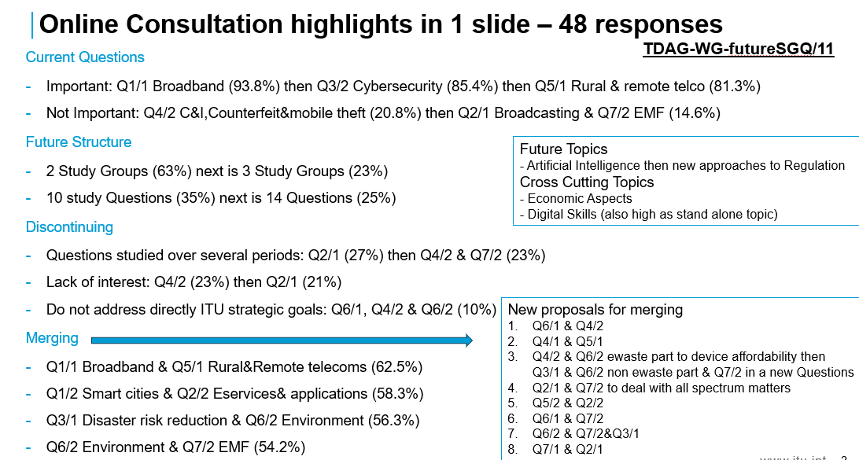
TDAG Chair thank the Chair for the comprehensive online consultation questionnaire and the analysis shared. Mr Oloyede (Nigeria) concurred and queried if proposals of merging were from survey. The Chair confirmed that it was the case. Mr Woodhouse (UK) also queried if the slide was a decision of today’s meeting or a summary result of the survey for all to consider. The Chair replied that it is a summary of results for use by all. Ms Murianki (Kenya) thanked the Chair and noted information on Q6/1 Consumer protection, from the results of the online consultation. Mr Digham (Egypt) said that this snapshot looks at merging from views of respondents and provides a place to start thinking of getting to 5 study Questions for each Study Group. He also pointed out the need to consider room for additional topics to be studied. Mr Mazar (Israel) was pleased to see the number of Questions reduced to 5 per Study Group and the merging options from the snapshot. He said that merging of Q6/2 ad Q7/2 is how ITU-T handles EMF and Environment, and similarly in Israel Ministry of Environment handles EMF matters too. Mr Woodhouse (United Kingdom), request a clarification as to whether resourcing commitments are expected to be less with 5 Questions per Study Group. The Chair shared his experience that there has been a sustained tendency to try to reduce the number of study Questions for efficiency reasons. Currently, Rapporteur Group meetings result in a participant being out of office for 4 weeks and with 5 Questions per Study Group, this can be reduced to 2 weeks where each Question is allocated a day for meeting. Ms Murianki (Kenya) concurred to prioritise the needs of developing countries and not focus on merging Questions. Mr Mazar (Israel) also said that in the future with the ITU building project, hosting may be easier if the duration of Rapporteur Group meeting is reduced from 4 weeks to 2 weeks. He proposed increasing the number of rapporteurs and vice rapporteurs for Questions that are merged. Mr Plossky (Russian Federation) proposed an informal consultation group to continue working after TDAG in May as previous WTDC discussions on Resolution 2 mainly on the Questions part, have been lengthy.
The document was noted with thanks.
Next steps
To move the rich discussion into a concrete document, the Chair proposed to prepare a draft revision of extracts from Resolution 2 annexes including the terms of reference of study Questions, which he will undertake in consultation with his vice Chairs, the SG1 and SG2 coordinators and active collaborators. He will submit this document as a contribution to the next TDAG-WG-futureSGQ meeting.
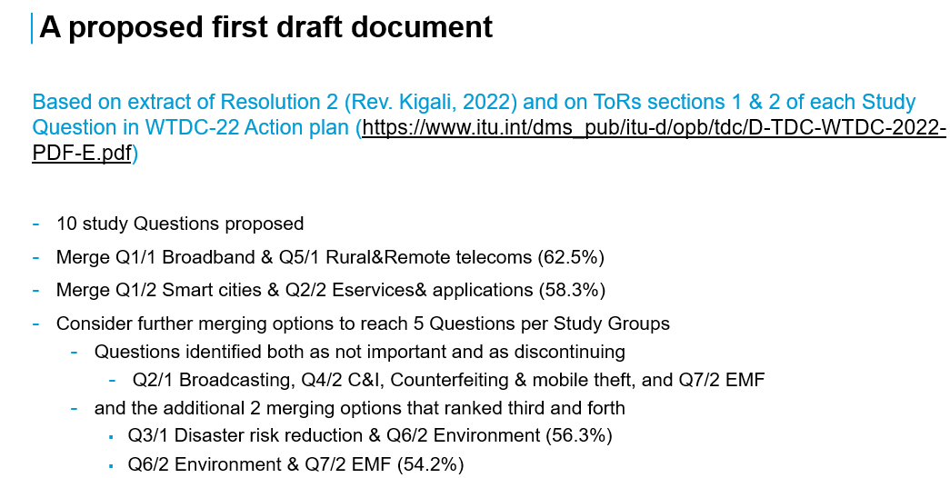
He proposed to have two more meetings before the final one in March 2025 namely on 14 January and on 11 February. Following interventions of Mr Mazar (Israel), Mr Plossky (Russian Federation), Mr Hirayama (Brazil), Mr Oloyede (Nigeria), Mr Benziane (Algeria) and Mr Woodhouse (UK), the Chair responded to queries, and it was agreed to have at least one additional meeting, before the final one in March 2025.
The Chair summarised next steps as indicated below:
- The Chair will prepare a draft revision of extracts of Resolution 2 annexes including the terms of reference of study Questions, for discussion in the next meeting. The revision will aim to incorporate the proposals as per items in the slide image above, as well as address issues raised today. This revision will aim to engage the widest possible set of contributions/views received formally and informally.
- The SG1 Coordinator and SG2 Chair will work with respective (co) rapporteurs towards a common document of:
- Needs of developing countries
- Revised ToRs of current study Questions in line with the above slide image
- The BDT secretariat will be tasked to request focal points from RTOs for the TDAG-WG-futureSGQ who will submit and present inputs of RTOs to the next TDAG-WG-futureSGQ
- The next emeeting will be held in January- February 2025 period after further consultation with BDT secretariat, BDT Director and TDAG Chair.
- Any other business
Dr Zavazava appreciated the discussions and outcomes of this meeting. He indicated that a TDAG emeeting will be held on 23 January 2025 where a progress report of the TDAG-WG-futureSGQ will be welcomed. The Chair acknowledged that all agenda items were covered and closed the meeting by expressing appreciation for the productive session and looking forward to future contributions and meetings. The meeting was adjourned with other thanks and positive remarks from the participants.
__________________

