TDAG Working Group  on the future of Study Group Questions  (TDAG-WG-futureSGQ)  3rd Meeting, Virtual, 3 December 2024 |  | 
 | Document TDAG-WG-futureSGQ/11-E
 | 1 November 2024
 | English only
Chair, TDAG-WG-futureSGQ
Results of the online consultation
on the future of Study Group Questions
Summary:
This document provides the results of the online consultation on the future of Study Group Questions.
Action required:
Participants are invited to use this document as appropriate in formulating their contributions for the next TDAG-WG-futureSGQ to be held on 3 December 2024.
References:
WTDC Resolution 2 (Rev. Kigali, 2022)

- Responses
Member State | 35
Sector Member | 7
Academia | 4
Other | 2
- Please state the membership type of your entity.

- Please state the country represented by your entity.
3 responses did not specify the country and are therefore not included in the analysis of responses for this question.
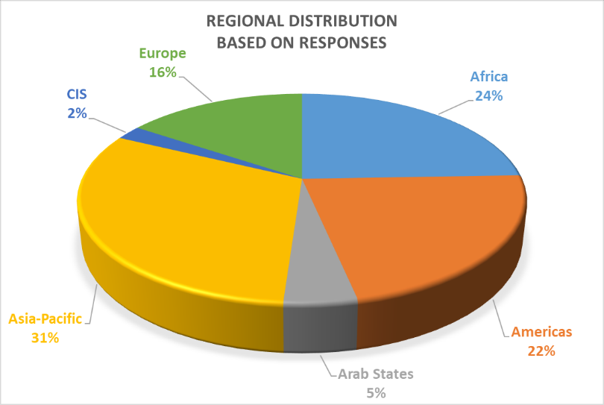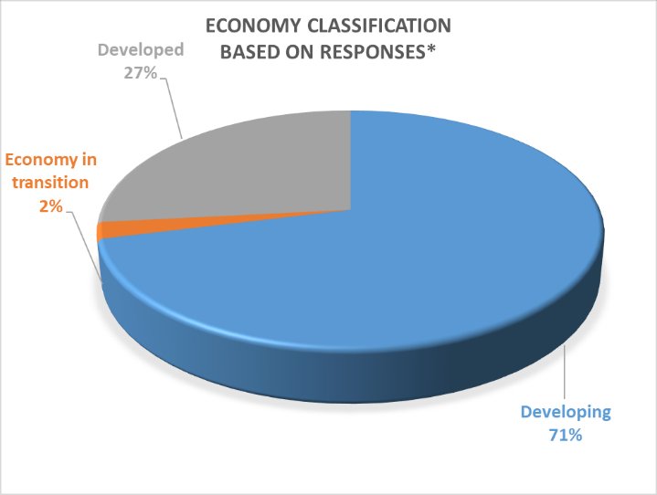
*based on classification used for ITU fellowships (see link)
B. Awareness and Importance of Questions
- Are you aware of the current structure of the ITU-D Study Groups and their Questions?

Yes | 45
No | 3

- Please tell which study Questions are important for you (see https://www.itu.int/en/ITU-D/Study-Groups/2022- 2025/Pages/reference/Questions-under-study.aspx):

Top 10 (most “important” first) Questions deemed “important” :
IMPORTANT

Top 1. 93.8%
- Question 1/1 Strategies and policies for the deployment of broadband in developing countries
(not important: 0%, neutral: 6.2%)

Top 2. 85.4%
- Question 3/2 Securing information and communication networks: Best practices for developing a culture of cybersecurity
(not important: 2.1%, neutral: 12.5%)

Top 3. 81.3%
- Question 5/1 Telecommunications/ICTs for rural and remote areas
(not important: 0%, neutral: 18.7%)

Top 4. 72.9%
- Question 5/2 Adoption of telecommunications/ICTs and improving digital skills
(not important: 4.2%, neutral: 22.9%)

Top 5. 68.8%
- Question 3/1 The use of telecommunications/ICTs for disaster risk reduction and management
(not important: 2.1%, neutral: 29.2%)

Top 6. 64.6% (two Questions)
- Question 4/1 Economic aspects of national telecommunications/ICTs
(not important: 4.2%, neutral: 31.2%)
- Question 7/1 Telecommunication/ICT accessibility to enable inclusive communication, especially for persons with disabilities
(not important: 4.2%, neutral: 31.2%)

Top 8. 62.5%
- Question 6/1 Consumer information, protection and rights
(not important: 6.3%, neutral: 31.2%)

Top 9. 60.4% (two Questions)
- Question 1/2 Smart sustainable cities and communities
(not important: 12.5%, neutral: 27.1%)
- Question 2/2 Enabling technologies for e-services and applications, including e-health and e-education
(not important: 4.2%, neutral: 35.4%)
Top 6 (most “not important” first) Questions deemed “not important”
NOT IMPORTANT

Top 1. 20.8%
- Question 4/2 Telecommunication/ICT equipment: Conformance and interoperability, combating counterfeiting and theft of mobile devices
(important: 33.3%, neutral: 45.9%)

Top 2. 14.6% (two Questions)
- Question 2/1 Strategies, policies, regulations and methods of migration to and adoption of digital technologies for broadcasting, including to provide new services for various environments (neutral, important)
(important: 27.1%, neutral: 58.3%)
- Question 7/2 Strategies and policies concerning human exposure to electromagnetic fields
(important: 39.6%, neutral: 45.8%)

Top 4. 12.5%
- Question 1/2 Smart sustainable cities and communities
(important: 60.4%, neutral: 27.1%)

Top 5. 6.3% (two Questions)
- Question 6/1 Consumer information, protection and rights
(important: 62.5%, neutral: 31.2%)
- Question 6/2 ICTs for the environment
(important: 58.3%, neutral: 35.4%)
C. Future Structure
- How many ITU-D study groups in total do you believe would be appropriate in the next study period?

Responses from “Other”:
- “Determine what is needed for important issues; no less than 2”
- “Depend on the study topic groups”
- “1-2 study groups”

10 study Questions | 17
12 study Questions | 7
14 study Questions | 12
No opinion | 3
Other | 9
- 14 Questions were studied during the previous and current study periods by the two study groups. How many Questions in total do you believe should be studied in the next study period?

“Other” responses are:
- “Same Questions for SG1 and 2 + additional Questions on statistics for SG3”
- “6 study Questions”
- “14 or fewer Questions is preferable, however, instead of suggesting a specific number below 14, it is important first to determine the relevant future issues and then adopt the number of Questions, depending on the number of topics and ability to confirm active Question Management Team Leadership”
- “5 study Questions”
- “15 study Questions”
- “16 study Questions”
- “Determine importance and relevance, then form a structure to accommodate, rather than arbitrary numbers”
- “Depend on study topics”
- “The number of Questions must be consistent with the topics that will actually be addressed.”
D. Discontinuing Questions
7 to 20: If you believe a study Question should be discontinued, please provide the reason(s).

Top 3 Questions that are considered to be discontinued because they have been studied over several periods
DISCONTINUE
Top 1. 27%
- Question 2/1 Strategies, policies, regulations and methods of migration to and adoption of digital technologies for broadcasting, including to provide new services for various environments (13 respondents)
Top 2. 23% (two Questions)
- Question 4/2 Telecommunication/ICT equipment: Conformance and interoperability, combating counterfeiting and theft of mobile devices (11 respondents)
- Question 7/2 Strategies and policies concerning human exposure to electromagnetic fields (11 respondents)

Top 4 Questions that are considered to be discontinued because of a lack of interest of membership
DISCONTINUE
Top 1. 23%
- Question 4/2 Telecommunication/ICT equipment: Conformance and interoperability, combating counterfeiting and theft of mobile devices (11 respondents)

Top 2. 21%

- Question 2/1 Strategies, policies, regulations and methods of migration to and adoption of digital technologies for broadcasting, including to provide new services for various environments (10 respondents)

Top 3. 15% (two Questions)

- Question 1/2 Smart sustainable cities and communities (7 respondents)
- Question 6/2 ICTs for the environment (7 respondents)
Top 3 Questions that are considered to be discontinued because they do not directly address the two strategic goals of the Union (universal connectivity and digital transformation)
DISCONTINUE
Top 1. 10% (three Questions)
- Question 6/1 Consumer information, protection and rights (5 respondents)
- Question 4/2 Telecommunication/ICT equipment: Conformance and interoperability, combating counterfeiting and theft of mobile devices (5 respondents)
- Question 6/2 ICTs for the environment (5 respondents)

Responses received apart from the 3 items shown in the graph above are detailed below
Question 1/1
44% (11) responses were “Other” as grouped below:
- “The Question should be revamped to be focused on the new technologies and not to repeat the topics from previous study periods”
- “Significant overlap of contributions with Q5/1”
- “This Question should continue but merged with other Questions.”
- “Should be continued to address issues not fully catered for in the last study periods”, “Remain”, “It should still be under study”, “It should continue”, “No deletion”, “The Question remains relevant. It must not be deleted.”, We believe this Question should be continued.”
- “No opinion”

Question 2/1
23% (8) responses were Other as grouped below:
- “Could be merged with Q1/1”
- “The Q2/1 and Q7/2 should be merged to establish a new Question to treat all the spectrum related matters, including broadband and broadcasting and new innovative services and their adoption.”
- “The Question should be revamped to be focussed on the new technologies and not to repeat the topics from previous study periods.” / “The Question's remit can be adequately addressed by streamlining its mandate with others.”
- “Remain”, “No deletion”, “The Question remains relevant. It must not be deleted.”
- “No opinion”

Question 3/1
39% (9) responses were “Other” as grouped below:
- “Could be merged with Q6/2”
- “The Question should be revamped to be focussed on the new technologies and not to repeat the topics from previous study periods”
- “Need of future requirements”
- “Should be continued as emerging issues of climate change and adoption of disaster management through ICTs has not been fully implemented and exhausted in the last study period”, “It should continue”, “No deletion”, “The Question remains relevant. It must not be deleted.”, “We believe this Question should be continued.”
- “No opinion”

Question 4/1
45% (10) responses were “Other” as grouped below:
- “The Question should be revamped to be focussed on the new technologies and not to repeat the topics from previous study periods”
- “Examine costs are better considered in a more specific context rather than as a standalone, unattached to specific service or devices”
- “The Question is interesting, but better studied by academia, not as ITU-D Study Groups”
- “It should continue to be under study”, “No deletion”, “Remain”, “It should continue”, “The Question remains relevant. It must not be deleted”, “We believe this Question should be continued”
- “No opinion”

Question 5/1
52% (11) responses were “Other” as grouped below:
- “Could be merged with Q1/1 section on technologies issues”
- “The Question should be merged with Q1/1”, “I think it should be combined with Q1/1”
- “Remain”, “It should continue”, “Should continue”, “It should continue to be under study”, “No deletion”, “The Question remains relevant. It must not be deleted”, “We believe this Question should be continued”
- “No opinion”

Question 6/1
50% (10) responses were “Other” as grouped below:
- “The Question should be revamped to be focussed on the new technologies and not to repeat the topics from previous study periods”
- “More relevant to the scope of SG2”
- “The Question is interesting, but not a concern for ITU-D Study Groups”
- “It should continue to be under study”, “Remain”, “It should continue”, “No deletion”, “The Question remains relevant. It must not be deleted”, “We believe this Question should be continued”
- “No opinion”

Question 7/1
41% (7) responses were “Other” as grouped below:
- “The Question should be revamped to be focussed on the new technologies and not to repeat the topics from previous study periods;”
- “It should continue to be under study;”, “It should continue”, “No deletion because accessibility is very important”, “The Question remains relevant. It must not be deleted”, “We believe this Question should be continued”
- “No opinion”

Question 1/2
36% (8) responses were “Other” as grouped below:
- “Could be merged with Q2/2”
- “The Question should be revamped to be focussed on the new technologies and not to repeat the topics from previous study periods”
- “The target should be expanded to digital twins”
- “The Question is interesting, but the added value of ITU-D Study Groups is little”
- “It should continue to be under study”, “No deletion”, “The Question remains relevant. It must not be deleted”
- “No opinion”

Question 2/2
42% (8) responses were “Other” as grouped below:
- “Could be merged with [Q1/2]”
- “The Question should be revamped to be focussed on the new technologies and not to repeat the topics from previous study periods”
- “Remain”, “Should continue to be under study”, “No deletion”, “The Question remains relevant. It must not be deleted”, “We believe this Question should be continued”
- “No opinion”

Question 3/2
53% (8) responses were “Other” as grouped below”
- “The Question should be revamped to be focussed on the new technologies and not to repeat the topics from previous study periods”
- “Remain” / “It should continue” / “It should continue to be under study” / “No deletion” / “The Question remains relevant. It must not be deleted” / “We believe this Question should be continued”
- “No opinion”

Question 4/2
23% (8) responses were “Other” as grouped below:
- “The Question should be revamped to be focussed on the new technologies and not to repeat the topics from previous study periods”
- “Counterfeit/theft = consumer issue; consider whether C&I could be better handled in BDT programs or via workshops or presentations during plenary. SG mechanism may not be the optimal way to enhance knowledge or capacity building in this area”
- “Given the maturity of this Question, Q4/2 could best address developing country needs via targeted BDT capacity building and programs, or via workshops or presentations during Study Group plenaries.”
- “Remain”, “It should continue”, “No deletion”, “The Question remains relevant. It must not be deleted”
- “No opinion”

Question 5/2
56% (9) responses were “Other” as grouped below:
- “The Question should be revamped to be focussed on the new technologies and not to repeat the topics from previous study periods”
- “I think it should be combined with the Q2/2”
- “Remain”, “It should continue to be under study”, “No deletion”, “The Question remains relevant. It must not be deleted”, “It should continue”, “We believe this Question should be continued”
- “No opinion”

Question 6/2
30% (7) responses were “Other” as grouped below:
- “Could be merged with Q3/1”
- “Remain”, “It should continue to be under study”, “No deletion”, “The Question remains relevant. It must not be deleted”, “We believe this Question should be continued”
- “No opinion”

Question 7/2
26% (7) responses were “Other” as grouped below:
- “Same answer as #17 [consider whether this could be better handled in BDT programs or via workshops or presentations during plenary. SG mechanism may not be the optimal way to enhance knowledge or capacity building in this area]”
- “This Question should be merged with Q2/1. The new Question should treat all the spectrum related matters, including broadband and broadcasting and new innovative services and their adoption.”
- “Given the maturity of this Question, Q7/2 could best address developing country needs via targeted BDT capacity building and programs, or via workshops or presentations during Study Group plenaries.”
- “I think it should be combined with the Q6/1”
- “No deletion”, “The Question remains relevant. It must not be deleted”
- “No opinion”
E. Merging of Questions
- Given potential similarities and overlaps, do you believe the following Questions should be merged:

Ranking (most agreed first) of merging options with over 50% responding “yes”
Top 1. Merging of Q1/1 and Q5/1 agreed by 62.5%
Merge Question 1/1 Strategies and policies for the deployment of broadband in developing countries with Question 5/1 Telecommunications/ICTs for rural and remote areas
Top 2. Merging of Q1/2 and Q2/2 agreed by 58.3%
Merge Question 1/2 Smart sustainable cities and communities with Question 2/2 Enabling technologies for e-services and applications, including e-health and e-education
Top 3. Merging of Q3/1 and Q6/2 agreed by 56.3%
Merge Question 3/1 The use of telecommunications/ICTs for disaster risk reduction and management with Question 6/2 ICTs for the environment
Top 4. Merging of Q6/2 and Q7/2 agreed by 54.2%
Merge Question 6/2 ICTs for the environment with Question 7/2 Strategies and policies concerning human exposure to electromagnetic fields
- If you believe other Questions should be merged, please specify which ones and provide the rationale(s).
Other proposals for merger:
- “Consumer protection (Q6/1) & mobile theft, counterfeit (Q4/2) may be compatible; not sure mobile theft or counterfeit are topics that should go forward standalone in the new period. Depending on how characterized, broadband and broadcasting might be compatible. Would need to see how smart cities and applications could be merged before supporting.”
- “Propose merging Q6/1 (Consumer Protection) with Q4/2 (Counterfeiting and Device theft Aspects) to examine more fully awareness aspects of device theft and counterfeiting as these relate to consumer protection”
- “Q4/1 and Q5/1 should be merged as they both address the telecommunication sector and can look at the sector wholesomely as one document”
- “We believe that Q4/2 and the e-waste elements of Q6/2 could be combined with a new Question on device affordability. We believe that Q3/1, non-e-waste elements of Q6/2, and Q7/2 could be combined into a single Question.”
- “The Q2/1 and Q7/2 should be merged to establish a new question to treat all the spectrum related matters, including broadband and broadcasting and new innovative services and their adoption.”
- “The merge of Q1/1 and Q5/1 could be approached with a more holistic view on advancing connectivity. Suggestions to consider to have a more inclusive title: Bringing Digital Transformation Further or Emerging technologies and Digital Transformation to connect everyone or Emerging technologies and Digital Transformation for meaningful connectivity.”
- “Q5/2 could be combined with the Q2/2.”
- “Q7/2 could be combined with the Q6/1.”
- “Q6/2 + Q7/2 + Q3/1”
- “Q7/1 & Q2/1”

F. New Topics to be Considered
- What are in your view the new topics to be addressed in the next study period, in particular to provide guidelines, best practices and experience sharing for developing countries?
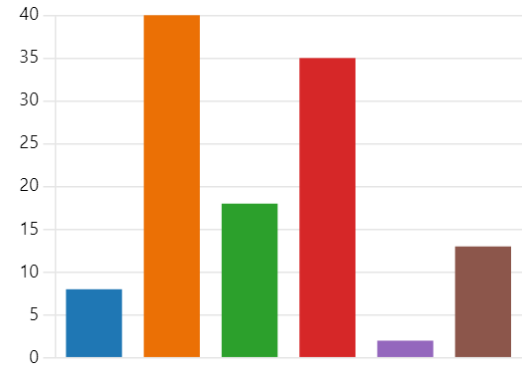
Airborne platforms | 8
Artificial intelligence (AI) and au… | 40
Metaverse | 18
New approaches to regulation (… | 35
No opinion | 2
Other | 13

Responses from “Other”:
- “Digital inclusion”
- “Space-based connectivity”, “Satellite communication”, “Satellite communications”, “Evolution of satellite communication direct to consumer”
- “Statistics issues as new Questions for SG3”
- “Environmental and energy impacts of new and emerging ICTs/telecommunications. Selecting specific technologies for topics is not necessarily helpful. Sharing experience/best practices that use these kinds of technologies will come naturally and are already being shared in the context of existing Questions (smart cities, etc.). For example, to have an AI topic or AI-focused Question could lead to confusion about where to submit any contribution that has AI components.”
- “Models of applications of universal service funds”
- “Guidelines to aid developing countries for licensing new and emerging telecommunication services including over the top applications"
- “1. AI, metaverse, automation and other emerging technologies.
- 2. Digital services and platforms adoption and related policy and regulatory environments.
- 3. New approaches to improving regulatory governance (e.g. regulatory sandboxes)”
- "Challenges and solutions for the implementation of the outputs of the work of the ITU-D study groups"
- “Innovative funding models and strategic partnerships for expanding broadband infrastructure in underserved regions”
- “In consideration of other proposals, we believe that the study program is best suited for technologically neutral Questions”

G. Cross cutting Topics to be Considered
- Do you believe the following cross-cutting topics can be addressed in a separate Question or across Questions?

- Are there other cross-cutting topics to be addressed in a separate Question or across Questions? If so, please explain.
Relevant responses received:
- “Compliance management”
- "1) Universal service funds utilisation in developing countries as cross cutting issues in separate questions; 2) Mapping aspects in relation to ICTs as cross cutting issues across Questions"
- "Start-up development"
- “It would be beneficial to expand the study of affordability in the ITU-D Study Questions, including in Q5/2 (Digital Skills).”
- “Evolution of satellite communication direct to consumer in separate Question”
- “E-services and applications should be a separate Question.”
- “Innovative funding models and strategic partnerships for expanding broadband infrastructure in underserved regions in economic aspect”
- “Aspects of digital inclusion (not fully generalizable across all Questions) may benefit from a matrix approach of a focused Question that coordinates with other Questions regularly.”
- Do you have any further comments related to future study Questions? If so, please provide your views below.
Relevant responses received:
- “More focus on WTDC Res 9 implementation”
- “I have no concrete idea, but current study Qs need load balancing. Some Qs have huge number of contributions, but some are not.”
- “The study groups should be mandated to develop guidelines and other related outputs so that at the end of the study period, the study reports will not be just study reports but also relevant guidelines and frameworks relating to the study Questions. For example, Q4/2 should be mandated to revise the guidelines to establish C&I regimes, plus other related works. This will make the study group active and receive more contributions.”
- It is worth mentioning that the concentration of several topics in a single Question places a management and efficiency challenge. It can be noted that not all the topics can be discussed and incorporated in the deliverables. A balanced approach would be beneficial, meaning that each Question needs to have a very clear focus that can be subdivided in various aspects. Another point is to define in each study period very specific topics that will be studied. Finally. we would like to highlight that the absence of a Question on a specific topic does not mean that the subject should not be the focus of BDT initiatives and projects.
- “Question 7/1 should be dedicated solely to people with disabilities and a Question 8/1 for gender, children, youth and the elderly.”
- “The objective of these reports is to support administrations develop their digital strategies for the next four years. The contributions and reports should fit the purpose of the Question and be in line with countries needs avoiding working on reports that would not be read. The suggestion to join Question Q1/1 and Q5/1 is not to focus all on broadband but focussed on the title of the Study Group 1, meaningful connectivity.”
- “Some Questions remain relevant and may need to be improved not completely deleted or merged”
- “We suggest 15 Questions in 3 future study groups.”
- “Emerging technologies”

- Do you have any proposals for innovative and effective approaches to work in ITU-D study groups? If so, please provide your views below.
Relevant responses received:
- “More workshops side to SG sessions”
- "1. To make all Questions to not repeat the topics in new output reports but to revise the existing ones. 2. Not to necessarily to include all of topics assigned to Questions to new output reports but to consider some topics as transferrable to the next study period if there is no sufficient materials"
- “Suggest reaching out to developing countries that do not traditionally engage with ITU-D Study Groups and asking what the Study Groups could offer that would make them interested in engaging. Are they aware of the Study Group outputs, are they helpful, etc. Perhaps a mentor system between BDT/countries actively engaged with ITU-D Study Groups and countries/sector members that are interested in engaging but don't have capacity to do so to assist in showing the benefits of participation and how to utilise output documents.”
- “It might be better to link ITU-D projects.”
- "Enhance capacity building by ensuring members studying the topics are retained in future study Questions as ITU on-boards new members. In addition, language barriers can be enhanced through deliberate trainings for management teams over the study period. This can be done by encouraging member countries to train representatives or by ITU offering such trainings. Enhance participation through specific trainings geared towards management teams."
- "Study Group 1: Digital Transformation: Enabling Policies and Regulatory Environments; Study Group 2: Universal and Meaningful Connectivity: Emerging Technologies and Innovative Approaches"
- "Decentralize Working Group meetings to Africa"
- “It has been the consensus to not overlap Questions sessions. However, some approaches can be implemented, for example, an initial session to present the contributions briefly, and for those that have a lot of interest, ad-hoc sessions for further discussion and even editing/drafting and/or considerations on how to use the content in the deliverables.”
- "Appoint focal points (one per region) who are experts on disability to ensure the implementation of the study group deliverables. These focal points with disabilities per region are supported by ITU fellowships for all ITU work, so that their point of view and experience are taken into account. Rapporteurs and vice-rapporteurs are people who work on the issues in their countries"
- “Interactive informative workshops, masterclass style on different matters & technologies. - Small group sessions, breakout facilitated conversations. - Organise country sessions where administrations can share their experiences, possibly under either a subject matter or a region focus. - Simplify the Liaison Statements and ensure we receive information from all groups of other Sectors of the ITU. - Organise a training session to new ITU-D Sector Members. - Possible work of infographics to reflect the main points of the reports and make them more accessible and useful.”
- “More workshops and attractions of the academia on researched topics relevant to study Questions”
- “SG1: for broadband and related areas. SG2: for consumer protection and related areas. SG3: for disaster risk and environment and their related areas.”
- “It is important to reduce the number of study Questions and assess the opportunity to establish more study groups as much as possible”
- “More focus and effort into smaller, interim deliverables and less emphasis on final reports. More webinars and workshop-style events. Encourage countries to bring problems as well as solutions for collaborative working. Leadership structures and Question management need urgent review. Our failure to adequately address this issue will continue to reduce interest in the ITU-D study programme and discourage participation.”

_______________

