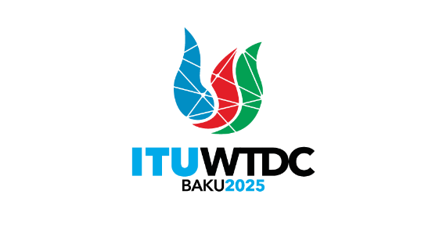 | TDAG Working Group  on ITU-D Priorities (TDAG-WG-ITUDP)  5th Meeting, Hybrid, 14 May 2025 |  | 
 |  | Document TDAG-WG-ITUDP/18-E
 |  | 8 May 2025
 |  | English only
Chair, TDAG-WG-ITUDP
Proposal for Baku Action Plan (WTDC-25)

Introduction
The Baku Action Plan describes the ITU-D priorities, scope of activities, associated outcomes and outputs for the period 2026-2029 and includes key performance indicators (KPIs).
The ITU-D action plan may be updated or modified by the TDAG to reflect the ITU strategic plan, changes in the telecommunications/ICTs environment and/or as a result of the performance evaluation to be conducted each year.
This Action Plan is also the basis for the annual ITU-D rolling operational plan and serves as an implementation framework as it provides a description on how to achieve the priorities and objectives of ITU-D, as identified by its membership at the WTDC. These priorities are based on ITU-D's core competencies and expertise and are closely linked to and aligned with the priorities and objectives identified by the larger development plans/initiatives of the United Nations SDGs, the ITU strategic plan and the WSIS Plan of Action. In particular, they all share a common vision of achieving sustainable development by leveraging the opportunities of digital tools and ICTs.
The ITU-D outputs (products and services) and corresponding KPIs are further elaborated in the ITU-D operational plan, taking into account the experience gained in implementing the Kigali Action Plan.
[ NEW

Alignment with the ITU strategic framework
The model followed in the Action Plan seeks to move towards greater alignment with the overall RBM structure with the framework envisioned in the ITU strategic plan for 2024-2027. This RBM model applies an increased client-driven approach to the thematic priorities defined by the ITU strategic plan to enhance ITU-D’s efficiency in focusing products, support and results along these strategic pathways towards the longer-term goals
This RBM model will serve as the framework for future planning and evaluation, enforcing a common structure between strategic and operational plans. This will include increased integration of ITU and United Nations statistics and indicators to enhance the evidence-driven approach to country needs analysis and planning. It will allow BDT to be more agile in adapting technical support and service offering to evolving trends and changing needs of members.
To further guide coherent programmatic focus in delivery of the mandate at all levels and through ITU's regional presence, the ITU-D framework is designed for full regional level synchronization of RBM, thematic priorities, operational planning, sequenced technical support offerings and portfolio performance assessments. This will also help regions to strategically match BDT technical support according to each of the regional initiatives and specific local trends, while also maintaining alignment with the global vision and mission defined in the ITU strategic plan.
…]

Terminology
Results-based management
Results-based management (RBM) is a management strategy by which all actors, contributing directly or indirectly to achieving a set of results, ensure that their processes, products and services contribute to the achievement of desired results (outputs, outcomes and higher-level goals or impact). The actors in turn use information and evidence on actual results to inform decision-making on the design, resourcing and delivery of programmes and activities, as well as for accountability and reporting.
ITU-D priorities
ITU-D priorities are listed in the Baku Action Plan to facilitate delivery of the ITU-D mandate and to give guidance to BDT for the next planning cycle on what ITU-D aims to achieve, in line with the overall RBM approach and the strategic goals and thematic priorities of the Union.
Enablers
The ITU Strategic Plan for 2024-2027 defines ''enablers" as ways of working that allow the Union to deliver on its goals and priorities more effectively and efficiently. They reflect the Union's values of efficiency, transparency and accountability, openness, universality and neutrality, human-centric, service-orientation and a focus on results. To achieve this, ITU leverages its key strengths and addresses its weaknesses so that it can support its membership.
Results
Results are changes in state or condition that derive from a cause-and-effect relationship. There are three types of such changes – outputs, outcomes and impact – that can be set in motion by a development intervention. The changes can be intended or unintended, positive and/or negative.
Outcomes
Outcomes represent changes in the institutional and behavioural capacities for development conditions that occur between the completion of outputs and the achievement of goals.
Outcomes relate to changes in institutional performance or behaviour among individuals or groups, and their achievement depends critically on the commitment and actions of stakeholders, as well as on results to be achieved by governments.
Outputs
Outputs are changes in skills or abilities and capacities of individuals or institutions, or the availability of new products and services that result from the completion of activities within a development intervention within the control of the organization. They are achieved with the resources provided and within the period specified in the ITU-D operational plan.
The ITU-D action plan indicates that "outputs" are the specialized "products and services" offered within the mandate of ITU-D as defined by Article 21 of the ITU Constitution, including, among others, capacity building and dissemination of ITU expertise and knowledge. The ITU-D outputs are further elaborated in the ITU-D operational plan.
Impact
Impact implies changes in people's lives. This might include changes in knowledge, skill, behavior, health or living conditions for children, adults, families or communities. Such changes are positive or negative long-term effects on identifiable population groups produced by a development intervention, directly or indirectly, intended or unintended. These effects can be economic, socio-cultural, institutional, environmental, technological or of other types.
Key performance indicators
Key performance indicators (KPIs) associated with the Baku Action Plan and the ITU-D operational plan enable Member States to monitor the progress and impact of the implementation of the above-mentioned plans, including ITU-D priorities.
ITU-D operational plan
ITU-D operational plan is prepared on a yearly basis by the BDT in consultation with the Telecommunication Development Advisory Group (TDAG) in accordance with the ITU-D action plan and the strategic and financial plans of the Union. It includes the detailed plan of activities for the subsequent year and a forecast for the following three-year period for ITU-D. The ITU Council reviews and approves the four-year rolling ITU-D operational plan.
Regional initiatives and other projects
Regional initiatives are intended to address specific telecommunications/ICTs priority areas, through partnerships and resource mobilization to implement projects. Under each regional initiative, projects are proposed, developed and implemented to meet the region's needs. The products and services to be developed through regional initiatives, in order to achieve related objectives and outcomes under the ITU-D contribution to the ITU strategic plan, will be identified in relevant project documents.
In fulfilling the Union's dual responsibility as a United Nations specialized agency and executing agency for implementing projects under the United Nations development system or other funding arrangements so as to facilitate and enhance telecommunications/ICTs development, ITU-D offers, organizes and coordinates technical cooperation assistance through regional initiatives and projects.
Partnerships
BDT will continue to develop partnerships with a wide range of stakeholders, including other United Nations agencies and regional telecommunication organizations, to mobilize resources from funding agencies, international financial institutions, ITU Member States and ITU-D Sector Members and other relevant partners. In executing projects, available local and regional expertise should be taken into account.

ITU-D priorities, outcomes, outputs and enablers

Structure of the Baku Action Plan
The Baku Action Plan follows an RBM framework based on the ITU-D priorities identified as key work areas that will support the achievement of the ITU strategic plan for 2024-2027.
[ NEW Figure 1 shows the structure of the proposed Baku Action Plan and Priorities contributing to the ITU strategic plan
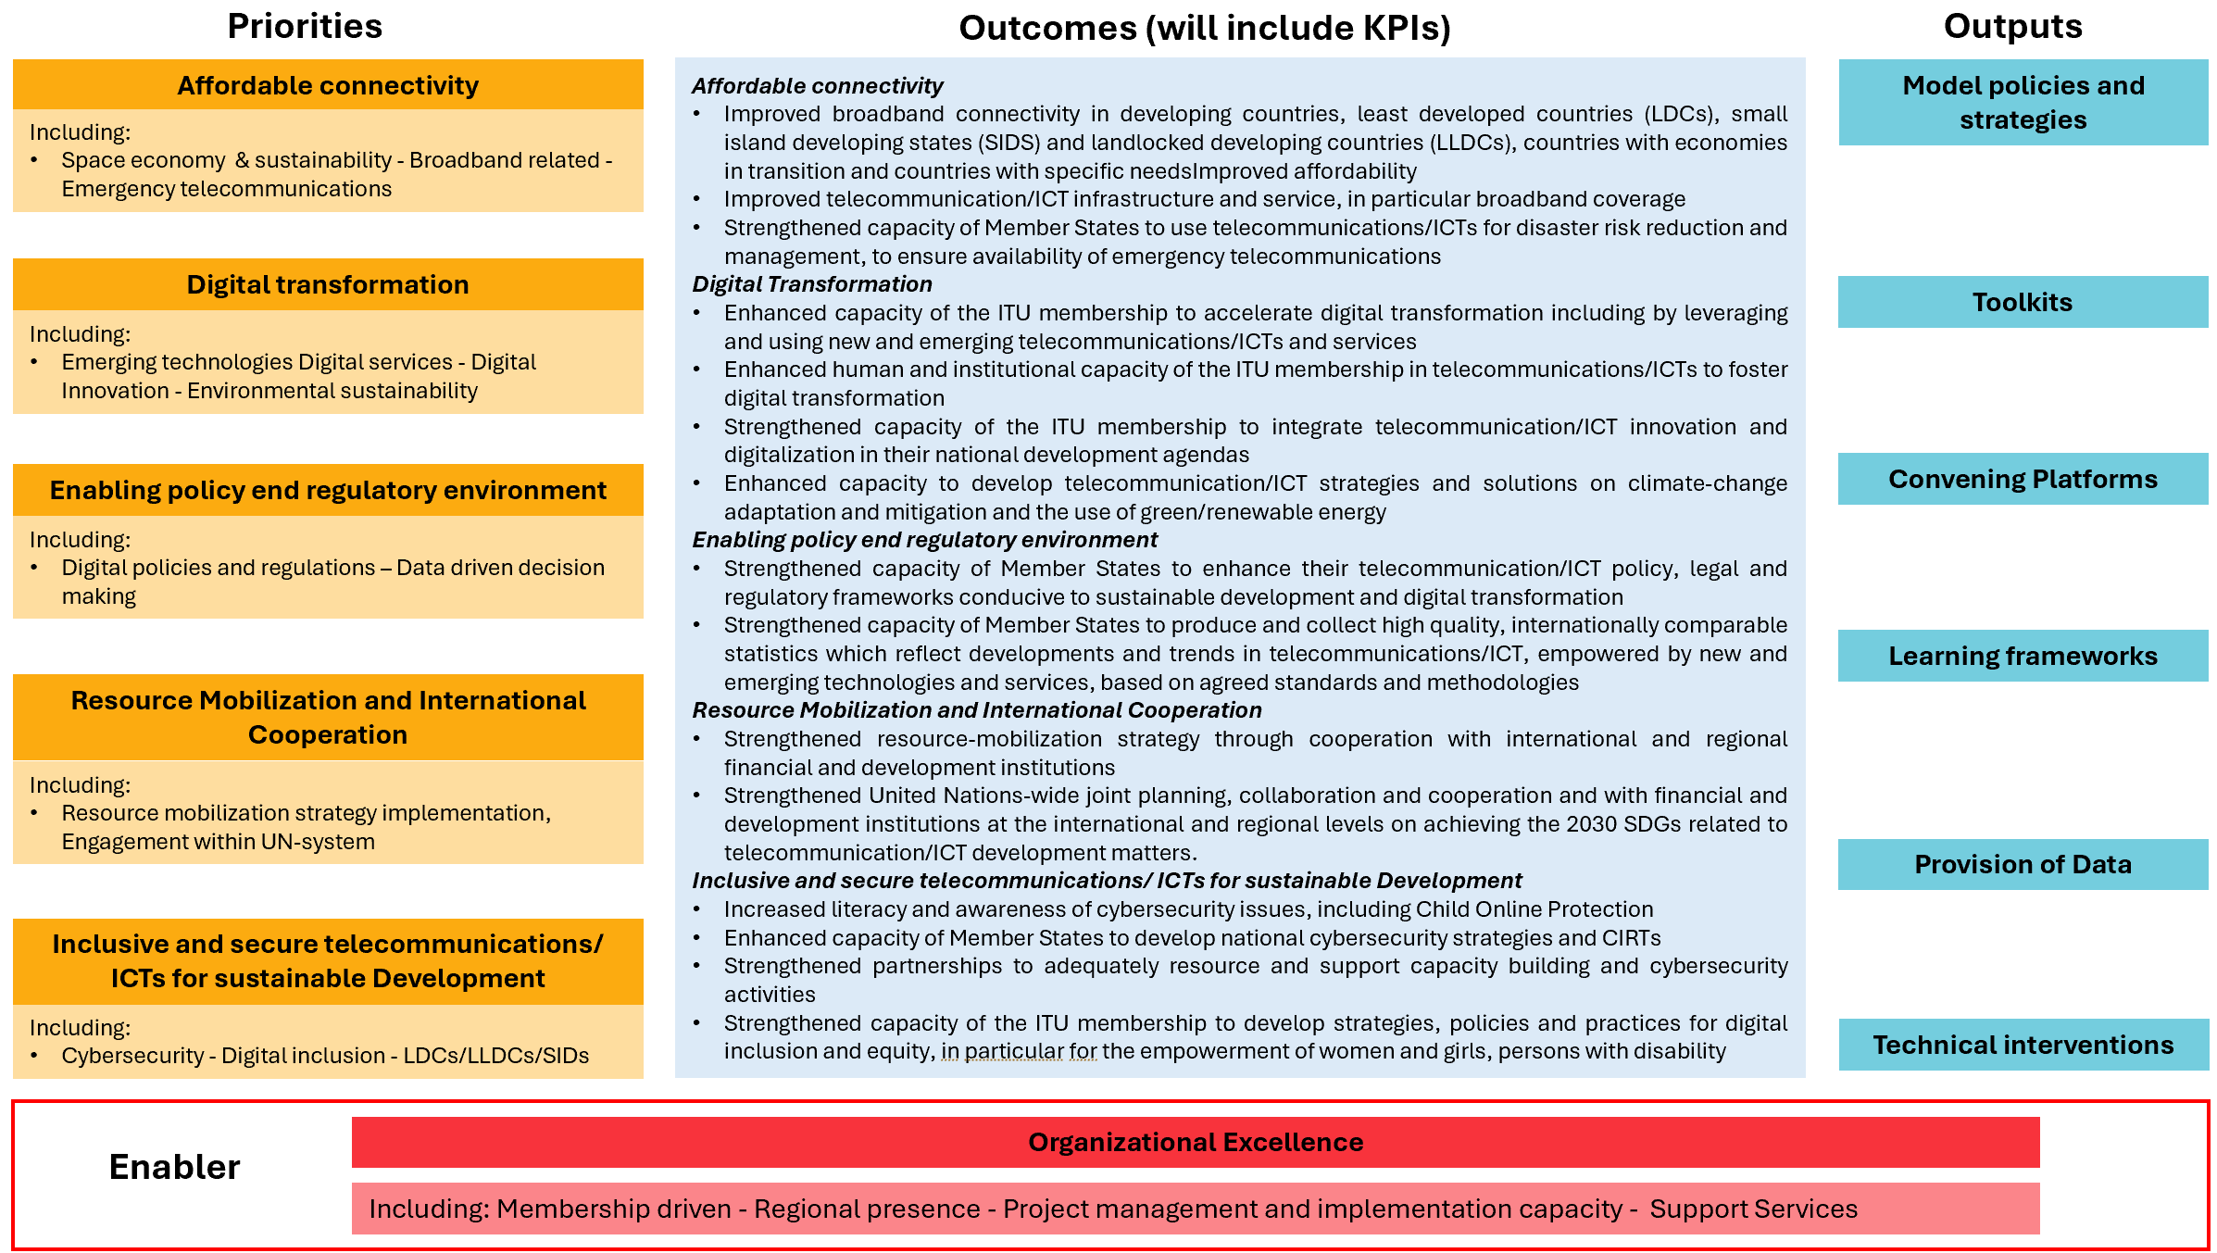
…]

ITU-D priorities
Affordable connectivity
This priority seeks to foster access to telecommunications/ICTs, including the Internet, digital communication services, broadband, voice services and such devices—at a cost that is reasonable and sustainable for individuals or households, relative to their income, without causing financial hardship. Under this priority, BDT will continue providing assistance to Member States in the development of telecommunications/ICTs infrastructure and services, expanding broadband access and coverage, and ensuring emergency telecommunications and disaster risk resilience.
[ NEW Outcomes and Key Performance Indictors (KPIs)
Outcomes | KPIs
Improved broadband connectivity in developing countries, least developed countries (LDCs), small island developing states (SIDS) and landlocked developing countries (LLDCs), countries with economies in transition and countries with specific needs |  | Number of countries with broadband plans [Disaggregated LDCs), (LLDCs), (SIDS]
Improved telecommunication/ICT infrastructure and service, in particular broadband coverage |  | Percentage of countries with available data where at least 90 per cent of the population is covered by 3G network or higher. [Disaggregated LDCs, LLDCs, SIDS, All countries]
Strengthened capacity of Member States to use telecommunications/ICTs for disaster risk reduction and management, to ensure availability of emergency telecommunications |  | Number of countries with a national emergency telecommunication plan as part of their national disaster risk reduction strategies
Digital transformation
The focus of this priority is to foster the development and use of telecommunications/ICTs, as well as applications and services, to close the digital divide and empower people and societies for sustainable development.
The priority will identify new approaches that engage Member States and other stakeholders in digital transformation, including start-ups, SMEs, entrepreneurships, public-private partnerships (PPPs), and the public and private sectors to support integration of ICT innovation and national development agendas while identifying needs and delivering initiatives at a national level.
Recognizing that telecommunications/ICTs come with risks, challenges and opportunities for the environment, ITU will continue to support the use of telecommunications/ICTs for monitoring, mitigating and adapting to climate change, facilitating digital solutions for energy efficiency and reduced carbon emissions and protecting human health and the environment from e-waste. The environmental lens addressing climate change and integrating environmental sustainability considerations is instrumental to promote sustainable digital transformation, also in line with the Strategy for Sustainability Management in the United Nations System 2020-2030.
[ NEW Outcomes and Key Performance Indictors (KPIs)
Outcomes | KPIs
Enhanced capacity to accelerate digital transformation and sustainable development through the use of new and emerging telecommunications/ICTs and services | Number of countries having adopted a digital sectoral strategy at the national level
Enhanced human and institutional capacity of the ITU membership in telecommunications/ICTs to foster digital transformation | Number of countries having adopted innovation strategies and initiatives
Strengthened capacity to develop and integrate telecommunication/ICT innovation and digitalization in national development agendas
Enhanced capacity to develop telecommunication/ICT strategies and solutions on climate-change adaptation and mitigation and the use of green/renewable energy | Number of countries having adopted an e-waste policy, legislation or regulation at national level
…]
Enabling policy and regulatory environment
The focus of this priority is to foster an enabling policy and regulatory environment conducive to sustainable telecommunication/ICT development and data-driven decision making, encouraging investment in infrastructure and ICTs and increased adoption of telecommunications/ ICTs.
[ NEW Outcomes and Key Performance Indictors (KPIs)
Outcomes | KPIs
Strengthened capacity of Member States to enhance their telecommunication/ICT policy, legal and regulatory frameworks conducive to sustainable development and digital transformation | Number of countries advancing to the next generation of regulation (G1-G4) and/or to a higher level of preparedness for the digital transformation (G5
Strengthened capacity of Member States to produce and collect high quality, internationally comparable statistics which reflect developments and trends in telecommunications/ICT, empowered by new and emerging technologies and services, based on agreed standards and methodologies | Percentage of Member States that submitted valid data no older than two years for at least 80 per cent of the indicators of the ITU World Telecommunication Indicators short questionnaire
 | Percentage of Member States submitting valid data no older than three years for at least 80 per cent of the indicators for the ITU’s household questionnaire
 | Percentage of Member States that submitted valid gender disaggregated data no older than three years for the indicator ‘Share of individuals using the Internet’
 | Percentage of Member States that submitted valid location disaggregated data (rural/urban) no older than three years for the indicator ‘share of individuals using the Internet’
 | Percentage of Member States that submitted valid data no older than three years for at least five of the information and communication technologies (ICTs) skills listed in the questionnaire
…]
Resource Mobilization and International Cooperation
The focus of this priority is on mobilizing and attracting resources and fostering international cooperation on telecommunication/ICT development issues. In this process, the needs of developing countries, including Least Developed Countries (LDCs), Small Island Developing States (SIDS), Landlocked Developing Countries (LLDCs) and countries with economies in transition, as well as underserved and vulnerable populations, should be prioritized and given due attention.
ITU also recognizes the importance of cultivating strategic partnerships with United Nations agencies and other organizations, including standardization bodies, to enhance cooperation for addressing challenges across the telecommunications/ICTs sector towards the delivery of the WSIS Action Lines and achievement of the 2030 SDGs.
[ NEW Outcomes and Key Performance Indictors (KPIs)
Outcomes | KPIs
Strengthened resource-mobilization strategy through cooperation with international and regional financial and development institutions | Number of ICT development agreements signed between ITU and partners to support implementation of the WTDC Action Plan
Strengthened United Nations-wide joint planning, collaboration and cooperation and with financial and development institutions at the international and regional levels on achieving the 2030 SDGs related to telecommunication/ICT development matters.
…]
Inclusive, safe and secure telecommunications/ICTs for sustainable development
The focus of this priority is on providing support for Member States to achieve secure telecommunications/ICTs for digital development, ensuring safe and meaningful telecommunications/ICTs access for all. Specifically, the priority tackles and addresses challenges related to building confidence and security in the use of ICTs, while fostering inclusion on its use, specifically in relation to of women, youth, persons with disabilities and persons with specific needs as well as providing tailored support to Least Developed Countries (LDCs), Landlocked Developing Countries (LLDCs), and Small Island Developing States (SIDS).
[ NEW Outcomes and Key Performance Indictors (KPIs)
Outcomes | KPIs
Increased literacy and awareness of cybersecurity issues, including online Child Protection | Number of countries having adopted cybersecurity strategies in their national development agenda
Enhanced capacity of Member States to develop national cybersecurity strategies and CIRTs | Number of countries with a computer incident response team (CIRT)
Strengthened partnerships to adequately resource and support capacity building and cybersecurity activities | Number of Member States increasing commitment to cybersecurity measured through the Global Cybersecurity Index (GCI)
Increased secured online services, including child online protection | Number of countries with online child support systems identified (e.g., helplines, referral systems)
Strengthened capacity of the ITU membership to develop strategies, policies and practices for digital inclusion and equity, in particular for the empowerment of women and girls, persons with disability | Number of countries having developed a digital inclusion policy and strategy at national level
…]

Outputs
As per the definition provided, outputs are mainly products and services developed by the BDT, to be used to ensure the delivery of the ITU-D mandate at the national, regional and international level.
Outputs are inherently cross-cutting, covering all priorities. Below, the proposed list of outputs.
- Model policies and strategies
- Toolkits
- Convening platforms
- Learning frameworks
- Provision of data
- Technical interventions
[ NEW

Enabler
Organization Excellence
Enhancing operational efficiency and effectiveness enables ITU to respond to changes in the telecommunication/ICT landscape and evolving membership needs, as well as enhanced understanding of local contexts and the ability to respond to countries' needs effectively. ITU, therefore, aims to improve internal processes including project management processes and implementation capabilities and accelerate decision-making by addressing operational inefficiencies and duplication, reflecting the values of transparency and accountability.
ITU also recognizes the need to build operational effectiveness, by increasing cross-functional synergies, encouraging internal innovation, providing consistent guidance on the organization's scope and developing a stronger performance and talent-management approach. To this end, the organization continue to implement a transformation plan for culture and skills based on four main tracks: strategic planning, innovation including IT systems and support services and human resource management. Organization excellence includes among others:
- Membership-driven
ITU will continue to work as a membership-driven organization to effectively support and reflect the needs of its diverse members. ITU recognizes the needs of all countries, in particular developing countries, including LDCs, SIDS, LLDCs and countries with economies in transition, which should be prioritized and given due attention.
ITU will also work to deepen its engagement with representatives of the telecommunication/ICT and other industry sectors, to demonstrate ITU's value proposition in the context of the strategic goals.
- Regional Presence
As an extension of ITU as a whole, the regional presence plays a vital role in the achievement of ITU's mission, enhancing the Union's understanding of local contexts and its ability to respond to countries' needs effectively.
The regional presence will consolidate strategic planning at the level of each regional/area office, implementing programmes and initiatives that are consistent with and based on the Union's strategic goals and thematic priorities.
The regional presence will strengthen ITU's position as a shaper/doer and enhance United Nations cooperation, to build enhanced regional opportunities and thereby reach more countries and define clearer, more impactful priorities for country-level engagements.
Efforts will also be made to strengthen capacity at the regional level to ensure the ability of the regional and area offices to implement the programmes and engagements determined based on the Union's strategic goals and thematic priorities.
- Project Management
In fulfilling ITU's dual responsibility as a United Nations specialized agency and executing agency for implementing telecommunication/ICT development projects under the United Nations development system or other funding arrangements, ITU‑D offers, organizes and coordinates technical cooperation assistance through regional initiatives and projects.
Strengthened project management capacity and implementation will ensure alignment with broader strategic plans and development outcomes, while introducing improved methods, tools, and practices to enhance the efficiency, effectiveness, and accountability of project planning, execution, monitoring, and completion.
- Support Services
To ensure effective and efficient delivery of ITU-D’s mandate and programmatic work, essential administrative and operational functions will be prioritized. These foundational services enable smooth operations, enabling program teams to focus on delivering results. These services include among others:
- Communications
- Fellowships
- Events support
- Document processing
- Performance monitoring and reporting
- HR and Budget support
- Overall coordination
…]

Regional initiatives
To be added later.

Resolutions
To be added once agreed at WTDC.

Study groups
To be added once agreed at WTDC.

Linkages and mapping
To be developed once all the relevant elements are in place.
________________

