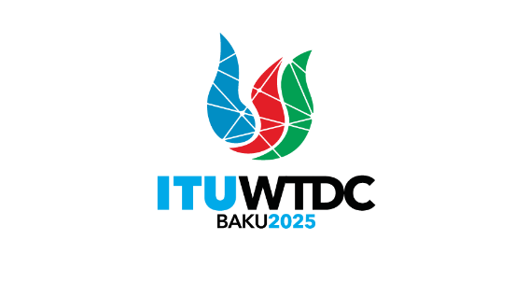 | TDAG Working Group  on ITU-D Priorities (TDAG-WG-ITUDP)  5th Meeting, Hybrid, 14 May 2025 |  | 
 |  | Document TDAG-WG-ITUDP/17-E
 |  | 13 May 2025
 |  | English only
Chair, TDAG-WG-ITUDP
Draft agenda

 | Items | Documents
1. | Adoption of the Agenda | TDAG-WG-ITUDP/17
2. | Proposal for Baku Action Plan (WTDC-25) | TDAG-WG-ITUDP/18
3. | Proposal for draft ITU-D Priorities | TDAG-WG-ITUDP/19
4. | The next meeting
5. | Any other business
_______________

