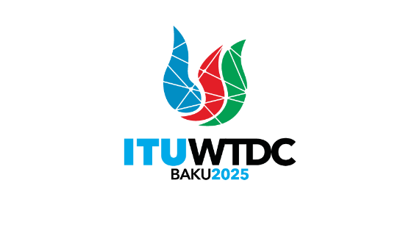 | TDAG Working Group  on ITU-D Priorities (TDAG-WG-ITUDP)  4th Meeting, Virtual, 1 May 2025 |  | 
 |  | Document TDAG-WG-ITUDP/11-E
 |  | 28 April 2025
 |  | English only
Chair, TDAG-WG-ITUDP
Draft agenda

 | Items | Documents
1. | Adoption of the Agenda | TDAG-WG-ITUDP/11
2. | Status of implementation of the ITU Strategic Plan 2024-2027 relating to ITU-D and preparation of the new Plan for 2028-2031
3. | Proposed structure of Baku Action Plan | TDAG-WG-ITUDP/13
4. | Outcomes of the Regional Preparatory Meetings for WTDC-25: The proposed Regional Initiatives for the period 2026-2029 | TDAG-WG-ITUDP/12
5. | The next meeting
6. | Any other business
_______________

