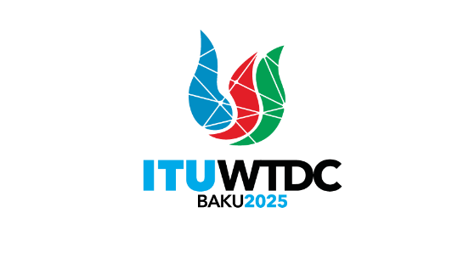 | TDAG Working Group  on ITU-D Priorities (TDAG-WG-ITUDP)  3rd Meeting, Virtual, 26 March 2025 |  | 
 |  | Document TDAG-WG-ITUDP/8-E
 |  | 31 March 2025
 |  | English only
Chair, TDAG-WG-ITUDP
Chair’s Note – 20 March 2025

TDAG Working Group on ITU-D Priorities is expected to organize its work basing on the Terms of Reference (TDAG-24/DT/5) and deliver outputs expected from this Working Group.
Proposal would be to have 2 more meetings (with option to have additional one during TDAG, if needed): 26 March and 2 May (side-to-side with the TDAG WG on Streamlining Resolutions, as an option) to cover all tasks for the Working Group, as per Terms of Reference.
- The Working Group on ITU-D Priorities should review:
  - Current ITU-D Priorities and related enablers set at WTDC-22;
  - Proposals to WTDC-25 including on regional initiatives, ITU-D study Questions;
  - Outcomes of the Regional Preparatory Meetings for WTDC-25;
  - 2030 Sustainable Development Goals and the relevant WSIS Action Lines for which ITU has lead responsibility;
  - Status of implementation and impact of the ITU Strategic Plan 2024-2027 relating to ITU-D;
  - Status of implementation and impact of the Kigali Action Plan (KAP) including its links with the Operational Plan;
  - Status of implementation and impact of the four-year rolling Operational Plan, identify areas of improvement.
- The Working Group on ITU-D Priorities should develop these deliverables:
  - Proposals for the new ITU-D Priorities;
  - Prepare proposals for the draft new ITU-D contribution to the ITU Strategic Plan for the next period (2028-2031);
  - Proposals for the next WTDC Action Plan;
  - Recommendations for the Draft Operational Plan;
  - Report to the TDAG-24.
- Proposed Approach
The TDAG-WG-ITUDP Chair proposes to put the review of 1.4-1.7 on the Agenda of the Working Group’s meeting on 26th of March, believing that this information will be helpful for discussions on Current ITU-D Priorities and related enablers set at WTDC-22 (1.1).
Review of proposed regional initiatives and ITU-D study Questions, as well as information on the outcomes of the Regional Preparatory Meetings for WTDC-25 (1.2-1.3) is more relevant during the next WG meeting in May (TBC) after all RPMs and the last meeting of Working Group on the Future of the Study Group Questions, scheduled for 16 April 2025. The results of TDAG WG on Declaration shall be taken into account as well.
In terms of TDAG-WG-ITUDP Deliverables (2.1-2.4), Chair proposes:
  - To start the discussion on the new ITU-D Priorities after reflecting on the current 5 ITU-D Priorities, as agreed at WTDC-22 , to see if/what improvements may be needed:
Affordable Connectivity;
Digital Transformation;
Enabling Policy and Regulatory Environment;
Resource Mobilization and International Cooperation;
Inclusive and secure telecommunications/ICTs for sustainable development.
The next step would be revision of current Outcomes, Outputs, Enablers for the same purpose of improvements and alignment with the agreed draft new ITU-D Priorities. After initial discussion on 26th March, it will be expected to receive written contributions from the Members of this Working Group with specific proposals and views regarding new ITU-D Priorities.
  - Proposals for the draft new ITU-D contribution to the ITU Strategic Plan for the next period (2028-2031) may be developed after Working Group agrees on the draft new ITU-D Priorities, taking into account the work of the Council Working Group for strategic and financial plans 2028-2031 (CWG-SFP) and other relevant updates.
  - To start work on the next WTDC Action Plan – Baku Action Plan – from the structure. Members of the WG are invited to consider the Proposed Structure of Baku Action Plan as provided in the Annex 1 of this Chair’s Note.
  - To propose Recommendations for the Draft Operational Plan in written form for the next WG meeting. If there are any proposals during the meeting of 26th March, they will be properly captured in the Report and included into final list of Recommendations.
  - Report to the TDAG-24 about results of this Working Group will be prepared and submitted after the last meeting of the WG.
The Chair of TDAG-WG-ITUDP is open to any views regarding the proposals expressed in this document.

ANNEX 1
Proposed structure of Baku Action Plan
- Introduction
- Terminology
- ITU-D priorities, outcomes, outputs and enablers
- Regional initiatives
- Resolutions
- Study groups
- Linkages and mapping
_______________

The Kigali Action Plan describes the ITU-D priorities and scope of activities and associated outcomes and outputs for the period 2023-2027 and includes KPIs. The ITU-D action plan may be updated or modified by TDAG to reflect the ITU strategic plan, changes in the telecommunication/ICT environment and/or as a result of the performance evaluation to be conducted each year. (Kigali Action Plan, page 27)

