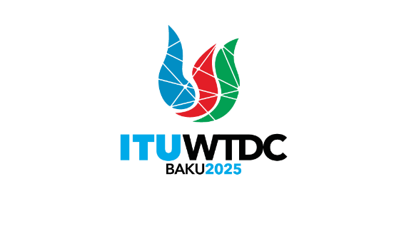 | TDAG Working Group  on the Declaration (TDAG-WG-DEC)  5th Meeting, 14 May 2025, Hybrid, Switzerland |  | 
 |  | Document TDAG-WG-DEC/17(Rev.1)-E
 |  | 15 May 2025
 |  | English only
Chair, TDAG-WG-DEC
Draft Agenda
Summary:
The document contains the draft agenda of the fifth meeting of the group.
Action required:
For action
References:
Terms of Reference of TDAG-WG-DEC: TDAG-24/DT/4

 | Item | Document
1 | Opening of the meeting
2 | Welcome remarks by the Chair of TDAG-WG-DEC
3 | Approval of the agenda | TDAG-WG-DEC/17
4 | Discussion on the title of the Baku Declaration and the theme of the World Telecommunication Development Conference 2025 (WTDC-25)
5 | Presentation of the second revised draft proposal for the Baku Declaration | TDAG-WG-DEC/14
6 | Presentation of new contributions to the draft proposal | TDAG-WG-DEC/18  TDAG-WG-DEC/19  TDAG-WG-DEC/20  TDAG-WG-DEC/21
7 | Discussion on suggested revisions and way forward
8 | Any other business
______________

