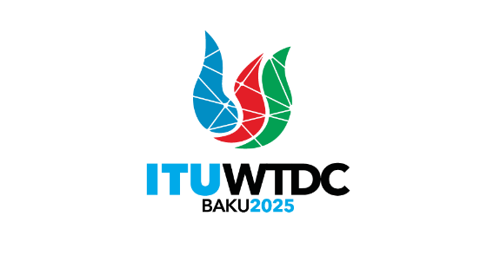 | TDAG Working Group  on the Declaration (TDAG-WG-DEC)  5th Meeting, 14 May 2025, Hybrid, Switzerland |  | 
 |  | Document TDAG-WG-DEC/17-E
 |  | 13 May 2025
 |  | English only
Chair, TDAG-WG-DEC
Draft Agenda
Summary:
The document contains the draft agenda of the fifth meeting of the group.
Action required:
For action
References:
Terms of Reference of TDAG-WG-DEC: TDAG-24/DT/4

 | Item | Document
1 | Opening of the meeting
2 | Welcome remarks by the Chair of TDAG-WG-DEC
3 | Approval of the agenda | TDAG-WG-DEC/17
4 | Presentation of the second revised draft proposal for the Baku Declaration 2025 | TDAG-WG-DEC/14
5 | Presentation of new contributions to the draft proposal | TDAG-WG-DEC/18  TDAG-WG-DEC/19  TDAG-WG-DEC/20  TDAG-WG-DEC/21
6 | Discussion on suggested revisions and way forward
7 | Any other business
______________

