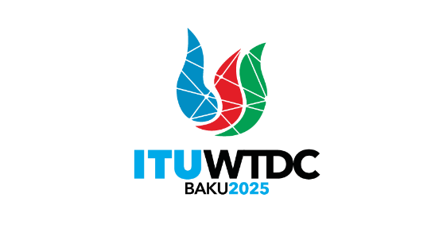 | TDAG Working Group  on the Declaration (TDAG-WG-DEC)  3rd Meeting, Virtual, 5 March 2025 |  | 
 |  | Document TDAG-WG-DEC/8-E
 |  | 3 March 2025
 |  | English only
Chair, TDAG-WG-DEC
Draft Agenda
Summary:
The document contains the draft agenda of the third meeting of the group.
Action required:
For action
References:
Terms of Reference of TDAG-WG-DEC: TDAG-24/DT/4

 | Item | Document
1 | Opening of the meeting
2 | Welcome remarks by the Chair of TDAG-WG-DEC
3 | Approval of the agenda
4 | Draft proposal for the Baku Declaration 2025: presentation and discussion | TDAG-WG-DEC/9
5 | Progress report by Regional Telecommunication Organizations:  - APT  - ATU  - CEPT  - CITEL  - LAS  - RCC
6 | Any other business
______________

