|  |  |
| --- | --- |
| **Regional Preparatory Meeting  for Europe for WTDC-25 (RPM-EUR)**  **Budapest, Hungary, 25-26 February 2025** |  |
|  |  |
|  | **Document** **RPM-EUR25/3(Rev.1)-E** |
|  | **4 February 2025** |
|  | **Original: English** |
| Director, Telecommunication Development Bureau | |
| State of digital development and trends in the Europe region:  Challenges and opportunities | |
|  | |
| **Agenda item:**  Item 5  **Summary:**  This document, prepared for the Regional Preparatory Meeting for the Europe region (RPM-EUR), aims to inform participants and stakeholders in setting the region’s digital agenda. It is structured into two parts: the first provides an overview of the state of digital connectivity in Europe through key indicators; and the second highlights impactful case studies from the region.  **Expected results:**  RPM-EUR is invited to note this document.  **References:**  N/A | |

State of digital development and trends in the Europe region: Challenges and opportunities

January 2025

Contents

Introduction 3

Part 1. The state of digital connectivity in the Europe region and recent trends 5

ICT regulation and digital policy frameworks 5

Internet use 12

Broadband subscriptions 18

Mobile network coverage 20

Availability of fixed-broadband infrastructure 22

Internet traffic 24

Affordability of ICT services 26

Mobile phone ownership and subscriptions 28

ICT skills 30

Revenue and investment 34

Cybersecurity 36

E-waste management 38

Disparities within the region 42

Overview of data availability in the Europe region 44

Part 2. BDT4Impact: Selected case studies from the Europe region 46

Promoting and measuring meaningful connectivity around the world 46

Promoting child online protection in the Europe region, e.g. Andorra, Malta and Serbia 46

IPv6 laboratory in Montenegro 46

Driving sustainable rural digital transformation in Albania 47

CyberDrills in Bulgaria and Cyprus enhance cybersecurity readiness in countries and across regions 47

Supporting broadband mapping systems in Albania, Bosnia and Herzegovina, and Moldova 48

Annex: Data resources 49

Introduction

The regional preparatory meetings (RPMs) aim at engaging the membership in the preparations for the World Telecommunication Development Conference (Baku, 2025). Prepared for the RPM for the Europe region on 25-26 February 2025, this document seeks to inform participants and stakeholders as they discuss the region’s digital agenda.[1] The document consists of two parts: the first provides an overview of the state of digital connectivity in Europe through key indicators, and the second showcases impactful case studies from the region.

**Universal and meaningful connectivity is a policy imperative.** The concept of universal and meaningful connectivity (UMC) has emerged as a vital policy objective. UMC is defined as enabling everyone to enjoy a safe, enriching and productive online experience at an affordable cost. It does not mean everyone must be connected all the time but describes a situation where everyone can access the Internet optimally and affordably whenever and wherever needed. In the journey towards UMC, the Europe region is leading the way, having achieved universal broadband access, bridged or considerably narrowed digital divides across generations, locations and genders.

**The Europe region is a global leader in regulation for digital transformation.** Europe boasts strong information and communication technology (ICT) regulatory frameworks and cohesive policy initiatives. Since the 1990s, the region has led significant telecommunication reforms, harmonizing regulatory approaches to foster competition, innovation and digital inclusion. The European Union’s unified digital framework, exemplified by initiatives such as the Digital Decade, has further enhanced the region’s position as a global leader in ICT governance. Despite these achievements, however, challenges remain: disparities in digital access and use persist between European single market countries and the other countries in the region, underscoring the need for targeted policies and greater collaboration.

**The Europe region boasts high levels of connectivity.** The region’s digital connectivity landscape reflects its successes and remaining challenges. Europe boasts high levels of Internet usage, with 91 per cent of the population using the Internet in 2024, far exceeding the global average of 68 per cent. The region has achieved gender parity in Internet use, with a near-equal proportion of men and women online. Mobile- and fixed-broadband subscriptions stand significantly above global averages. Mobile network coverage has also seen rapid expansion, with 5G networks already covering 72 per cent of the population as of 2024; yet, urban-rural divides persist, particularly in access to high-speed networks, underscoring the need for continued investment in rural areas.

**The Europe region leads in broadband affordability, making connectivity accessible to all.** In terms of affordability, Europe stands out as the region with the most affordable broadband services globally. Entry-level mobile-broadband services account for just 0.3 per cent of gross national income (GNI) per capita, compared to a global average of 1.1 per cent. Fixed-broadband services, though costlier, remain affordable by international standards, with average costs below the target of the ITU/UNESCO Broadband Commission for Sustainable Development of 2 per cent of monthly GNI per capita.

**Cybersecurity is a priority for a digitally secure future.** Overall, European countries exhibit strong commitment to cybersecurity, as reflected in the region’s average score of 66 out of 100 in the Global Cybersecurity Index (GCI). However, there are some stark differences: some countries rank among the global leaders, while others lag far behind, with the region’s worst performer scoring just 25.9.

**The Europe region leads in e-waste management but faces regional disparities.** Europe generates nearly 20 per cent of the world’s e-waste, amounting to approximately 12.3 billion kg in 2022. The region boasts one of the highest recycling rates globally at 46 per cent, which is twice the global average; disparities persist, however, with some countries lacking the infrastructure and policy frameworks needed to address e-waste effectively.

**The telecommunication sector drives economic growth but reveals investment disparities.**  
The telecommunication sector is a cornerstone of the Europe region’s digital economy, contributing significantly to economic development both directly and indirectly. In 2023, the sector generated USD 290 billion in revenue, accounting for an average of 1.2 per cent of gross domestic product (GDP) across the region. Disparities in investment, however, highlight underlying challenges, with some countries investing substantially more as a percentage of GDP compared to others. This uneven distribution of resources could hinder the pace of digital transformation in less-developed parts of the region, emphasizing the need for targeted policies to stimulate investment and ensure balanced growth.

**High data availability and quality enable evidence-based policy-making.** The Europe region stands out for the availability and quality of its ICT data, which exceeds that of other regions. This comprehensive and reliable data enables policy-makers to identify gaps, set priorities, design effective interventions and track progress. High-quality data collection supports Europe’s strong digital performance, helping governments make informed decisions and achieve impactful results in areas such as Internet access, cybersecurity and broadband development.

**Initiatives demonstrate the transformative power of digital connectivity.** The second part of this document presents a selection of impactful initiatives led or supported by the ITU Telecommunication Development Bureau (BDT) in collaboration with regional stakeholders. These stories demonstrate the potential of connectivity to drive social and economic development. For instance, Montenegro’s IPv6 laboratory showcases how innovation can enhance digital readiness. In Albania, the Digital Agriculture and Rural Transformation programme is leveraging technology to support smallholder farmers, contributing to the United Nations Sustainable Development Goals (SDGs). Broadband mapping initiatives in Albania, Bosnia and Herzegovina, and Moldova reveal the importance of targeted interventions to enhance connectivity in underserved and hard-to-reach areas. These are concrete, tangible examples of how ITU, Member States and partners can combine to tackle some of the challenges identified in this document and accelerate progress towards UMC and digital transformation.

**The Europe region is ready to shape the future of digital transformation.** Building on its successes and addressing remaining gaps, Europe has the potential to achieve UMC in the near future. This will enable the region to unleash the full potential of digital technologies for social progress and economic prosperity.

Part 1. The state of digital connectivity in the Europe region and recent trends

ICT regulation and digital policy frameworks

The digital transformation in the Europe region is driven by its strong ICT regulatory frameworks and key digital policy initiatives, which play a crucial role in balancing the development of digital public services, digital inclusion and the growth of digital markets. As Europe continues to refine its regulatory approaches, understanding its priorities and challenges provides valuable insights into effective digital governance.

***The Europe region, a global pioneer in ICT regulation***

Since the 1990s, Europe has led significant telecommunication regulatory reforms, aligning closely with commitments under the General Agreement on Trade in Services (GATS) of the World Trade Organization (WTO). The European Union (EU) has championed a unified regional approach, created a harmonized framework that liberalized markets, promoted competition and fostered cross-border integration. This includes establishing independent regulatory authorities, enforcing open market access and adopting technology-neutral policies. These reforms have strengthened the telecommunication sector, setting a global standard for regionalized ICT regulation and governance and enabling the expansion of digital services across EU Member States and other countries of the region.

Evolution of the generations of ICT regulation in the Europe region

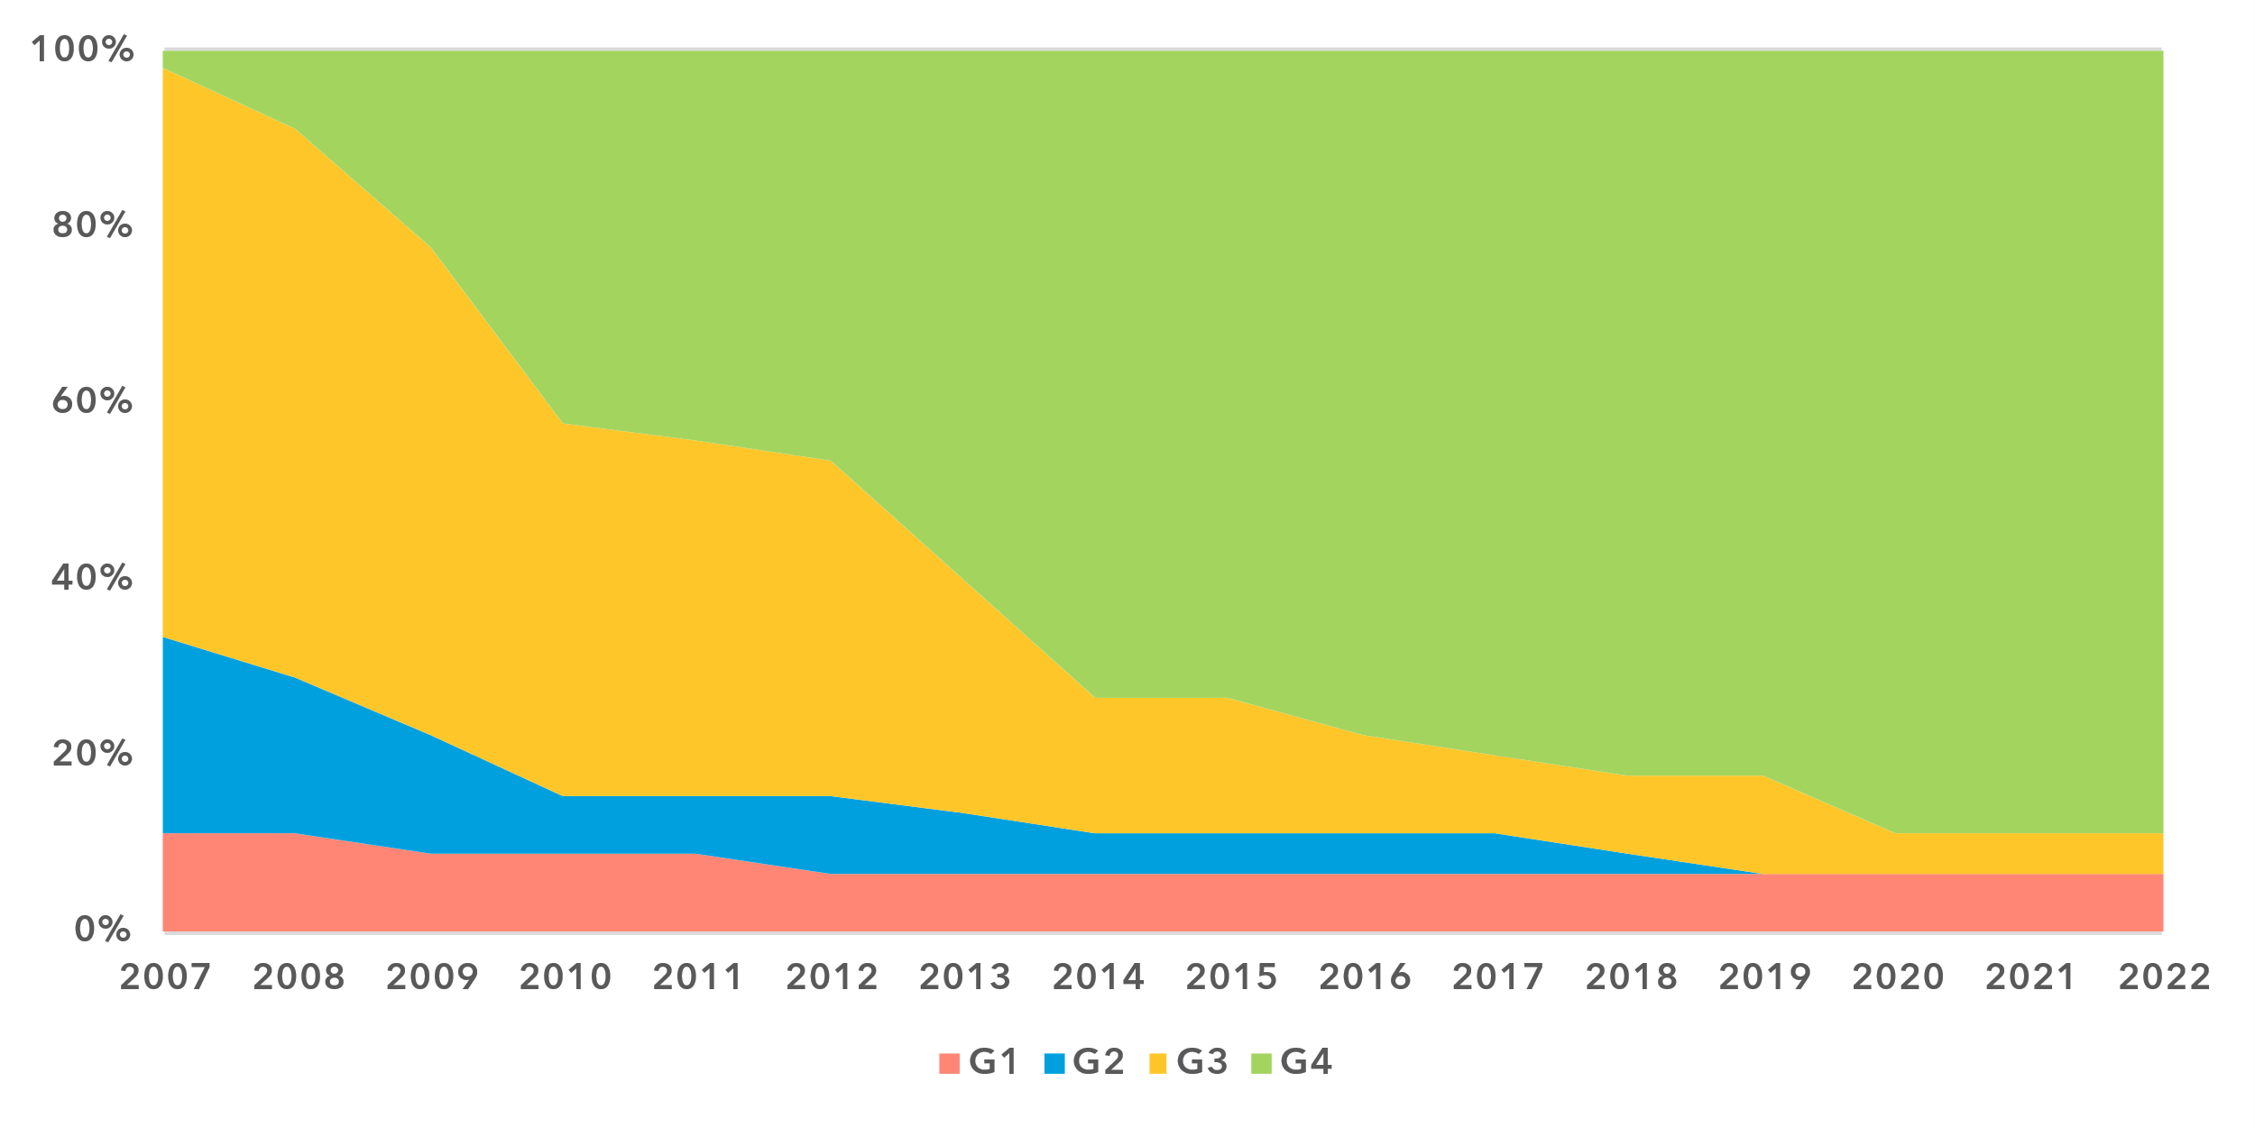

Note: The generations of ICT regulation provide a high-level conceptual framework for assessing the overall development of national legal instruments, policies and governance for the ICT and digital sectors. Generations 1 through 4 are based on [ICT Regulatory Tracker](https://app.gen5.digital/tracker/metrics) scores:

G1 – Command and control approach: score between 0 and 40   
G2 – Early open markets: score between 40 and 70   
G3 – Enabling investment and access: score between 70 and 85   
G4 – Integrated telecommunication regulation: score between 85 and 100

Data for 2021 is unavailable; 2020 data is used as a proxy for 2021.

Source: ITU

Today, the Europe region is home to the world’s top-performing countries in ICT regulation, with the 10 highest-ranked countries globally all situated in the region. Nearly 90 per cent of European countries have achieved the most advanced generation of ICT regulation (i.e. G4 – integrated telecommunication regulation). Italy leads the way followed closely by Lithuania, Finland, Ireland and Slovenia. However, gaps persist, as three countries remain in the first generation (i.e. G1 – command and control approach), and the country with the least-developed regulatory framework in the region ranks 184th out of 193 countries worldwide in 2022. These three G1 countries, microstates with fully State-owned ICT sectors, face limited prospects for regulatory advancement owing to their small market size.

In contrast, two countries currently in the third generation (i.e. G3 – enabling investment and access), Ukraine and Israel, show significant potential to advance their regulatory frameworks and strengthen their ICT markets. However, both have been facing significant challenges, particularly due to conflicts that hinder progress in regulatory reforms and market development.

***The Europe region’s trailblazing role in digital policy***

Europe has established itself as a global leader in digital policy, integrating its regionally harmonized approach with the goals of the Digital Decade initiative to set robust standards for digital regulation and governance.[2] Through the cohesive EU framework, Member States have aligned on key issues such as data protection, digital markets and cross-border connectivity, creating a unified digital ecosystem that fosters competition and consumer trust while influencing global regulatory trends. Europe’s strong ICT regulatory foundation has supported the region in building sound governance frameworks for digital markets, exemplified by the Digital Market Act and the Digital Services Act, positioning it ahead of many parts of the world. The region boasts the highest proportion of countries with ‘Advanced’ digital governance frameworks, at 60 per cent (as of 2023). Some 18 per cent of European countries appear in the ‘Leading’ category, matching the Asia and the Pacific region and significantly outperforming other regions. Eight of the 18 countries in the ‘Leading’ category for digital governance are from Europe: Austria, Estonia, Finland, Germany, the Kingdom of the Netherlands, Norway, Portugal and the United Kingdom.

Level of digital governance frameworks, by region (%), 2023

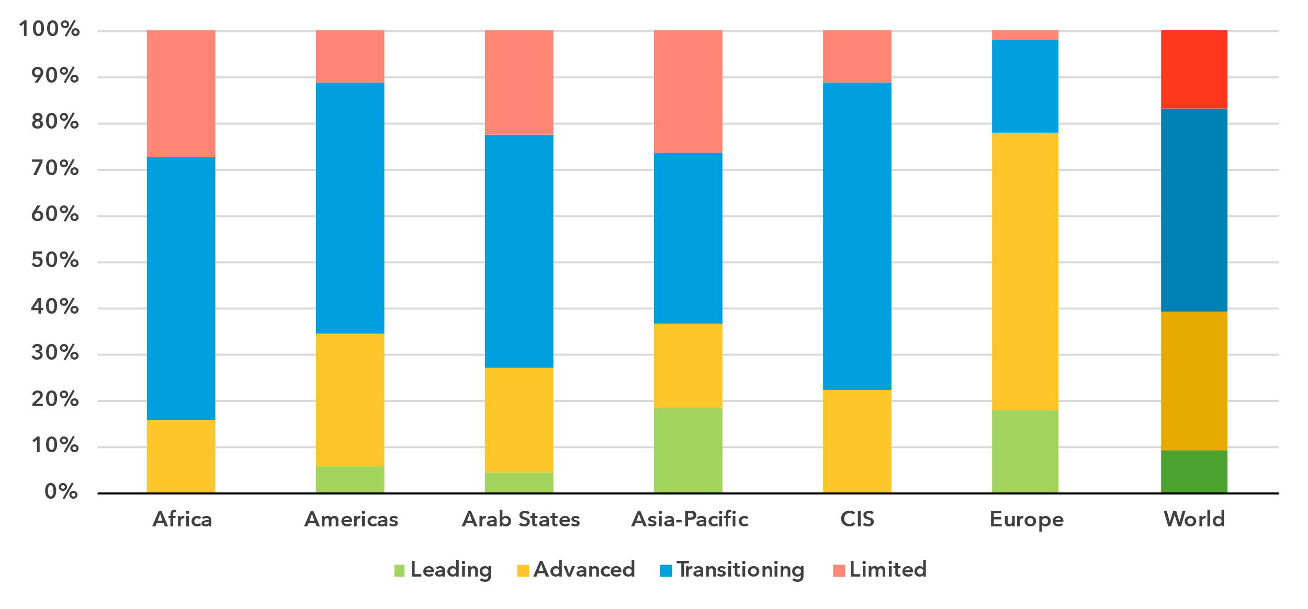

Note: The level of readiness is assessed based on the [G5 Benchmark 2023](https://app.gen5.digital/benchmark/metrics) (see [methodology](https://app.gen5.digital/G5Benchmark_methodology_2023.pdf)).

Source: ITU, [gen5.digital](https://gen5.digital/).

The Europe region has only one country at the ‘Limited’ level of readiness and the lowest proportion of ‘Transitioning’ countries among all regions. While these countries must increase investment and implement targeted initiatives to improve their enabling environments for digital markets, they stand to benefit significantly from the region’s strong integration and collaborative frameworks, which may enable rapid progress.

***Digital gaps beyond the European single market***

Despite Europe’s advanced legal, policy and governance frameworks for digital transformation, progress across the region remains uneven. Countries within the European single market (including EU and European Free Trade Association (EFTA) Member States) and the United Kingdom[3] demonstrate an overall digital readiness of 74 per cent, according to the ITU Unified Framework. This is 20 percentage points higher than the other countries in the region, which still perform above global averages in most areas. The gap between European single market countries and other countries in the region is particularly wide in important benchmarks such as regional and international cooperation (36-point gap), and in legal instruments for the telecommunication/ICT sector and ICT market rules (each with a 21-point gap).

Legal, policy and governance frameworks for digital transformation, 2023

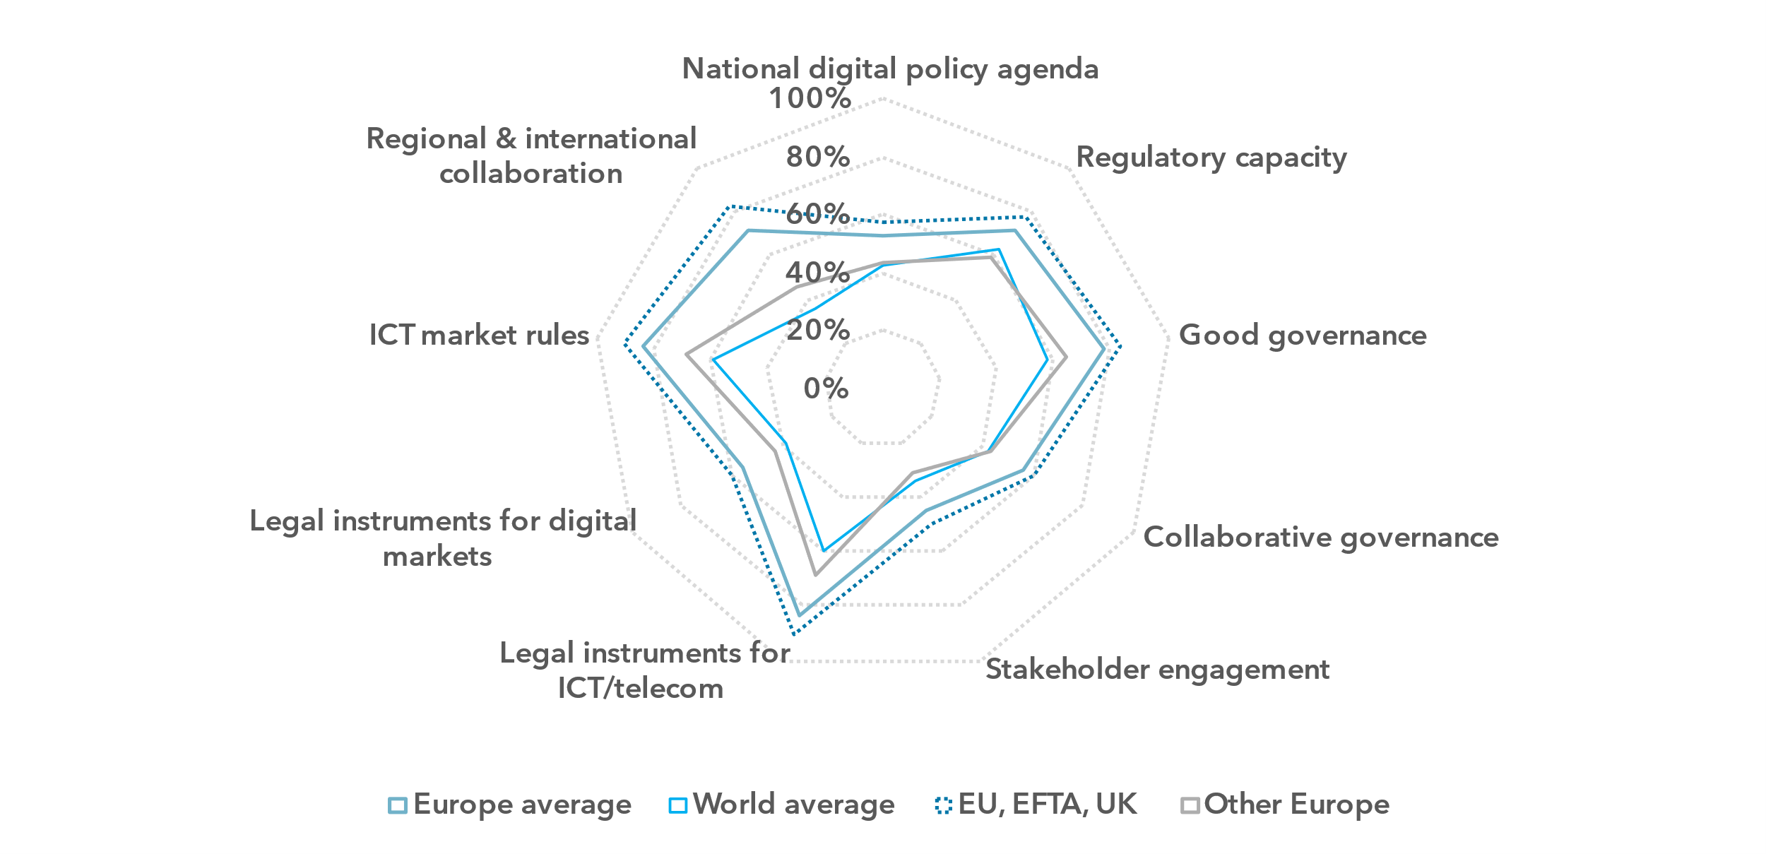

Note: The nine thematic benchmarks (as in the chart above) each comprise a subset of indicators, as part of the [ITU Unified Framework for the readiness of national policy, legal and governance frameworks for digital transformation](https://www.itu.int/pub/D-PREF-BB.REG_OUT01-2023/en).

The chart shows the average progress score on the nine benchmarks for: Europe; European single market (EU and EFTA) and the United Kingdom; other European countries; and the world. The percentage of achievement on each benchmark indicates the proportion of met versus unmet targets on indicators in each benchmark in each group.

Source: ITU

National digital strategies further illustrate these disparities. Over two-thirds of European single market countries have adopted such strategies to align policies supporting e-government, inclusion and the growth of digital economies, compared to just over one-third of other European countries. Moreover, half of EU countries with digital strategies include mechanisms for implementation and operational objectives, enabling faster and more efficient progress. In contrast, fewer than a third of other countries in the region include these elements. Universal access to broadband, a critical driver of digital inclusion, remains unaddressed at the policy level in 62 per cent of other European countries, where access to and use of digital services remain significantly lower than the rest of the region.

Regulatory capacity, a cornerstone of digital governance, also reveals stark differences. All European single market countries have established separate regulatory authorities for ICTs and digital services with strong decision-making autonomy. In comparison, a third of other European countries still have no ICT or digital regulators altogether and only half of the existing ones enjoy autonomy. The use of key policy instruments varies widely across the region. For instance, ex-post policy reviews are conducted in 77 per cent of EU countries, compared to just 38 per cent of other European countries, limiting opportunities to evaluate implementation outcomes and refine policy directions for improved results.

Broad, outcome-oriented collaboration has been recognized as essential for enabling coherent and mutually reinforcing cross-sectoral frameworks for digital transformation[4], but collaboration between regulators is another area where gaps persist. The European single market leads with a collaborative governance benchmark of 61 per cent in 2023, significantly above the global average of 43 per cent. ICT regulators in EU countries most often collaborate with counterparts from the postal, spectrum management, broadcasting and cybersecurity authorities, with engagement levels between 75 and 92 per cent. Only half of EU ICT regulators, however, engage with data protection and consumer protection authorities, highlighting significant room for improvement in these critical areas. Collaboration with financial regulators is even more limited, practiced in only 19 per cent of EU countries compared to a global average of 33 per cent.

In other European countries, the collaborative governance benchmark stands at a modest 43 per cent, with stronger collaboration observed with spectrum management regulators and education ministries, involving 77 per cent of ICT regulators. Key areas such as broadcasting, cybersecurity and competition see collaboration in just over half of these countries. The lowest levels of collaboration – only 8 per cent – are with government entities responsible for transport and energy regulation while collaborative practices with financial regulators are almost non-existent.

Across all regions, there is a considerable gap between the levels of maturity of telecommunication and digital regulation; Europe is no exception. European single market countries, as early adopters of telecommunication reforms, have today some of the most comprehensive ICT regulatory frameworks in the world and achieve 90 per cent of this benchmark in 2023. By comparison, legal instruments for digital markets score 60 per cent in these countries, still significantly higher than the global average of 39 per cent. Other European countries lag, scoring 59 per cent and 43 per cent, respectively, on the legal instruments for ICT and digital market benchmarks. Notable gaps in telecommunication regulation, ranging from 20 to 30 percentage points, persist between EU and other countries in areas such as unified licensing regimes, infrastructure sharing, co-location and number portability. In digital regulation, e-government capacity demonstrates the starkest gap, with all European single market countries having high or very high capacity, compared to only 15 per cent of other European countries[5]. Despite these gaps, both subregions show full alignment in critical areas, including national cybersecurity strategies, data protection and e-commerce laws, with all countries in the region having these instruments in place.

A regionally harmonized regulatory approach has allowed European single market countries to position themselves at the forefront of telecommunication and digital development globally, with 84 per cent participating in regional integration mechanisms that include ICTs or digital chapters as of 2023. In contrast, none of other European countries are engaged in such mechanisms or participate in regional agreements on cross-border data flows. Furthermore, all single market countries have made a commitment to facilitate trade in telecommunication services under GATS, compared to only half of other European countries. These disparities in adopting harmonized legal frameworks risk impeding cross-border digital transactions and e-commerce across the Europe region and beyond, limiting opportunities to strengthen digital economies across the region. Nonetheless, a notable achievement in international cooperation is that all countries in the region are party to the Council of Europe Convention on Cybercrime (Budapest Convention), and all were also engaged in bilateral agreements that addressed either capacity development or information sharing in cybersecurity[6].

To advance digital transformation readiness across the region, fostering greater regional cooperation, harmonizing regulatory frameworks and addressing disparities in policy adoption and implementation will be critical to ensuring inclusive and sustainable progress.

***Challenges facing non-EU countries in building supportive ecosystems for emerging technologies***

Creating supportive ecosystems for emerging technologies is essential for fostering innovation and the competitiveness of digital economies. European single market countries are considerably better equipped than other European countries across key related policy and regulatory areas, scoring consistently above the world averages. Major regionalized instruments such as the Artificial Intelligence (AI) Act and the European industrial strategy are providing cohesive frameworks for advancing innovation, ethical standards and market competitiveness, further enhancing the region’s economic resilience.

Policy instruments enabling emerging technologies ecosystems, Europe region, 2023

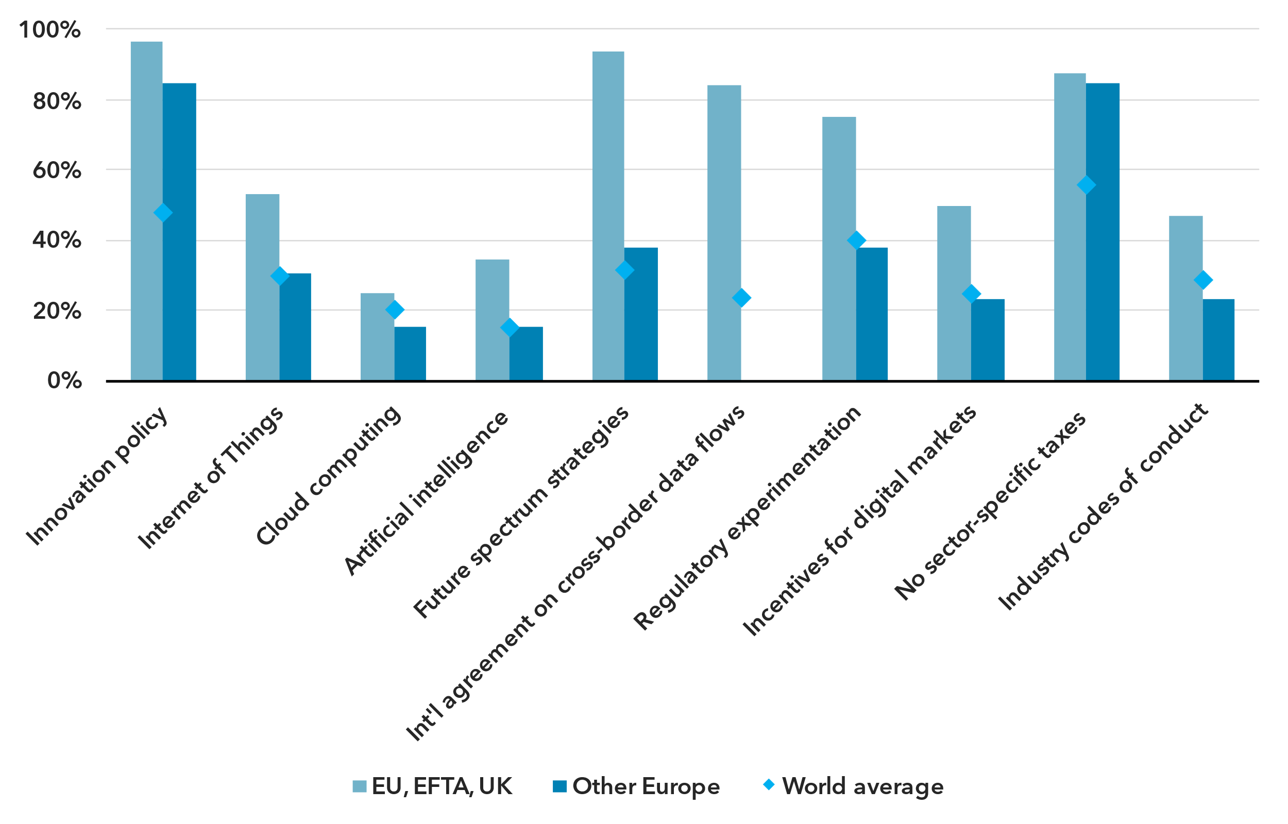

Note: The subregions’ average scores for key indicators under national digital agenda policy, legal instruments for digital markets, stakeholder engagement and regional and international collaboration in the ITU Unified Framework for countries in and outside the European single market compared to the world average.

Source: ITU

Non-EU countries in the Europe region are less likely to have frameworks for emerging technologies and currently fall slightly below global averages in most key areas. Only 15 per cent of these countries have instruments for AI and cloud computing, while just over one-third have adopted regulations or standards for the Internet of Things. Spectrum strategies addressing new digital technologies are in place in only 38 per cent of non-EU countries, compared to 94 per cent across the European single market. However, leveraging broader regional dynamics, 97 per cent of EU countries and 85 per cent of other European countries have adopted innovation policies, providing a holistic framework for science, technology and innovation development.

Regulatory experimentation mechanisms, essential for testing and refining innovative services, business models and policy approaches, are indispensable for fostering emerging technologies and digital ecosystems; yet, only 38 per cent of non-EU countries have implemented such mechanisms, compared to 75 per cent of European single market countries. Targeted incentives for ICT and digital market players, which can drive investment and lower entry barriers for new players, have been introduced in just 23 per cent of non-EU countries. On a positive note, 88 per cent of EU countries and 85 per cent of non-EU countries have refrained from imposing specific taxes on ICT and digital services, enhancing the overall ease of doing business.

Regulatory fragmentation stemming from the uneven development of policy and regulatory frameworks for emerging technologies across the Europe region hinders cross-border economic exchanges, creates uncertainty for investors and innovators and may stifle the growth of dynamic digital ecosystems. Overcoming these challenges will require targeted strategies to attract investment, enhance policy coherence and strengthen regional partnerships to build robust, inclusive and sustainable digital economies across the region.

Internet use

***Internet use in the Europe region approaching universality***

Percentage of individuals using the Internet

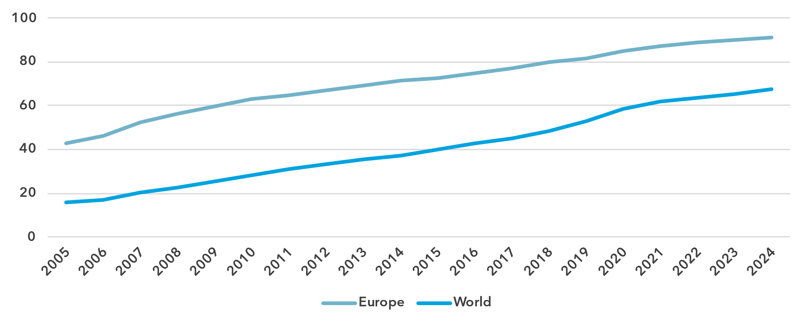Source: ITU

For most indicators assessed, the Europe region is either the leading region or a close second. This includes for the percentage of individuals using the Internet, which stood at 91 per cent in 2024, approaching universal use.[7] This puts Europe far ahead of the global average of 68 per cent. Because of the very high rate, growth in Internet use has been modest in Europe, having progressed by 2.4 per cent annually on average in the last decade. In comparison, Internet use globally grew 6.1 per cent annually over the same period. In terms of Internet use, Europe is relatively homogeneous, with only 20 percentage points separating the countries with the highest rate (100 per cent) and the lowest rate (80 per cent).

Percentage of individuals using the Internet in the Europe region, 2023 or latest year available[8]

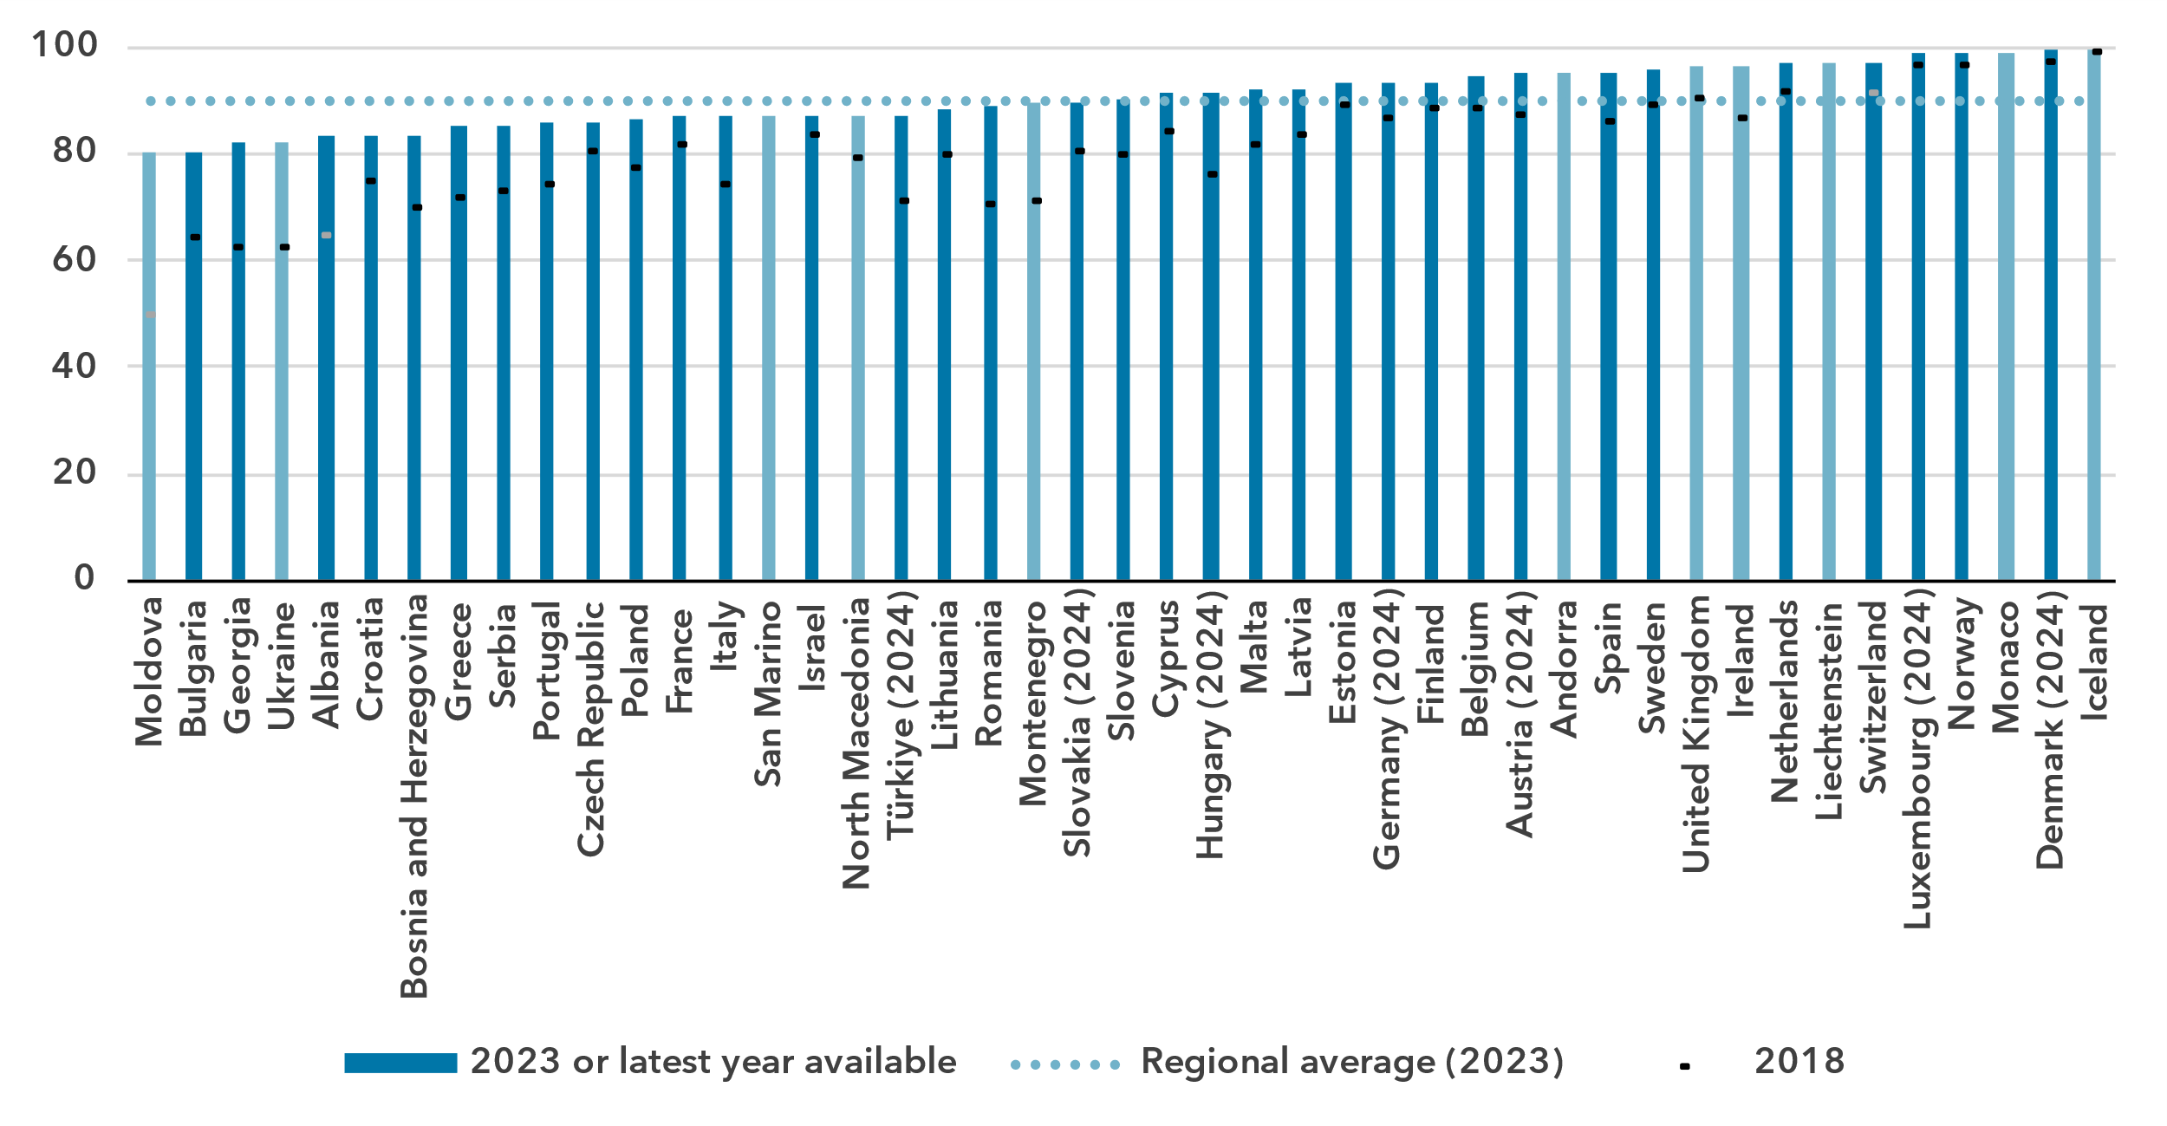

Note: ITU estimates are in a lighter shade, country submitted data in a darker shade.

Source: ITU

***Gender parity in Internet use has been reached***

Percentage of individuals using the Internet, by gender, 2024

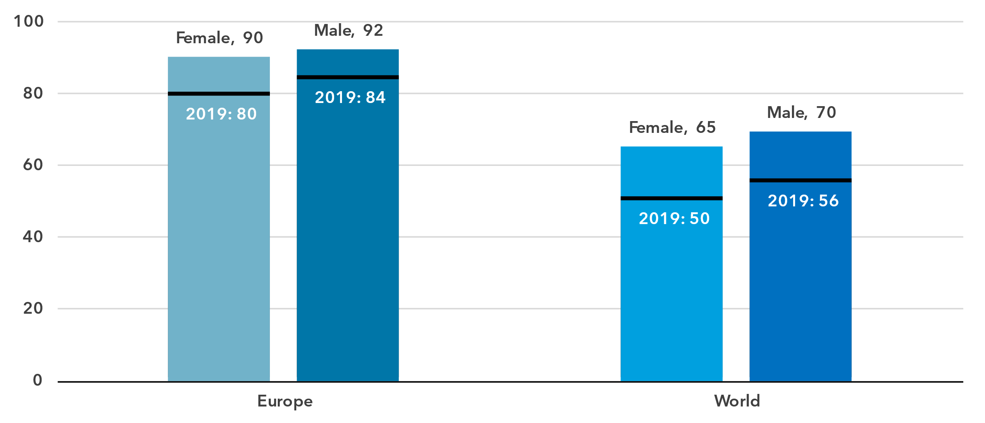

Source: ITU

In 2024, 90 per cent of women in the Europe region were online, compared with 92 per cent of men. This translates into a gender parity score (GPS) of 0.98, up from 0.94 in 2019, indicating that parity has been achieved.[9]

In most countries of the region, gender parity has been reached with a GPS between 0.98 and 1.02. In nine countries, there is still a bias towards men using the Internet, while in four countries the bias is towards women.

Percentage of individuals using the Internet, by gender, 2023 or latest year available

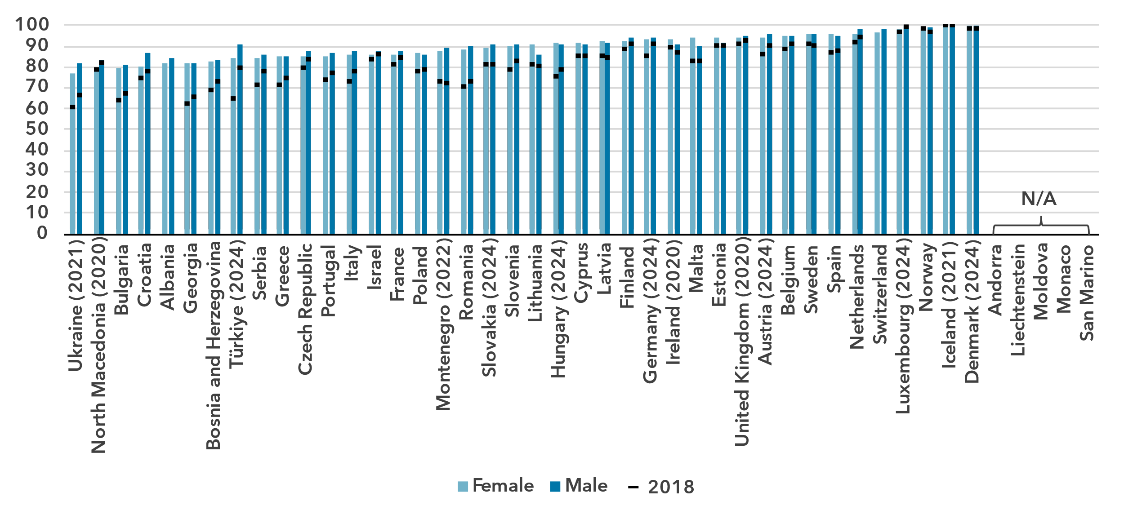

Source: ITU

***Almost all young people use the Internet***

Percentage of individuals aged between 15 and 24 years using the Internet, 2024

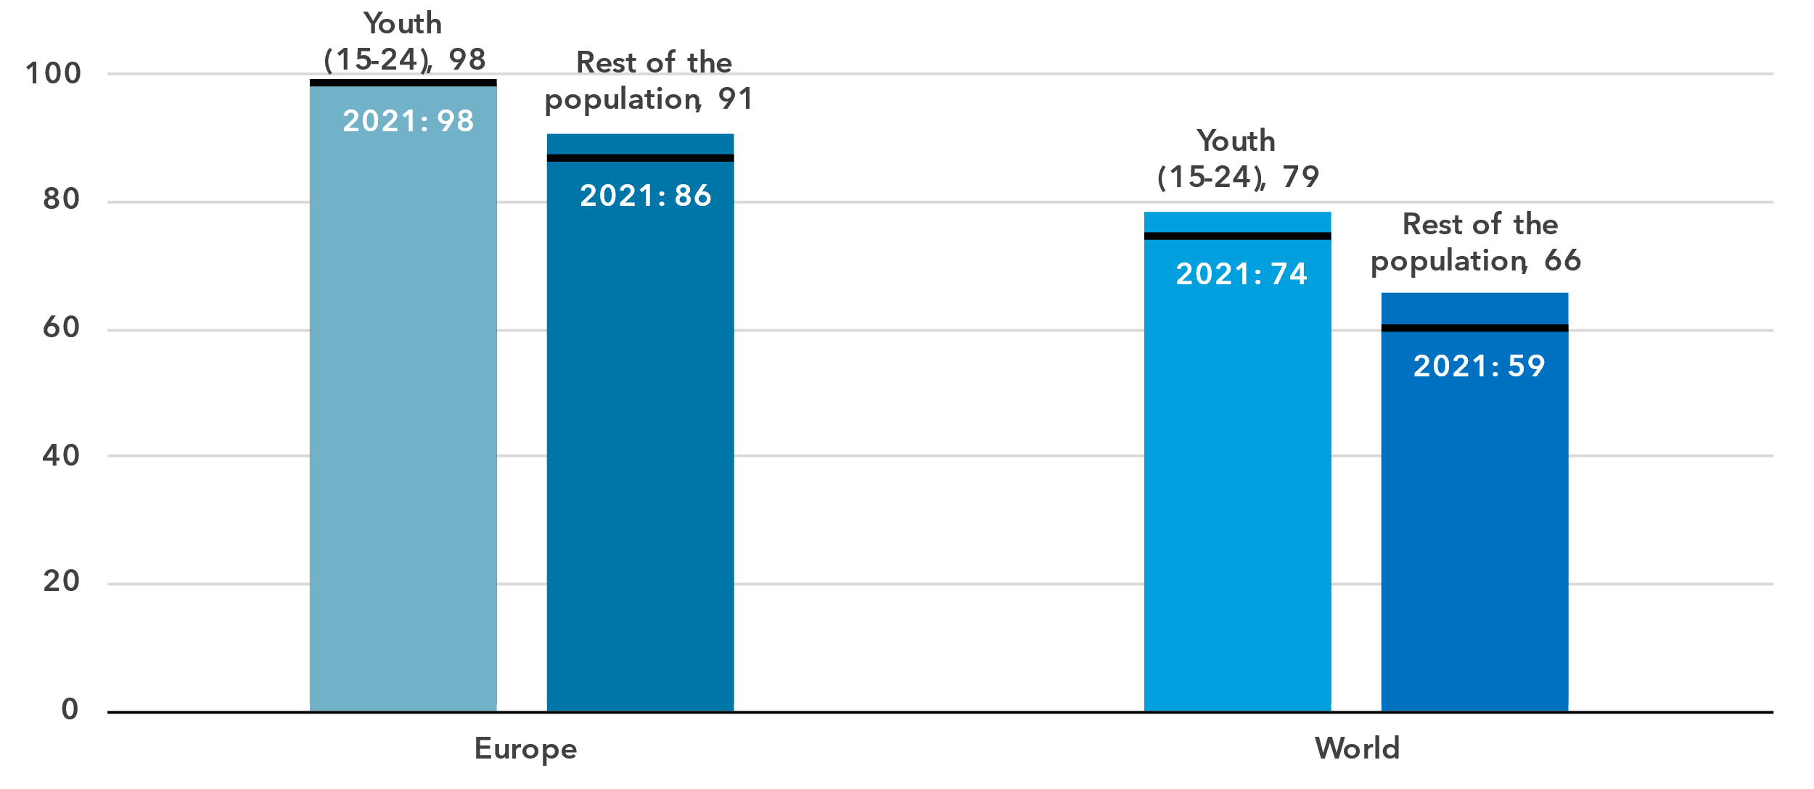

Source: ITU

Among young people (aged 15 to 24 years), almost no one is offline in the Europe region. While the percentage of young people using the Internet has been stable at 98 per cent over the last four years, the generational gap, which is measured as the ratio of Internet users between young people and the rest of the population, has been steadily improving since 2021. This means other age groups are catching up, so that it will only be a matter of time before universal use will be reached in the region.

In all countries of the region for which data is available, Internet use among young people is above 93 per cent. For the 25-to-74-year-old population, the percentages ranged from 79 to 100 per cent. The picture is different though for the older population, aged 75 years and above, where the Internet penetration was between 19 and 92 per cent for the ten countries with available data.

Percentage of individuals using the Internet by age group, 2023 or latest year available

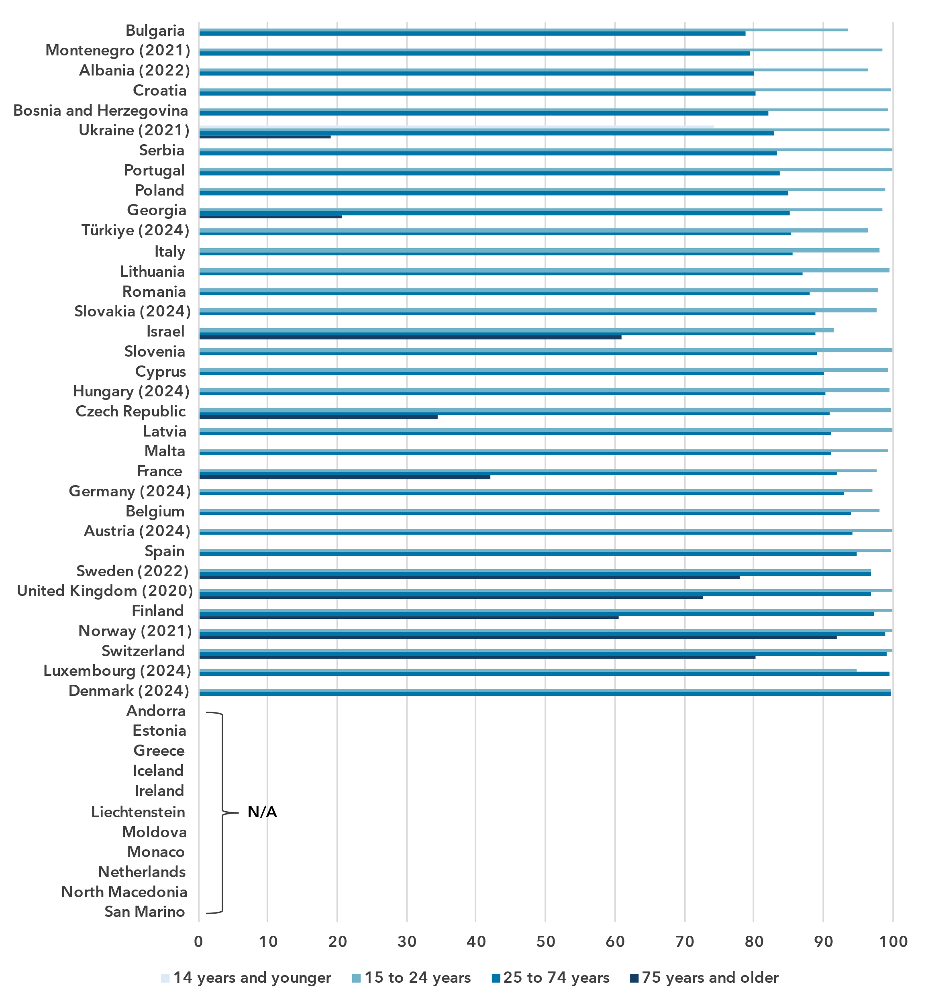

Source: ITU

***Internet use in rural areas trails only somewhat behind urban areas***

Percentage of individuals using the Internet, by location, 2024

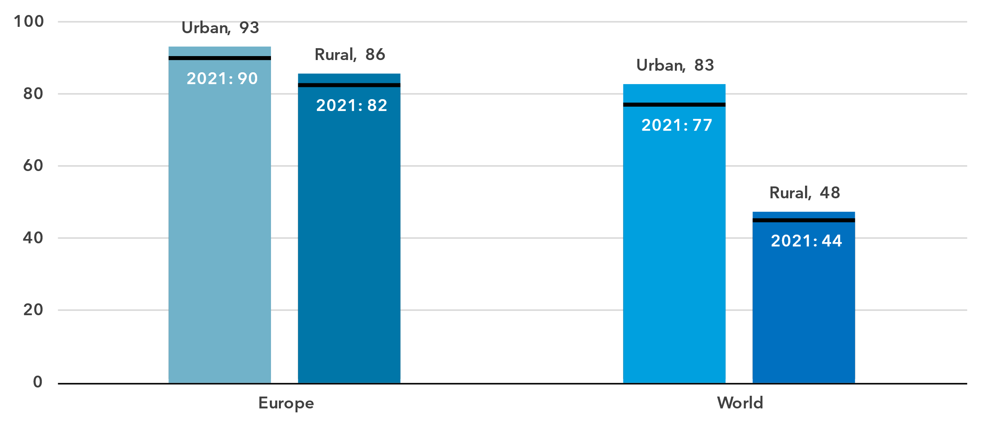

Source: ITU

In urban areas in the Europe region, 93 per cent of the population was online, compared with 86 per cent in rural areas. This gap is much smaller than it is globally, with 83 per cent online in urban areas, against only 44 per cent in rural areas.

In countries with high overall Internet penetration, the urban-rural gap was much smaller than in countries with lower overall Internet penetration.

Percentage of individuals using the Internet by location, 2023 or latest year available

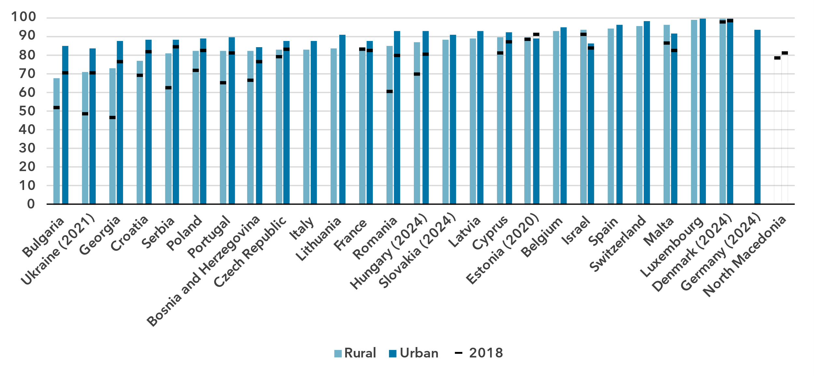Source: ITU

Broadband subscriptions

***The Europe region is the frontrunner in fixed-broadband subscriptions***

Broadband subscriptions per 100 inhabitants

|  |  |
| --- | --- |
| **Mobile** | **Fixed** |

Source: ITU

The Europe region had 112 active mobile-broadband subscriptions per 100 inhabitants in 2024, above the global average of 95. The difference is considerably higher for fixed-broadband penetration: Europe boasted 37 subscriptions per 100 inhabitants, almost twice the global average of 20, and much higher than any other region.

Mobile-broadband penetration showed significant variation across the region, though, ranging from 70 subscriptions per 100 inhabitants in Bosnia and Herzegovina to 215 in Poland.

Active mobile-broadband subscriptions per 100 inhabitants, 2023 or latest year available

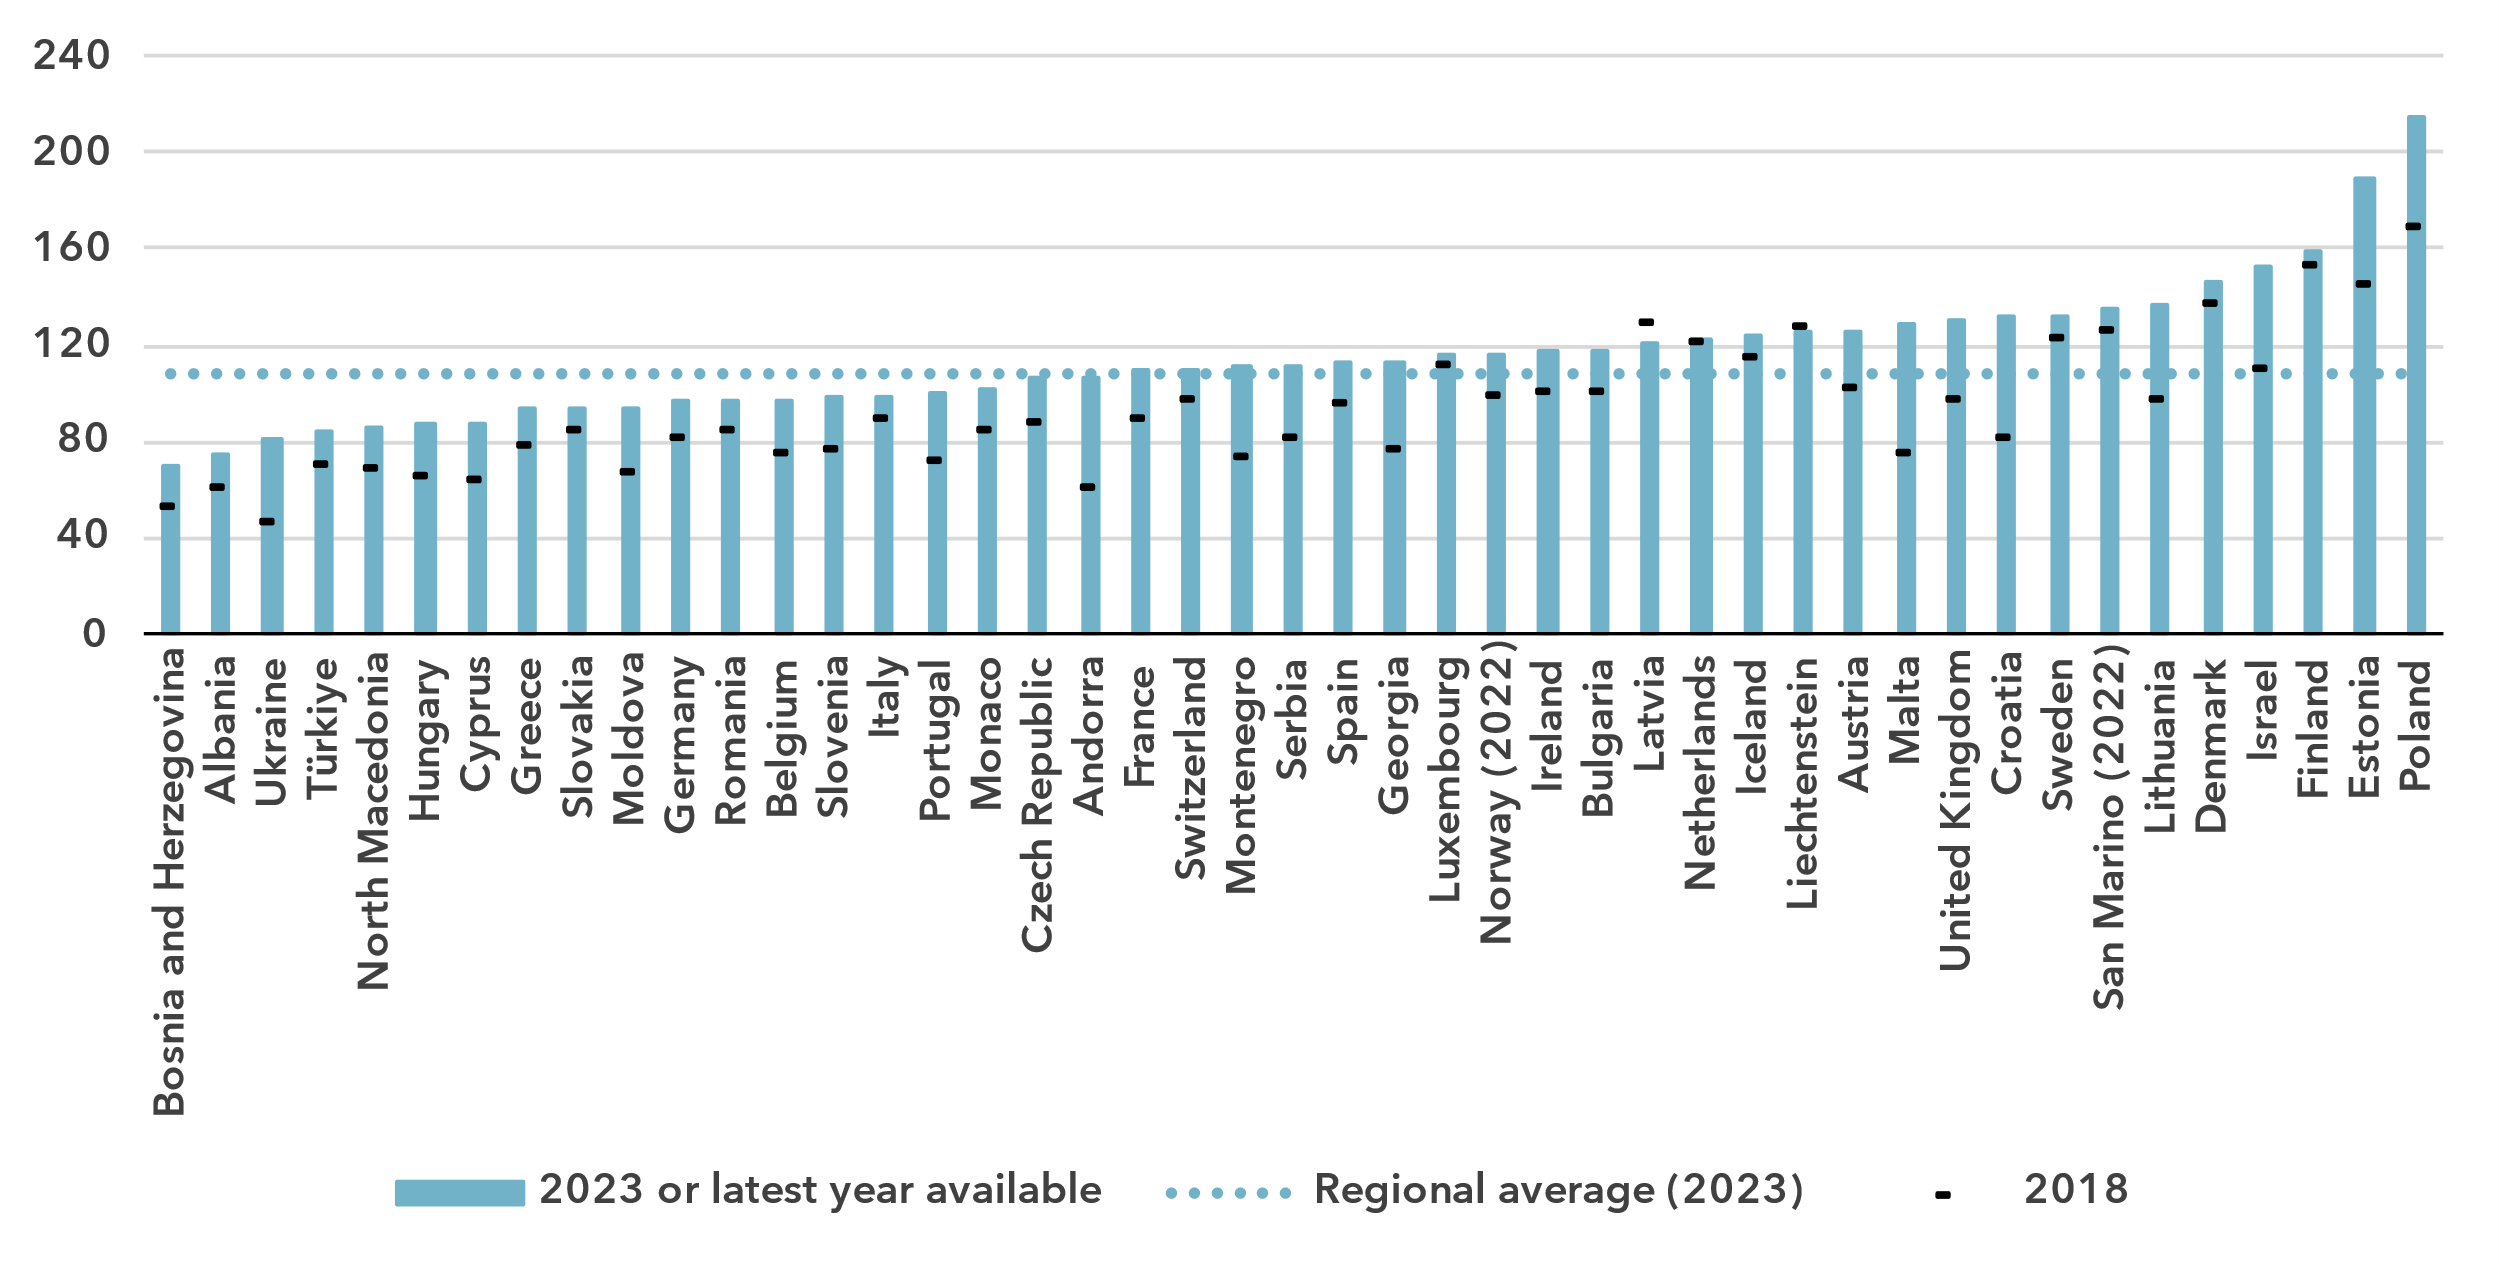Source: ITU

Fixed-broadband subscriptions ranged from 20 per 100 inhabitants in Ukraine to 56 in Monaco. Unlike in other, lower-income regions, in Europe almost all the fixed-broadband subscriptions had an advertised speed of 10 Mbit/s or above.

Fixed-broadband subscriptions per 100 inhabitants, 2023 or latest year available

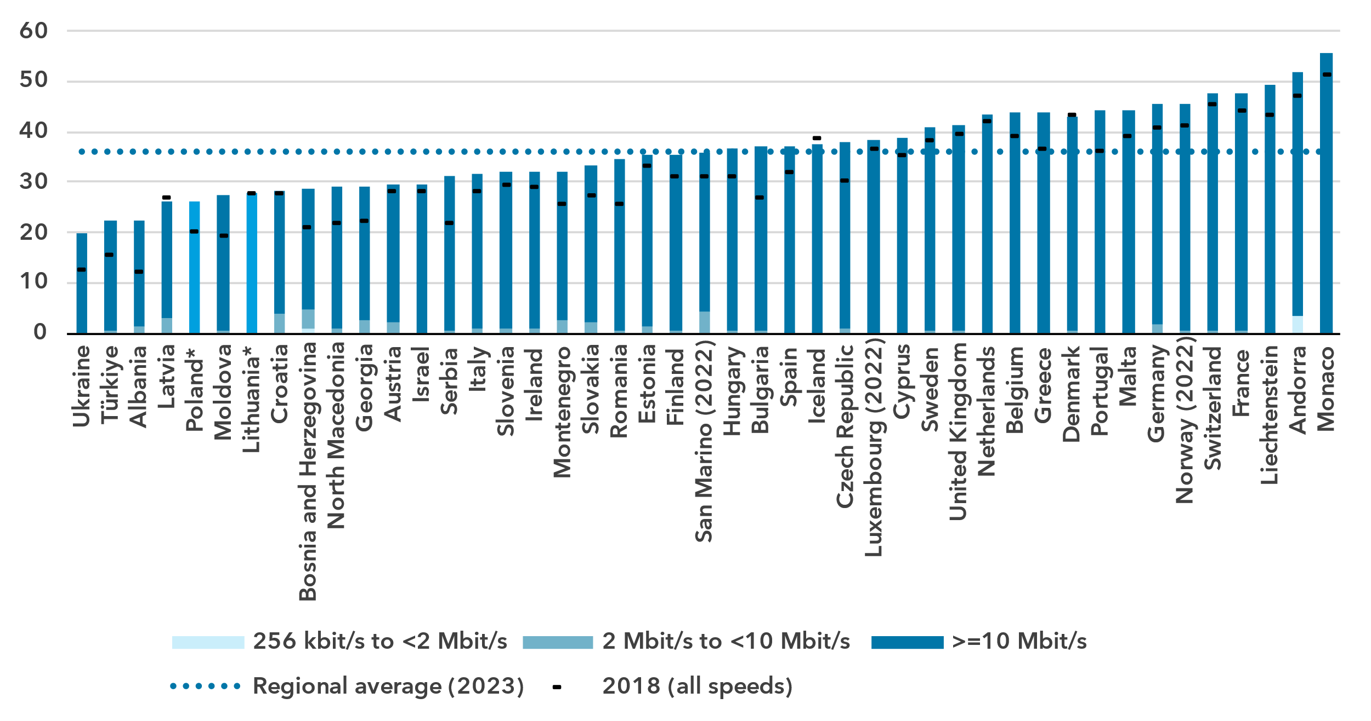* Full breakdown by speed not available for Poland and Lithuania.

Source: ITU

Mobile network coverage

***5G network roll-out is progressing fast***

Percentage of population covered by type of mobile network

|  |  |
| --- | --- |
| **Europe** | **World** |

Note: The values for 2G, 3G and 4G networks show the incremental percentage of the population that is not covered by a more advanced technology network (e.g. in 2024, 96 per cent of the world population is covered by at least a 3G or above network, that is 4 per cent + 41 per cent + 51 per cent). There is insufficient data to produce estimates for 5G coverage prior to 2020.

Source: ITU

Between 2020 and 2024, 5G mobile network coverage in the region increased from 28 to 72 per cent of the population. Globally, 5G coverage grew only from 9 to 51 per cent. Where 5G was not yet available, 4G mobile networks covered 99 per cent of the population in 2024, implying that almost everyone in the Europe region has access to a good quality mobile network.

However, the roll-out of 5G has been uneven in the region: while in some countries, mostly located in Eastern Europe or the Western Balkans, 5G is not available at all, it is already available to the whole population in other countries.

Percentage of population covered by type of mobile network, 2023 or latest year available

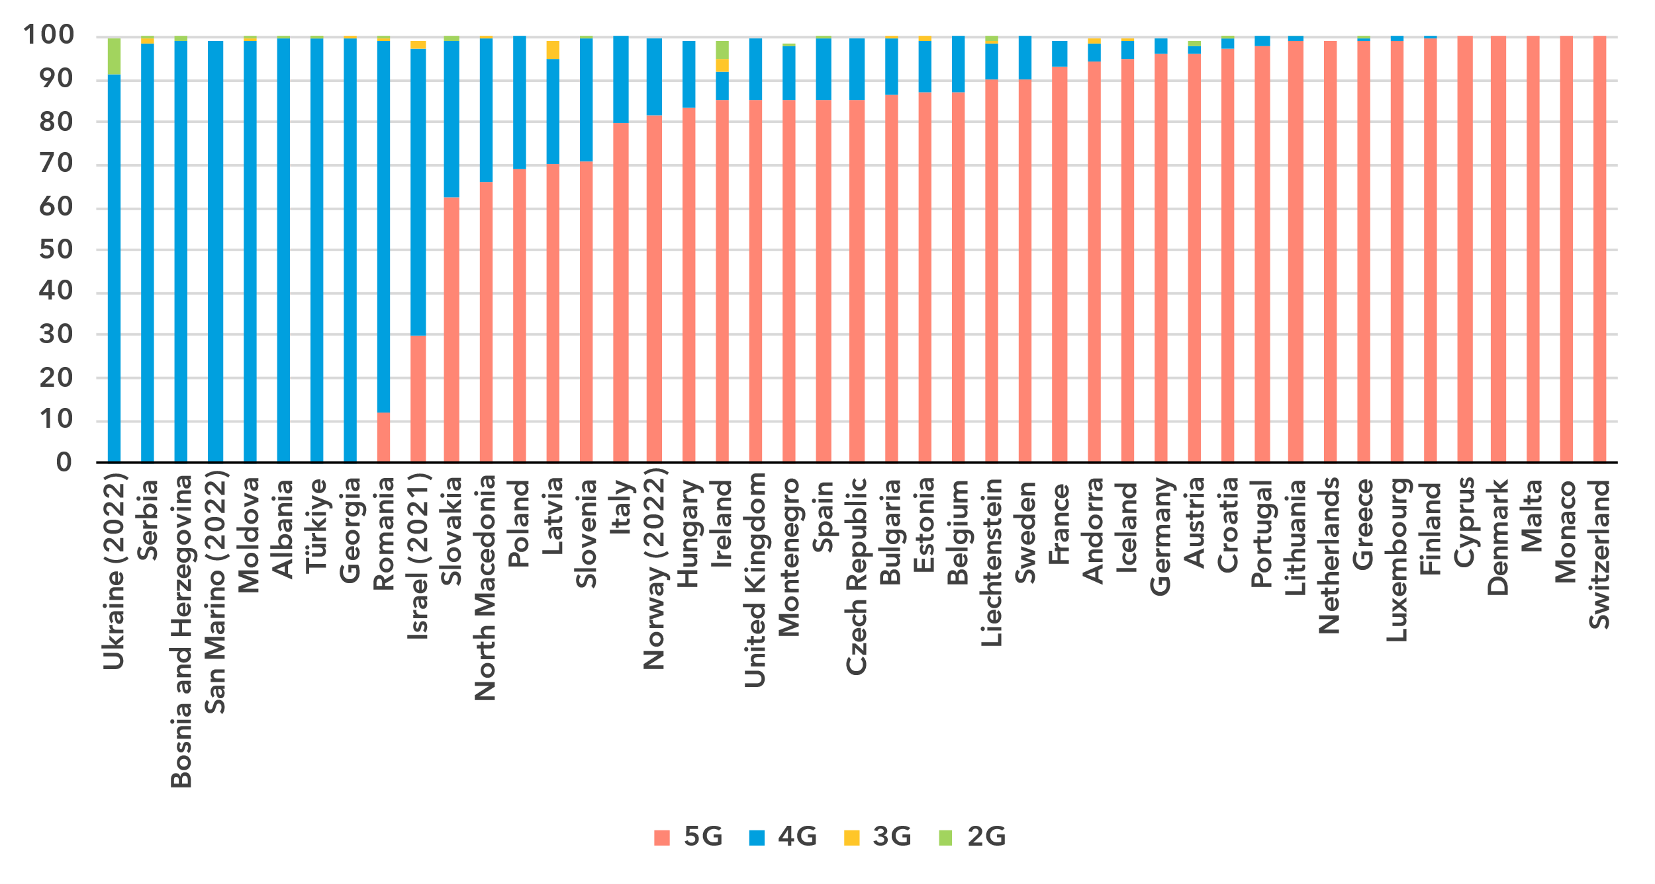

Note: The values for 2G, 3G and 4G networks show the incremental percentage of the population that is not covered by a more advanced technology network (e.g. in 2023, 99 per cent of the population in Slovakia is covered by at least a 4G or above network, that is 63 per cent + 36 per cent).

Source: ITU

There is a significant gap in 5G mobile network availability between rural and urban areas. In 2024, 5G covered 81 per cent of the urban population in Europe, but only 46 per cent in rural areas. The disparity was much smaller for 4G networks, with 100 per cent of the population covered in urban areas compared with 97 per cent in rural areas.

Population coverage by type of mobile network and location, 2024

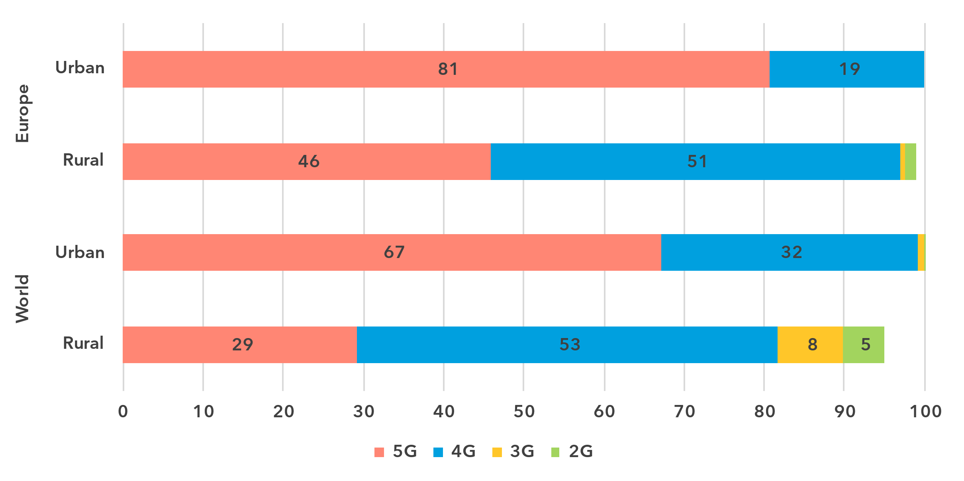

Note: The values for 2G, 3G and 4G networks show the incremental percentage of the population that is not covered by a more advanced technology network (e.g. 90 per cent of the world's rural population is covered by at least a 3G or above network, that is 29 per cent + 53 per cent + 8 per cent).

Source: ITU

Availability of fixed-broadband infrastructure

***Six out of ten people live within 10 km of an optical fibre node***

Fixed-broadband infrastructure forms the backbone of the Internet and is a cornerstone of digital transformation efforts. As part of ongoing research at ITU, the broadband map initiative provides an overview of fixed-broadband infrastructure placement. Overlaying this data with demographic data makes it possible to infer the availability and proximity of fixed broadband to populations. This is essential for planning – costly – infrastructure projects and helps to ensure that networks have the necessary capacity and reach.

Map of transmission networks and submarine cables for the Europe region

Note: The image reports active and planned submarine cables and operational, planned and under-construction transmission networks (optical fibre cable and microwave).

The designations employed and the presentation of material on the map do not imply the expression of any opinion whatsoever on the part of ITU or its secretariat concerning the legal status of the country, territory, city or area or its authorities, or concerning the delimitation of its frontiers or boundaries.

Source: ITU, <https://bbmaps.itu.int/app>

Proximity to an optical fibre node is a crucial metric for transformative connectivity as it directly impacts network performance, reliability and scalability. It reduces latency, improves connection stability and lowers deployment costs, making broadband access more affordable and efficient. Additionally, it enables easier upgrades to support growing bandwidth demands, ensuring networks remain future-proof.

As of 2023, 61 per cent of the population of the Europe region lived within 10 km of an optical fibre node. Almost 9 of every 10 people (88 per cent) lived within 50 km, 97 per cent within 50 km and almost everyone within 100 km of a node.

Percentage of population within reach of an optical fibre node, 2023

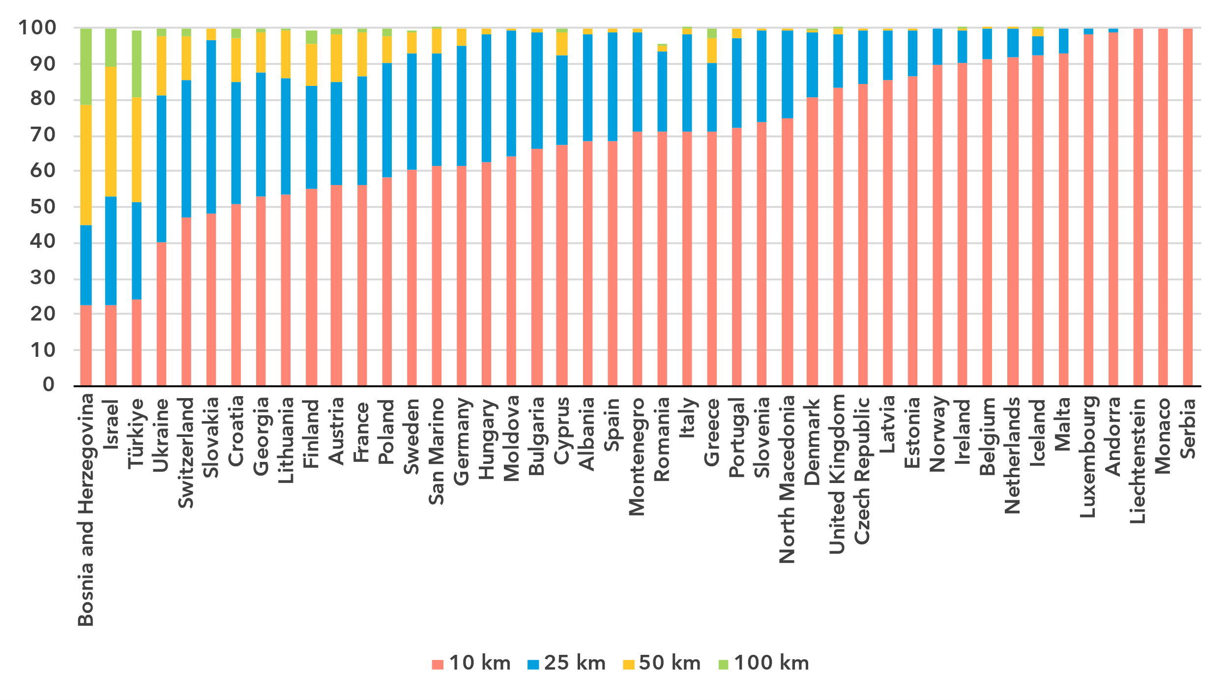Note: The percentage of population within reach of transmission networks refers to the percentage of people that are within physical reach of nodes on core terrestrial transmission networks for a given distance (see <https://bbmaps.itu.int/indicators-bbmaps>).

Source: ITU

Internet traffic

***Internet traffic in the Europe region growing faster than globally***

Broadband Internet traffic per subscription per month, in gigabytes

|  |  |
| --- | --- |
| **Mobile** | **Fixed** |

Source: ITU

Internet traffic measures the total volume of data downloaded and upload by the end users in a country over a given period. For ease of interpretation, figures presented refer to the average monthly traffic per both fixed- and mobile-broadband subscription. Traffic levels are typically higher for fixed than mobile broadband, not only because subscriptions are shared by multiple users (e.g. in households), but also because they include mobile traffic routed over Wi-Fi when available.

Between 2019 and 2024 monthly mobile-broadband traffic in the Europe region increased from 5 to 15 GB per mobile-broadband subscription, outstripping the global average for traffic growth, which increased from 6 to 14 GB per month during the same period. Fixed-broadband traffic in the region increased from a monthly 170 GB to 370 GB per subscription, while it increased from 141 to 311 GB globally.

Mobile-broadband Internet traffic, in gigabytes, per subscription per month, 2023 or latest year available

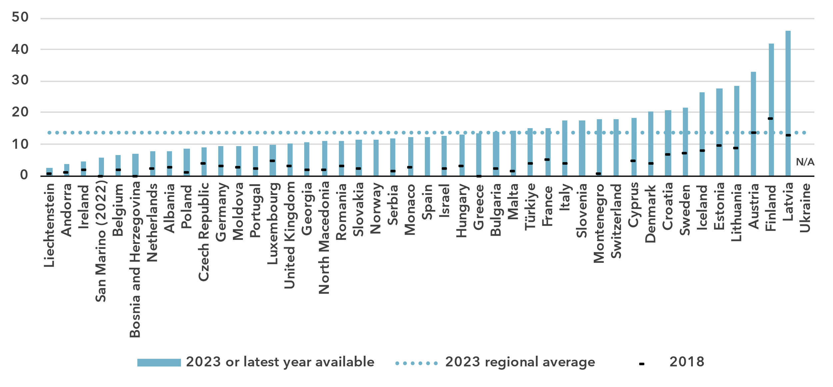Note: Internet traffic originating within country.

Source: ITU

The region shows more heterogeneity for indicators of Internet traffic by subscription than for some of the other indicators explored in this document. For mobile-broadband traffic, the values ranged from 2 GB per subscription per month to 46 GB. For fixed-broadband traffic, the spread was from 107 to 530 GB per subscription per month.

Fixed-broadband Internet traffic per subscription per month, in gigabytes, 2023 or latest year available

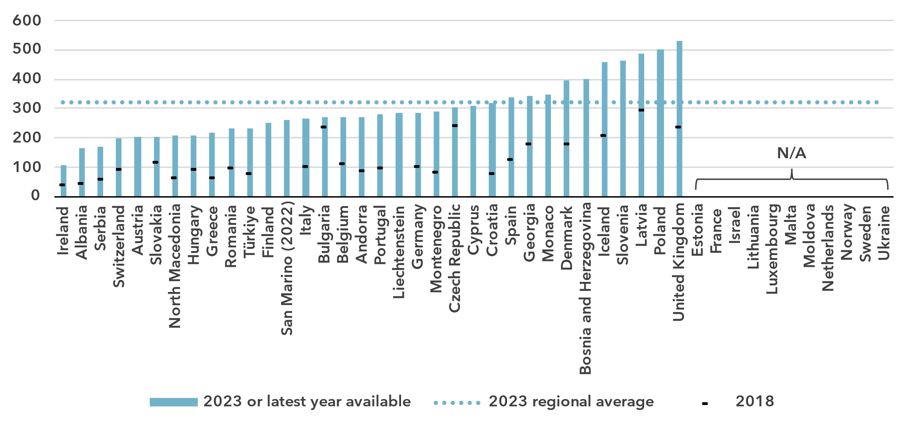Source: ITU

Affordability of ICT services

***Mobile and fixed broadband generally affordable in the Europe region***

Broadband basket prices as % of gross national income per capita, 2018-2024

|  |  |
| --- | --- |
| **Mobile (2 GB)** | **Fixed (5 GB)** |

Note: Median values shown in the chart are calculated as a percentage of GNI per capita for the set of economies for which data was available for all years from 2018 to 2024 for a given basket to adjust the effect of changing data availability.

Source: ITU

Internet cost is a barrier to Internet use and to meaningful connectivity. The ITU/UNESCO [Broadband Commission for Sustainable Development](https://www.broadbandcommission.org/) set itself the goal of making broadband in developing countries affordable by 2025, affordability being defined as the availability of broadband access at a price that is less than 2 per cent of monthly GNI per capita.

Europe is the region with the most affordable prices for both mobile and fixed broadband. For an entry-level data-only mobile-broadband service, the average European citizen had to pay 0.3 per cent of GNI per capita in 2024, substantially below the global average of 1.1 per cent. In all countries of the Europe region, the price of such a service was below the 2-per-cent target of the Broadband Commission.

Entry-level fixed-broadband subscriptions are typically costlier than mobile for various reasons, including the cost of infrastructure, higher speeds and larger allowances included, and different market conditions. In the Europe region, the average cost of an entry-level fixed-broadband service stood at 1.1 per cent of GNI[10], far below the global average of 2.5 per cent. This made the Europe region the only region below the Broadband Commission’s 2-per-cent target. Of the 44 countries, only six recorded a price above this target.

Broadband basket prices as % of gross national income per capita, 2024

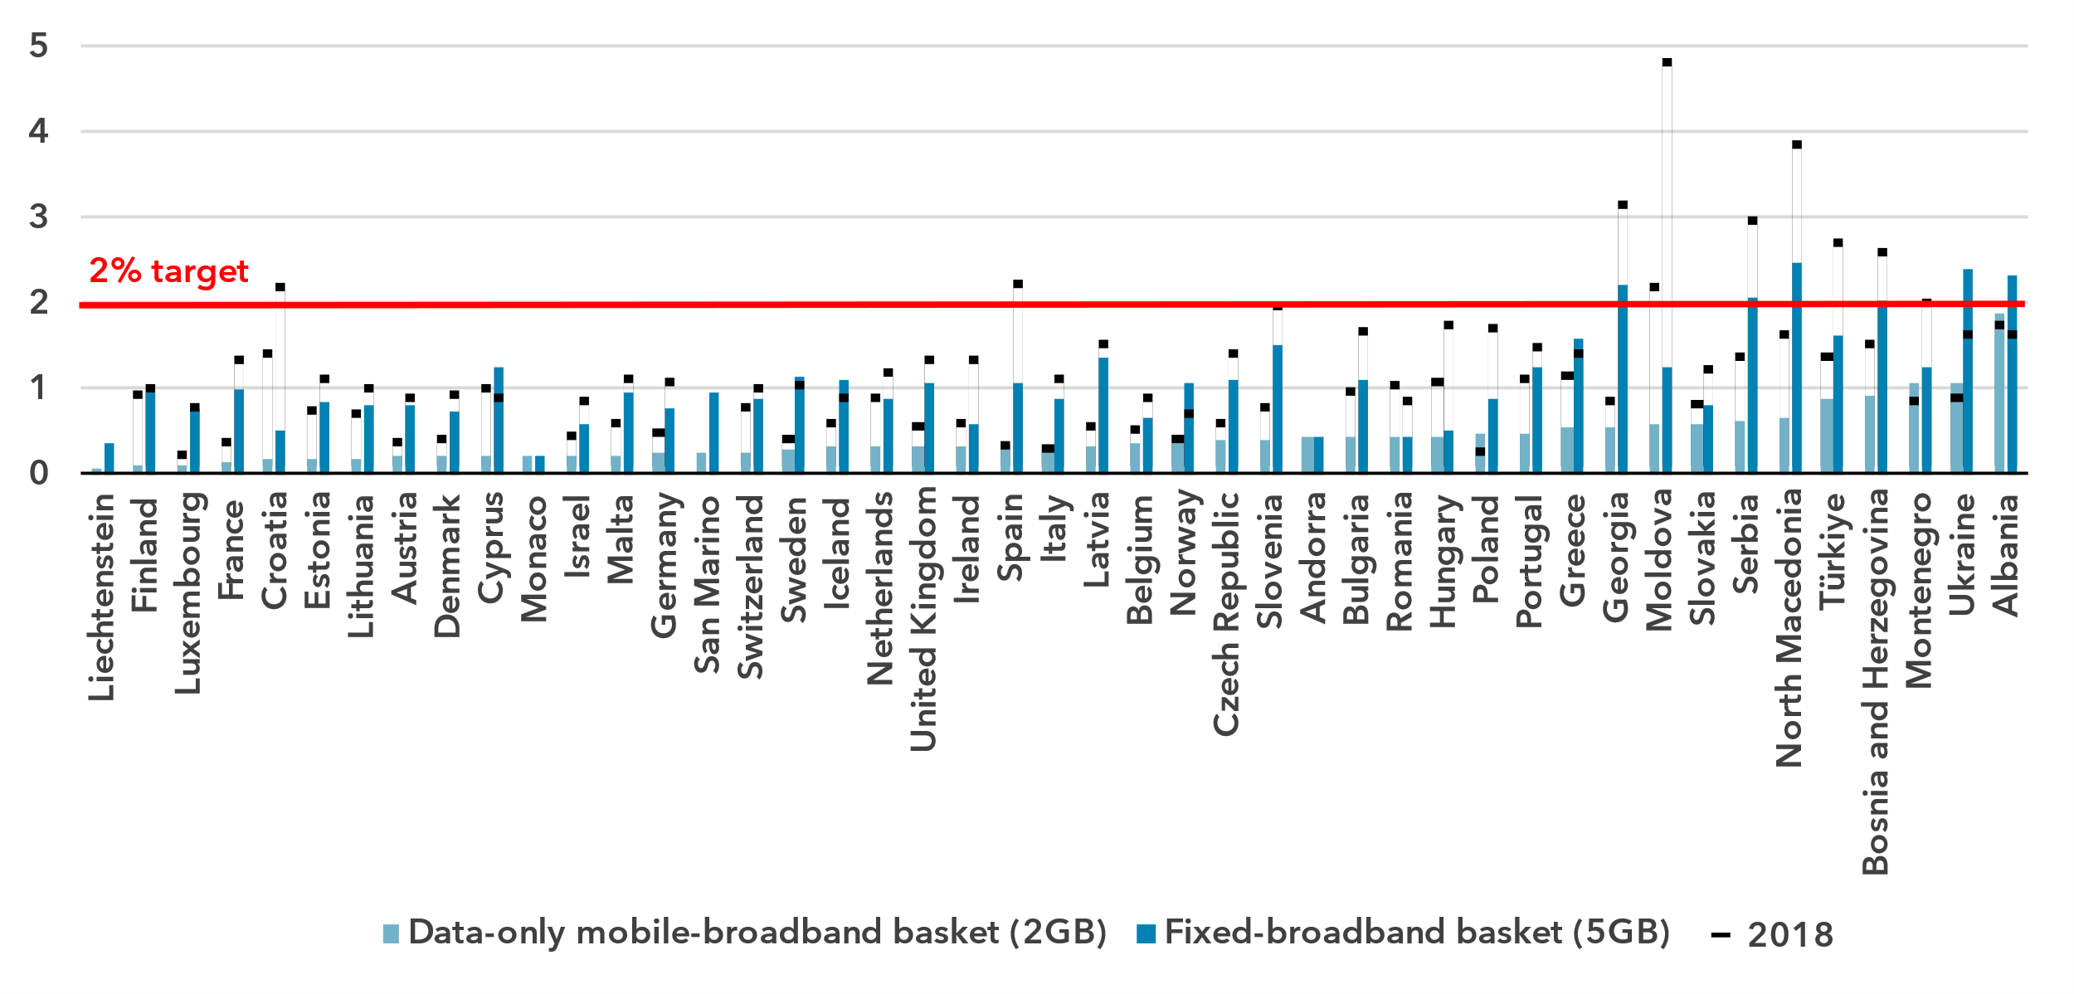Source: ITU

Mobile phone ownership and subscriptions

***Mobile phone ownership is universal***

|  |  |
| --- | --- |
| Percentage of individuals owning a mobile phone | Percentage of individuals owning a mobile phone by gender, 2024 |

Note: Individuals aged 10 and older.

Source: ITU

While globally “only” four out of five individuals aged 10 or older owned a mobile phone, in Europe this number stood at 95 out of 100, which for practical purposes means they have achieved universality. There was only a small difference between the share of men owning a mobile phone and the share of women owning one, which leads to a gender parity score of 1.00.

Percentage of individuals owning a mobile phone, 2023 or latest year available

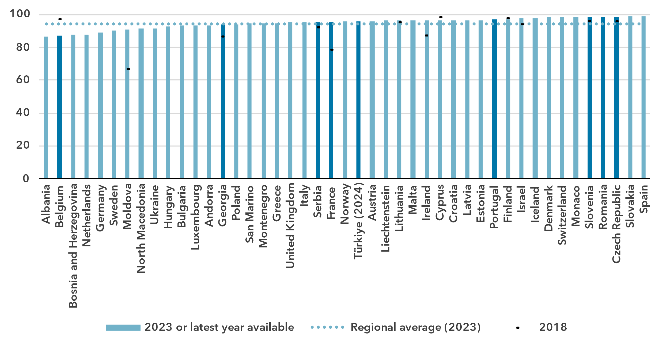Notes: Individuals aged 10 and older. ITU estimates are in a lighter shade, country submitted data in a darker shade.

Source: ITU

In all countries of the region, mobile ownership was very high, between 86 and 100 per cent. For the 11 countries for which gender disaggregated data is available, the gender parity score indicated that gender parity was reached in all but two countries.

To use a mobile phone, a mobile-cellular or mobile-broadband subscription is needed. In the Europe region, there were 125 subscriptions per 100 inhabitants in 2024, somewhat above the global average of 112. This indicator is plateauing in Europe, as it has hardly moved since 2012.

Mobile-cellular subscriptions per 100 inhabitants

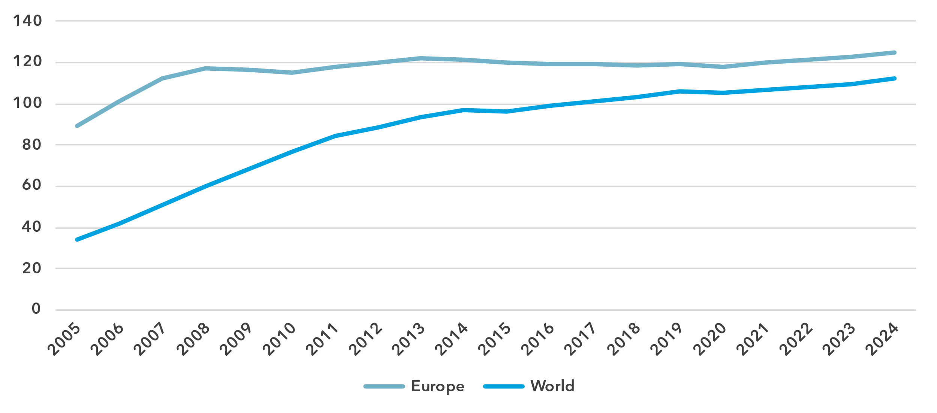

Source: ITU

At the country level, the region was relatively homogeneous, with values ranging from 93 to 156 subscriptions per 100 inhabitants, with one outlier at 207.

Mobile-cellular subscriptions per 100 inhabitants, 2023 or latest year available

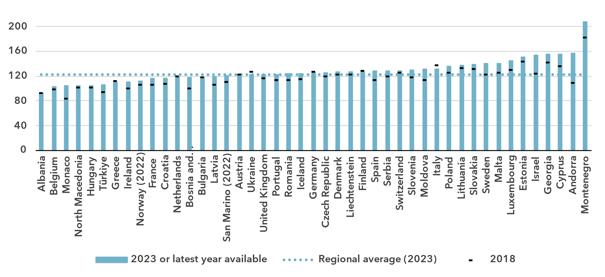

Source: ITU

ICT skills

***Large variety in ICT skills among Internet users***

As self-reporting of individuals’ ICT skills is subjective, ICT skills are measured based on household surveys asking whether an individual has recently performed certain activities. Performing these activities presupposes a degree of proficiency in relevant digital skills. The activities are grouped into five areas: information and data literacy; communication and collaboration; digital content creation; safety; and problem solving.

While the importance of digital skills in leveraging ICTs for economic prosperity and social well-being is well-documented, data remain very scant, although better in the Europe region, with 38 countries having submitted data since 2020. However, fewer – just 20 countries – provided comparable data on ICT skill levels (see box for details on the methodology for calculating ICT skill levels).

|  |  |  |  |  |  |  |
| --- | --- | --- | --- | --- | --- | --- |
| **Methodology for calculating ICT skill levels**  At its 11th meeting in September 2023, ITU’s Expert Group on ICT household indicators (EGH) [recommended changes](https://www.itu.int/itu-d/meetings/statistics/wp-content/uploads/sites/8/2023/09/Report-of-the-EGH-subgroup-on-ICT-Skills.pdf) in how data on ICT skill levels are reported, including, most importantly, that skill levels of individuals should be assessed for different areas.  *Individuals should be assessed on the number of activities within a skill area they report having done in the last three months using the following progression:*   |  |  |  | | --- | --- | --- | | None | Basic | Above basic | | 0 activities | 1 activity | More than 1 activity |  * *Skill levels should not be assessed in skill areas where fewer than two indicators are collected.* * *Indicators should be weighted equally within each skill area.* * *Skill areas with different numbers of components should be treated equally.*   While this recommendation does not require any additional data collection, it does require that countries perform additional analysis on existing survey microdata. ITU requested data on ICT skills for the first time in its April 2024 data collection and received data from 40 countries, including 20 European countries. However, other countries were unable to provide data, even though in many cases data on the underlying activities had been collected. It is expected that data availability will improve as familiarity with these new recommendations increases. |

ICT skills data goes beyond simple access and use of ICTs to provide a view of the capabilities of ICT users. Data on individuals in the Europe region with different levels of ICT skills are shown below as a share of Internet users. This data demonstrates the substantial variation between countries in the level of ICT skills of those already using the Internet. It also shows the areas where attention is needed to increase ICT skills.

Percentage of Internet users with ICT skills in information and data literacy, 2023 or latest year available

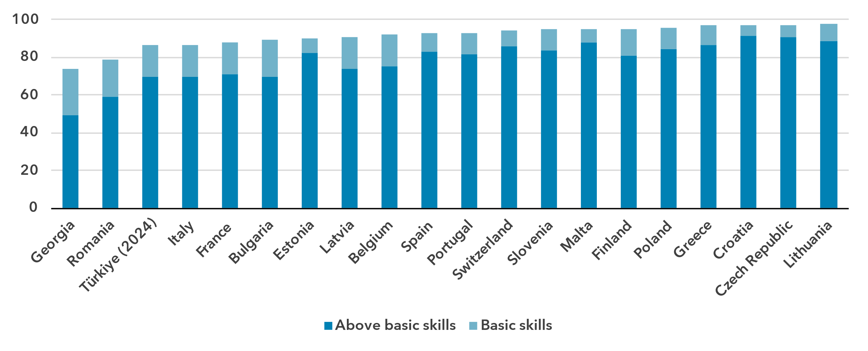Note: Bulgaria, Georgia, Latvia and Türkiyecalculate skill levels using the [methodology recommended](https://www.itu.int/itu-d/meetings/statistics/wp-content/uploads/sites/8/2023/09/Report-of-the-EGH-subgroup-on-ICT-Skills.pdf) by the ITU’s Expert Group on ICT household indicators. All other countries calculate skill levels using the Joint Research Council of the European Commission [Digital Skills Indicator (DSI) 2.0](https://publications.jrc.ec.europa.eu/repository/handle/JRC130341).

Source: ITU

Skill levels for information and data literacy, referring to activities such as reading news online or seeking health information, are generally high in Europe. In this area, values ranged from 74 per cent of Internet users in Georgia with at least basic skills to 98 per cent in Lithuania.

Percentage of Internet users with ICT skills in communication and collaboration, 2023 or latest year available

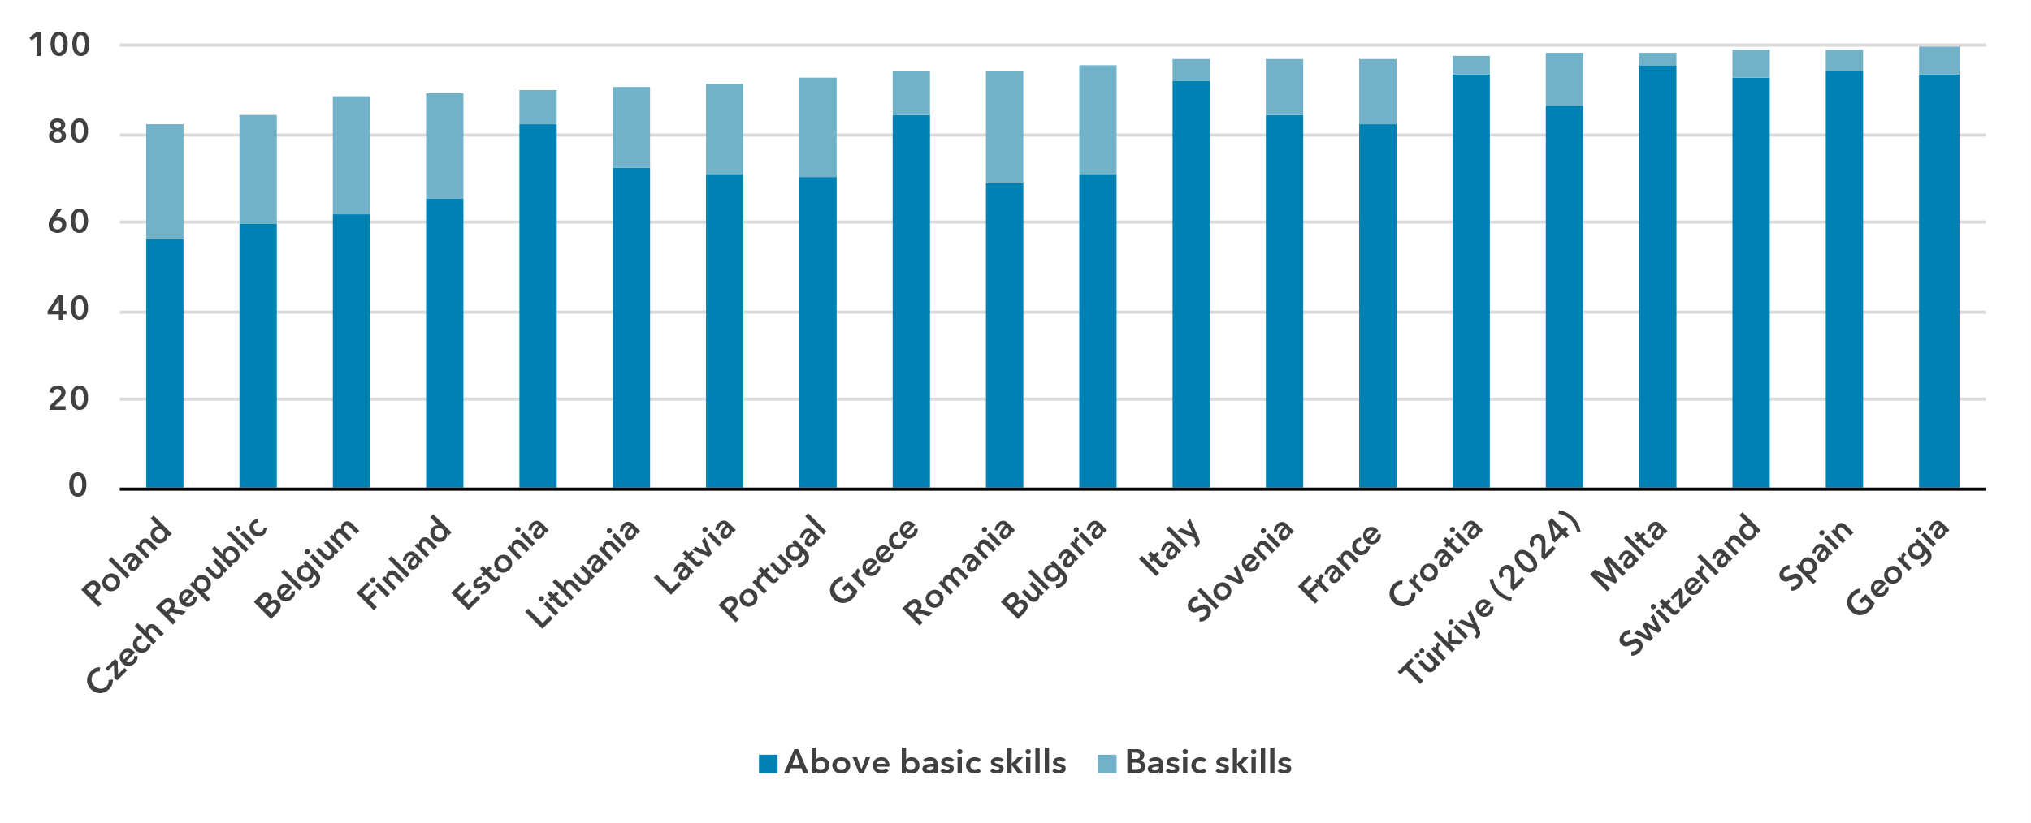Note: Bulgaria, Georgia, Latvia and Türkiyecalculate skill levels using the [methodology recommended](https://www.itu.int/itu-d/meetings/statistics/wp-content/uploads/sites/8/2023/09/Report-of-the-EGH-subgroup-on-ICT-Skills.pdf) by the ITU’s Expert Group on ICT household indicators. All other countries calculate skill levels using the Joint Research Council of the European Commission [Digital Skills Indicator (DSI) 2.0](https://publications.jrc.ec.europa.eu/repository/handle/JRC130341).

Source: ITU

Communication and collaboration are typically what most people use the Internet for; activities in this area include essentials such as making calls using messaging apps. This is confirmed by the data for this skill area. Between 82 and 100 per cent of Internet users had at least basic skills in the countries for which there is data.

Percentage of Internet users with ICT skills in digital content creation, 2023

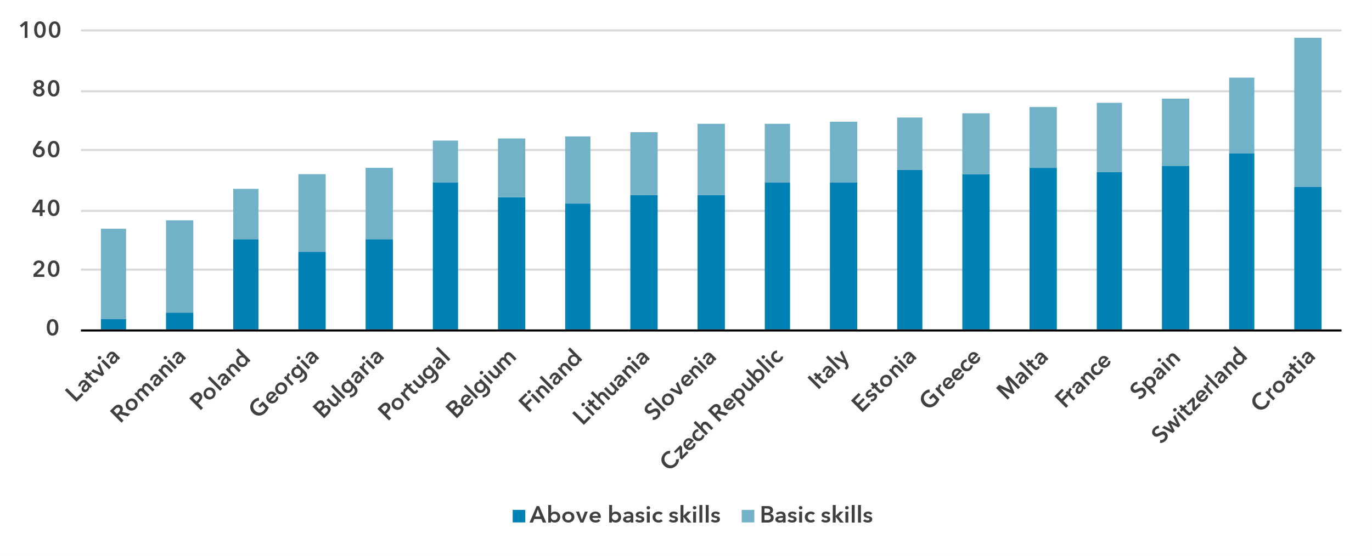Note: Bulgaria, Georgia and Latviacalculate skill levels using the [methodology recommended](https://www.itu.int/itu-d/meetings/statistics/wp-content/uploads/sites/8/2023/09/Report-of-the-EGH-subgroup-on-ICT-Skills.pdf) by the ITU’s Expert Group on ICT household indicators. All other countries calculate skill levels using the Joint Research Council of the European Commission [Digital Skills Indicator (DSI) 2.0](https://publications.jrc.ec.europa.eu/repository/handle/JRC130341).

Source: ITU

This stands in contrast to digital content creation, for which skill levels were much lower. Skill levels in digital content creation, which includes activities such as using spreadsheets or copy and paste tools, also varied substantially among countries. The share of Internet users with at least basic skills in this area ranged from 34 to 98 per cent of Internet users.

Percentage of Internet users with ICT skills in safety, 2023

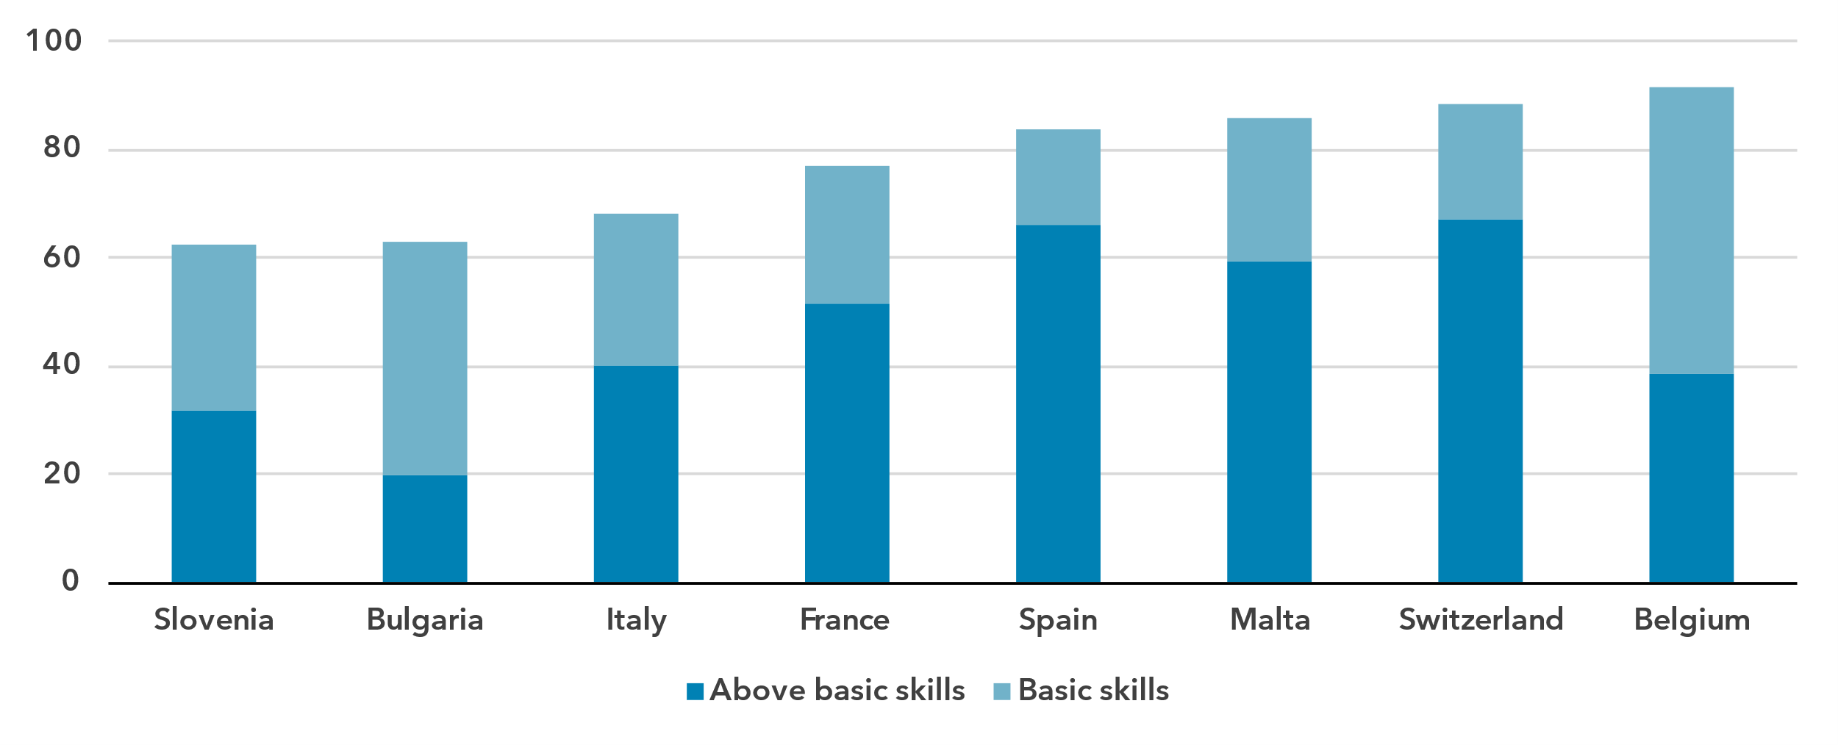Note: Bulgariacalculates skill levels using the [methodology recommended](https://www.itu.int/itu-d/meetings/statistics/wp-content/uploads/sites/8/2023/09/Report-of-the-EGH-subgroup-on-ICT-Skills.pdf) by the ITU’s Expert Group on ICT household indicators. All other countries calculate skill levels using the Joint Research Council of the European Commission [Digital Skills Indicator (DSI) 2.0](https://publications.jrc.ec.europa.eu/repository/handle/JRC130341).

Source: ITU

Safety is another essential skill for ICT users; activities in this area include changing privacy settings and setting up security measures. While only eight countries reported data on safety skill levels, shares of Internet users with at least basic safety skills ranged widely – from 41 to 92 per cent for these countries.

Percentage of Internet users with ICT skills in problem solving, 2023 or latest year available

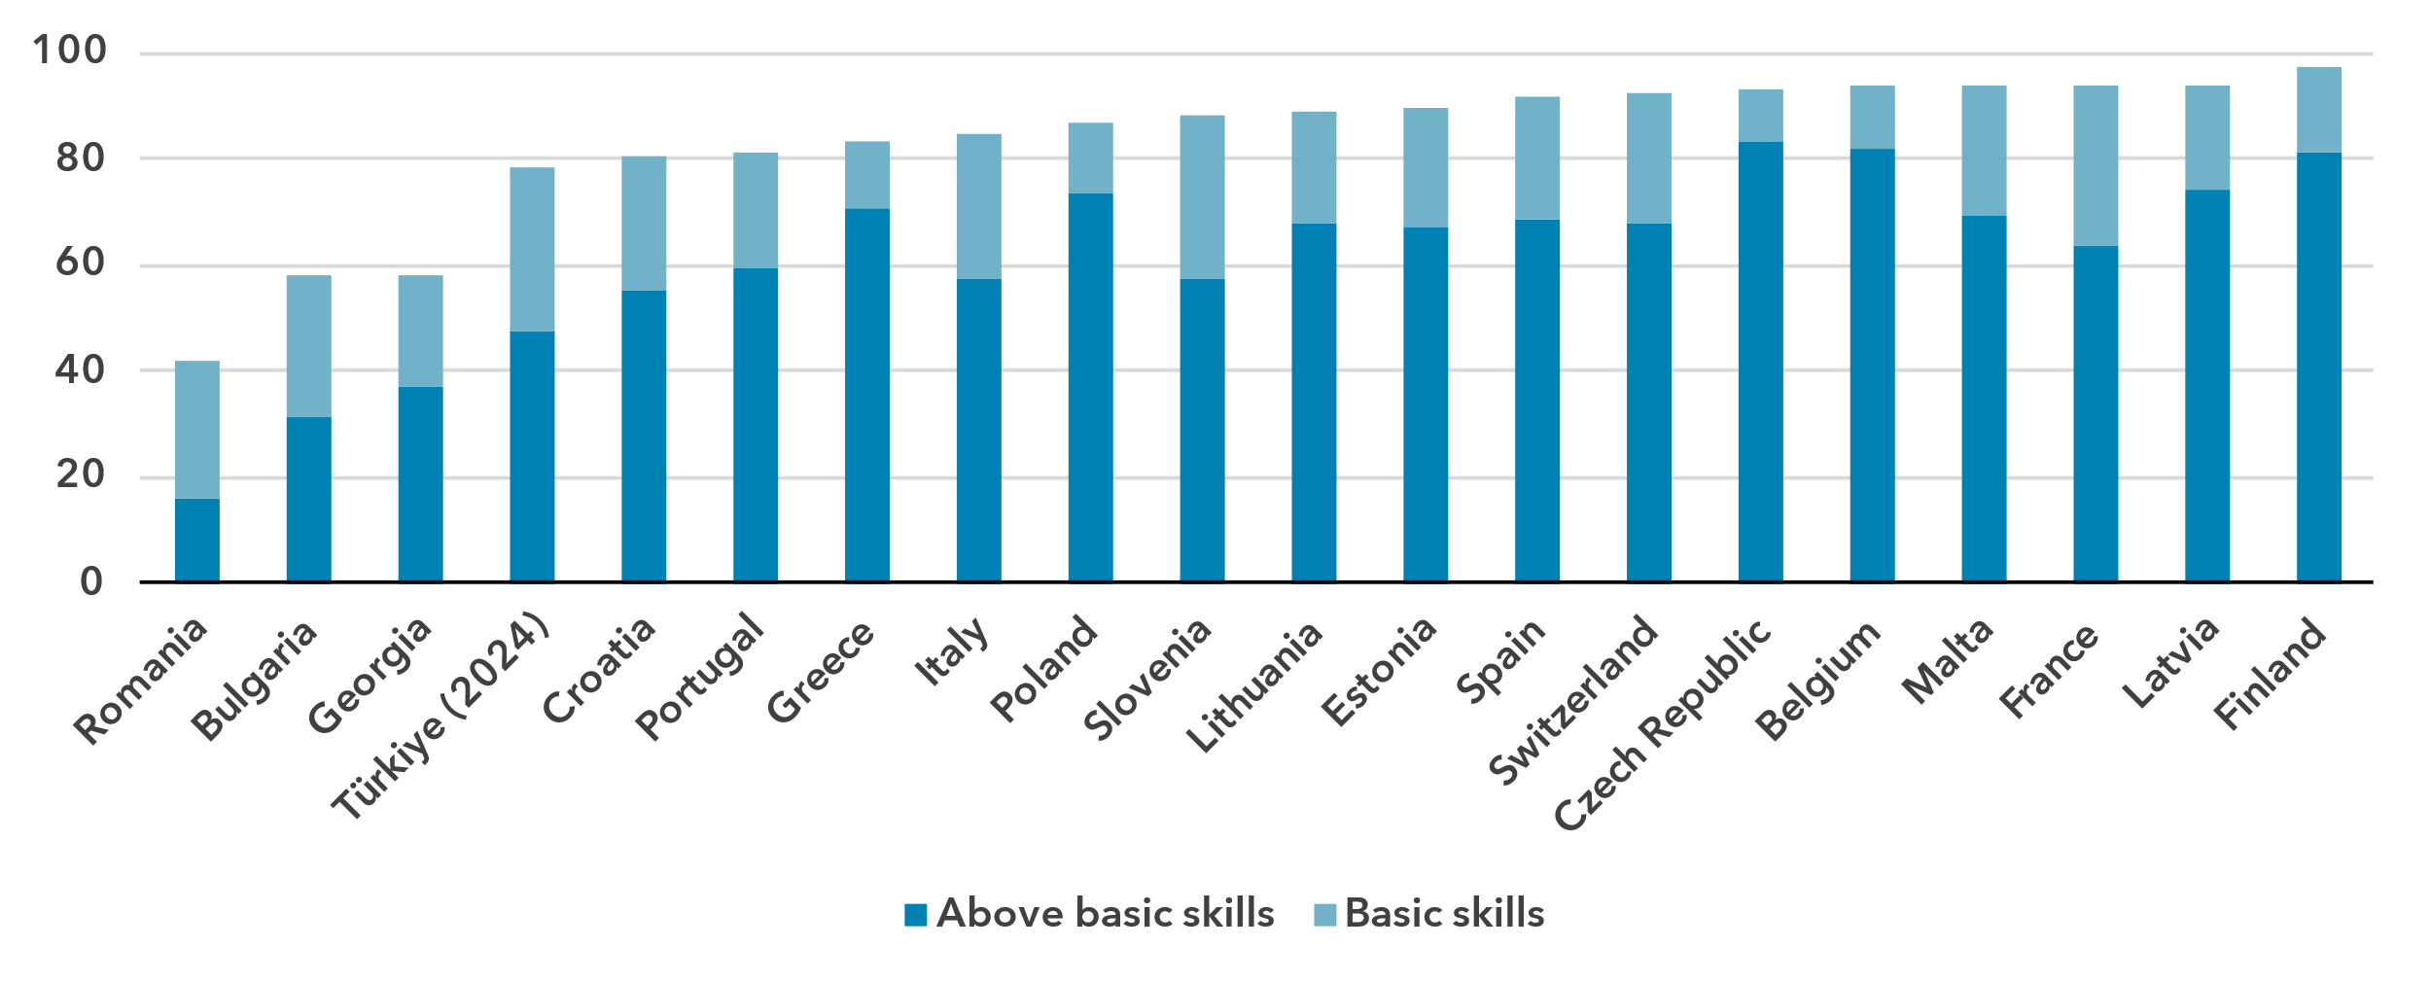 Note: Bulgaria, Georgia, Latvia and Türkiyecalculate skill levels using the [methodology recommended](https://www.itu.int/itu-d/meetings/statistics/wp-content/uploads/sites/8/2023/09/Report-of-the-EGH-subgroup-on-ICT-Skills.pdf) by the ITU’s Expert Group on ICT household indicators. All other countries calculate skill levels using the Joint Research Council of the European Commission [Digital Skills Indicator (DSI) 2.0](https://publications.jrc.ec.europa.eu/repository/handle/JRC130341).

Source: ITU

Finally, for problem solving, an area which includes activities such as installing new devices or purchasing products online, a skills divide is apparent between countries. Fewer than 60 per cent of Internet users in Romania, Bulgaria and Georgia have at least basic skills in this area while nearly 80 per cent or more have at least basic skills in all other reporting countries.

Revenue and investment

***The European telecommunication sector is a key economic driver***

The telecommunication sector is an important enabler of economic development, with both direct and indirect impacts. While it is harder to capture the indirect impact, recent data on revenue and investment reveals the significance of the sector’s direct impact on development but also the considerable gaps between countries.

Revenue from all telecommunication services, in USD billion and as a % of GDP, 2023 or latest available year

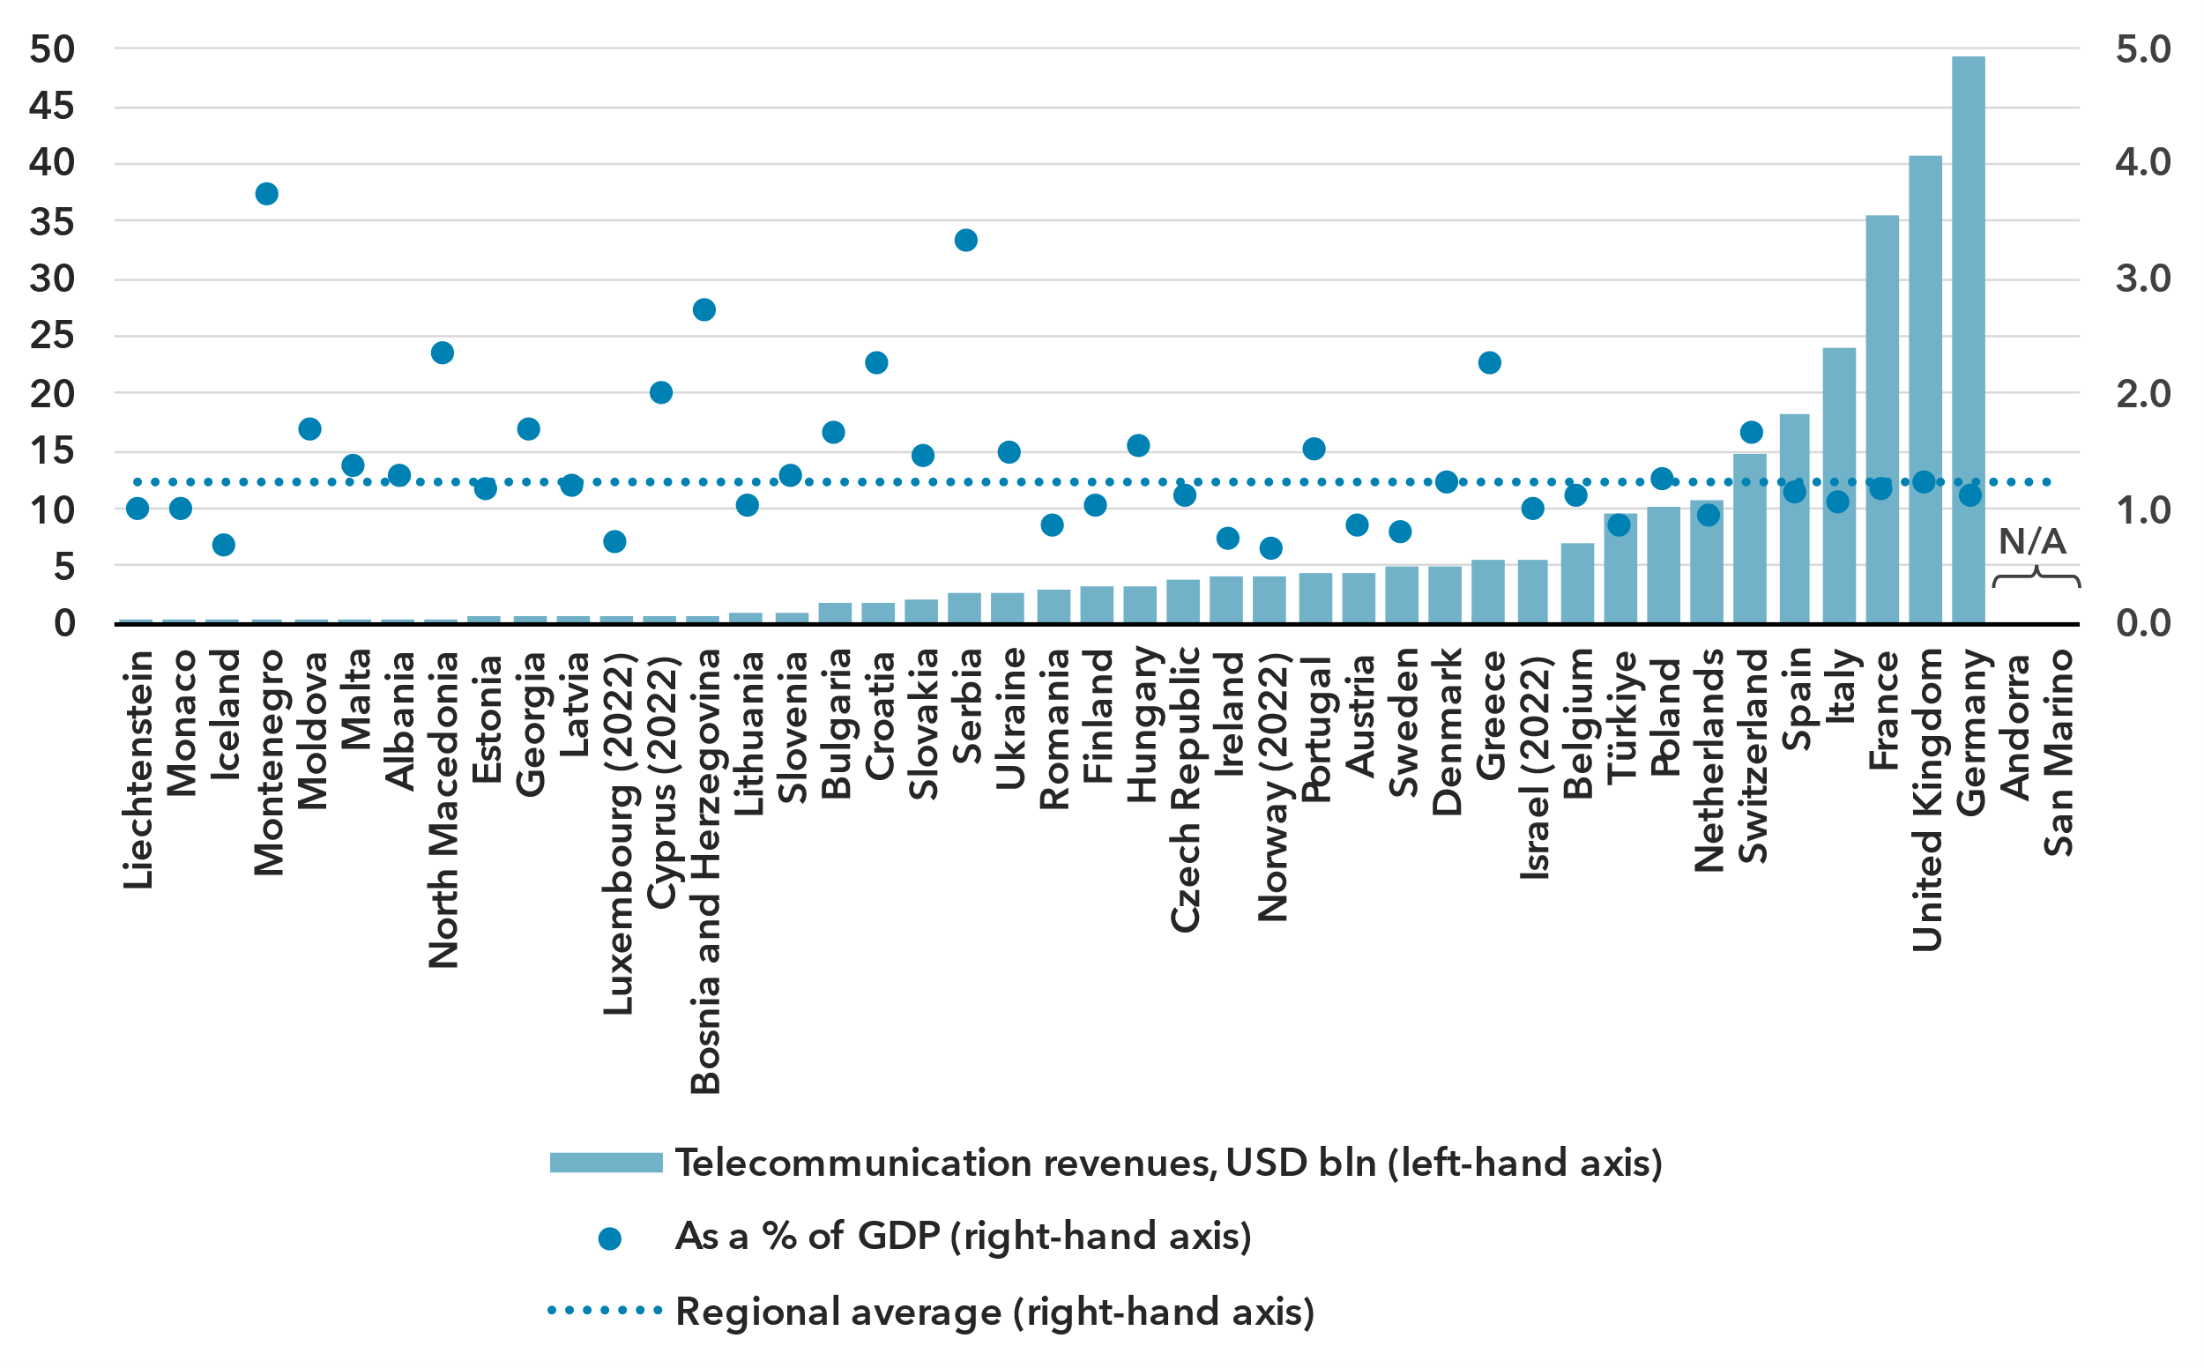Note: Annual average exchange rates applied, last available year values at constant 2023 prices.

Source: ITU, World Bank World Development Indicators

In 2023, the telecommunication sector in the Europe region generated total revenue of USD 290 billion, averaging USD 6.7 billion per country. This sector contributed an average of 1.2 per cent to the region's GDP. The size of the telecommunication market varies significantly across European countries, with 11 countries reporting revenue of up to USD 500 million, while Germany, the largest market, achieved nearly USD 50 billion. Although the sector typically represents 1.2 per cent of a country's GDP, this proportion fluctuates, ranging from less than 1 per cent in nine countries to over 3 per cent in two countries.

The European telecommunication sector has attracted around USD 90 billion in investment in recent years, amounting to around 0.3 per cent of the region’s GDP. By nature, the level of investment fluctuates annually, which is why statistics are presented as the period average for 2021-2023.

The five largest European economies with investment levels of at least USD 6 billion account for around two-thirds of the region’s total telecommunication investments, whereas 13 economies barely reach investment levels of USD 200 million.

Investment capacity is shaped by the actual and potential size of the telecommunication market in a country. Typically, investment amounts to a quarter of the revenue in the sector, but this rate varies significantly, with seven European countries investing only around 15 to 20 per cent of sector revenue on the lower end, and six countries investing between 35 and 47 per cent on the higher end.

Annual investment in telecommunication services, in USD billion and as % of GDP

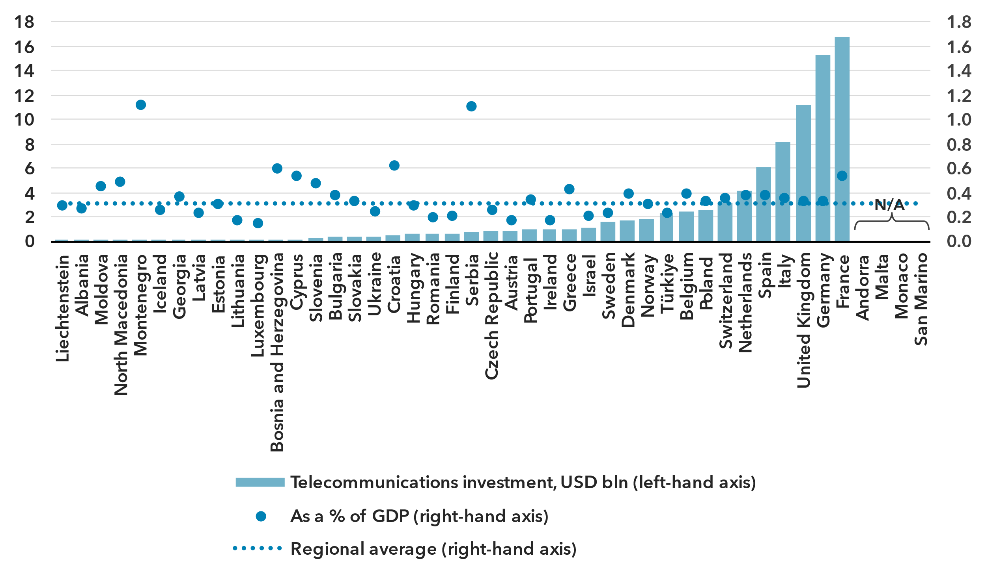Note: Data is a three-year (2021-2023) average of available data points to correct for annual fluctuations and gaps. Investment figures are in constant 2023 USD.

Source: ITU, World Bank World Development Indicators

Cybersecurity

***The Europe region countries exhibit high levels of cybersecurity commitment***

Meaningful connectivity requires trustworthy and secure communications. With over 5.5 billion people now online, cybersecurity in the digital economy is no longer an afterthought. Addressing cybersecurity requires a holistic approach addressing legal, technical, organizational, capacity development and cooperation issues. Since 2015, the Global Cybersecurity Index (GCI) has tracked countries' performance on these issues, each represented by a pillar of the index, with an aggregate GCI score on a 0-100 scale. The 2024 edition revealed a notable improvement in countries’ commitment to cybersecurity: the average GCI score for the world reached 66, up 14 points from the 2021 edition.

Global Cybersecurity Index scores, 2017-2024

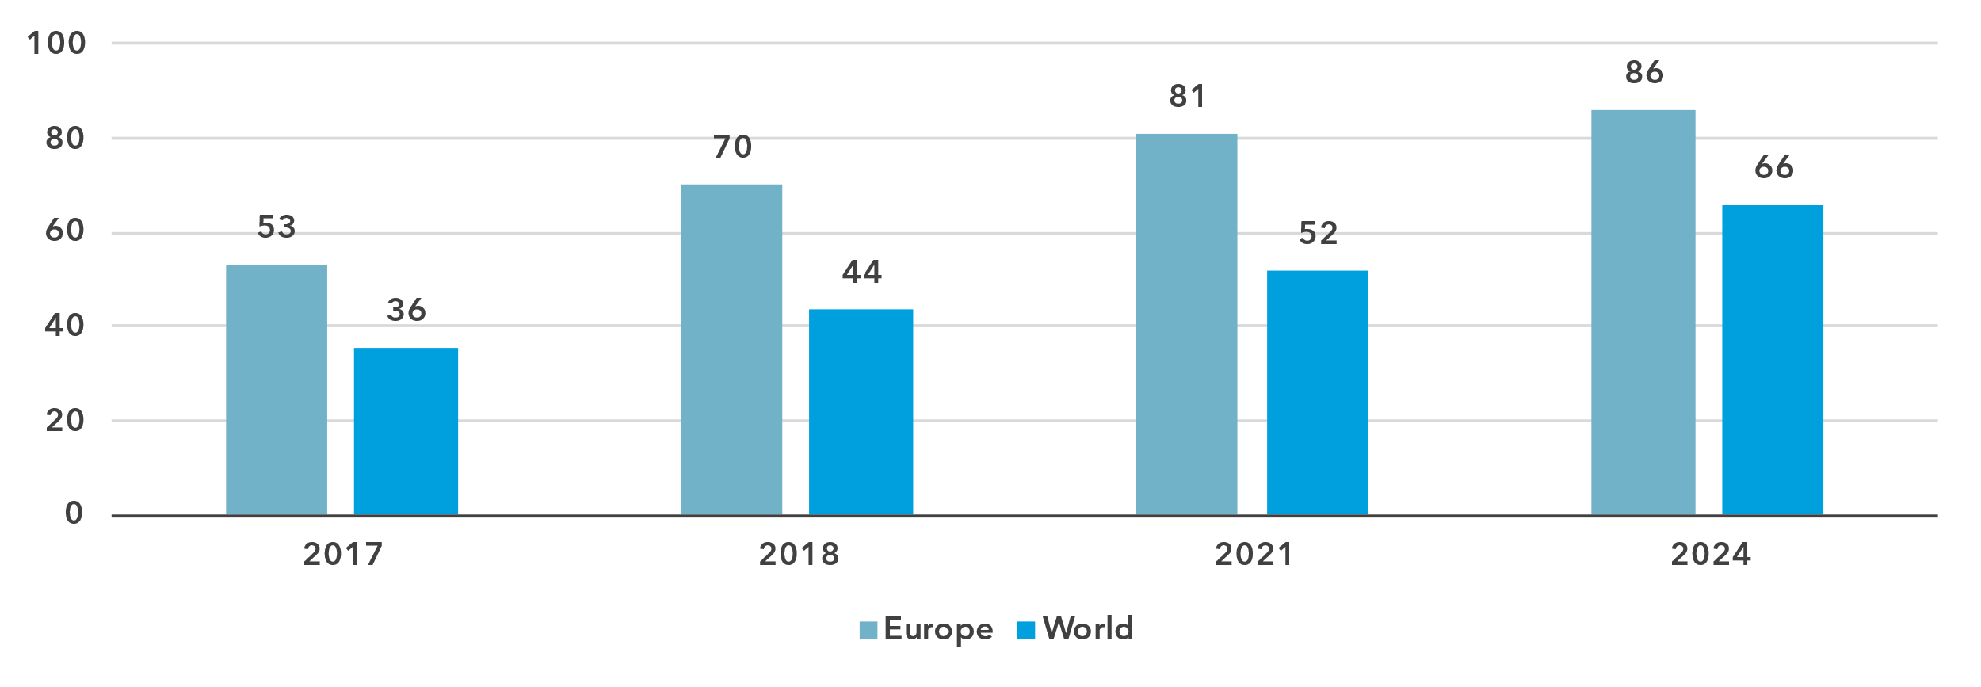

Note: Questions and weightings have been updated between editions, in collaboration with the GCI Expert Group, to better measure cybersecurity commitments by countries.

Source: ITU

The countries of the Europe region have continued to expand their commitments with an average score of 86, a gain of 5 points from the previous edition.

Global Cybersecurity Index scores, by pillar and overall, 2024

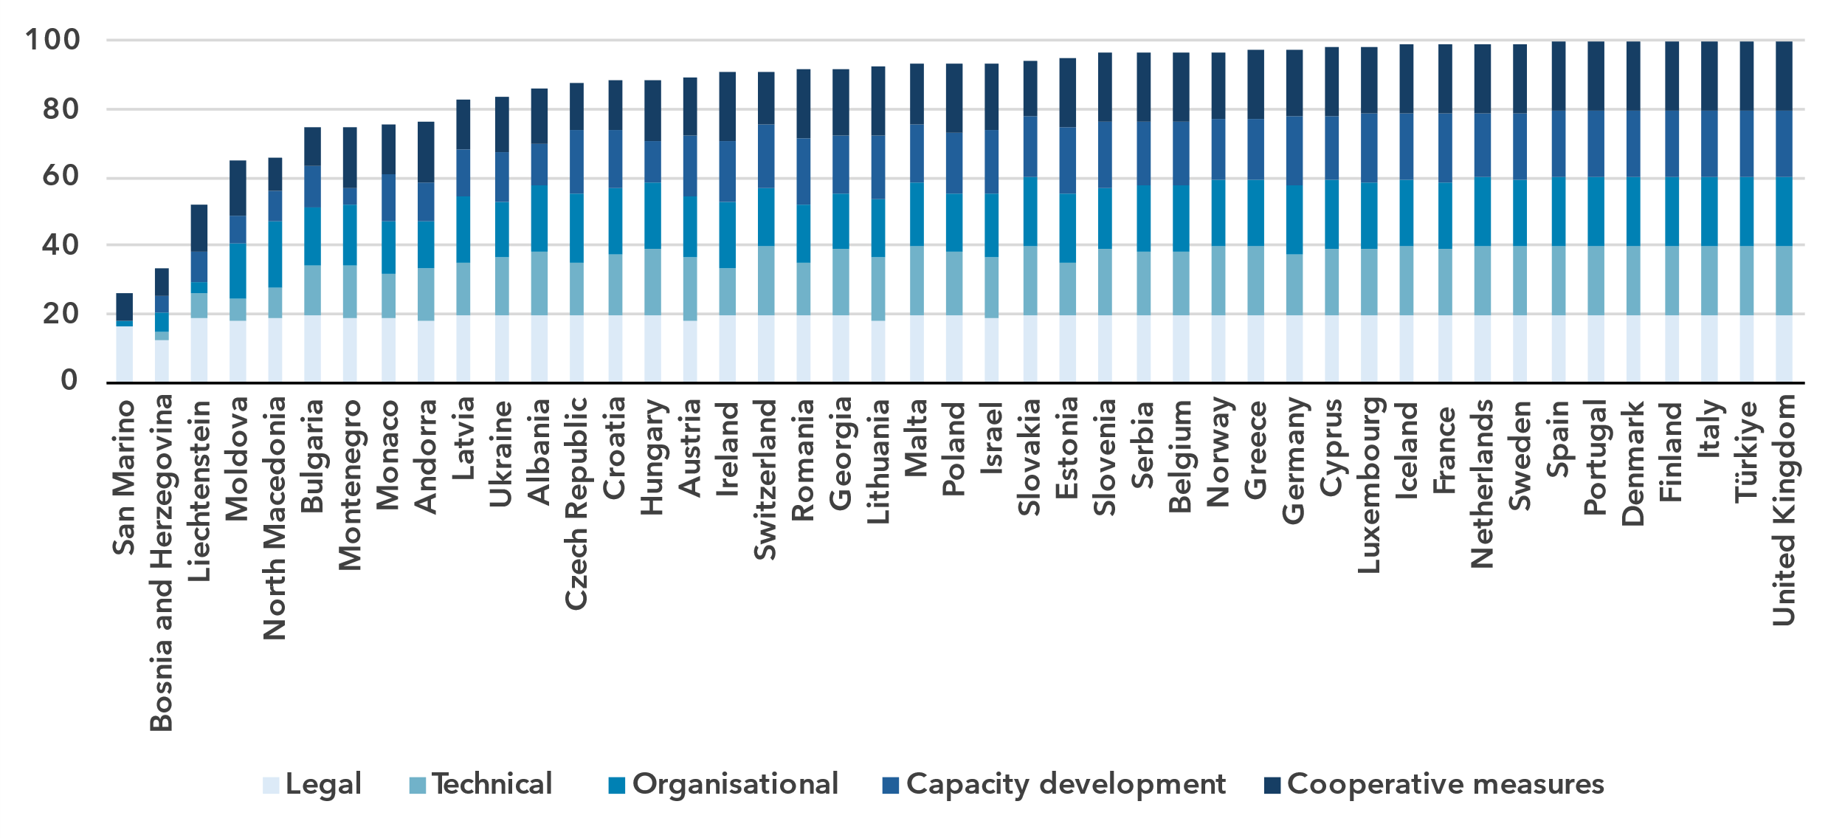Note: The overall GCI score shown is the sum of the score of the five pillars.

Source: ITU

The performance of European countries in the GCI is mixed, with a 74-point difference between the region’s best performers, which achieved the maximum score of 100, and the region’s worst performer San Marino, scoring 25.9.

Globally, countries from all categories of level of development are represented among the top scoring countries in the GCI, indicating that development level is not a reliable predictor of cybersecurity efforts. The Europe region’s large number of high-income countries, in particular Northern European countries, continue to score very well. While Southern Europe is the lowest scoring subregion, it has also made the largest improvement from the previous edition, increasing from 70 to 78.8 points.

The technical pillar of the GCI assesses the effectiveness of national mechanisms and institutional structures in detecting, preventing, responding to and mitigating cyberthreats and incidents. Computer incident response teams (CIRTs) are responsible for protection against, detection of and response to cybersecurity incidents and can enhance a country’s ability to manage such incidents. Nearly all countries in the Europe region have established national CIRTs, and many are participating in regional cyber exercises. Still, there is a need to further develop these CIRTS and to expand efforts for the protection of critical information infrastructure.

Child online protection (COP) encompasses strategies and initiatives to protect children from harm or exploitation online. This includes ensuring children are using age-appropriate software and filtering tools and educating parents and children about staying safe online. COP is tracked through questions under the legal, organizational and capacity development pillars. A total of 164 countries reported having legal measures on COP in the 2024 edition of the GCI, compared to 130 countries in the previous edition. These measures were sometimes part of other rules, regulations and substantive law, such as on online crime or sexual exploitation. Some 74 per cent of European countries have some form of COP strategy with associated actions; however, linking these efforts to educational efforts for educators, parents and policy-makers is key.

Finally, to meet the demand for cybersecurity professionals, countries are increasingly developing cybersecurity skills within their populations. While 91 per cent of European countries have cybersecurity-focused university degrees, it is important to ensure that there are multiple pathways towards building cybersecurity competency in order to meet ongoing cyber needs.

E-waste management

As countries strive to harness the benefits of technology to drive economic growth and achieve national development priorities, the challenge of managing electronic waste has become increasingly urgent. Strengthened e-waste policy and regulatory e-waste management are pivotal for ensuring environmental sustainability, supporting circular economy practices and advancing progress towards the SDGs.

E-waste generated, in million kg, 2022

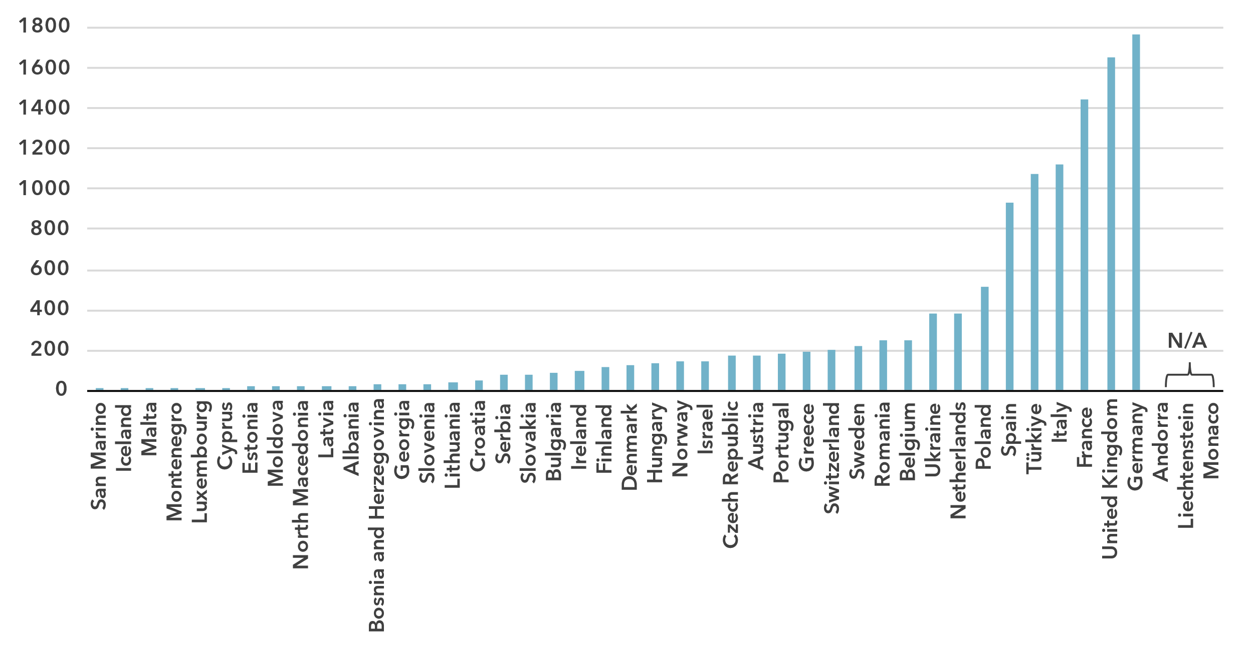Source: ITU and UNITAR, [Global E-waste Monitor, 2024](https://www.itu.int/hub/publication/d-gen-e_waste-01-2024/)

The [Global E-waste Monitor (2024](https://www.itu.int/hub/publication/d-gen-e_waste-01-2024/)) finds that, in 2022, the Europe region generated approximately 12.3 billion kg of e-waste, representing almost 20 percent of global e-waste generation (62 billion kg). However, significant disparities exist across the region. Countries like Germany (1 767 million kg), the United Kingdom (1 652 million kg) and France (1 445 million kg) were the largest contributors, together accounting for nearly 40 percent of the region’s total e-waste. In contrast, countries like San Marino, Iceland and Malta generated close to 20 million kg of e-waste combined, representing less than 0.2 percent of Europe’s total e-waste generation. This significant variation reflects differences in population size, economic development and technological adoption across the region.

E-waste per capita generated, in kg, 2022

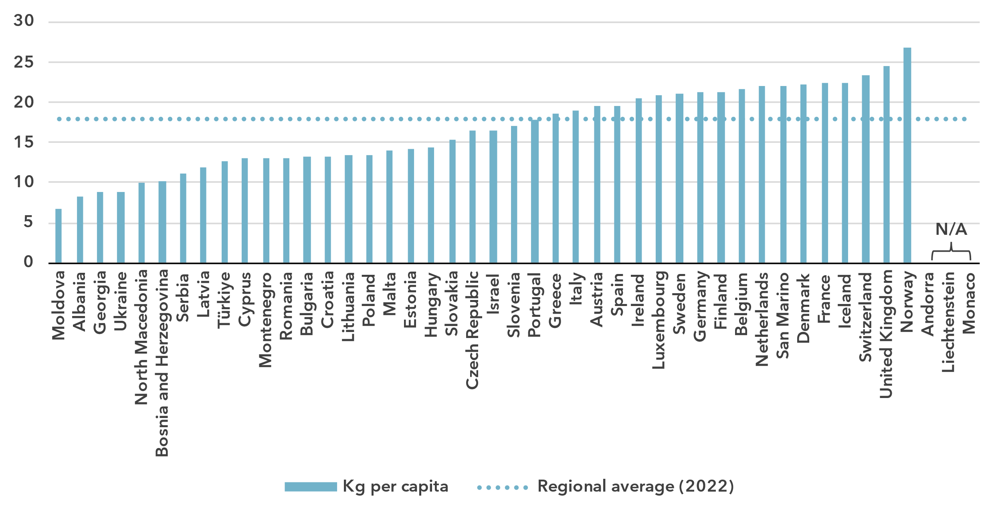Source: ITU and UNITAR, [Global E-waste Monitor, 2024](https://www.itu.int/hub/publication/d-gen-e_waste-01-2024/)

The analysis of e-waste trends in Europe can be further deepened by examining per capita e-waste generation. While Europe collectively exceeds the global per capita e-waste average of 7.8 kg, disparities between countries are significant. The regional average of 18 kg per capita reflects a diverse landscape where high-income nations drive up the overall figure. For instance, Norway and the United Kingdom stand out with the highest per capita e-waste generation at 26.8 kg and 24.5 kg, respectively—more than three times the global average. Similarly, Switzerland and France, with per capita e-waste generation of 23.4 kg and 22.4 kg, respectively, also exhibit high figures, in line with their economic status and widespread access to advanced digital technologies. In contrast, lower-income nations such as Moldova (6.8 kg) and Albania (8.3 kg) generate significantly less e-waste per capita. Meanwhile, mid-range contributors such as the Czech Republic (16.5 kg) and Portugal (17.8 kg) hover closer to the regional average yet still generate more than twice the global average.

Europe is among the regions generating the most e-waste. However, it also boasts one of the highest documented collection and recycling rates, recycling 46.2 percent (5 704 million kg) of the e-waste generated—more than double the global rate of 22.3 percent. Notably, Germany reported recycling 956.6 million kg of e-waste in 2022. In contrast, a few countries in the region, such as Albania and Georgia, lack significant formal recycling activity.

E-waste policies and regulations in place, 2022

|  |  |  |  |  |
| --- | --- | --- | --- | --- |
| **Country** | **National e-waste legislation/policy or regulation** | **Extended producer responsibility framework for e-waste** | **Collection targets** | **Recycling targets** |
| Albania | Yes | Yes | No | No |
| Andorra | N/A | N/A | N/A | N/A |
| Austria | Yes | Yes | Yes | Yes |
| Belgium | Yes | Yes | Yes | Yes |
| Bosnia and Herzegovina | Yes | Yes | Yes | Yes |
| Bulgaria | Yes | Yes | Yes | Yes |
| Croatia | Yes | Yes | Yes | Yes |
| Cyprus | Yes | Yes | Yes | Yes |
| Czech Republic | Yes | Yes | Yes | Yes |
| Denmark | Yes | Yes | Yes | Yes |
| Estonia | Yes | Yes | Yes | Yes |
| Finland | Yes | Yes | Yes | Yes |
| France | Yes | Yes | Yes | Yes |
| Georgia | Yes | Yes | Yes | No |
| Germany | Yes | Yes | Yes | Yes |
| Greece | Yes | Yes | Yes | Yes |
| Hungary | Yes | Yes | Yes | Yes |
| Iceland | Yes | Yes | Yes | Yes |
| Ireland | Yes | Yes | Yes | Yes |
| Israel | Yes | Yes | No | No |
| Italy | Yes | Yes | Yes | Yes |
| Latvia | Yes | Yes | Yes | Yes |
| Liechtenstein | N/A | N/A | N/A | N/A |
| Lithuania | Yes | Yes | Yes | Yes |
| Luxembourg | Yes | Yes | Yes | Yes |
| Malta | Yes | Yes | Yes | Yes |
| Moldova | Yes | Yes | Yes | No |
| Monaco | N/A | N/A | N/A | N/A |
| Montenegro | Yes | No | No | No |
| Netherlands | Yes | Yes | Yes | Yes |
| North Macedonia | Yes | Yes | Yes | No |
| Norway | Yes | Yes | Yes | Yes |
| Poland | Yes | Yes | Yes | Yes |
| Portugal | Yes | Yes | Yes | Yes |
| Romania | Yes | Yes | Yes | Yes |
| San Marino | No | No | No | No |
| Serbia | Yes | Yes | Yes | No |
| Slovakia | Yes | Yes | Yes | Yes |
| Slovenia | Yes | Yes | Yes | Yes |
| Spain | Yes | Yes | Yes | Yes |
| Sweden | Yes | Yes | Yes | Yes |
| Switzerland | Yes | Yes | Yes | Yes |
| Türkiye | Yes | Yes | Yes | Yes |
| Ukraine | Yes | No | No | No |
| United Kingdom | Yes | Yes | Yes | Yes |

Source: ITU and UNITAR, [Global E-waste Monitor, 2024](https://www.itu.int/hub/publication/d-gen-e_waste-01-2024/)

Europe region countries, in particular those within the European Union, stand out as global leaders in effective e-waste legislation and management. Globally, only 42 percent of countries (81 of 193) have enacted national e-waste policies, legislation or regulations. Europe emerges as one of the regions with the most extensive implementation, with 41 countries, or 89.1 percent of the region, having implemented such frameworks. Moreover, 39 European countries have adopted extended producer responsibility (EPR) frameworks for e-waste, accounting for 84.8 percent of the region. This represents nearly half of the 67 countries worldwide with legal provisions on EPR for e-waste. These frameworks are critical for holding producers accountable for the entire lifecycle of their products, from design to disposal, and underline Europe’s leadership in promoting sustainable e-waste management practices.

Countries with national e-waste legislation, policy or regulation tend to have a wide network of collection points for the separate collection of e-waste, as well as better documentation and e-waste management infrastructure. However, the stagnation of the global e-waste collection and recycling rate is likely exacerbated by the fact that only 46 countries worldwide have collection rate targets and only 36 have recycling rate targets. Of these, 37 and 33, respectively, are European countries. Expanding national e-waste legislation and establishing collection and recycling targets in the remaining countries will further strengthen the Europe region’s efforts to advance a circular economy and reduce environmental and health impacts.

Disparities within the region

***Regional averages conceal disparities in connectivity among Europe region countries***

Europe is diverse in many respects: income level, with the wealthiest country’s GNI per capita nearly 50 times larger than the poorest; urbanization rate, which ranges from less than 50 per cent to 100 per cent; and population, which ranges from microstates with fewer than 100 000 residents to large countries with more than 80 million residents.

Given these differences, it can be useful to group European countries into clusters, according to their scores on indicators of Internet use, mobile phone ownership, mobile-broadband and fixed-broadband subscription rates, affordability of entry-level mobile and fixed broadband, and gender equality. This cluster analysis yields four distinct groups, the respective members of which share similar ICT profiles.

The first group, consisting of three quarters of Europe region countries (34 of the 45 countries analysed) is characterized by rates of ICT usage and ownership that are well above the world average. Both fixed broadband and data-only mobile broadband are very affordable relative to the world average, with the median entry-level prices as a share of monthly GNI per capita far below the Broadband Commission target of 2 per cent of monthly GNI per capita or lower. There is also a high level of gender parity in terms of Internet use in this group.

The second group, consisting of Estonia and Poland, is similar to the main group of European countries. These countries also have above-average rates of ICT use and ownership and excellent affordability and gender parity. The primary difference with these countries is their higher subscription rates for both mobile broadband and fixed broadband.

When compared to the first two groups, the next, consisting of Croatia, Moldova and Türkiye, has somewhat lower rates of ICT use. This is in addition to lower subscription rates and somewhat worse affordability scores. However, averages in this group are still substantially above global averages in nearly all cases, with mobile phone ownership on the same level as in the above groups. The average Internet use for these countries is still 83 per cent compared to a global rate of only 65 per cent. Conversely, gender parity is less positive for this group with the gender parity score for average Internet use falling below that for the world.

This group is also similar in most respects to the final group of Albania, Bosnia and Herzegovina, Georgia, North Macedonia, Serbia and Ukraine. ICT use and ownership is still higher than global averages in these countries though not quite as high as for other European countries. ICT services are somewhat less affordable as well with the average price for the data-only mobile-broadband basket above the Broadband Commission target of 2 per cent of monthly GNI per capita or lower. Gender parity, however, is improved in this final group compared to that in the third group and similar to that in most European countries.

The diversity of these groups of countries underlines the need to design tailored approaches to achieve universal and meaningful connectivity.

Average of key ICT indicators by groups of similar European countries, 2023

|  |  |  |  |  |  |
| --- | --- | --- | --- | --- | --- |
|  | Group | | | |  |
| **Indicator (unit)** | 1  (34 European countries) | 2  (2 European countries) | 3  (3 European countries) | 4  (6 European countries) | **World average** |
| Share of individuals using the Internet (%) | 92.4 | 89.8 | 83.1 | 83.9 | **65.4** |
| Gender equality - Internet use  (gender parity score) | 0.99 | 1.02 | 0.92 | 0.98 | **0.93** |
| Share of individuals owning mobile phones (%) | 95.6 | 95.5 | 94.6 | 91.2 | **78.6** |
| Mobile-broadband subscriptions  (per 100 inhabitants) | 115.0 | 202.3 | 103.8 | 89.4 | **89.9** |
| Fixed-broadband subscriptions  (per 100 inhabitants) | 39.5 | 30.7 | 26.1 | 26.7 | **18.6** |
| Data-only mobile broadband prices  (as a % of GNI per capita) | 0.3 | 0.3 | 0.7 | 0.7 | **2.8** |
| Fixed broadband prices (as a % of GNI per capita) | 0.9 | 0.8 | 1.4 | 2.2 | **1.3** |

Note: Group medians shown for data-only mobile-broadband and fixed-broadband prices as a % of GNI per capita.

Source: ITU

Overview of data availability in the Europe region

Data plays a key role in achieving universal and meaningful connectivity. Reliable and timely data equips policy-makers to identify needs, set priorities, design effective interventions, track progress and measure impact. Investing in data yields substantial returns by enabling better decision-making and more efficient interventions.

The importance of data for the delivery of the Kigali Action Plan of the World Telecommunication Development Conference (Kigali, 2022) was acknowledged by the ITU Telecommunication Development Sector’s Telecommunication Development Advisory Group, which adopted five key performance indicators (KPIs) tracking the extent to which Member States submit timely ICT data to ITU, including KPIs related to the submission of ICT skills data and data on Internet use disaggregated by location and gender.

The availability and quality of ICT statistics in the Europe region, including both administrative indicators and those derived from household surveys, are exceptional and generally surpass those of other regions.

Availability for a core set of 14 administrative ICT indicators, typically collected by national regulatory authorities or ministries, is on average 90 per cent in the region (see indicator list in the note of the figure below). Some 12 countries report full availability, while 29 countries are missing only one indicator. Even the two countries with the lowest data availability provide recent data for nine indicators. Countries need to improve the quality and availability of international bandwidth usage, as well as fixed broadband Internet traffic data, as they are only available in, respectively, 18 and 34 of the 45 European countries studied.

Percentage availability of selected administrative ICT indicators, 2022-2023

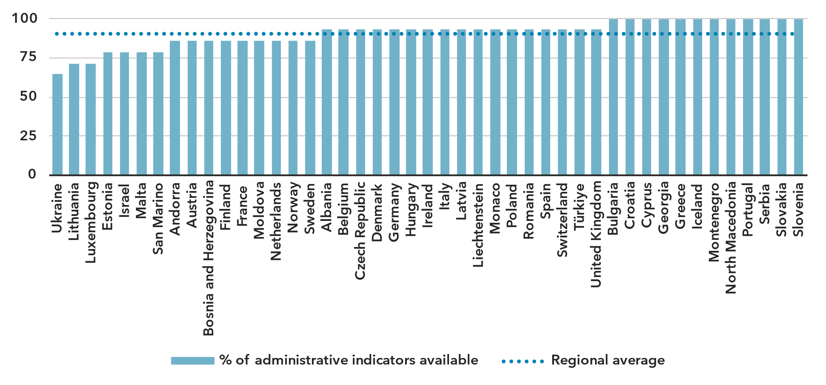Note: An indicator is considered available if at least one value is available for the period in question. Assessment based on the following set: active mobile-broadband subscriptions, fixed-broadband subscriptions (total, as well as by speed-tiers: 256 Kbit/s to 2 Mbit/s, 2 Mbit/s to 10 Mbit/s, and above 10 Mbit/s), mobile network coverage indicators by technology (at least 2G, 3G, LTE/WiMAX, 5G), total fixed-broadband Internet traffic, mobile-broadband Internet traffic within the country, international bandwidth usage, total telecommunication revenue and investment in telecommunication services.

Source: ITU

Data on ICT access and use by households and individuals is also widely available. This is partly due to the European Commission’s funding of annual ICT household surveys in member countries and neighbouring countries. Nevertheless, data remains scarce for several countries, in particular microstates. In addition, data for some socio-economic disaggregation is rarely reported for some countries.

Latest year of submission of ICT household survey data, by socio-economic attribute



Source: ITU

Part 2. BDT4Impact: Selected case studies from the Europe region

Promoting and measuring meaningful connectivity around the world  
[Universal and meaningful connectivity (UMC)](https://www.itu.int/itu-d/sites/projectumc/) is the foundation for a safe, satisfying, enriching and productive online experience at an affordable cost.

The ITU Telecommunication Development Bureau (BDT) and the European Commission have launched a EUR 3 million project on promoting and measuring universal and meaningful digital connectivity. In line with both ITU’s mission to connect the world and leave no one behind and the objectives of the European Union’s Global Gateway, the project aims to make UMC a top policy priority; generate more and better UMC data; and improve evidence-based policy-making, fund sourcing and project implementation.

The work will help to advance holistic policy approaches and provide recommendations on boosting good-quality Internet and mobile access.

As part of the project, a series of regional workshops were held in 2024 in the Bahamas, Qatar and Thailand. Apart from the learning experiences, the workshops provided opportunities for participants to network with various data producers and learn from other countries’ challenges and experiences.

More workshops are planned for 2025, including one in March targeting the members of 18 United Nations country teams of Europe and Central Asia, and another in June, targeting the administrations of the Western Balkans (Albania, Bosnia and Herzegovina, Montenegro, North Macedonia and Serbia), Georgia, Moldova, Türkiye and Ukraine.

Promoting child online protection in the Europe region, e.g. Andorra, Malta and Serbia

Although the Internet represents priceless opportunities for young people—from education to social activity, it also poses risks such as cyberbullying, data protection issues, harassment and financial exploitation.

The ITU Office for Europe is facilitating [child online protection](https://www.itu.int/en/ITU-D/Cybersecurity/Pages/COP/COP.aspx) (COP) initiatives across the region, collaborating with national stakeholders to promote safer digital environments for children.

In Andorra, a national COP assessment was launched in collaboration with the country’s government and facilitated a multistakeholder event on the topic.

In Malta, a train-the-trainer event helped to raise awareness of the protection and rights of children online. The training taught educators across the country the skills to confront these issues at school, train education-system colleagues and create a safer online experience for children.

The training was conducted at the request of the Malta Foundation for the Wellbeing of Society, led by former President of Malta Marie-Louise Coleiro.

In Serbia, support was given to the rollout of [COP guidelines](https://www.itu-cop-guidelines.com/) by the National Contact Centre for Children’s Safety. The guidelines were launched in a national event that was complemented by a dissemination campaign in schools that reached 60 educators and nearly 1 000 children.

IPv6 laboratory in Montenegro

The migration to Internet Protocol version 6 (IPv6), a high version Internet protocol, is a fundamental enabler of digital economy transformation and better social governance. The transition from IPv4 to IPv6 is a technical upgrade and a key step towards a more robust and sustainable digital future.

An [IPv6 laboratory was officially opened](https://www.itu.int/itu-d/sites/digital-impact-unlocked/opening-of-the-ipv6-laboratory-in-montenegro/) at the University of Montenegro in Podgorica, marking a milestone in Montenegro’s journey towards IPv6 readiness. The laboratory is fostering innovation, building capacity and helping to develop Montenegro’s digital infrastructure.

Other activities helping Montenegro to advance its digital transformation journey include: a national workshop on IPv6 strategies and policies; training of experts from public institutions; a technical assistance paper for the deployment of IPv6; and an IPv6 transition workshop.

In the area of broadband, ITU has developed a national broadband plan which aims to bring Montenegro towards universal and meaningful connectivity and aligns with European Union targets.

Driving sustainable rural digital transformation in Albania

Agriculture is a cornerstone of the Albanian economy; more than 40 per cent of the population live in rural areas, and nearly half of jobs rely directly or indirectly on the country’s agricultural and food system.

Digital Agriculture and Rural Transformation (DART) is a groundbreaking joint programme leveraging digitalization to advance Albania’s sustainability goals with interventions targeting smallholder farmers.

With funding from the Digital Transformation Window of the Joint SDG Fund, BDT is supporting the initiative along with the Food and Agriculture Organization (the lead agency); the United Nations’ Resident Coordinator’s Office for Albania; the International Labour Organization; and Albania’s Ministries of Agriculture and Rural Development, Infrastructure and Energy, and Finance and Economy.

DART is developing a national digital agriculture strategy and action plan aligned with the European Union’s legal framework, improving the delivery of digital public services, and developing digital capacities among small-scale farmers, students, technical, vocational and educational training schools and centres, and public sector employees.

By bridging the gap between vision and impact, Albania's agricultural sector is moving towards a digital sustainable future while contributing to the SDGs.

CyberDrills in Bulgaria and Cyprus enhance cybersecurity readiness in countries and across regions

Two recent CyberDrill events drew participants from multiple countries, helping bolster their capacity to respond to cyberattacks and other disruptions, and protect themselves from cyber threats.

The [ITU Cybersecurity Forum and CyberDrill for Europe and Mediterranean](https://www.itu.int/en/ITU-D/Cybersecurity/Pages/CyberDrill-2024/Europe-Regional-CyberDrill.aspx), held in Sofia, Bulgaria, brought together representatives from 19 countries, as well as experts from the Forum of Incident Response and Security Teams, Europol, the World Bank and the European Union Agency for Cybersecurity.

The event fostered a comprehensive dialogue on cybersecurity among participants from government agencies, national CIRTs, private sector companies, academia and international organizations.

In Cyprus, the 2023 [Interregional CyberDrill for the Europe and the Asia and the Pacific regions](https://www.itu.int/en/ITU-D/Cybersecurity/Pages/CyberDrill-2023/EUR-ASP-23-CD.aspx) also promoted collaboration for a more secure digital future.

Hosted by the country’s Digital Security Authority, the event tested organizations’ cyber capabilities by running simulations of cyberattacks, information-security incidents and other disruptions.

Experts from across the Europe and the Asia and the Pacific regions highlighted common experiences in combating escalating cyber threats, as well as region-specific challenges and approaches. Case studies provided actionable strategies, while discussions with key stakeholders offered diverse perspectives on fostering cooperation within regions and across borders.

Supporting broadband mapping systems in Albania, Bosnia and Herzegovina, and Moldova

Technical assistance has been provided in broadband mapping systems in Albania, Bosnia and Herzegovina, and Moldova, and in building regional collaboration through two regulators’ networks: [the European Mediterranean Regulators Group (EMERG) and the Eastern Partnership Electronic Communications Regulators Network (EaPeReg)](https://www.itu.int/en/ITU-D/bdt-director/Pages/News.aspx?ItemID=647).

In Bosnia and Herzegovina support was given in tailored policy recommendations to enhance the enabling environment for broadband mapping, while in Albania and Moldova, assistance was provided for dedicated technical specifications for the development of broadband mapping systems.

Over 2023-24, a series of six joint workshops were delivered in coordination with EMERG and EaPeReg to exchange best practices and address challenges related to broadband infrastructure and emerging technologies. The workshops yielded a compendium of 18 case studies that showcased broadband mapping systems and experiences in numerous countries; these case studies serve as a resource for global best practices.

ITU support has also included: a policy paper that analyses the regulatory environment in Bosnia and Herzegovina, with recommendations for a functional broadband mapping system; and reports outlining the technical requirements for implementing broadband mapping systems in each of the three countries.

Annex: Data resources

To ensure up-to-date information and enhance readability, all data presented in this document is available for download as Excel files:

* [Country-level data](https://www.itu.int/en/ITU-D/Statistics/Documents/facts/rpm_arb_pub_2025_data.xlsx) organized by tabs corresponding to the sections of this document (URL: <https://www.itu.int/en/ITU-D/Statistics/Documents/facts/rpm_eur_pub_2025_data.xlsx>). Country level data were extracted from the [ITU DataHub](https://datahub.itu.int/), reflecting the February 2025 data release.
* [Regional and global estimates](https://www.itu.int/en/ITU-D/Statistics/Documents/facts/ITU_regional_global_Key_ICT_indicator_aggregates_Nov_2024.xlsx), as compiled for [Facts and Figures 2024](https://www.itu.int/itu-d/reports/statistics/facts-figures-2024/) (URL: <https://www.itu.int/en/ITU-D/Statistics/Documents/facts/ITU_regional_global_Key_ICT_indicator_aggregates_Nov_2024.xlsx>).

________________

1. The ITU Europe region covers the following 46 economies: Albania, Andorra, Austria, Belgium, Bosnia and Herzegovina, Bulgaria, Croatia, Cyprus, the Czech Republic, Denmark, Estonia, Finland, France, Georgia, Germany, Greece, Hungary, Iceland, Ireland, Israel, Italy, Latvia, Liechtenstein, Lithuania, Luxembourg, Malta, Moldova, Monaco, Montenegro, the Kingdom of the Netherlands, North Macedonia, Norway, Poland, Portugal, Romania, San Marino, Serbia, Slovakia, Slovenia, Spain, Sweden, Switzerland, Türkiye, Ukraine, United Kingdom and the Vatican. The Vatican is excluded from this assessment due to insufficient data availability.
2. See EU, [A Europe fit for the digital age – Empowering people with a new generation of technologies](https://commission.europa.eu/strategy-and-policy/priorities-2019-2024/europe-fit-digital-age_en)
3. For the purposes of this analysis, the term 'EU Single Market' also encompasses UK due to its historical and policy similarities with EU countries.
4. ITU, [Global Digital Regulatory Outlook 2023](https://www.itu.int/pub/D-PREF-BB.REG_OUT01-2023/en)
5. e-Government capacities as defined by UNDESA in the E-Government Development Index (EGDI).
6. ITU, [Global Cybersecurity Index 2024](https://www.itu.int/epublications/publication/global-cybersecurity-index-2024).
7. Considering that some people may never want to connect, as a matter of convention universality is taken to mean an Internet penetration rate of at least 95 per cent.
8. In this document, for figures and tables reporting economy-level data, all economies are shown except for the Vatican, for which no data is available. Countries are sorted by value of the indicator. A data point is only shown if it is for the year 2020 or later, otherwise it is marked as not available (N/A), or excluded altogether (when data is not available for many countries). In addition, a marker shows the data point for the year 2018, if available. Data is extracted from the [ITU DataHub](https://datahub.itu.int/), based on the data release of end January 2025. Since country-level data is available for the year 2023 at best, for comparison purposes, the regional average for the year 2023 is reported as well, as published in [Facts and Figures 2024](https://www.itu.int/itu-d/reports/statistics/facts-figures-2024/). To save space in these figures and tables, “Netherlands” is used instead of “Netherlands (Kingdom of the)”.
9. The gender parity score is calculated as the proportion of women who use the Internet divided by the proportion of men who use the Internet. A value less than one indicates that men are more likely to use the Internet than women, while a value greater than one indicates the opposite. Gender parity is considered achieved if the value lies between 0.98 and 1.02.
10. Considering only those countries for which data was available for all years from 2018 to 2024.