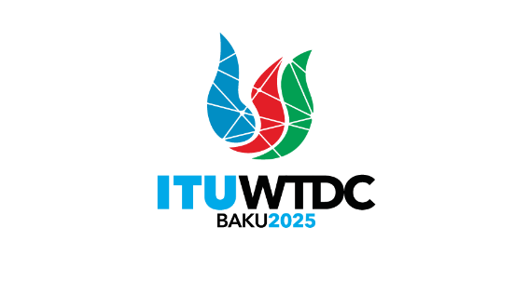 | Regional Preparatory Meeting  for Commonwealth of Independent States  for WTDC-25 (RPM-CIS)  Bishkek, Kyrgyzstan, 24-25 April 2025 |  | 
Heads of Delegation Meeting |  | Document RPM-CIS25/DT/2-E
 |  | 17 April 2025
 |  | English only
Draft agenda of the Heads of Delegation Meeting
Thursday, 24 April 2025, 0815h-0900h

 | Documents
1. Welcome & opening remarks
2. Approval of the agenda | RPM-CIS25/DT/2
3. Chair and Vice-Chairs of RPM-CIS
4. Briefing on RPM Documents
5. Draft time management plan | RPM-CIS25/DT/1
6. Admission of press to the RPM
7. Any other business

Dr Cosmas Luckyson Zavazava
Director, BDT
________________

