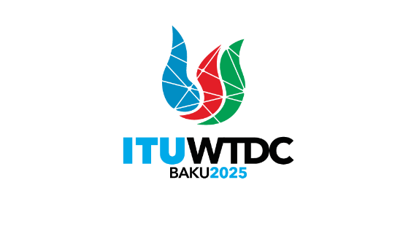 | Regional Preparatory Meeting  for CIS Countries for WTDC-25 (RPM-CIS)  Bishkek, Kyrgyzstan, 24-25 April 2025 |  | 
 |  | Document RPM-CIS25/5(Rev.2)-E
 |  | 17 March 2025
 |  | Original: English
Chair, TDAG-WG-futureSGQ
Progress report on the work of the TDAG-WG-futureSGQ
Agenda item:
Item 7.2
Summary:
This document presents a report on the activities of the TDAG Working Group on the future of Study Group Questions (TDAG-WG-futureSGQ) since May 2024. This revised version provides a shortened version of the updates from second, third and fourth meetings of TDAG-WG-futureSGQ and includes a section on updates from the fifth meeting held on 4 March 2025.
Action required:
RPM-CIS is invited to note this document and provide guidance as deemed appropriate.
References:
- WTDC Resolution 2 (Rev. Kigali, 2022)
- TDAG-24/25 (first progress report of TDAG-WG-futureSGQ)

- Introduction
At the 31st meeting of TDAG held in Geneva from 20-23 May 2024, the first progress report of TDAG Working Group on the future of Study Group Questions (document TDAG-24/25) was presented. The document shared the report of the first meeting of the TDAG Working Group on the future of Study Group Questions (TDAG-WG-futureSGQ) which included a proposed composition of the working group, a background document, a proposed the terms of reference for the working group and a proposed calendar of future fully online meetings.
Following the approval of the terms of reference at the TDAG meeting of May 2024, the TDAG-WG-futureSGQ held its second and third two fully online meetings on 3 September 2024 and 3 December 2024, respectively. At the December meeting, an additional meeting prior to the final one on 4 March 2025, was agreed. The fourth meeting was held on 21 January 2025.
This document shares the main outcomes of the second, third and fourth meeting of TDAG-WG-futureSGQ.
- The second fully online meeting of the TDAG-WG-futureSGQ held on 3 September 2024
The information shared below is from the report of the second meeting of TDAG-WG-futureSGQ (document TDAG-WG-futureSGQ/10).
The focus of the meeting was to review and agree on the content of the online consultation form (questionnaire) developed to gather views from all interested members subscribed to the TDAG and TDAG-WG-futureSGQ’s mailing lists.
The consultation form was structured into the following sections:
- Section 1 (“Current study Questions”) included general queries to respondents about their knowledge of the current structure of the ITU-D Study Groups, as well as which Study Questions in the current study period were important to them.
- Section 2 (“Number of Questions”) enquired on the number of Study Questions to consider in the next study period with a deeper dive in Questions to merge or discontinue.
- Section 3 (“New topics”) focused on identifying emerging topics to be addressed in the upcoming study period, with an emphasis on providing guidelines, best practices, and experience sharing for developing countries.
- Section 4 (“Cross-cutting topics”) probed on cross-cutting topics to be addressed in a separate study Question or across multiple study Questions.
The meeting agreed that the consultation form would be updated as per discussions held at the meeting and shared on 17 September 2024, with deadline for responses set to 1 October 2024. The results would be made available (as a contribution to the next meeting) by end of October 2024 to guide inputs from the membership for the next meeting of TDAG-WG-futureSGQ, scheduled on 3 December 2024, and to assist regional groups in preparing for WTDC-25.
- The third fully online meeting of the TDAG-WG-futureSGQ held on 3 December 2024
The information shared below is from the report of the third meeting of TDAG-WG-futureSGQ (document TDAG-WG-futureSGQ/16).
The results of the online consultation were presented as per the image below. These are for use by all in preparing contributions for submission to future TDAG-WG-futureSGQ meetings.
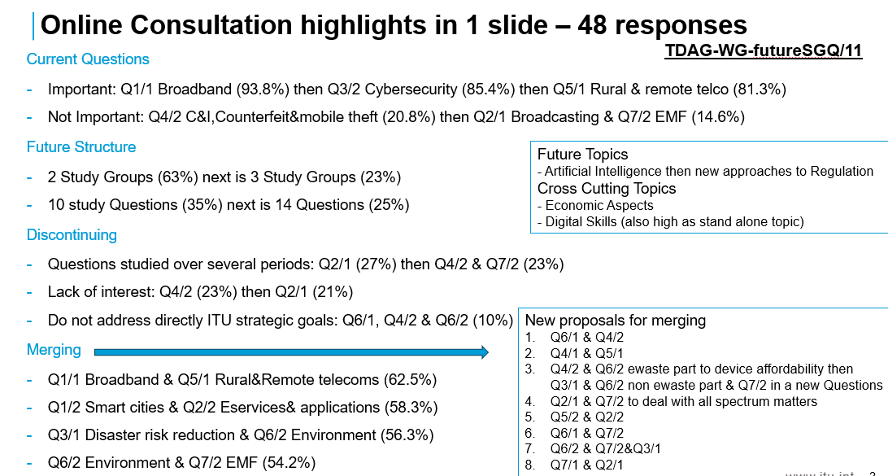
A contribution from the African Telecommunication Union (ATU) and a contribution on the initial views of Rapporteurs and co-Rapporteurs of Study Group 1 were received and discussed.
The meeting agreed that:
- The Chair will prepare a draft revision of extracts of Resolution 2 annexes including the terms of reference of Study Questions, for discussion in the next meeting. This document will consider the online consultation results, the contributions received as well as the views shared at the meeting. It will aim to engage the widest possible set of contributions/views received formally and informally. This document will be a contribution to the next TDAG-WG-futureSGQ meeting.
- The BDT secretariat will be tasked to request focal points from RTOs for the TDAG-WG-futureSGQ who will submit and present inputs of RTOs to the next TDAG-WG-futureSGQ.
- An additional e-meeting will be held in January- February 2025 period after further consultation with BDT secretariat, BDT Director and TDAG Chair.
- The fourth fully online meeting of the TDAG-WG-futureSGQ held on 21 January 2025
The information shared below is from the report of the fourth meeting of TDAG-WG-futureSGQ (document TDAG-WG-futureSGQ/25). This meeting was attended by over 80 participants.
Six contributions as listed below, were received, presented and extensively discussed:
- Views from the Asia-Pacific Community (APT).
- Two proposals for new Questions (Device Affordability/Availability and Application of Artificial Intelligence).
- The initial views of Rapporteurs and co-Rapporteurs of Study Group 2.
- The revised terms of reference of most of the Study Group 1 Questions.
- Document TDAG-WG-futureSGQ/23 which is the draft revision of extracts of Resolution 2 annexes including the terms of reference of Study Questions prepared by the Chair, as agreed in the previous meeting.
The meeting agreed that:
- Document TDAG-WG-futureSGQ/23 be updated to incorporate inputs from the contributions received and from discussions at the meeting. The final version of the document is planned to be shared as a deliverable of the TDAG-WG-futureSGQ.
- The two proposals for new Questions be reviewed collaboratively by the authors and participants who shared views on them at the meeting. The reviewed proposals would be presented at the next meeting and integrated into a revised version of document TDAG-WG-futureSGQ/23.
- The fifth fully online meeting of the TDAG-WG-futureSGQ held on 4 March 2025
The information shared below is from the report of the fifth meeting of TDAG-WG-futureSGQ (document TDAG-WG-futureSGQ/34). This meeting was attended by over 80 participants.
Six contributions as listed below, were received, presented and extensively discussed:
- Reports from the Industry Advisory Group on Development Issues and Private Sector Chief Regulatory Officers (IAGDI-CRO) on two tech talks organized on the themes of the two ITU-D study groups. They discussed on topics which may serve as inputs for future study Questions.
- Updated views from the African Telecommunication Union (ATU) on new topics (device affordability/availability and application of artificial intelligence), on number of study groups and on the draft proposal of the deliverable of TDAG-WG-futureSGQ.
- Completed compilation of terms of reference for ITU-D Study Group 1 (SG1) Questions, provided by the SG1 Vice-Chair and Coordinator on future study Questions on behalf of the SG1 (co-)rapporteurs.
- Updated proposal from China for a new Question on application of artificial intelligence (AI), following comments and offline discussions since the previous meeting.
- Proposal from Egypt on bases and guidelines for proposing future Questions, and comments on the draft proposal of the deliverable of TDAG-WG-futureSGQ.
- Document TDAG-WG-futureSGQ/29 which is the second draft revision of extracts of Resolution 2 annexes including the terms of reference of Study Questions prepared by the Chair, following contributions, comments and offline discussions since the previous meeting.
The meeting agreed to:
- uphold the current two study groups. Discussion of a possible third study group was recognized, but was considered outside the scope of the two study groups and would need to be discussed as a separate topic.
- have five study Questions in each of the two study groups.
- merge the Q1/1 (broadband) and Q5/1 (rural and remote areas) of the current study period.
- agree on focus for Q4/1 (economic aspects).
- include the new topic on AI into an existing study Question.
Further discussions were needed to achieve consensus on the following points:
- where to fit the new topic on device availability & affordability.
- whether some specific Questions (including Q6/1 with Q4/2 or Q5/2, Q7/1 with Q5/2, Q1/2 with Q2/2, Q4/2 C&I with Q6/2 and Q7/2) should be merged or not, and in which study group they should be studied (including Q3/1 and Q3/2)¹.
- whether some standalone or merged Questions (including Q1/1 merged with Q5/1, Q2/1)¹ should extend their scope to become more attractive.1
_______________

The Question numbers refer to the Questions of the 2022-2025 study period: link

