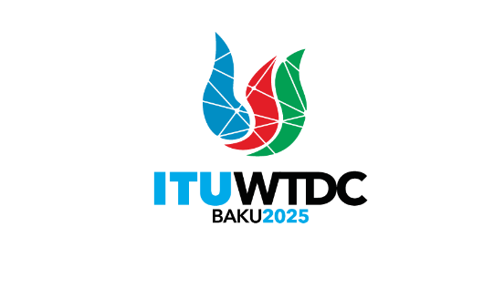 | Regional Preparatory Meetings  for WTDC-25 (RPMs) |  | 
 |  | Document RPMs/4-E
 |  | 10 December 2024
 |  | Original: English
Director, Telecommunication Development Bureau
Report on the decisions of other ITU Conferences, Assemblies and meetings
related to ITU-D work
Agenda item:
Item 6
Summary:
This document summarizes the key outcomes of:
- WTSA-24 (see Addendum 1), and
- RA-23 and WRC-23 (see Addendum 2)
while highlighting decisions that are relevant to the work of the Development Sector.
Action required:
This document is presented to the six RPMs for WTDC-25. The RPMs are invited to note these reports and provide guidance as deemed appropriate.
________________

