|  |  |  |  |
| --- | --- | --- | --- |
|  | **Regional Preparatory Meeting  for CIS Countries for WTDC-25 (RPM-CIS)**  **Bishkek, Kyrgyzstan, 24-25 April 2025** | |  |
|  | |  | |
|  | | **Document** **RPM-CIS25/3(Rev.1)-E** | |
|  | | **9 April 2025** | |
|  | | **Original: English** | |
| Director, Telecommunication Development Bureau | | | |
| State of digital development and trends in the CIS region:  Challenges and opportunities | | | |
|  | | | |
| **Agenda item:**  5  **Summary:**  This document, prepared for the Regional Preparatory Meeting for the CIS region for the World Telecommunication Development Conference WTDC-25, aims to inform participants and stakeholders in setting the region’s digital agenda. It has two parts: the first provides an overview of the state of digital connectivity in the CIS region through key indicators, and the second highlights impactful case studies from the region.  **Expected results:**  RPM-CIS is invited to note this document.  **References:**  N/A | | | |

State of digital development and trends in the CIS region: Challenges and opportunities

March 2025

Contents

Introduction 3

Part 1. The state of digital connectivity in the CIS region and recent trends 5

ICT regulation and digital policy frameworks 5

Internet use 11

Broadband subscriptions 16

Mobile network coverage 18

Availability of fixed broadband infrastructure 20

Internet traffic and international bandwidth 22

Affordability of ICT services 26

Mobile phone ownership and subscriptions 28

ICT skills 31

Revenues and investment 36

Cybersecurity 38

E-waste management 40

Overview of data availability in the CIS region 43

Part 2. BDT4Impact: Selected case studies from the CIS region 45

Supporting connectivity in rural Armenia 45

Promoting universal and meaningful connectivity in Uzbekistan 45

Young people from five CIS countries learn to create and pitch startups 45

Enhancing Azerbaijan’s ICT data systems 46

Regional forum in Kyrgyzstan highlights strategies for meaningful connectivity 47

Cyberdrills boost cybersecurity readiness across CIS countries 47

Annex: Data resources 48

Introduction

Regional preparatory meetings (RPMs) engage the ITU community in the preparations for the World Telecommunication Development Conference 2025 (WTDC-25). The present document is presented to the RPM for the Commonwealth of Independent States (CIS) region on 24-25 April 2025, and seeks to inform participants and stakeholders as they discuss the region’s digital agenda.[1] It consists of two parts: the first provides an overview of the state of digital connectivity in the CIS region through key indicators, and the second showcases impactful case studies from the region.

**Universal and meaningful connectivity is a policy imperative.** The concept of universal and meaningful connectivity (UMC) has emerged as a vital policy objective. UMC is defined as enabling everyone to enjoy a safe, enriching, and productive online experience at an affordable cost. UMC does not mean everyone must be connected all the time but describes a situation where everyone can access the Internet optimally and affordably whenever and wherever needed. This objective must be at the core of any digital policy to ensure that everyone can contribute to and benefit from digital transformation.

**The CIS region is advancing but faces structural challenges.** The region’s nine economies vary widely in their levels of digital development. Several countries have near-universal Internet access, while others lag due to lack of infrastructure, affordability barriers, and inadequate regulations. Seven of the nine CIS countries are landlocked, making them dependent on neighbouring states for connectivity and transit infrastructure. Despite progress in mobile broadband expansion and ICT service affordability, persistent disparities are observed between urban and rural areas and across income levels, particularly in access to high-speed Internet.

**Internet use is high, but gaps remain.** In 2024, 92 per cent of individuals in the CIS region were online, well above the global average of 68 per cent. However, the urban-rural divide persists, with 95 per cent of urban residents online, compared with 85 per cent in rural areas, where 7 per cent of the population simply has no possibility of accessing the Internet. Moreover, older adults are also less likely to be online, limiting the region’s full digital inclusion and that population’s participation in digital.

**Gender parity in Internet use has been achieved.** In 2024, 93 per cent of men and 91 per cent of women were online, yielding a gender parity score of 0.98, above the global average. While some national disparities persist, the CIS region stands out in this area.

**Fixed broadband expansion is uneven.** One-third of the CIS population lives within 10 km of a fibre-optic node, and 93 per cent are within 100 km. Some countries have robust broadband networks, while others rely heavily on mobile connectivity, restricting the growth of high-speed, high-capacity services.

**Mobile broadband is highly affordable.** The median price of a two-gigabyte mobile broadband plan was 0.7 per cent of GNI per capita in 2024, well below the UN Broadband Commission two per cent affordability target. The cost is below two per cent in all but one country of the region. However, fixed broadband remains expensive in several countries.

**Digital regulation is lacking.** Only one of the nine CIS countries (Armenia) has reached the most mature stage of ICT regulation (Generation 4, or G4); globally, 38 per cent of countries have reached this stage. Kyrgyzstan is in Generation 3, and the remaining seven CIS countries are all in Generation 1 or 2. The lack of regulatory maturity impacts market competition, investment, and the expansion of digital services. Strengthening ICT regulation will be essential to fostering a competitive market, improving digital infrastructure, and enabling innovation across the region.

**Regional cooperation could strengthen digital development.** While CIS countries have made progress on an individual basis, greater collaboration in policy alignment, infrastructure sharing and regulatory harmonization could accelerate this. Coordinating cross-border initiatives and improving spectrum management may help create a more integrated and competitive digital market. Expanding regional dialogue on ICT policies could also help address shared challenges such as infrastructure costs and cybersecurity risks.

**Cybersecurity requires attention.** The CIS region achieved an average score of 67 out of 100 in the ITU Global Cybersecurity Index (GCI) 2024, slightly above the global average of 66. However, cybersecurity readiness varies widely, with a nearly 70-point GCI score gap between the region’s best and worst performers.

**E-waste management is a growing concern.** The CIS region generated 2.5 billion kilograms of electronic waste in 2022, but only 6.5 per cent was formally collected and recycled, less than one-third of the global recycling rate (22.3 per cent). Only three countries have e-waste regulations, highlighting the need for stronger sustainability policies.

**ICT skills levels vary across skill areas.** Digital literacy is a key enabler of meaningful connectivity, but data on the topic remain extremely scant, with only three CIS countries having some data available. Communication and collaboration skills are nearly universal among Internet users in these countries. In other areas these countries report lower levels of digital competency among Internet users, particularly in the critical areas of digital content creation and safety.

**A lack of reliable data hinders progress towards UMC.** Data gaps remain a major challenge, limiting evidence-based policy-making. While some CIS countries collect and report ICT statistics regularly, others lack comprehensive household survey data on ICT use and ICT skills. Without detailed, disaggregated data, governments struggle to design effective interventions, allocate resources efficiently, and track progress. Addressing this issue requires investments in national statistical systems and regional data-sharing mechanisms.

**Impactful initiatives demonstrate the power of digital connectivity.** The second part of this document highlights transformative projects across the CIS region, showcasing how digital technologies are driving social and economic development. These examples illustrate how targeted interventions can bridge digital divides, enhance digital literacy and foster innovation. By scaling successful models, the region can accelerate its progress towards UMC.

**The path forward requires a holistic approach.** Achieving UMC in this region will require coordinated efforts across governments, industry, and international organizations. Priorities include expanding infrastructure, improving affordability, strengthening regulation, enhancing cybersecurity and closing digital skill gaps. A collaborative and evidence-based approach will ensure that digital transformation is inclusive, sustainable and aligned with national and regional development goals.

Part 1. The state of digital connectivity in the CIS region and recent trends

ICT regulation and digital policy frameworks

The evolving landscape of ICT regulation and digital policy frameworks plays a critical role in driving an inclusive and sustainable digital transformation and fostering thriving digital economies. To ensure national frameworks remain effective and adaptive, it is crucial to assess progress, identify best practices and address gaps.

***ICT regulation in the CIS region follows its own path.***

Over the past 15 years, ICT regulation in the Commonwealth of Independent States (CIS) region has evolved towards greater market liberalization. Regulatory frameworks have been introduced in key areas such as universal access, infrastructure sharing and spectrum management. However, progress remains uneven across countries and challenges persist, including limited competition in certain market segments, the absence of converged licensing frameworks and varying degrees of alignment with global best practices.

In 2007, seven CIS countries were at the Generation 1 stage (G1) and two in Generation 2 (G2), the least advanced levels of ICT regulation. Today, five countries have moved up the scale from G1, but so far only two countries have graduated to the most advanced levels. The region was the last to see a country reach G4: Armenia did so in 2018, when 73 other countries had already reached that level. To date it remains the only G4 country in the region. Kyrgyzstan advanced to G3 in 2020.

Evolution of the generations of ICT regulation in the CIS region

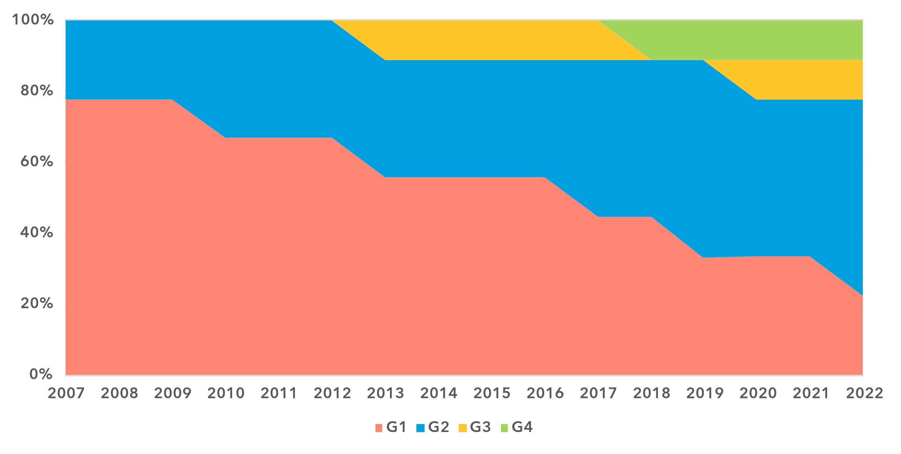

Note: The ‘Generations of ICT regulation’ provides a high-level conceptual framework for assessing the overall development of national legal instruments, policies and governance for the ICT and digital sectors. Generations 1 through 4 are based on [ICT Regulatory Tracker](https://app.gen5.digital/tracker/metrics) scores:

G1 – Command and control approach: score between 0 and 40   
G2 – Early open markets: score between 40 and 70   
G3 – Enabling investment and access: score between 70 and 85   
G4 – Integrated telecommunication regulation: score between 85 and 100

Data for 2021 is unavailable; 2020 data is used as a proxy for 2021.

Source: ITU

Seven of the nine CIS countries are landlocked developing countries (LLDCs), facing the associated structural barriers such as dependence on transit countries for international connectivity (submarine cables or fibre) and higher infrastructure costs. LLDCs in the region are nonetheless represented across all regulatory generations, demonstrating that effective ICT regulation can help address market constraints and drive ICT development even in an unfavourable context.

Building on past reforms, most CIS countries could benefit from further regulatory initiatives to ensure a level playing field across all ICT market segments, particularly in fixed-line connectivity, and to promote private sector participation and attract foreign investment.

***Digital governance in CIS: laying the groundwork***

Digital governance in the CIS region remains in its early stages: under the G5 benchmark, not a single country is at the highest tier for digital governance frameworks, the Leading category.[2] As of 2023, only Armenia and the Russian Federation have attained the Advanced level, both having made significant progress since 2021. The rest of the region falls within the Transitioning category, except for one country classified as Limited. The gap of 42 percentage points between the region’s most and least advanced country in digital governance highlights significant disparities within the region.

The region's overall digital governance score stands at 44 per cent, eight percentage points below the global average. Most countries lag slightly behind world averages across all areas. The region’s strongest relative performance is under the digital economic policy pillar, where the region is just six percentage points behind the world average. The most significant shortfall is under the pillar of national collaborative governance, where the gap reaches 42 percentage points. However, this is also where the region has seen the most substantial improvement since 2021, with an increase of 23 percentage points. Another significant improvement is the 17-percentage point gain under digital development toolbox.

Addressing persistent gaps in digital governance requires accelerating institutional and policy reforms to strengthen the foundations for digital development in the region.

***Readiness of national frameworks in CIS requires further strengthening***

Effective ICT regulation and sound digital governance are pivotal to achieving universal and meaningful connectivity and driving inclusive and sustainable digital transformation. Holistic and coherent policy and regulatory frameworks foster competitive ICT and digital markets, attract investment and generate positive spillover effects across economies, governments and societies.

Compared to other regions, the CIS region demonstrated the lowest overall readiness of the national policy, legal and governance frameworks for digital transformation, with an assessed score of just 34 points, compared to the world average of 51. The region’s performance lags the world average on all nine benchmarks, with gaps ranging from 1 to 47 points. LLDCs perform in line with the rest of the region on all benchmarks.

National digital transformation agendas are a critical foundation for bridging digital divides and expanding access to digital opportunities. These agendas rely on a mix of instruments, including holistic and sectoral digital policies and targeted strategies aimed at connecting all citizens, businesses and government institutions. In the CIS region, only one-third of the targets under the digital economic policy agenda pillar were met in 2023. Six countries have adopted national digital strategies covering multiple sectors (supporting economic diversification), and six have implemented ICT accessibility policies for persons with disabilities, promoting broad digital inclusion. However, only the Russian Federation and Uzbekistan have adopted national employment strategies for youth, and Kazakhstan is the only country with a dedicated digital skills policy.

Legal, policy and governance frameworks for digital transformation, 2022-2023

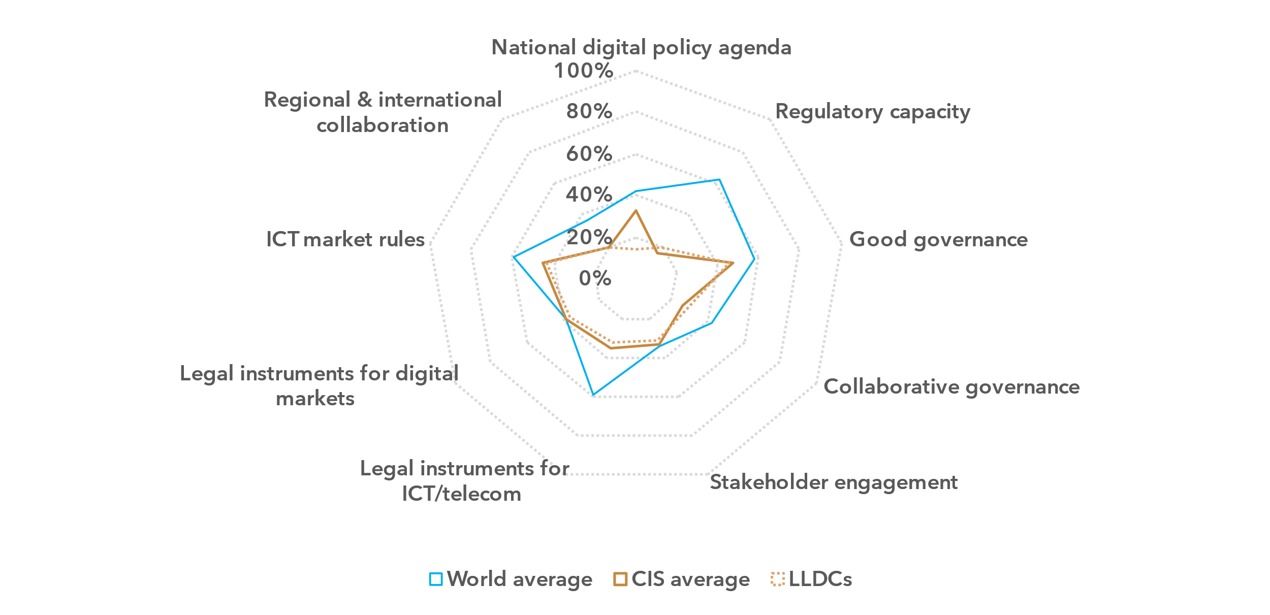Note: The nine thematic benchmarks (as in the chart above) each comprise a subset of indicators, as part of the [ITU Unified Framework for the readiness of national policy, legal and governance frameworks for digital transformation](https://www.itu.int/pub/D-PREF-BB.REG_OUT01-2023/en).

The chart shows progress on the nine benchmarks for the CIS region (average for the group) compared to the world average and the average for LLDCs (seven countries) in the region. The percentage of achievement on each benchmark indicates the proportion of met versus unmet targets on indicators in each benchmark.

Source: ITU

Unlike other regions, CIS exhibits a similar level of development in regulatory frameworks for ICT and digital markets. The legal instruments for ICT markets benchmark stands at 35 per cent, while the legal instruments for digital markets benchmark is slightly higher at 38 per cent. However, mixed trends are seen in both areas, revealing significant disparities within the region.

While six countries permit infrastructure sharing for mobile operators, only three mandate the sharing of essential facilities and co-location – a practice that enhances infrastructure competition. Cross-sector infrastructure sharing, which reduces connectivity costs and enhances network redundancy, is practised in only two countries.

Spectrum policies are relatively well developed, with six countries implementing spectrum refarming to optimize frequency use and meet rising demand for spectrum for new services. However, no country has introduced a secondary spectrum market, which would improve efficiency and expand access to underutilized frequencies.

Sectoral digital policies for education and health are present in three countries, boosting opportunities for meaningful digital inclusion in these countries. However, only one country has smart city regulations aimed at technology-driven urban development and reduction of cities’ environmental footprint.

Market competition in ICT and digital markets remains limited across the region. The market rules benchmark, which assesses competition dynamics, stands at 45 points, well below the global average of 59. While full competition in mobile cellular services is allowed in six countries, only two extend this to fixed-line markets. Foreign ownership of facility-based operators is permitted in five countries, increasing market participation, but only one country has a framework for assessing market dominance.

Regional and international cooperation, a key lever of ICT regulation and digital governance, remains largely underutilized in the CIS region. The regional benchmark for this area is just 20, 16 points below the world average and the lowest of all regions. This deficit can be seen as a strategic opportunity: strengthening regional collaboration could accelerate national policy reforms, foster regionally integrated digital markets and scale digital and emerging technologies across the region.

***Governance reforms advance unevenly***

Institutional arrangements and governance are critical to successful policy implementation and regulatory enforcement.

The CIS region ranks the lowest globally in the regulatory capacity benchmark, at just 16 per cent, 47 points below the world average. Lagging global trends, only four countries in the region – Armenia, Azerbaijan, Kyrgyzstan, and, since 2024, Tajikistan – have separate ICT regulatory authorities, strengthening oversight and policy implementation. However, only one of these regulators has financial and decision-making autonomy. Uzbekistan is set to establish a regulatory authority, following the adoption in 2024 of a new law to that effect.

Around the world, 168 national ICT regulators are working on technical standards, infrastructure and market regulation, ensuring regulatory consistency and fostering a stable, predictable environment for investment and competition. The dearth of dedicated regulators in the CIS region highlights the need for further institutional reforms.

Regulatory capacity and good governance in the CIS region, 2022-2023

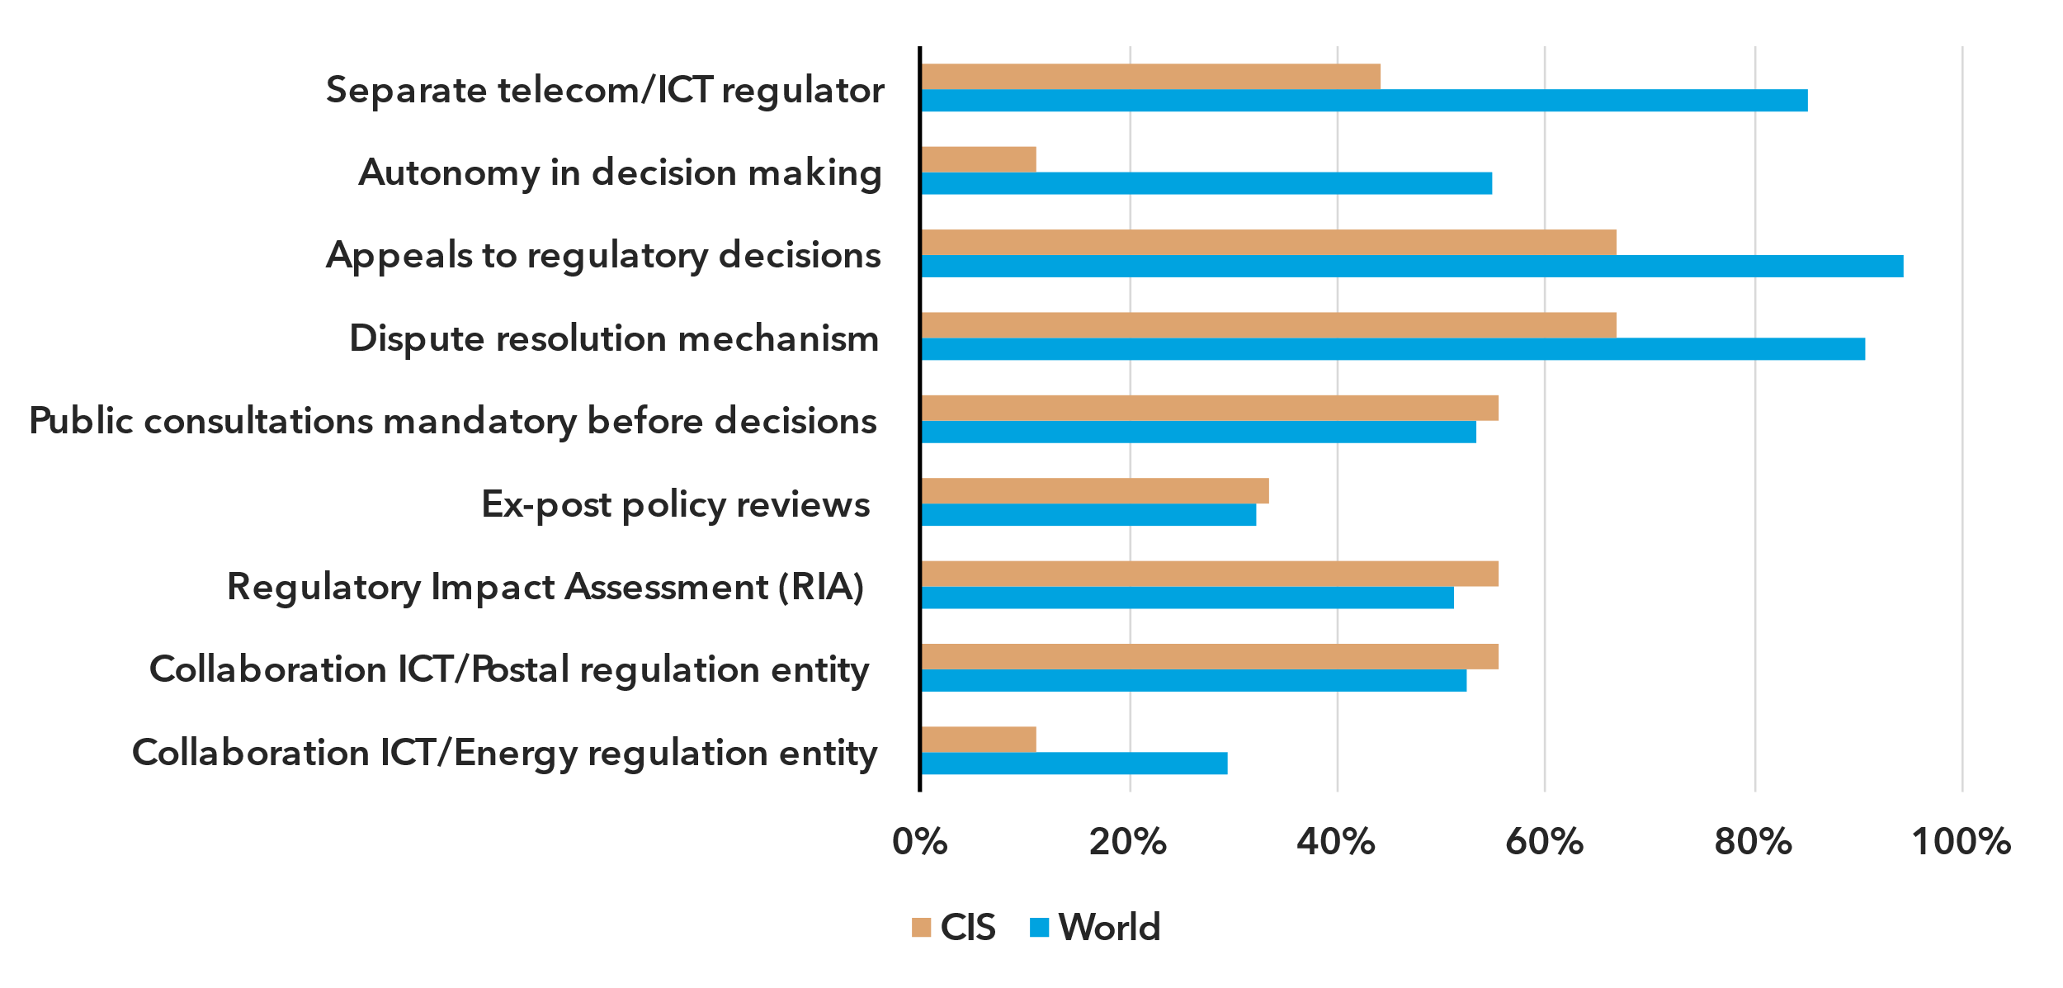

Note: The average scores for the CIS region on key related indicators for the regulatory capacity, good governance and stakeholder engagement benchmarks under the ITU Unified Framework are compared with the world average.

Source: ITU, based on data from ITU and SDG Indicators

Performance under the governance benchmarks in the CIS region varies. The strongest relative performance is in good governance, at 47 per cent. Six countries have established dispute resolution and appeals mechanisms for regulatory decisions, enhancing predictability and investor confidence. Public consultations on regulatory matters take place in five countries, aligning with the global average. However, critical tools for evidence-based policy-making, such as regulatory impact assessments and ex-post policy reviews, are less common (conducted in four and three countries, respectively).

Collaborative governance, or the capacity of government entities to engage in coordinated policy-making and whole-of-government policy implementation, remains underdeveloped, with a regional score of 26 per cent for the benchmark, well below the global average of 42. Most collaboration occurs in traditional areas such as postal and broadcasting regulation, practised in five and four countries, respectively. In contrast, cooperation on key cross-sectoral issues, such as energy and transport, is almost absent, with only one country engaging in such practices.

Strengthening governance and institutional capacity stands as a priority for accelerating digital transformation in the CIS region and achieving national digital policy objectives. Institutions with the requisite autonomy and capability, supported by cross-sector collaboration, are critical to effectively addressing emerging challenges and developing digital policies that align with global standards while responding to regional needs.

***CIS policy landscape for emerging technologies shows progress, not yet fully realized***

The widespread adoption of emerging technologies can help attract private capital into new markets, fuel digital economy growth and enhance public service delivery. A range of policy instruments is available to maintain a level playing field in rapidly evolving digital markets, tailored to accommodate the diverse sizes and types of market players. Beyond market dynamics, emerging technology policies shape outcomes for consumers, businesses and governments, strengthening digital resilience and fostering economic and social progress.

In the CIS region, the regulatory landscape for emerging technologies presents a mixed picture. While some areas align with global trends, significant gaps remain.

A strong foundation for emerging technology development lies in the adoption of comprehensive national digital strategies. With six CIS countries implementing such strategies, the region has a broad policy framework to support emerging technology deployment across sectors and market segments. However, industrial policies for digitalization of key sectors – critical for enhancing national competitiveness in the global digital economy – remain largely untapped. Only two CIS countries have adopted such policies, compared to the global average of 46 per cent, signalling an opportunity for further policy development in this area to accelerate the region’s digital transformation.

Creating an environment that fosters innovation is a key policy objective in digital economies, ensuring that emerging technologies can take root and start to scale. The CIS region stands out with relatively strong adoption of national innovation policies – more widespread here than in any region except Europe, and clearly above the world average. As of 2023, five countries have implemented innovation policies. However, mechanisms for regulatory experimentation such as sandboxes or innovation clusters exist in only three countries, limiting opportunities for testing and scaling new technologies across the region.

Turning the potential of emerging technologies into long-term economic and social value also requires targeted policies. Strategies for transformative technologies are gradually taking shape in the region. Three countries have adopted policies for advanced spectrum technologies, while two have introduced regulations or standards for the Internet of Things (IoT). However, the region faces a significant policy gap in the critical area of artificial intelligence (AI), with the Russian Federation being the only country to have adopted a national AI policy.

Enabling environment for emerging technologies in the CIS region, 2023

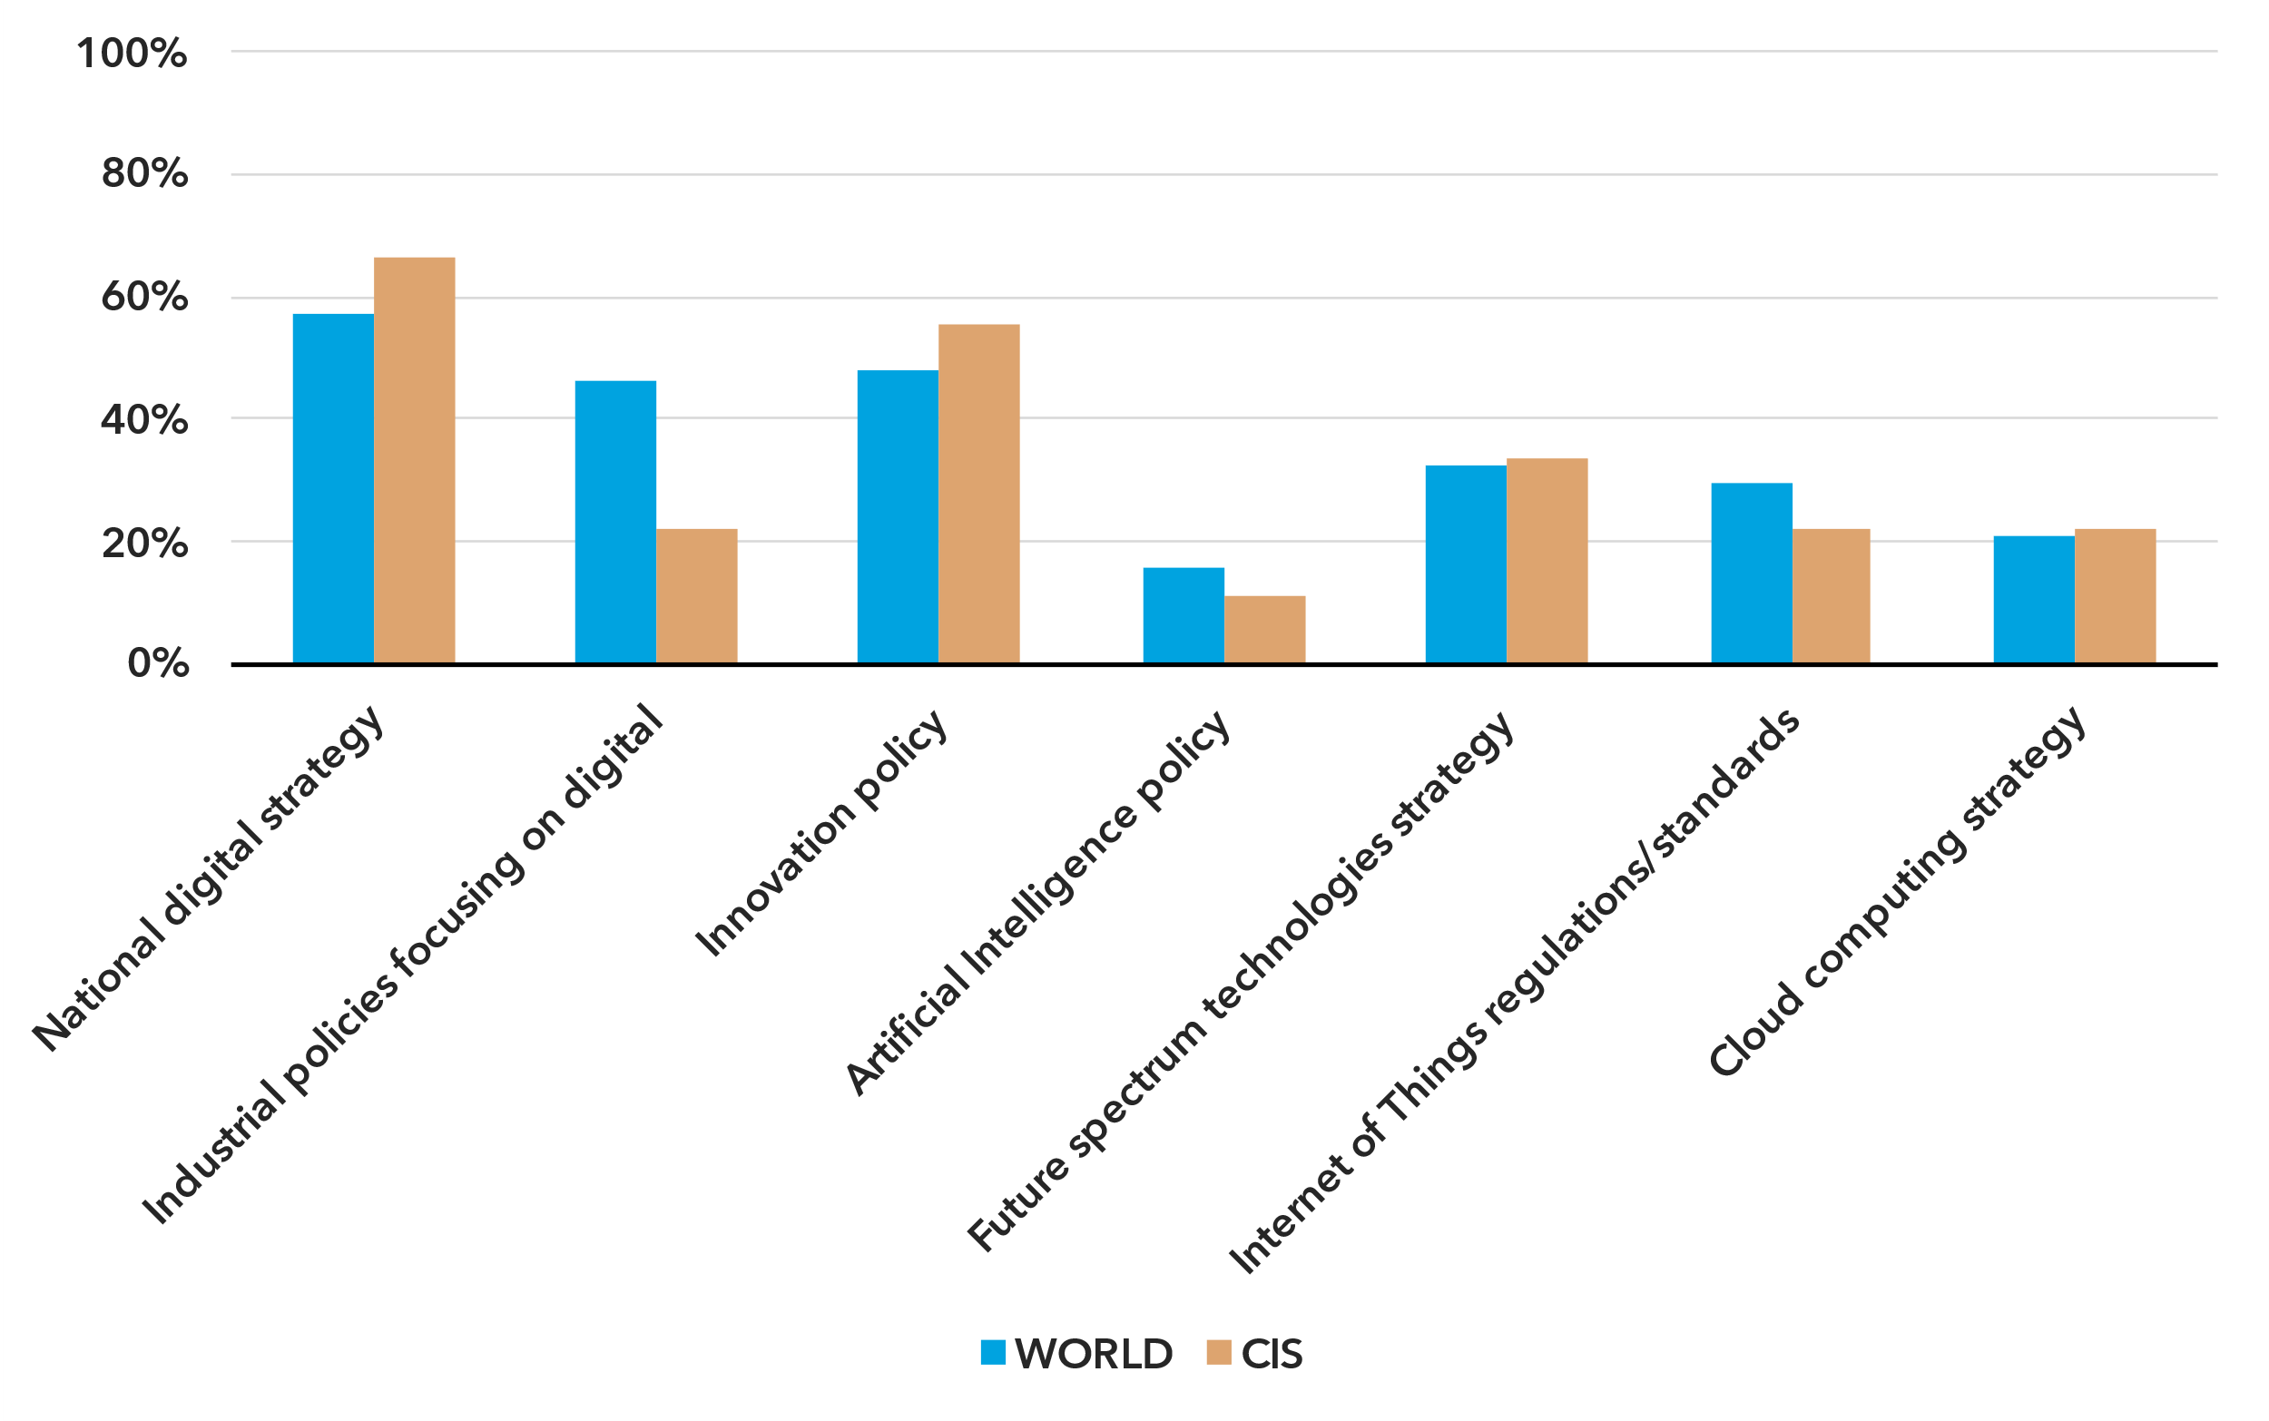Note: The region’s average scores on key indicators for the national digital agenda and legal instruments for digital markets under the ITU Unified Framework are compared to the world average.

Source: ITU

Ensuring fair competition is critical for scaling innovation and fostering sustainable growth of digital markets. While 22 per cent of countries worldwide have adopted competition policies specifically tailored to digital markets, no CIS country has introduced such a framework. This gap is significant, as competition policies are essential for promoting market dynamism and preventing anti-competitive behaviours in fast-moving digital sectors.

The CIS region has an opportunity to build on recent progress in fostering an enabling environment for emerging technologies, maximizing their benefits while mitigating risks. By accelerating digital policy reforms and adopting diverse, agile regulatory frameworks aligned with global good practices, CIS countries can strengthen their position in both regional and international digital ecosystems.

The United Nations Programme of Action for LLDCs[3] adopted in December 2024 underscores the urgency of bridging digital divides, enhancing digital skills and leveraging digital transformation for sustainable development. Supporting LLDCs in advancing responsible digital innovation and ensuring the ethical use of emerging technologies will be essential to unlocking the potential of digital entrepreneurship and value creation. This, in turn, can drive the growth of interconnected digital economies within the region and beyond.

Internet use

***Internet adoption in CIS is nearing universal levels***

Percentage of individuals using the Internet

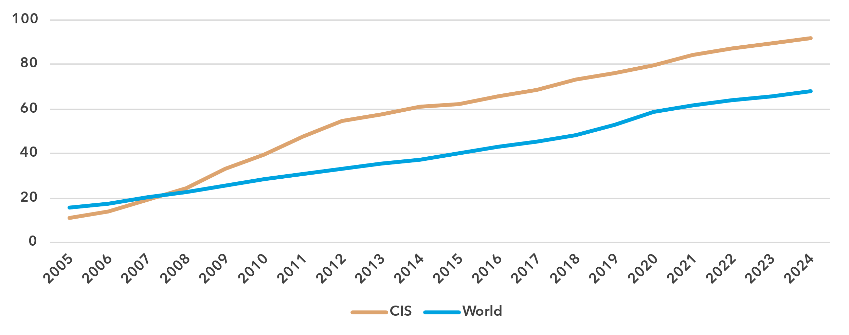Source: ITU

In 2024 the proportion of people online in the CIS region stood at 92 per cent, well above the global average of 68 per cent, and close to universal use.[4] Since 2005, the average annual growth rate of Internet penetration in the region has been 11.8 per cent, against 8 per cent globally. Over the last 10 years, growth has tapered off and now stands at 4.2, compared to 6.1 per cent globally.

Percentage of individuals using the Internet in the CIS region, 2023[5]

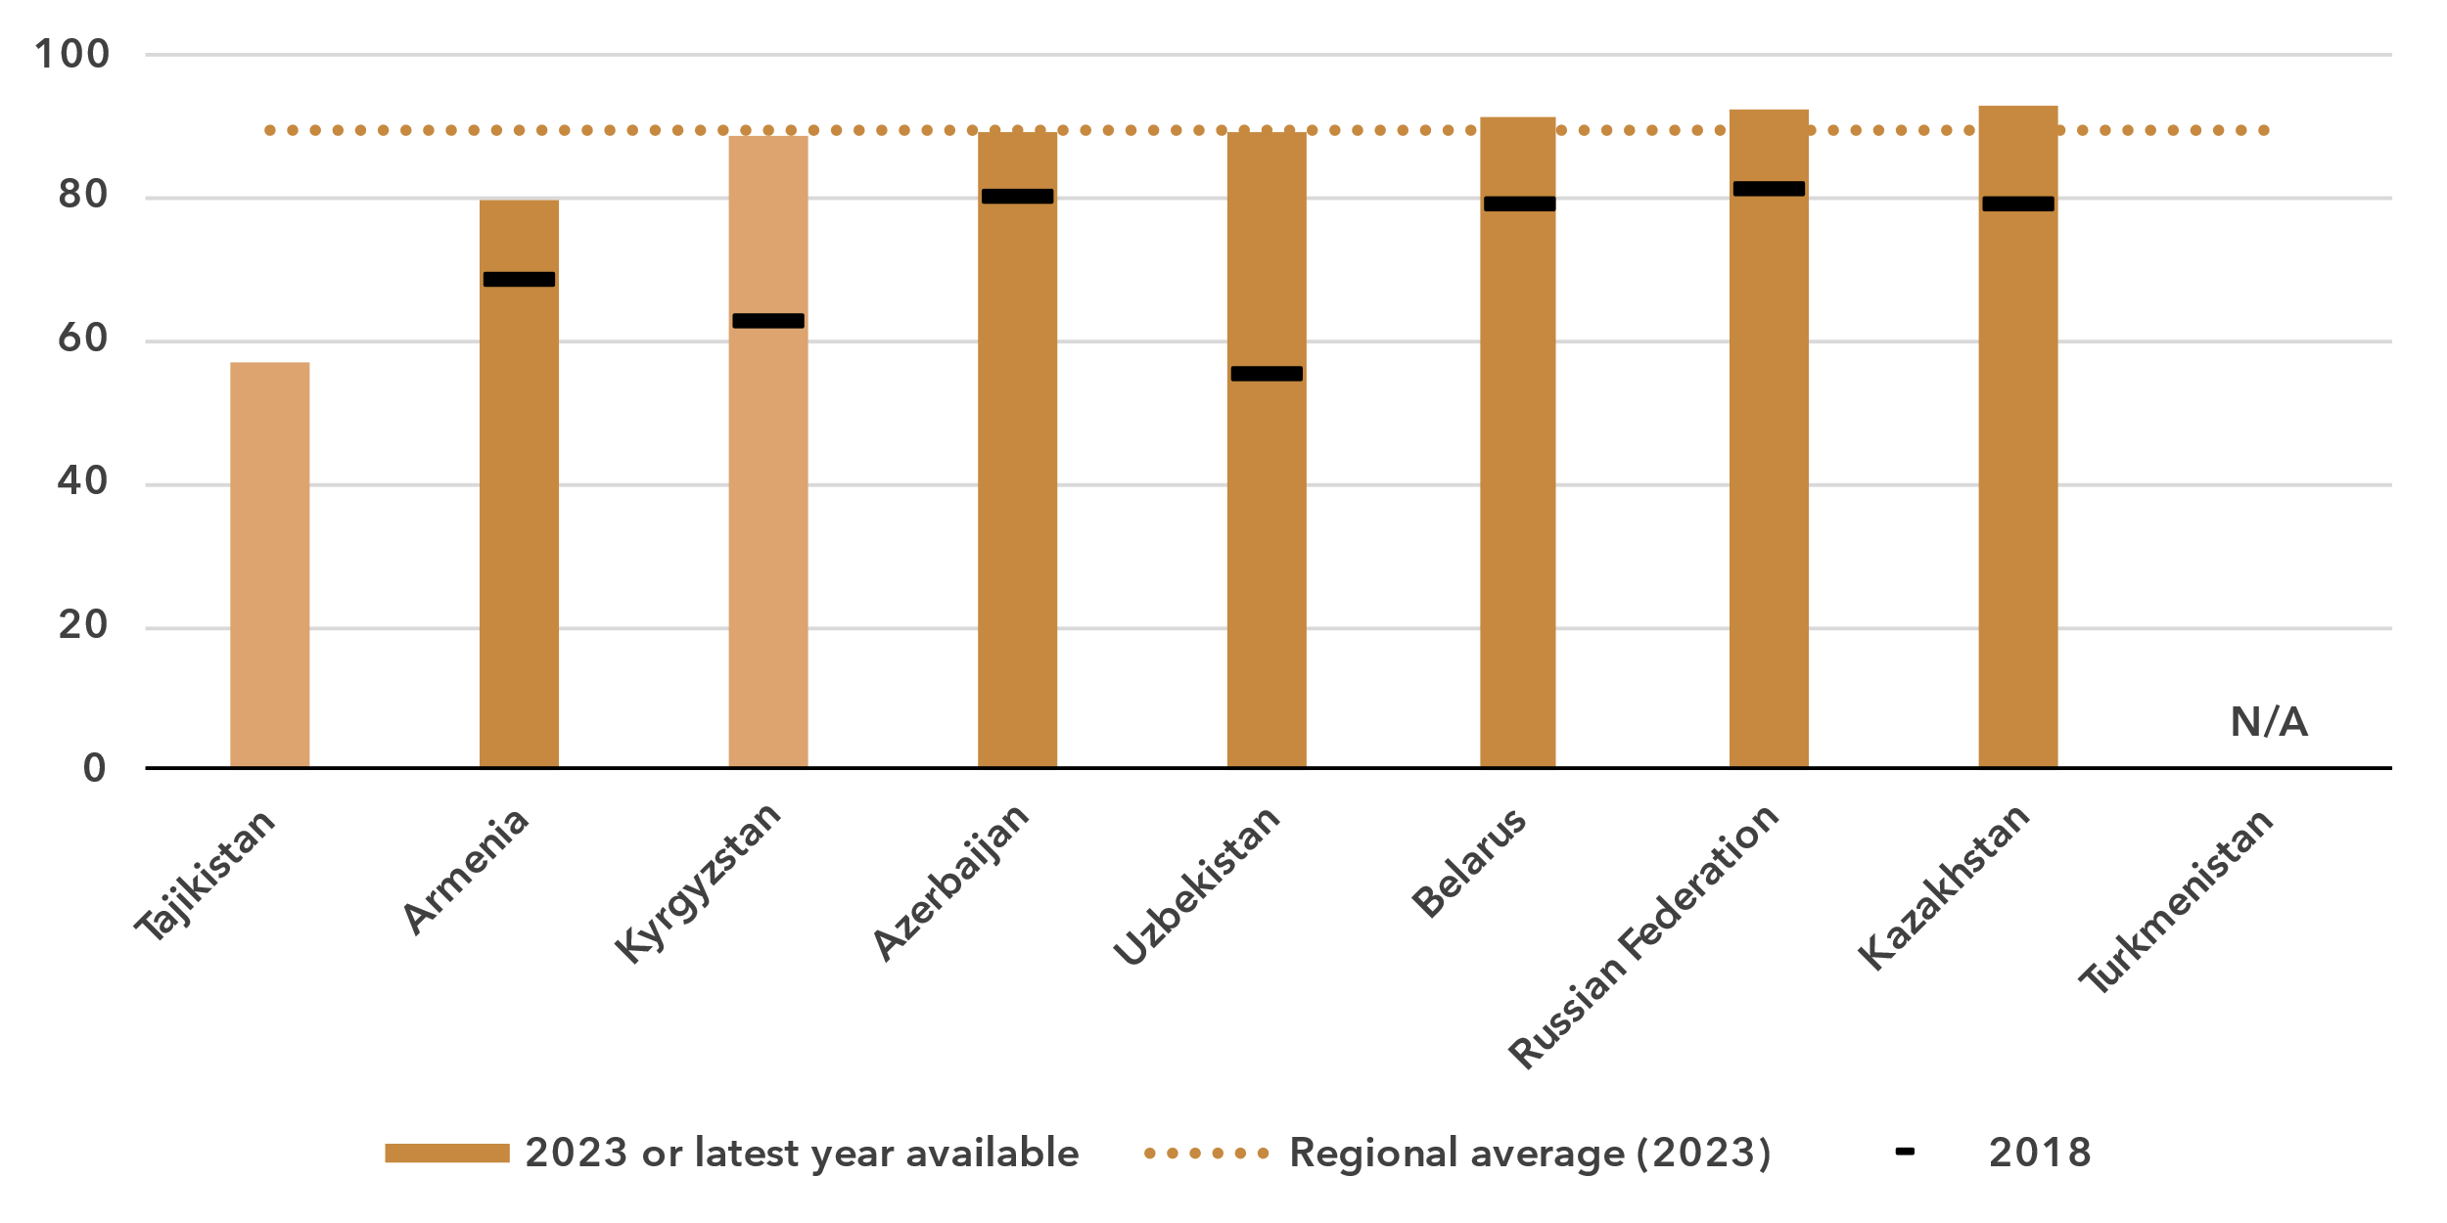 Note: Figures based on official national statistics are shaded dark to distinguish them from figures based on non-official data.

Source: ITU

In the nine countries of the CIS region, Internet use ranged from 57 to 93 per cent.

***Gender parity in Internet use has been achieved***

Percentage of individuals using the Internet, by gender, 2024

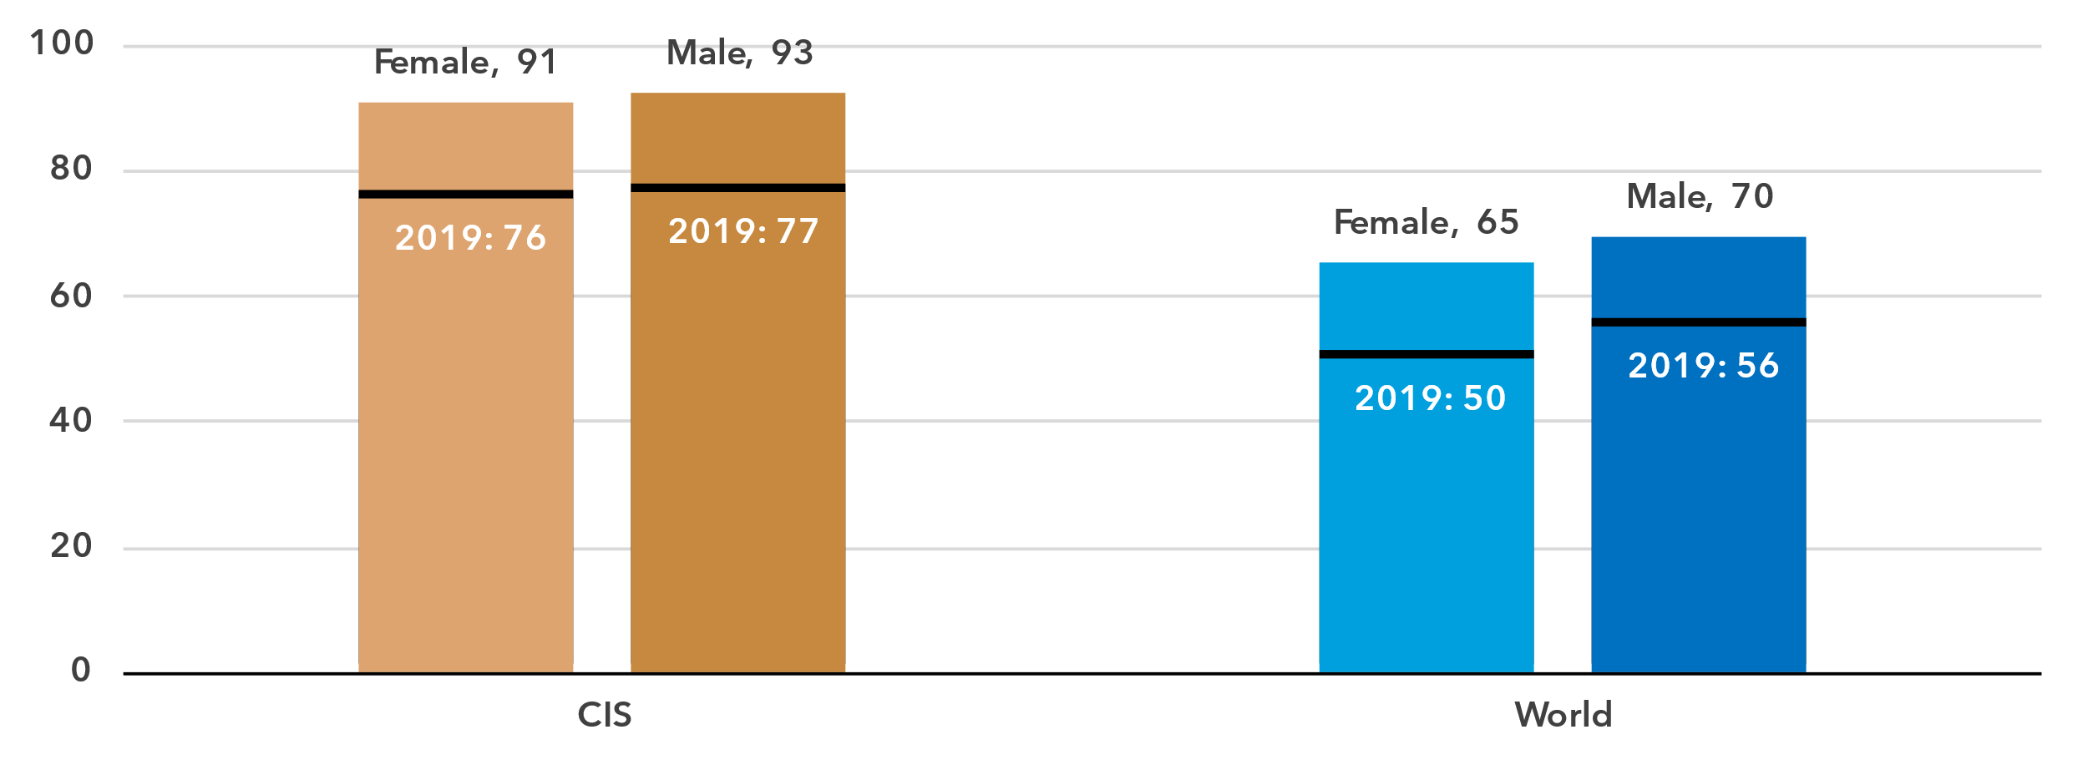Source: ITU

In 2024, 93 per cent of men in the CIS were online, against 91 per cent of women. This converts into a gender parity score (GPS)[6] of 0.98, well ahead of the global GPS of 0.94. Despite the small bias against women, gender parity is considered to have been achieved.

At the country level, gender parity has been achieved in three of the seven countries with data available. In the remaining four countries, three show a bias in favour of men, while in Armenia women are more likely to use the Internet.

Percentage of individuals using the Internet, by gender, 2023 or latest year available

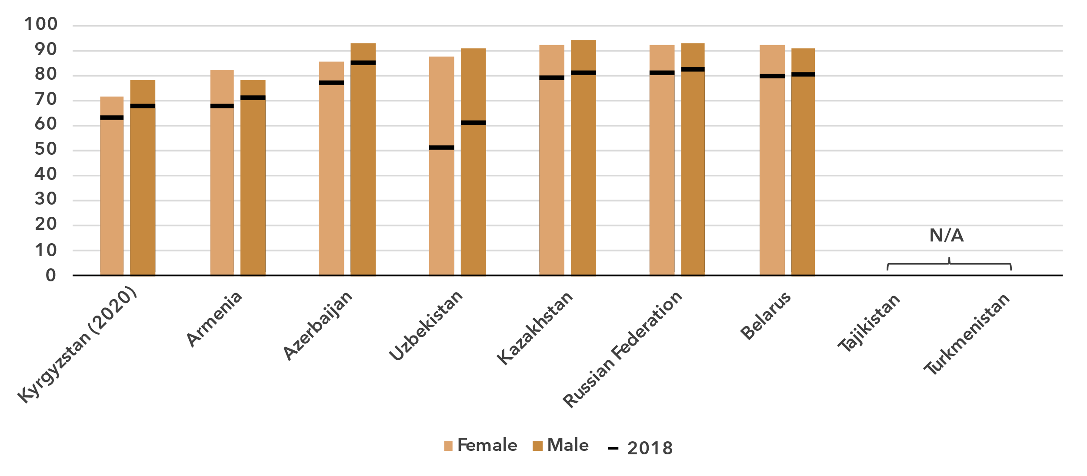

Source: ITU

***Almost all young people in the region are online***

Percentage of individuals aged between 15 and 24 years using the Internet, 2024

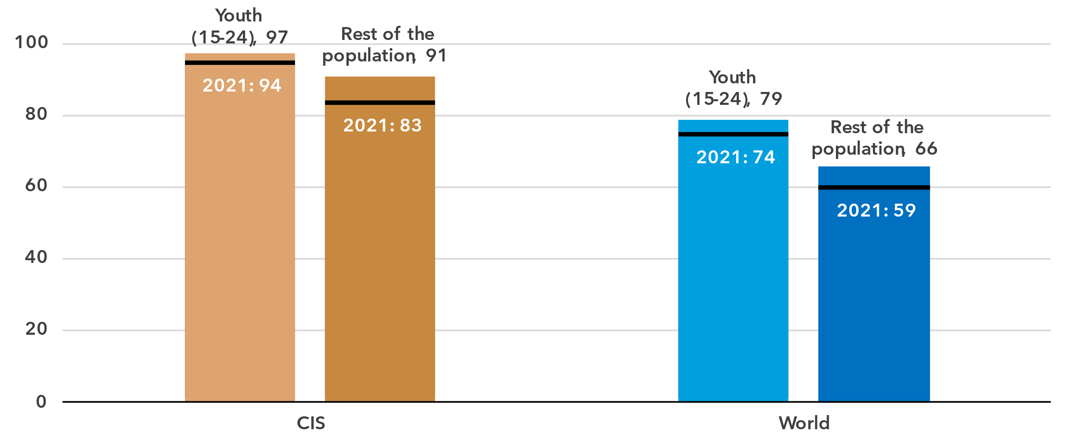

Source: ITU

In 2024 among young people (aged 15 to 24) Internet users made up 97 per cent, compared to 91 per cent for the rest of the population. The generational gap in this region – measured as the ratio of Internet users between these two groups – is smaller than the global average. It has been shrinking in the region over the last four years, in line with a global trend.

In most countries for which data are available, the percentage of young people online is very high. This stands in sharp contrast with the proportion of the elderly (those 75 years and older) using the Internet, which is low or very low in all economies in the region for which there are data for this age group.

Percentage of individuals using the Internet by age group, 2023 or latest year available

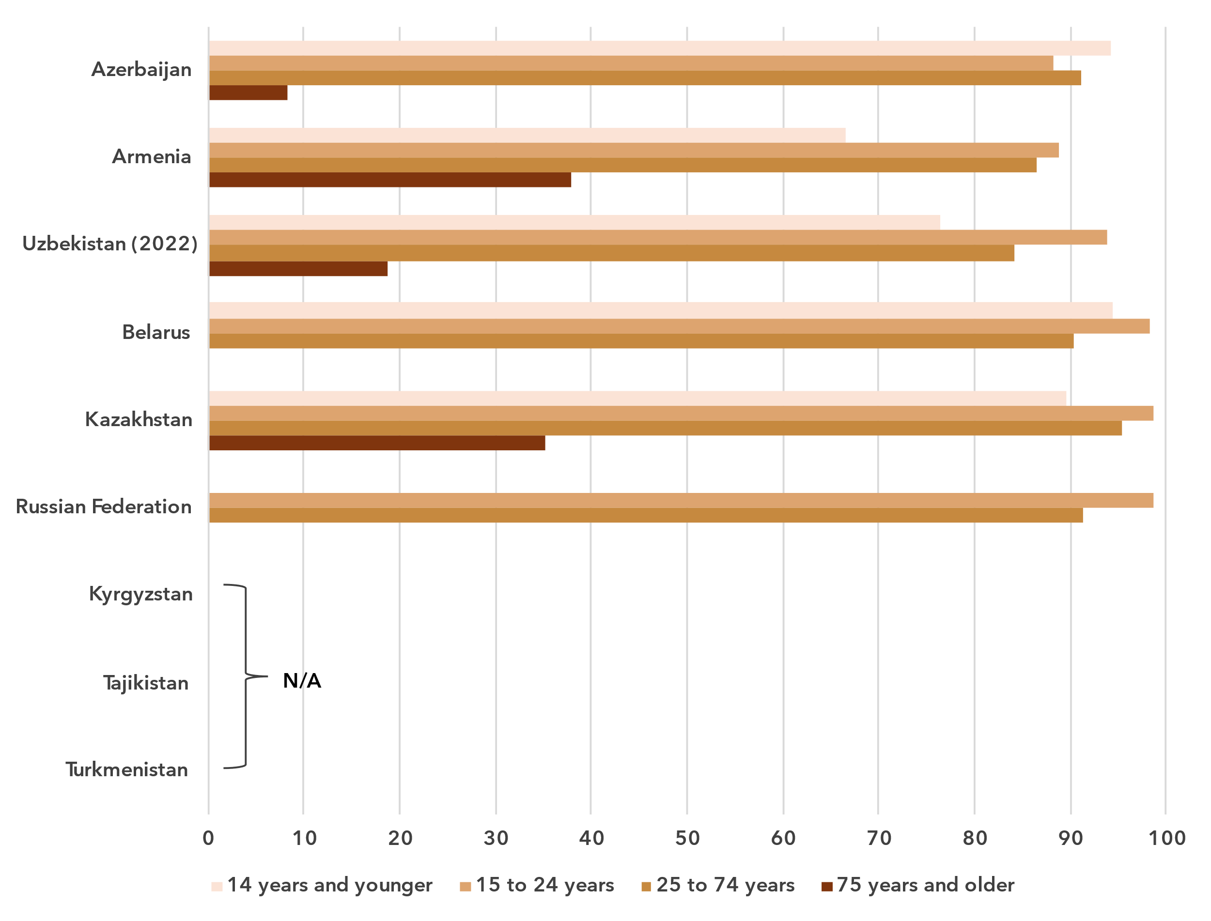

Note: Missing bars for certain age groups indicate that no data is available for those groups.

Source: ITU

***Rural-urban Internet use gaps persist but are narrowing***

Percentage of individuals using the Internet, by location, 2024

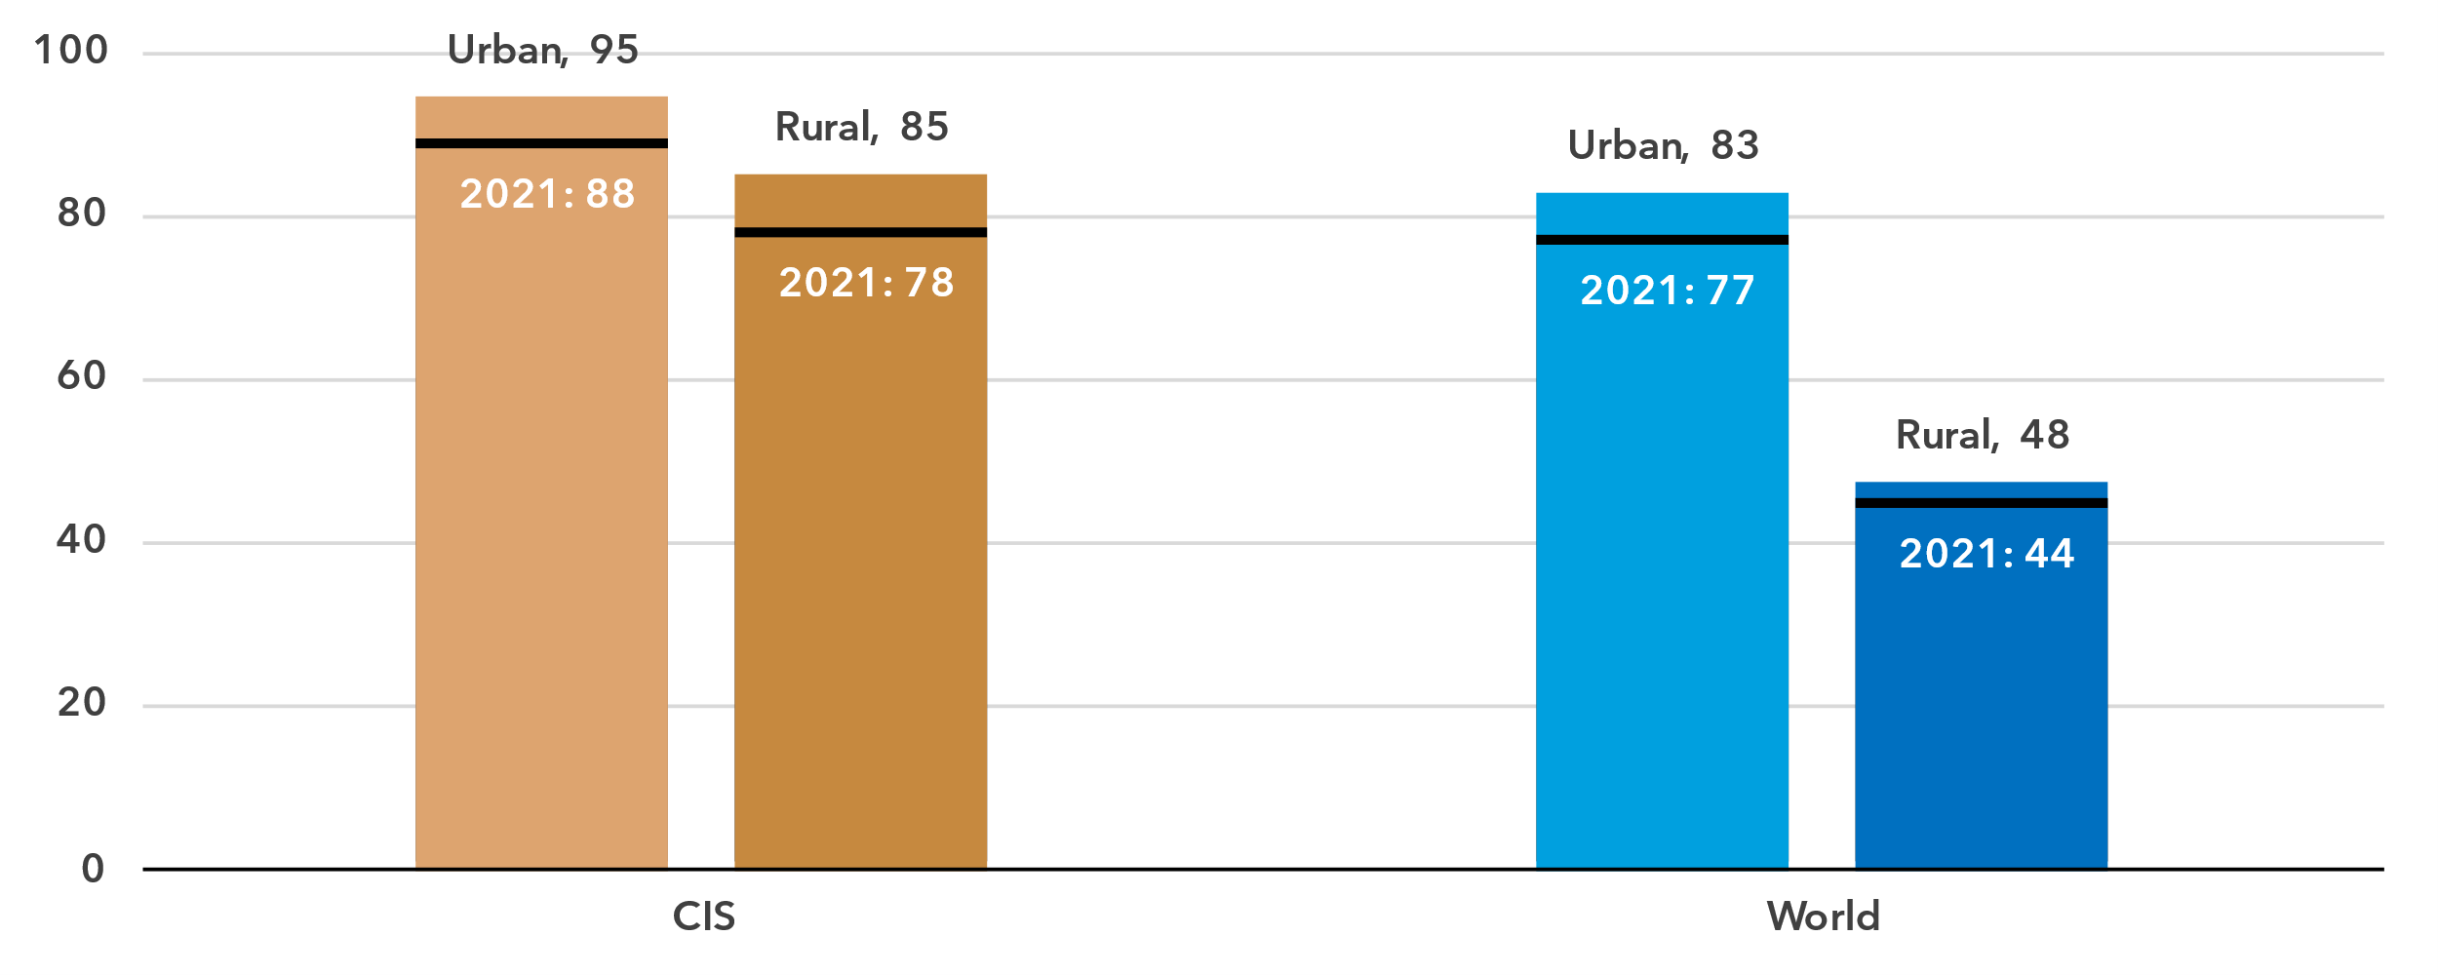

Source: ITU

In urban areas in the CIS region, 95 per cent of the population was online in 2024, compared with 85 per cent in rural areas. This gap is much smaller than it is globally, with 83 per cent online in urban areas, against only 48 per cent in rural areas. In all the countries in the region the urban-rural gap was quite small.

Percentage of individuals using the Internet by location, 2023 or latest year available

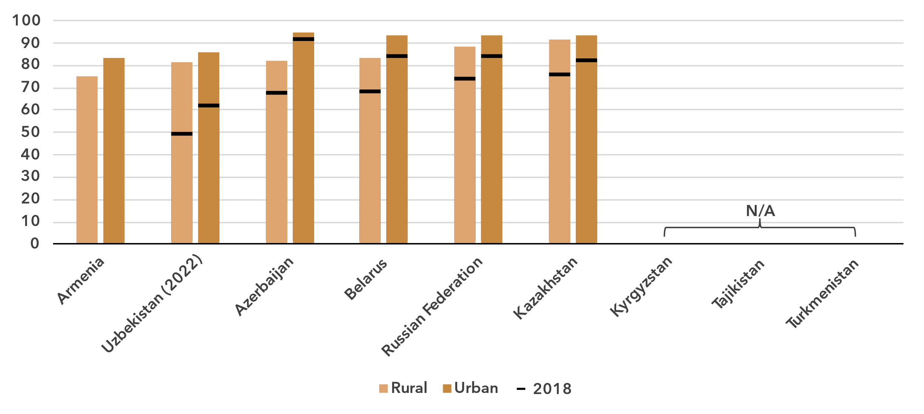Source: ITU

Broadband subscriptions

***CIS maintains high broadband subscription rates***

Broadband subscriptions per 100 inhabitants

|  |  |
| --- | --- |
| **Mobile** | **Fixed** |

Source: ITU

In 2024, there were 108 mobile broadband subscriptions per 100 inhabitants in the CIS region, well ahead of the global average of 95. For fixed broadband subscriptions the region overtook the world average in 2010, reaching 25 subscriptions per 100 inhabitants in 2024, also well ahead of the global average.

Active mobile broadband subscriptions per 100 inhabitants, 2023

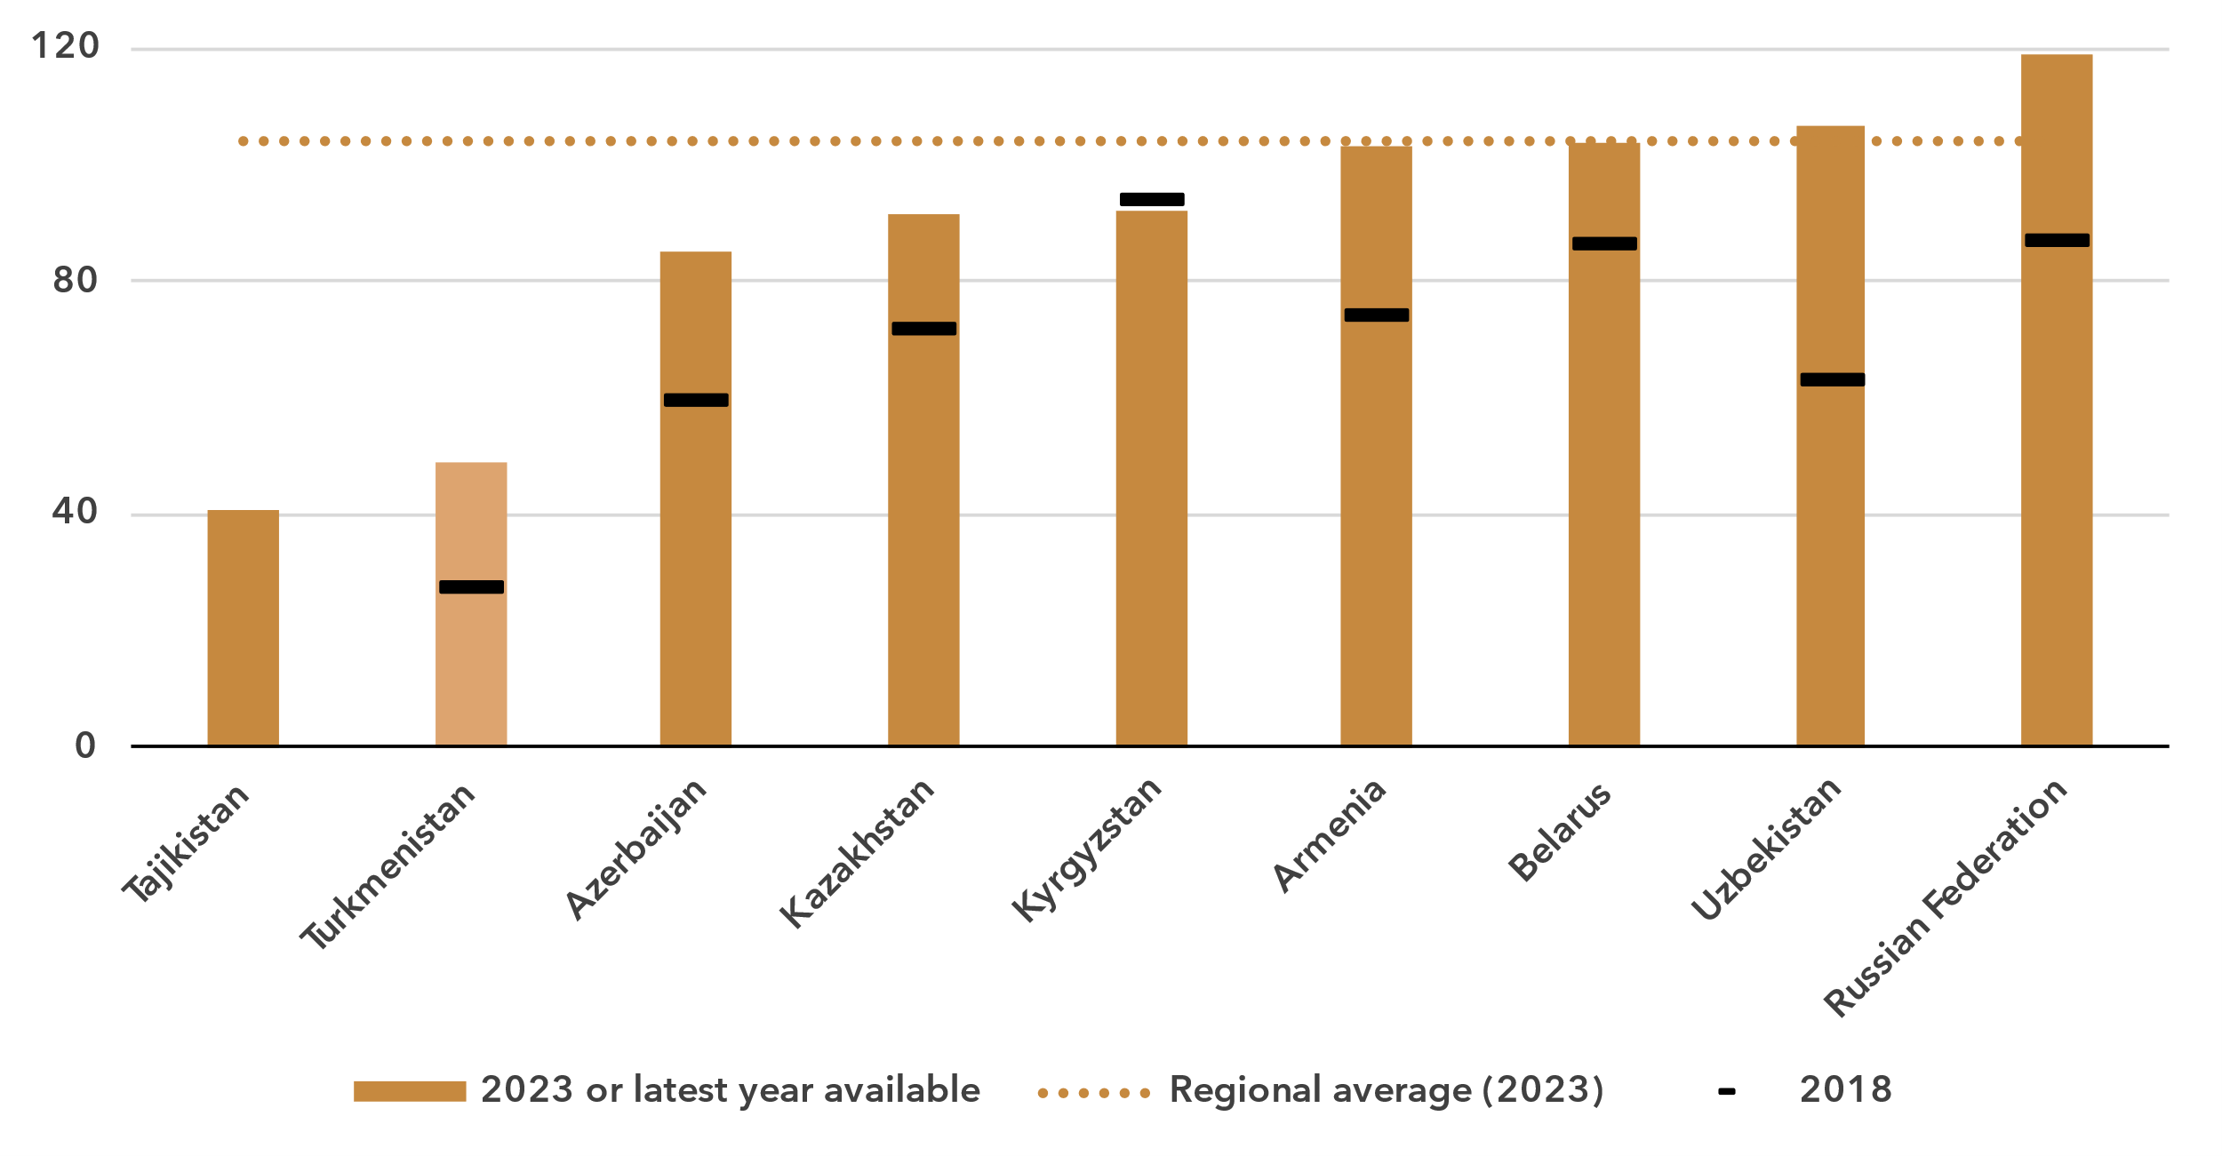

Note: Figures based on official national statistics are shaded dark to distinguish them from figures based on non-official data.

Source: ITU

The number of mobile broadband subscriptions per 100 inhabitants ranged from 41 in Tajikistan to 119 in the Russian Federation. The relative spread was larger for fixed broadband, from 1 subscription per 100 inhabitants in Tajikistan to 34 in Belarus. In all countries for which data were available, between 70 and 93 per cent of the subscriptions had an advertised speed of at least 10 Mbit/s.

Fixed broadband subscriptions per 100 inhabitants, 2023 or latest year available

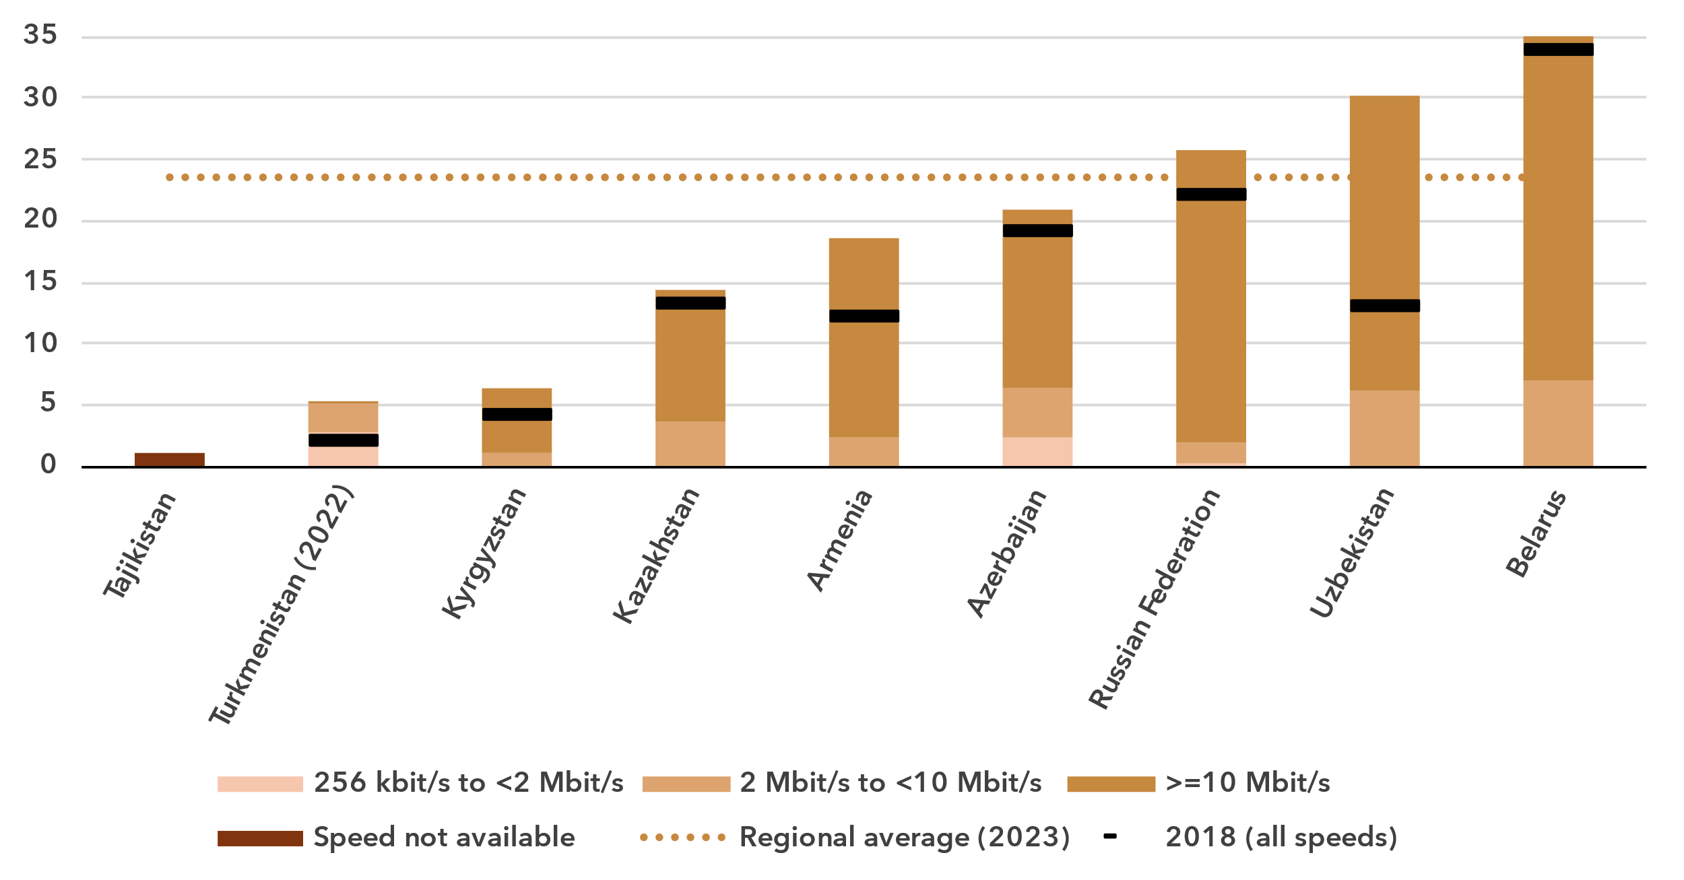Source: ITU

Mobile network coverage

***5G roll-out is slow across the region***

Percentage of population covered by type of mobile network

|  |  |
| --- | --- |
| **CIS** | **World** |

Note: The values for 2G, 3G and 4G networks show the incremental percentage of the population that is not covered by a more advanced technology network (e.g. in 2024, 96 per cent of the world population is covered by a 3G network or better, that is 4 per cent + 41 per cent + 51 per cent). There are insufficient data to produce estimates for 5G coverage prior to 2020.

Source: ITU

Between 2020 and 2024, 5G mobile network coverage in the CIS region increased, albeit slowly, from 0.4 to 12 per cent of the population. Over the same period, global coverage went from 9 to 51 per cent. In the region, 4G mobile networks covered 94 per cent of the population in 2024, above the global average of 92 per cent. Finally, 98 per cent of the population had access to at least a 3G mobile broadband network, leaving 2 per cent without access to any mobile broadband network and therefore without any possibility of accessing the Internet. This coverage gap was 2 percentage points smaller than the global average. Only three countries in the region have started 5G roll-out, covering less than 40 per cent of the population in all cases.

There is a gap in network availability between rural and urban areas in the region. In 2024, 5G covered 18 per cent of the urban population, with zero coverage in rural areas. The disparity also existed for 4G networks, which cover all the urban population but only 83 per cent of the rural population. When including 3G networks, coverage reached 93 per cent in rural regions. This means that while every urban resident had access to a mobile broadband network, 7 per cent of the rural population in the CIS region remained off the grid.

Percentage of population covered by type of mobile network, 2023

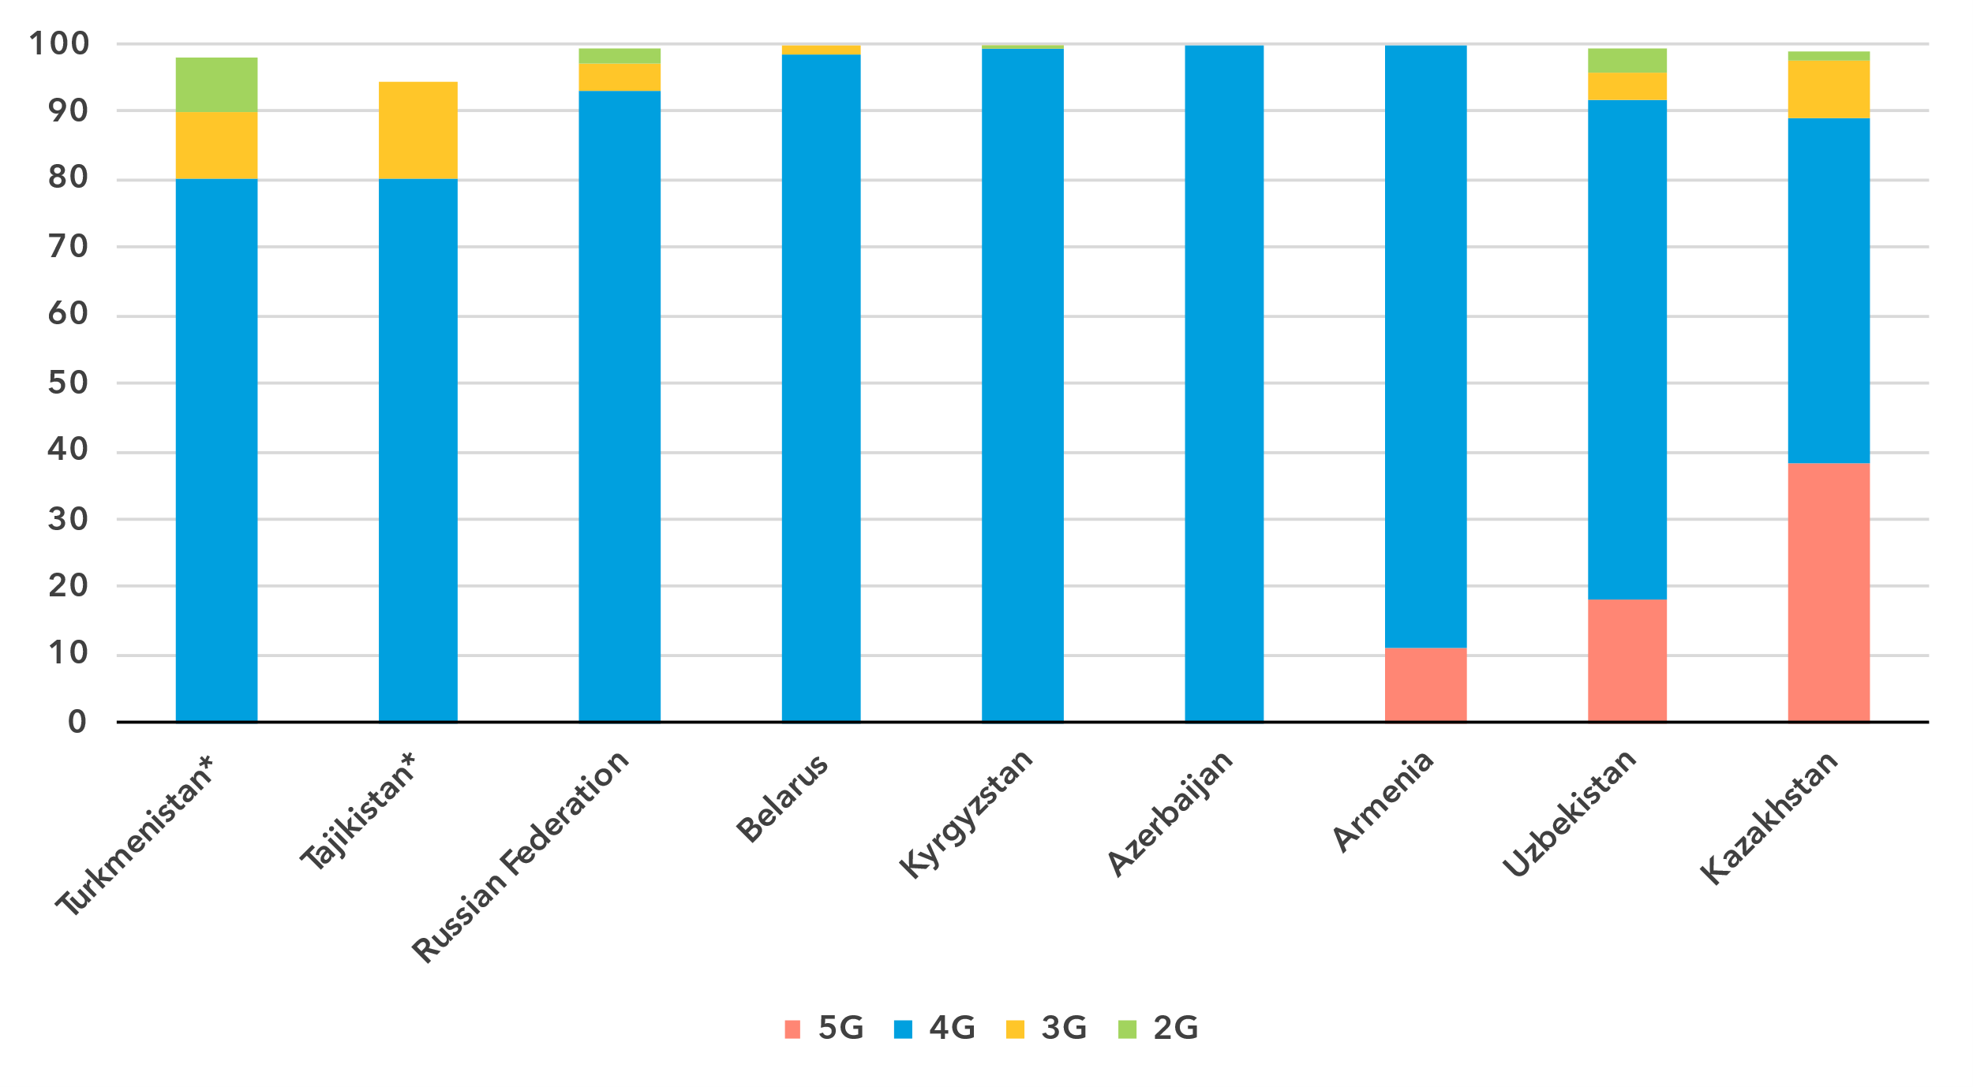

* Data are ITU estimates

Note: The values for 2G, 3G and 4G networks show the incremental percentage of the population that is not covered by a more advanced technology network (e.g. in 2023, 100 per cent of the population in Armenia is covered by a 4G network or better, that is 11 per cent + 89 per cent).

Source: ITU

Population coverage by type of mobile network and location, 2024

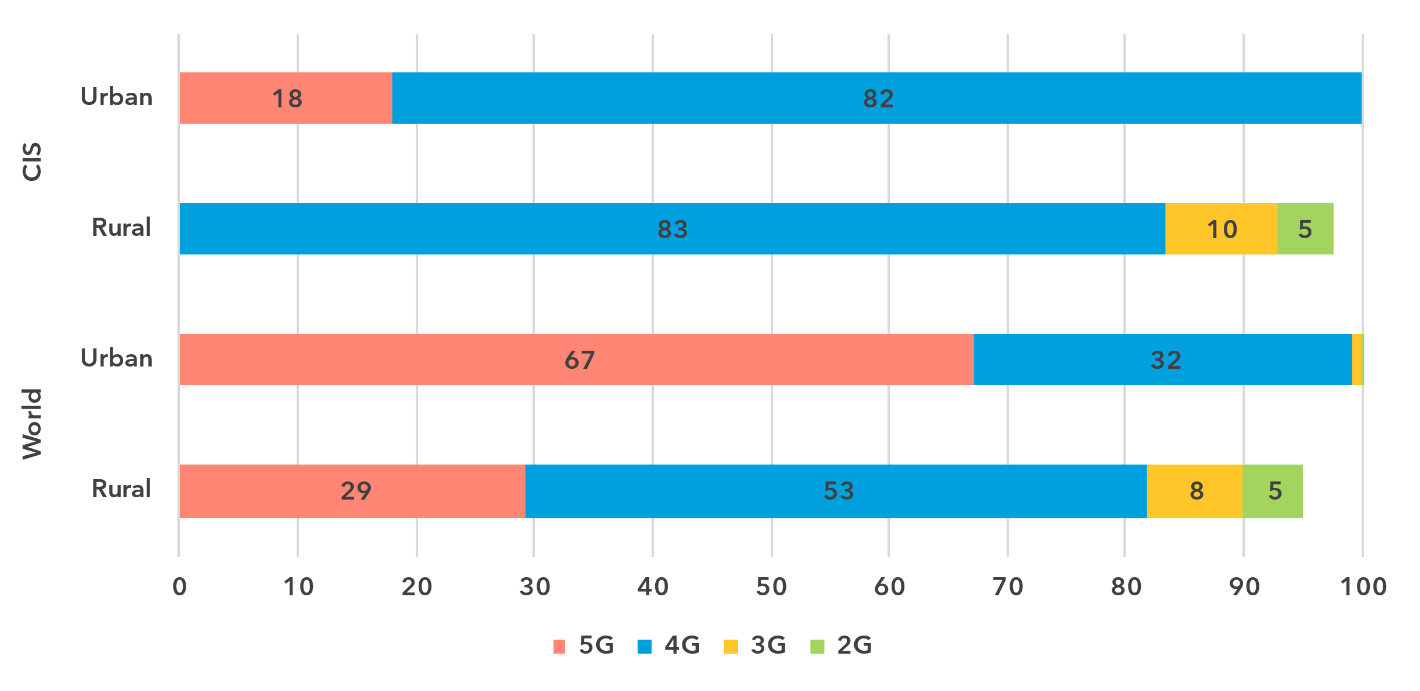

Note: The values for 2G, 3G and 4G networks show the incremental percentage of the population that is not covered by a more advanced technology network (e.g. 90 per cent of the world's rural population is covered by a 3G network or better, that is 29 per cent + 53 per cent + 8 per cent).

Source: ITU

Availability of fixed broadband infrastructure

***One-third of the population lives within 10 km of a fibre-optic node***

Fixed broadband infrastructure forms the backbone of the Internet and is a cornerstone of digital transformation efforts. As part of ongoing research at ITU, the broadband map initiative provides an overview of fixed broadband infrastructure placement. Overlaying this data with demographic data makes it possible to infer the availability and proximity of fixed broadband to populations. This is essential for planning – costly – infrastructure projects and helps to ensure that networks have the necessary capacity and reach.

Map of transmission networks and submarine cables for the CIS region

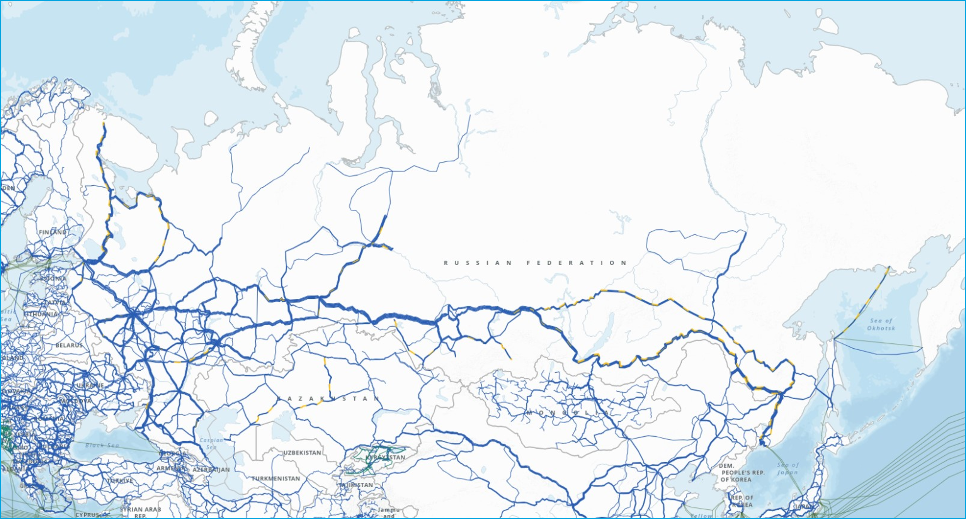

Note: The map shows active and planned submarine cables, and operational, planned and under-construction transmission networks (fibre-optic cable and microwave).

The designations employed and the presentation of material on the map do not imply the expression of any opinion whatsoever on the part of ITU or its secretariat concerning the legal status of any country, territory, city or area or its authorities, or concerning the delimitation of its frontiers or boundaries.

Source: ITU, <https://bbmaps.itu.int/app>

Proximity to a fibre-optic node is a crucial metric for transformative connectivity as it directly impacts connection performance, reliability and scalability. It reduces latency, improves connection stability and lowers deployment costs, making broadband access more affordable and efficient. Additionally, it facilitates upgrades to support growing bandwidth demands, ensuring networks remain future-ready.

As of 2023, one-third of the population of the CIS region lived within 10 km of a fibre-optic node. Sixty-two per cent lived within 25 km, 80 per cent within 50 km and 93 per cent within 100 km of a node.

Percentage of population within reach of a fibre-optic node, 2023

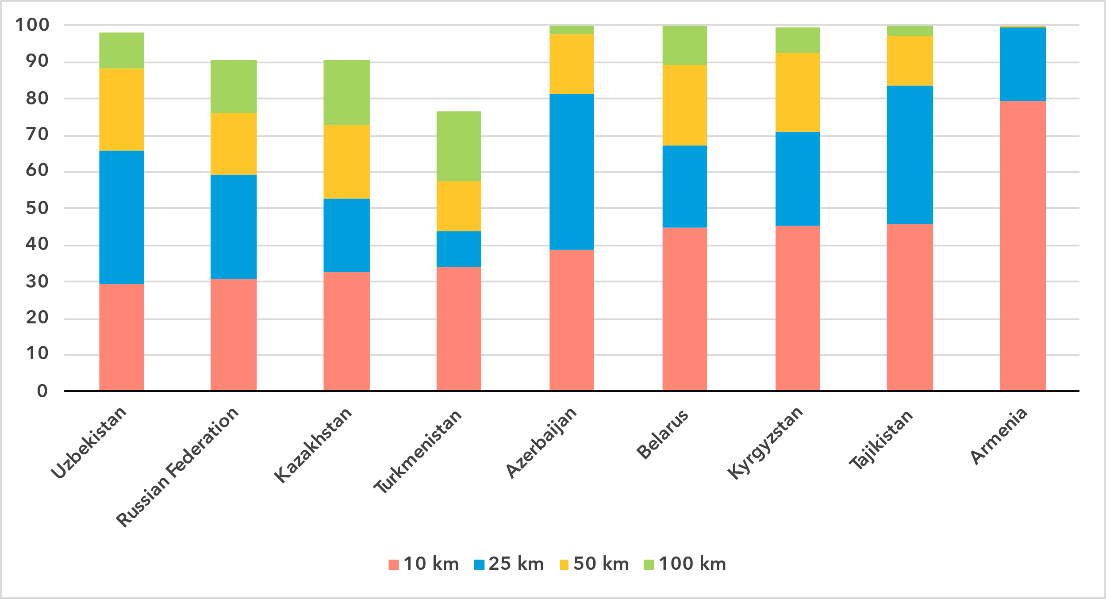Note: The percentage of population within reach of transmission networks refers to the percentage of people that are within physical reach of nodes on core terrestrial transmission networks for a given distance (see <https://bbmaps.itu.int/indicators-bbmaps>).

Source: ITU

Internet traffic and international bandwidth

***Mobile data consumption exceeds global averages, while fixed broadband lags***

Broadband Internet traffic per subscription per month (GB)

|  |  |
| --- | --- |
| **Mobile** | **Fixed** |

Source: ITU

Internet traffic measures the total volume of data downloaded and upload by the end users in a country over a given period. For ease of interpretation, figures presented refer to the average monthly traffic per both fixed and mobile broadband subscription. Traffic levels are typically higher for fixed than mobile broadband, not only because subscriptions are shared by multiple users (e.g. in households), but also because they include mobile traffic routed over Wi-Fi when available.

Between 2019 and 2024 monthly mobile broadband traffic in the CIS region increased from 7 to 19 GB per mobile broadband subscription, above the global average, which increased from 6 to 14 GB during the same period. The situation was reversed for fixed broadband traffic, which in the CIS region increased from a monthly 96 GB to 228 GB per subscription, compared to the global average which increased from 141 to 311 GB.

Mobile broadband Internet traffic (GB) per subscription per month, 2023

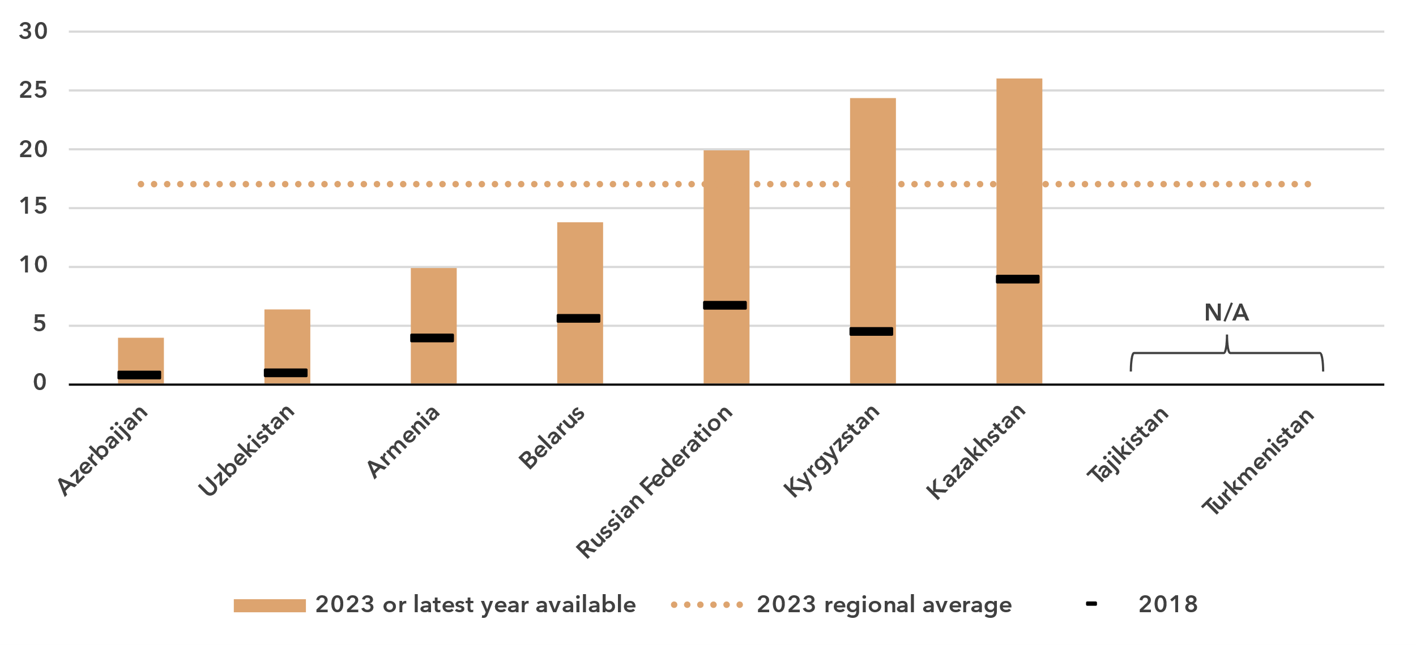

Note: Internet traffic originating within country.

Source: ITU

The region exhibits considerable variety when it comes to traffic indicators. Mobile broadband traffic, per subscription per month, ranged from 4 GB to 26. For fixed broadband traffic, the spread was between 46 and 511 GB. Of note is that some countries with high mobile broadband traffic have low fixed broadband traffic and vice-versa.

Fixed broadband Internet traffic per subscription per month (GB), 2023

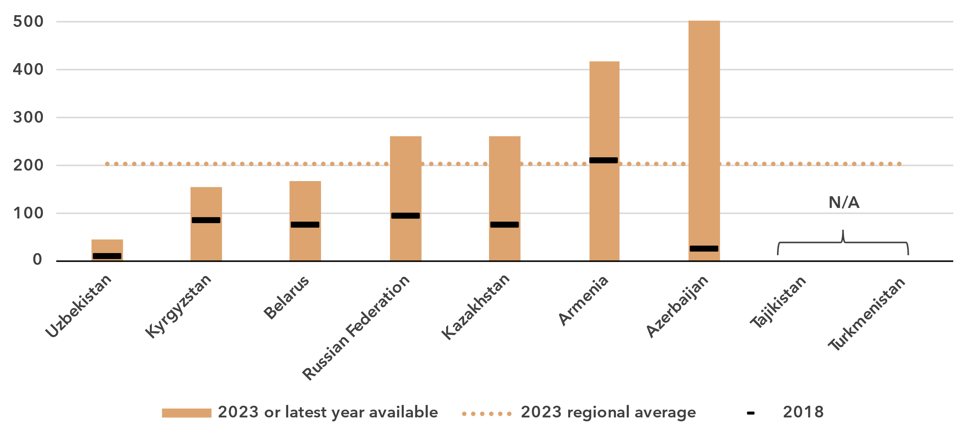Source: ITU

International bandwidth per Internet user (kbit/s)

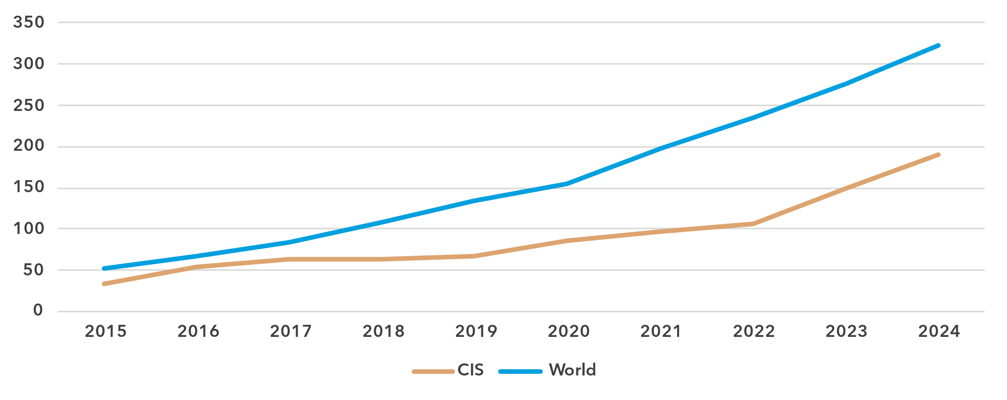

Source: ITU

Unlike the end-user Internet traffic measured above, international bandwidth usage is a throughput measure that refers to the annual average of the used capacity of international connections, typically via submarine or terrestrial fibre-optic cables or microwave links. In the CIS region, overland fibre cables dominate both the domestic backbone and the international connectivity landscape, due to the geographical characteristics of many landlocked countries and those with extensive land areas. Landlocked countries rely heavily on their neighbours to maintain links to global data flows. Routes often traverse multiple countries and require coordination and robust agreements. Enhancing redundancy and diversity of routes can improve network resilience, however, crossing over adverse terrains can significantly increase transit costs. Consequently, it is not surprising that the average international bandwidth usage in the CIS region at 190 kbit/s was well below the global average of 323 kbit/s in 2024.

Demand for international bandwidth depends on many country-specific factors, such as geographical location or the size and development of domestic middle-mile connectivity infrastructure, or the relative share of local content. The presence of data centres and Internet exchange points can also somewhat reduce the demand for international data exchange for larger countries. Countries in the region showed high variation in terms of bandwidth usage. In Belarus, bandwidth usage reached 371 kbit/s, above the world average, while Turkmenistan reported bandwidth usage levels of only 23 kbit/s (albeit for 2021).

International bandwidth per Internet user (kbit/s), 2023 or latest year available

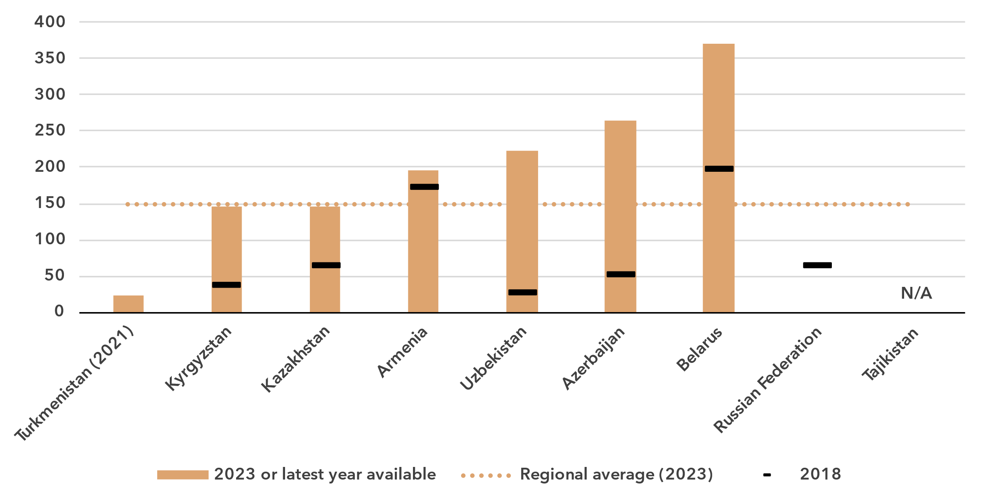

Source: ITU

Affordability of ICT services

***Mobile broadband has become highly affordable across the region***

Broadband basket prices as % of gross national income per capita, 2018-2024

|  |  |
| --- | --- |
| **Mobile (2GB)** | **Fixed (5GB)** |

Note: Median values shown in the chart are calculated as a percentage of GNI per capita for the set of economies for which data was available for all years from 2018 to 2024 for a given basket to adjust the effect of changing data availability.

Source: ITU

Internet cost is a barrier to Internet use and to meaningful connectivity. The United Nations [Broadband Commission for Sustainable Development](https://www.broadbandcommission.org/) set up the goal of making broadband in developing countries affordable by 2025, affordability being defined as the availability of broadband at a price that is less than two per cent of monthly GNI per capita.

Entry-level data-only mobile broadband prices have gone down significantly in the region, from 1.5 per cent of GNI per capita in 2018 to 0.7 in 2024, well below the Broadband Commission’s target and well below the global median.[7]

While access to mobile broadband is generally affordable across CIS countries, the situation is more uneven for fixed broadband. In four countries of the region, the price has been consistently well below the two per cent target. However, the basket was more costly in the other countries, reaching up to 5-6 per cent in two of them, even after a significant decline in recent years. In a region consisting of merely nine countries, even modest year-on-year fluctuations in two countries can have an impact the median trend.

In all but one country, the mobile broadband price was below the Broadband Commission target. For fixed broadband, that was the case in four out of nine countries.

Broadband basket prices as % of gross national income per capita, 2024

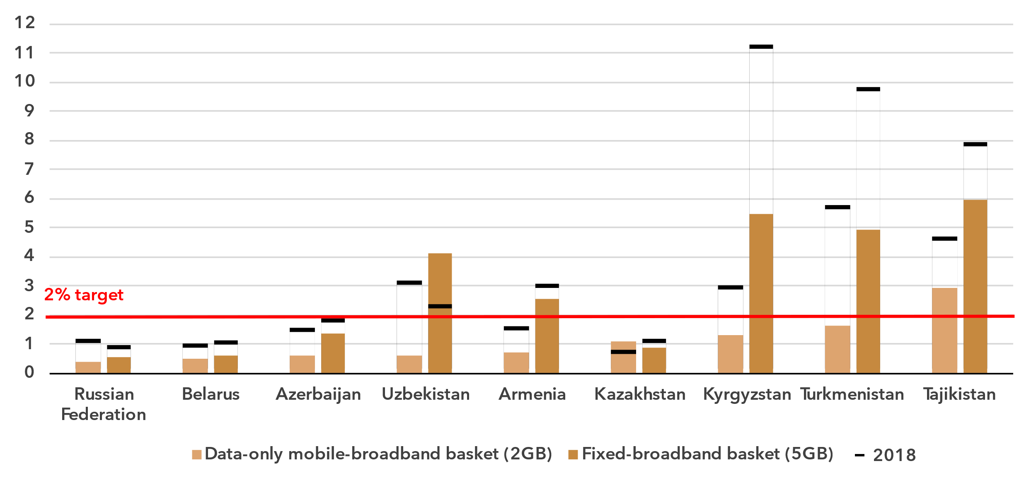Source: ITU

Mobile phone ownership and subscriptions

***Mobile phone ownership is nearly universal***

|  |  |
| --- | --- |
| Percentage of individuals owning a mobile phone | Percentage of individuals owning a mobile phone by gender, 2024 |

Note: Individuals aged 10 and older.

Source: ITU

In 2024, 94 per cent of individuals in the CIS region aged 10 and older owned a mobile phone, almost reaching universal ownership (defined as a mobile phone ownership of at least 95 per cent).

As for Internet use, gender parity in mobile phone ownership was reached, with a GPS of 0.99, up from 0.98 in 2021. At the global level, GPS during that period improved slightly, from 0.91 to 0.93.

Percentage of individuals owning a mobile phone, 2023

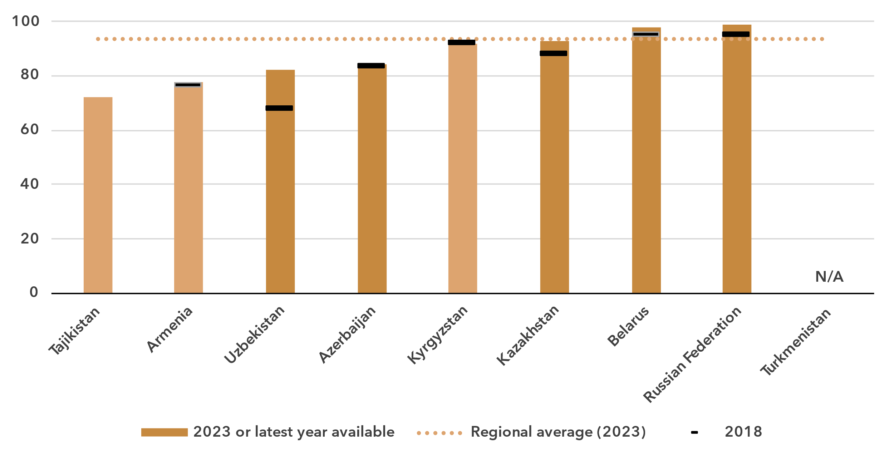 Notes: Figures based on official national statistics are shaded dark to distinguish them from figures based on non-official data.

Source: ITU

At the country level, mobile phone ownership ranged from an estimated 72 per cent in Tajikistan to 99 per cent in the Russian Federation.

In four of the six countries with data available, gender parity was reached. In Uzbekistan, men were much more likely than women to own a mobile phone, while in Armenia it was the other way around.

Percentage of individuals owning a mobile phone, by gender, 2023 or latest year available

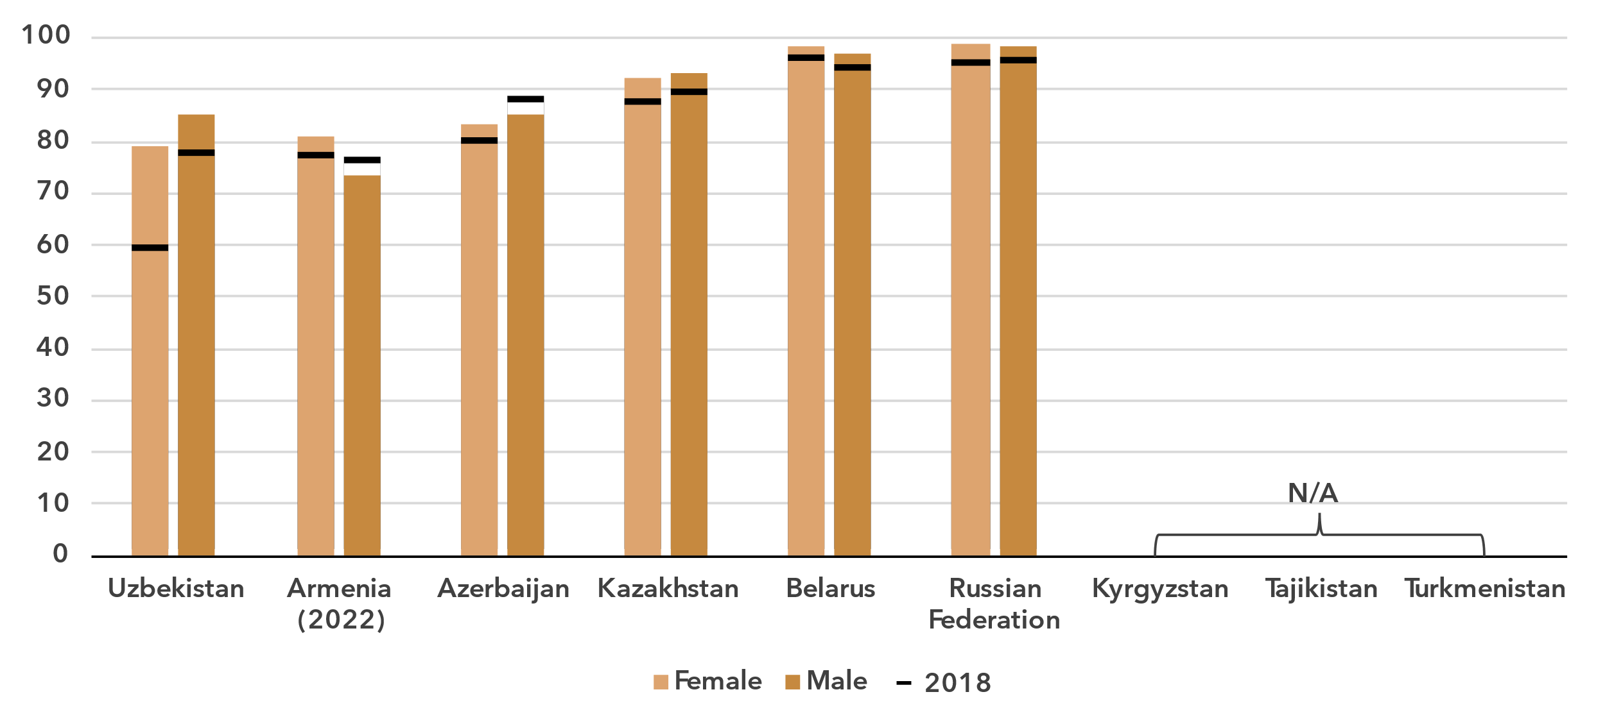

Source: ITU

Mobile-cellular subscriptions per 100 inhabitants

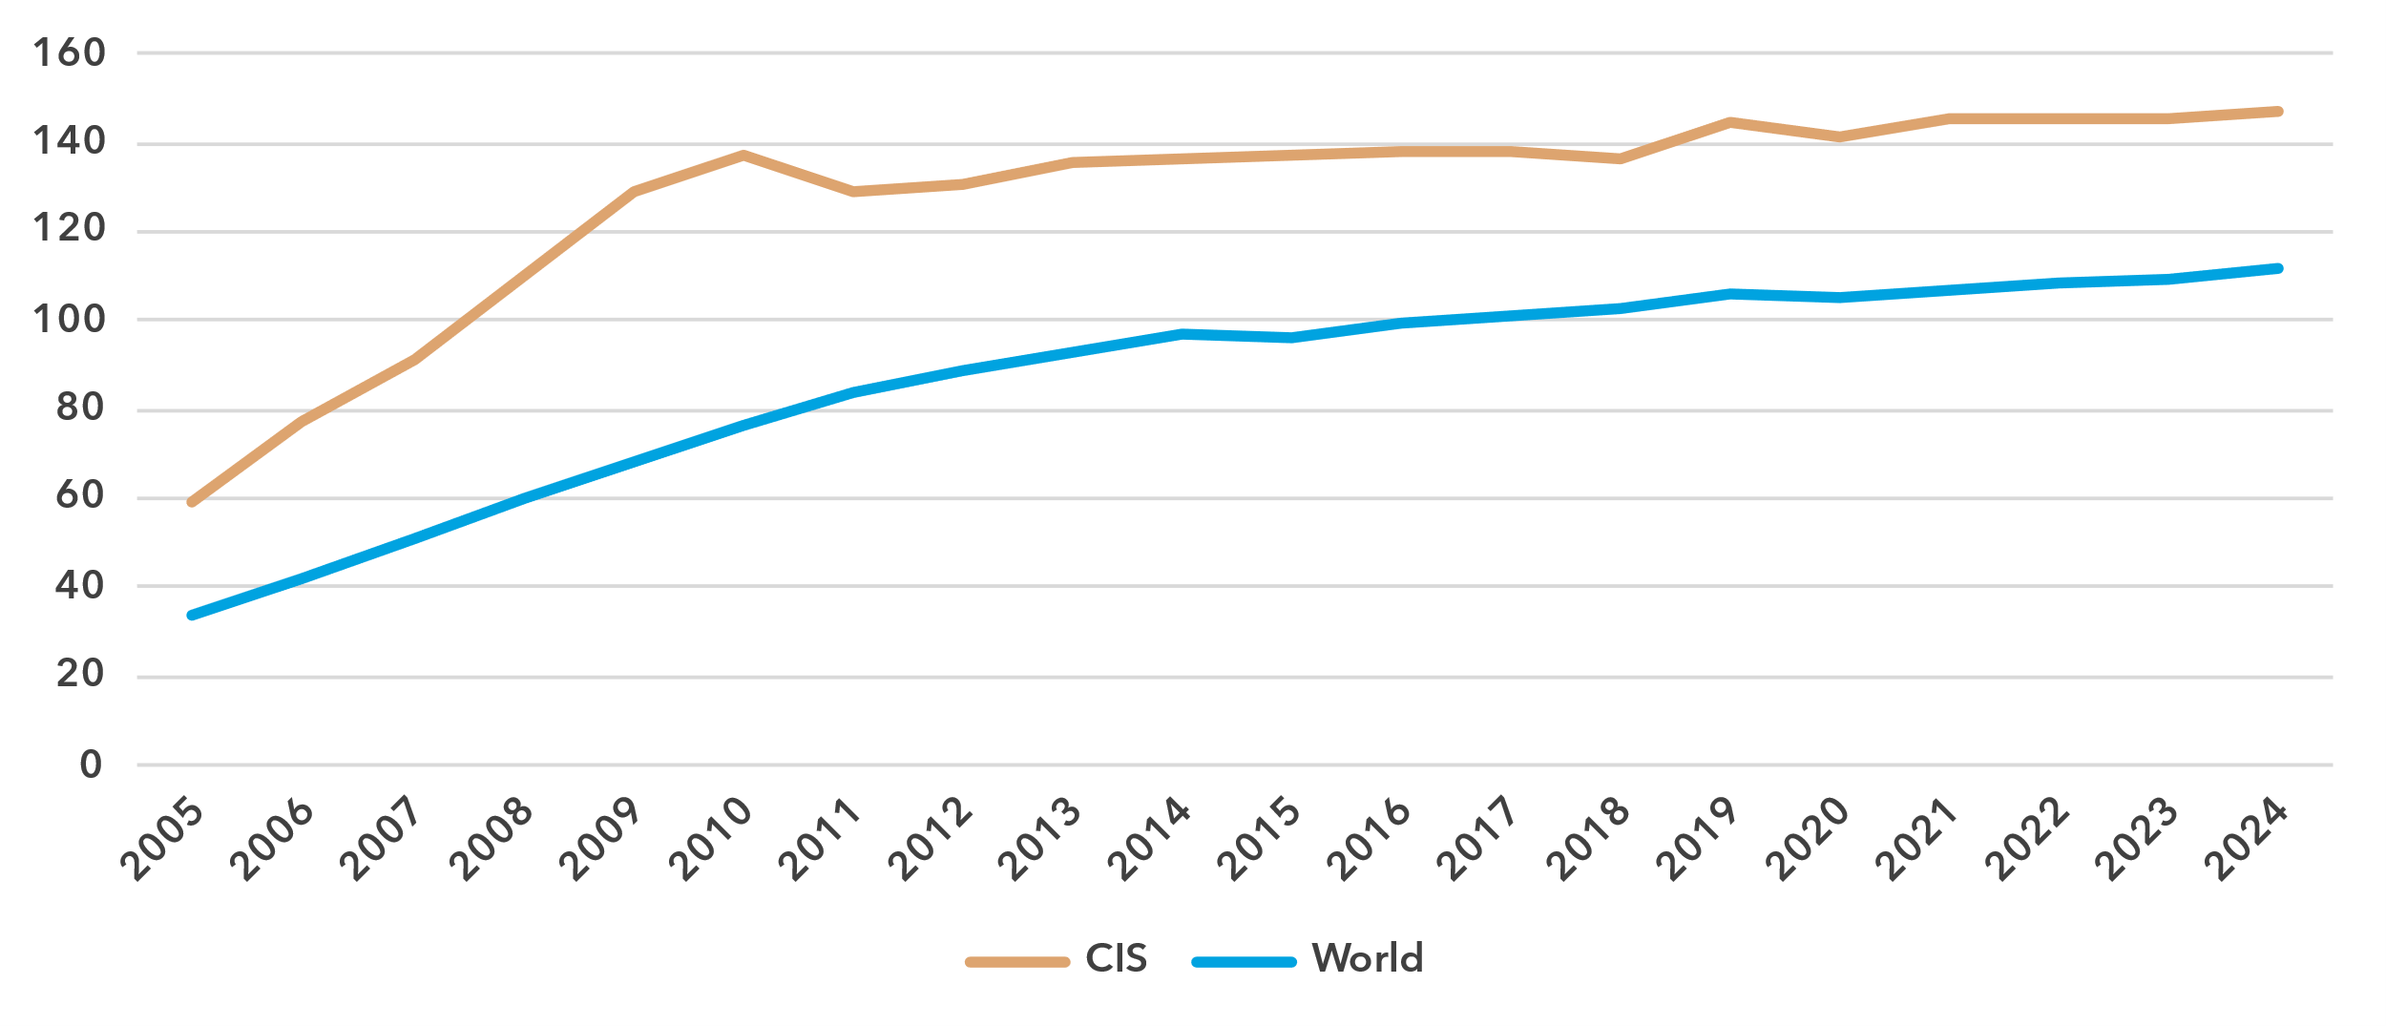

Source: ITU

To use a mobile phone, a mobile-cellular or mobile broadband subscription is needed. In the CIS region, there were 147 subscriptions per 100 inhabitants in 2024, considerably more than the global average.

At the country level, however, there was a gap between the economies with the least and the most subscriptions per 100 inhabitants, 76 and 181 respectively.

Mobile-cellular subscriptions per 100 inhabitants, 2023 or latest year available

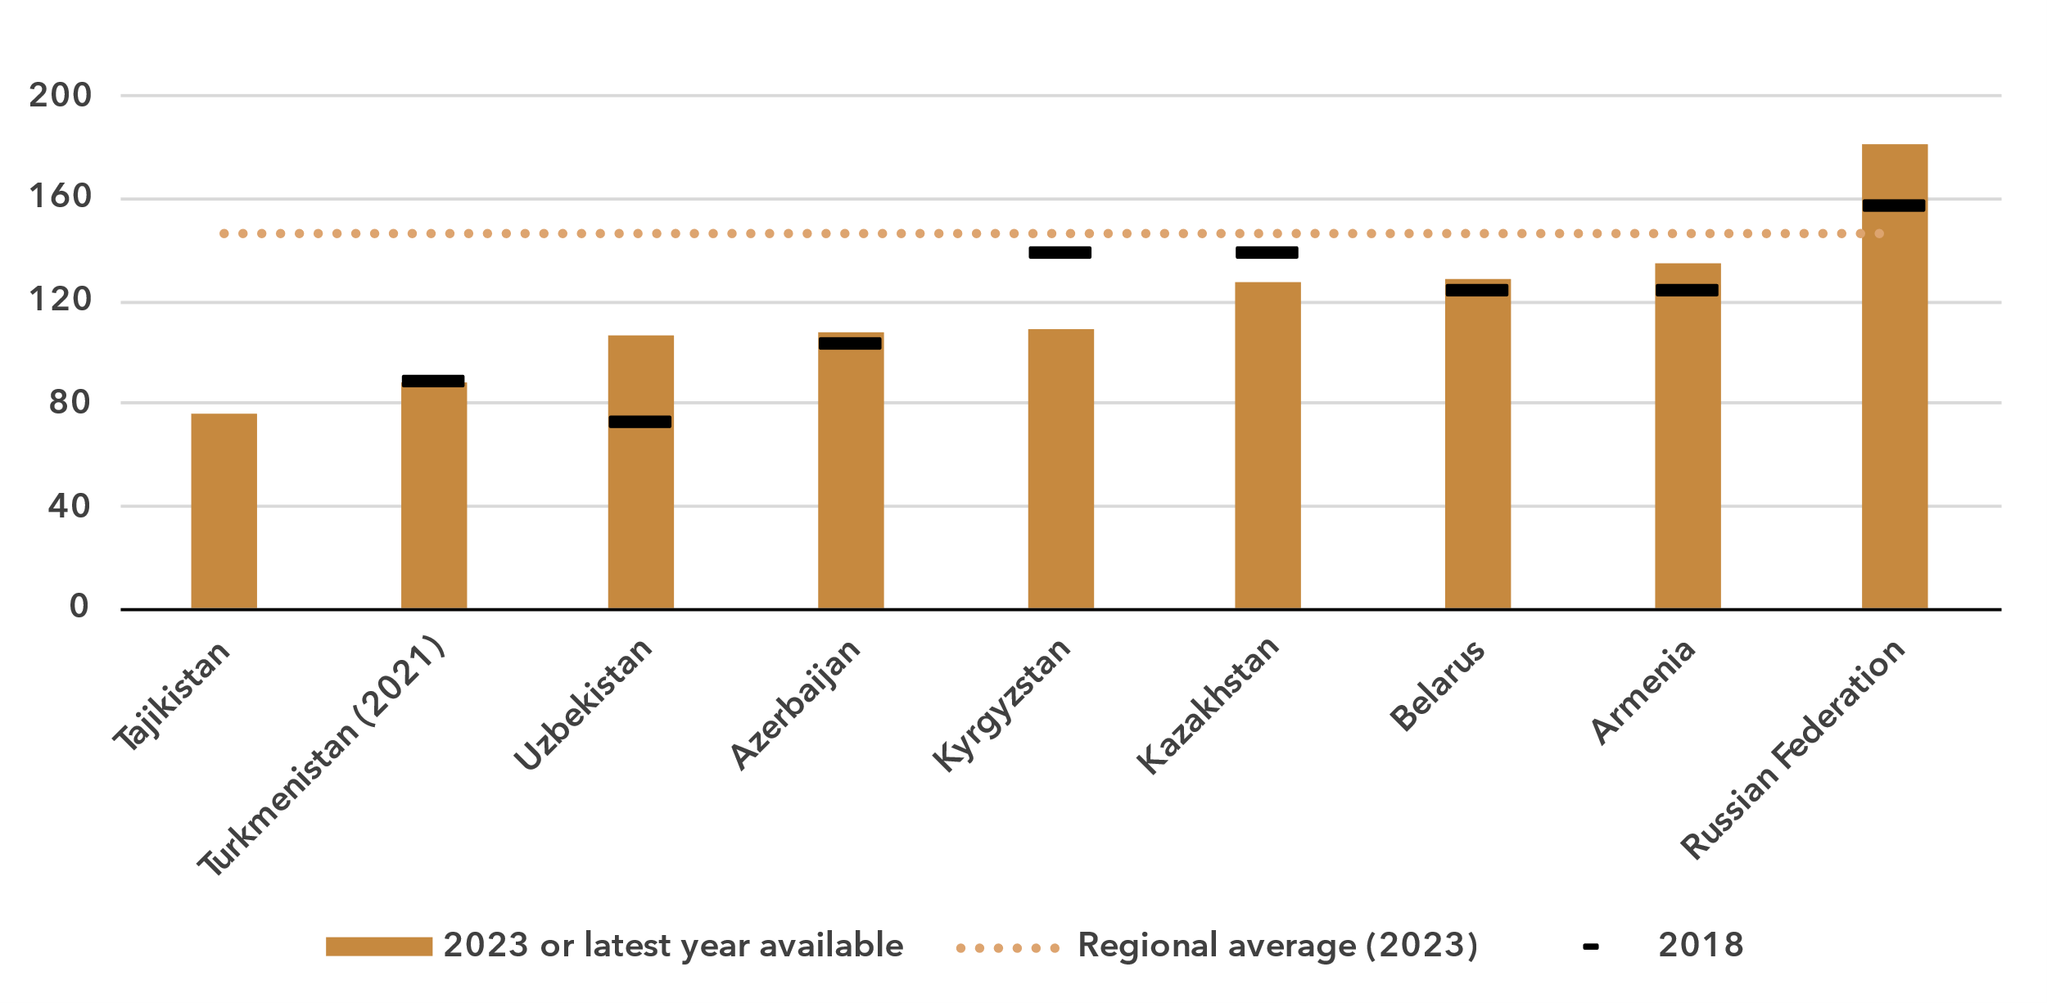Source: ITU

ICT skills

***Significant variation in ICT skill levels among Internet users***

Because self-reporting of individuals’ ICT skills is subjective, ICT skills are measured based on household surveys asking whether an individual has recently performed certain activities. Performing these activities presupposes a degree of proficiency in relevant digital skills. The activities are grouped into five areas: information and data literacy; communication and collaboration; digital content creation; safety; and problem solving.

While the importance of digital skills in leveraging ICTs for economic prosperity and social well-being is well-documented, data remain very scant. In the CIS region, five out of nine countries have submitted data since 2020. Even fewer – just three countries – provided comparable data on ICT skill levels (see box for details on the methodology for calculating ICT skill levels).

|  |  |  |  |  |  |  |
| --- | --- | --- | --- | --- | --- | --- |
| **Methodology for calculating ICT skill levels**  At its 11th meeting in September 2023, the ITU Expert Group on ICT Household Indicators (EGH) [recommended changes](https://www.itu.int/itu-d/meetings/statistics/wp-content/uploads/sites/8/2023/09/Report-of-the-EGH-subgroup-on-ICT-Skills.pdf) in how data on ICT skill levels are reported – most importantly, that skill levels of individuals should be assessed for different areas.  *Individuals should be assessed on the number of activities within a skill area they report having done in the last three months using the following progression:*   |  |  |  | | --- | --- | --- | | None | Basic | Above basic | | 0 activities | 1 activity | More than 1 activity |  * *Skill levels should not be assessed in skill areas where fewer than two indicators are collected.* * *Indicators should be weighted equally within each skill area.* * *Skill areas with different numbers of components should be treated equally.*   While this recommendation does not require any additional data collection, it does require that countries perform additional analysis on existing survey microdata. ITU requested data on ICT skills for the first time in its April 2024 data collection, and received data from 40 countries, including three countries in the CIS region. However, other countries were unable to provide data, even though in many cases data on the underlying activities had been collected. It is expected that data availability will improve as familiarity with these new recommendations increases. |

ICT skills data goes beyond simple access and use of ICTs to provide a view of the capabilities of ICT users. Data on individuals in the CIS region with different levels of ICT skills are shown below as a share of Internet users. These data demonstrate the substantial variation between countries in the level of ICT skills among Internet users. They also show the areas where attention is needed to increase those skills.

Percentage of Internet users with specific ICT skills in the CIS region, by skill level, 2023

|  |  |
| --- | --- |
| **Azerbaijan** | **Belarus** |
| **Russian Federation** |  |
|  |  |

Note: Data for Azerbaijan refer to individuals aged 7 and older. Data for Belarus refer to individuals aged 6 to 72. Data for Russian Federation refer to individuals aged 15 and older.

Source: ITU

In general, communication and collaboration skill levels are very high among Internet users in the three countries for which data are available – all report that between 95 and 100 per cent of Internet users have at least basic skills in this area.

Information and data literacy skill levels are also high among Internet users in those countries (between 72 and 90 per cent with at least basic skills), although less than communication and collaboration skill levels.

In Azerbaijan, all Internet users reported having at least basic digital content creation skills. In the other two countries, only around one-half of Internet users had such skills.

Safety skill levels are very low in the Russian Federation – less than 20 per cent of Internet users had at least basic skills in this area, while in Belarus almost half of Internet users had at least basic safety skills.

Finally, in all countries problem-solving skill levels were quite high, with between 76 and 82 per cent of Internet users reporting at least basic skills in this area.

A different way to analyse these data is by comparing the distribution of country values for the activities that comprise each of the five skill areas, showing the prevalence of each activity among Internet users relative to others in the same area. The data reveal the wide range of variation in ICT skills in countries in the region, even when focusing only on those using the Internet.

Percentage of Internet users with information and data literacy skills, 2023

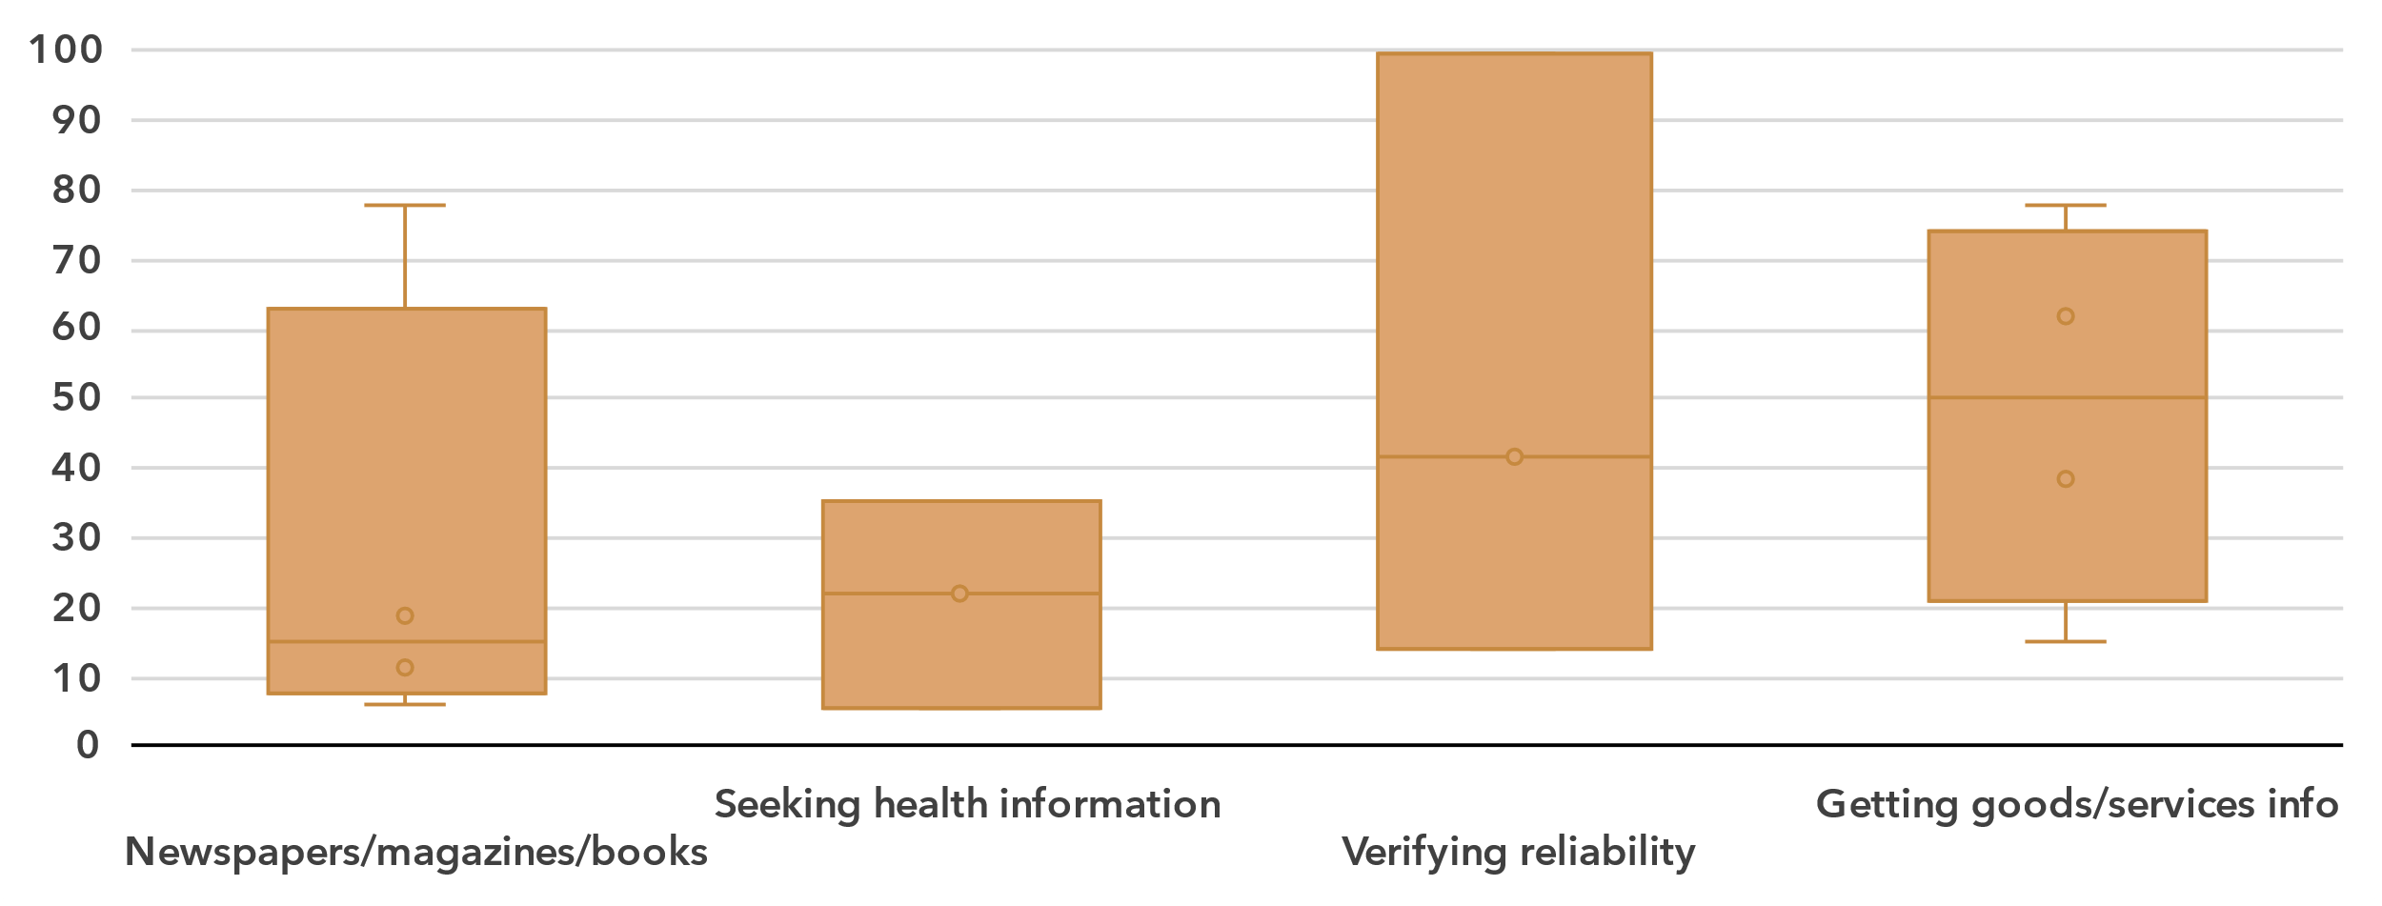Note: Bars indicate the 25th, median and 75th percentile of all country values. The whiskers (bottom and top lines) indicate individual minimum and maximum values. In-scope age varies between countries. Country data are for 2023. Data availability varies between indicators: three or four countries per activity*.* Detailed information – including complete indicator names – is available [here](https://www.itu.int/en/ITU-D/Statistics/Documents/facts/rpm_cis_pub_2025_data.xlsx).

Source: ITU

For information and data literacy, the ability to obtain information about goods or services had the highest median score (50 per cent) among the four activities that make up this skill category. The next most widespread skill was verifying the reliability of information found online, which had a median of 42 per cent, but with a widespread across countries. Obtaining health information had a median of 22 per cent. Using the Internet to read or download newspapers, magazines or books was less frequently reported (median of 15 per cent), albeit with considerable variation among countries.

Percentage of Internet users with communication and collaboration skills, 2023

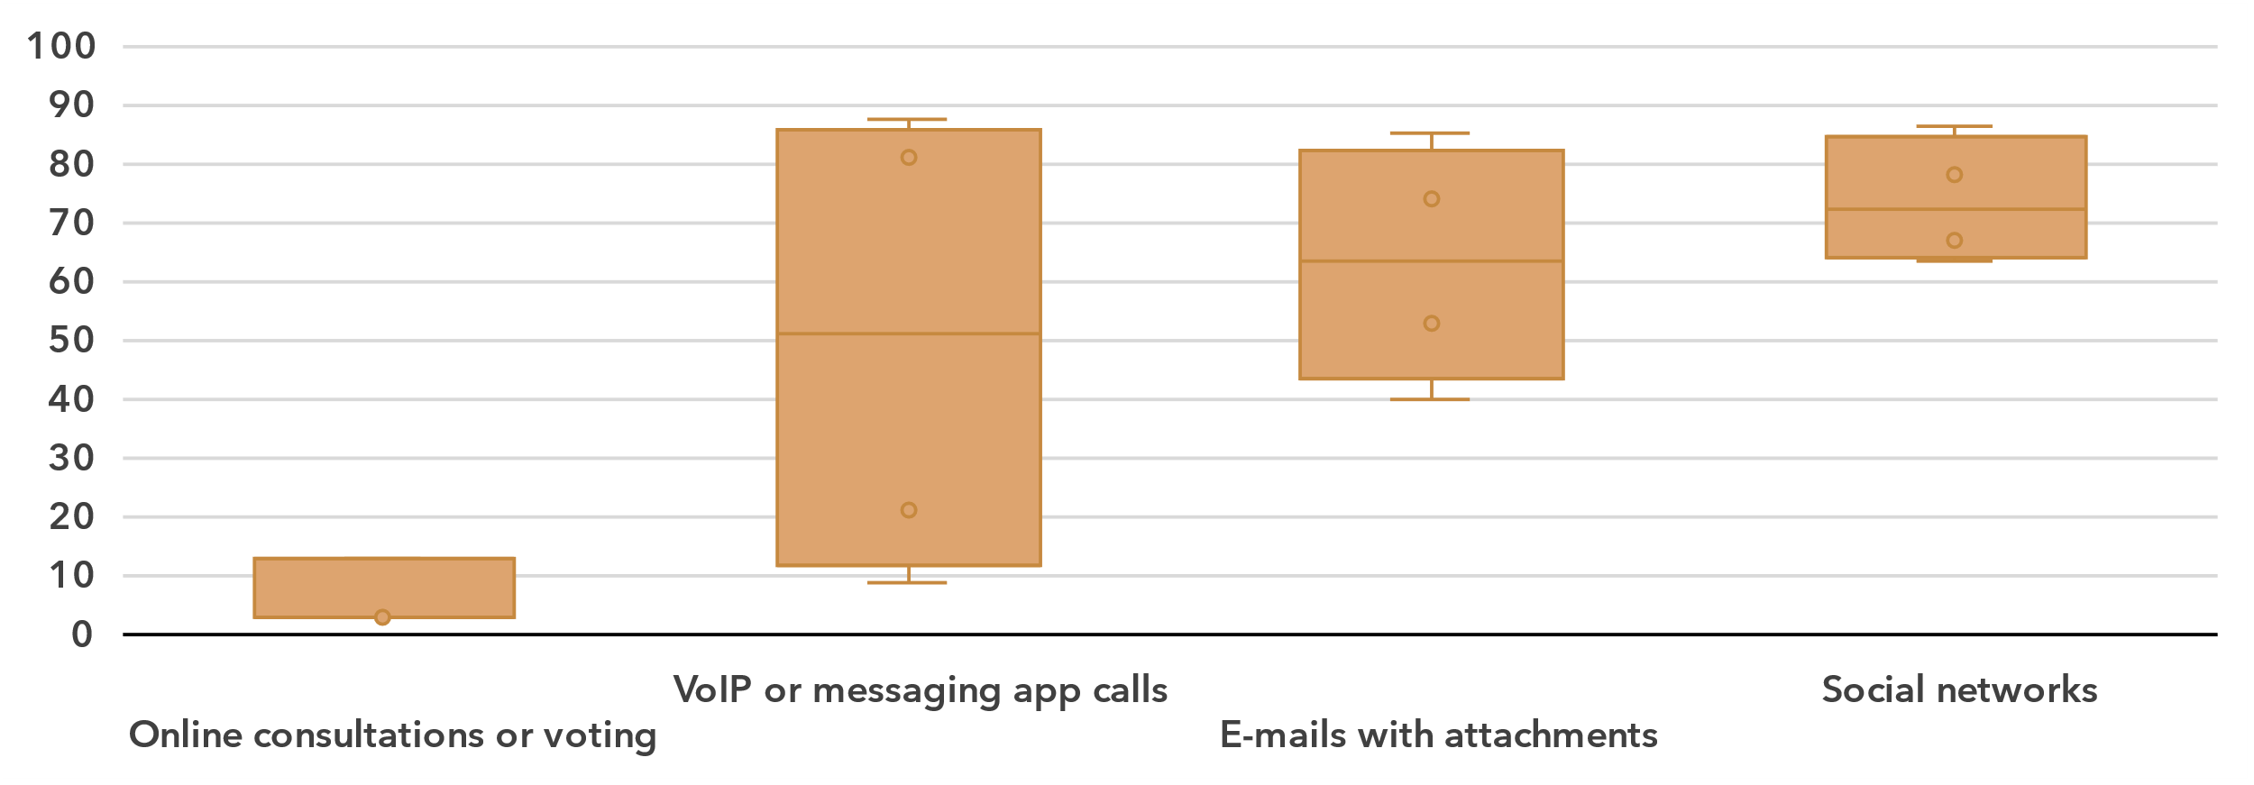Note: Bars indicate the 25th, median and 75th percentile of all country values. The whiskers (bottom and top lines) indicate individual minimum and maximum values. In-scope age varies between countries. Country data are for 2023. Data availability varies between indicators: three or four countries per activity*.* Detailed information – including complete indicator names – is available [here](https://www.itu.int/en/ITU-D/Statistics/Documents/facts/rpm_cis_pub_2025_data.xlsx).

Source: ITU

The medians for communication and collaboration were much higher than for information and data literacy, especially for participating in social networks (median of 73 per cent). The one exception was taking part in online consultations or voting to define civic or political issues, which had a median of only three per cent.

Percentage of Internet users with digital content creation skills, 2023

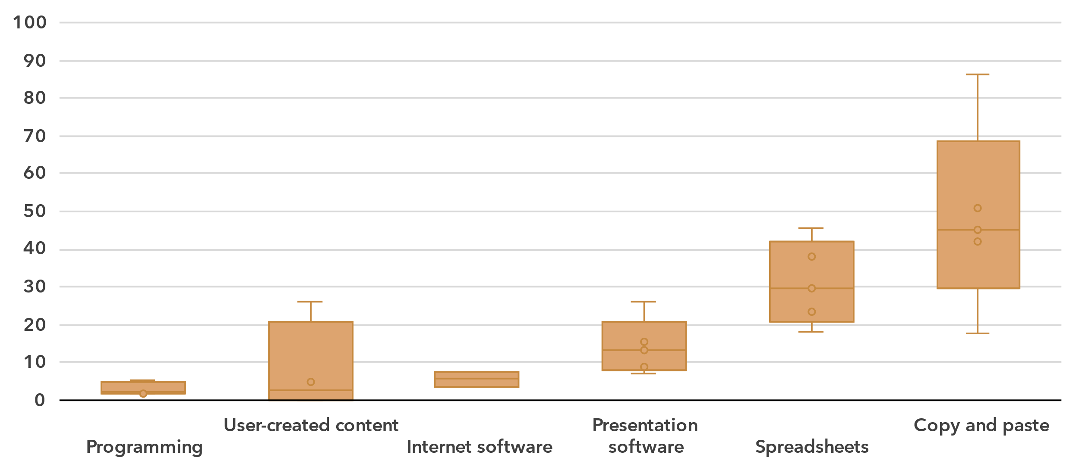Note: Bars indicate the 25th, median and 75th percentile of all country values. The whiskers (bottom and top lines) indicate individual minimum and maximum values. In-scope age varies between countries. Country data are for 2023. Data availability varies among indicators, ranging from two countries for *Using software run over the Internet for editing text documents, spreadsheets or presentations* to five countries for three other activities*.* Detailed information – including complete indicator names – is available [here](https://www.itu.int/en/ITU-D/Statistics/Documents/facts/rpm_cis_pub_2025_data.xlsx).

Source: ITU

The digital content creation skill area generally shows relatively low medians for most of the six activities, ranging from 2 to 45 per cent.

Percentage of Internet users with safety skills, 2023

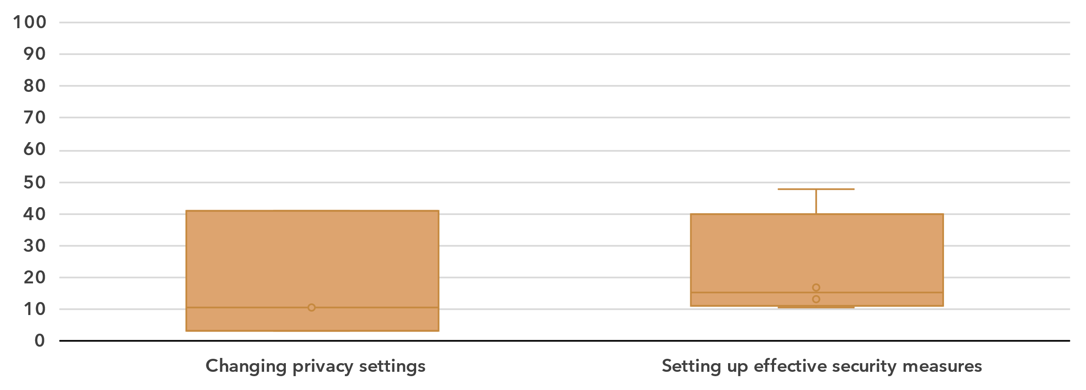Note: Bars indicate the 25th, median and 75th percentile of all country values. The whiskers (bottom and top lines) indicate individual minimum and maximum values. In-scope age varies between countries. Country data are for 2023. Three countries provided data for *Changing privacy settings*, while four countries provided data for *Setting up effective security measures.* Detailed information – including complete indicator names – is available [here](https://www.itu.int/en/ITU-D/Statistics/Documents/facts/rpm_cis_pub_2025_data.xlsx).

Source: ITU

The two activities in the safety category showed a similar, low prevalence in the countries of the region. The median shares were 10 and 15 per cent for changing privacy settings on one’s device, account or app and setting up effective security measures to protect devices and accounts, respectively.

Percentage of Internet users with problem solving skills, 2023

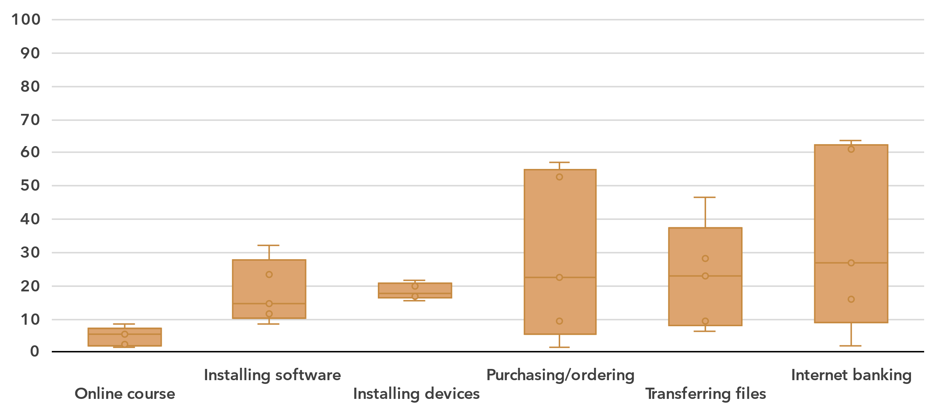Note: Bars indicate the 25th, median and 75th percentile of all country values. The whiskers (bottom and top lines) indicate individual minimum and maximum values. In-scope age varies between countries. Country data are for 2023. Five countries provided data for each indicator*.* Detailed information – including complete indicator names – is available [here](https://www.itu.int/en/ITU-D/Statistics/Documents/facts/rpm_cis_pub_2025_data.xlsx).

Source: ITU

Finally, the medians for activities in the problem-solving skill area were on the low side, from 5 per cent for doing an online course to 27 per cent for Internet banking. Here as well, the share of individuals doing these activities varied widely between countries in the region.

Revenues and investment

***Increased investment in telecommunication infrastructure is needed for universal and meaningful connectivity***

The telecommunication sector is an important enabler of economic development, with both direct and indirect impacts. While the indirect impact is hard to capture, the direct impact that the sector has on development is clearly visible from recent data on revenue and investment, as is the considerable variation between individual countries.

Revenue from all telecommunication services, in USD billion and as a % of GDP, 2023

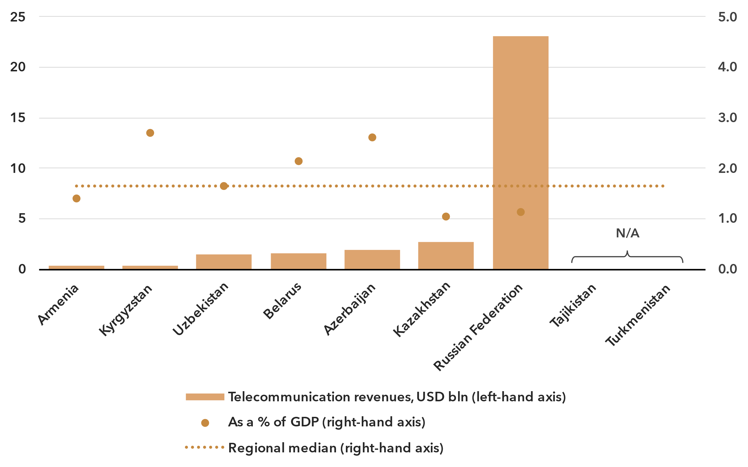Note: Annual average exchange rates applied, last available year values at constant 2023 prices.

Source: ITU, World Bank World Development Indicators

The ICT services sector includes activities providing telecommunications and related service activities, i.e. transmitting voice, data, text, sound and video, over wired, wireless, satellite or other networks.[8] The total annual retail revenue for the sector in the CIS region, for the seven countries that provided data in the last available year since 2021, is estimated at around USD 31 billion. However, the size of the telecommunication market varies significantly across countries, with two countries reporting revenue below USD 400 million, while the Russian Federation, the largest market, totalled USD 23 billion in revenue. This sector contributed an average of 1.7 per cent to the region's GDP. This proportion fluctuates, ranging from around 1 to 2.7 per cent.

Annual investment in telecommunication services, in USD billion and as % of GDP

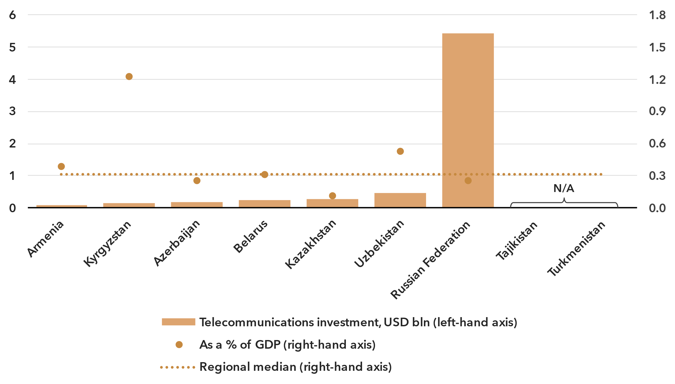 Note: Data are a three-year (2021-2023) average of available data points to correct for annual fluctuations and gaps. Investment figures are in constant 2023 US dollars.

Source: ITU, World Bank World Development Indicators

The deployment of new network technologies and the upgrading of existing ones are highly capital-intensive activities. Investment projects often span multiple years and spending fluctuates, which is why statistics are presented as the period average for 2021-2023. Those countries in the CIS region for which data was available made annual investments ranging from less than USD 0.5 billion (six countries) to USD 5 billion (Russian Federation). This corresponded to a median value of 0.3 per cent of GDP over the 2021-2023 period.[9]

Ensuring the infrastructure requirements for universal and meaningful connectivity requires significant, continuous investment efforts. On average, the ICT sector in the region invests around 22 per cent of its revenue, with significant variations across countries, from less than 10 per cent to nearly 40 per cent.

Cybersecurity

***Cybersecurity commitments vary widely across the region***

Meaningful connectivity requires trustworthy and secure communications. With over 5.5 billion people now online, cybersecurity in the digital economy is no longer an afterthought. Addressing cybersecurity requires a holistic approach encompassing legal, technical, organizational, capacity development, and cooperation issues. Since 2015, the Global Cybersecurity Index (GCI) has tracked countries' performance on these issues, each represented by a pillar of the index, with an aggregate GCI score on a 0-100 scale. The 2024 edition revealed a notable improvement in countries’ commitment to cybersecurity: around the world, the average GCI score reached 66, up 14 points from the 2021 edition. The countries in the CIS region have continued to expand their commitments, with an average score of 67, up 8 points from the previous edition

Global Cybersecurity Index scores, 2017-2024

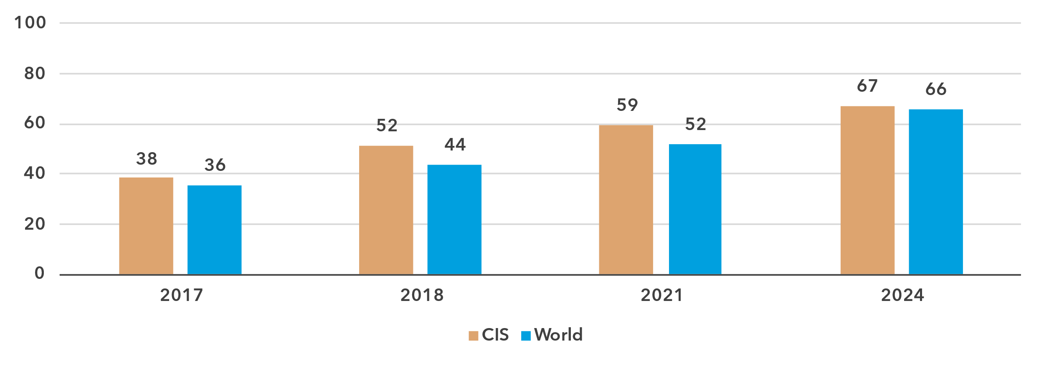Note: Questions and weightings have been updated between editions, in collaboration with the GCI Expert Group, to better measure cybersecurity commitments by countries.

Source: ITU

The performance in the GCI of the CIS region countries various greatly, with a nearly 70-point gap between the region’s best performer, Kazakhstan (94), and the region’s worst performers, Tajikistan and Turkmenistan (25 and 26, respectively).

The technical pillar of the GCI assesses the effectiveness of national mechanisms and institutional structures in detecting, preventing, responding to, and mitigating cyber threats and incidents. Computer incident response teams (CIRTs) are responsible for protection against, detection of, and response to cybersecurity incidents, and can enhance a country’s ability to manage cybersecurity incidents. Seven CIS countries have established their national CIRTs, and many are participating in regional cyber exercises. Still, there is a need for further development of these CIRTS, particularly among lower- and upper-middle income countries, and the protection of critical information infrastructure should be strengthened.

Global Cybersecurity Index scores, by pillar and overall, 2024

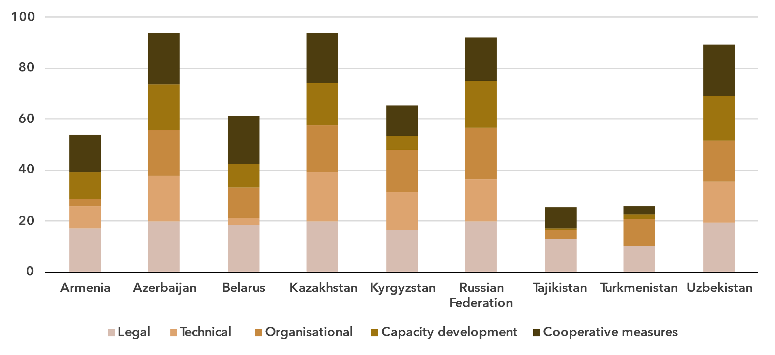Note: The overall CGI score shown is the sum of the score of the five pillars

Source: ITU

Child online protection (COP) encompasses strategies and initiatives to protect children from harm or exploitation online. This includes ensuring children are using age-appropriate software and filtering tools and educating parents and children about staying safe online. Child online protection is tracked through questions under the legal, organizational, and capacity development pillars. A total of 164 countries worldwide reported having legal measures on child online protection in the GCI 2024, compared to 130 countries in the previous edition. These measures were sometimes part of other rules, regulations, and substantive law, such as on online crime or sexual exploitation. Three CIS countries have some form of a child online protection strategy with associated actions. Linking these efforts to educational efforts for educators, parents, and policy makers is key for long term impact.

Finally, to meet the demand for cybersecurity professionals, countries are increasingly developing cybersecurity skills within their populations. While six countries in the CIS region have training courses for cybersecurity professionals, countries still need to work to ensure that there are multiple pathways towards building cybersecurity competency to meet ongoing cyber needs.

E-waste management

***E-waste recycling rates remain critically low***

As countries strive to harness the benefits of technology to drive economic growth and achieve their national development priorities, the challenge of managing electronic waste has become increasingly urgent. Strengthened e-waste policy and regulatory e-waste management are pivotal for ensuring environmental sustainability, supporting circular economy practices, and advancing progress towards the sustainable development goals (SDGs).

E-waste generated, in millions of kilograms, 2022

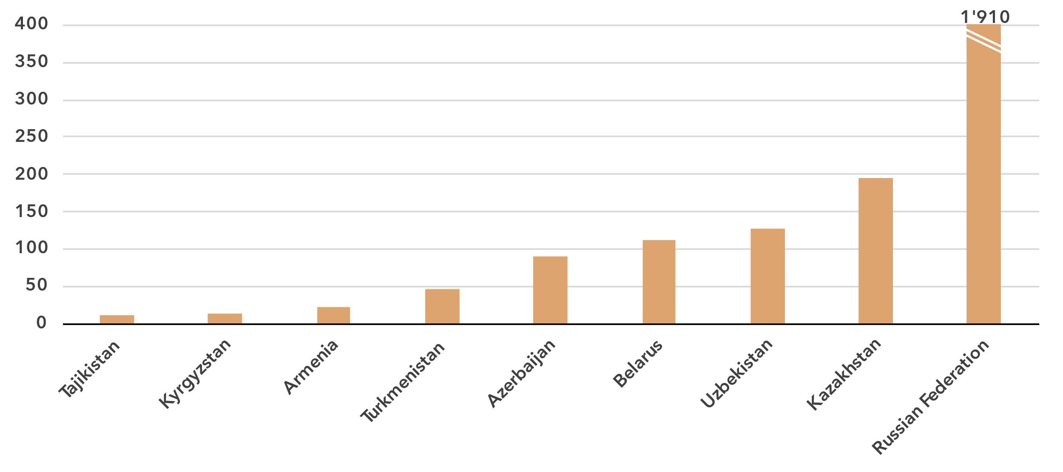 Source: ITU and UNITAR, [Global E-waste Monitor, 2024](https://www.itu.int/hub/publication/d-gen-e_waste-01-2024/)

The [Global E-waste Monitor 2024](https://www.itu.int/en/ITU-D/Environment/Pages/Publications/The-Global-E-waste-Monitor-2024.aspx) finds that in 2022, the CIS countries generated approximately 2.5 billion kg of e-waste, representing some 4.1 per cent of global e-waste generation (62 billion kg). Significant disparities exist across the region. The Russian Federation is the largest contributor, generating 1.9 billion kg, and accounting for more than 75 per cent of the region’s total e-waste. In contrast, smaller countries like Kyrgyzstan and Tajikistan generated 26 million kg of e-waste combined, barely one per cent of the region’s total. This significant variation reflects differences in population size, economic development, and technological adoption across the region.

E-waste per capita generated in kg, 2022

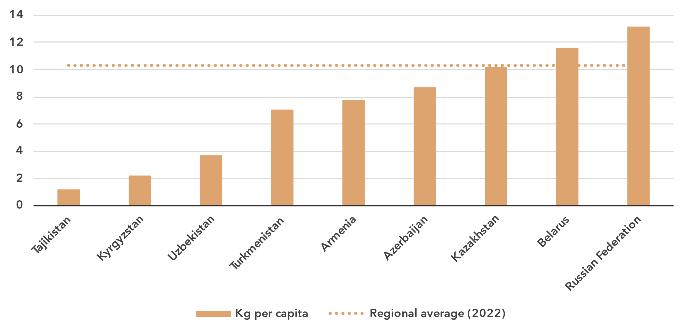Source: ITU and UNITAR, [Global E-waste Monitor, 2024](https://www.itu.int/hub/publication/d-gen-e_waste-01-2024/)

The analysis of e-waste trends in the CIS can be further deepened by examining per capita e-waste generation. While the regional average of 10.3 kg per capita per year in the CIS is above the global average of 7.8 kg, disparities between countries are stark. The regional average is dominated by the larger countries: notably, the Russian Federation stands out with the highest per capita generation at 13.2 kg, more than 1.5 times the global average. Mid-range contributors such as Turkmenistan (7.1 kg) and Armenia (7.8 kg) are closer to the global average. Lower-income countries such as Kyrgyzstan and Tajikistan, with just 2.2 kg and 1.2 kg of e-waste, respectively, generate significantly less.

Only 6.5 per cent (164.3 million kg) of the e-waste generated was documented as properly collected and recycled – well below the global average of 22.3 per cent. Armenia, Azerbaijan, Belarus, Kazakhstan, Tajikistan and the Russian Federation report formal collection and recycling initiatives. The other countries are not documented as having any significant formal recycling activity.

E-waste policies and regulations in place, 2022

|  |  |  |  |  |
| --- | --- | --- | --- | --- |
|  | **National e-waste legislation/policy or regulation** | **Extended producer responsibility (EPR) framework for e-waste** | **Collection targets** | **Recycling targets** |
| Armenia | No | No | No | No |
| Azerbaijan | No | No | No | No |
| Belarus | Yes | Yes | No | No |
| Kazakhstan | Yes | Yes | Yes | No |
| Kyrgyzstan | No | No | No | No |
| Russian Federation | Yes | Yes | No | No |
| Tajikistan | No | No | No | No |
| Turkmenistan | No | No | No | No |
| Uzbekistan | No | No | No | No |

Source: ITU and UNITAR, [Global E-waste Monitor, 2024](https://www.itu.int/hub/publication/d-gen-e_waste-01-2024/)

The lack of comprehensive policies for e-waste management remains a significant challenge in the CIS region, and only three countries have implemented national e-waste legislation and extended producer responsibility (EPR) frameworks. Globally, 42 per cent of countries (81 out of 193) have enacted national e-waste policies, legislation, or regulations. In contrast, within the CIS only Belarus, Kazakhstan, and the Russian Federation have a national e-waste policy, legislation or regulation in place, just one-third of the countries in the region.

The same three countries are the only ones in the region to have introduced EPR frameworks for e-waste, which are essential for holding producers accountable for the entire lifecycle of their products. The absence of these frameworks across most of the CIS exacerbates the region’s e-waste challenges, contributing to the continued reliance on unregulated waste management practices that are harmful to both the environment and public health.

Global statistics show that countries with a policy or legal instrument that includes e-waste collection targets have a collection rate of 25 per cent on average, slightly higher than the worldwide average of 22 per cent. In the CIS region, only Kazakhstan has set such collection targets in its regulatory framework. Without sustainable e-waste policies, the region risks missing key opportunities to advance towards a circular economy and reduce its environmental footprint.

Overview of data availability in the CIS region

***Data availability generally good in the region***

Data plays a key role in achieving universal and meaningful connectivity. Reliable and timely data equips policy-makers to identify needs, set priorities, design effective interventions, track progress, and measure impact. Investing in data yields substantial returns by enabling better decision-making and more efficient interventions.

The importance of data for the delivery of the Kigali Action Plan was acknowledged by the Telecommunication Development Advisory Group of ITU, which adopted five key performance indicators (KPIs) tracking the extent to which Member States submit timely ICT data to ITU, including KPIs related to the submission of data on ICT skills and Internet use, disaggregated by location and gender.

The availability and quality of ICT statistics in the CIS region, including both administrative indicators and those derived from household surveys, are generally good and surpass those of most other regions.

For the core set of 14 administrative ICT indicators, typically collected by national regulatory authorities or ministries, availability is on average 82 per cent in the region (see indicator list in the note of the figure below). Six of the nine countries report full availability, and one country indicates that only two of the indicators are unavailable. The two remaining countries should work towards improving the submission of administrative data.

Percentage availability of selected administrative ICT indicators, 2022-2023

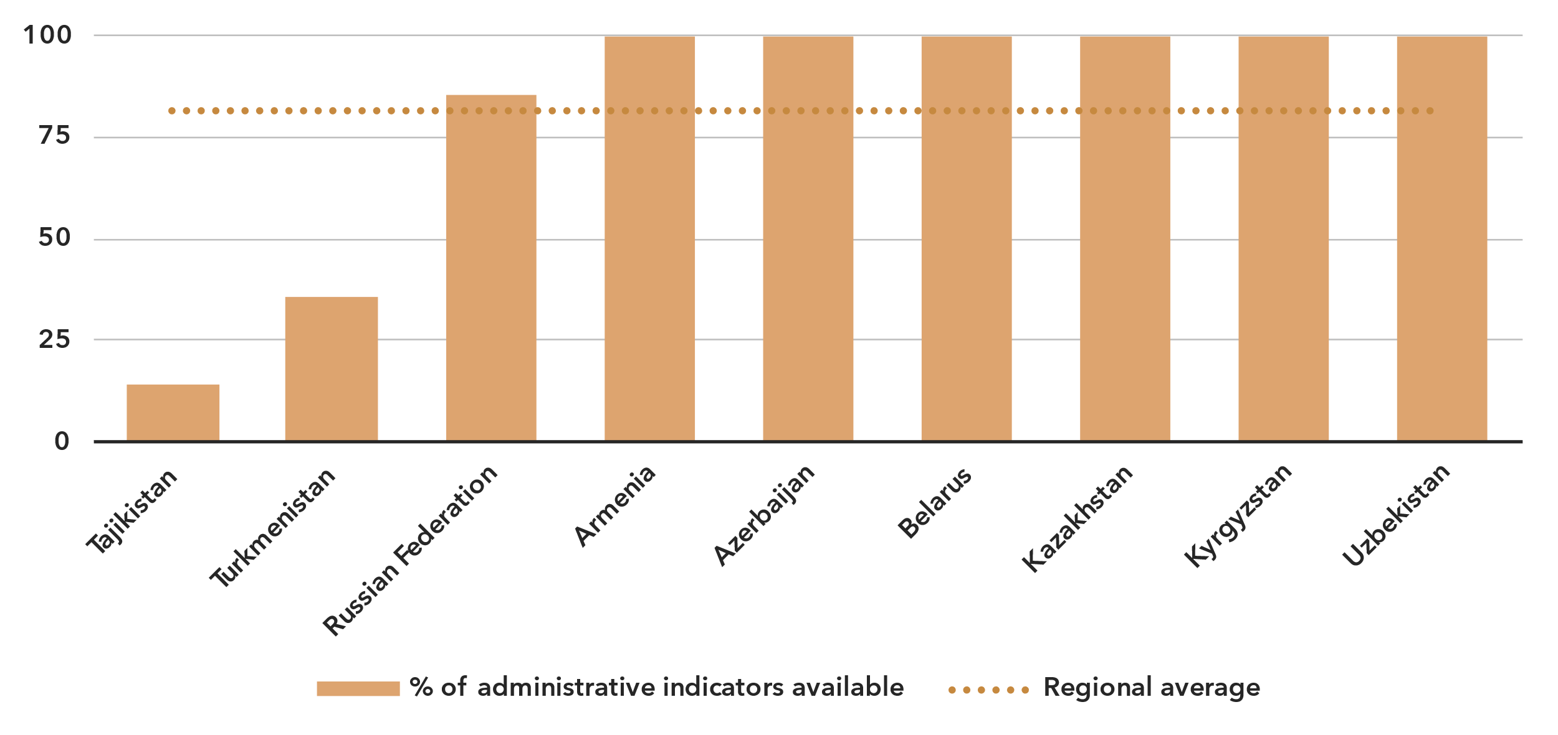Note: An indicator is considered available if at least one value is available for the period in question. Assessment is based on the following set: active mobile broadband subscriptions, fixed broadband subscriptions (total, as well as by speed-tiers: 256 Kbit/s to 2 Mbit/s, 2 Mbit/s to 10 Mbit/s, and above 10 Mbit/s), mobile network coverage indicators by technology (at least 2G, 3G, LTE/WiMAX, 5G), total fixed broadband Internet traffic, mobile broadband Internet traffic within the country, international bandwidth usage, total telecommunication revenues and investment in telecommunication services.

Source: ITU

Data on ICT access and usage by households and individuals is also varied across CIS countries. Six countries (Armenia, Azerbaijan, Belarus, Kazakhstan, the Russian Federation, and Uzbekistan) conduct regular ICT household surveys. By contrast, Kyrgyzstan has not provided data on ICT household indicators since 2020, and Tajikistan and Turkmenistan have never provided any data on these indicators.

Latest year of submission of ICT household survey data, by socio-economic attribute



Source: ITU

The issue is similar for data disaggregated by socio-economic attributes. Azerbaijan, Belarus, Kazakhstan, Russian Federation, and Uzbekistan have submitted recent data (2022 or more recent) for at least five of the six attributes of interest.

Even when data is available, it may suffer from poor sample design, inadequate collection methods, or low response rates. Such shortcomings are likely to yield misleading results and may result in misguided policies. (For example, overestimation of ICT skills could lead policy-makers to shift focus away from supporting populations that need training in this area.) Addressing these challenges requires a dual approach targeting both the producers and users of data. Through continuous efforts in capacity building, technical assistance, and advocacy, ITU aims to enhance the availability and quality of ICT data globally.

Part 2. BDT4Impact: Selected case studies from the CIS region

Supporting connectivity in rural Armenia

A [pilot project was implemented in 2024 in rural areas of Armenia](https://www.itu.int/itu-d/sites/digital-impact-unlocked/driving-rural-connectivity-in-armenia/) to boost connectivity and encourage innovation, sustainable development, and opportunities for social participation.

The project, implemented by the ITU Telecommunication Development Bureau, deployed 18 000 meters of broadband network and conducted training sessions on computer literacy, digital skills, Internet safety, and entrepreneurship.

In six rural communities – Landjanist, Lanjar, Lusashogh, Urtsalanj, Vardashat, and Zangakatun – the effort focused on improving Internet access and digital skills, enabling local businesses to reach a global audience, and promoting economic growth. The project achieved its goals through technical design, capacity and network development, and community engagement.

The project was implemented in coordination with the Ministry of High-Tech Industry of the Republic of Armenia, local authorities, and other partners.

Promoting universal and meaningful connectivity in Uzbekistan

In June 2024 a regional workshop for CIS participants was held in Tashkent, the capital of Uzbekistan, to explore the concept of universal and meaningful connectivity (UMC) and considered how to mainstream it in national digital policies.

This introductory workshop was aimed at policy-makers on digital connectivity and national stakeholders responsible for measuring the development of telecommunications and ICTs. It included regulators, telecom operators, research institutions, and representatives of ministries and national statistics offices.

Organized by the Telecommunication Development Bureau in collaboration with the Ministry of Digital Technologies of the Republic of Uzbekistan, the CIS Statistics Committee, and the Regional Commonwealth in the field of Communications, the workshop also aimed to improve the capacity of countries in the region to produce and disseminate statistical data and examined how to use data to identify good practices and policy recommendations.

Over four days, participants attended sessions on embracing UMC and new requirements for ICT policies; data-driven decision-making; strategies for solving the challenges of measuring UMC; and the state of ICT statistics at country and regional level.

Young people from five CIS countries learn to create and pitch startups

University students and aspiring entrepreneurs from Armenia, Kazakhstan, Kyrgyzstan, Russia and Tajikistan in 2023 and 2024 participated in two-day ideathons to learn what a startup is and what it takes to begin developing a business.

The students learned about the main approaches to generating ideas, how to formulate a problem and how to create a pitch deck to present a startup project to potential users and investors.

The events, led by the Telecommunication Development Bureau, were held in person at universities in each of the countries.

The 180 participants pitched projects in agrotech, logistics, education, human resources tech, tourism and other areas.

The training included short lectures, interactive sessions, personalized work with mentors, and pitching of ideas. Feedback was provided by ITU regional staff, experts with startup experience and representatives of incubators and accelerators.

The programme was shaped by an [ITU regional study](https://www.itu.int/en/ITU-D/Regional-Presence/CIS/Documents/Publications/EN%20Startup%20Central%20Eurasia%20Ecosystem%20Ranking%20Report.pdf) on the development of startup ecosystems in Central Eurasia. The study found that the academic community is one of the six building blocks of any start-up ecosystem.

Enhancing Azerbaijan’s ICT data systems

Azerbaijan has received [comprehensive expert and technical assistance to enhance its national ICT data-collection and analysis systems](https://www.itu.int/itu-d/sites/digital-impact-unlocked/enhancing-azerbaijans-ict-data-systems/).

The assistance, provided through an initiative led by the Telecommunication Development Bureau, aims to align Azerbaijan's ICT data methodologies with international standards, making it possible to compare and analyse data in a meaningful way on a global scale. ITU's support includes training sessions for local experts, the development of data-collection tools, and the establishment of robust data analysis frameworks.

The work focused on improving the accuracy and reliability of ICT data, which is crucial for informed decision-making and policy development. By adopting ITU data methodologies, Azerbaijan can better monitor and evaluate the progress of its ICT sector, identify gaps, and implement effective strategies for growth.

Jeyhun Huseynzade, Head of the Strategic Analysis, Innovation, and Digitalization Department at the Ministry of Digital Development and Transport, emphasized that global standardization of data allows meaningful comparisons and analyses of ICT trends on a global scale.

“Adopting ITU standards and methodologies raises a nation’s profile and acknowledgment of its data internationally, promoting a spirit of cooperation and enabling better evidenced-based decision-making,” Mr. Huseynzade said.

This collaboration underscores the commitment to fostering digital development and enhancing the capabilities of Member States in the CIS region. By strengthening its ICT infrastructure, Azerbaijan is contributing to the country’s socioeconomic development and its integration into the global digital economy.

Azerbaijan is preparing to host the 2025 World Telecommunication Development Conference (WTDC) in Baku, 17-28 November, where global leaders and stakeholders will gather to discuss and develop strategies for advancing telecommunications and ICT development worldwide.

Regional forum in Kyrgyzstan highlights strategies for meaningful connectivity

Experts, policy-makers and industry leaders came together in Kyrgyzstan in August 2023 to delve into key aspects of digital transformation.

The three-day ITU Regional Forum on Digital Transformation was organized in collaboration with the Ministry of Digital Development of the Kyrgyz Republic and emphasized the critical role of collaboration and innovation in driving digital progress across the region.

The event focused on developing national digital transformation strategies, exploring innovative regulatory approaches, and enhancing infrastructure and connectivity. Participants shared experiences and best practices and promoted robust governance, regulatory flexibility, and universal service financing to ensure meaningful connectivity for all.

Key sessions included discussions on institutional frameworks for digital transformation, technical and regulatory solutions for connecting the unconnected, and capacity building for informed decision-making. The forum provided a platform for regional cooperation, aiming to advance digital development agendas and foster sustainable growth through technology.

The insights gained from the forum are expected to guide future initiatives and policies in the region.

Cyberdrills boost cybersecurity readiness across CIS countries

In a push to bolster cybersecurity readiness across CIS countries, the Telecommunication Development Bureau organized national and regional cyberdrills in 2023 and 2024.

The events underscored the need for robust measures and international cooperation to combat evolving cyber threats.

In October 2023, Abu Dhabi hosted the Arab-CIS Interregional Cyberdrill, where experts repelled simulated cyberattacks, sharing best practices and strategies. The cybertraining participants from the CIS region represented Armenia, Azerbaijan, Belarus, Kazakhstan, Kyrgyzstan, Russia, Tajikistan, Turkmenistan and Uzbekistan.

The event stressed the importance of national computer incident response teams (CIRTs) and computer security incident response teams (CSIRTs) in building cyber resilience. The event concluded with a commitment to strengthen cybersecurity frameworks and international cooperation.

In December 2024 a national cyberdrill was held in Yerevan, the capital of Armenia, boosting cybersecurity readiness and resilience among the country’s critical infrastructure operators.

“Such events are an excellent opportunity for our cyberdefense personnel to face realistic challenges and connect with other CIRTs, with whom we later establish continuous partnerships and share the experience,” said Dr Gevorg Mantashyan, First Deputy Minister of High-Tech Industry of Armenia.

The event highlighted cross-sector collaboration and capacity building and focused on the latest cybersecurity trends and challenges. More than 200 professionals participated.

Annex: Data resources

To ensure up-to-date information and enhance readability, all data presented in this document are available for download as Excel files:

* [Country-level data](https://www.itu.int/en/ITU-D/Statistics/Documents/facts/rpm_arb_pub_2025_data.xlsx) organized by tabs corresponding to the sections of this document (URL: <https://www.itu.int/en/ITU-D/Statistics/Documents/facts/rpm_cis_pub_2025_data.xlsx>). Country-level data were extracted from the [ITU DataHub](https://datahub.itu.int/), reflecting the February 2025 data release.
* [Regional and global estimates](https://www.itu.int/en/ITU-D/Statistics/Documents/facts/ITU_regional_global_Key_ICT_indicator_aggregates_Nov_2024.xlsx), as compiled for [Facts and Figures 2024](https://www.itu.int/itu-d/reports/statistics/facts-figures-2024/) (URL: <https://www.itu.int/en/ITUD/Statistics/Documents/facts/ITU_regional_global_Key_ICT_indicator_aggregates_Nov_2024.xlsx>).

________________

1. As of March 2025, the CIS region, as defined by ITU, consists of the following nine countries: Armenia, Azerbaijan, Belarus, Kazakhstan, Kyrgyzstan, Russian Federation, Tajikistan, Turkmenistan, and Uzbekistan.
2. The tiers of the G5 Benchmark reflect a country's level of digital governance. The four levels, from least to most advanced, are: Limited, Transitioning, Advanced and Leading. The G5 Benchmark encompasses 119 targets under four pillars: national collaborative governance, policy design principles, digital development toolbox, and digital economic policy agenda. See [gen5.digital/benchmark](https://app.gen5.digital/benchmark/metrics).
3. [Programme of Action for LLDCs for the Decade 2024–2034](https://docs.un.org/A/RES/79/233)
4. Considering that some people may never want to connect, as a matter of convention universality is taken to mean an Internet penetration rate of at least 95 per cent.
5. In this document, for figures reporting economy-level data, all economies are shown. Countries are sorted by their score for the indicator. A data point is only shown if it is for the year 2020 or later, otherwise it is marked as not available (N/A), or excluded altogether (when data are not available for many countries). In addition, a marker shows the data point for the year 2018, if available. Data are extracted from the [ITU DataHub](https://datahub.itu.int/), based on the data release of February 2025. Since country-level data are available for the year 2023 at best, for comparison purposes, the regional average for the year 2023 is reported as well, as published in [Facts and Figures 2024](https://www.itu.int/itu-d/reports/statistics/facts-figures-2024/).
6. The gender parity score is calculated as the proportion of women who use the Internet divided by the proportion of men who use the Internet. A value less than one indicates that men are more likely to use the Internet than women, while a value greater than one indicates the opposite. Gender parity is considered achieved if the value lies between 0.98 and 1.02.
7. Considering only those countries for which data was available for all years from 2018 to 2024.
8. For a complete definition, see the International Standard Industrial Classification of All Economic Activities (ISIC), Rev. 4, division 61.
9. Investment statistics collected by ITU refer to acquiring or upgrading property (including tangible assets such as plants and non-tangible assets such as computer software) and networks. Not included are expenditure on research and development, annual fees for operating licences and the use of radio spectrum, and investment in telecommunication software or equipment for internal use.