|  |  |
| --- | --- |
| **Regional Preparatory Meeting for Asia and the Pacific for WTDC-25 (RPM-ASP)**  **Bangkok, Thailand, 20-21 March 2025** |  |
|  |  |
|  | **Document** **RPM-ASP25/3-E** |
|  | **13 February 2025** |
|  | **Original: English** |
| Director, Telecommunication Development Bureau | |
| State of digital development and trends in Asia and the Pacific:  Challenges and opportunities | |
|  | |
| **Agenda item:**  Item 5  **Summary:**  This document, prepared for the RPM for Asia and the Pacific, aims to inform participants and stakeholders in setting the region’s digital agenda. It is structured into two parts: the first provides an overview of the state of digital connectivity in Asia and the Pacific through key indicators, and the second highlights impactful case studies from the region.  **Expected results:**  RPM-ASP is invited to note this document.  **References:**  N/A | |

State of digital development and trends in Asia and the Pacific: Challenges and opportunities

February 2025

Contents

Introduction 3

Part 1. The state of digital connectivity in Asia and the Pacific and recent trends 5

ICT regulation and digital policy frameworks 5

Internet use 11

Broadband subscriptions 16

Mobile network coverage 18

Availability of fixed-broadband infrastructure 21

Internet traffic and international bandwidth 23

Affordability of ICT services 27

Mobile phone ownership and subscriptions 29

ICT skills 32

Revenue and investment 38

Cybersecurity 40

E-waste management 42

Disparities within the region 46

Overview of data availability in Asia and the Pacific 48

Part 2. BDT4Impact: Selected case studies from Asia and the Pacific 51

Farmers in Papua New Guinea gain digital skills to boost their businesses 51

Smart Village Gokina reaps the rewards of digital transformation 51

Workshop in Mongolia delves into regional digital infrastructure challenges 51

Girls in ICT Day 2024 provided digital skills, role models and career ideas 52

Leaders focus on digital inclusion as a component of healthy aging 52

Innovation Centre in New Delhi unites stakeholders, enables digital advancements across sectors 53

Annex: Data resources 54

Introduction

The Regional Preparatory Meetings (RPMs) aim at engaging the membership in the preparations of the World Telecommunication Development Conference 2025 (WTDC-25). Prepared for the [RPM for Asia and the Pacific](https://www.itu.int/itu-d/meetings/wtdc25/rpm/asp/home/) held on 20-21 March 2025, this document seeks to inform participants and stakeholders as they discuss the region’s digital agenda.[1] The document consists of two parts: the first provides an overview of the state of digital connectivity in the region through key indicators, and the second showcases impactful case studies.

**Universal and meaningful connectivity is a policy imperative.** The concept of universal and meaningful connectivity (UMC) has emerged as a vital policy objective. UMC is defined as enabling everyone to enjoy a safe, enriching, and productive online experience at an affordable cost. UMC does not mean everyone must be connected all the time but describes a situation where everyone can access the Internet optimally and affordably whenever and wherever needed. While the Asia and the Pacific region is making notable progress toward UMC, significant challenges remain.

**The region is marked by significant contrasts in digital development.** Home to 41 Member States, including Palau, the latest to join the Union in 2024, the region encompasses a wide range of countries, from some of the most technologically advanced nations to others still striving to bridge multiple connectivity gaps. This diversity is reflected in vastly different levels of digital development not only across countries but also within countries.

**Thanks to rapid expansion, universal access is within reach.** Mobile network coverage in the Asia-Pacific region has expanded faster than in most regions, with 96.2 percent of the population covered by at least a 4G network. Although some remote areas still face significant coverage gap, these gains bring universal access—the ability for everyone to connect to the Internet—within reach. The focus must now shift to overcoming barriers to usage and enabling meaningful connectivity.

**Connectivity quality shapes the digital experience across the region.** While mobile network coverage has expanded significantly, the availability and quality of infrastructure vary widely, directly influencing how people access and use the Internet. 5G is advancing rapidly in high-income economies but remains limited in several low-income countries. Differences in fixed-broadband infrastructure and international bandwidth capacity mean that some users enjoy high-speed, reliable connections, while others face slower, less reliable service. These disparities are reflected in vastly different patterns of data consumption. Addressing these inequalities requires investments in network capacity, attractive spectrum pricing, backhaul expansion, and policies that enhance service quality and affordability.

**Affordability and digital skills are essential enablers of UMC.** Broadband prices have been declining across the Asia and the Pacific region, making entry-level mobile broadband affordable in most countries. The region’s average mobile broadband price is now below the global average. Fixed broadband prices have also been decreasing, yet this technology remains unaffordable in nearly half of the countries. Moreover, digital literacy disparities limit individuals' ability to benefit fully from connectivity. Even among Internet users, digital skills vary widely in the region. Digital content creation, problem solving, and safety skills generally lag far behind communication and collaboration skills.

**Sound ICT policies and regulations are key for digital transformation.** Sound and comprehensive regulations and policies are essential for fostering investment, competition and innovation in the ICT sector. The Asia and the Pacific region exhibits a broad spectrum of regulatory maturity, with some economies having highly developed ICT policies while others are still in the process of establishing independent regulatory authorities. Countries with advanced regulatory environments have seen greater progress in broadband expansion and digital service adoption, while regulatory gaps in some areas continue to impede investment and market growth.

**Investment in ICT infrastructure is a key driver of economic growth.** Investment in ICT infrastructure deployment and upgrade is essential [for UMC and digital transformation]. The telecom sector is a significant source of revenue across the region, yet capital expenditures remain uneven, with higher-income countries leading in network expansion while others struggle with financial and regulatory constraints.

**Insufficient collection and recycling hinder the circular economy for electronics.** The rapid growth of digital technologies has led to a significant increase in electronic waste (e-waste), posing environmental and regulatory challenges. The region’s e-waste recycling rate is about half the world’s average rate. While some countries have implemented national e-waste management policies and recycling initiatives, many still lack formal collection systems and extended producer responsibility frameworks. The disparity in e-waste policies underscores the need for stronger regulations, investment in recycling infrastructure, and regional cooperation to promote e-waste management.

**Cybersecurity frameworks are essential for digital trust and resilience.** With increasing connectivity comes the need for robust cybersecurity policies and data governance frameworks. The Asia and the Pacific region has seen a growing focus on cybersecurity, with many economies adopting national cybersecurity strategies and enhancing digital resilience measures. However, cybersecurity preparedness remains extremely uneven, with some countries ranking among the global leaders while others face substantial vulnerabilities. Strengthening regional collaboration and countries’ incidence response capabilities will be crucial to ensuring a secure regional digital landscape.

**Reliable data is essential for achieving UMC.** Accurate, granular, and timely data is crucial for identifying gaps, designing interventions, and measuring progress. However, many Asia and the Pacific countries lack comprehensive, up-to-date ICT statistics, and most do not disaggregate data by socio-economic attributes, seriously limiting evidence-based policymaking and hindering progress towards UMC.

**Impactful initiatives demonstrate the power of digital connectivity**. The second part of this document presents a selection of projects and initiatives supported by the ITU Telecommunication Development Bureau (BDT) in collaboration with regional stakeholders. These case studies highlight how digital technologies are transforming education, healthcare, entrepreneurship, and rural development, and fostering digital innovation. These examples illustrate how targeted interventions can drive meaningful change and create opportunities for communities across the Asia and the Pacific region.

**The region has made great strides but the journey towards UMC is still long.** The Asia and the Pacific’s digital journey has been remarkable, but universal access is only a milestone. Achieving meaningful connectivity for everyone and enabling digital transformation in all countries will require a multi-faceted approach, including infrastructure investments, policy reforms, capacity building, and regional cooperation.

Part 1. The state of digital connectivity in Asia and the Pacific and recent trends

ICT regulation and digital policy frameworks

The evolving landscape of ICT regulation and digital policy frameworks plays a critical role in driving an inclusive and sustainable digital transformation as well as fostering thriving digital economies. To ensure national frameworks remain effective and adaptive, it is crucial to assess progress, identify best practices and address existing gaps.

***ICT regulation in Asia and the Pacific has advanced positively, but key reforms remain outstanding***

ICT regulation in Asia and the Pacific region has undergone transformative changes over the past fifteen years, driven by the need to align with global good practices and respond to evolving markets and rapid technological innovation. In 2007, 90 per cent of countries in the region were classified as Generation 1 (G1) or Generation 2 (G2), the least advanced levels of ICT regulatory maturity. Australia became the first country in the region to achieve Generation 4 (G4), the most advanced level, in 2008, joining a select group of five G4 countries globally at the time.

Today, a quarter of the 39 countries studied in the region have upgraded their national legal frameworks to G4 status, while only three remain in G1. Two thirds linger in G2 and G3 – underscoring the urgency of addressing gaps and enhancing regulatory maturity.

Evolution of the generations of ICT regulation in Asia and the Pacific

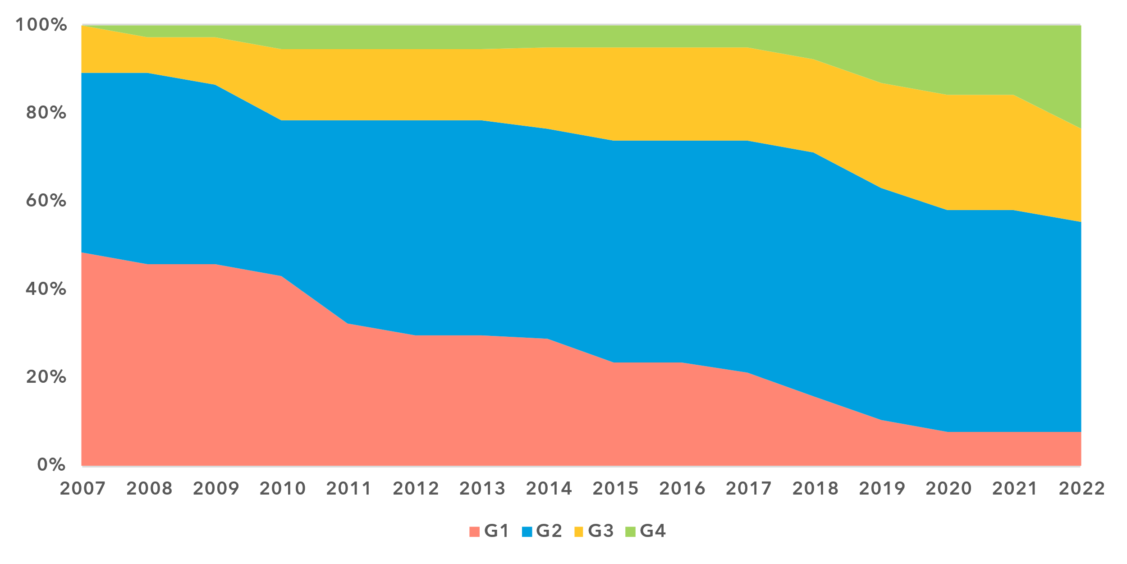

Note: The ‘Generations of ICT regulation’ provides a high-level conceptual framework for assessing the overall development of national legal instruments, policies and governance for the ICT and digital sectors. Generations 1 through 4 are based on [ICT Regulatory Tracker](https://app.gen5.digital/tracker/metrics) scores:

G1 – Command and control approach: score between 0 and 40   
G2 – Early open markets: score between 40 and 70   
G3 – Enabling investment and access: score between 70 and 85   
G4 – Integrated telecommunication regulation: score between 85 and 100

Data for 2021 is unavailable; 2020 data is used as a proxy for 2021.

Source: ITU

Progress across the region varies, influenced by the diverse development profiles of countries. The regional average for ICT regulatory maturity stands at 66 per cent, compared to 56 per cent for Least Developed Countries (LDCs) and 55 per cent for Small Island Developing States (SIDS) in the region. All remain below the global average of 72 per cent, revealing a need for focused reforms to bolster ICT regulatory frameworks – which are also the foundation of digital readiness and market take-up.

***Mixed progress in digital governance***

Asia and the Pacific is home to several of the world's top countries with respect to digital governance frameworks. In 2023, seven of the 19 countries in the Leading tier of the G5 Benchmark are from the region: Australia, India, Malaysia, New Zealand, Philippines and the Republic of Korea, with Singapore ranking highest in the region and third globally. This places Asia and the Pacific as the region with the second-largest number of Leading countries, following Europe – which has eight. But the region also includes the country with the world's lowest readiness – a SIDS – underscoring significant disparities, particularly among LDCs and SIDS compared to other countries.

Despite notable policy advancements since 2021, digital governance frameworks across the region continue to lag the global average. Two-thirds of countries remain at either the Limited or Transitioning level, falling short of establishing a solid foundation for inclusive, accelerated and sustainable digital transformation.

***Readiness of national frameworks reveals gaps within the region***

Advanced digital readiness of national and regional policy, legal and governance frameworks – underpinned by robust ICT regulation and adaptive digital governance – is essential for achieving meaningful digital inclusion and a successful transition to digital economies. To enable digital transformation across all sectors, countries must establish consistent and balanced national frameworks and implement them effectively. These are also key for regional harmonization and economic integration, positioning both ICT and digital policies as top priorities for national and regional development agendas.

Legal, policy and governance frameworks for digital transformation, 2023

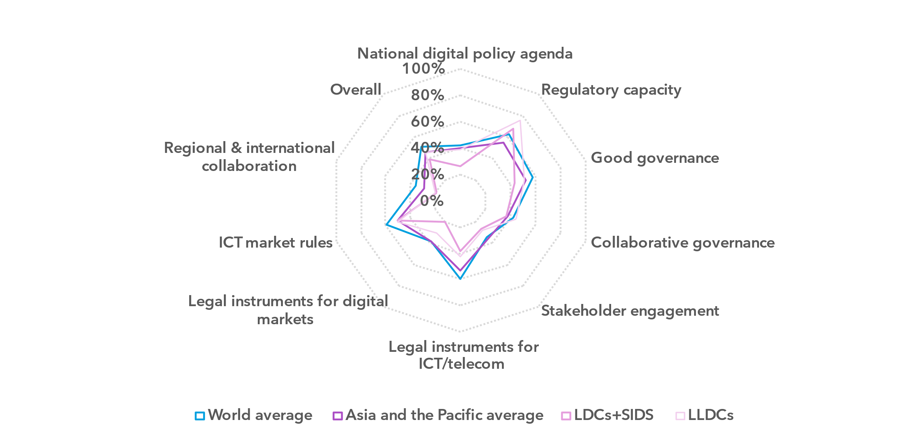Note: The nine thematic benchmarks (as in the chart above) each comprise a subset of indicators, as part of the [ITU Unified Framework for the readiness of national policy, legal and governance frameworks for digital transformation](https://www.itu.int/pub/D-PREF-BB.REG_OUT01-2023/en).

The chart shows progress on the nine benchmarks for the Asia-Pacific region (average for the group) compared to the world average and the average for LDCs and SIDS in the region (21 countries, including four countries which are both SIDS and LDCs). The percentage of achievement on each benchmark indicates the proportion of met versus unmet targets on indicators in each benchmark.

Source: ITU

The overall readiness of Asia and the Pacific frameworks for digital transformation stands at 45 per cent, six percentage points below the world average, reflecting significant gaps across all nine thematic benchmarks. Regional disparities are also prominent, with LDCs and SIDS in the region underperforming by 6 to 18 percentage points on six benchmarks, in 2023. Compared to the regional average, landlocked developing countries (LLDCs) perform at a similar level or better on six of the nine thematic benchmarks, notably exceeding the regional performance on the Regulatory Capacity benchmark by 21 percentage points.

The region performs best in Regulatory Capacity, achieving 55 per cent, though still below the world average. Notably, LDCs and SIDS outperform the regional average in this area, reaching 68 per cent and exceeding the global benchmark of 63 per cent. This strength can be attributed to substantial international development aid and capacity building over the past decade, providing a solid institutional foundation to foster digital technologies and services. However, to fully harness their potential, these countries must now focus on actively developing digital economies while mitigating risks for governments, businesses and consumers.

In Good Governance, LDCs and SIDS lag significantly behind, scoring 43 per cent compared to the regional and world averages of 52 and 58 per cent. Yet, their performance aligns with the regional average in Collaborative Governance, and they are only 5 percentage points below the global benchmark of 42 per cent. This relative strength presents an opportunity to drive essential reforms in ICT and digital markets and leverage regional frameworks for digital transformation of public and private sectors.

Traditional areas of regulatory oversight in the region remain underdeveloped relative to global standards. For Legal Instruments for ICT Markets, the regional average is 53 per cent, trailing the world average of 59 per cent, with LDCs and SIDS falling further behind at 39 per cent. Similarly, on Market Rules, the averages for the region as well as for LDCs and SIDS stand at 50 per cent, 9 percentage points below the global benchmark. These shortcomings also hinder the development of efficient and inclusive digital markets, underscoring the urgent need for further reforms.

The region also faces major challenges in Legal Instruments for Digital Markets, scoring 39 per cent – or 14 percentage points lower than on the Legal Instruments for ICT Markets. LDCs and SIDS are particularly disadvantaged, with only 20 per cent of this benchmark achieved. This regulatory deficit undermines their readiness for digital transformation, threatening to stall broader development prospects.

Another critical gap lies in Regional and International Cooperation, where Asia and the Pacific scores 29 per cent, below the already low world average of 38 per cent. This shortfall limits the region’s ability to scale digital innovation and adopt transformative technologies to advance development across the board. Nonetheless, notable regional initiatives demonstrate strong potential for progress across the region such as the ASEAN Digital Integration Framework Action Plan (DIFAP), ITU-ASEAN Digital Government Technical Framework, the APEC Digital Economy Work Program, the Belt and Road Initiative (BRI) Digital Silk Road, the Pacific Islands Forum (PIF) Digital Transformation Agenda, and ICT and digital initiatives of the Asia-Pacific Telecommunity (APT) and SAARC.

These initiatives offer concrete mechanisms to strengthen national policy, legal, and governance frameworks for digital transformation while supporting LDCs and SIDS in overcoming structural barriers. By prioritizing regional harmonization and targeted interventions, the region can drive inclusive and sustainable growth through digital transformation.

***Policies driving digital inclusion advance rapidly though unevenly***

Rapid advancements in technology and business models have outpaced governance frameworks in most countries across the region, leaving critical gaps in public policies aimed at fostering digital inclusion.

Broad, multi-sector policy instruments are key to aligning market and government stakeholders with digital inclusion goals, such as leaving no one behind. While Asia and the Pacific show a high level of adoption of national digital strategies, with 71 per cent of countries exceeding the world average, this figure drops to just 48 per cent for LDCs and SIDS in the region. Over half of the countries in the region, and 80 per cent of LLDCs, have introduced universal access and service policies including broadband as an essential service, well above the global average of 38 per cent. However, LDCs and SIDS must expedite the implementation of these frameworks by developing clear roadmaps and identifying funding mechanisms for universal access initiatives. Additionally, to ensure inclusivity, it is crucial for the region to advance digital inclusion strategies targeting specific groups, such as persons with disabilities, which are currently only found in 16 percent of countries in the region and are virtually absent in LDCs, LLDCs, and SIDS. Encouragingly, some SIDS are taking steps to address these policy gaps.

Digital inclusion policy instruments, Asia and the Pacific, 2023

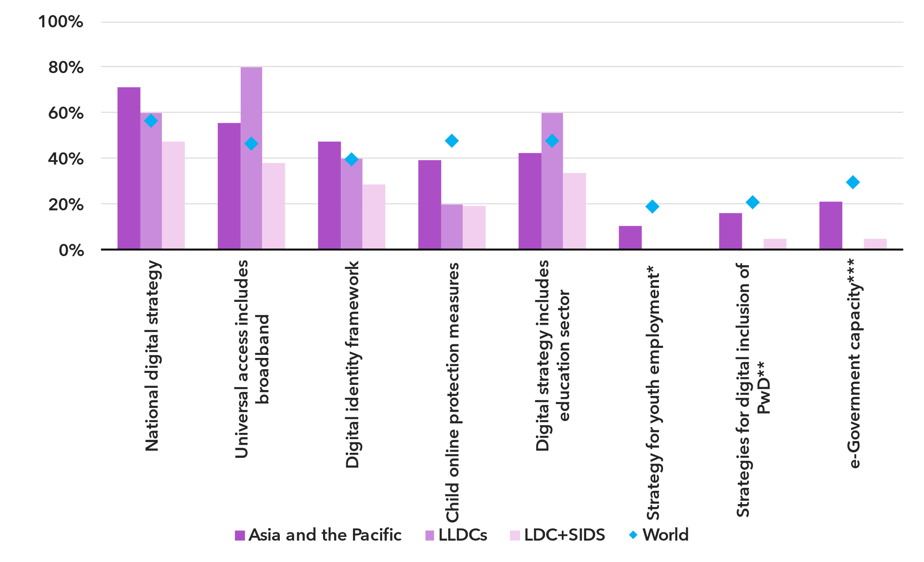* Based on SDG Target 8.b Develop and operationalize global strategy for youth employment and to implement the Global Jobs Pact of the ILO

** Persons with disabilities

*** Based on the UNDESA E-Government Development Index

Note: The region’s average scores for key indicators in the National Digital Agenda and Legal Instruments for Digital Markets under the ITU Unified Framework are compared to the averages for LDCs and SIDS (combined) and LLDCs in the region, and the world average.

Source: ITU, based on data from ITU, SDG Indicators and the E-Government Development Index

Digital identity frameworks play a pivotal role in promoting digital inclusion too, providing citizens with secure, reliable and universally accessible means to access essential public services and participate in the digital economy. While 47 per cent of countries in the region have established these systems – above the global average – LDCs and SIDS are significantly behind. This gap is partly due to low e-government capacity in 80 per cent of the region’s countries, with LDCs, LLDCs and SIDS particularly disadvantaged.

Digital inclusion for youth is especially important for unlocking learning, economic opportunities and civic engagement. LLDCs are leading in the adoption of digital strategies for transforming education, with 60 per cent of countries implementing such policies. In contrast, the region falls below the world average of 42 per cent and only one-third of LDCs and SIDS have policies mainstreaming digital tools in education. Efforts to prepare youth for future employment in the digital economy remain limited, with only 10 per cent of countries in the region adopting strategies for youth employment – and none among the 26 LDCs, LLDCs and SIDS. Similarly, child online protection measures are insufficient, present in just 40 per cent of countries and a mere 20 per cent of LDCs, LLDCs, and SIDS.

Broader policy initiatives are needed to ensure digital inclusion for all and build a digitally competent workforce for the future across the region and in particular in the most vulnerable and least developed countries. Focused investments in digital skills, workforce readiness for digital economies and inclusive governance can transform the region’s population dividend into a robust digital dividend.

***LDCs, LLDCs and SIDS lag in leveraging emerging technologies***

Digital economy policy agendas in Asia and the Pacific are less advanced than the global average, highlighting the limited progress across much of the region in building comprehensive, agile frameworks to support digital transformation across economic sectors.

Several key instruments are required in the policy toolbox of every country to ensure governance keeps pace with rapid emerging technologies shifts in the region.

Innovation policies play a critical role in leveraging emerging technologies to drive economic prosperity by creating an environment that fosters digital innovation, technology development and digital value creation. While Asia and the Pacific and LLDC averages are lower but close to the world average of 48 per cent, only 14 per cent of SIDS and LDCs in the region have an innovation policy.

Targeted emerging technology policies can enable developing countries to transform their economies, create new entrepreneurship opportunities and enhance the efficiency of the public sector. In Asia and the Pacific, 42 per cent of countries have adopted regulations or standards for the Internet of Things (IoT), well above the world average of 30 per cent. The region also leads in cloud computing strategies, with 24 per cent adoption compared to the world average of 21 per cent and matches the global average for Artificial Intelligence policies of 16 per cent. However, LDCs and SIDS in the region lag significantly, with only 10 per cent having any policy related to emerging technologies, signalling systemic gaps in responding to the fast-evolving challenges and opportunities in digital markets.

Pro-active government policies promoting digital innovation in commercial services and digital public goods can lower barriers to market entry, encourage investment in emerging sectors and accelerate the growth of local innovation ecosystems. Regulatory experimentation mechanisms such as sandboxes have been adopted in 39 per cent of countries in Asia and the Pacific, closely aligning with the world average of 40 per cent. LDCs, LLDCs and SIDS in the region, however, are half as likely to enable regulatory experimentation compared to the regional average. The proportion of countries exempt from sector-specific taxes on ICT and digital services in the region is relatively high at 47 per cent, though it remains below the world average of 56 per cent. In comparison, targeted incentives for ICT and digital market players are present in only 18 per cent of countries in the region and are entirely absent in LDCs, LLDCs and SIDS in the region, underscoring the lack of agile strategies to accelerate the digital economy agendas in these countries.

Enabling environment for emerging technologies, Asia and the Pacific, 2023

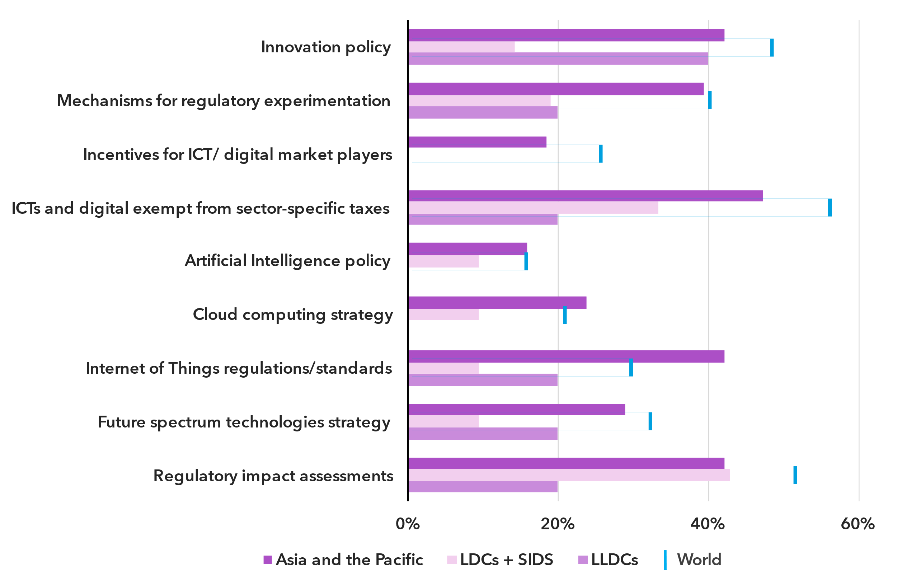Note: The regions’ average scores for key indicators in the National Digital Agenda, Legal Instruments for Digital Markets, Stakeholder Engagement and Good Governance under the ITU Unified Framework are compared to the averages for LDCs and SIDS (combined) and LLDCs in the region, and the world average.

Source: ITU

Incentivizing digital innovation and advancing emerging technology development stand as key priorities for strengthening digital governance in Asia and the Pacific. Targeted and regionalized reforms are essential to attract investment in digital ecosystems, drive economic development and accelerate regional integration.

Internet use

***Internet use in Asia and the Pacific on par with global average***

Percentage of individuals using the Internet

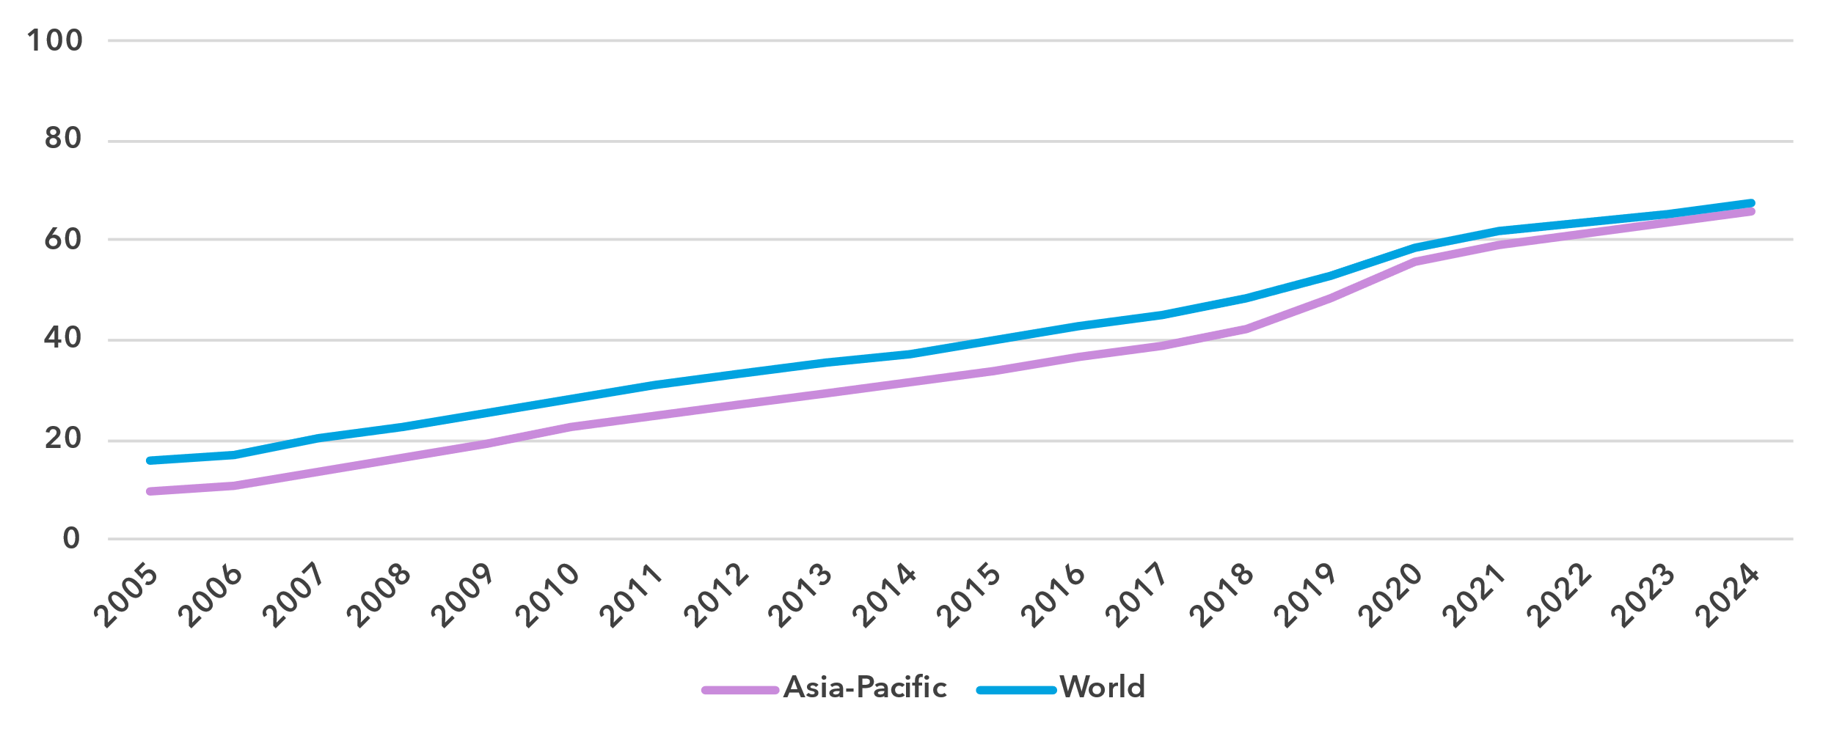Source: ITU

The proportion of people online in Asia and the Pacific stood at 66 per cent in 2024, just two percentage points below the global average. Since 2005, the average annual growth rate of Internet penetration has been 10.7 per cent in the region, against 8 per cent globally. Over the last ten years, these percentages were more modest, at 7.8 and 6.1 per cent respectively.

Asia and the Pacific is a very heterogeneous region, from tiny Pacific islands to the biggest and most populous countries in the world. The region also contains economies on all positions in the development spectrum, from least developed countries to high-income economies. This heterogeneity is reflected in the country level data on Internet use, with penetration levels from 18 to 99 per cent. Indeed, in six of the economies, universal use has been reached.[2]

Percentage of individuals using the Internet in Asia and the Pacific, 2023 or latest year available[3]

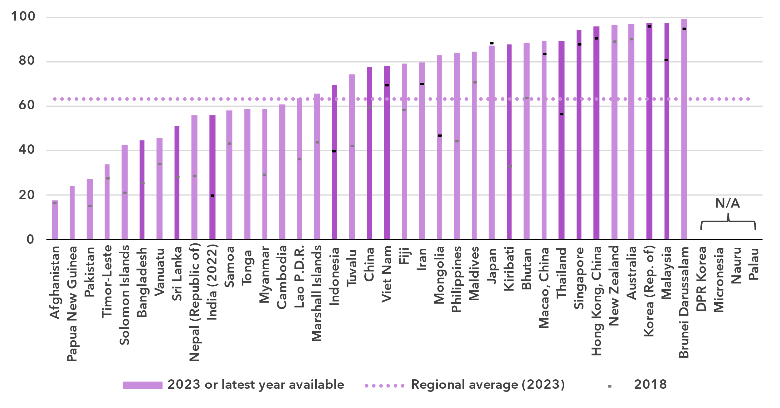

Note: Country submitted are in a darker shade, non-official data in a lighter shade.

Source: ITU

***Gender parity in Internet use is improving***

Percentage of individuals using the Internet, by gender, 2024

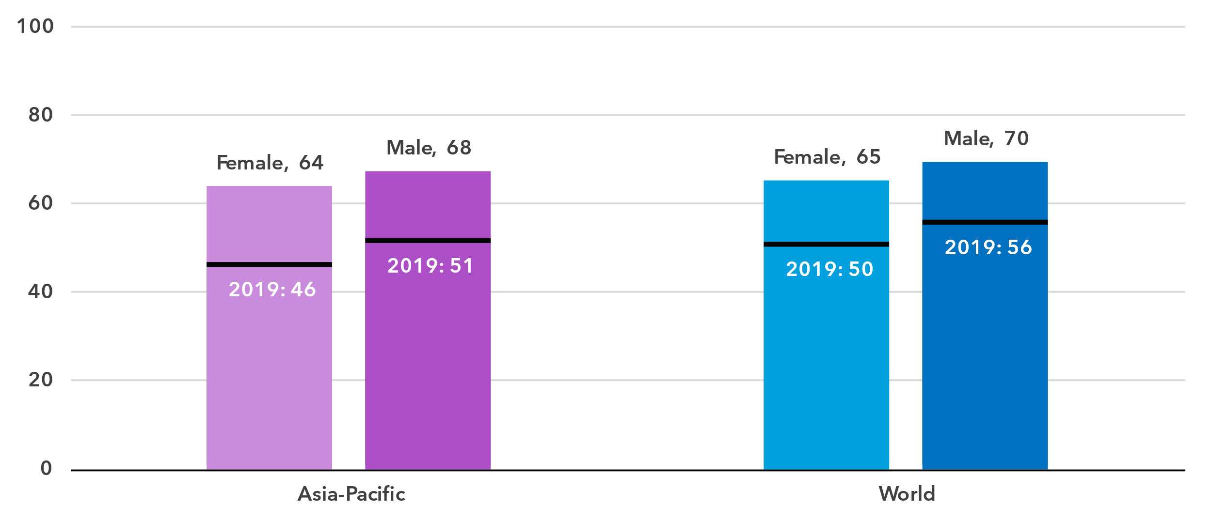

Source: ITU

In 2024, 68 per cent of men were online in Asia and the Pacific, against 64 per cent of women. This converts into a gender parity score (GPS)[4] of 0.95, just ahead of the global GPS of 0.94. Furthermore, in the last five years, the GPS has improved significantly from 0.89 to 0.95.

Gender parity is closely linked to overall development level and Internet penetration of a country. The three countries with the lowest Internet penetration levels also have the lowest GPS. All other countries are close to, or have achieved gender parity, except for the Maldives, where Internet use is heavily biased in favour of women.

Percentage of individuals using the Internet, by gender, 2023 or latest year available

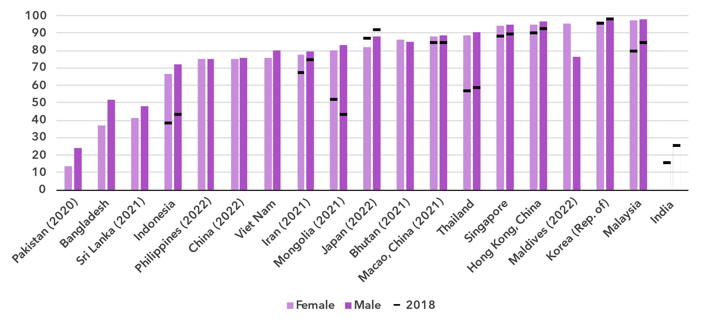

Source: ITU

***The generational gap is larger in Asia and the Pacific than globally***

Percentage of individuals aged between 15 and 24 years using the Internet, 2024

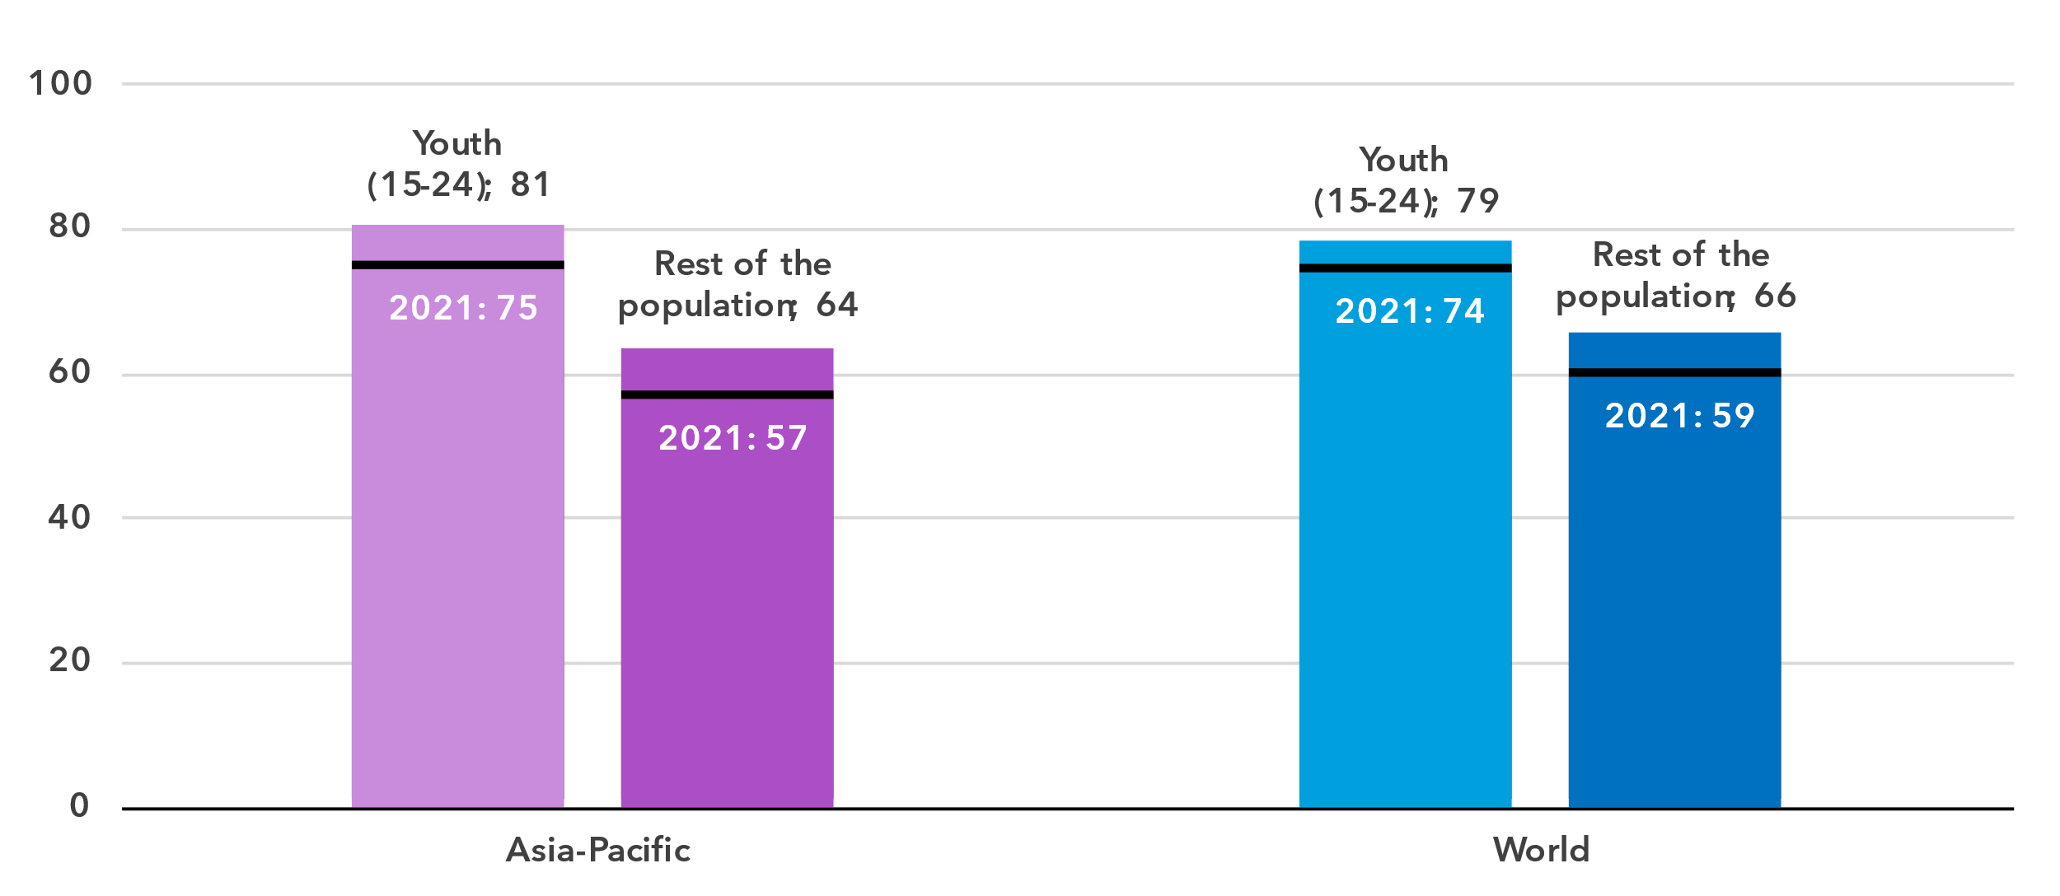

Source: ITU

In Asia and the Pacific, 81 per cent of young people aged 15 to 24 used the Internet in 2024, compared to 66 per cent of the rest of the population. The generational gap in this region—measured as the ratio of Internet users between these two groups—is higher than the global average. Both in the region and globally, the ration has been shrinking over the last four years.

In most countries for which there are data, the percentage of young people online is very high. This stands in sharp contrast with the proportion of the elderly (those 75 years and older) using the Internet, which is low or very low in all countries bar one.

Percentage of individuals using the Internet by age group, 2023 or latest year available

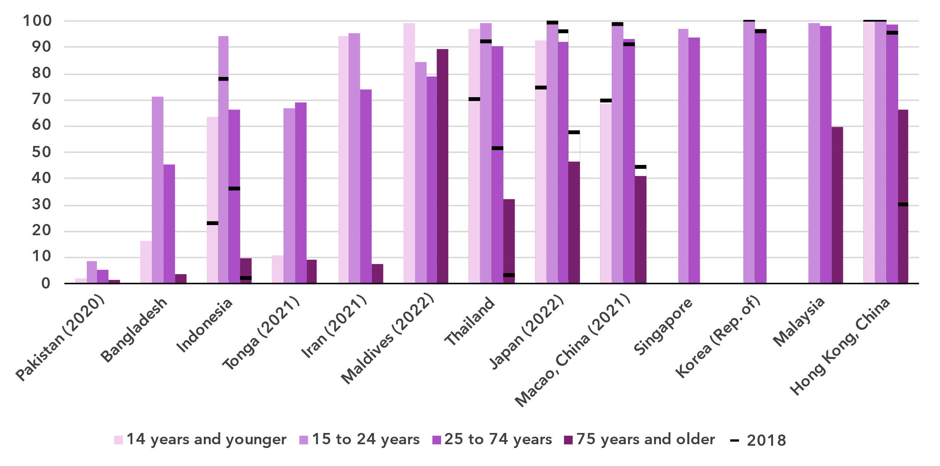

Source: ITU

***Internet use in rural areas trails behind that in urban areas***

Percentage of individuals using the Internet, by location, 2024

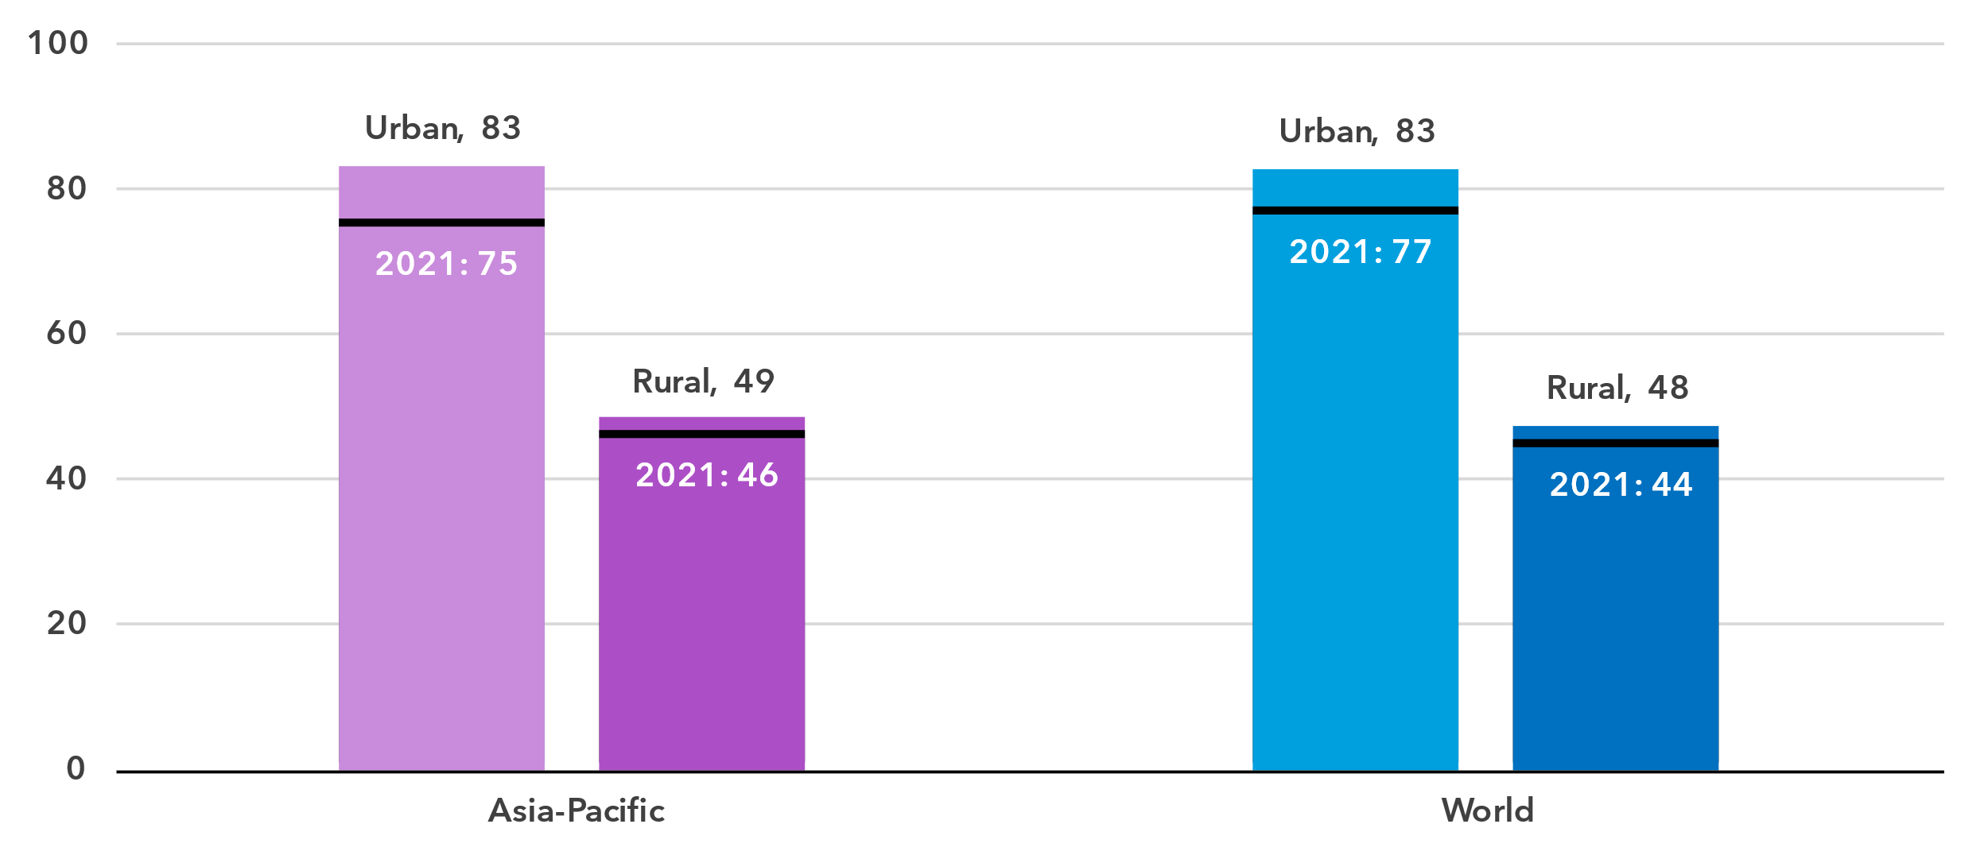

Source: ITU

In Asia and the Pacific, 83 per cent of the population living in urban areas used the Internet in 2024, same as the global average. This starkly contrasts with the region’s rural areas, where only 49 per cent of the population used the Internet; though, again, this is in line with the global average.

Generally, in countries with high overall Internet penetration, the urban-rural gap was much smaller than in countries with a lower Internet use percentage

Percentage of individuals using the Internet by location, 2023 or latest year available

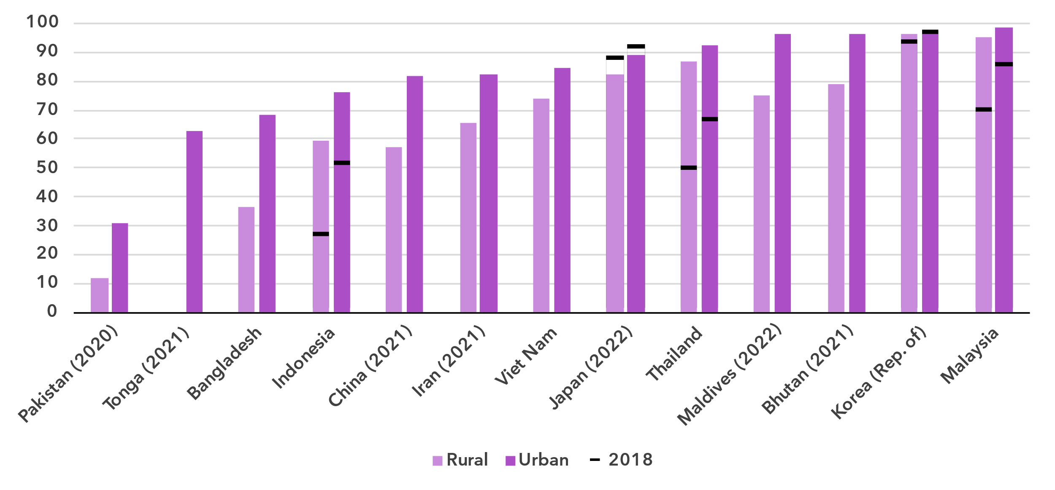Source: ITU

Broadband subscriptions

***Mobile broadband important for access to the Internet in lower income countries***

Broadband subscriptions per 100 inhabitants

|  |  |
| --- | --- |
| **Mobile** | **Fixed** |

Source: ITU

In 2024, there were 97 mobile broadband subscriptions per 100 inhabitants in Asia and the Pacific. After trailing until 2017, the region overtook the global average in 2018 and is now two subscriptions per 100 inhabitants ahead. Similarly for fixed-broadband subscriptions, where the region overtook the world in 2022 and recorded 21 subscriptions per 100 inhabitants in 2024, one more than the global average.

Active mobile-broadband subscriptions per 100 inhabitants, 2023 or latest year available

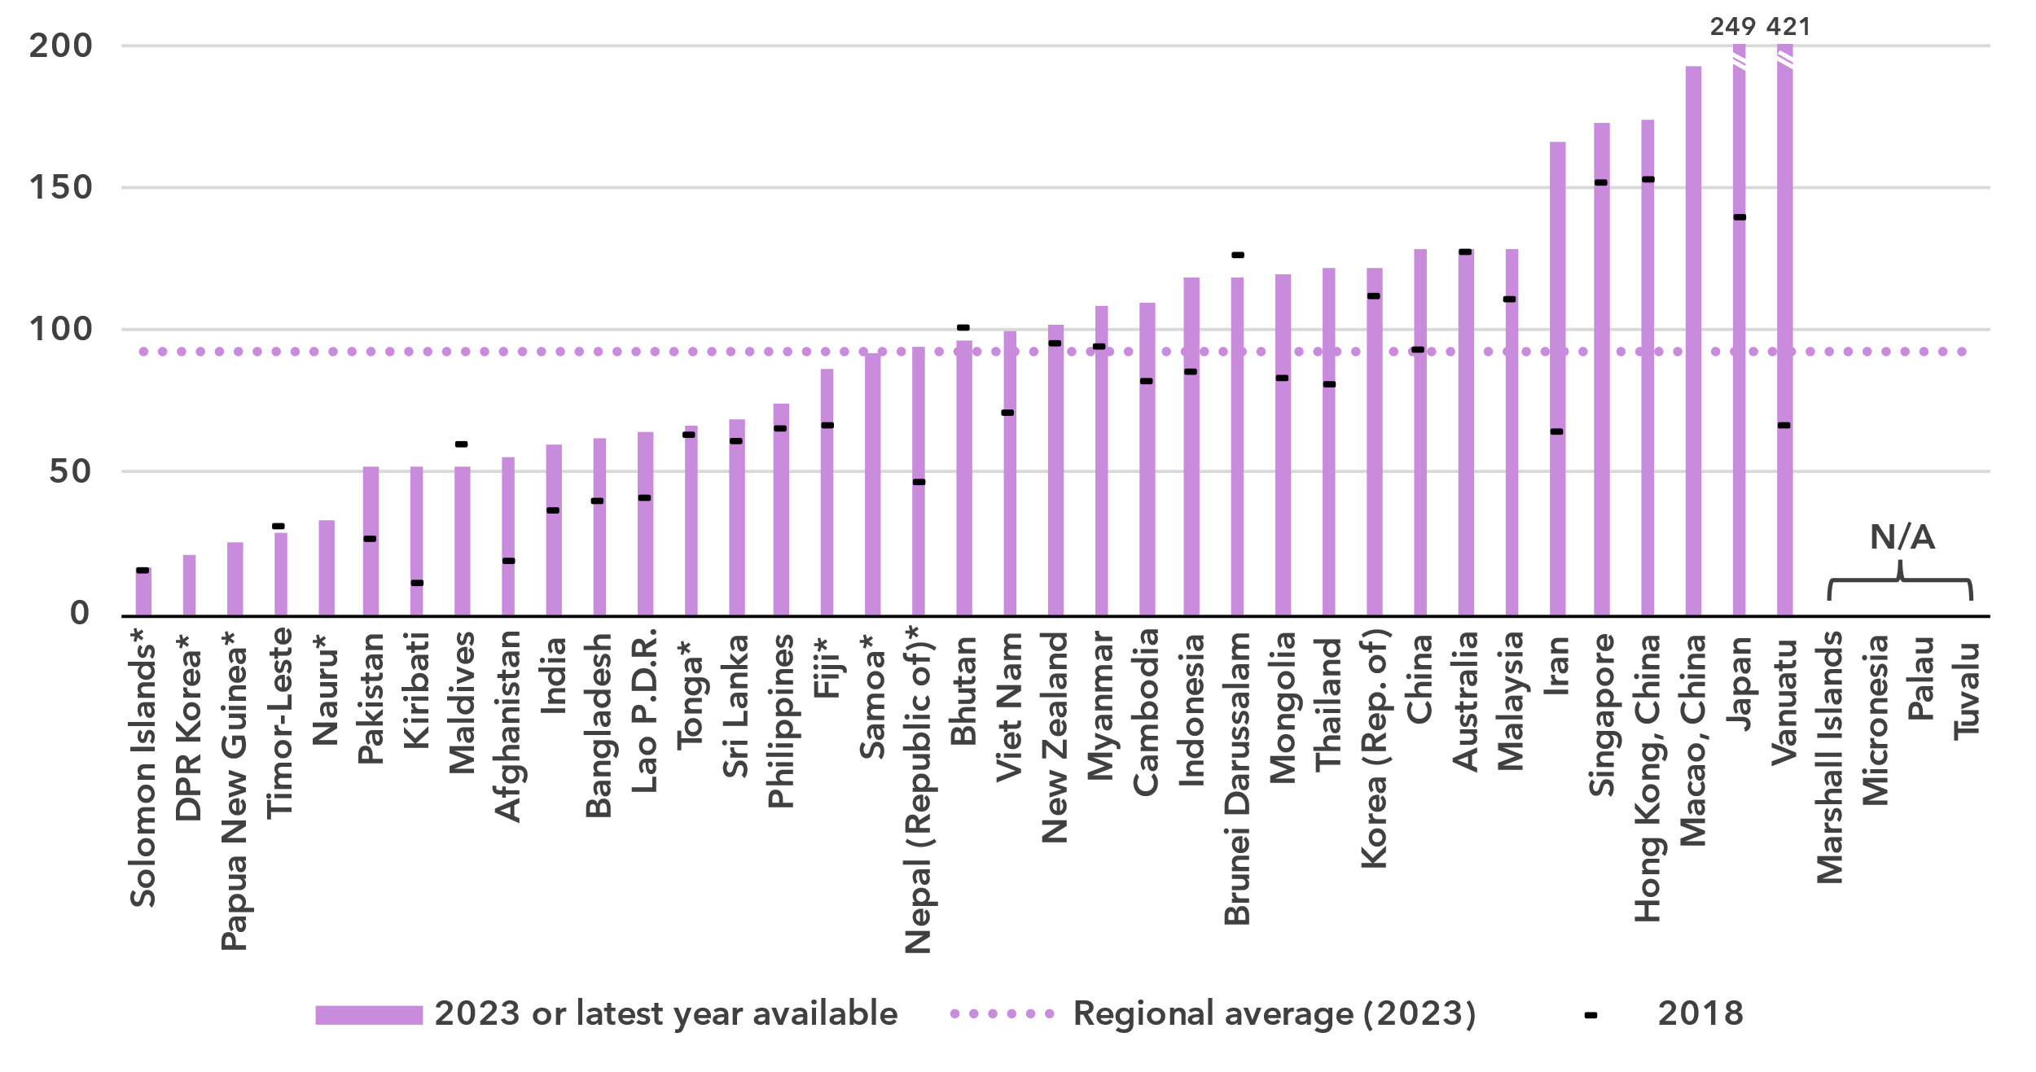* Data are ITU estimates.

Source: ITU

In most economies of the region, there is a substantial and growing level of mobile broadband subscriptions, underscoring the importance of mobile broadband as a gateway to the Internet. However, there is a significant disparity between the lowest (11 subscriptions per 100 inhabitants) and the highest (421 subscriptions per 100 inhabitants).

The heterogeneity of the region is expressed well in the country-level numbers of fixed broadband subscriptions. High income economies have high levels of fixed broadband subscriptions per 100 inhabitants, while in the lower income economies these are often very low. Furthermore, in the economies with high levels of fixed broadband subscriptions, almost all of these are with speeds of more than 10 Mbit per second, while this is not true for the economies with low subscription levels.

Fixed-broadband subscriptions per 100 inhabitants, 2023 or latest year available

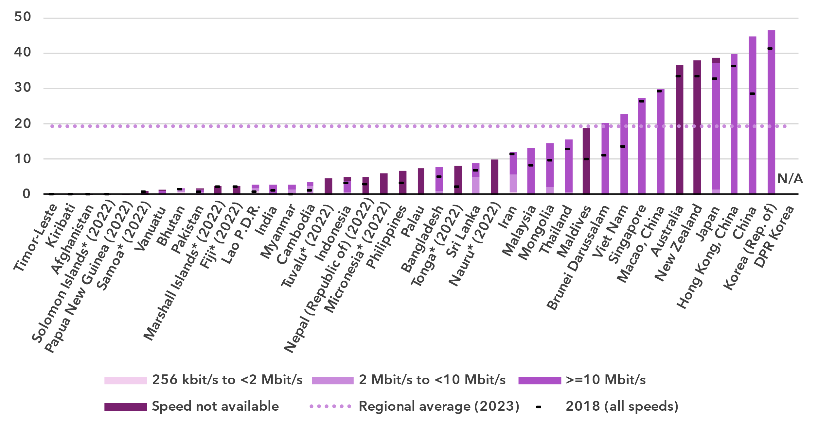* Data are ITU estimates.

Source: ITU

Mobile network coverage

***5G network roll-out is progressing well***

Percentage of population covered by type of mobile network

|  |  |
| --- | --- |
| **Asia and the Pacific** | **World** |

Note: The values for 2G, 3G and 4G networks show the incremental percentage of the population that is not covered by a more advanced technology network (e.g. in 2024, 96 per cent of the world population is covered by at least a 3G or above network, that is 4 per cent + 41 per cent + 51 per cent). There are insufficient data to produce estimates for 5G coverage prior to 2020.

Source: ITU

Between 2020 and 2024, 5G mobile network coverage in the region increased from 3 to 62 per cent of the population. This was much faster growth than the global coverage, which increased from 9 to 51 per cent over the same period. In the region, 4G mobile networks covered 96 per cent of the population in 2024, also above the global average of 92 per cent. Furthermore, 98 per cent of the population in Asia and the Pacific had access to at least a 3G mobile broadband network, leaving only 2 per cent without access to a mobile broadband network and therefore without any possibility of accessing the Internet. This coverage gap was two percentage points smaller than the global average.

Percentage of population covered by type of mobile network, 2023 or latest year available

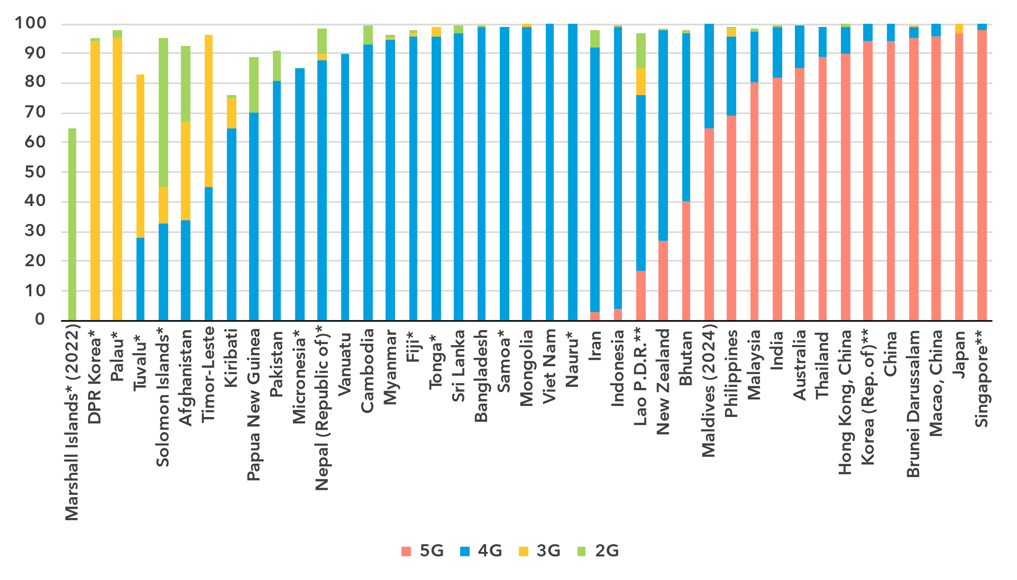* Data are ITU estimates.

** Data for 5G coverage are ITU estimates.

Note: The values for 2G, 3G and 4G networks show the incremental percentage of the population that is not covered by a more advanced technology network (e.g. in 2023, 99 per cent of the population in Thailand is covered by at least a 4G or above network, that is 89 per cent + 10 per cent).

Source: ITU

The region’s diversity is evident again in the roll-out of mobile networks. In thirteen countries, more than half the population had access to a 5G network. In stark contrast 5G was not available at all in 23 out of 41 economies, where 4G remained the most advanced technology as of 2024.

Population coverage by type of mobile network and location, 2024

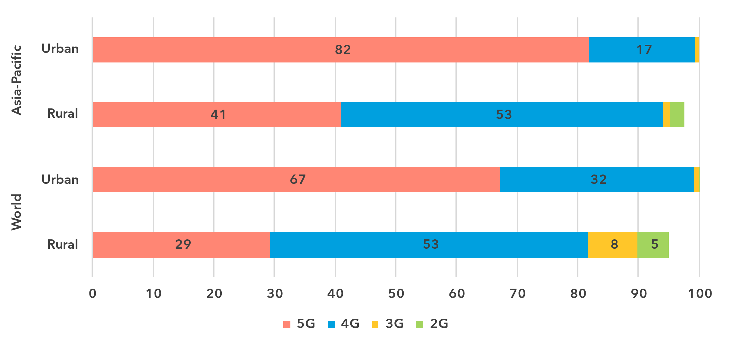

Note: The values for 2G, 3G and 4G networks show the incremental percentage of the population that is not covered by a more advanced technology network (e.g. 90 per cent of the world's rural population is covered by at least a 3G or above network, that is 29 per cent + 53 per cent + 8 per cent).

Source: ITU

As with Internet use, there is a significant gap in network availability between rural and urban areas. In 2024, 5G covered 82 per cent of the urban population in Asia and the Pacific, but only 41 per cent in rural areas. The disparity also existed for 4G networks, but to a much smaller extent, with 99 per cent of the urban population covered compared with 94 per cent in rural areas. When including 3G networks, coverage reached 100 per cent in urban areas but only 95 per cent in rural regions. This means that while every urban resident had access to a mobile broadband network, 5 per cent of the rural population in Asia and the Pacific remained off the grid, less than the global average (10 per cent).

Availability of fixed-broadband infrastructure

***Only one quarter of the population lives within 10 km of a fibre node***

Fixed-broadband infrastructure forms the backbone of the Internet and is a cornerstone of digital transformation efforts. As part of ongoing research at ITU, the broadband map initiative provides an overview of fixed-broadband infrastructure placement. Overlaying this data with demographic data makes it possible to infer the availability and proximity of fixed broadband to populations. This is essential for planning – costly – infrastructure projects and helps to ensure that networks have the necessary capacity and reach.

Map of transmission networks and submarine cables for the Asia and the Pacific region

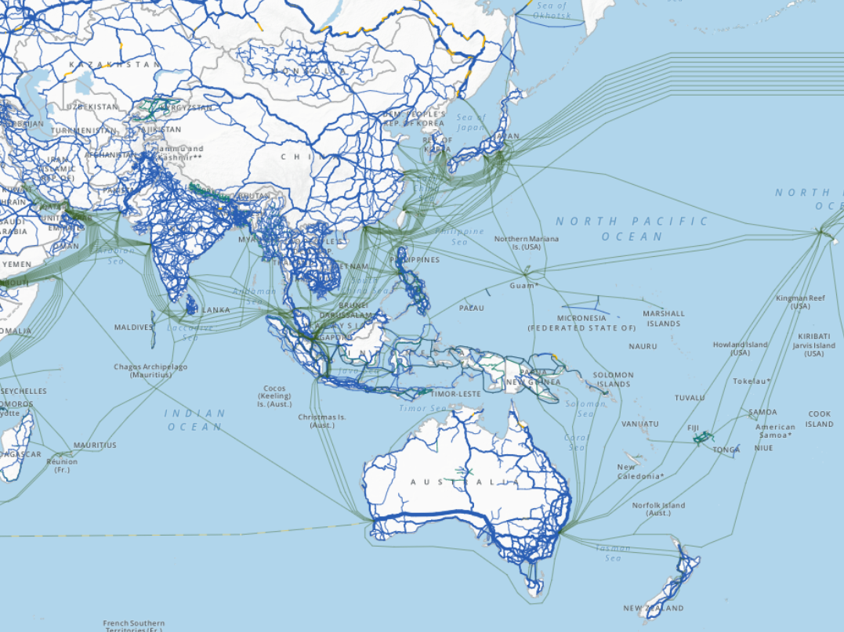

Note: The image reports active and planned submarine cables, and operational, planned and under-construction transmission networks (fibre-optic cable and microwave).

The designations employed and the presentation of material on the map do not imply the expression of any opinion whatsoever on the part of ITU or its secretariat concerning the legal status of the country, territory, city or area or its authorities, or concerning the delimitation of its frontiers or boundaries.

Source: ITU, <https://bbmaps.itu.int/app>

Proximity to an optical fibre node is a crucial metric for transformative connectivity as it directly impacts network performance, reliability and scalability. It reduces latency, improves connection stability and lowers deployment costs, making broadband access more affordable and efficient. Additionally, it enables easier upgrades to support growing bandwidth demands, ensuring networks remain future-ready.

As of 2023, 25 per cent of the population of the Asia and the Pacific region lived within 10 km of an optical fibre node. More than half of the population (56 per cent) lived within 25 km, 74 per cent within 50 km and 88 per cent within 100 km of a node.

Percentage of population within reach of a fibre node, 2023

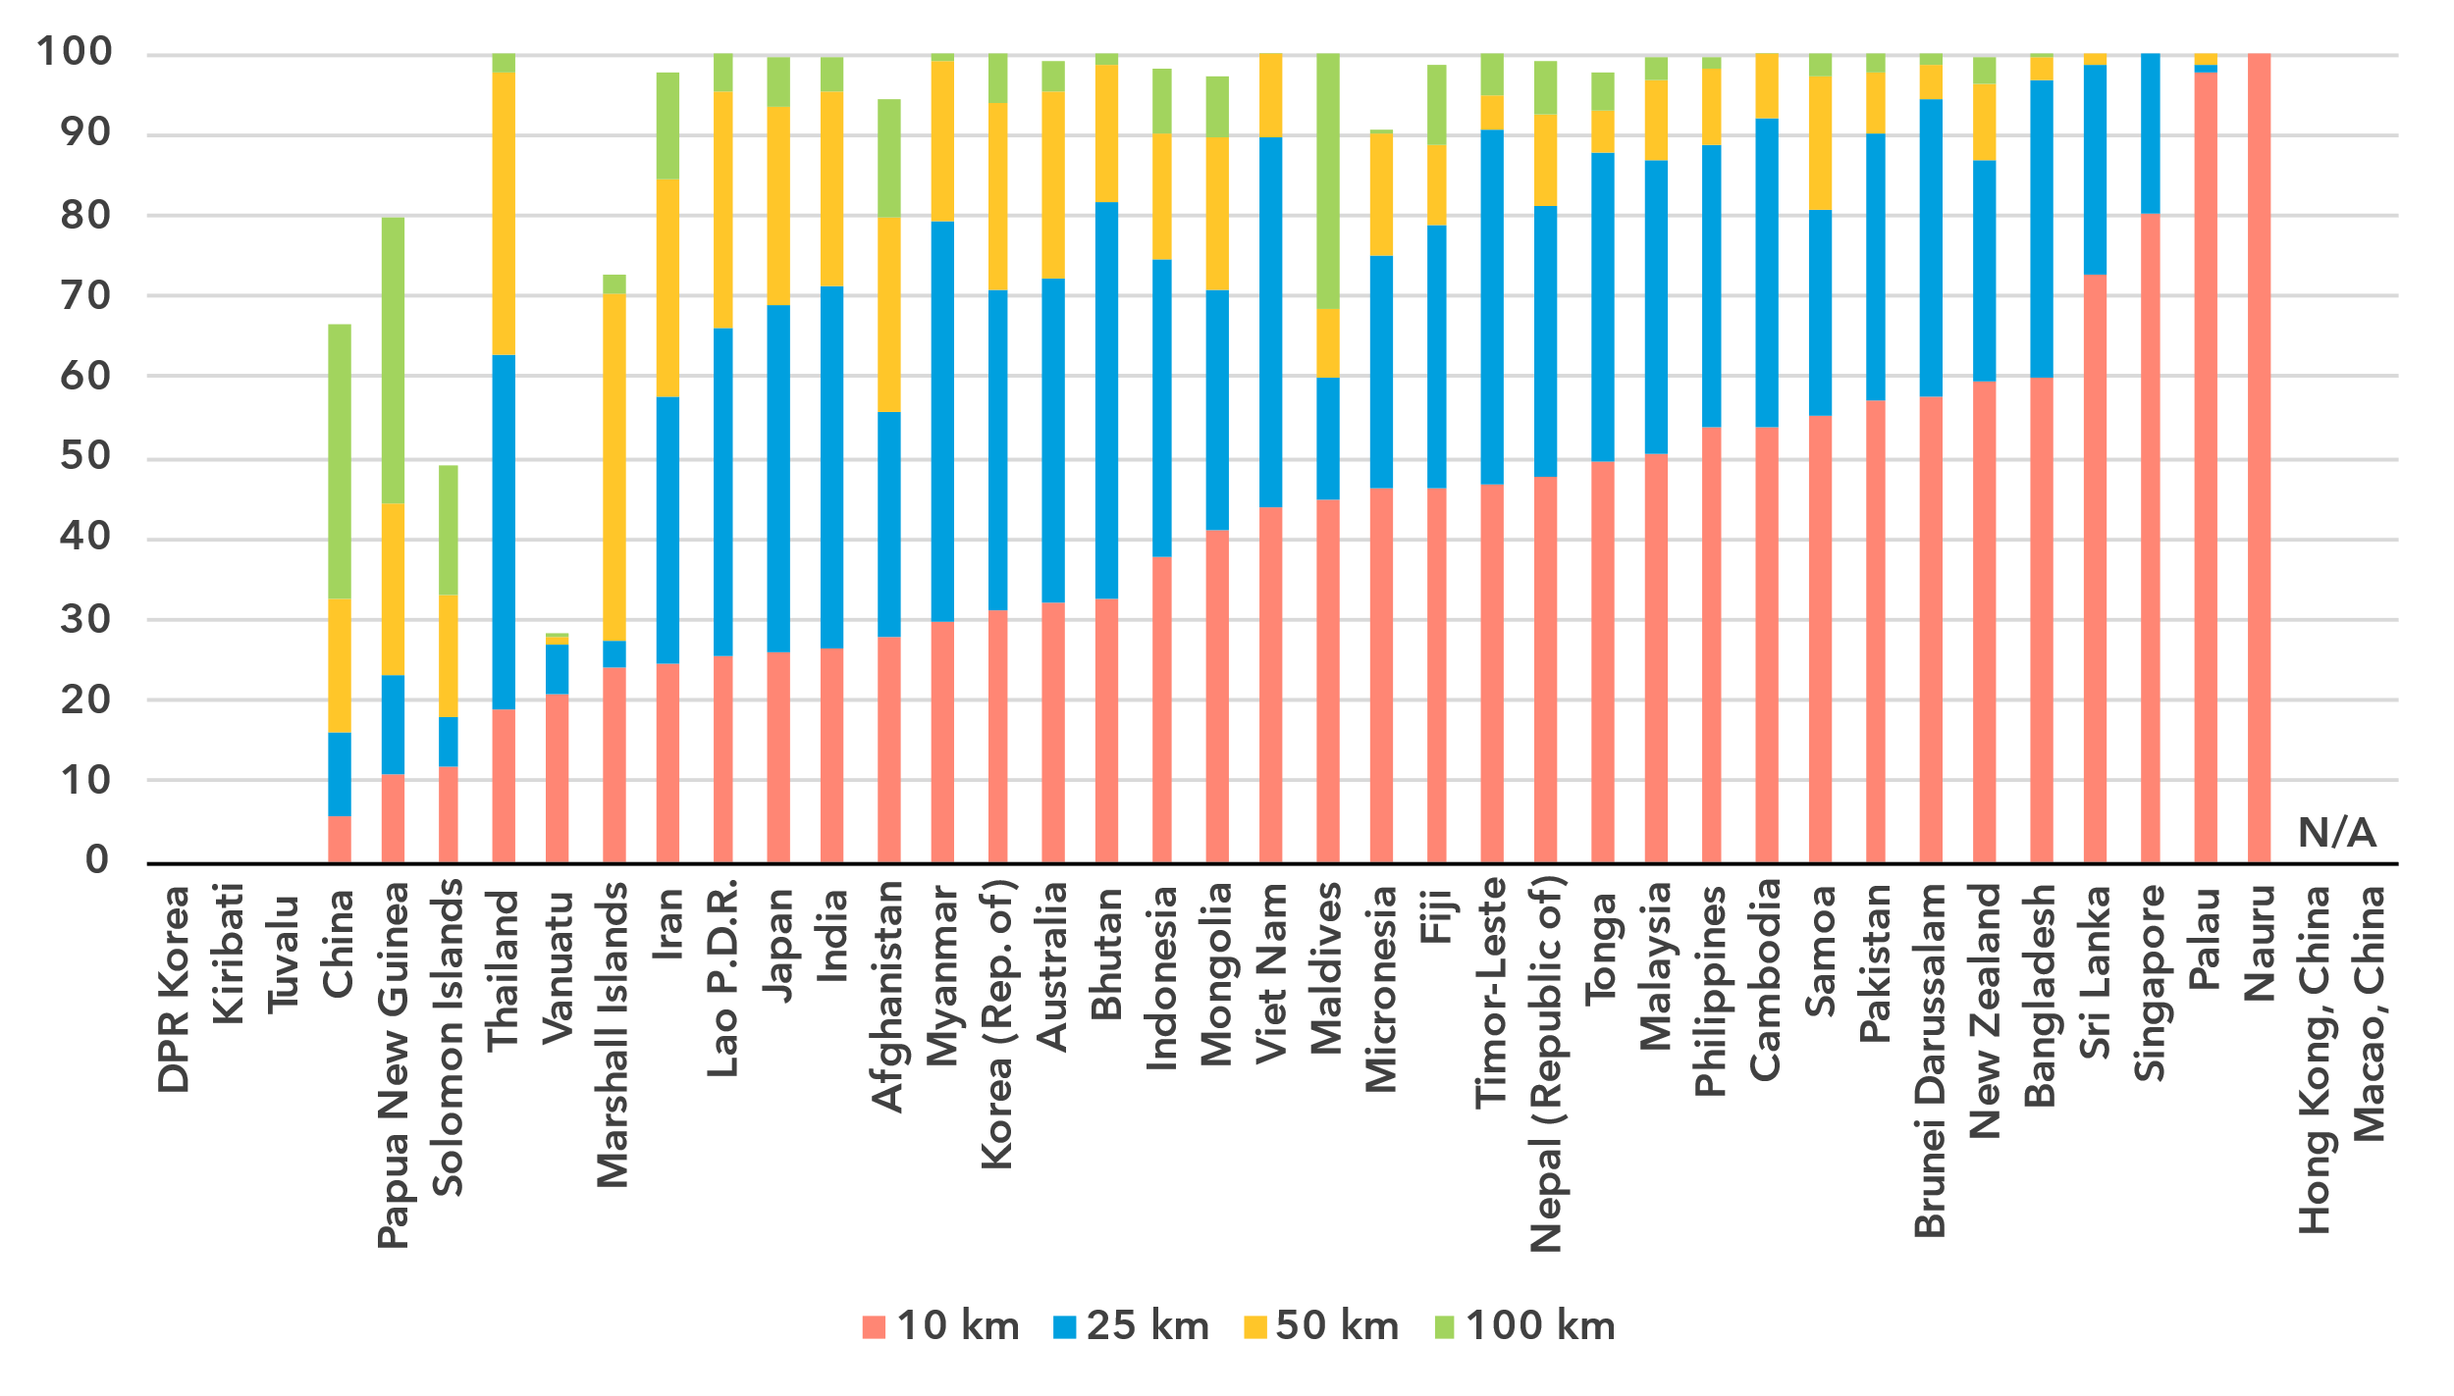Note: The percentage of population within reach of transmission networks refers to the percentage of people that are within physical reach of nodes on core terrestrial transmission networks for a given distance (see <https://bbmaps.itu.int/indicators-bbmaps>).

Source: ITU

Internet traffic and international bandwidth

***Mobile Internet traffic in Asia and the Pacific above the global average, fixed traffic below***

Broadband Internet traffic per subscription per month (GB)

|  |  |
| --- | --- |
| **Mobile** | **Fixed** |

Source: ITU

Internet traffic measures the total volume of data downloaded or uploaded by end users over a given period. For ease of interpretation, figures presented refer to the average monthly traffic per fixed as well as mobile broadband subscription. Traffic levels are typically higher for fixed than mobile broadband, not only because subscriptions are shared by multiple users (e.g. in households), but also because it also includes mobile device traffic routed over Wi-Fi when available.

Between 2019 and 2024 monthly mobile broadband traffic in the region increased from 7 to 15 gigabytes (GB) per mobile broadband subscription, during which time global traffic increased from 6 to 14 GB per mobile broadband subscription. The situation was reversed for fixed broadband traffic, which in Asia and the Pacific increased from a monthly 117 GB to 271 GB per subscription, while globally it increased from 141 to 311 GB.

Mobile-broadband Internet traffic (GB) per subscription per month, 2023 or latest year available

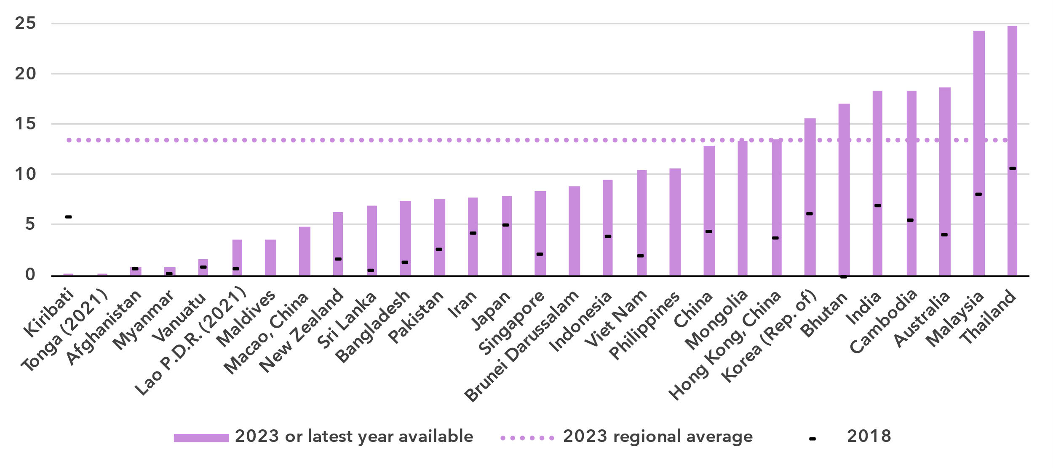Note: Internet traffic originating within country.

Source: ITU

The region also exhibits a large variety when it comes to traffic indicators. Mobile broadband traffic ranged from less than 1 GB per subscription per month to 25. For fixed broadband traffic, the spread was from only 3 to 482 GB per subscription per month. Of note is that some countries with high mobile broadband traffic have only average fixed broadband traffic and vice-versa.

Fixed-broadband Internet traffic per subscription per month (GB), 2023 or latest year available

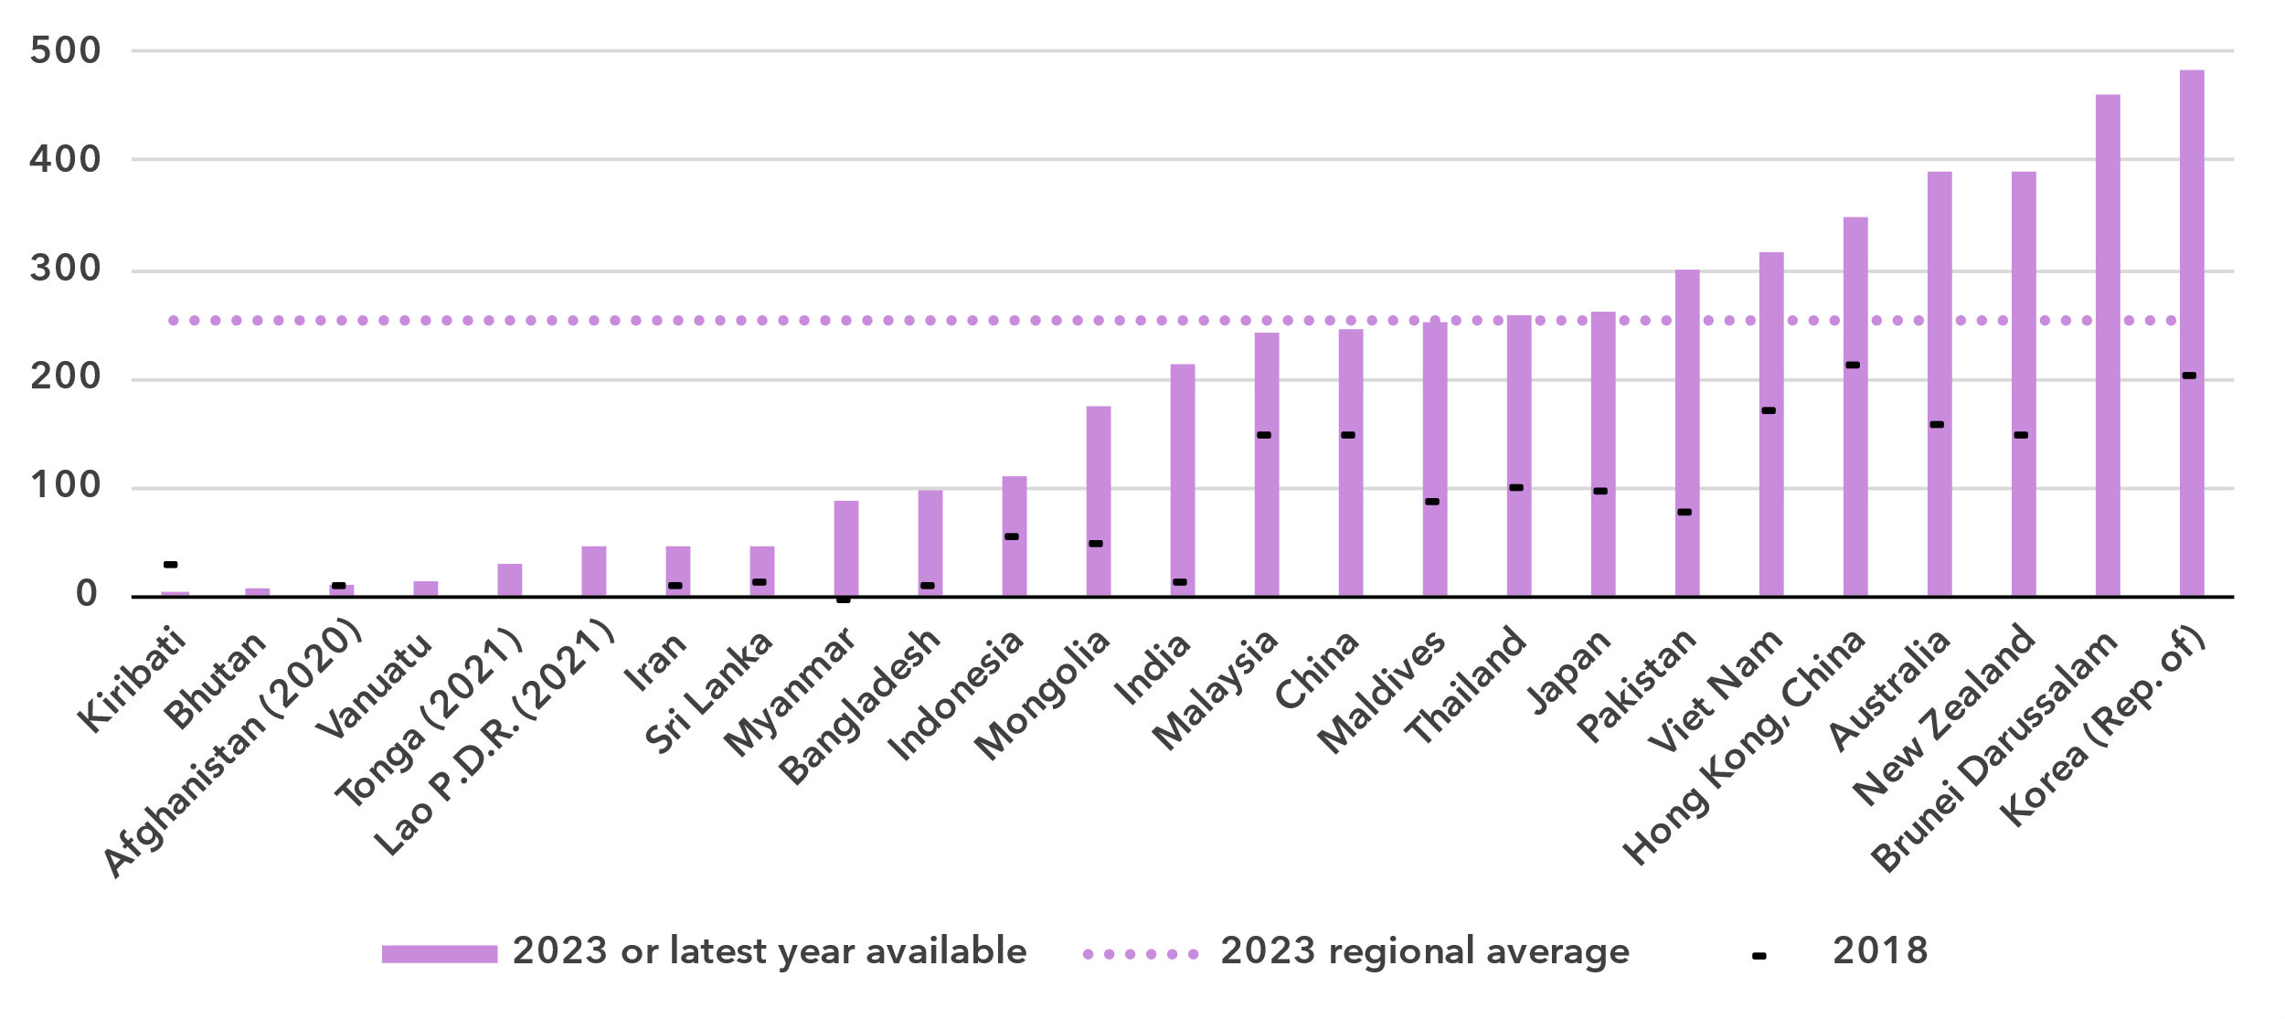Source: ITU

Unlike the end-user Internet traffic measured above, international bandwidth usage is a throughput measure that refers to the annual average used capacity of international connections, typically carried over submarine or terrestrial fibre-optic cables or microwave links. It does not sum up all traffic, incoming and outgoing, but captures the larger of the two. For comparability, the figure for bandwidth is divided by the number of Internet users in the country.

International bandwidth per Internet user (kbit/s)

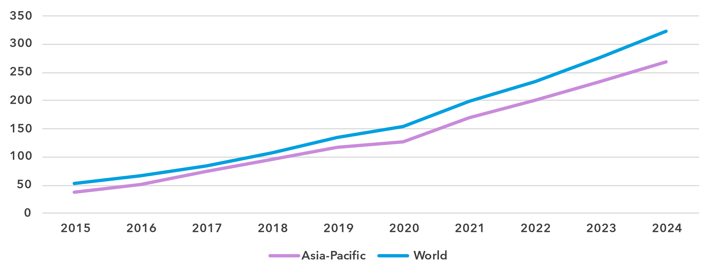

Source: ITU

International bandwidth usage in Asia and the Pacific stood at 265 kbit/s in 2024, 17 per cent below the global average of 323 kbit/s. However, this regional average includes data for Hong Kong, China and Singapore, which are both transit hubs. Taking the median instead, which dampens the impact of outliers, the typical bandwidth in the region is only 99 kbit/s in 2023.

International bandwidth per Internet user (kbit/s), 2023 or latest year available

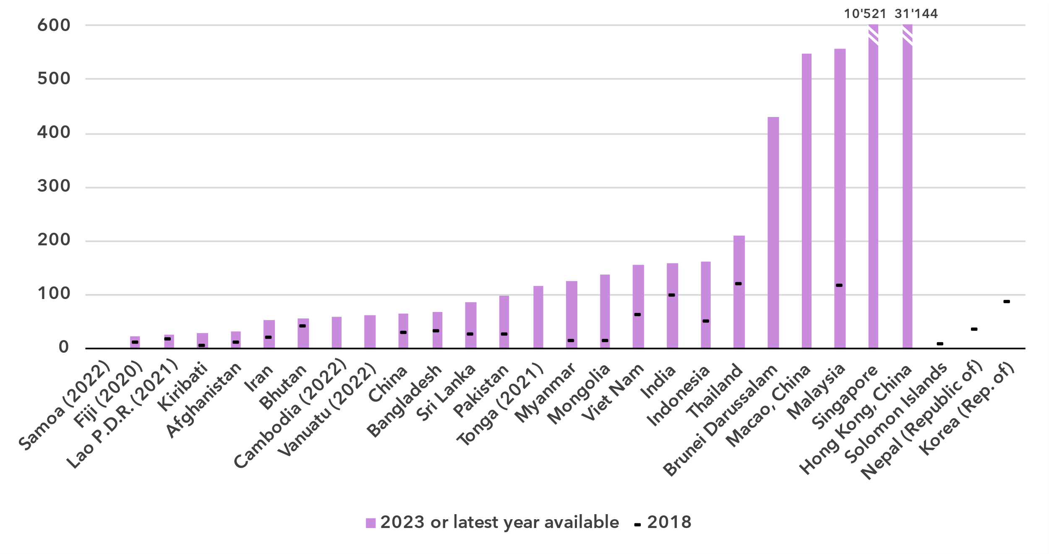 Source: ITU

International bandwidth usage reflects the state of international connectivity infrastructure (presence of submarine and overland cables, including redundancies) and the degree to which a country is connected to international data flows. Demand for international bandwidth depends on many country-specific factors, such as geographical location or the size and development of domestic middle-mile connectivity infrastructure (e.g., small islands are dependent on international linkages, while a high density of data centres and Internet exchange points can somewhat reduce the demand for international data exchange for larger countries). While data are only available for around half of the countries in the region, there are large variations. Five economies reported bandwidth usage exceeding 400 kbit/s, which is already above the world average, while 13 countries reported bandwidth usage levels below 100 kbit/s, suggesting that international linkages may hamper universal and meaningful connectivity.

Affordability of ICT services

***Mobile and fixed broadband generally affordable in Asia, but expensive in many parts of the Pacific***

Broadband basket prices as % of gross national income per capita, 2018-2024

|  |  |
| --- | --- |
| **Mobile (2GB)** | **Fixed (5GB)** |

Note: Median values shown in the chart are calculated as a percentage of GNI per capita for the set of economies for which data was available for all years from 2018 to 2024 for a given basket to adjust the effect of changing data availability.

Source: ITU

Internet cost is a barrier to Internet use and to meaningful connectivity. The United Nations [Broadband Commission for Sustainable Development](https://www.broadbandcommission.org/) set itself the goal of making broadband in developing countries affordable by 2025, affordability being defined as the availability of broadband access at a price that is less than 2 per cent of monthly GNI per capita.

Entry-level data-only mobile broadband prices have gone done significantly in the region, from 1.7 per cent of GNI per capita in 2018 to 0.9 in 2024, well below the 2 per cent target of the Broadband Commission.[5] For an entry-level fixed broadband service, the median price in 2024 was 2.2 per cent of GNI per capita. This was still above the Broadband Commission target, but if the current trend continues, the region will drop below the target in the next years.

Mobile broadband basket prices as % of gross national income per capita, 2024

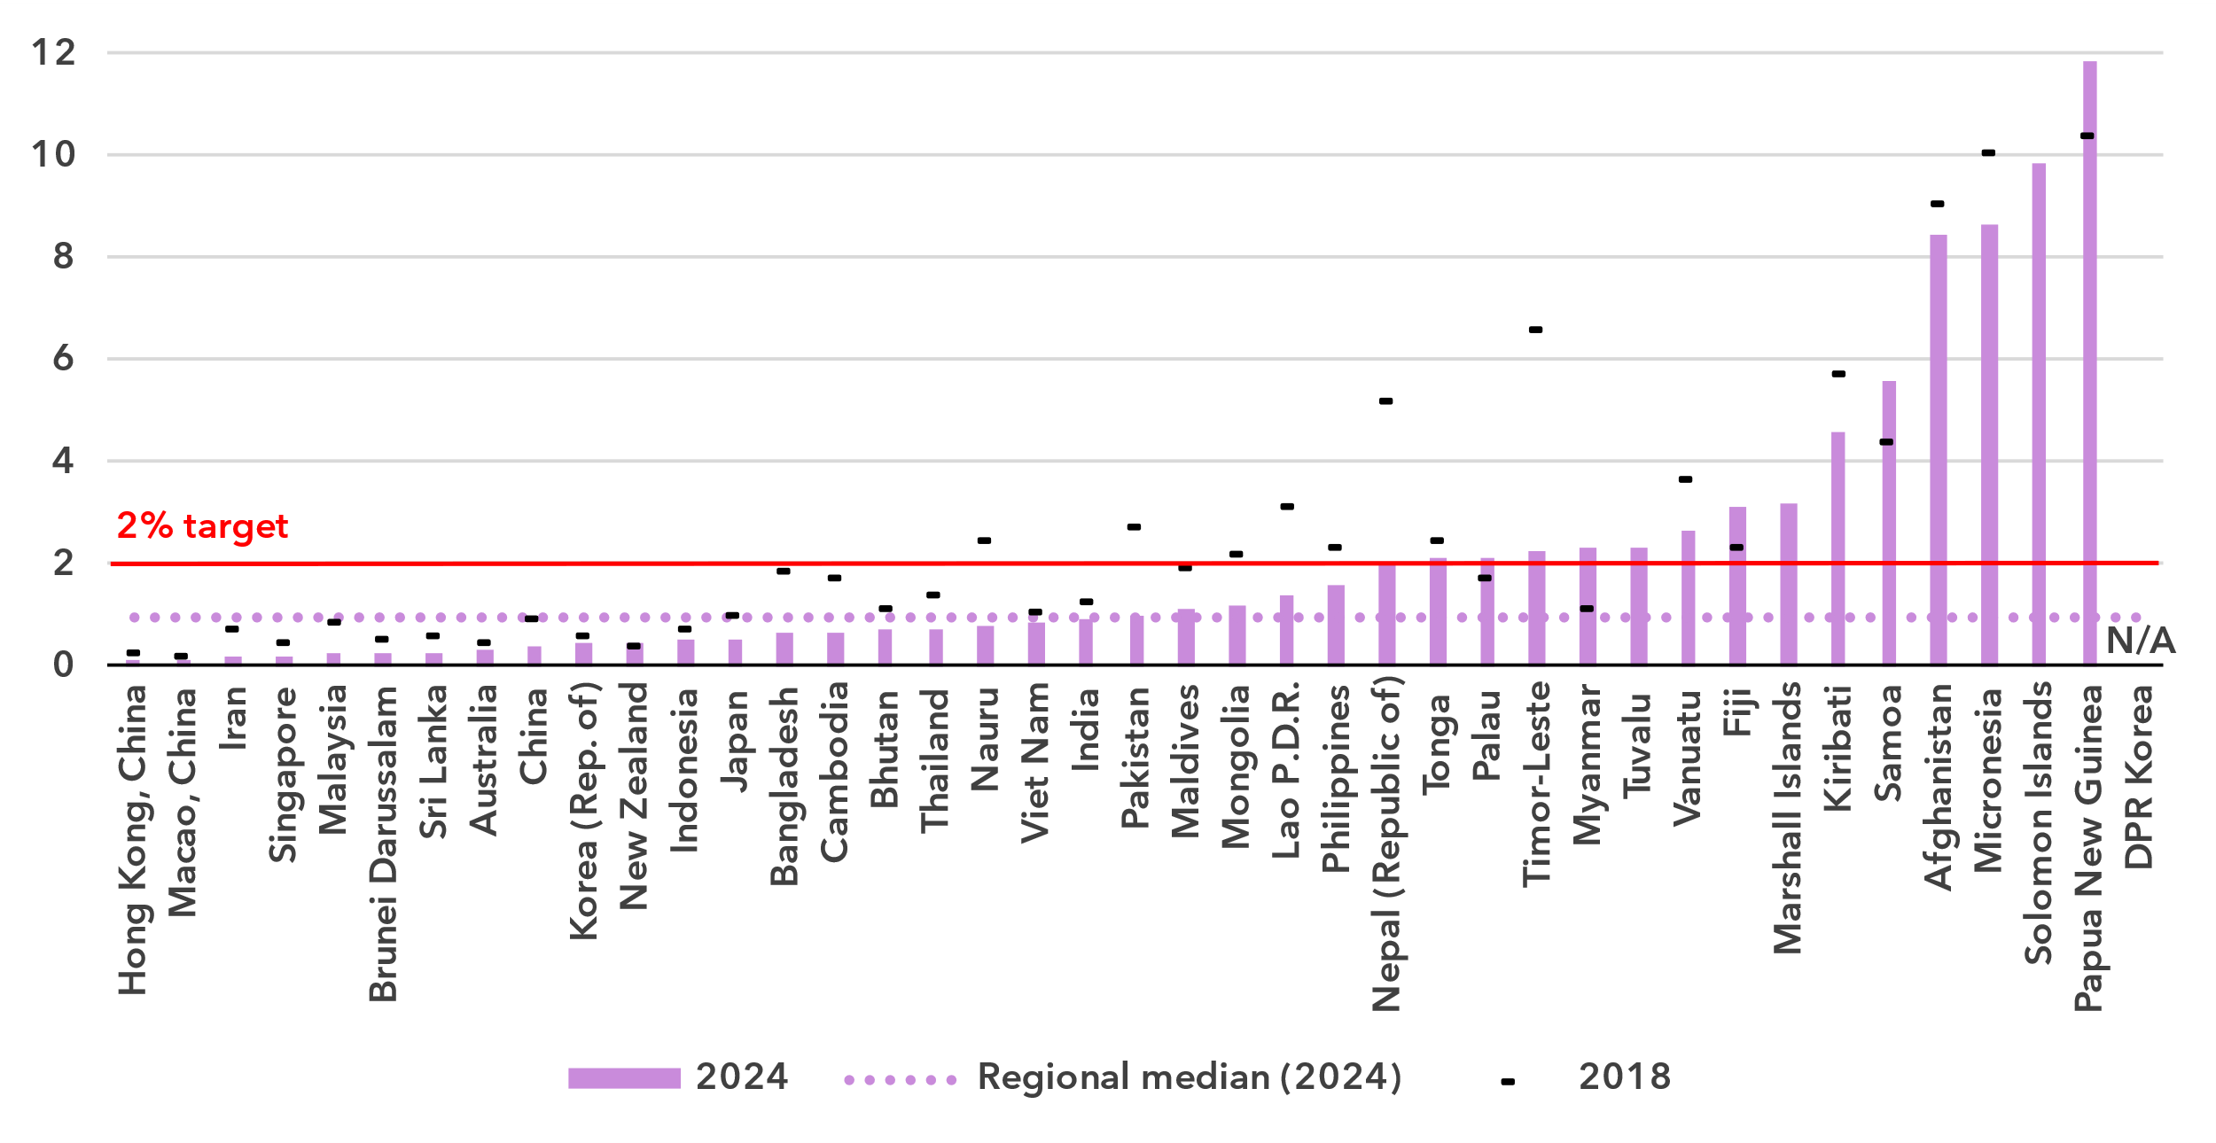Source: ITU

In 14 of 40 countries, the mobile broadband price was above the 2 per cent Broadband Commission target. Ten of these countries are small Pacific islands. For fixed broadband, prices in 23 out 38 countries were above the 2 per cent target. This included seven Pacific islands, which all had prices above 5 per cent of GNI per capita.

Fixed broadband basket prices as % of gross national income per capita, 2024 or latest year available

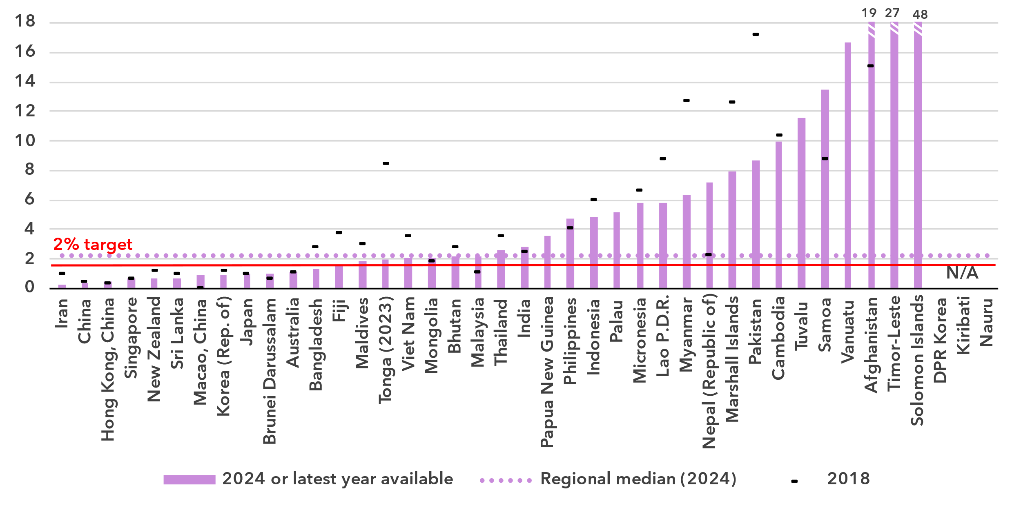Source: ITU

Mobile phone ownership and subscriptions

***Mobile phone ownership is very high in the region***

|  |  |
| --- | --- |
| Percentage of individuals owning a mobile phone | Percentage of individuals owning a mobile phone by gender, 2024 |

Note: Individuals aged 10 and older.

Source: ITU

In 2024, 77 per cent of individuals in Asia and the Pacific aged 10 and older owned a mobile phone, three percentage points less than the global average. Growth over the last five years has been modest, which is not surprising considering the level is already high. The gender parity score for ownership stood at 0.92, improving from 0.89 in 2021. During the same period, the global GPS also improved slightly, from 0.91 to 0.93.

Percentage of individuals owning a mobile phone, 2023

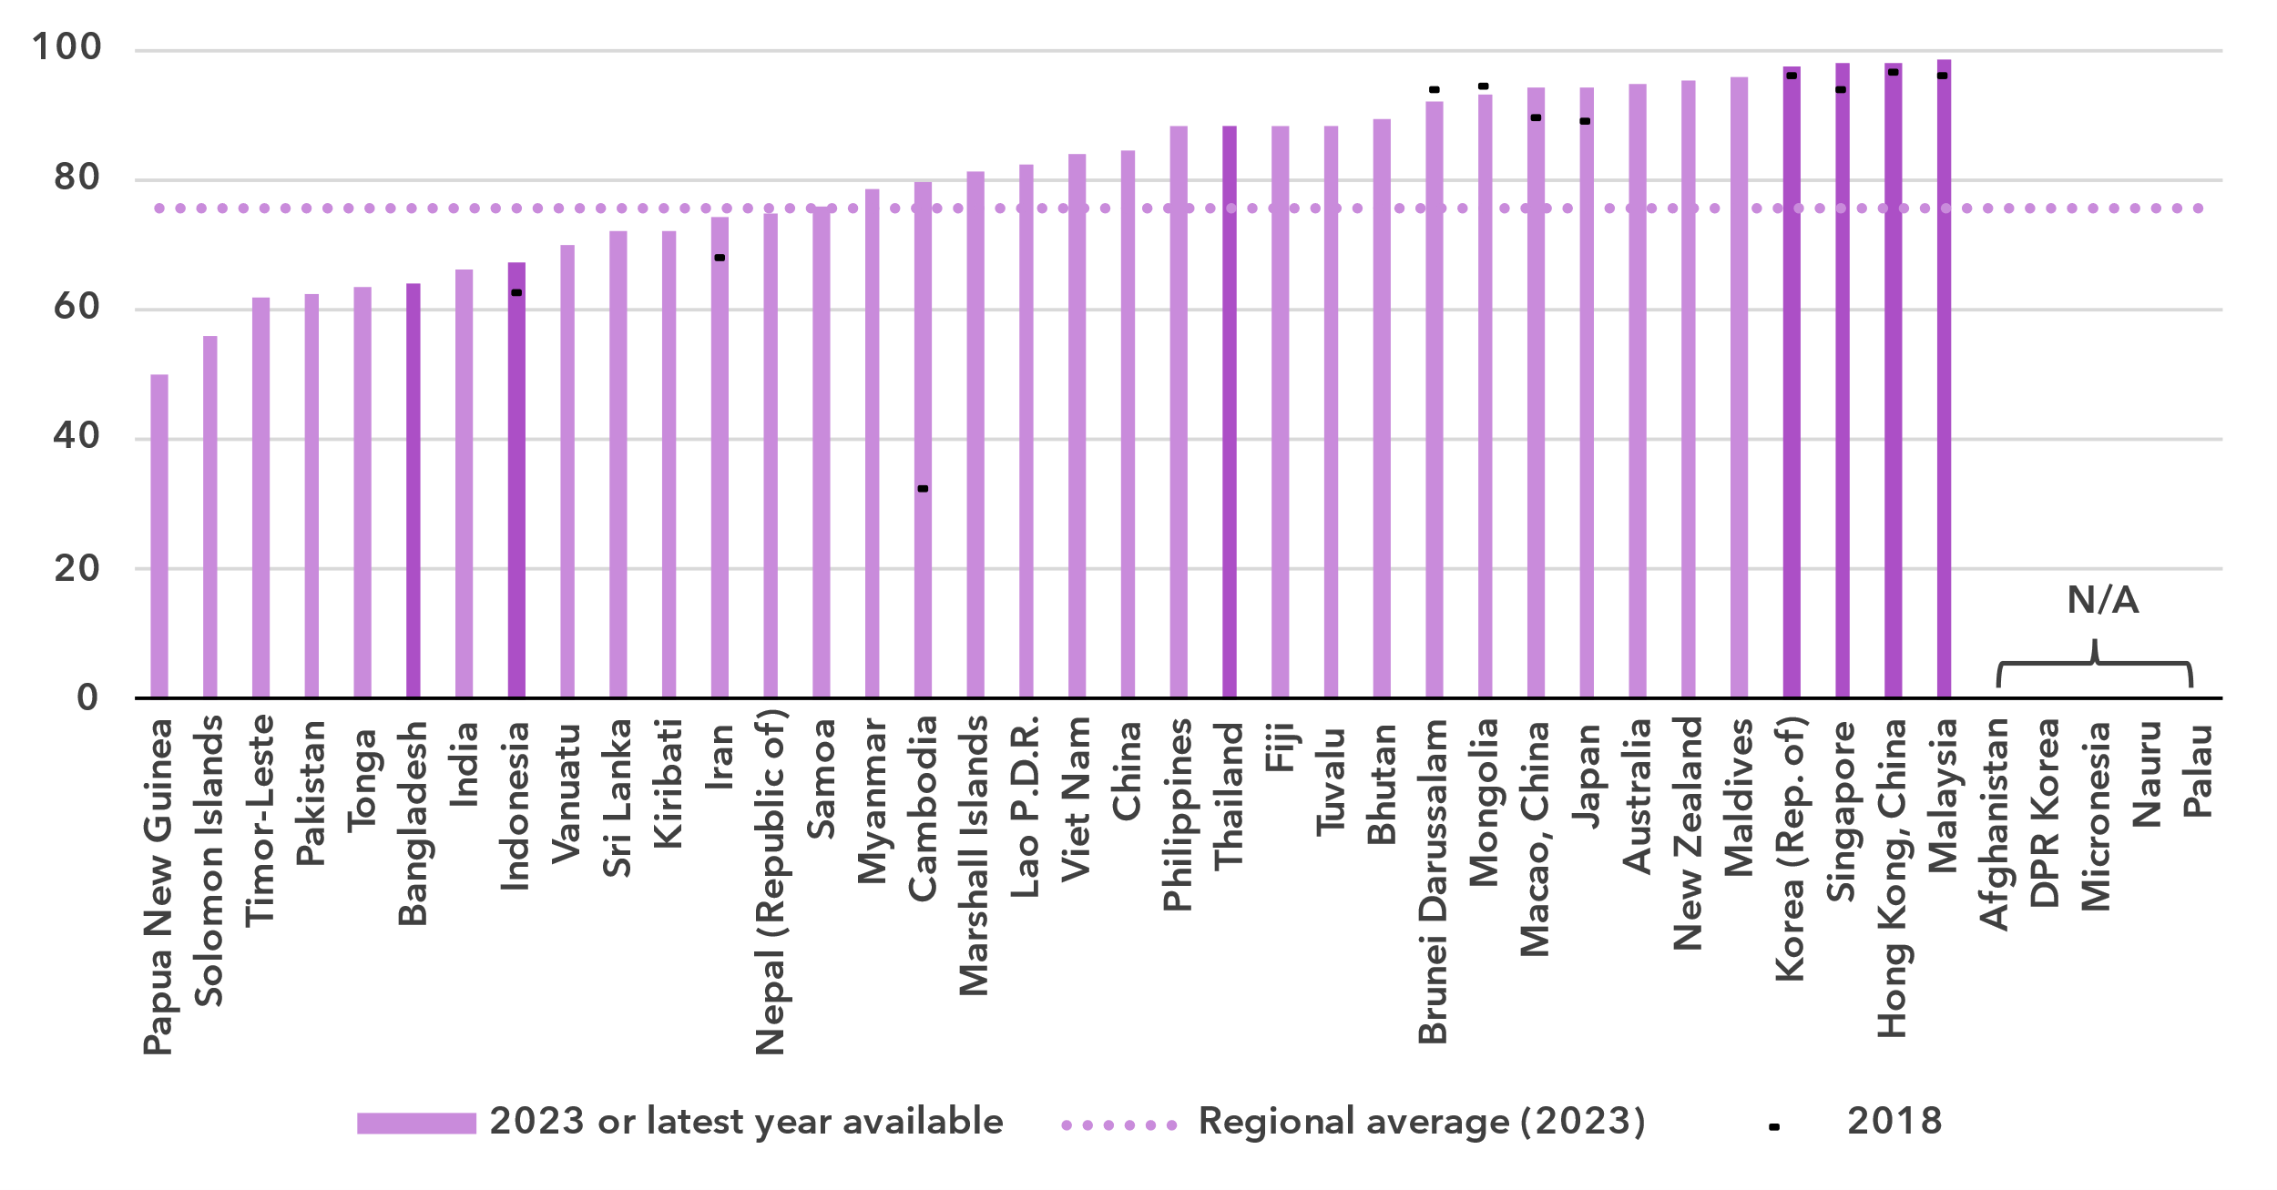Notes: Individuals aged 10 and older. Country submitted are in a darker shade, non-official data in a lighter shade.

Source: ITU

In sixteen (out of 36) countries, mobile phone ownership was below 80 per cent of the population, including five Pacific islands. In the 12 countries for which data are available for a recent year, gender parity was reached in seven of them.

Percentage of individuals owning a mobile phone, by gender, 2023 or latest year available

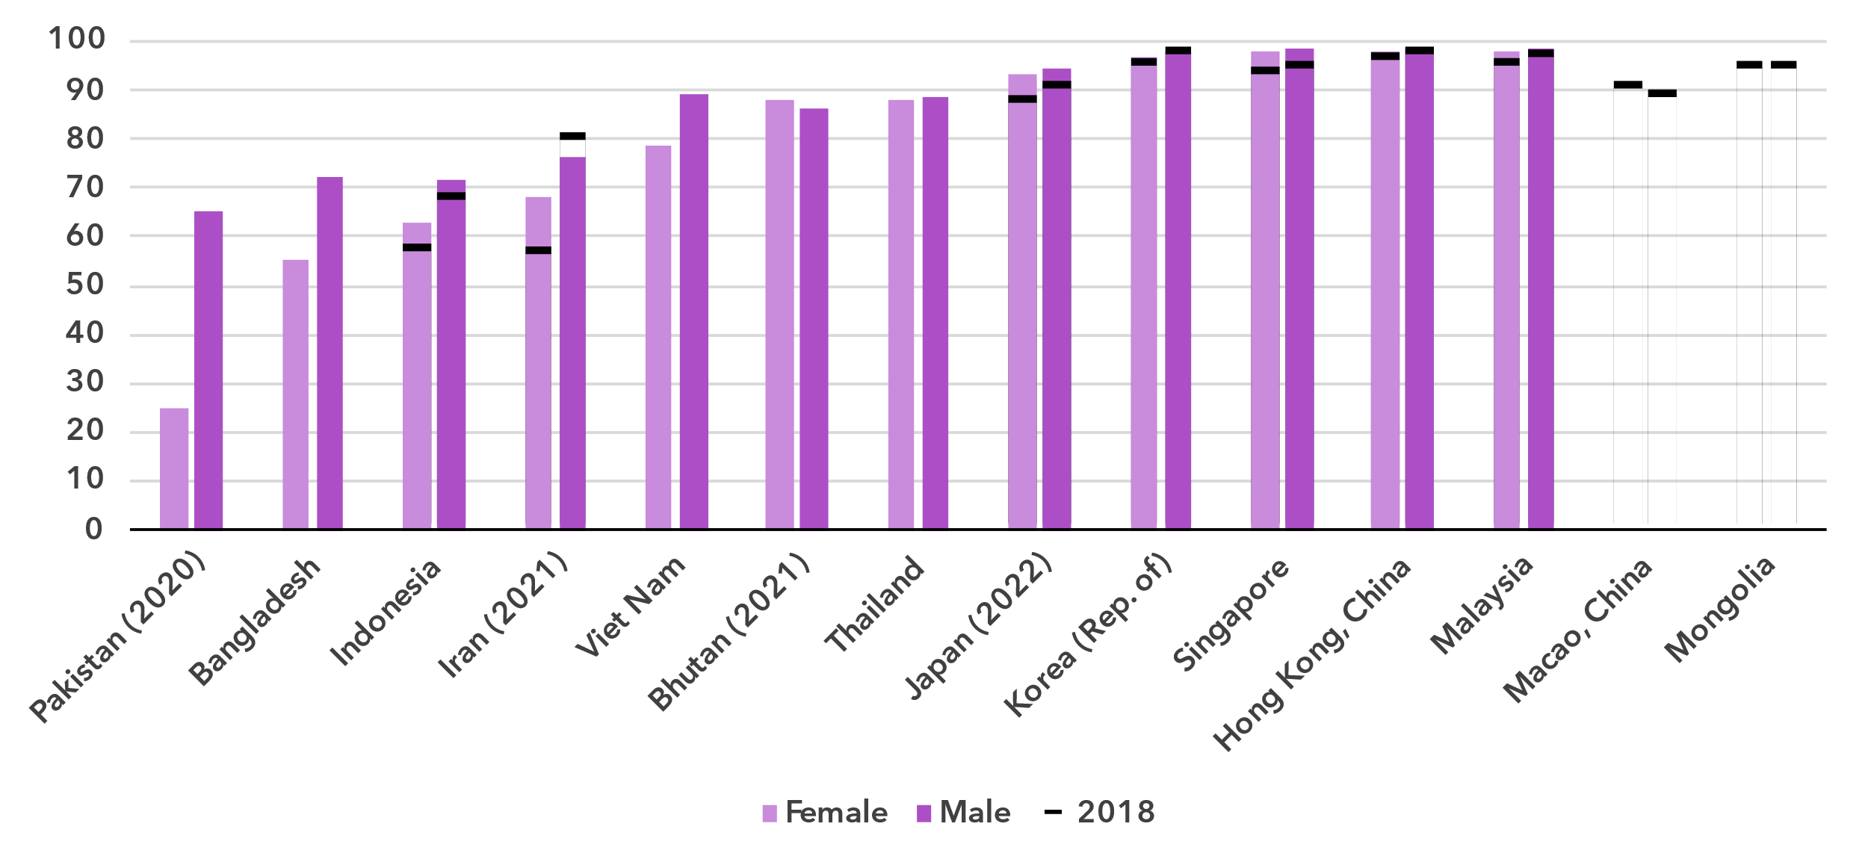Notes: Individuals aged 10 and older.

Source: ITU

Mobile-cellular subscriptions per 100 inhabitants

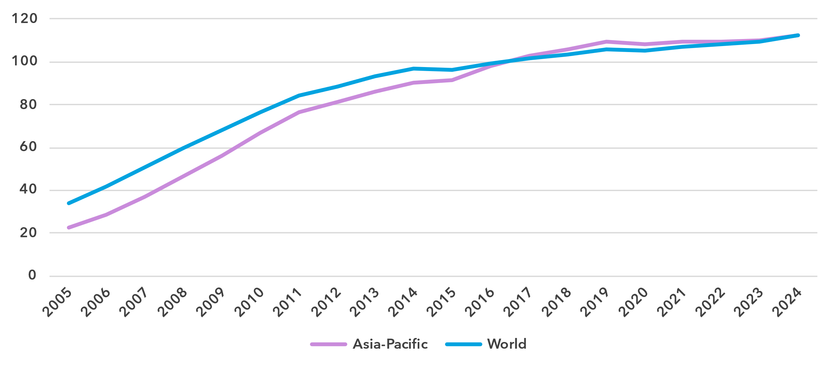

Source: ITU

To use a mobile phone, a mobile-cellular or mobile broadband subscription is needed. In Asia and the Pacific, there were 112 subscriptions per 100 inhabitants in 2024, identical to the global average. This indicator is starting to plateau, as it has increased only very modestly in the last five years.

At the country level though, there was still a significant gap between the economies with least and most subscriptions per 100 inhabitants, at 20 and 319 respectively. Of the 16 countries below the regional average, nine were small Pacific islands.

Mobile-cellular subscriptions per 100 inhabitants, 2023 or latest year available

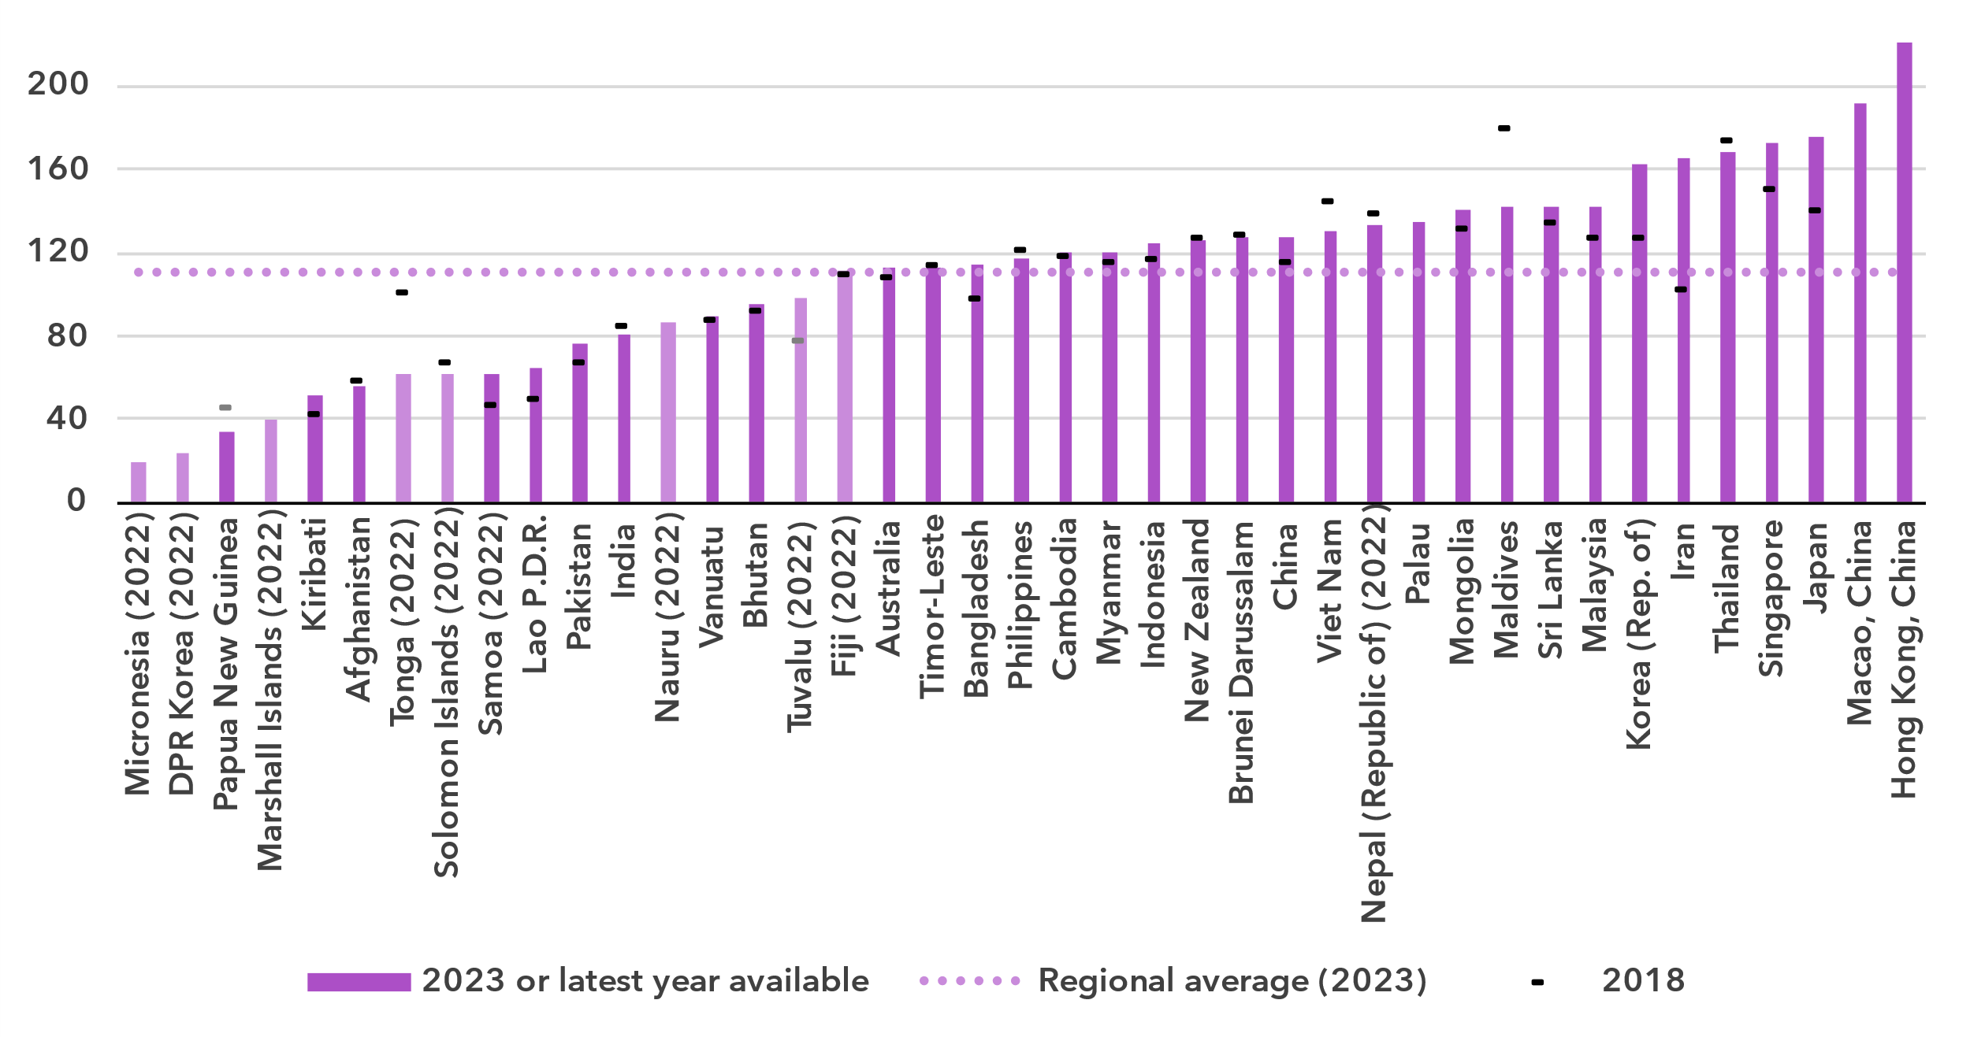Notes: Country submitted are in a darker shade, non-official data in a lighter shade.

Source: ITU

ICT skills

***Large variety in ICT skills among Internet users***

Because self-reporting of individuals’ ICT skills is subjective, ICT skills are measured based on household surveys asking whether an individual has recently performed certain activities. Performing these activities presupposes a degree of proficiency in relevant digital skills. The activities are grouped into five areas: information and data literacy; communication and collaboration; digital content creation; safety; and problem solving.

While the importance of digital skills in leveraging ICTs for economic prosperity and social well-being is well-documented, data remain very scant, with only 13 countries in Asia and the Pacific having submitted data since 2020. Even fewer – just 6 countries – provided (at least some) comparable data on ICT skill levels (see box for details on the methodology for calculating ICT skill levels).

|  |  |  |  |  |  |  |
| --- | --- | --- | --- | --- | --- | --- |
| **Methodology for calculating ICT skill levels**  At its 11th meeting in September 2023, ITU’s Expert Group on ICT Household Indicators (EGH) [recommended changes](https://www.itu.int/itu-d/meetings/statistics/wp-content/uploads/sites/8/2023/09/Report-of-the-EGH-subgroup-on-ICT-Skills.pdf) in how data on ICT skill levels are reported – most importantly, that skill levels of individuals should be assessed for different areas.  *Individuals should be assessed on the number of activities within a skill area they report having done in the last three months using the following progression:*   |  |  |  | | --- | --- | --- | | None | Basic | Above basic | | 0 activities | 1 activity | More than 1 activity |  * *Skill levels should not be assessed in skill areas where fewer than two indicators are collected.* * *Indicators should be weighted equally within each skill area.* * *Skill areas with different numbers of components should be treated equally.*   While this recommendation does not require any additional data collection, it does require that countries perform additional analysis on existing survey microdata. ITU requested data on ICT skills for the first time in its April 2024 data collection, and received data from 40 countries, including 6 countries in Asia and the Pacific. However, other countries were unable to provide data, even though in many cases data on the underlying activities had been collected. It is expected that data availability will improve as familiarity with these new recommendations increases. |

ICT skills data goes beyond simple access and use of ICTs to provide a view of the capabilities of ICT users. Data on individuals in Asia and the Pacific with different levels of ICT skills are shown below as a share of Internet users. These data demonstrate the substantial variation between countries in the level of ICT skills of those already using the Internet. They also show the areas where attention is needed to increase ICT skills.

Percentage of Internet users with ICT skills in Asia and the Pacific, by skill level, 2023 or latest year available

|  |  |
| --- | --- |
| **Brunei Darussalam (2022)** | **Hong Kong, China** |
| **Japan (2022)** | **Korea (Rep. of)** |
| **Malaysia** | **Viet Nam** |

Note: Data for Japan and Viet Nam refer to individuals aged 6 and older. Data for the Hong Kong, China refer to individuals aged 10 and older. Data for Brunei Darussalam and Malaysia refer to individuals aged 15 and older. Data for Republic of Korea refer to individuals aged 16-74.

Source: ITU

In general, communication and collaboration skill levels are very high in the four countries with available data. However, in Viet Nam there are relatively fewer individuals with above basic skills in this area.

Digital content creation and problem solving skill levels are also quite high in the countries with available data though not as high as communication and collaboration skill levels – Hong Kong, China reported somewhat lower levels than for the others.

For the three countries with available data (Brunei Darussalam, Hong Kong, and Republic of Korea), safety skill levels are notably lower than skill levels in other areas.

Comparing between countries, Brunei Darussalam, Malaysia and Republic of Korea have similar profiles with high levels of at least basic skills in all skill areas for which data are available – with safety skill levels lagging others. In Hong Kong, China and Japan skill levels are somewhat lower, indicating room for improvement in skill areas such as digital content creation, problem solving, and especially safety in Hong Kong, China.

A different way to analyse these data is by comparing the distribution of country values for the activities that comprise each of the five skill areas. This provides a view of the prevalence of each activity among Internet users relative to others in the same area. It also shows the wide range of variation in ICT skills in countries in the region even when focusing only on those using the Internet.

Percentage of Internet users with information and data literacy skills, latest year available

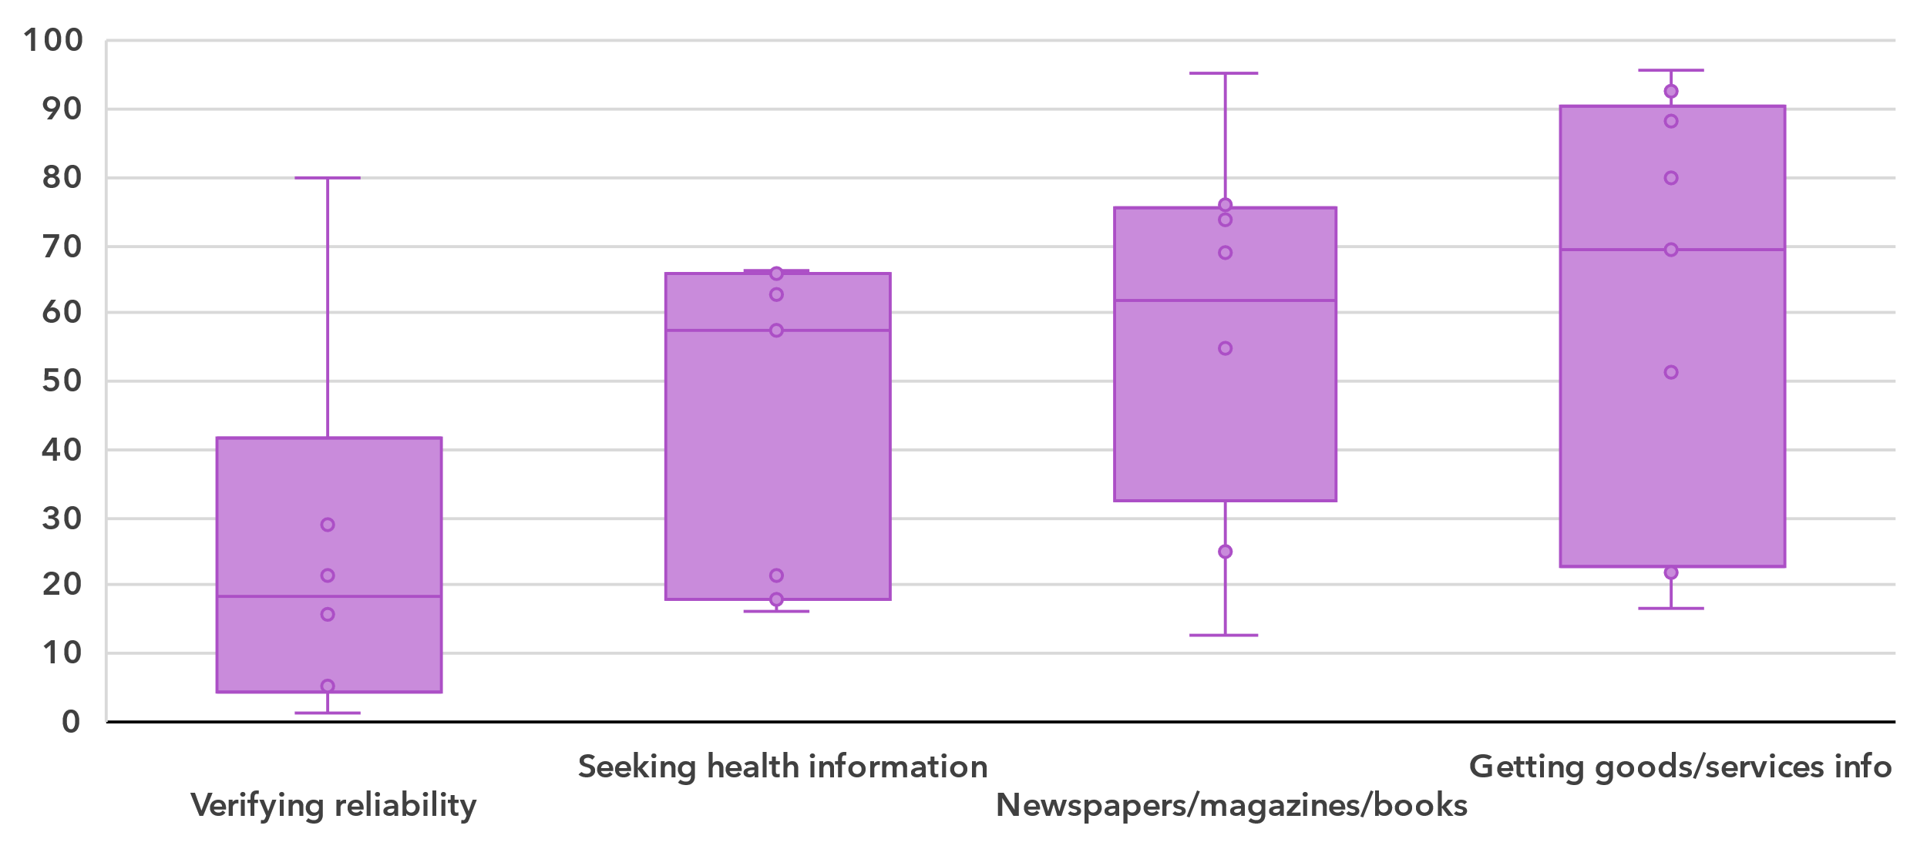Note: Bars indicate the 25th, median and 75th percentile of all country values. The whiskers (bottom and top lines) indicate individual minimum and maximum values. In-scope age varies between countries. Country data are for 2023 where available but no earlier than 2020. Data availability varies between indicators, ranging from six countries for *Verifying the reliability of information found online to* nine countries for *Getting information about goods or services.* Detailed information – including complete indicator names – is available [here](https://www.itu.int/en/ITU-D/Statistics/Documents/facts/rpm_asp_pub_2025_data.xlsx).

Source: ITU

For information and data literacy, getting information about goods or services had the highest median (69 per cent) of the four activities that make up this skill category. Using the Internet to read or download newspapers, magazines or books, and seeking health information had similar distributions of country shares. Conversely, verifying the reliability of information found online was less frequently reported (median of 19 per cent) by individuals across the region.

Percentage of Internet users with communication and collaboration skills, latest year available

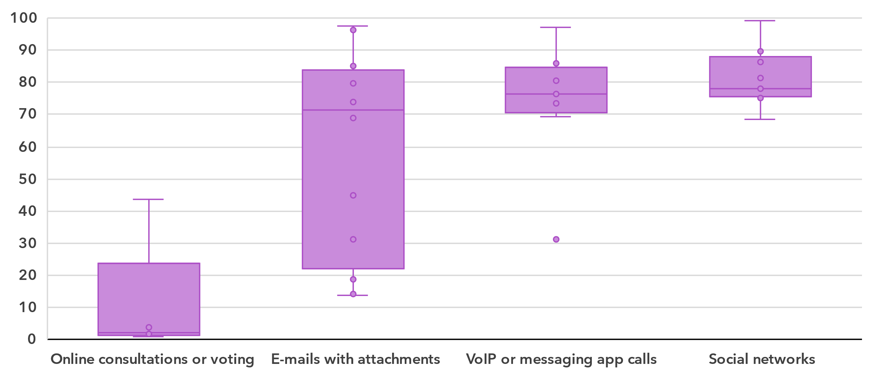Note: Bars indicate the 25th, median and 75th percentile of all country values. The whiskers (bottom and top lines) indicate individual minimum and maximum values. In-scope age varies between countries. Country data are for 2023 where available but no earlier than 2020. Data availability varies between indicators, ranging from five countries for *Taking part in online consultation or voting to define civic or political issues* and 12 countries for *Sending messages with attached files.* Detailed information – including complete indicator names – is available [here](https://www.itu.int/en/ITU-D/Statistics/Documents/facts/rpm_asp_pub_2025_data.xlsx).

Source: ITU

The medians for communication and collaboration were much higher than for information and data literacy, ranging from 71 to 78 per cent. The one exception was taking part in online consultations or voting to define civic or political issues, which had a median of only 2 per cent.

Percentage of Internet users with digital content creation skills, latest year available

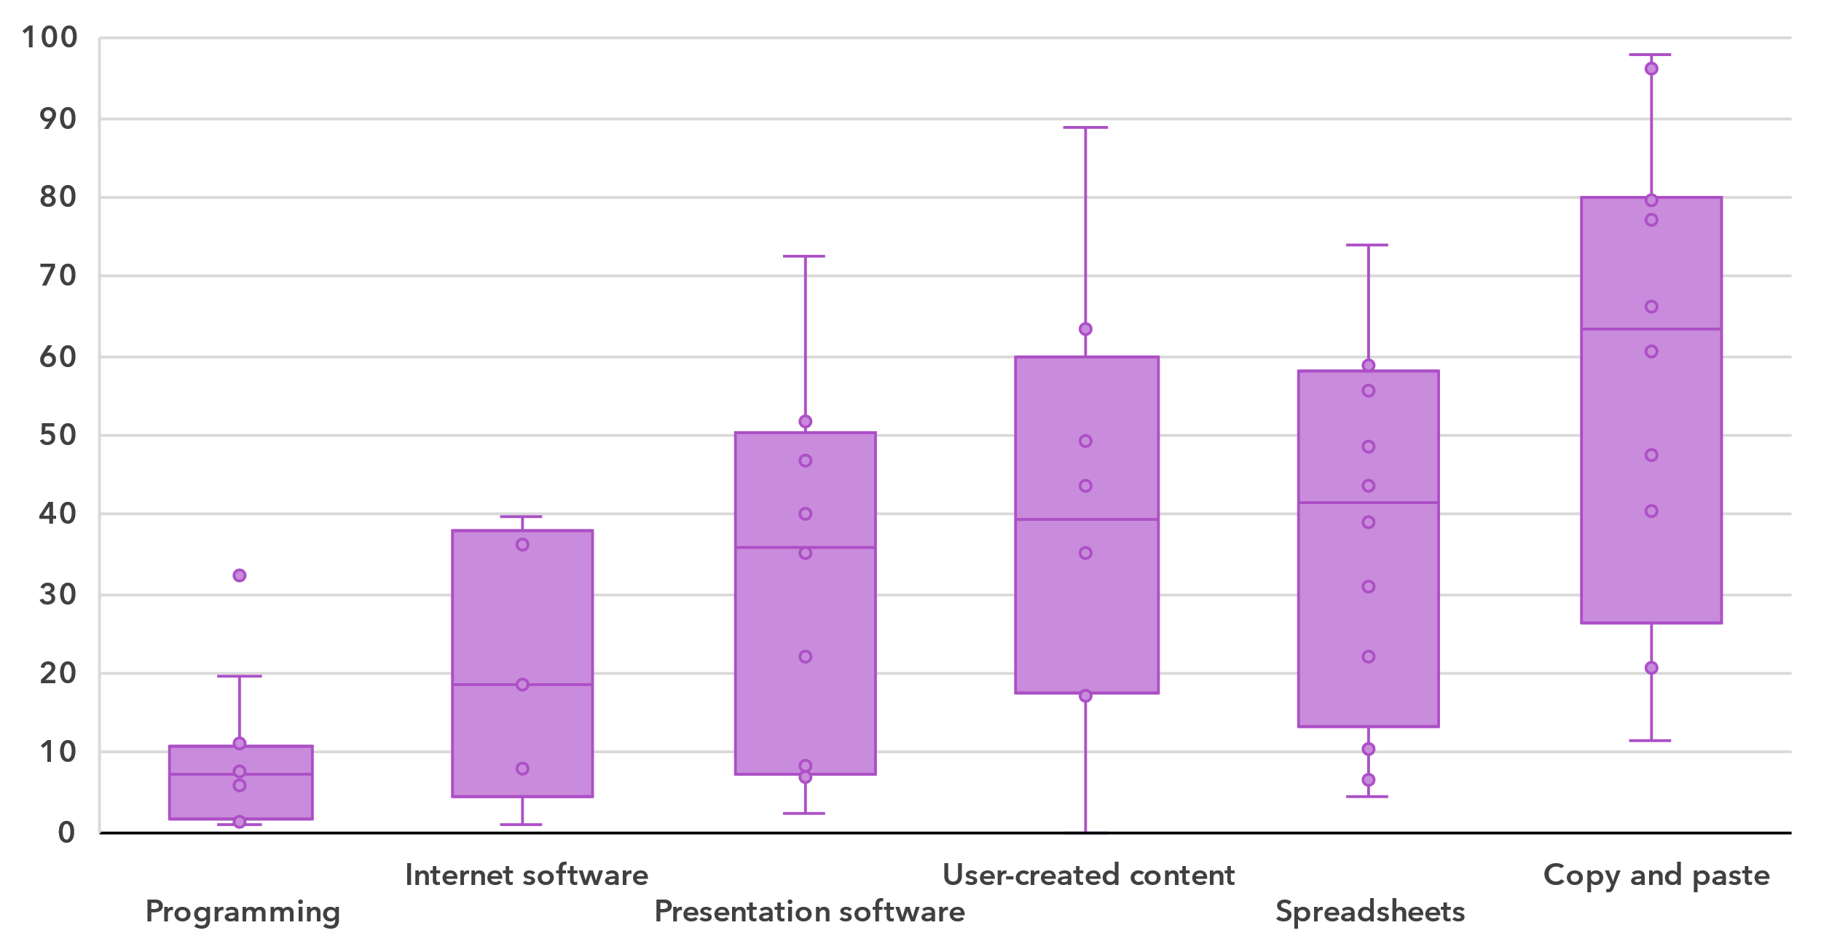Note: Bars indicate the 25th, median and 75th percentile of all country values. The whiskers (bottom and top lines) indicate individual minimum and maximum values. In-scope age varies between countries. Country data are for 2023 where available but no earlier than 2020. Data availability varies among indicators, ranging from five countries for *Using software run over the Internet for editing text documents, spreadsheets or presentations* to eight countries for *Uploading self/user-created content to a website to be shared* and 12 countries for all other indicators*.* Detailed information – including complete indicator names – is available [here](https://www.itu.int/en/ITU-D/Statistics/Documents/facts/rpm_asp_pub_2025_data.xlsx).

Source: ITU

The digital content creation skill area generally shows relatively low medians for five of the six activities, ranging from 7 to 41 per cent. The exception is using copy and paste tools within a document, which had a median of 63 per cent though there was substantial variation between countries for this activity.

Percentage of Internet users with safety skills, latest year available

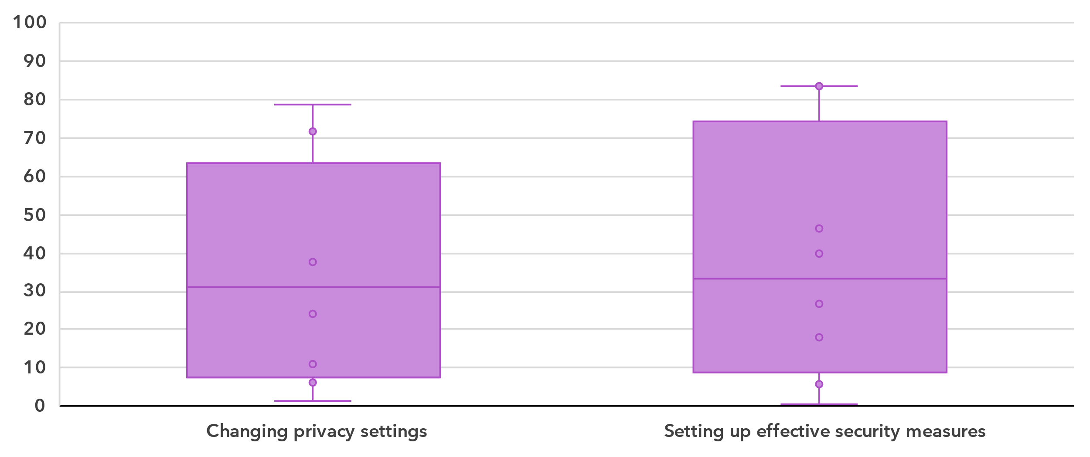Note: Bars indicate the 25th, median and 75th percentile of all country values. The whiskers (bottom and top lines) indicate individual minimum and maximum values. In-scope age varies between countries. Country data are for 2023 where available but no earlier than 2020. Eight countries provided data for each indicator*.* Detailed information – including complete indicator names – is available [here](https://www.itu.int/en/ITU-D/Statistics/Documents/facts/rpm_asp_pub_2025_data.xlsx).

Source: ITU

The two activities in the safety category showed similar prevalence for countries in the region. The median shares were 31 and 33 per cent for changing privacy settings on one’s device, account or app and setting up effective security measures to protect devices and accounts, respectively. However, the share of individuals doing these activities varied widely between countries in the region.

Percentage of Internet users with problem solving skills, latest year available

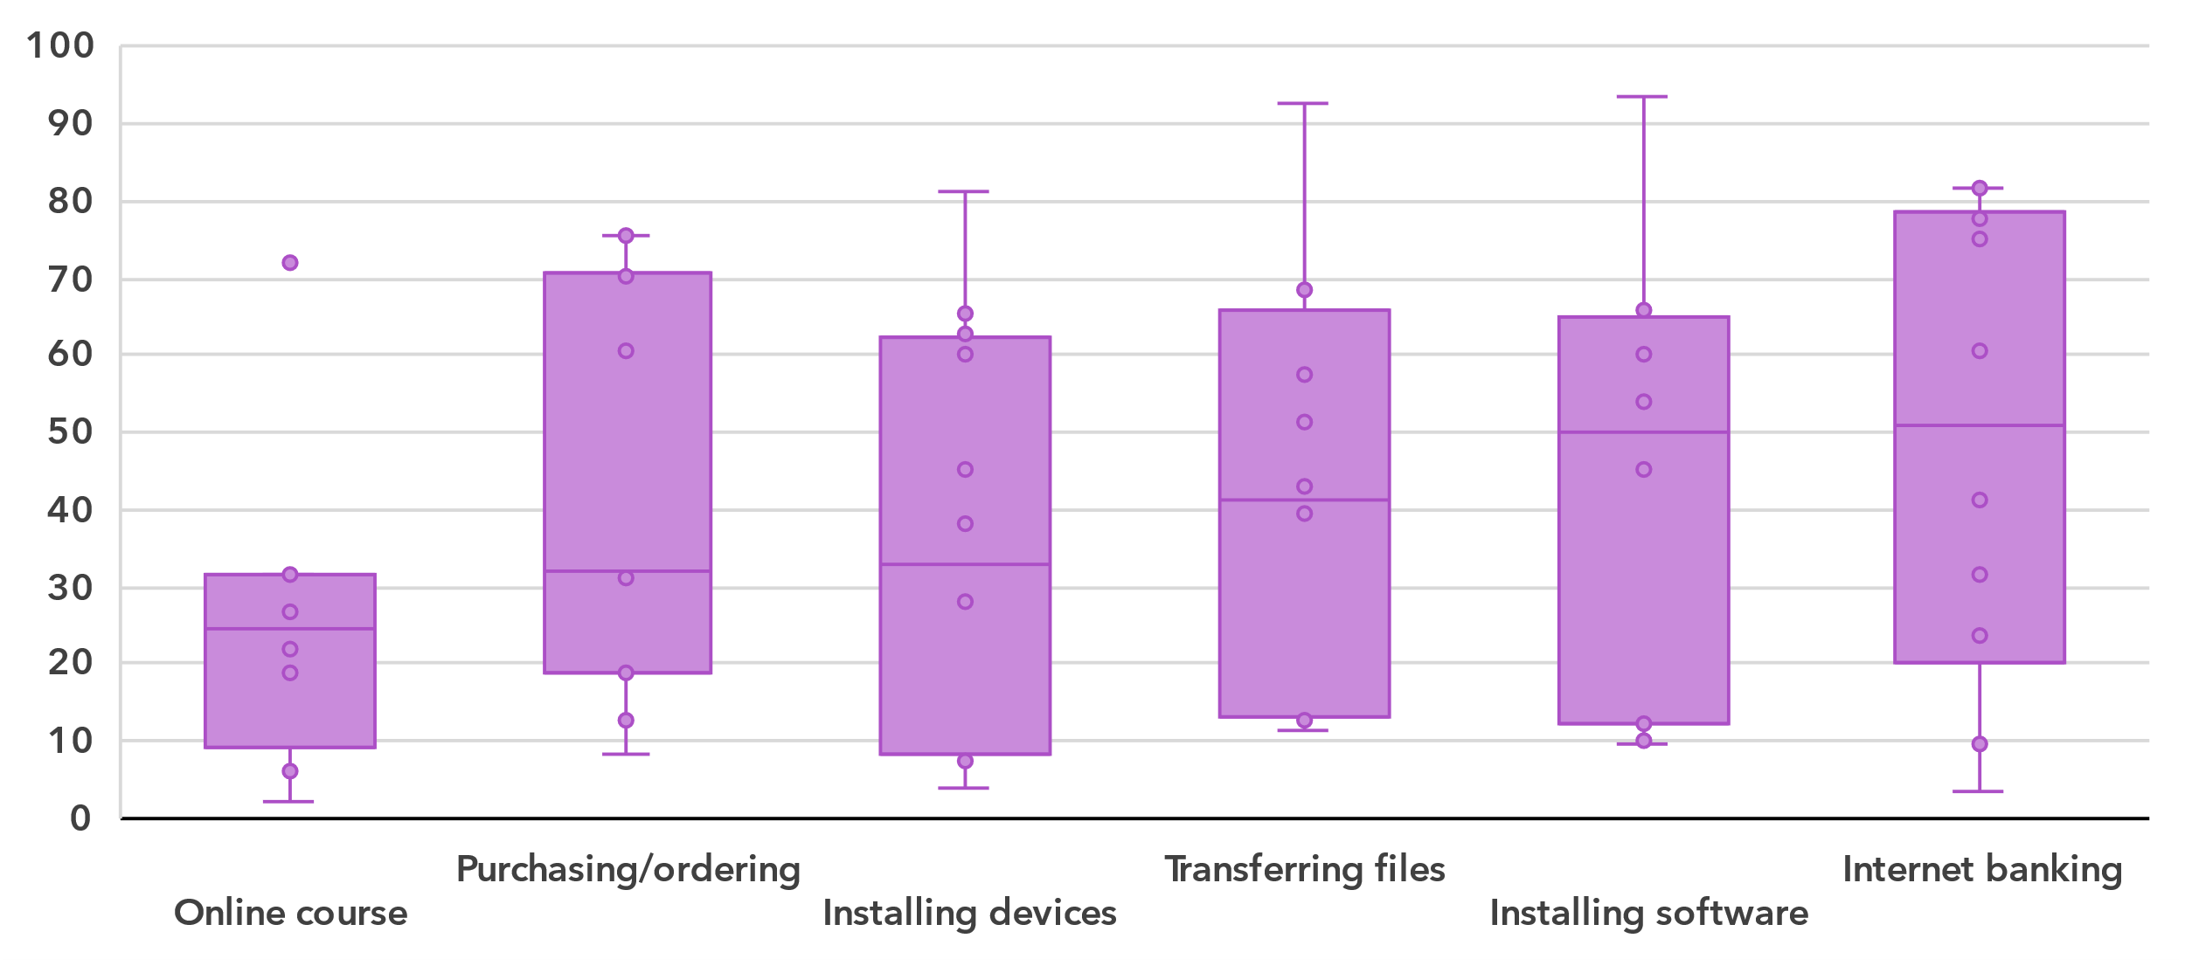Note: Bars indicate the 25th, median and 75th percentile of all country values. The whiskers (bottom and top lines) indicate individual minimum and maximum values. In-scope age varies between countries. Country data are for 2023 where available but no earlier than 2020. Data availability varies between eight and 12 countries for each indicator*.* Detailed information – including complete indicator names – is available [here](https://www.itu.int/en/ITU-D/Statistics/Documents/facts/rpm_asp_pub_2025_data.xlsx).

Source: ITU

Finally, the medians for activities in the problem-solving skill area vary widely, from 24 per cent for doing an online course to 51 per cent for Internet banking.

Revenue and investment

***The telecom sector is a key economic driver in Asia and the Pacific***

The telecommunication sector is an important enabler of economic development, with both direct and indirect impacts. While it is harder to capture the indirect impact, recent data on revenue and investment reveals the significance of the sector’s direct impact on development but also the considerable gaps between countries.

Revenue from all telecommunication services, in USD billion and as a % of GDP, 2023 or latest available year

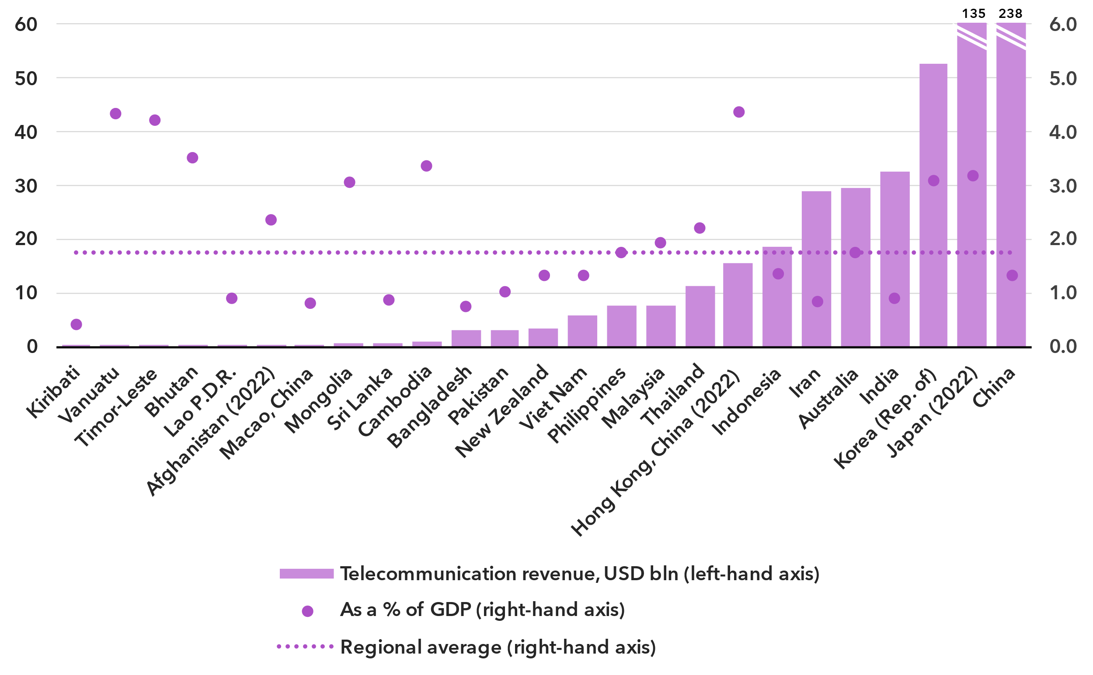Note: Annual average exchange rates applied, last available year values at constant 2023 prices.

Source: ITU, World Bank World Development Indicators

The ICT services sector includes activities providing telecommunications and related service activities, i.e. transmitting voice, data, text, sound and video, over wired, wireless, satellite or other networks.[6] The total retail revenues for the sector in the Asia and the Pacific region, for the 25 countries that provided data in the last available year since 2021, is estimated at around USD 597 billion. However, the size of the telecommunication market varies significantly across countries, with nine countries reporting revenue of up to USD 750 million, while China, the largest market, achieved USD 238 billion, followed by Japan at USD 135 billion.

This sector contributed an average of 1.7 per cent to the region's GDP. This proportion fluctuates, ranging from less than 1 per cent in seven countries to over 3 per cent in eight countries.

Annual investment in telecommunication services, in USD billion and as % of GDP

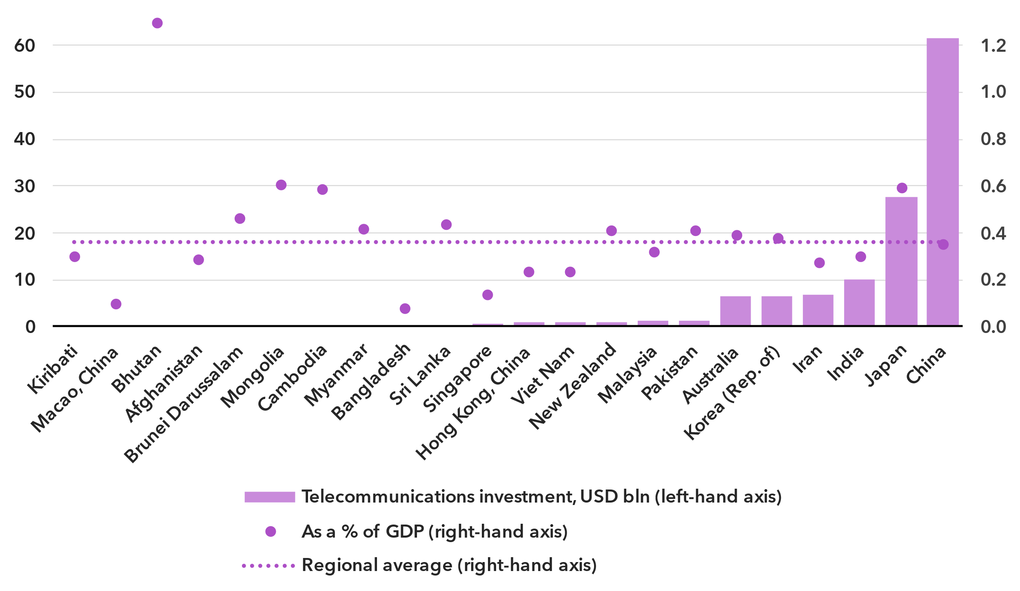Note: Data are a three-year (2021-2023) average of available data points to correct for annual fluctuations and gaps. Investment figures are in constant 2023 US dollars.

Source: ITU, World Bank World Development Indicators

The deployment of new network technologies and the upgrading of existing ones are highly capital-intensive activities. Investment projects often span multiple years and values fluctuate, which is why statistics are presented as the period average for 2021-2023. Those countries in the Asia and the Pacific region for which data was available made annual investments ranging from less than USD 1 billion in nine countries, to USD 28 billion in Japan and USD 62 billion in China. This corresponded to a median value of 0.4 per cent of GDP over the 2021-2023 period.[7]

Investment is unevenly distributed across countries in the region, and both the levels and the per GDP rates of capital expenditure vary significantly. Low levels of investment in countries with mobile network coverage gaps and low mobile and fixed broadband penetration is a particular concern, as it perpetuates digital development divides.

Cybersecurity

***Asia and the Pacific shows progress, but many countries still lag***

Meaningful connectivity requires trustworthy and secure communications. With over 5.5 billion people now online, cybersecurity is no longer an afterthought in the digital economy. Addressing cybersecurity requires a holistic approach encompassing legal, technical, organizational, capacity development, and cooperation domains. Since 2015, the Global Cybersecurity Index (GCI) has tracked countries' measures across these areas, each representing a pillar of the GCI. Overall GCI scores are measured on a 0-100 scale, with each pillar scored out of 20. The 2024 edition revealed a notable improvement in countries’ commitment to cybersecurity: the world’s average GCI score reached 66 out, on a 0-to-100 scale, up 14 points from the 2021 edition. The countries in Asia and the Pacific have continued to expand their commitments reaching an average score of 61, a gain of 13 points from the previous edition.

Global Cybersecurity Index scores, 2017-2024

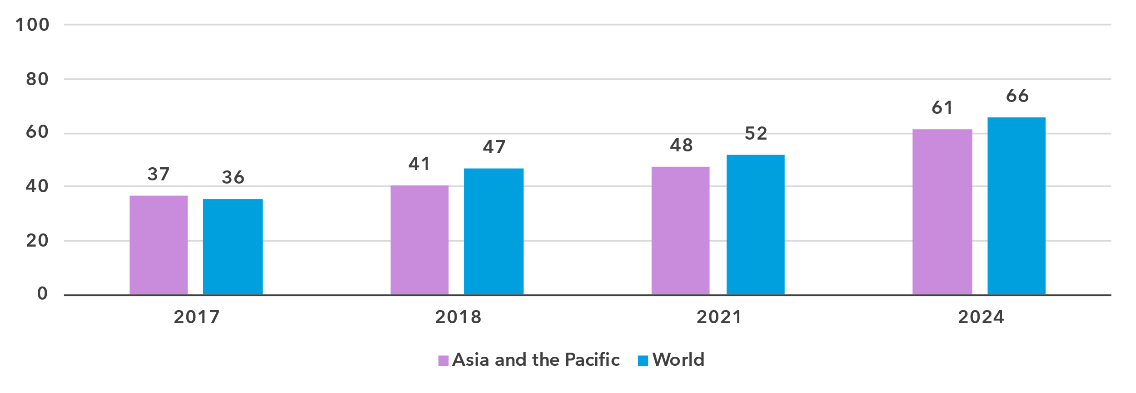

Note: Questions and weightings have been updated between editions, in collaboration with the GCI Expert Group, to better measure cybersecurity commitments by countries.

Source: ITU

The performance in the GCI of Asia and the Pacific region countries is mixed, with a 94-point between the region’s best performers, which achieved the maximum score of 100, and the region’s worst performer, the Democratic People’s Republic of Korea, with a score of 6.2.[8] The next lowest scoring country is Micronesia, scoring 8.8, followed by other Small Island Developing States.

Global Cybersecurity Index scores, by pillar and overall, 2024

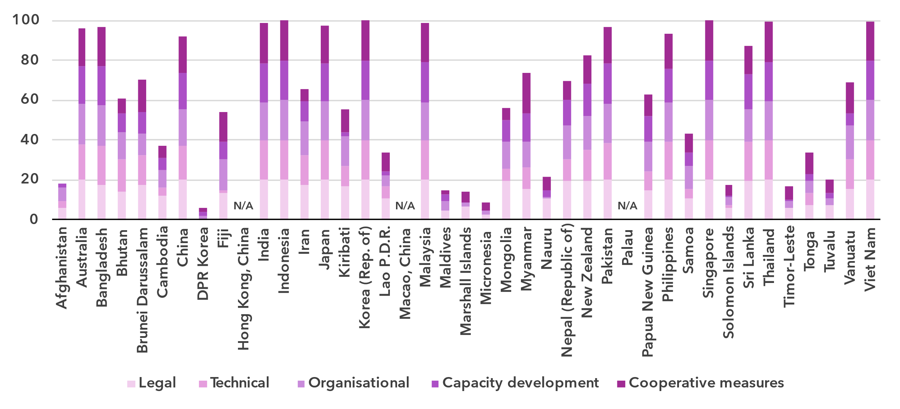Note: The overall CGI score shown is the sum of the score of the five pillars

Source: ITU

While Small Island Developing States are among the lowest performers in the region, some SIDSs have shown significant improvement in the past years, including Kiribati, Papua New Guinea, and Vanuatu. Across the rest of Asia and the Pacific, LLDCs Bhutan and Mongolia have also made significant improvements.

The Technical Pillar of the GCI assesses the effectiveness of national mechanisms and institutional structures in detecting, preventing, responding to, and mitigating cyber threats and incidents. Computer Incident Response Teams (CIRTs) are responsible for the protection against, detection of, and response to cybersecurity incidents, and can enhance a country’s ability to manage cybersecurity incidents. 76 per cent (29) countries in Asia and the Pacific have established their national CIRTs, and many are participating in regional cyber exercises. Still, there is need for further development of these CIRTS, and expanding efforts around the protection of critical information infrastructure.

Child Online Protection (COP) encompasses strategies and initiatives designed to protect children from harm or exploitation online. This includes ensuring children are using age-appropriate software and filtering tools and educating parents and children about staying safe online. COP is tracked through questions under the Legal, Organizational, and Capacity Development pillars. A total of 164 countries reported having legal measures on COP in the GCI 2024, compared to 130 countries in the previous edition. These measures were sometimes part of other rules, regulations, and substantive law, such as on online crime or sexual exploitation. Forty-five per cent (17) of countries in Asia and the Pacific have some form of a COP strategy with associated actions. However, linking these efforts to educational efforts for educators, parents, and policy makers is key.

Finally, to meet the demand for cybersecurity professionals, countries are increasingly developing cybersecurity skills within their populations. While 66 per cent (25) countries in Asia and the Pacific have cybersecurity-focused university degrees, ensuring that there are multiple pathways towards building cybersecurity competency is important to meet ongoing cyber needs.

E-waste management

***Lack of formalized collection and recycling targets impedes progress towards a circular economy for electronics***

As countries strive to harness the benefits of technology to drive economic growth and achieve their national development priorities, the challenge of managing electronic waste has become increasingly urgent. Strengthened e-waste policy and regulatory e-waste management are pivotal for ensuring environmental sustainability, supporting circular economy practices, and advancing progress towards the sustainable development goals (SDGs).

E-waste generated, in billions of kilograms, 2022 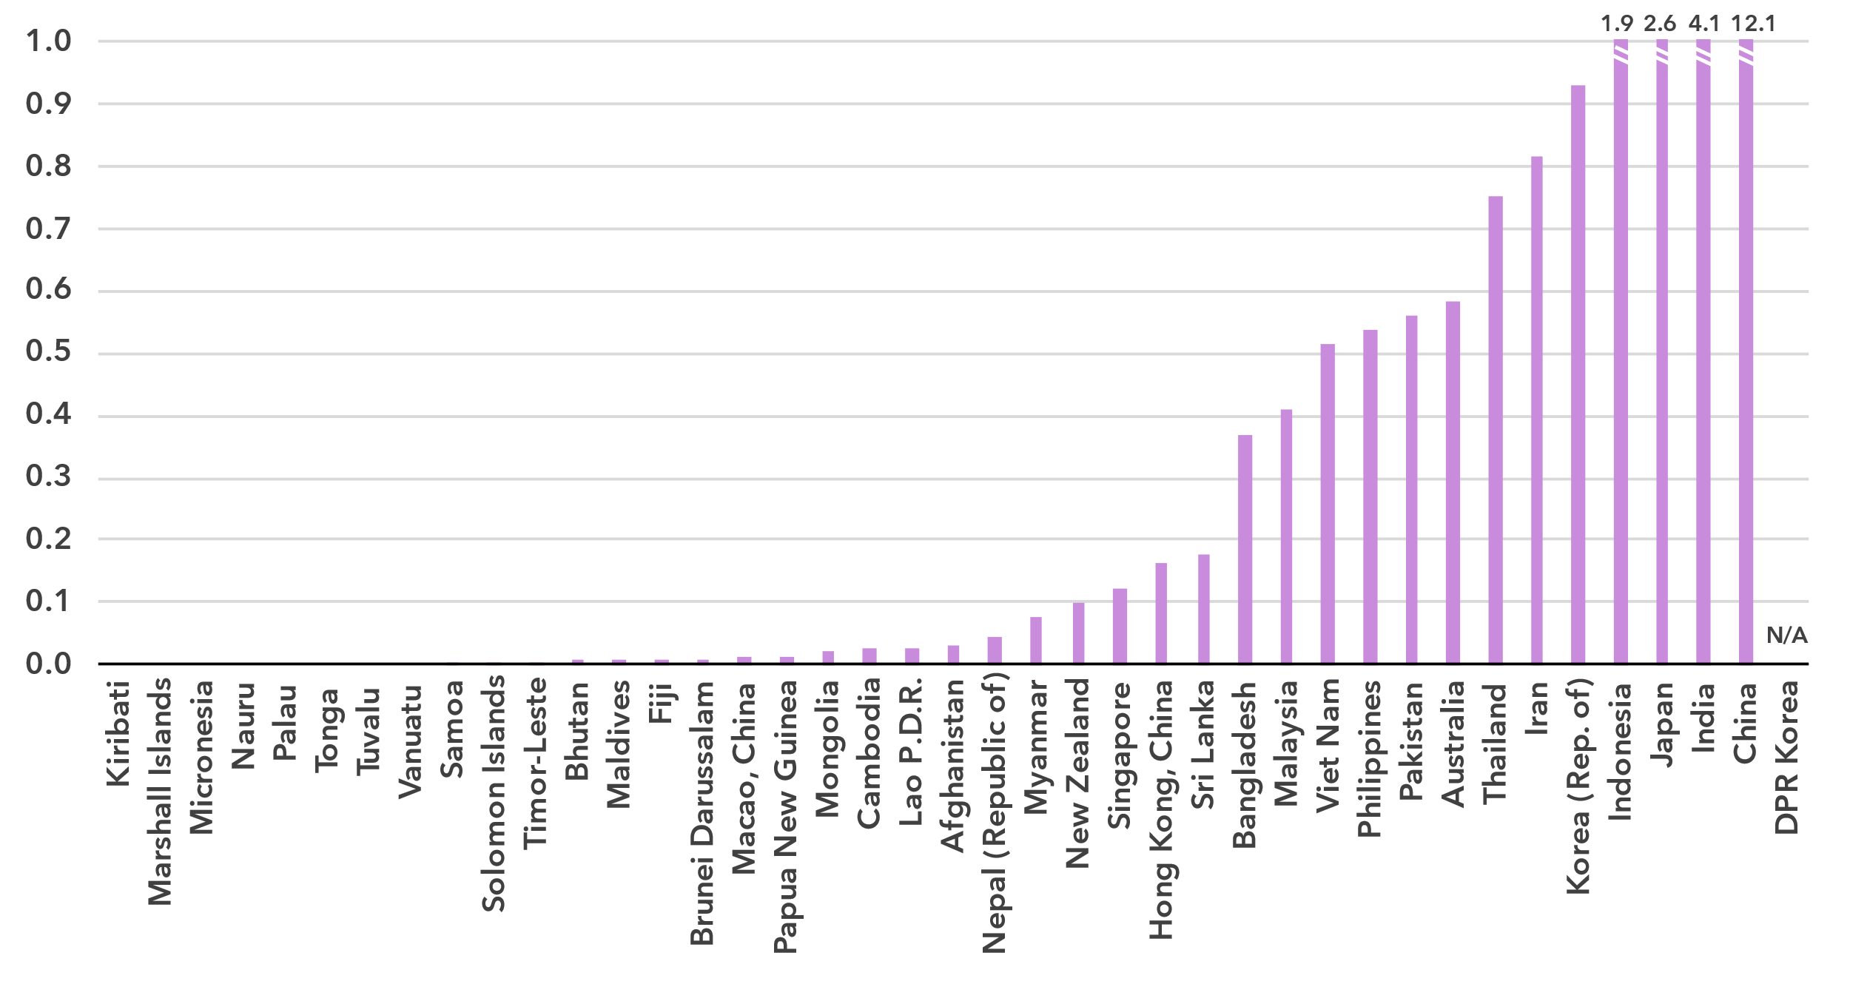

Source: ITU and UNITAR, [Global E-waste Monitor, 2024](https://www.itu.int/hub/publication/d-gen-e_waste-01-2024/)

The [Global E-waste Monitor 2024](https://www.itu.int/en/ITU-D/Environment/Pages/Publications/The-Global-E-waste-Monitor-2024.aspx) finds that in 2022, Asia and the Pacific generated approximately 27 billion kg of e-waste, representing almost 44 percent of global e-waste generation (62 billion kg). However, significant disparities exist across the region. China is the largest contributor, producing 12 billion kg, followed by India (4.1 billion kg) and Japan (2.6 billion kg). Together these three countries generated over 60 percent of the region’s total e-waste. In contrast, smaller countries such as small island states, including Kiribati, Tuvalu, and Nauru, generated less than 5 million kg combined, reflecting differences in population size, economic development, and levels of technological adoption.

E-waste per capita generated in kg, 2022

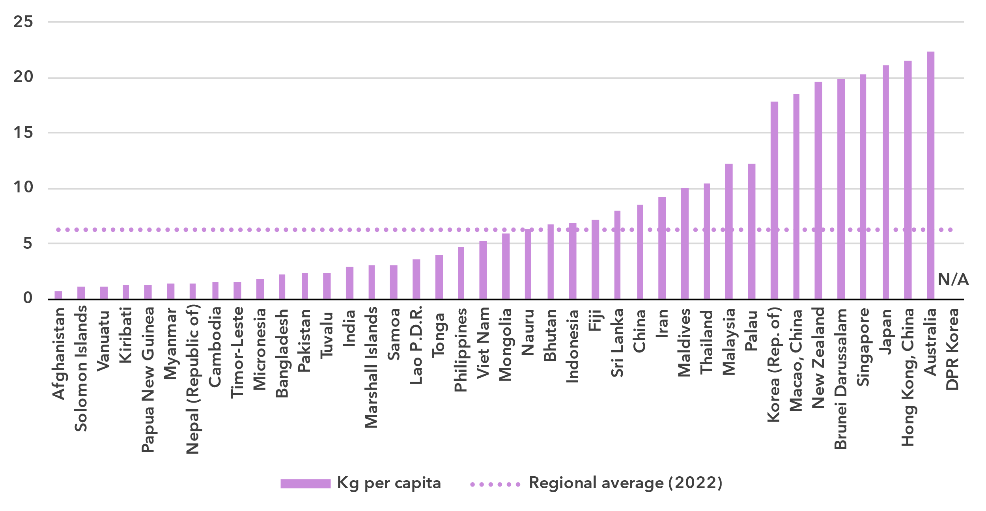Source: ITU and UNITAR, [Global E-waste Monitor, 2024](https://www.itu.int/hub/publication/d-gen-e_waste-01-2024/)

The analysis of e-waste trends in Asia and the Pacific can be further deepened by examining per capita e-waste generation. While the region collectively approaches the global per capita e-waste average of 7.8 kg, disparities between countries are stark. The regional average of 6.2 kg per capita reflects a diverse landscape where high-income countries significantly drive up the overall figure. For instance, Australia (22.4 kg per capita) generates nearly three times the global average, while Japan (21.2 kg per capita) and New Zealand (19.6 kg per capita) exceed the regional average more than three times. In contrast, low-income countries such as the Republic of Nepal (1.4 kg per capita), Papua New Guinea (1.3 kg per capita), and Afghanistan (0.8 kg per capita) have e-waste per capita generation rates at less than a fifth of the global average. Meanwhile, mid-range contributors such as Malaysia (12.2 kg per capita) and Thailand (10.5 kg per capita) have e-waste generation levels above the regional average of 6.2 kg, though still significantly below the highest per capita generators in the region.

Despite these high e-waste generation rates, only 12.8 percent (3.5 billion kg) of the e-waste generated was documented as properly collected and recycled- well below the global documented formal collection and recycling rate of 22.3 percent in 2022. A few countries, such as India and the Republic of Korea, report formal collection and recycling initiatives. Notably, China documented having recycled 2.0 billion kg of e-waste. In contrast, many countries in the region, including high e-waste generators like Indonesia and the Islamic Republic of Iran (which together producer over 2.7 billion kg), lack significant formal recycling activity.

E-waste policies and regulations in place, 2022

|  |  |  |  |  |
| --- | --- | --- | --- | --- |
|  | **National e-waste legislation/policy or regulation** | **Extended producer responsibility (EPR) framework for e-waste** | **Collection targets** | **Recycling targets** |
| Afghanistan | No | No | No | No |
| Australia | Yes | Yes | Yes | Yes |
| Bangladesh | Yes | Yes | Yes | No |
| Bhutan | No | No | No | No |
| Brunei Darussalam | No | No | No | No |
| Cambodia | Yes | No | No | No |
| China | Yes | Yes | No | Yes |
| Dem. People's Rep. of Korea | N/A | N/A | N/A | N/A |
| Fiji | No | No | No | No |
| Hong Kong, China | No | No | No | No |
| India | Yes | Yes | Yes | No |
| Indonesia | No* | No | No | No |
| Iran (Islamic Republic of) | Yes | No | No | No |
| Japan | Yes | No | No | Yes |
| Kiribati | No | No | No | No |
| Korea (Rep. of) | Yes | Yes | No | No |
| Lao P.D.R. | No | No | No | No |
| Macao, China | No | No | No | No |
| Malaysia | Yes | No | No | No |
| Maldives | No | No | No | No |
| Marshall Islands | No | No | No | No |
| Micronesia | No | No | No | No |
| Mongolia | No | No | No | No |
| Myanmar | No | No | No | No |
| Nauru | No | No | No | No |
| Nepal (Republic of) | No | No | No | No |
| New Zealand | No | No | No | No |
| Pakistan | No | No | No | No |
| Palau | No | No | No | No |
| Papua New Guinea | No | No | No | No |
| Philippines | No | No | No | No |
| Samoa | No | No | No | No |
| Singapore | Yes | No** | Yes | No |
| Solomon Islands | No | No | No | No |
| Sri Lanka | No | No | No | No |
| Thailand | No | No | No | No |
| Timor-Leste | No | No | No | No |
| Tonga | No | No | No | No |
| Tuvalu | No | No | No | No |
| Vanuatu | No | No | No | No |
| Viet Nam | Yes | Yes | No | No |

*The Indonesian e-waste regulatory framework was strengthened after publication of the Global E-waste Monitor.

** Singapore begun the process of adopting an EPR framework after publication of the Global E-waste Monitor.

Source: ITU and UNITAR, [Global E-waste Monitor, 2024](https://www.itu.int/hub/publication/d-gen-e_waste-01-2024/)

The lack of comprehensive policies for e-waste management remains a significant challenge in Asia and the Pacific, where only a few countries have implemented national e-waste legislation and extended producer responsibility (EPR) frameworks. Globally, 42 per cent of countries (81 out of 193) have enacted national e-waste policies, legislation, or regulations. In contrast, only 12 countries[9] in Asia and the Pacific have done so, which accounts for just 29 per cent of the 41 ITU Member States in the region.

Moreover, only 7 countries[10] in Asia and the Pacific have introduced EPR frameworks for e-waste, which are essential for holding producers accountable for the entire lifecycle of their products. This figure is well below the global average, where 67 of the 81 countries with national e-waste policies or legislation have adopted EPR systems. The absence of these frameworks across most of Asia and the Pacific exacerbates the region’s e-waste challenges, contributing to the continued reliance on unregulated waste management practices that are harmful to both the environment and public health.

The lack of formalized collection and recycling targets can significantly impede progress towards a circular economy for electronics. Globally, countries with collection targets achieve an average e-waste collection rate of 25 percent, significantly higher than the global average of 22.3 percent. In Asia and the Pacific, just 4 countries have implemented collection targets, and 3 have established recycling targets. Without such policies, the region risks missing key opportunities to advance towards a circular economy and reduce its environmental footprint.

Disparities within the region

***Regional averages conceal disparities in connectivity among countries in Asia and the Pacific***

The Asia and Pacific region is diverse in many respects: income level, with the wealthiest country’s GNI per capita more than 60 times larger than the poorest; urbanization rate, which ranges from less than 20 per cent to 100 per cent; and population, which ranges from Small Island Developing States (SIDS) with less than 50,000 residents to the two most populous countries in the world with more than one billion residents.

Given these differences, it can be useful to group countries in Asia and the Pacific into clusters, according to their scores on indicators of Internet use, mobile phone ownership, mobile broadband and fixed broadband subscription rates, affordability of entry-level mobile and fixed broadband, and gender equality. This ‘cluster analysis’ yields three distinct groups[11], whose respective members share similar ICT profiles.

The first group, consisting of nearly half of Asia and Pacific countries, is characterized by rates of ICT usage and ownership that are well above the world average – notably one country classified as an LDC (Bhutan) is included in this group. Both fixed broadband and data-only mobile broadband are affordable relative to the world average, with the median entry-level prices as a share of monthly GNI per capita below the Broadband Commission target of 2 per cent of monthly GNI per capita or lower. There is also a relatively high level of gender parity in terms of Internet use in this group.

The second group, consisting of Bangladesh, Cambodia, India, Indonesia, Kiribati, Lao P.D.R., Marshall Islands, Micronesia, Myanmar, Nepal, Palau, Samoa, Sri Lanka, Tonga, Tuvalu, and Vanuatu is closer to world averages for most indicators. Their average level of Internet use and mobile phone ownership are below the world average. Gender parity for Internet use is also below the world average and prices for both fixed and mobile broadband services are above the 2 per cent of monthly GNI per capita target. Of these countries, Bangladesh, Cambodia, Kiribati, Lao P.D.R., Nepal, and Tuvalu are classified as LDCs.

The final group, consisting of Afghanistan, Pakistan, Solomon Island, and Timor-Leste, has the lowest rates of ICT use. This is in addition to low subscription rates and much worse affordability scores. Averages in this group are still substantially below global averages in all cases with average Internet use gender parity score falling well below that for the world. The low results for these indicators reflect the development challenges faced by these countries, all but one of which (Pakistan is the exception) are classified as LDCs.

Finally, Papua New Guinea – another LDC – does not fall into any of the three groups, due to its low levels of ICT use and ownership, poor gender parity and a lack of affordability of broadband services.

The diversity of these groups of countries underlines the need to design tailored approaches to achieve universal and meaningful connectivity.

Average of key ICT indicators by groups of similar countries in Asia and the Pacific, 2023

|  |  |  |  |  |
| --- | --- | --- | --- | --- |
|  | Group | |  | |
| **Indicator (units)** | 1  (19 Asia and the Pacific countries) | 2  (16 Asia and the Pacific countries) | 3  (4 Asia and the Pacific countries) | **World average** |
| Share of individuals using the Internet (%) | 88.9 | 56.8 | 30.4 | **65.4** |
| Gender equality - Internet use  (gender parity score) | 0.96 | 0.88 | 0.74 | **0.93** |
| Share of individuals owning mobile phones (%) | 91.6 | 73.7 | 57.6 | **78.6** |
| Mobile-broadband subscriptions  (per 100 inhabitants) | 130.8 | 92.9 | 47.1 | **89.9** |
| Fixed-broadband subscriptions  (per 100 inhabitants) | 24.1 | 4.5 | 0.7 | **18.6** |
| Data-only mobile broadband prices  (as a % of GNI per capita) | 0.5 | 2.4 | 6.4 | **2.8** |
| Fixed broadband prices (as a % of GNI per capita) | 1.1 | 6.2 | 24.6 | **1.3** |

Note: Group medians shown for data-only mobile broadband and fixed broadband prices as a % of GNI per capita.

Source: ITU

Overview of data availability in Asia and the Pacific

Data plays a key role in achieving universal and meaningful connectivity. Reliable and timely data equips policymakers to identify needs, set priorities, design effective interventions, track progress, and measure impact. Investing in data yields substantial returns by enabling better decision-making and more efficient interventions.

The importance of data for the delivery of the Kigali Action Plan was acknowledged by the BDT’s Telecommunication Development Advisory Group, which adopted five key performance indicators (KPIs) tracking the extent to which Member States submit timely ICT data to ITU, including KPIs related to the submission of ICT skills data and data on Internet use disaggregated by location and gender.

The availability and quality of ICT statistics vary significantly across the Asia and the Pacific region, including both administrative indicators and those derived from household surveys.

On average, two-thirds of a core set of 14 administrative ICT indicators, typically collected by national regulatory authorities or ministries, is available in the region (see indicator list in the note of the figure below). Availability reaches 100 per cent (i.e., recent data is available for the 14 indicators) in 10 countries, while 8 countries are missing only one indicator. At the other end, 13 countries collect less than half of the core set of administrative indicators, and 9 of them report data for 3 indicators or less.

Data availability is generally good for the fixed and mobile broadband subscription indicators as well as for 3G and 4G mobile network coverage indicators. Countries should focus their data collection and reporting on indicators for fixed broadband speed breakdown, fixed and mobile broadband traffic, as well as for investment and revenue, which are only available for hardly more than half of the countries in the region.

Percentage availability of selected administrative ICT indicators, 2022-2023

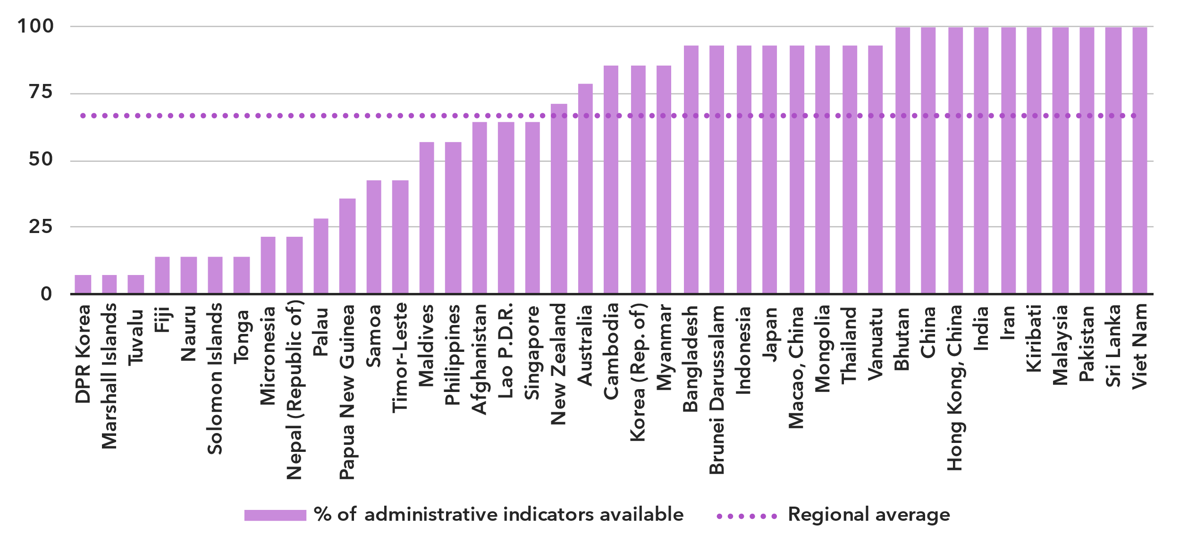Note: An indicator is considered available if at least one value is available for the period in question. Assessment based on the following set: active mobile broadband subscriptions, fixed broadband subscriptions (total, as well as by speed-tiers: 256 Kbit/s to 2 Mbit/s, 2 Mbit/s to 10 Mbit/s, and above 10 Mbit/s), mobile network coverage indicators by technology (at least 2G, 3G, LTE/WiMAX, 5G), total fixed broadband Internet traffic, mobile broadband Internet traffic within the country, international bandwidth usage, total telecommunication revenues and investment in telecommunication services.

Source: ITU

Data on ICT access and usage by households and individuals, usually derived from household surveys, remains limited. Only 14 countries in Asia and the Pacific have provided at least partial data for ICT household indicators for the period 2022-2023. Fourteen countries did not provide any data in the last ten years.

The issue is even more acute for data disaggregated by socio-economic attributes, which is often not available. Only six Asia-Pacific countries have submitted recent data (2022 or more recent) for all six attributes of interest (see table on next page). Eight other countries have submitted recent data for at least one attribute.

Even when data is available, it may suffer from poor sample design, inadequate collection methods, or low response rates. Such shortcomings are likely to yield misleading results and may result in misguided policies. (For example, overestimation of ICT skills could lead policymakers to shift focus away from supporting populations that need training in this area.) Addressing these challenges requires a dual approach targeting both the producers and users of data. Through continuous efforts in capacity building, technical assistance, and advocacy, ITU aims to enhance the availability and quality of ICT data globally.

Latest year of submission of ICT household survey data, by socio-economic attribute



Source: ITU

Part 2. BDT4Impact: Selected case studies from Asia and the Pacific

The second part of this document presents a selection of projects and initiatives supported by the ITU Telecommunication Development Bureau (BDT) in the Asia-Pacific region. For more BDT impact stories, visit <https://www.itu.int/itu-d/sites/digital-impact-unlocked/all-stories/list/>.

Farmers in Papua New Guinea gain digital skills to boost their businesses

Deep in a Papua New Guinea rainforest, farmers are using newfound [digital skills to increase the sales of their products](https://www.itu.int/itu-d/sites/digital-impact-unlocked/digital-training-empowers-vanilla-farmers-in-papua-new-guinea-to-find-new-markets/) **–** from pure vanilla to fish to turmeric **–** and bring greater prosperity to their communities.

Since 2020, more than 1,260 Papua New Guinea farmers have learned to conduct e-commerce, advertise online and find new markets, thanks to the EU-funded Support to Rural Entrepreneurship, Investment and Trade in Papua New Guinea Programme, a joint programme with FAO, ILO, ITU, UNCDF and UNDP.

“Farmers are very excited to learn about basic computing,” [West Sepik farmer and teacher](https://www.itu.int/itu-d/sites/digital-impact-unlocked/building-digital-skills-to-accelerate-economic-prosperity/) Joseph Wotom said. “I believe it will bring increased cash right into the village and boost the living standard.”

East Sepik farmer Jenelyn Mamba created a website to find new buyers for her village’s vanilla beans after participating in the Programme’s five-day course. She is one of the first dried vanilla exporters to Australia, New Zealand and the United States of America.

“As a girl in the community, I feel that the trainings have really equipped me with the skills to actively participate,” Ms. Mamba said.

The Programme has set up seven hubs to promote connectivity and plans to establish five more.

Smart Village Gokina reaps the rewards of digital transformation

Pakistan launched its [first Smart Village in 2023 in Gokina](https://www.itu.int/itu-d/sites/digital-impact-unlocked/connectivity-impacting-rural-lives-in-pakistan/), and the success of the project has sparked enthusiasm for expanding the model to more villages in the country.

Gokina’s example showed how digital transformation can help a village overcome challenges like poor access to job opportunities, health care, education, and more, said Ali Asghar, Senior Joint Secretary, Ministry of Information Technology and Telecommunications (MoITT).

“Through the platforms provided by the Ministry of IT and ITU, we provide the facilities and services for e-health, for e-education and for e-agriculture, and for entrepreneurship and digital training skills,” Mr. Asghar said. “The rural community, especially the women and girls in rural areas, will be the major beneficiaries of this project because of the digital services provided at their doorstep.”

The ITU Smart Villages initiative in Pakistan is being implemented with MoITT / USF Pakistan and is supported by ITU and Huawei projects. Implementing partners include TeleTaleem, Sahat Kehani, and Baidari.

Workshop in Mongolia delves into regional digital infrastructure challenges

The challenges of developing countries – especially those which are landlocked – in building resilient digital infrastructure was the subject of a [workshop in Ulaanbaatar, Mongolia](https://www.itu.int/itu-d/sites/digital-impact-unlocked/spectrum-management-training-programmes-for-space-and-satellite-and-5g-deployment-in-mongolia/), conducted in October 2024 by ITU’s Telecommunication Development Bureau and the International Think Tank for Landlocked Developing Countries.

The integration of upcoming non-terrestrial networks, direct-to-device services, and other new satellite technologies into digital infrastructure development is essential for building a resilient and inclusive digital ecosystem. The workshop examined ways that satellite and space services can support affordable, resilient and universal connectivity, emphasizing the need to overcome connectivity challenges and advance sustainable development in the Asia and the Pacific region.

Participants looked at case studies from ten countries, including Azerbaijan, Bangladesh, Bhutan, Cambodia, Indonesia, Laos, Malaysia, Nepal, Pakistan, and Sri Lanka. The event was supported by the Department of Infrastructure, Transport, Regional Development, Communications and the Arts of Australia, Mongolia’s Ministry of Digital Development, Innovation and communication (MDDIC), and its Communications and Regulatory Commission (CRC).

The event featured sessions related to national satellite regulations and space policies, as well as a segment on Partner2Connect, where new pledges were presented from Mongolia for the first time.

ASEAN Digital Ministers focus on interoperable Digital Government Infrastructure

The [ADGMIN (ASEAN Digital Ministers) Meeting](https://asean.org/joint-media-statement-of-the-5th-asean-digital-ministers-meeting-and-related-meetings/) held in Bangkok in January 2025 endorsed the ‘ASEAN Digital Government Technical Framework’ developed under the aegis of ASEAN-ITU Priority Cooperation Areas (2024-2026) to strengthen cooperation between ASEAN and ITU. A physical workshop was hosted in Brunei in October 2024, where in consultation with the ASEAN Member States, the technical framework was developed.

The interoperability framework is envisaged to provide a strategic blueprint for ASEAN Member States to establish and enhance interoperability within their digital government services. The framework elaborated on technical and technological aspects of interoperability, addressing infrastructure, data exchange protocols, privacy, security, and semantic consistency.

The ADGMIN meeting encouraged ASEAN Member States to take the opportunity of ITU resources and technical assistance to accelerate digital transformation in the region. The Meeting also extended its deep appreciation on the occasion of ITU’s 160th anniversary in 2025 reflecting its remarkable journey since 1865.

Leaders focus on digital inclusion as a component of healthy aging

The ITU Regional Office for Asia and the Pacific organized an [information session](https://www.itu.int/en/ITU-D/Regional-Presence/AsiaPacific/Pages/Events/2024/Information%20Session%20on%20Healthy%20Aging%20in%20Thailand%20through%20ICT/Information-Session-on-Healthy-Aging-in-Thailand-through-ICT.aspx) in Thailand that stressed the importance of information and communications technology for healthy aging.

Representatives from government and UN agencies, academia and non-governmental organizations gathered for the hybrid event, which featured presentations and discussions on providing the country’s growing population of older people with the digital skills and tools they need to be engaged, empowered citizens.

Participants also examined Thailand’s demographic trends and sought to better understand the challenges older people face in the country. The session noted that many older people have found themselves left behind in the wake of the world’s post-pandemic digital transformation.

Thailand is one of the world’s fastest-aging countries. Organizers said that the digital realm offers many opportunities for aging gracefully and becoming more active, less-vulnerable community members.

The event was organized by ITU and Thailand’s Ministry of Digital Economy and Society, with partners Jutendo University of Japan and the World Health Organization.

Innovation Centre in New Delhi unites stakeholders, enables digital advancements across sectors

ITU’s [new Area Office and Innovation Centre in India’s capital](https://www.itu.int/en/mediacentre/Pages/PR-2023-03-22-ITU-india-area-office-and-innovation-centre-opening.aspx) is serving as a hub for promoting advanced technologies in the region and beyond.

Inaugurated in 2023, the Centre has been bringing together government, industry, academia and others in an entrepreneurial environment so that digital technology advancements can reach communities that need them most in sectors such as agriculture, health, and education.

The Centre also serves as a platform for the exchange of ideas, success stories, innovative solutions and global endeavours. It is pursuing four objectives: strategic foresight, open technology innovation, the growth of small and medium enterprises and entrepreneurship, and policy experimentation.

Officials in India noted that the Innovation Centre is the first of its kind under the auspices of ITU and that it will play an important role in the development of new telecommunication technologies.

The facility is in the Centre for Development of Telematics, and the office is funded by the Government of India.

Annex: Data resources

To ensure up-to-date information, and enhance readability, all data presented in this document are available for download as Excel files:

* [Country-level data](https://www.itu.int/en/ITU-D/Statistics/Documents/facts/rpm_arb_pub_2025_data.xlsx) organized by tabs corresponding to the sections of this document (URL: <https://www.itu.int/en/ITU-D/Statistics/Documents/facts/rpm_asp_pub_2025_data.xlsx>). Country level data were extracted from the [ITU DataHub](https://datahub.itu.int/), reflecting the February 2025 data release.
* [Regional and global estimates](https://www.itu.int/en/ITU-D/Statistics/Documents/facts/ITU_regional_global_Key_ICT_indicator_aggregates_Nov_2024.xlsx), as compiled for [Facts and Figures 2024](https://www.itu.int/itu-d/reports/statistics/facts-figures-2024/) (URL: <https://www.itu.int/en/ITU-D/Statistics/Documents/facts/ITU_regional_global_Key_ICT_indicator_aggregates_Nov_2024.xlsx>).

1. As of February 2025, the Asia and the Pacific region, as defined by ITU, consists of the following 41 economies: Afghanistan; Australia; Bangladesh; Bhutan; Brunei Darussalam; Cambodia; China; Dem. People’s Rep. of Korea; Fiji; Hong Kong, China; India; Indonesia; Iran (Islamic Republic of); Japan; Kiribati; Korea (Rep. of); Lao P.D.R.; Macao, China; Malaysia; Maldives; Marshall Islands; Micronesia; Mongolia; Myanmar; Nauru; Nepal (Republic of); New Zealand; Pakistan; Palau; Papua New Guinea; Philippines; Samoa; Singapore; Solomon Islands; Sri Lanka; Thailand; Timor-Leste; Tonga; Tuvalu; Vanuatu; and Viet Nam.
2. Considering that some people may never want to connect, as a matter of convention universality is taken to mean an Internet penetration rate of at least 95 per cent.
3. In this document, for figures reporting economy-level data, all economies are shown. Countries are sorted by value of the indicator. A data point is only shown if it is for the year 2020 or later, otherwise it is marked as not available (N/A), or excluded altogether (when data are not available for many countries). In addition, a marker shows the data point for the year 2018, if available. Data are extracted from the [ITU DataHub](https://datahub.itu.int/), based on the data release of February 2025. Since country-level data are available for the year 2023 at best, for comparison purposes, the regional average for the year 2023 is reported as well, as published in [Facts and Figures 2024](https://www.itu.int/itu-d/reports/statistics/facts-figures-2024/). To save space in these figures, “DPR Korea” is used instead of “Dem. People’s Rep. of Korea” and “Iran” instead of “Iran (Islamic Republic of)”.
4. The gender parity score is calculated as the proportion of women who use the Internet divided by the proportion of men who use the Internet. A value less than one indicates that men are more likely to use the Internet than women, while a value greater than one indicates the opposite. Gender parity is considered achieved if the value lies between 0.98 and 1.02.
5. Considering only those countries for which data was available for all years from 2018 to 2024.
6. For a complete definition, see ISIC Rev. 4 class 61.
7. Investment statistics collected by ITU refer to acquiring or upgrading property (including tangible assets such as plants and non-tangible assets such as computer software) and networks. Expenditure on research and development, annual fees for operating licences and the use of radio spectrum, and investment in telecommunication software or equipment for internal use are excluded.
8. Data for DPR Korea is based on desk research, as the country did not provide any inputs.
9. Including Indonesia, where the e-waste regulatory framework was strengthened after publication of the Global E-waste Monitor.
10. Including Singapore, which begun the process of adopting an EPR framework after publication of the Global E-waste Monitor.
11. Papua New Guinea is not included in the three groups due to substantial differences in connectivity with others in the region. The Democratic People's Republic of Korea is excluded because of insufficient data.