Regional Preparatory Meeting  for Arab States for WTDC-25 (RPM-ARB)  Amman, Jordan, 4-5 February 2025 | 
 | Document RPM-ARB25/5-E
 | 13 December 2025
 | Original: English
Chair, TDAG-WG-futureSGQ
Progress report on the work of the TDAG-WG-futureSGQ
Agenda item:
Item 7.2
Summary:
This document presents a report on the activities of the TDAG Working Group on the future of Study Group Questions (TDAG-WG-futureSGQ) since May 2024.
Action required:
RPM-ARB is invited to note this document and provide guidance as deemed appropriate.
References:
- WTDC Resolution 2 (Rev. Kigali, 2022)
- TDAG-24/25 (first progress report of TDAG-WG-futureSGQ)

- Introduction
At the 31st meeting of TDAG held in Geneva from 20-23 May 2024, the first progress report of TDAG Working Group on the future of Study Group Questions (document TDAG-24/25) was presented. The document shared the report of the first meeting of the TDAG Working Group on the future of Study Group Questions (TDAG-WG-futureSGQ) which included a proposed composition of the working group, a background document, a proposed the terms of reference for the working group and a proposed calendar of future fully online meetings.
Following the approval of the terms of reference at the TDAG meeting of May 2024, the TDAG-WG-futureSGQ held its second and third two fully online meetings on 3 September 2024 and 3 December 2024, respectively. This document shares the reports of the two meetings.
- The second fully online meeting of the TDAG-WG-futureSGQ held on 3 September 2024
The information shared below is from the report of the second meeting of TDAG-WG-futureSGQ (document TDAG-WG-futureSGQ/10).
Opening of the meeting and welcome remarks
Dr Ahmad Sharafat (Iran (Islamic Republic of)), Chair of the TDAG Working Group on the future of Study Group Questions (TDAG-WG-futureSGQ) welcomed all present (see list of participant TDAG-WG-futureSGQ/9) for the second meeting of this TDAG Working Group.
He acknowledged the presence of Dr Cosmas Luckyson Zavazava, Director of the BDT, who extended greetings to the participants and wished them successful outcomes of the TDAG working groups. The Chair thanked also Ms Roxanne McElvane Webber (Unites States), Chair of TDAG, for her presence.
The Chair provided a summary of the previous meeting held on 24 March 2024. During that meeting, the terms of reference of TDAG-WG-futureSGQ were agreed upon and subsequently endorsed by TDAG, and a background paper that shared considerations to be mindful of when making proposals for future study Questions was discussed. He highlighted that two additional virtual meetings were scheduled, on 3 December 2024 and 4 March 2025.
- Approval of the agenda
The agenda was presented in Document TDAG-WG-futureSGQ/7(Rev.1). The Chair highlighted that the focus of the meeting would be to review and agree on the online consultation form (questionnaire) that had been prepared as part of the mandate of this TDAG Working Group. He noted that no other contribution was received. The agenda was approved without comments.
- Contributions submitted to TDAG-WG-futureSGQ
Document TDAG-WG-futureSGQ/8 was introduced, which contained an online consultation form (questionnaire) developed in collaboration with the TDAG-WG-futureSGQ management team and the secretariat. This consultation was informal and aimed to gather views from all interested members subscribed to the TDAG and TDAG-WG-futureSGQ’s mailing lists.
The consultation form was structured into the following sections:
- Section 1 (“Current study Questions”) included general queries to respondents about their knowledge of the current structure of the ITU-D study groups, as well as which Questions in the current study period were important to them.
- Section 2 (“Number of Questions”) enquired on the number of Questions to consider in the next study period with a deeper dive in Questions to merge or discontinue.
- Section 3 (“New topics”) focused on identifying emerging topics to be addressed in the upcoming study period, with an emphasis on providing guidelines, best practices, and experience sharing for developing countries.
- Section 4 (“Cross-cutting topics”) probed on cross-cutting topics to be addressed in a separate study Question or across multiple study Questions.
The following subsections provide the gist of discussions and agreements reached for each section of the consultation form. All question numbers below refer to the numbers included in Document TDAG-WG-futureSGQ/8.
  - Section 1 (“Current study Questions”)
- Mr Woodhouse (United Kingdom) proposed the addition of two questions aimed at identifying the membership type and country represented by the respondent’s entity as this information would enable better statistical analysis of the outcome of the consultation, per region and per level of development. With the understanding that the additional questions may lead to inference of the submitter of the consultation form, the proposal was agreed following comments from Dr Oloyede (Nigeria), Dr Mazar (Israel) and Ms Rimkeviciene (Lithuania).
- Question 1 asked whether the respondent is aware of the current structure of the ITU-D study groups and their Questions. This question was agreed without changes.
- Question 2 asked whether the current structure of the ITU-D study groups and their Questions addressed the needs of the respondent’s country and organization. Mr Woodhouse (United Kingdom) proposed to rephrase it in a way to determine how well the current study Questions meet the respondents’ needs on a five-point scale. However, and following interventions by Dr Oloyede (Nigeria), it was agreed to remove the question.
- Question 3 asked which study Questions are important for the respondent. This question was agreed without changes.
  - Section 2 (“Number of Questions”)
- A proposal was made to add a new question on how many study groups would be appropriate for the next study period. While some concerns from Dr Mazar (Israel) were raised about the impact of having more than two study groups, support from Mr Plossky (Russian Federation) were also expressed. Since the intent was to collect views on the number of study groups and not to make an immediate decision, this new question was agreed to be included.
- Questions 5 to 18 asked whether each of the fourteen study Questions respectively should be discontinued, and if so to provide the reason(s). The following actions were agreed:
  - A proposal was made Dr Mazar (Israel) and supported by Dr Imanaka (NICT, Japan) to simplify the first option of the multiple choices to “This Question was studied over several study periods,” and remove “with little evolution,” making it more neutral.
  - A proposal was made by Dr Mazar (Israel) and supported by Dr Imanaka (NICT, Japan) to remove the second option "All topics in this Question have already been studied" due to the potential for ambiguity and the challenge of proving that all topics have indeed been addressed.
- Question 19 asked whether some Questions should be merged given potential similarities and overlaps. Suggestions were made by Dr Mazar (Israel) and Dr Imanaka (NICT, Japan) to provide some existing statistics namely: 1) the number of documents received for each Question, in order to understand the level of workload; and 2) the number of contributions submitted to multiple Questions, in order to get an idea of potential similarities and overlap between them. The secretariat was requested to add corresponding links in the consultation form to such statistics, if possible.
- Ms Vicente (GSOA), proposed the inclusion of a new question that invites additional details related to the options selected in Question 19, e.g., proposed title of the resulting merged Question. Following discussions with interventions from Mr Burton (United States) and Mr Woodhouse (United Kingdom), it was decided not to add this question, since this consultation only aims to identify potential candidates for mergers and not to decide how the merging is implemented.
- Question 20 asked whether other Questions not listed in Question 19 should be merged, and if so, to specify which ones and to provide the rationale(s). This question was agreed without changes.
  - Section 3 (“New topics”)
- Question 21 sought views on new topics to be addressed in the next study period. A query was made by Dr Mazar (Israel) on the inclusion of airborne platforms as a topic, expressing concerns about potential duplication of work with ITU-R. It was clarified that the intention was not to duplicate work but to share case studies and experiences for the benefit of ITU-D members. The TDAG-WG-futureSGQ secretariat highlighted that the last option (“Other”) will allow respondents to suggest other new topics they feel appropriate. The Chair proposed to add a note to indicate that the topics listed are only examples, and the proposal was agreed.
  - Section 4 (“Cross-cutting topics”)
- Question 22 asked views whether listed cross-cutting topics proposed can be addressed in a separate Question or across Questions. The proposal of Mr Mazar (Israel) to add “Economic aspects” as an additional cross-cutting topic, was agreed.
- Question 23 asked views whether other cross-cutting topics not listed in Question 22 should be addressed in a separate Question or across Questions, and if so to provide further explanation. This question was agreed without changes.
- Following interventions by Mr Woodhouse (United Kingdom) and Mr Burton (United States), it was agreed to add a new question which asked if respondents have any further comments related to future study Questions, as well as to submit contributions that reflect their views to the TDAG-WG-futureSGQ in addition to this questionnaire.
- Question 24 concluded the consultation form by seeking views for any innovative and effective approaches to work in ITU-D study groups. This question was agreed without changes.
  - Next steps
It was agreed that the consultation form would be updated to reflect the agreements made during this meeting and shared on 17 September 2024, with a response deadline set to 1 October 2024.
The results would be then submitted as a contribution by 15 October 2024 to guide inputs from the membership for the next meeting of TDAG-WG-futureSGQ, scheduled on 3 December 2024, and to assist regional groups in preparing for WTDC-25.
- Any other business
The Chair acknowledged that all agenda items were covered, and that the online consultation form would be sent out in accordance with the agreed schedule.
The Chair closed the meeting by expressing appreciation for the productive session and looking forward to future contributions and meetings. The meeting was adjourned with other thanks and positive remarks from the participants.
- The third fully online meeting of the TDAG-WG-futureSGQ held on 3 December 2024
The information shared below is from the report of the third meeting of TDAG-WG-futureSGQ (document TDAG-WG-futureSGQ/16).
Opening of the meeting and welcome remarks
Dr Ahmad Sharafat (Iran (Islamic Republic of)), Chair of the TDAG Working Group on the future of Study Group Questions (TDAG-WG-futureSGQ) welcomed all present (see list of participant TDAG-WG-futureSGQ/15) for the third meeting of this TDAG Working Group.
He acknowledged the presence of Dr Cosmas Luckyson Zavazava, Director of the BDT, who extended greetings to the participants and wished them successful outcomes for the meeting. The Chair also acknowledged the presence of Ms Roxanne McElvane Webber (Unites States), Chair of TDAG, who also wished the meeting well. Dr Fadel Digham (Egypt), Chair of ITU-D Study Group 2 and vice Chair of TDAG-WG-futureSGQ noted the important work of the working group and wished for good outcomes.
- Approval of the agenda
The agenda was presented in Document TDAG-WG-futureSGQ/13(Rev.1) with some changes in the order of presentation of contributions received.The agenda was approved without comments.
- Contributions submitted to TDAG-WG-futureSGQ
Document TDAG-WG-futureSGQ/14 from African Telecommunication Union (ATU) was introduced by Ms Caecilia Nyamustwa (Zimbabwe) in her capacity as Chair of WG2 for WTDC-25 preparations at ATU. She indicated that a second contribution will be provided at the next TDAG-WG-futureSGQ meeting which will share revisions to terms of references (ToRs) of study Questions. The current contribution proposed (1) to maintain the number of Study Groups as it is, (2) to include as future study areas, within Questions, Artificial Intelligence, Airborne platforms, the Metaverse and new regulatory approaches (3) to supplement current Questions. Mr Teddy Woodhouse (United Kingdom) requested more information on whether topics of Study Group 2 are to be kept or the current study Questions. Ms Nyamutswa (Zimbabwe) explained that views came out strongly not to merge current Questions while new topics would be proposed and included in the second contribution of ATU which will be submitted in the future TDAG-WG-futureSGQ. The Chair shared his understanding that the contribution is an initial input on ATU’s work in progress, and the door is not closed for reconsidering the positions taken in this contribution. Ms Nyamustwa (Zimbabwe) confirmed that the Chair’s understanding is correct. The TDAG Chair said that not having a topic in the title of a study Question does not mean that the topic will not be studied. The topic would still be part of a Question and be studied. She requested all to consider for each study Question “Is this study Question the best way, or the only way to tackle the topic concerned?” She stressed on bringing innovation and freshness to the study Questions and to finding an optimal way to bring information to members when a topic is not mentioned in the title of a study Question. This would include workshops, webinars and interim deliverable on the topic. The Chair added that there were indeed cases where workshops had higher attendance than actual study group meetings. He urged all to consider opening the door to new frontiers for Questions on new topics as ICTs is evolving at an accelerating pace and Questions need to embrace them in a coordinated manner. Mr Digham (Egypt) proposed to develop new modalities such as focus group mechanism to inject new topics regardless of the prevailing Questions. The Chair thanked him for this proposal which would indeed bring in a new modality to get fresh ideas. Mr Plossky (Russian Federation) concurred with TDAG Chair’s views and indicated if an existing Question has new topics injected then they continue to be studied. He proposed an instruction to be added in the scope part of Resolution 2, to maintain (not further study) the work of Questions no longer under Study which is then addressed at plenary meetings of Study Groups. The Chair thanked him for the suggestion that would bring in a much-needed new approach. Mr Roberto Hirayama (Brazil) shared that workshops are extremely useful for new and novel topics while there is a distinction to be made between topics and a Question which tackles topics in a more detailed way. Less mature topics and cross cutting topics lend themselves to workshops. Ms Nyamustwa (Zimbabwe) indicated that the revised ToR of current Questions will be shared in the next ATU contribution and will enable us all to see which Questions stay and which ones can be tackled as topics.
The document was noted with thanks.
Document TDAG-WG-futureSGQ/12 was introduced by Mr Roberto Hirayama (Brazil) in his capacity as Study Group 1 (SG1) Coordinator on the Future of Study Questions. The document shared the initial views of Rapporteurs and co-Rapporteurs of SG1, with the annex containing the revised ToR proposed for Question 5/1 on Rural and Remote Telecommunications. Mr Digham (Egypt) shared that specific focus, and decisiveness is needed for example on
- Q2/1 Broadcasting: to clarify it is not stand-alone broadcasting networks but also includes the convergence of telecoms and broadcasting (3GPP) and emergency broadcasting services.
- Q5/1 Rural and remote areas: to clarify if it treats only connectivity or the total package of connectivity/infrastructure as well as digital applications/services.
- Q7/1 Accessibility: to clarify if it refers to inclusiveness with broader scope including other vulnerable groups such as rural/ remote groups (Q5/1), women, etc.
Ms Alison Balzer (USA), the co-rapporteur for the Q3/1 on Disaster risk reduction and management, indicated that Q3/1 inputs will be shared shortly to SG1 Coordinator. She noted that the online consultation results indicated a possible merging of Q3/1 and Q6/2 on ICT and the environment. The current position for Q3/1 is not to merge while still being open especially in view of comments of TDAG Chair. Ms Otieno (Kenya) shared her views which concur with Mr Digham’s on having a specific focus when discussing the future of study Questions. In response to Mr Digham’s question, Ms Caecilia (Zimbabwe) indicated that rural and remote aspect covers all connectivity/infrastructure as well as digital applications/services. The rural and remote aspect should be key in a Question and not swallowed by other aspects. Ms Natalia Vicente (GSOA) shared some thoughts to consider, including “what is the objective of this question and therefore does it make sense to continue as it is with the same title? Are we forced to continue doing one specific question for developing countries or go outside the box and think about advancing technology and digitalization everywhere?” Mr Hirayama (Brazil) thanked Q5/1 and Q3/1 (co)rapporteurs for being present and sharing views. He looks forward to their inputs to the next contribution of SG1 to the TDAG WG. He thanked Mr Digham for his insights and indicated that often the distinctions are made on what has more weight. He continued that regulations and policies go to SG1. He further clarified each Question numbers listed in his document as requested by TDAG Chair. Mr Benziane (Algeria) indicated that at WTSA there was a discussion on the need for strategic planning of study groups. The pertinent question may be “To what extent these study group Questions have been impactful for membership and have addressed the Kigali Action Plan?”. He added that given that SDG targets are mainly off track, a different thinking at WTDC is warranted which would include looking at the role and contribution of Study Groups to the entire WTDC process. There is need to think outside of the box and bring new things to the table. The Chair welcomed the comments of Mr Benziane that strategic foresight and strategic planning is much needed. He reiterated the terms of reference number 2 of this working group which is ‘’To align, as far as possible, the proposed study Questions to BDT thematic priorities, proposed regional initiatives, the 2030 Sustainable Development Goals and WSIS Action Lines (C2, C5 and C6) for which ITU has lead responsibility.” Mr Burton (USA) thanked SG1 Coordinator for the excellent document presented and concurred with previous interveners on a strategic approach. He noted that there is an opportunity here, not just from the topics but to really rethink the way where we're achieving our goals. He shared the following question “How can the terms of reference allow for more focused discussions in a way that fulfils the remit of the ITU and really advance those key priorities of developing countries? How are we thinking and determining what is most useful for developing countries? What are the best mechanisms to deliver knowledge (apart from reports) to developing countries?” Mr Digham (Egypt) appreciated the great discussion and philosophy which would lead to better planning of Study Groups. Instead of focusing on study Questions, it may be good reflect on what are/will be the digital developmental needs of countries in the next 4 years and how can the work of ITU-D Study Groups help to address them. He shared the example of Q3/1 on Cloud Computing which was not maintained from the previous Study Group period as Cloud Computing is a tool/technology and not a developmental need. Mr Dusenge (Rwanda) echoed the need to combine study Questions with a view to reducing overlaps between the Q1/1 and Q5/1.
The document was noted with thanks.
Document TDAG-WG-futureSGQ/11 which is the results of the online consultation was presented by Chair. He indicated that the results are for use in preparing contributions by all for submission to TDAG-WG-futureSGQ meetings, include the next meeting. A one slide snapshot based on a summary of the survey was presented as below
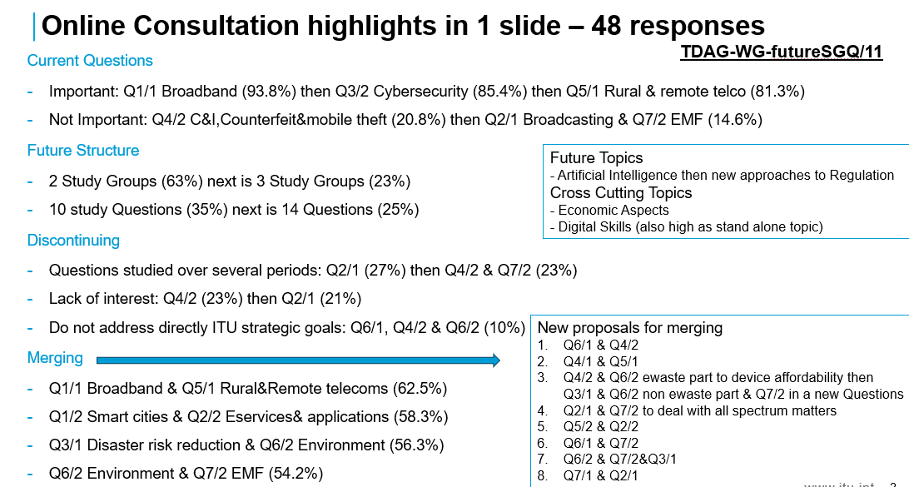
TDAG Chair thank the Chair for the comprehensive online consultation questionnaire and the analysis shared. Mr Oloyede (Nigeria) concurred and queried if proposals of merging were from survey. The Chair confirmed that it was the case. Mr Woodhouse (UK) also queried if the slide was a decision of today’s meeting or a summary result of the survey for all to consider. The Chair replied that it is a summary of results for use by all. Ms Murianki (Kenya) thanked the Chair and noted information on Q6/1 Consumer protection, from the results of the online consultation. Mr Digham (Egypt) said that this snapshot looks at merging from views of respondents and provides a place to start thinking of getting to 5 study Questions for each Study Group. He also pointed out the need to consider room for additional topics to be studied. Mr Mazar (Israel) was pleased to see the number of Questions reduced to 5 per Study Group and the merging options from the snapshot. He said that merging of Q6/2 ad Q7/2 is how ITU-T handles EMF and Environment, and similarly in Israel Ministry of Environment handles EMF matters too. Mr Woodhouse (United Kingdom), request a clarification as to whether resourcing commitments are expected to be less with 5 Questions per Study Group. The Chair shared his experience that there has been a sustained tendency to try to reduce the number of study Questions for efficiency reasons. Currently, Rapporteur Group meetings result in a participant being out of office for 4 weeks and with 5 Questions per Study Group, this can be reduced to 2 weeks where each Question is allocated a day for meeting. Ms Murianki (Kenya) concurred to prioritise the needs of developing countries and not focus on merging Questions. Mr Mazar (Israel) also said that in the future with the ITU building project, hosting may be easier if the duration of Rapporteur Group meeting is reduced from 4 weeks to 2 weeks. He proposed increasing the number of rapporteurs and vice rapporteurs for Questions that are merged. Mr Plossky (Russian Federation) proposed an informal consultation group to continue working after TDAG in May as previous WTDC discussions on Resolution 2 mainly on the Questions part, have been lengthy.
The document was noted with thanks.
Next steps
To move the rich discussion into a concrete document, the Chair proposed to prepare a draft revision of extracts from Resolution 2 annexes including the terms of reference of study Questions, which he will undertake in consultation with his vice Chairs, the SG1 and SG2 coordinators and active collaborators. He will submit this document as a contribution to the next TDAG-WG-futureSGQ meeting.
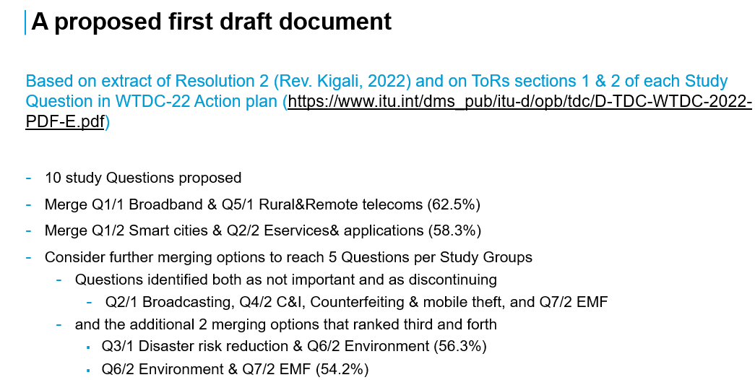
He proposed to have two more meetings before the final one in March 2025 namely on 14 January and on 11 February. Following interventions of Mr Mazar (Israel), Mr Plossky (Russian Federation), Mr Hirayama (Brazil), Mr Oloyede (Nigeria), Mr Benziane (Algeria) and Mr Woodhouse (UK), the Chair responded to queries, and it was agreed to have at least one additional meeting, before the final one in March 2025.
The Chair summarised next steps as indicated below:
- The Chair will prepare a draft revision of extracts of Resolution 2 annexes including the terms of reference of study Questions, for discussion in the next meeting. The revision will aim to incorporate the proposals as per items in the slide image above, as well as address issues raised today. This revision will aim to engage the widest possible set of contributions/views received formally and informally.
- The SG1 Coordinator and SG2 Chair will work with respective (co) rapporteurs towards a common document of:
- Needs of developing countries
- Revised ToRs of current study Questions in line with the above slide image
- The BDT secretariat will be tasked to request focal points from RTOs for the TDAG-WG-futureSGQ who will submit and present inputs of RTOs to the next TDAG-WG-futureSGQ
- The next emeeting will be held in January- February 2025 period after further consultation with BDT secretariat, BDT Director and TDAG Chair.
- Any other business
Dr Zavazava appreciated the discussions and outcomes of this meeting. He indicated that a TDAG emeeting will be held on 23 January 2025 where a progress report of the TDAG-WG-futureSGQ will be welcomed. The Chair acknowledged that all agenda items were covered and closed the meeting by expressing appreciation for the productive session and looking forward to future contributions and meetings. The meeting was adjourned with other thanks and positive remarks from the participants.
- D. Conclusion
The next (virtual) meetings of the TDAG-WG-futureSGQ are planned for the 21st of January 2025 and the 3rd of March 2025.
_______________

