|  |  |
| --- | --- |
| **Regional Preparatory Meeting  for Arab States for WTDC-25 (RPM-ARB)**  **Amman, Jordan, 4-5 February 2025** |  |
|  |  |
|  | **Document** **RPM-ARB25/3(Rev.2)-E** |
|  | **29 January 2025** |
|  | **Original: English** |
| Director, Telecommunication Development Bureau | |
| State of digital development and trends in the Arab States region:  Challenges and opportunities | |
|  | |
| **Agenda item:**  Item 5  **Summary:**  This document, prepared for the RPM for the Arab States region, aims to inform participants and stakeholders in setting the region’s digital agenda. It is structured in two parts: the first provides an overview of the state of digital connectivity in the Arab States Region through key indicators, and the second highlights impactful case studies from the region.  **Expected results:**  RPM-ARB is invited to note this document.  **References:**  N/A | |

State of digital development and trends in the Arab States region: Challenges and opportunities

December 2024

Contents

Contents 2

Introduction 3

Part 1. The state of digital connectivity in the Arab States and recent trends 5

ICT regulation and digital policy frameworks 5

Internet use 11

Broadband subscriptions 16

Mobile network coverage 18

Availability of fixed-broadband infrastructure 21

Internet traffic and international bandwidth 23

Affordability of ICT services 27

Mobile phone ownership and subscriptions 29

ICT skills 32

Revenues and investment 37

Cybersecurity 39

E-waste management 41

Disparity within the region 44

Overview of data availability in the Arab States 46

Part 2. BDT4Impact: Selected case studies from the Arab States 48

Record-breaking cyber response trainings 48

Transforming government services in Djibouti 48

Enhancing the growth and reach of start-ups in the Arab States 49

Building capacity and developing specialized trainer skills in Jordan 49

Preparing National Emergency Telecommunications Plans in the Arab States 49

Partner2Connect implementation for impact in Egypt 50

Annex: Data resources 51

Introduction

Regional preparatory meetings (RPMs) aim at engaging the membership in the preparations of the ITU World Telecommunication Development Conference 2025 (WTDC-25). This document, prepared for the RPM for the Arab States region on 4-5 February 2025, seeks to inform participants and stakeholders as they set the region’s digital agenda.[1] It is structured in two parts: the first provides an overview of the state of digital connectivity in the Arab States through key indicators, and the second highlights impactful case studies from the region.

**A region marked by digital diversity.** The countries in the Arab States region are characterized by stark diversity in digital development, shaped by socio-economic, geographic, demographic and geopolitical factors. Regional averages conceal vast disparities across and within countries and should be interpreted with caution. For instance, there is an 82-percentage-point gap between the country with the region’s lowest Internet penetration and those countries with universal usage. Country-level data featured in this document provides the necessary granularity for the analysis.

**Universal access within reach.** An estimated 95 per cent of the population in the region is covered by a mobile broadband network which supports access to the Internet. The region is thus on the cusp of achieving universal access. The focus must now shift towards addressing barriers to usage and improving the quality of the online experience.

**Barriers continue to limit Internet use.** Even though over 90 per cent of the region’s population had access to the Internet, only 70 per cent was online as of 2024. This indicates that connectivity faces challenges that go beyond infrastructure. Other barriers include lack of awareness about the Internet and its benefits, lack of affordability, and limited digital skills. These not only prevent individuals from using the Internet but also affect the quality of the online experience for those that do.

**Mobile Internet is generally affordable.** Affordability remains a significant barrier to both usage and an improved online experience. While mobile broadband is generally affordable across the region, in low-income economies fixed broadband costs frequently exceed 5 per cent of gross national income per capita.

**Infrastructure challenges hinder connectivity.** The ability to fully reap the benefits of the Internet is heavily shaped by the reliability and speed of the connection. In the Arab States, 5G roll-out has been significantly slower than the global average. As of 2024, 5G remained unavailable in 75 per cent of the region's economies, and was only available to 13 per cent of the population. Additionally, fixed broadband penetration remains very low, at just one-half the global average.

**ICT skills are crucial for realizing the potential of the Internet.** ICT skills are a key enabler of digital transformation, but data on the prevalence of such skills within the population remain exceedingly sparse in the Arab States. The data that are available nonetheless reveal significant disparities in digital proficiency, particularly in areas such as problem-solving and safety skills, which are essential for meaningful participation in the digital economy.

**Digital divides deepen inequalities.** Within most Arab States, significant digital divides across demographic groups hinder inclusive socio-economic development. The digital gender gap remains wide: across the region, only 64 per cent of women are online, compared to 75 per cent of men. This limits opportunities for women to fully participate in the digital economy. Internet usage in the region’s rural areas stands at just 50 per cent, compared to 83 per cent in urban areas. This exacerbates inequalities in access to education, healthcare, and economic opportunities. Furthermore, older generations lag significantly behind young people in digital proficiency, creating a generational gap that risks leaving many behind in an increasingly digital world.

**Closing the divides for digital to be an equalizer**. Bridging these divides is crucial to unlocking the full potential of digital transformation, particularly in countries facing high unemployment and significant socio-economic challenges. Failure to close the divides can lead to a multi-track region, deepening the existing socio-economic disparities and fuelling tensions.

**Universal and meaningful connectivity as a global priority.** Universal and meaningful connectivity (UMC) is a situation where everyone can enjoy a safe, enriching, and productive online experience at an affordable cost. Since 2021, this concept has emerged as a critical policy objective globally. UMC does not mean everyone must be connected all the time. Instead, UMC is a situation where everyone can access the Internet in optimal conditions, at an affordable cost, whenever and wherever needed. It is up to individuals to choose how to use this opportunity.

**No single pathway towards UMC.** Achieving UMC requires holistic strategies encompassing infrastructure, policy, education, and multistakeholder involvement. Recognizing the great diversity of the Arab States, this document does not propose a one-size-fits-all digital strategy. Instead, cluster analysis is used to identify three distinct country groups characterized by shared challenges. This creates opportunities for emulation and knowledge sharing.

**Regulatory improvements can yield far-reaching gains.** While the document does not provide specific policy recommendations, the analysis points to significant scope for improving regulatory frameworks in the region. The quality of regulatory capacity and the overall environment in most countries lag behind the world average. A sound and conducive regulatory regime is essential to promote investment, adoption, and innovation in ICTs. Upgrading these frameworks can thus lead to substantial gains.

**More and better data is part of the solution.** Designing effective and targeted interventions and monitoring progress requires reliable data. Data availability in the Arab States is uneven, particularly disaggregated data by gender, location and age. Most countries do not fully assess key enablers such as ICT skills. Investing in data collection and quality improvement is vital, and ITU offers capacity development and technical assistance to support these efforts.

**Showcasing the power of connectivity through impactful stories.** The second part of the document presents a selection of impactful projects and initiatives led or supported by the ITU Telecommunication Development Bureau (BDT) in collaboration with regional stakeholders. These stories demonstrate how digital connectivity can transform lives by creating opportunities for education, healthcare, and entrepreneurship and empowering individuals and communities, especially in rural and underserved areas. These are concrete, tangible examples of how ITU, Member States and partners can team up to tackle some of the challenges identified in this document and accelerate progress towards UMC.

Part 1. The state of digital connectivity in the Arab States and recent trends

ICT regulation and digital policy frameworks

The evolving landscape of ICT regulation and digital policy frameworks is central to shaping an inclusive and sustainable digital transformation. It is thus essential to benchmark progress, identify good practices and address gaps to ensure national frameworks remain adaptive and impactful.

***ICT regulation in the Arab States region is progressing steadily, but gaps remain***

Over the past 15 years the region has made significant strides, advancing through the generations of ICT regulation. In 2007 fewer than 10 per cent of Arab States were classified as G3, and none had achieved G4 status (the two more advanced generations). Today, nearly 55 per cent of the region have reached G3 or G4. Morocco led the way as the first Arab State to attain G4 status in 2012, achieving this milestone five years after the first country ever had reached it. By 2022 Bahrain, Jordan, Morocco, Oman and Saudi Arabia had also advanced to G4, bringing the total to 74 countries worldwide benefiting from an enabling ICT regulatory environment.

Evolution of the generations of ICT regulation in the Arab States

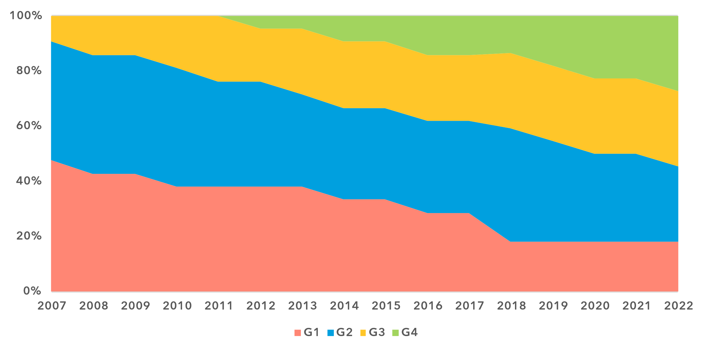

Note: The ‘Generations of ICT regulation’ provides a high-level conceptual framework for assessing the overall development of national legal instruments, policies and governance for the ICT and digital sectors. Generations 1 through 4 are based on [ICT Regulatory Tracker](https://app.gen5.digital/tracker/metrics) scores:

G1 – Command and control approach: score between 0 and 40   
G2 – Early open markets: score between 40 and 70   
G3 – Enabling investment and access: score between 70 and 85   
G4 – Integrated telecommunication regulation: score between 85 and 100

Data for 2021 is unavailable; 2020 data is used as a proxy for 2021.

Source: ITU

Overall, the Arab States region demonstrates an ICT regulatory maturity level that is 10 points below the global average, with an average regional score of 62.7 (out of 100) compared to the global average of 72.4. This trend is consistent across the four pillars of the ICT Regulatory Tracker: regulatory authority, regulatory mandates, regulatory regime and competition frameworks. Notably, the most significant gap is observed in competition frameworks, where the regional average score is 30 points lower than the global average.

Important disparities also persist within the region, with an almost 90-point gap between the country with the most developed national regulatory framework for the ICT sector and the one with the least developed framework. Nearly 45 per cent of countries in the region remain in the least advanced regulatory generations, G1 and G2 – a proportion notably higher than in other regions. Many of these countries face conflict or economic instability, further exacerbating their developmental challenges. Of the 16 countries worldwide still classified as G1, 4 are Arab States; these are countries whose ICT policy and regulatory frameworks have not kept pace with technological evolution in the past decade.

***Continued evolution of institutional landscapes is key to digital transformation***

Strong institutions and effective governance are indispensable for the success of a country’s digital transformation. They provide the stability, accountability and strategic direction necessary to harness emerging technologies, manage risks and align public and private stakeholders with high-level policy goals. By fostering trust, facilitating collaboration and ensuring the adaptability of policies and frameworks, robust institutions can create an enabling environment for innovation and inclusive growth in the digital world.

Regulatory authorities are well established in the Arab States region, with 82 per cent of countries having a separate ICT regulator.[2] Across key areas of institutional capacity such as autonomy of decision-making, sources of financing of the regulatory authority and enforcement capacity, the region’s performance generally remains below the world average, albeit by a modest margin. In the area of accountability, however, the region outperforms the world average, positioning itself as a higher-performing region. Institutional mechanisms such as those for dispute resolution and appeals against regulatory decisions achieve an average score of around 80 per cent of the benchmark in the region, though they still trail the global average and leading regions.

Regulatory capacity in the Arab States region (%), 2022-2023

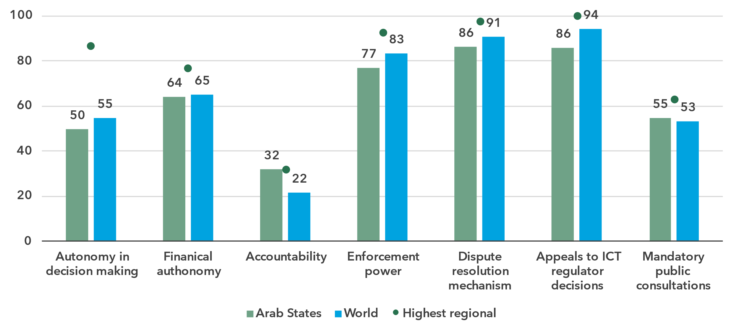

Note: The region’s average scores for key related indicators in the Regulatory Capacity, Good Governance and Stakeholder Engagement benchmarks under the ITU Unified Framework for the Arab States compared to the world average and the highest performing region (various regions are the benchmarks for each indicator).

Source: ITU

Examining governance processes in the Arab States region highlights opportunities to adopt agile approaches more widely across the public sector to enhance progress on digital transformation initiatives.

* **Stakeholder engagement and public participation** in the policy and regulatory process are pillars of good governance. Although public consultations before major regulatory decisions are mandatory in 55 per cent of countries, only 9 per cent make use of these consultations to collect and meaningfully integrate stakeholder feedback into decision-making.[3]
* Regular **policy reviews** are essential to keep regulatory frameworks adaptive, relevant and effective amid rapid technological change. However, only 18 per cent of government agencies in the region conduct ex-post policy reviews and just 5 per cent perform rolling reviews – significantly lower than global averages of 32 per cent and 12 per cent, respectively.[4]
* **Regulatory impact assessments (RIA)** play a key role in evaluating policy impacts and identifying options that promote innovation and mitigate risks. Among Arab States, only 27 per cent of regulators conduct RIA prior to major decisions, compared to a global average of 51 per cent.[5]

Strong institutions are pivotal to translating policies into action. Strengthening the digital skills and expertise of regulators in the region along with their administrative capacity is equally crucial to implementing forward-looking strategies and fostering sustainable, inclusive digital ecosystems.

***Readiness of national frameworks in key areas: opportunities to unlock inclusive growth***

ICT and digital policy and regulation are essential tools for addressing emerging technological and economic challenges while advancing national priorities for prosperity and resilience.

Around the world and in all regions, the state of the enabling environment in most countries currently does not provide sufficient leverage to allow either public sector initiatives or private sector players to unleash the full potential of digital transformation.[6] Despite notable progress, only 18 countries worldwide met the requirements for the Leading category of the G5 Benchmark in 2023, up from nine in 2021.[7] Saudi Arabia is the only Arab State in this group, having joined it in 2023, while Egypt, Kuwait, Qatar, Oman, and the United Arab Emirates have reached the Advanced category, demonstrating steady progress in creating enabling environments for digital markets. However, the majority of countries in the region remain in the Transitioning or Limited categories, with significant work ahead to enable meaningful digital transformation.

The Arab States as a group trail more advanced regions in digital transformation, performing better only than Africa and on par with the CIS region according to the G5 Benchmark 2023. The region’s scores hover near or below the world average across most thematic benchmarks. The indicators for market rules and legal instruments for ICT markets exhibit the largest gaps, scoring respectively 37 per cent and 39 per cent lower than the world average. Notably, the region achieves its highest score – 57 per cent – in regulatory capacity, highlighting a key strength with the potential to drive progress across other benchmarks. Conversely, the lowest score is in regional and international collaboration, underscoring the need for greater focus on fostering cross-border partnerships, which could also accelerate advancements in other areas, such as legal instruments for digital markets and market rules.

Legal, policy and governance frameworks for digital transformation, 2022-2023

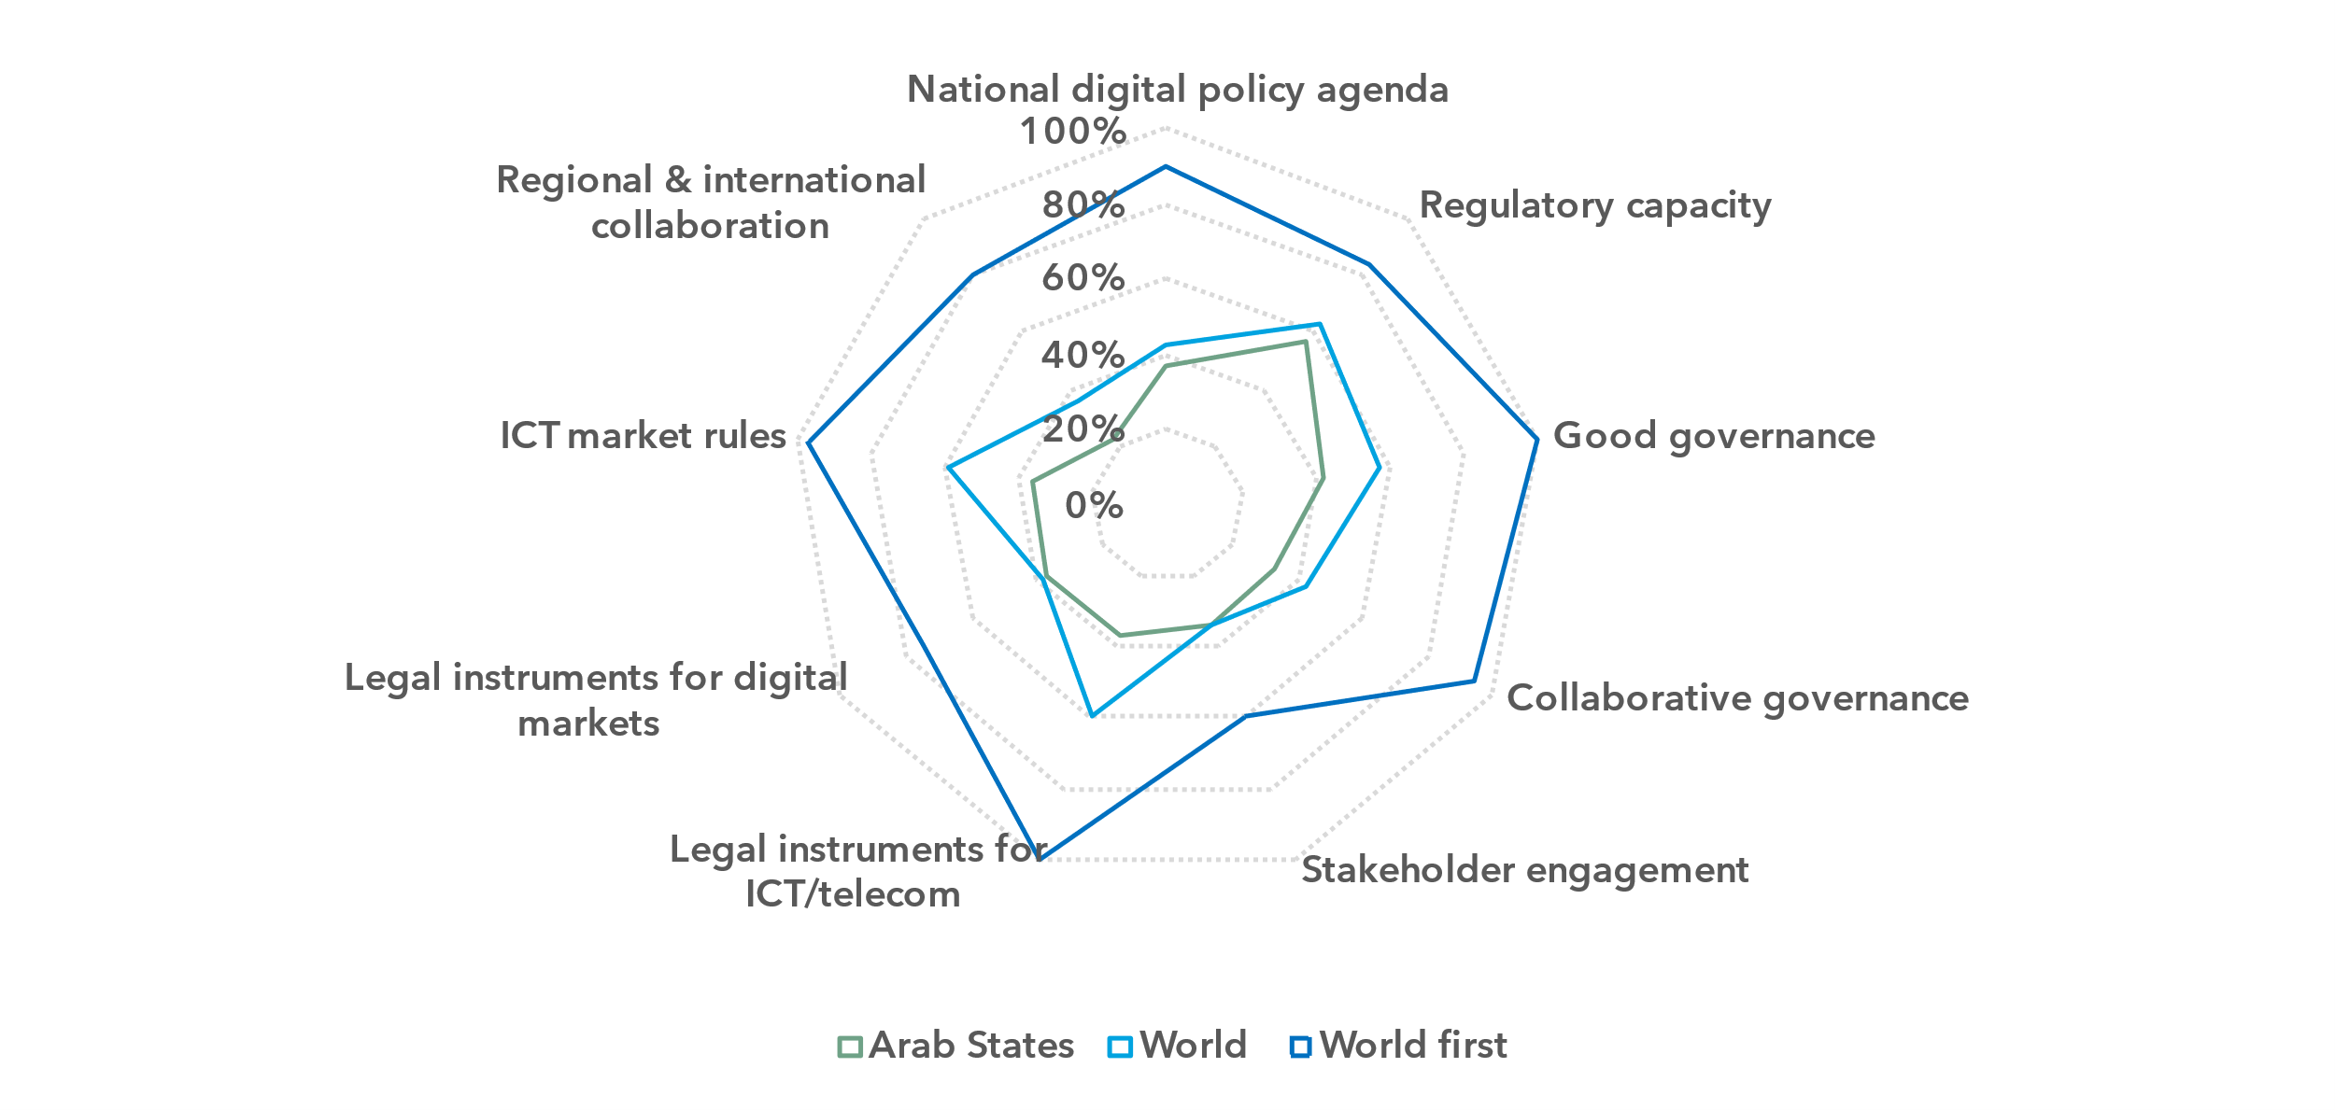

Note: The nine thematic benchmarks (as in the chart above) each comprise a subset of indicators, as part of the [ITU Unified Framework for the readiness of national policy, legal and governance frameworks for digital transformation](https://www.itu.int/pub/D-PREF-BB.REG_OUT01-2023/en).

The chart shows progress on the nine benchmarks for Arab States (average for the group) compared to the world average and the highest performing country, in 2023. The percentage of achievement on each benchmark indicates the proportion of met versus unmet targets on indicators in each benchmark.

Source: ITU

Comparing Arab States to the most advanced global performers in digital readiness reveals substantial opportunities for growth in the region. Strengthening legal, policy and governance frameworks will be critical for the region to unlock the full potential of digital economies and achieve long-term transformation.

***Fostering ecosystems for emerging technologies remains a top priority***

Shaping digital policy and regulatory frameworks for emerging technologies and innovation is about creating the conditions for economies to evolve, diversify and thrive in a rapidly changing global landscape. In the Arab States region, progress in this area remains uneven, with most countries falling below global benchmarks while excelling in select areas.

Key instruments contributing to accelerating digital transformation and building resilience include the following:

* **Foundational instruments**National digital strategies align policy, regulation and innovation to support the adoption and growth of emerging technologies. Among the Arab States, one-half have adopted such a strategy. Cross-cutting instruments, including data protection policies and national cybersecurity strategies, are critical enablers of digital transformation across sectors. By 2023, 59 per cent and 68 per cent of countries, respectively, had implemented such strategies/policies. Digital identity systems – vital for scaling digital government, e-commerce and digital platforms – have been established in 55 per cent of countries, surpassing the global average of 40 per cent.
* **Competition policy**Competition policy is a central piece in driving take-up and innovation in digital markets while mitigating risks. However, Bahrain is the only country in the region to have adopted a competition policy applicable to digital markets, compared to 22 per cent globally as of 2023. Furthermore, less than 10 per cent of Arab States have adopted frameworks that are both technology- and service-neutral, although one-half of the countries have either one or the other. Non-neutral frameworks add administrative complexity and hinder competition, particularly in emerging technologies and services.
* **Innovation and technology policies**Innovation and technology policies identify priority areas for technological advancement in specific sectors and establish mechanisms to support innovation in digital markets. Despite their importance, national innovation policies or regulations governing the Internet of Things (IoT) and cloud computing are to be found in only about one-third of Arab States. Policies on artificial intelligence (AI) and new spectrum technologies are even less prevalent, adopted by just 18 per cent of countries. The absence of these frameworks represents a missed opportunity to strengthen national and regional innovation ecosystems. For countries that have adopted such policies, ensuring cross-sectoral policy coherence, robust technology governance capacities and effective implementation are critical.
* **Broader economic policies**   
  Economic policies also influence digital innovation. While still significant, the proportion of Arab States imposing taxes on ICT and digital services, 45 per cent, is lower than the global average of 56 per cent. Additionally, only one in five countries in the region offer regulatory incentives for ICT and digital market players.

In the most advanced regulatory environments among the Arab States, a marked shift is underway, from infrastructure-focused policies to broader, holistic initiatives that support cross-sectoral digital transformation. Sustaining this momentum is vital to creating an enabling environment for emerging technology ecosystems and fully realizing the digital value chain across the region.

Key instruments for enabling digital markets, 2022-2023

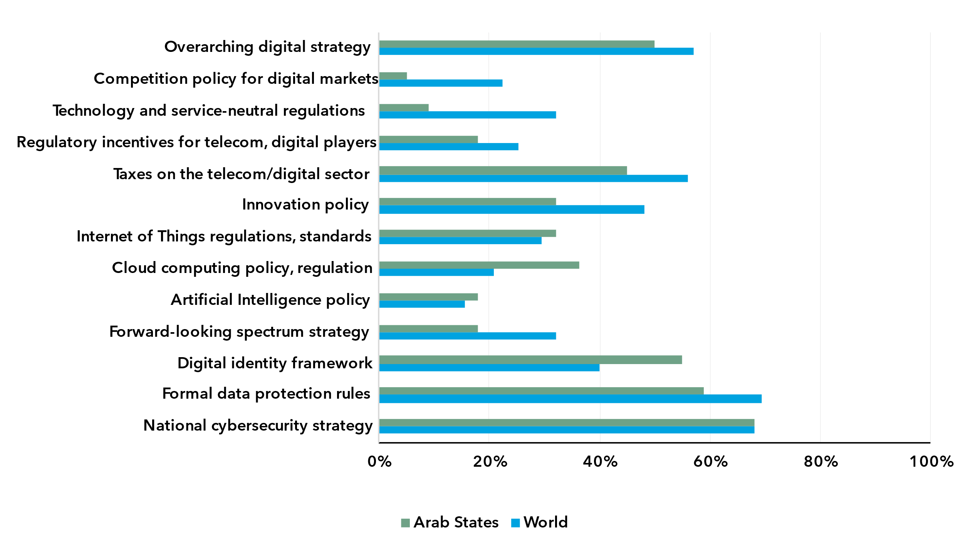

Note: The region’s average scores for key indicators related to National Digital Agenda, Legal Instruments for Digital Markets and Market Rules under the ITU Unified Framework for Arab States compared to the world average.

Data on national cybersecurity strategies is based on the Global Cybersecurity Index (GCI) 2024. Data on all other indicators is based on the G5 Benchmark 2023.

Source: ITU

Internet use

***Internet use in the Arab states has evolved in lockstep with the global average***

Percentage of individuals using the Internet

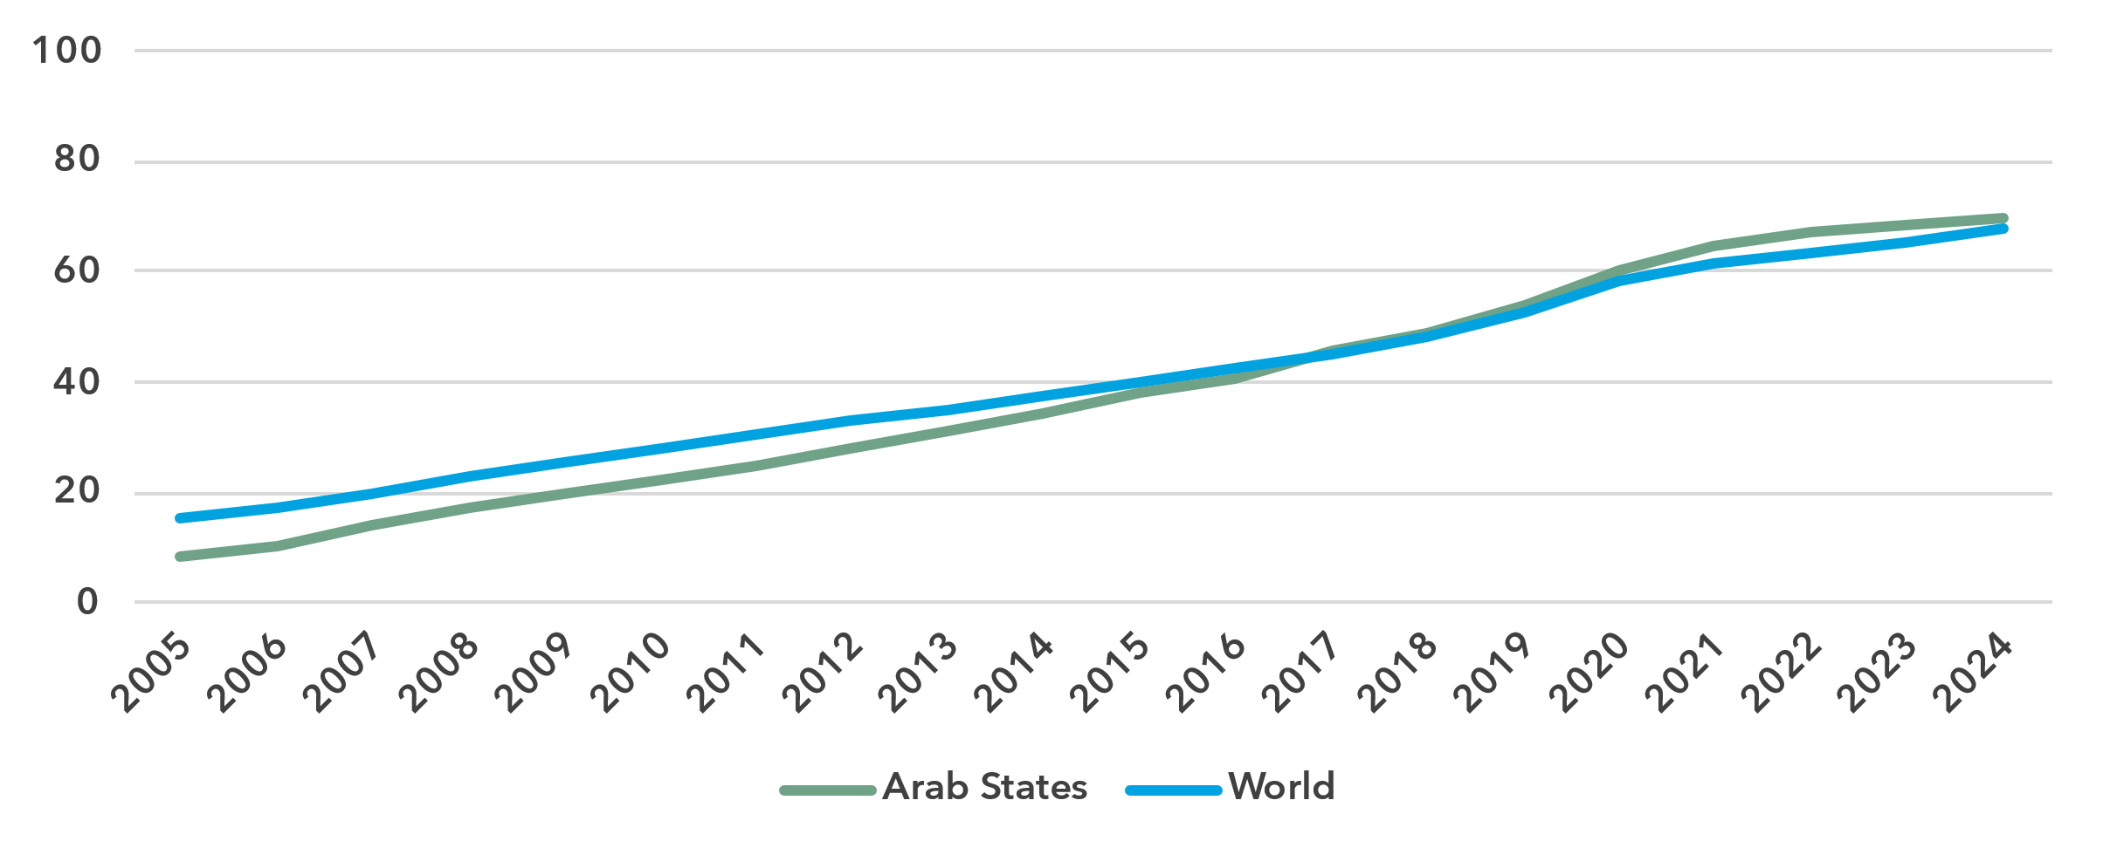

Source: ITU

In 2024, 70 per cent of the population in the Arab States was using the Internet, slightly above the world total of 68 per cent. In 2014, the Arab States moved ahead of the global average. Since 2005, the average annual growth rate of Internet penetration has been 11.6 per cent in the Arab States, against 8 per cent globally. Over the last ten years, these percentages were more modest, at 7.3 and 6.1 per cent respectively.

The Arab States are a heterogeneous region: it includes some economies that are poor and conflict-ridden, with very low Internet use penetration rates, as well as rich economies where nearly everyone is online. As a result, there is a spread of 82 percentage points between the economy with the lowest percentage of Internet users (18 per cent) and the economies with the highest percentage (100 per cent).

Percentage of individuals using the Internet in the Arab states, latest year available[8]

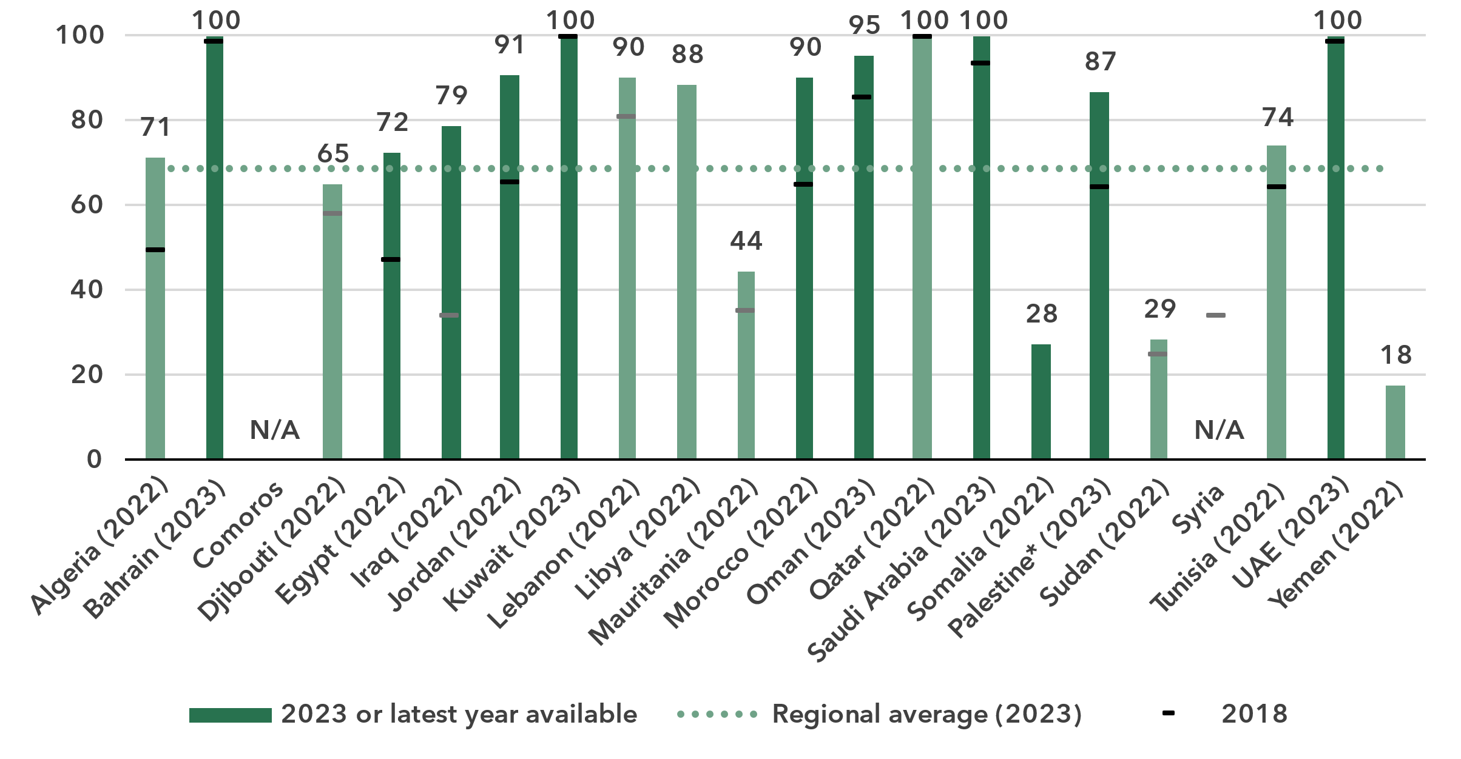

* The State of Palestine is not an ITU Member State; the status of the State of Palestine in ITU is the subject of Resolution 99 (Rev. Dubai, 2018) of the ITU Plenipotentiary Conference.

Note: ITU estimates are in a lighter shade, country-submitted data in a darker shade.

Source: ITU

***Persistent disparity in Internet use by gender***

Percentage of individuals using the Internet, by gender, 2024

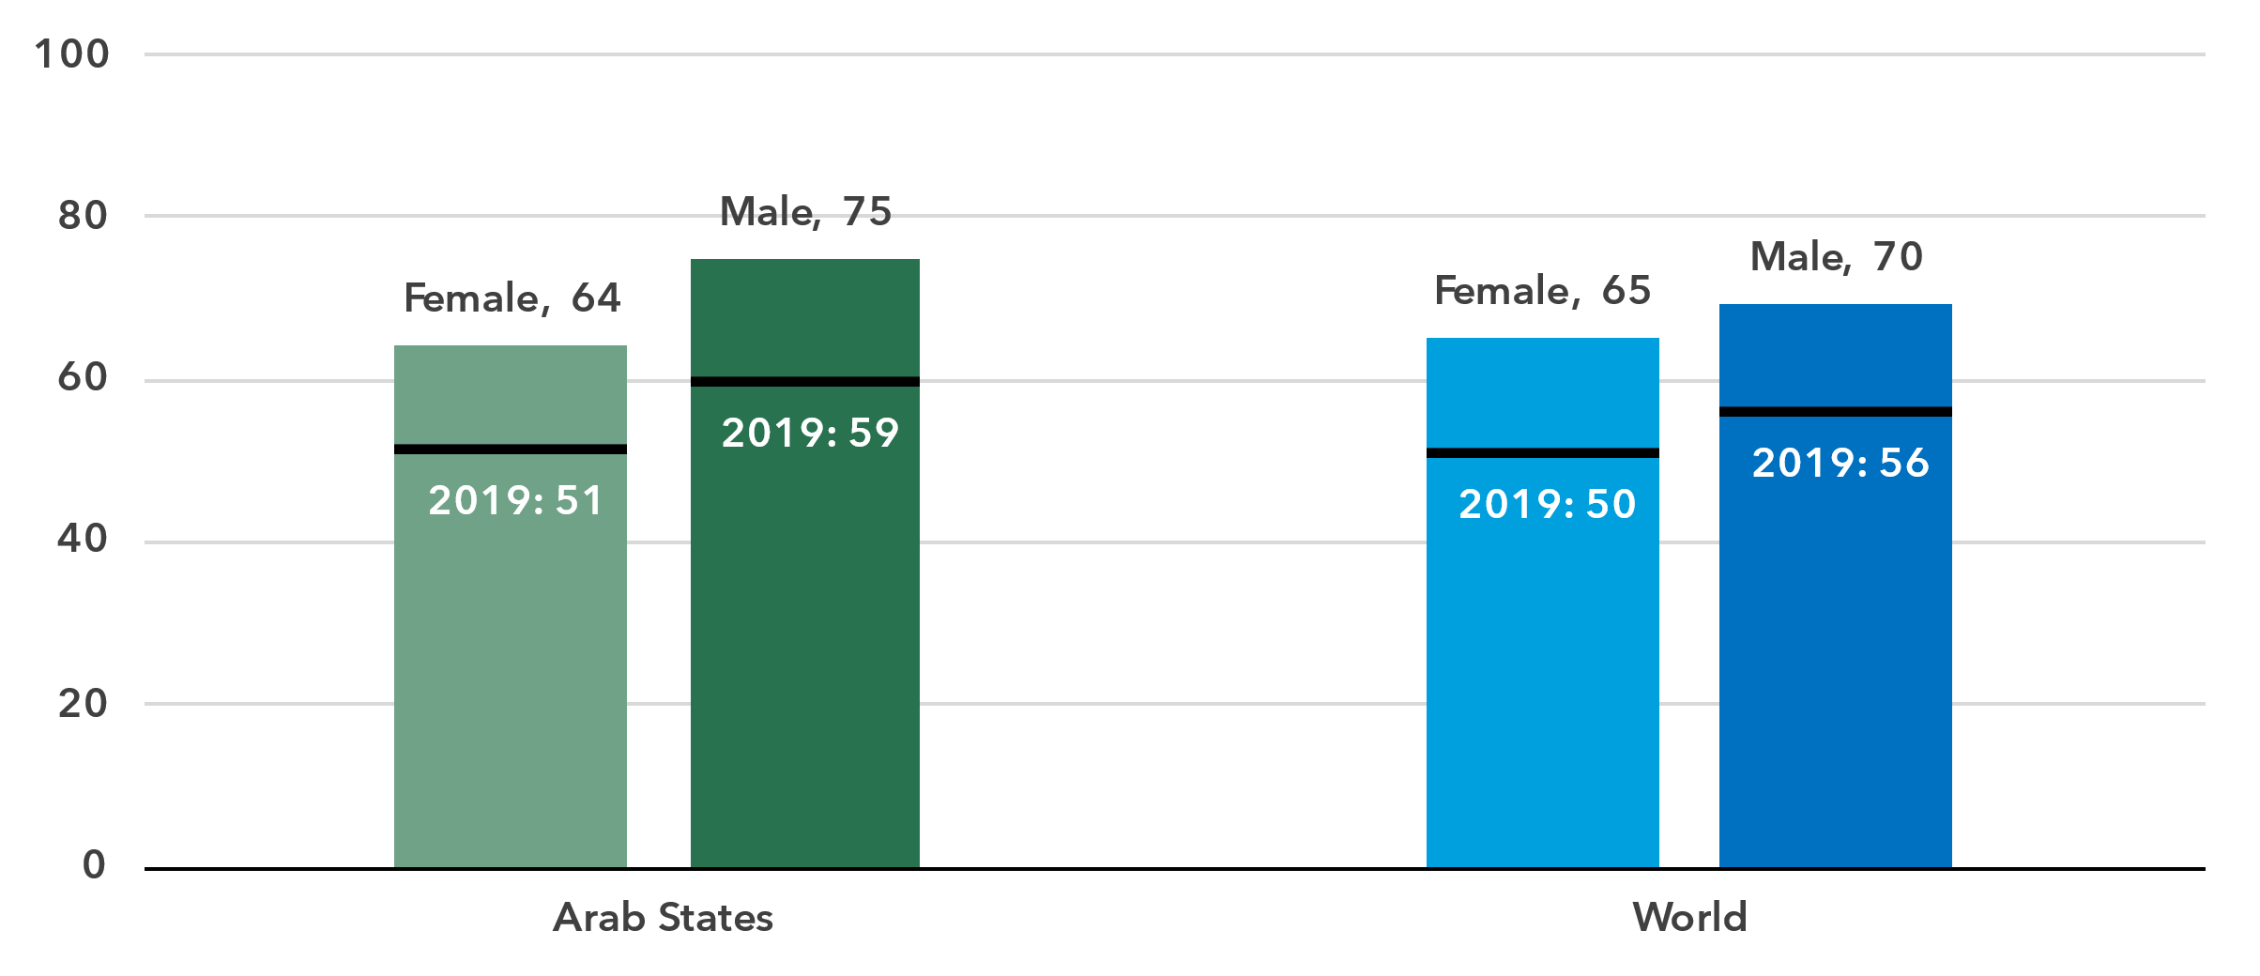

Source: ITU

In 2024, 75 per cent of men were online in the Arab States, against 64 per cent of women. This converts into a gender parity score (GPS)[9] of 0.86, which is significantly lower than the global GPS of 0.94. Furthermore, in the last five years, the GPS has not improved.

Percentage of individuals using the Internet, by gender, latest year available

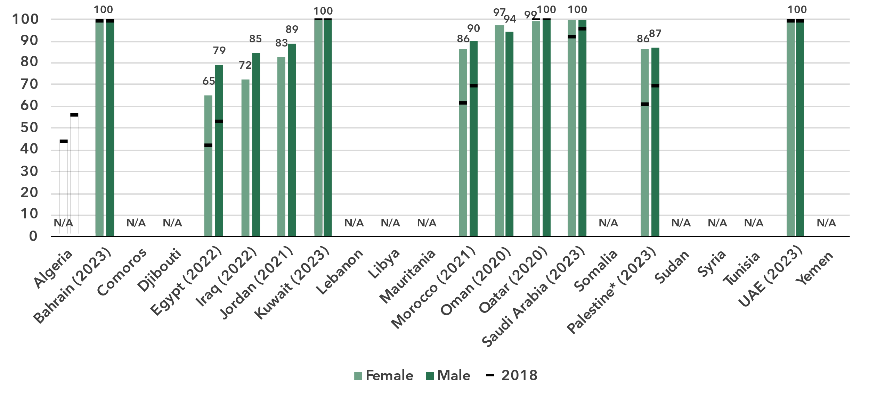

* The State of Palestine is not an ITU Member State; the status of the State of Palestine in ITU is the subject of Resolution 99 (Rev. Dubai, 2018) of the ITU Plenipotentiary Conference.

Source: ITU

In countries with universal or nearly universal Internet use, gender parity has inherently been achieved. Elsewhere in the region, the lack of gender-disaggregated Internet use data limits insight into these gaps. However, estimates based on international trends suggest that the gender divide remains significant in several of these countries.[10]

***Young people much more likely to use the Internet***

Percentage of individuals aged between 15 and 24 years using the Internet, 2024

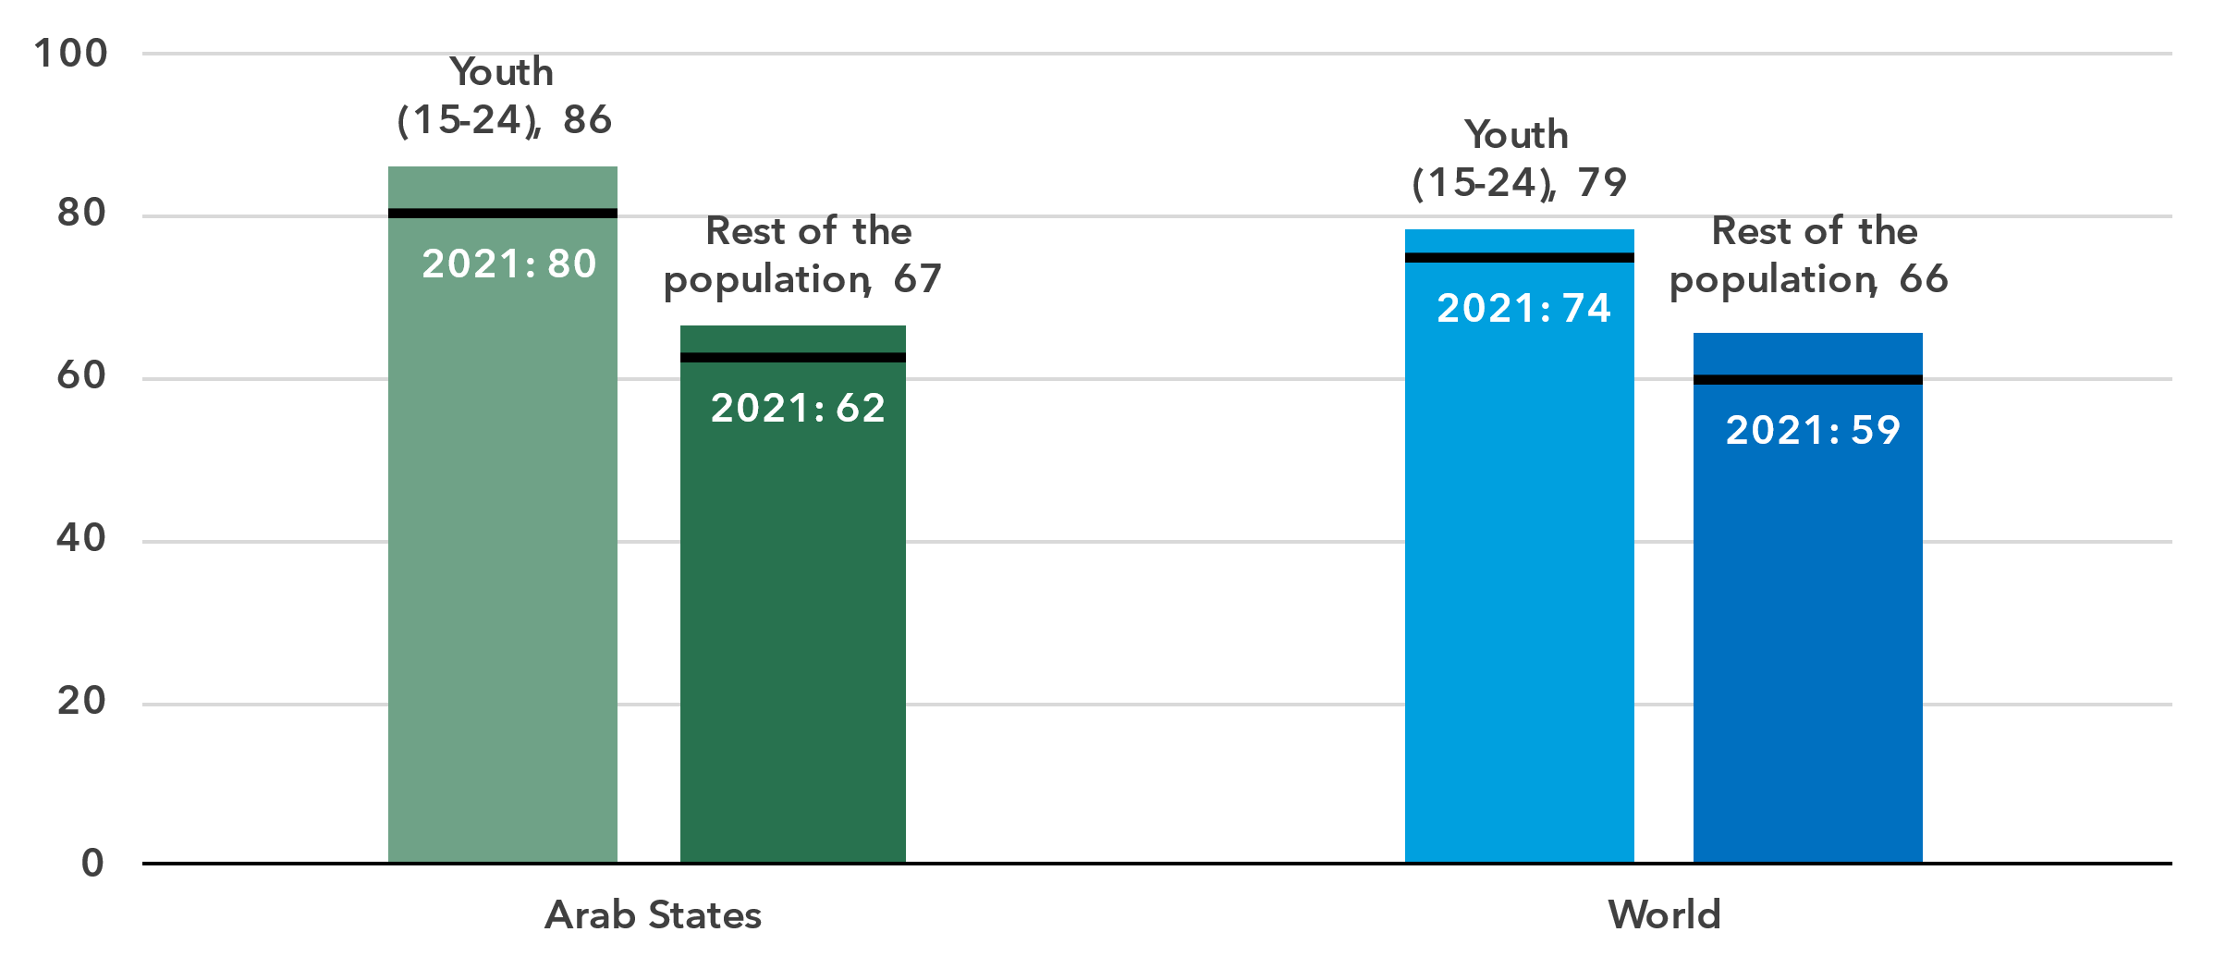

Source: ITU

In the Arab States, 86 per cent of young people aged 15 to 24 used the Internet in 2024, compared to 67 per cent of the rest of the population. The generational gap in this region—measured as the ratio of Internet users between these two groups—has not improved since 2021 and remains significantly higher than the global average, which has been steadily narrowing over the same period.

Percentage of individuals using the Internet by age group, latest year available

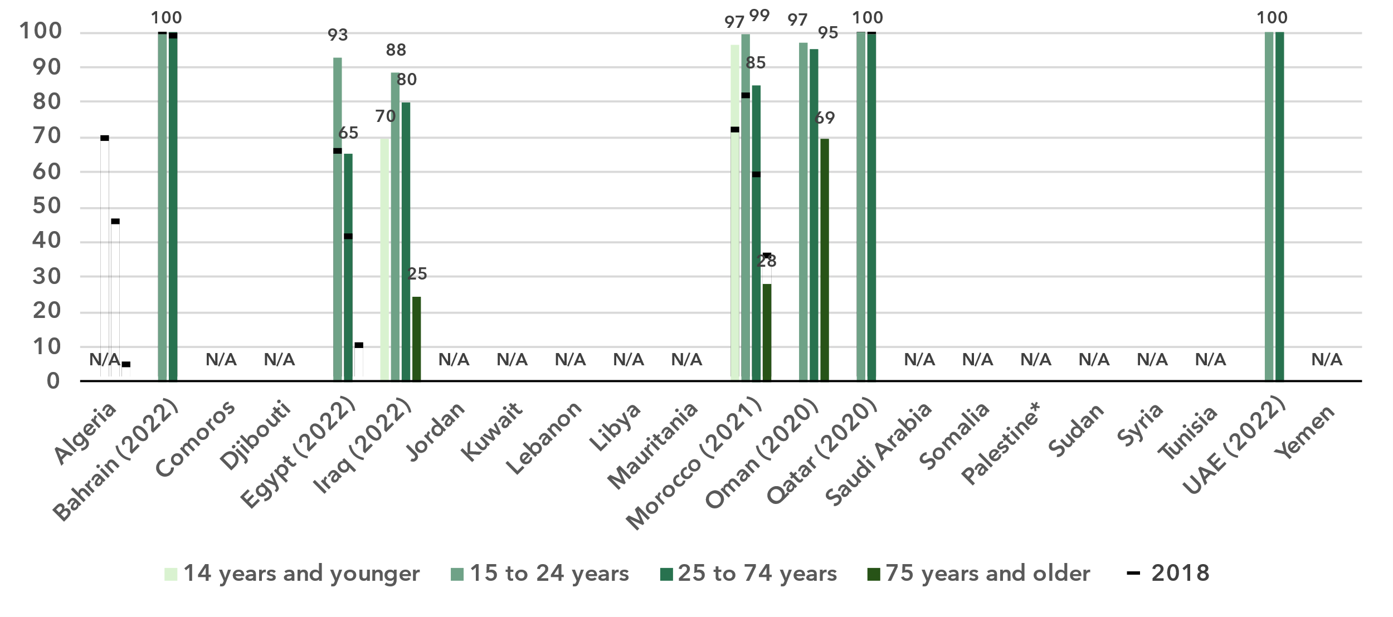

* The State of Palestine is not an ITU Member State; the status of the State of Palestine in ITU is the subject of Resolution 99 (Rev. Dubai, 2018) of the ITU Plenipotentiary Conference.

Source: ITU

Country-level data on the generational gap are available for only a small number of countries, and even fewer provide data for all age groups. However, the pattern is clear: Internet use among older individuals is quite limited, whereas most young people are online.

***Internet use in rural areas trails behind that in urban areas***

Percentage of individuals using the Internet, by location, 2024

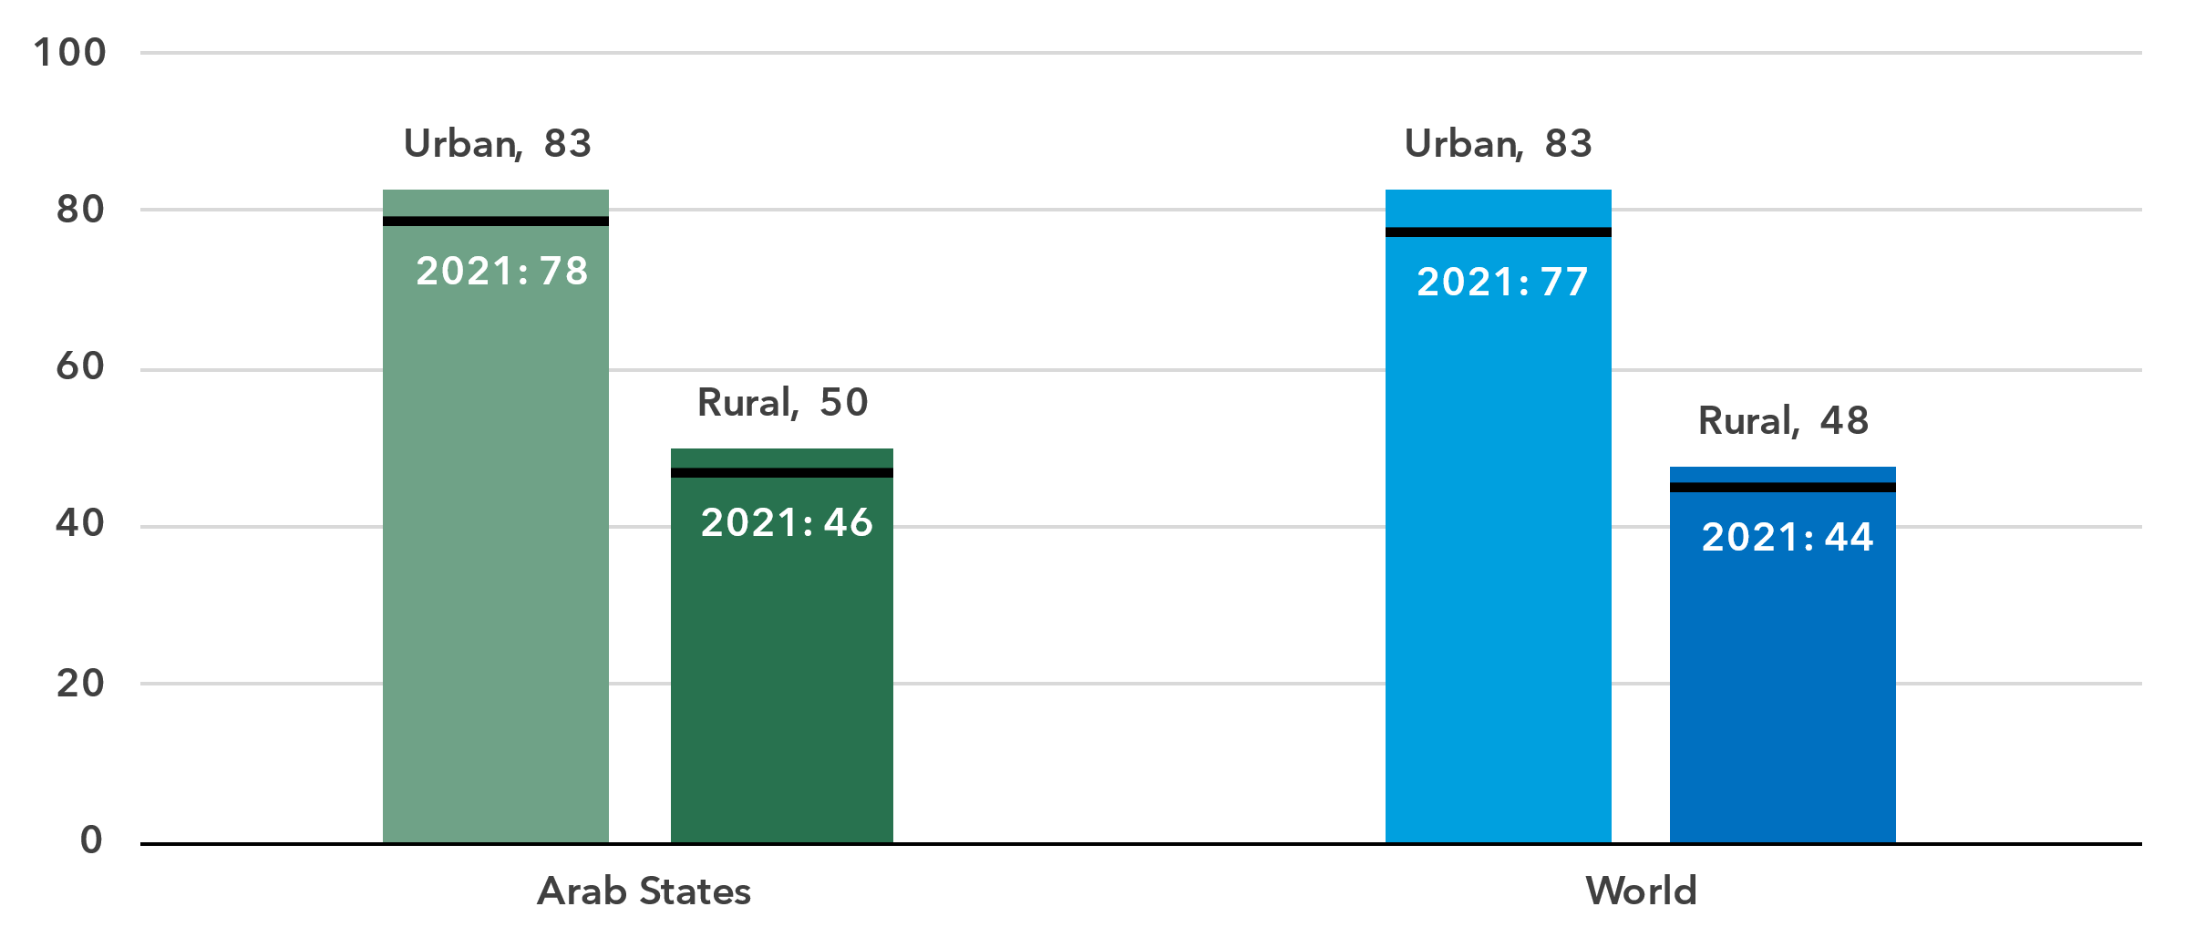

Source: ITU

In the Arab states, 83 per cent of the population living in urban areas used the Internet in 2024, in line with the global average. This starkly contrasts with the region’s rural areas, where only one-half of the population used the Internet; though, again, this is in line with the global average.

Broadband subscriptions

***Fixed broadband subscriptions are lagging***

Broadband subscriptions per 100 inhabitants

|  |  |
| --- | --- |
| **Mobile** | **Fixed** |

Source: ITU

In 2024 the Arab States had 85 active mobile broadband subscriptions per 100 inhabitants, 10 less than the global average of 95. Over the past decade, growth in mobile broadband subscriptions in the region has lagged behind the global trend.

Fixed broadband subscriptions in the Arab States, when measured per 100 inhabitants, are less than half the global average. The region exhibits an unusual pattern: after declining between 2008 and 2015, the indicator has shown a slow recovery, though it remains below its 2008 level. Meanwhile, the global average continues to rise steadily.

Active mobile broadband subscriptions per 100 inhabitants, latest year available

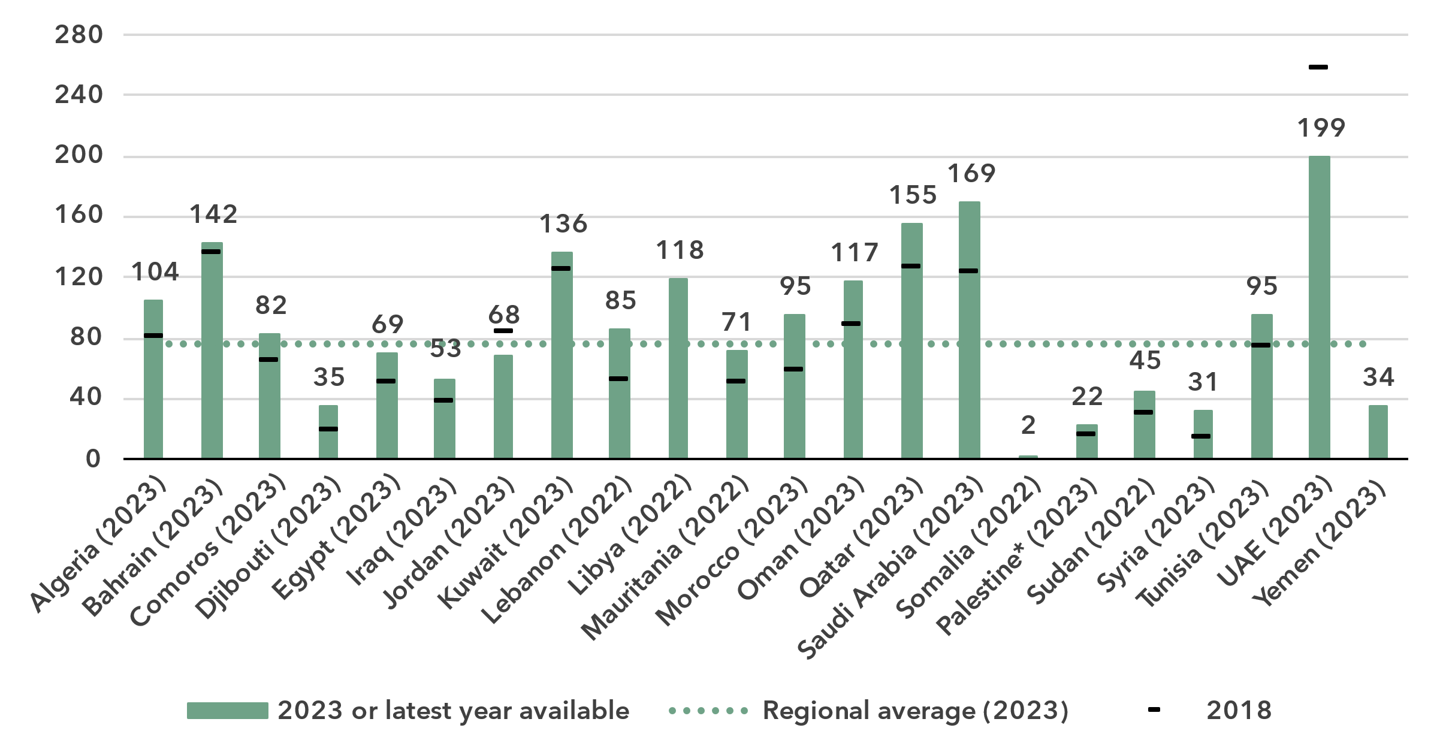

* The State of Palestine is not an ITU Member State; the status of the State of Palestine in ITU is the subject of Resolution 99 (Rev. Dubai, 2018) of the ITU Plenipotentiary Conference.

Source: ITU

In most economies of the region, there is a substantial and growing level of mobile broadband subscriptions, underscoring the importance of mobile broadband as a gateway to the Internet. However, there is a significant disparity between the lowest (2 subscriptions per 100 inhabitants) and the highest (199 subscriptions per 100 inhabitants).

Fixed broadband penetration on the other hand is quite low in most economies in the region. In the economies with higher subscriptions levels, most of these are high-speed subscriptions, meaning at least 10 Mbit/s. In contrast, where subscriptions levels are low, the quality of these fixed connections in terms of speed is often low as well.

Fixed broadband subscriptions per 100 inhabitants, latest year available

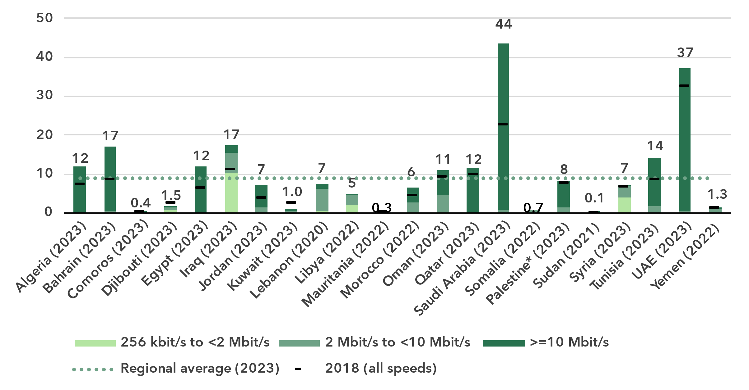

* The State of Palestine is not an ITU Member State; the status of the State of Palestine in ITU is the subject of Resolution 99 (Rev. Dubai, 2018) of the ITU Plenipotentiary Conference.

Source: ITU

Mobile network coverage

***5G network roll-out is progressing slowly***

Percentage of population covered by type of mobile network

|  |  |
| --- | --- |
| **Arab States** | **World** |

Note: The values for 2G, 3G and 4G networks show the incremental percentage of the population that is not covered by a more advanced technology network (e.g. in 2024, 96 per cent of the world population is covered by at least a 3G or above network, that is 4 per cent + 41 per cent + 51 per cent). There are insufficient data to produce estimates for 5G coverage prior to 2020.

Source: ITU

Between 2020 and 2024, 5G mobile network coverage in the region increased from 8 to 13 per cent of the population. Globally, 5G coverage grew at a much faster pace over the same period, from 9 to 51 per cent. In the region, 4G mobile networks covered 87 per cent of the population in 2024, slightly below the global average of 92 per cent. Furthermore, 95 per cent of the population in the Arab States had access to at least a 3G mobile broadband network, leaving 5 per cent without access to a mobile broadband network and therefore without any possibility of accessing the Internet. This coverage gap was one percentage point larger than the global average.

Percentage of population covered by type of mobile network, latest year available

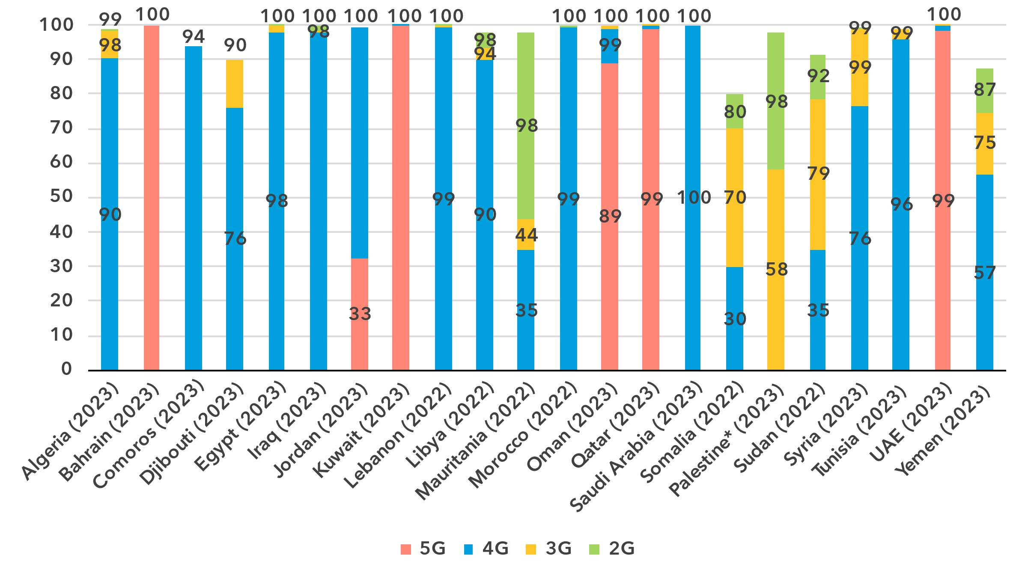

* The State of Palestine is not an ITU Member State; the status of the State of Palestine in ITU is the subject of Resolution 99 (Rev. Dubai, 2018) of the ITU Plenipotentiary Conference.

Note: The values for 2G, 3G and 4G networks show the incremental percentage of the population that is not covered by a more advanced technology network (e.g. in 2023, 75 per cent of the population in Yemen is covered by at least a 3G or above network, that is 57 per cent + 18 per cent).

Source: ITU

The region’s diversity is evident again in the roll-out of mobile networks. In four countries, 5G coverage reaches at least 99 per cent. In stark contrast 5G was not available at all in three-quarters of the economies, where 4G remained the most advanced technology as of 2024. In three economies, at least 25 per cent of the population lacked access to any mobile broadband network whatsoever.

Population coverage by type of mobile network and location, 2024

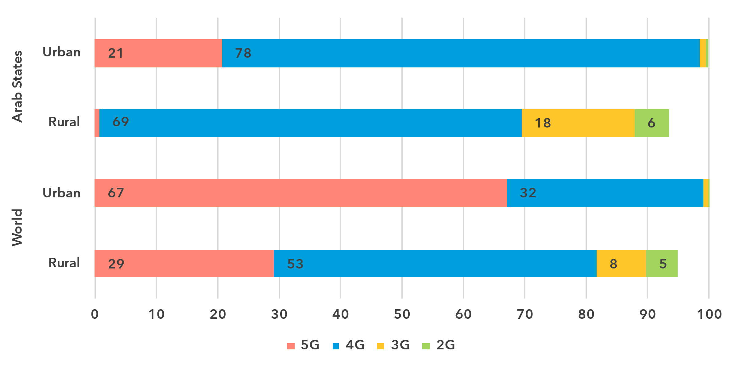

Note: The values for 2G, 3G and 4G networks show the incremental percentage of the population that is not covered by a more advanced technology network (e.g. 90 per cent of the world's rural population is covered by at least a 3G or above network, that is 29 per cent + 53 per cent + 8 per cent).

Source: ITU

As with Internet use, there is a significant gap in network availability between rural and urban areas. In 2024, 5G covered 21 per cent of the overall population in the Arab States, but only 1 per cent in rural areas. The disparity was also notable for 4G networks, with 99 per cent of the urban population covered compared with 70 per cent in rural areas. When including 3G networks, coverage reached 100 per cent in urban areas but only 88 per cent in rural regions. This means that while every urban resident had access to a mobile broadband network, 12 per cent of the rural population in the Arab States remained off the grid, in line with the global average (10 per cent).

Availability of fixed broadband infrastructure

***A quarter of the population lives within 10 km of a fibre node***

Fixed broadband infrastructure forms the backbone of the Internet and is a cornerstone of digital transformation efforts. As part of the ongoing research at ITU, the broadband map initiative provides an overview of the fixed broadband infrastructure placement. Overlaying this data with demographic data makes it possible to infer the availability and proximity of fixed broadband to populations. This is essential for planning – costly – infrastructure projects and helps to ensure that networks have the necessary capacity and reach.

Map of transmission networks and submarine cables for the Arab States region

Note: The image reports active and planned submarine cables, and operational, planned and under-construction transmission networks (fibre-optic cable and microwave). For reasons of space, Comoros is shown in the inset to the right.

The designations employed and the presentation of material on the map do not imply the expression of any opinion whatsoever on the part of ITU or its secretariat concerning the legal status of the country, territory, city or area or its authorities, or concerning the delimitation of its frontiers or boundaries.

Source: ITU, <https://bbmaps.itu.int/app>, 2024

Proximity to a fibre node is a crucial metric for transformative connectivity as it directly impacts network performance, reliability, and scalability. It reduces latency, improves connection stability, and lowers deployment costs, making broadband access more affordable and efficient. Additionally, it enables easier upgrades to support growing bandwidth demands, ensuring networks remain future-proof.

As of 2023, 26 per cent of the population of Arab States lived within 10 km of a fibre node. More than half (58 per cent) lived within 50 km, 82 per cent within 50 km and 93 per cent within 100 km.

Percentage of population within reach of a fibre node, 2023

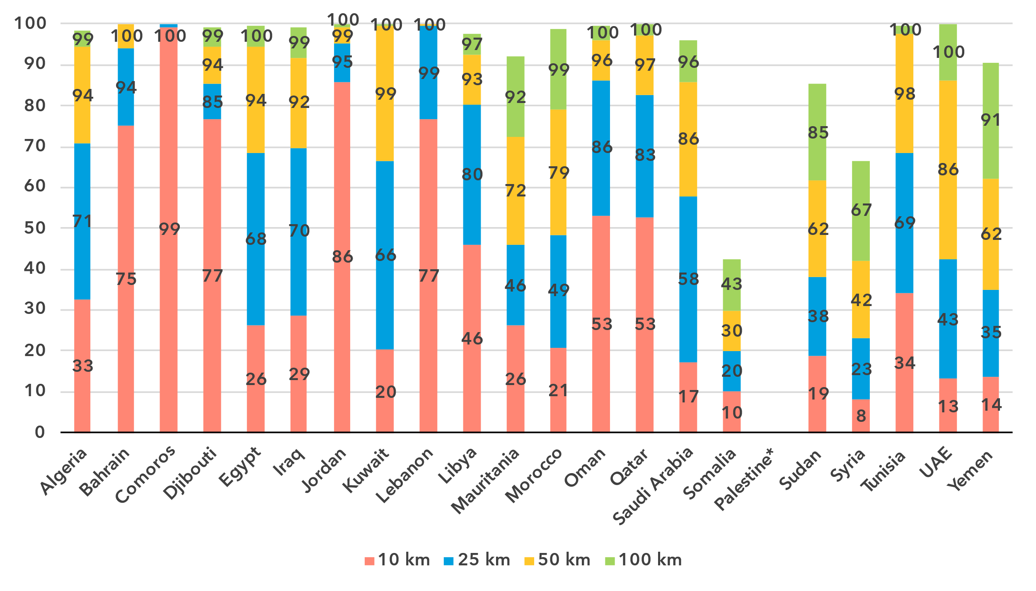* The State of Palestine is not an ITU Member State; the status of the State of Palestine in ITU is the subject of Resolution 99 (Rev. Dubai, 2018) of the ITU Plenipotentiary Conference.

Note: The percentage of population within reach of transmission networks refers to the percentage of people that are within physical reach of nodes on core terrestrial transmission networks for a given distance (see <https://bbmaps.itu.int/indicators-bbmaps>).

Source: ITU

Internet traffic and international bandwidth

***Internet traffic in the Arab States growing faster than globally***

Broadband Internet traffic per subscription per month (GB)

|  |  |
| --- | --- |
| **Mobile** | **Fixed** |

Source: ITU

Internet traffic measures the total volume of data downloaded or uploaded by end users over a given period. For ease of interpretation, figures presented refer to the average monthly traffic per fixed as well as mobile broadband subscription. Traffic levels are typically higher for fixed than mobile broadband, not only because subscriptions are shared by multiple users (e.g. in households), but also because it also includes mobile device traffic routed over Wi-Fi when available.

Between 2019 and 2024 monthly mobile broadband traffic in the region increased from 5 to 16 gigabytes (GB) per mobile broadband subscription, outstripping the global average for traffic growth, which increased from 6 to 14 GB per month during the same period. A similar development took place in fixed broadband traffic, which in the Arab States increased from a monthly 136 GB to 371 GB per subscription, while globally it increased from 141 to 311 GB.

Mobile broadband Internet traffic (GB) per subscription per month, latest year available

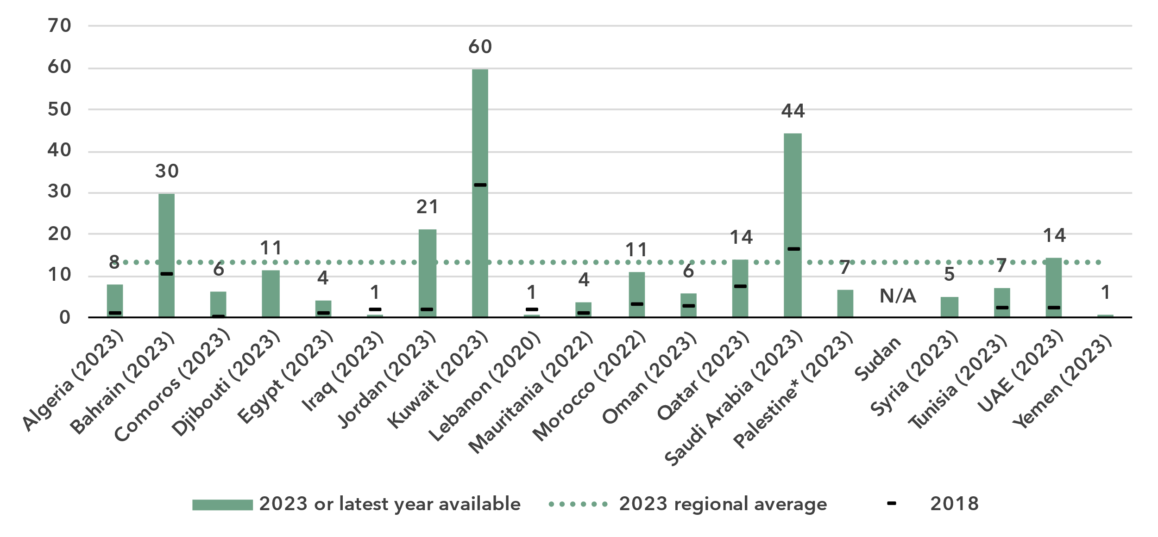

* The State of Palestine is not an ITU Member State; the status of the State of Palestine in ITU is the subject of Resolution 99 (Rev. Dubai, 2018) of the ITU Plenipotentiary Conference.

Note: Internet traffic originating within country.

Source: ITU

The heterogeneity of the region is once again confirmed by the country-level data for indicators of Internet traffic by subscription. Consumers in higher-income economies use more data per broadband subscription than consumers in lower-income economies. It should be noted that mobile is not a substitute for fixed; rather, the two are complementary. The economies with high fixed broadband traffic also have high mobile broadband traffic and vice versa.

Fixed broadband Internet traffic per subscription per month (GB), latest year available

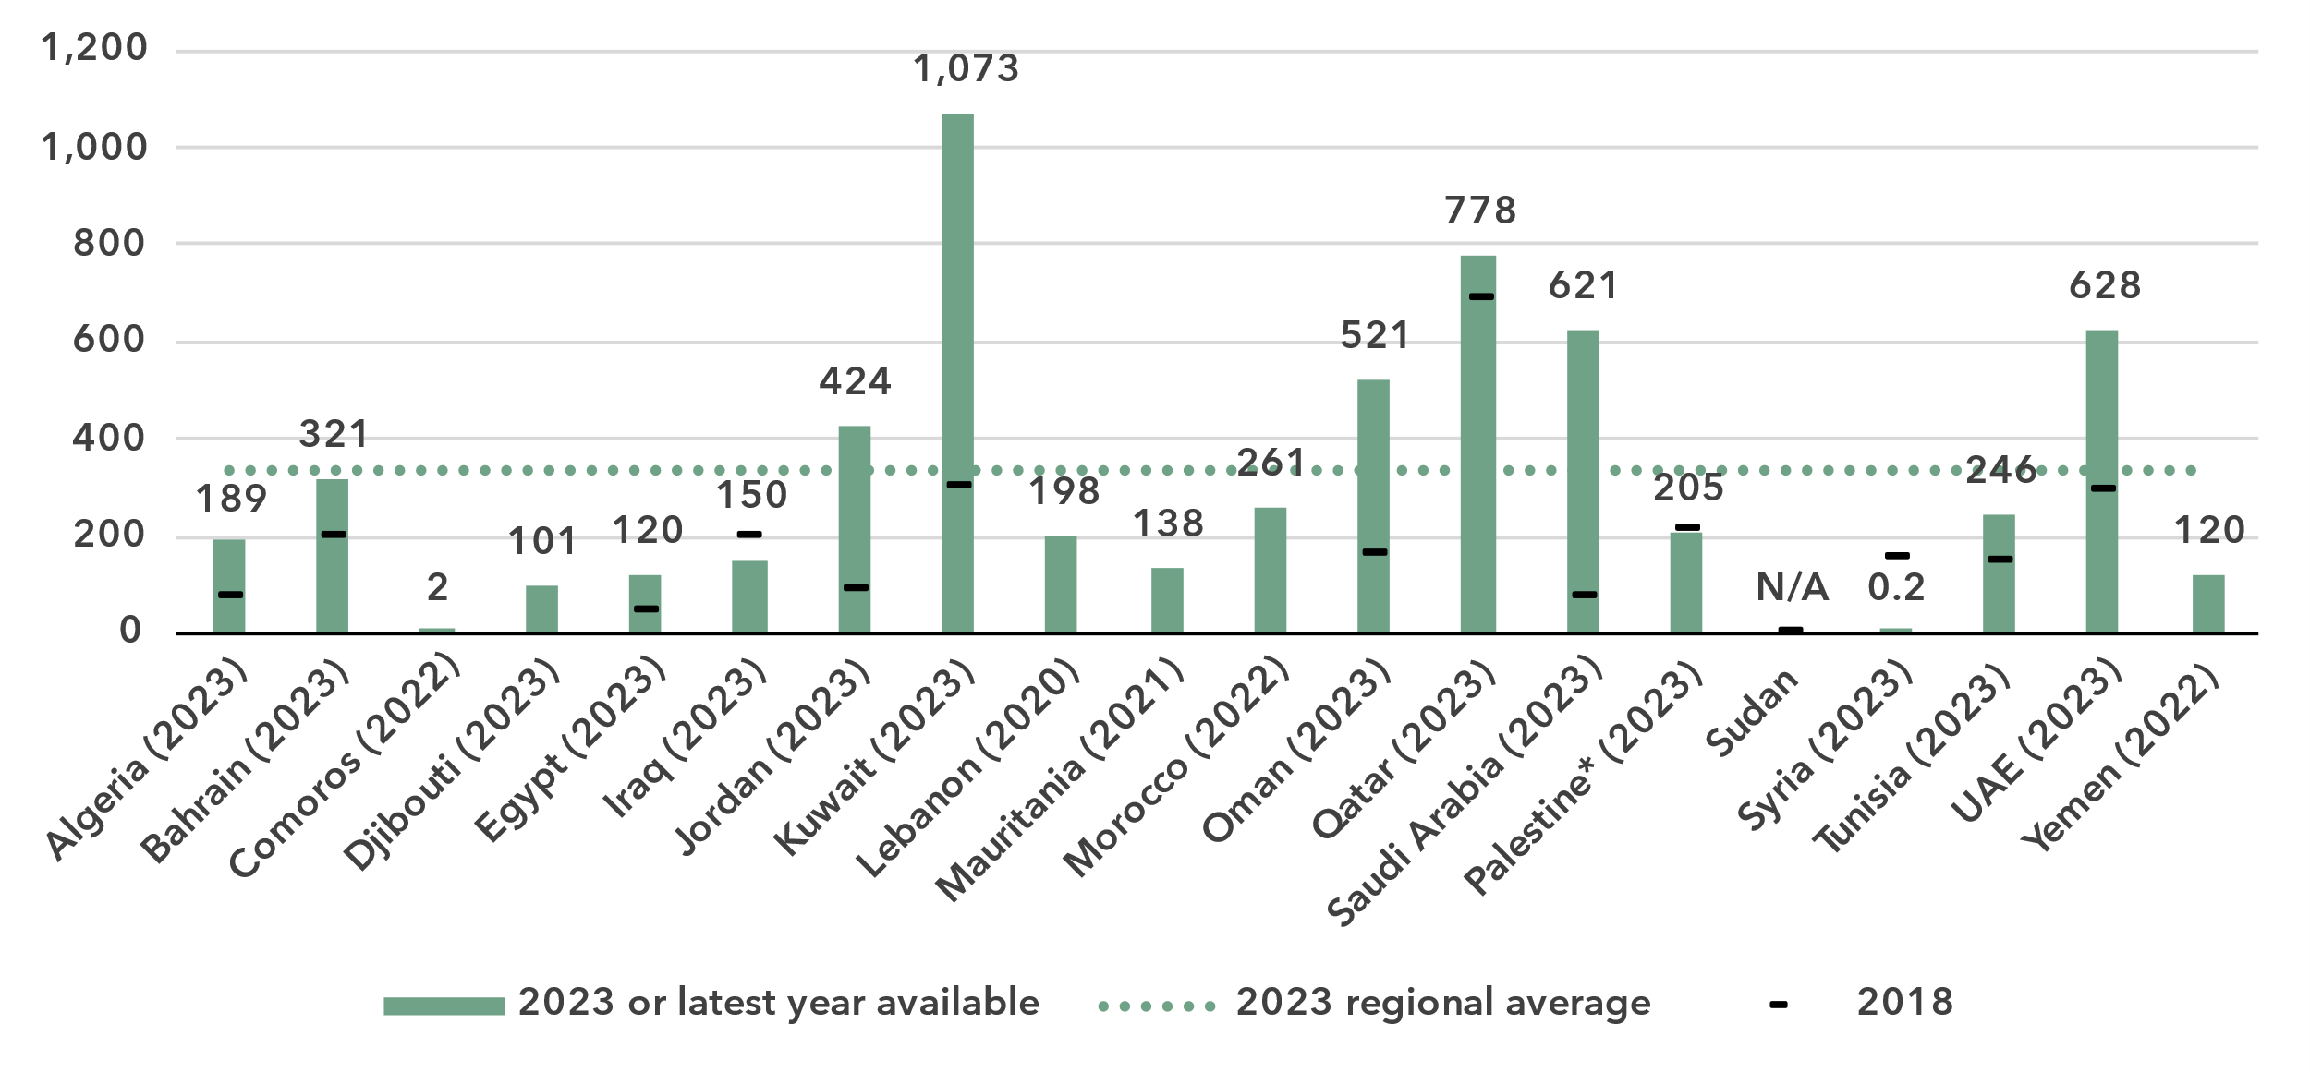

* The State of Palestine is not an ITU Member State; the status of the State of Palestine in ITU is the subject of Resolution 99 (Rev. Dubai, 2018) of the ITU Plenipotentiary Conference.

Source: ITU

Unlike the end-user Internet traffic measured above, international bandwidth usage is a throughput measure that refers to the annual average used capacity of international connections, typically carried over submarine or terrestrial fibre-optic cables or microwave links. It does not sum up all traffic, incoming and outgoing, but captures the larger of the two. For comparability, the figure for bandwidth is divided by the number of Internet users in the country.

International bandwidth per Internet user (kbit/s)

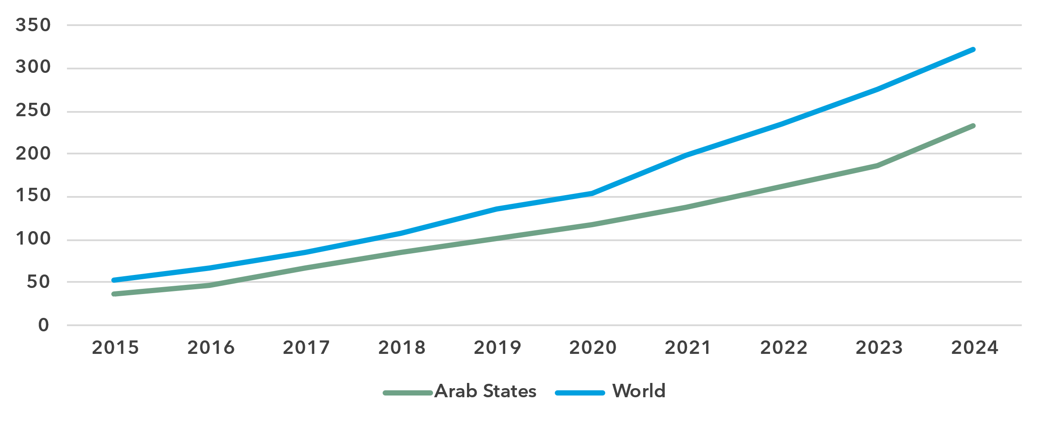

Source: ITU

International bandwidth usage in the Arab States is around 72 per cent of the world average. In recent years, growth of bandwidth usage in the region has accelerated, even exceeding global growth rates, thanks to the deployment of additional submarine cable capacity, especially in the Mediterranean, Red Sea and Gulf regions. The average annual growth rate of 19 per cent between 2021 and 2024 was very similar the worldwide average (18 per cent).

International bandwidth per Internet user (kbit/s), latest year available

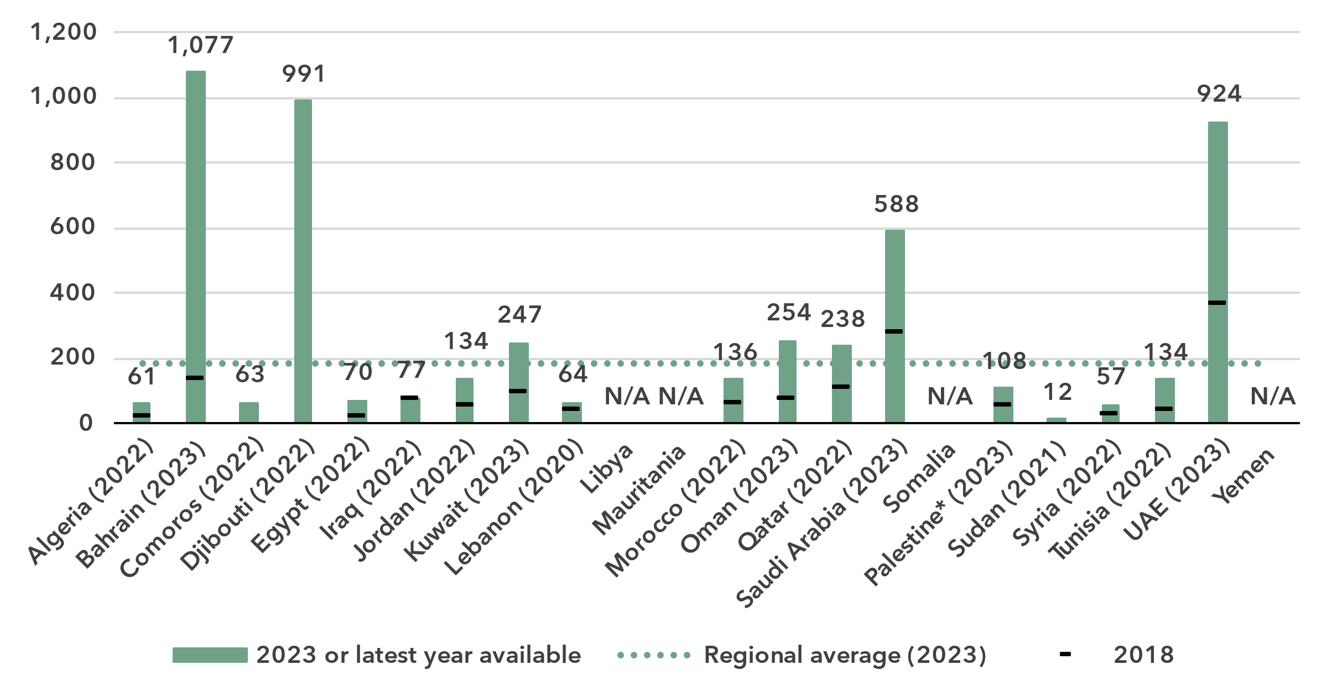

* The State of Palestine is not an ITU Member State; the status of the State of Palestine in ITU is the subject of Resolution 99 (Rev. Dubai, 2018) of the ITU Plenipotentiary Conference.

Source: ITU

The International connectivity infrastructure across the Arab States is very diverse. Some economies in the region have robust international linkage, with multiple submarine or terrestrial cable systems allowing very high international bandwidth usage.

International bandwidth usage is a complex measure, which has to be interpreted in relation to the availability of physical connections, actual and expected domestic demand, as well as agreements with network providers.

High values for international bandwidth per Internet user can indicate that a country is well integrated in international data flows, often with sufficient redundancies in the connectivity infrastructure, or that it is a transit hub (e.g. Djibouti, which has nine operational submarine cables, but very low Internet use penetration domestically), or a combination of the two. By contrast, low bandwidth usage signals that international connectivity is a barrier to universal and meaningful connectivity, as in the case of Sudan.

Affordability of ICT services

***Mobile broadband generally affordable, but fixed broadband remains expensive in many of the Arab States.***

Broadband basket prices as % of gross national income per capita

|  |  |
| --- | --- |
| **Mobile (2GB)** | **Fixed (5GB)** |

Note: Median values shown in the chart are calculated as a percentage of GNI per capita for the set of economies for which data was available for all years from 2018 to 2024 for a given basket in order to adjust the effect of changing data availability.

Source: ITU

High Internet cost is a barrier to Internet use and to meaningful connectivity. The United Nations [Broadband Commission for Sustainable Development](https://www.broadbandcommission.org/) set itself the goal of making broadband in developing countries affordable by 2025, affordability being defined as the availability of broadband access at a price that is less than 2 per cent of monthly GNI per capita. While entry-level data-only mobile broadband services are generally affordable in the Arab States (consistently below the world average), fixed broadband remains above both the world average and the 2 per cent target.

Trends show a remarkable decline in mobile broadband prices since 2018. Fixed broadband on the other hand showed fluctuations, reflecting the shock of the COVID-19 pandemic.

Variations within the region can to a large extent be explained by income variations: both mobile and fixed broadband are affordable in the eight high- and upper-middle-income economies of the region: the cost of mobile broadband ranges from 0.14 per cent of GNI per capita in Qatar to 1.65 per cent of GNI per capita in Iraq. Fixed broadband ranges from 0.33 per cent of GNI per capita in Saudi Arabia to 5.76 per cent in Iraq.

Lower-middle- and low-income economies show a more diverse picture: Iraq, Tunisia, Egypt, Morocco and the State of Palestine[11] meet the 2 per cent target for mobile broadband. But the cost exceeds 5 per cent of GNI per capita in Djibouti and Comoros (both 5.8 per cent) and reaches 10 per cent in the Syrian Arab Republic.

Entry-level fixed broadband subscriptions are typically costlier than mobile for various reasons, including the cost of infrastructure, higher speeds and larger allowances included, and different market conditions. In the Arab States, the difference between mobile and fixed costs as a fraction of GNI per capita is 2 percentage points, more than the difference at the global level (1.4). The high cost of fixed broadband acts as a barrier to meaningful connectivity in many of the lower-middle- and low-income economies of the Arab States region. It exceeds 5 per cent in five countries, and 15 per cent in three.

Broadband basket prices as % of gross national income per capita, 2024

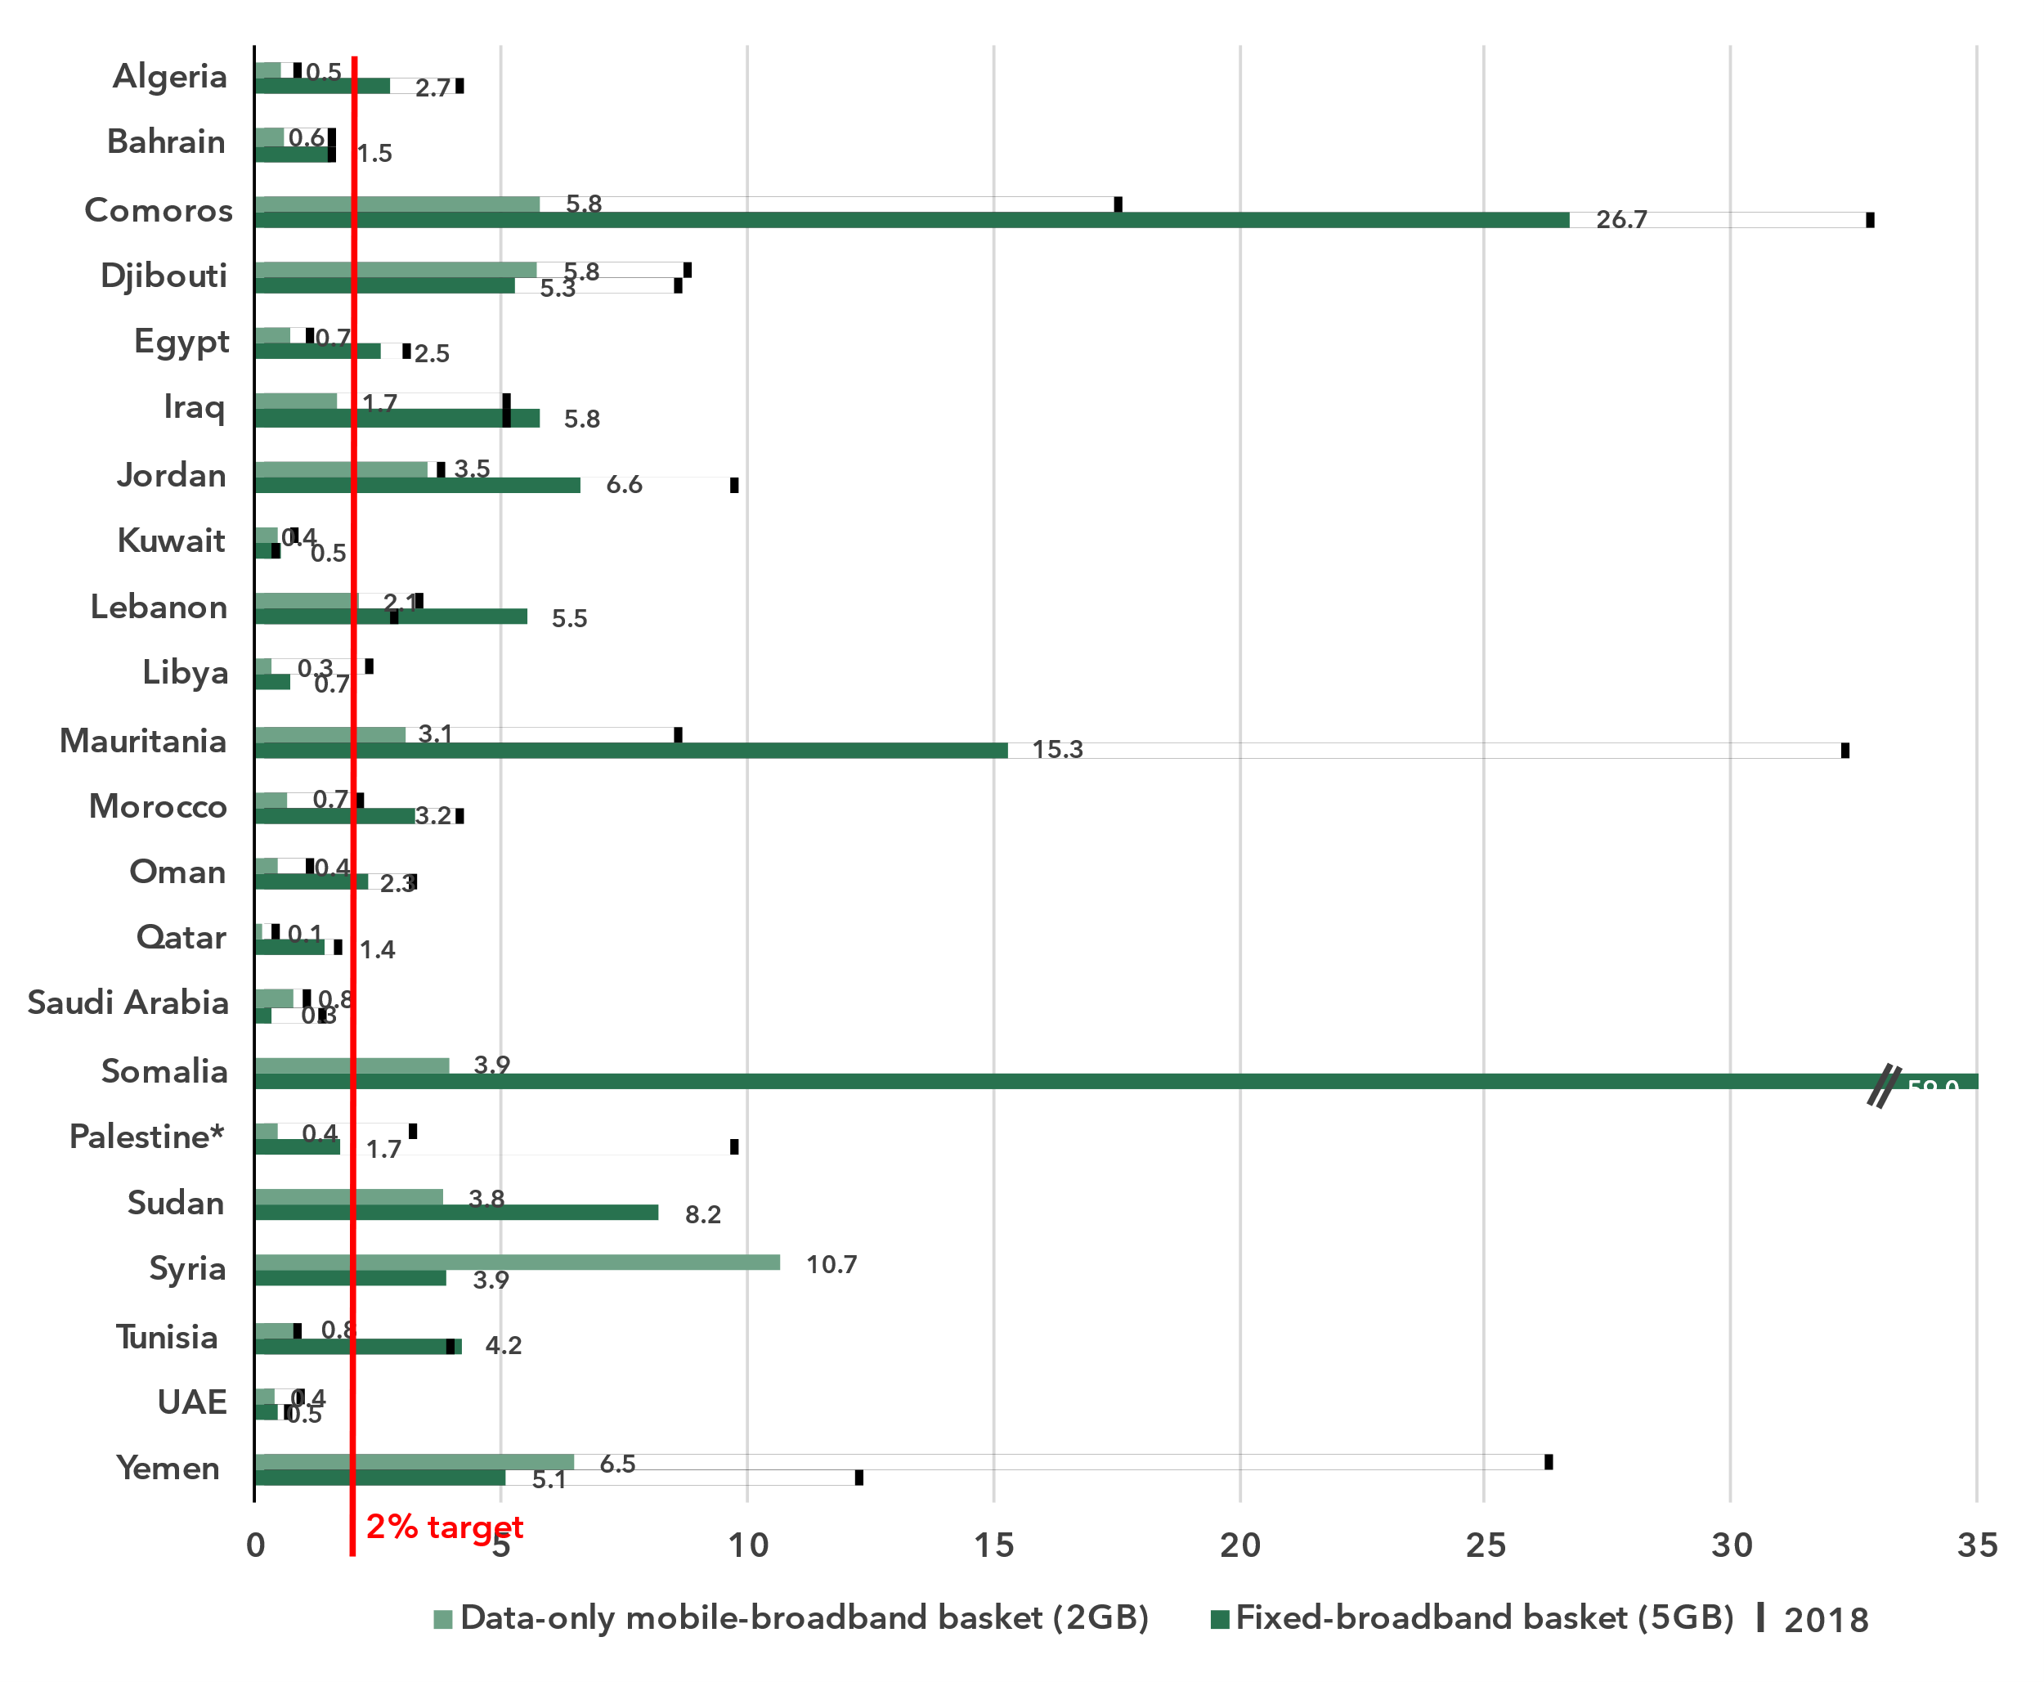* The State of Palestine is not an ITU Member State; the status of the State of Palestine in ITU is the subject of Resolution 99 (Rev. Dubai, 2018) of the ITU Plenipotentiary Conference.

Source: ITU

Mobile phone ownership and subscriptions

***Mobile phone ownership moving towards universality***

|  |  |
| --- | --- |
| Percentage of individuals owning a mobile phone | Percentage of individuals owning a mobile phone by gender, 2024 |

Note: Individuals aged 10 and older.

Source: ITU

In 2024, 83 per cent of individuals in the Arab States aged 10 and older owned a mobile phone, three percentage points more than the global average. Growth over the last five years has been modest, which is not surprising considering the level is already high. The gender parity score for ownership stood at 0.90, unchanged from 2021. During the same period, the global GPS improved slightly, from 0.91 to 0.93.

Percentage of individuals owning a mobile phone, latest year available

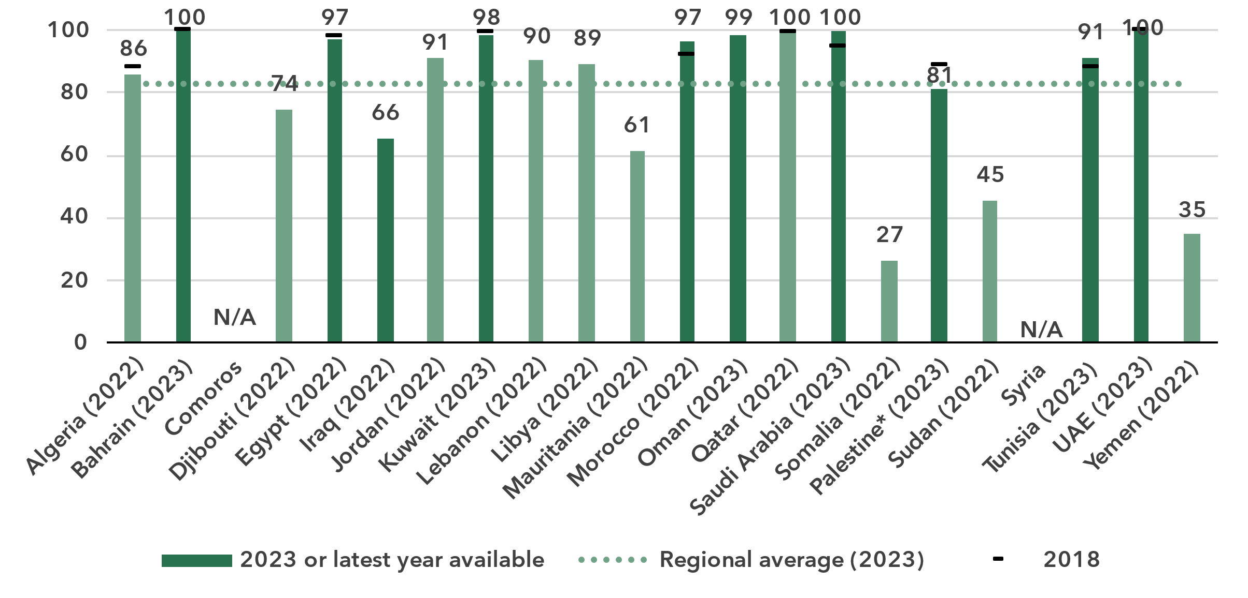

* The State of Palestine is not an ITU Member State; the status of the State of Palestine in ITU is the subject of Resolution 99 (Rev. Dubai, 2018) of the ITU Plenipotentiary Conference.

Notes: Individuals aged 10 and older. ITU estimates are in a lighter shade, country submitted data in a darker shade.

Source: ITU

In most economies of the region, mobile phone ownership was universal (defined as 95 per cent or more) or nearly universal.

Percentage of individuals owning a mobile phone, by gender, latest year available

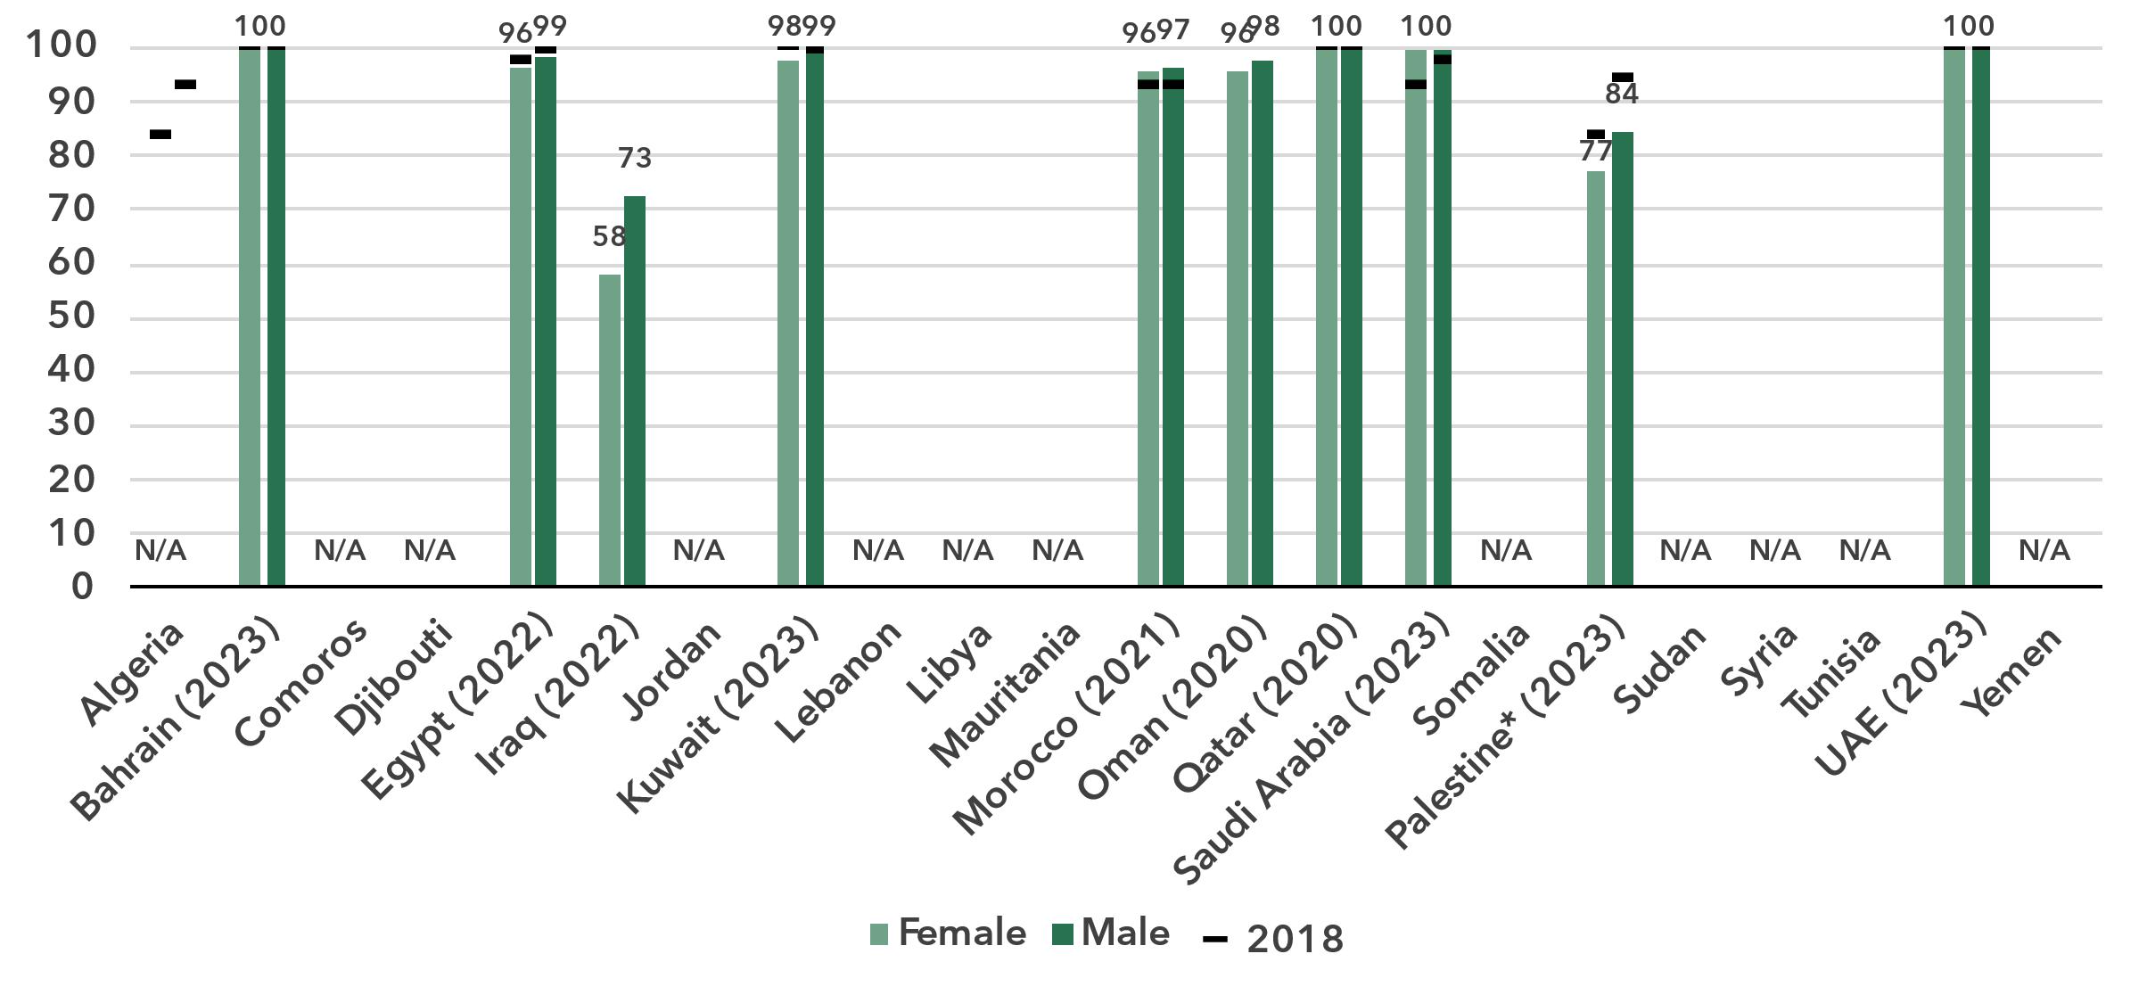

* The State of Palestine is not an ITU Member State; the status of the State of Palestine in ITU is the subject of Resolution 99 (Rev. Dubai, 2018) of the ITU Plenipotentiary Conference.

Note: Individuals aged 10 and older.

Source: ITU

Gender-disaggregated data on ownership is scarce among Arab States, with only 10 countries reporting such data. Of these, eight countries have ownership rates exceeding 95 per cent, indicating they have achieved or are close to achieving gender parity. However, the remaining two countries exhibit significant gender gaps, particularly Iraq, which has a GPS of 0.79. Economies with low ownership rates often also exhibit low gender parity scores. Unfortunately, in many countries the lack of data makes it impossible to fully understand the extent of the problem or take effective action.

Mobile-cellular subscriptions per 100 inhabitants

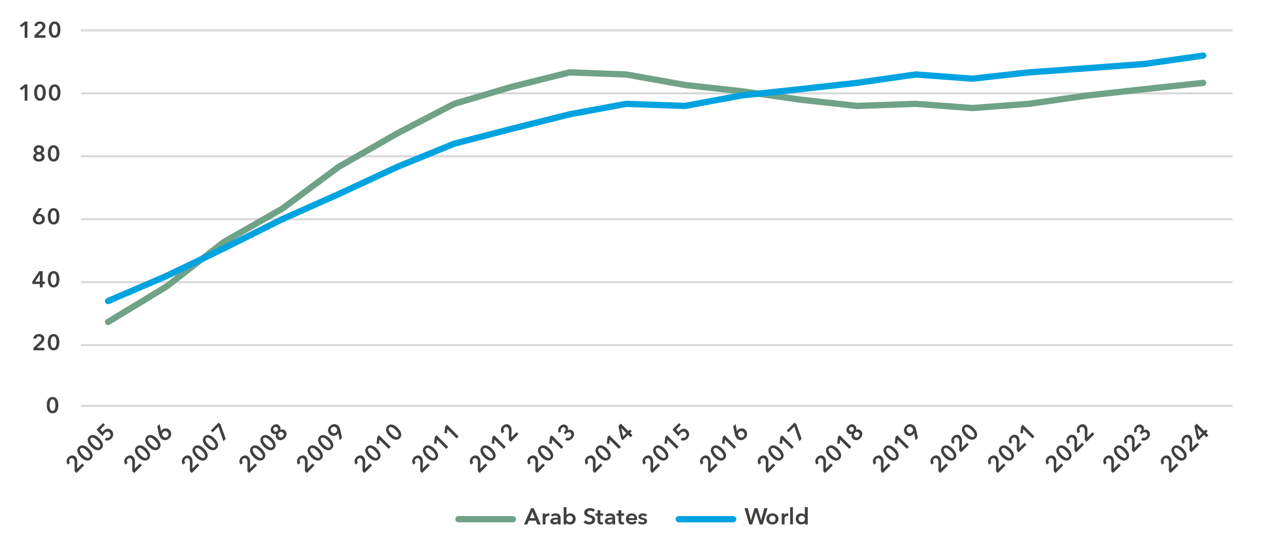

Source: ITU

To use a mobile phone, a mobile-cellular or mobile broadband subscription is needed. While the Arab States are slightly ahead of global rates for most indicators, for mobile-cellular subscriptions the region dropped below the global average in 2017 and has remained below it since.

Mobile-cellular subscriptions per 100 inhabitants, latest year available

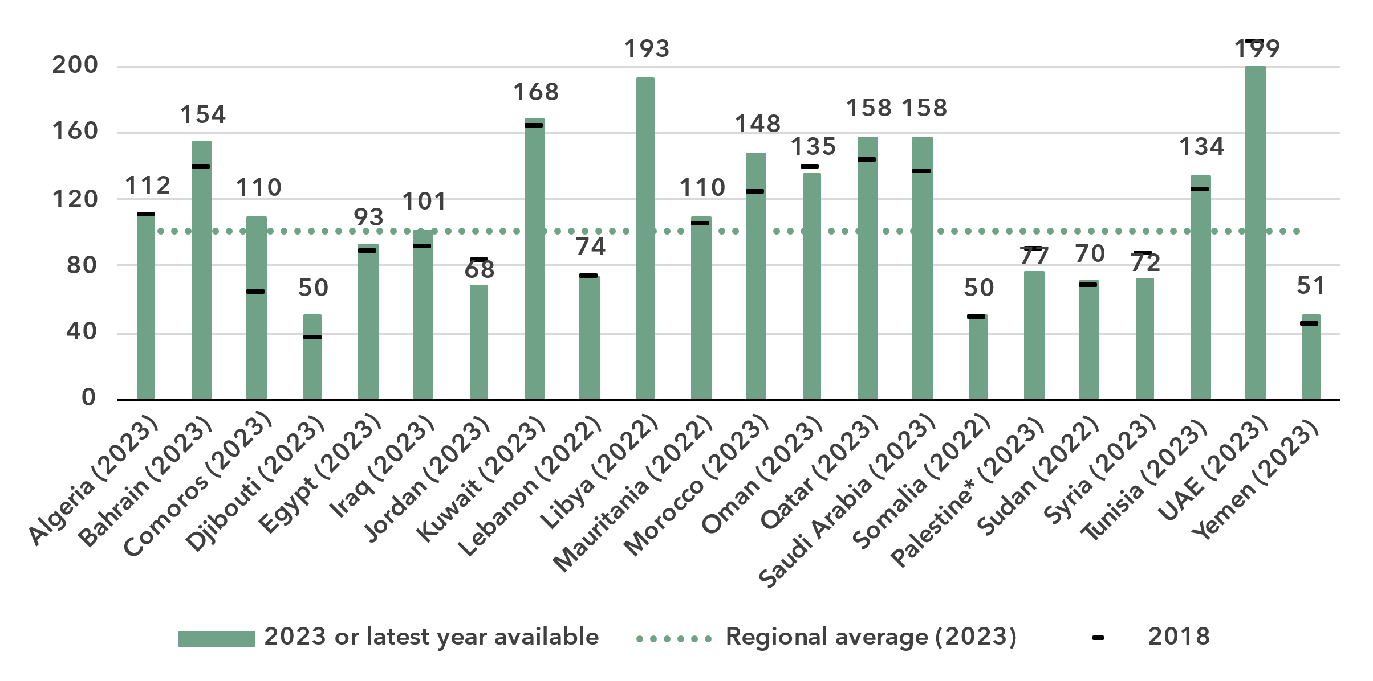

* The State of Palestine is not an ITU Member State; the status of the State of Palestine in ITU is the subject of Resolution 99 (Rev. Dubai, 2018) of the ITU Plenipotentiary Conference.

Source: ITU

Penetration rates of mobile cellular subscriptions are strongly correlated with the level of development of the economies in the region.

ICT skills

***Large variety in ICT skills among Internet users***

Because self-reporting of individuals’ ICT skills is subjective, ICT skills are measured based on household surveys asking whether an individual has recently performed certain activities. Performing these activities presupposes a degree of proficiency in relevant digital skills. The activities are grouped into five areas: information and data literacy; communication and collaboration; digital content creation; safety; and problem solving.

While the importance of digital skills in leveraging ICTs for economic prosperity and social well-being is well-documented, data remain very scant. Since 2020 only 90 economies, including 11 Arab States, have submitted data, frequently patchy, on digital skills. Even fewer – just 40 countries, including 2 Arab States – provided comparable data on ICT skill levels (see box for details on the methodology for calculating ICT skill levels).

Percentage of Internet users with ICT skills in the Arab States, by skill level, 2023

|  |  |
| --- | --- |
| **Oman** | **State of Palestine\*** |

* The State of Palestine is not an ITU Member State; the status of the State of Palestine in ITU is the subject of Resolution 99 (Rev. Dubai, 2018) of the ITU Plenipotentiary Conference.

Note: Data for Oman refer to individuals aged 18 and older. Data for the State of Palestine refer to individuals aged 10 and older.

Source: ITU

In the State of Palestine, communication and collaboration is the category for which most Internet users—88 per cent in all—have reported having basic or above basic skills. The second highest level of skills was in information and data literacy, with 67 per cent of Internet users having at least basic skills. Digital content creation follows, at 53 per cent. For the last two categories, safety and problem solving, only 26 and 27 per cent of Internet users, respectively, reported at least basic skills.

The picture in Oman looks quite different. Except for communication and collaboration, for which data are not available, a large proportion of Internet users report having at least basic or above basic skills, between 88 and 95 per cent in each category.

|  |  |  |  |  |  |  |
| --- | --- | --- | --- | --- | --- | --- |
| **Methodology for calculating ICT skill levels**  At its 11th meeting in September 2023, ITU’s Expert Group on ICT Household Indicators (EGH) [recommended changes](https://www.itu.int/itu-d/meetings/statistics/wp-content/uploads/sites/8/2023/09/Report-of-the-EGH-subgroup-on-ICT-Skills.pdf) in how data on ICT skill levels are reported – most importantly, that skill levels of individuals should be assessed for different areas.  *Individuals should be assessed on the number of activities within a skill area they report having done in the last three months using the following progression:*   |  |  |  | | --- | --- | --- | | None | Basic | Above basic | | 0 activities | 1 activity | More than 1 activity |  * *Skill levels should not be assessed in skill areas where fewer than two indicators are collected.* * *Indicators should be weighted equally within each skill area.* * *Skill areas with different numbers of components should be treated equally.*   While this recommendation does not require any additional data collection, it does require that countries perform additional analysis on existing survey microdata. ITU requested data on ICT skills for the first time in its April 2024 data collection, and received data from 40 countries, including 2 Arab States. However, other countries were unable to provide data, even though in many cases data on the underlying activities had been collected. It is expected that data availability will improve as familiarity with these new recommendations increases. |

A different way to analyse these data is by comparing the distribution of country values for the activities that comprise each of the five skill areas. This provides a view of the prevalence of each activity among Internet users relative to others in the same area. It also shows the wide range of variation in ICT skills in countries in the region even when focusing only on those using the Internet.

Percentage of Internet users with information and data literacy skills, latest year available

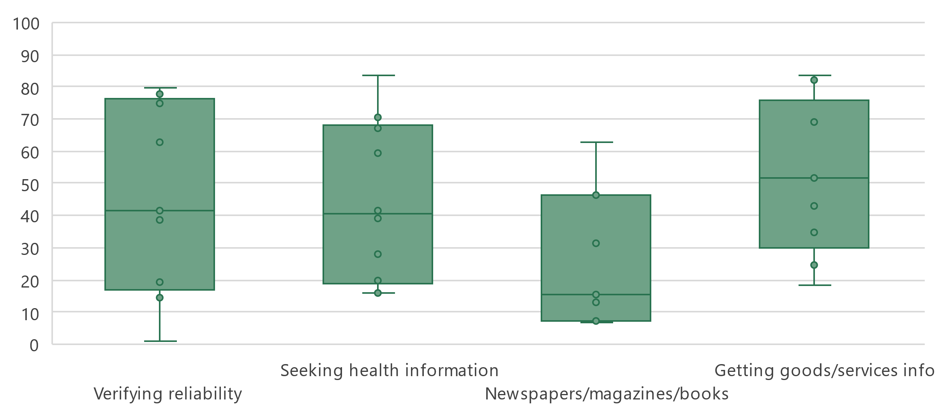

Note: Bars indicate the 25th, median and 75th percentile of all country values. Bottom and top lines indicate minimum and maximum values. In-scope age varies between countries. Country data are for 2023 where available and no later than 2020. Data availability varies between indicators, ranging from seven countries for *Reading or downloading newspapers, magazines or books to* ten countries for *Seeking health information.* Detailed information – including complete indicator names – is available [here](https://www.itu.int/en/ITU-D/Statistics/Documents/facts/rpm_arb_pub_2025_data.xlsx).

Source: ITU

For information and data literacy, getting information about goods or services had the highest median (52 per cent) of the four activities that make up this skill category. Verifying the reliability of information found online, seeking health information had similar distributions of country shares. Conversely, using the Internet to read or download newspapers, magazines or books was less frequently reported (median of 16 per cent) by individuals across the region.

Percentage of Internet users with communication and collaboration skills, latest year available

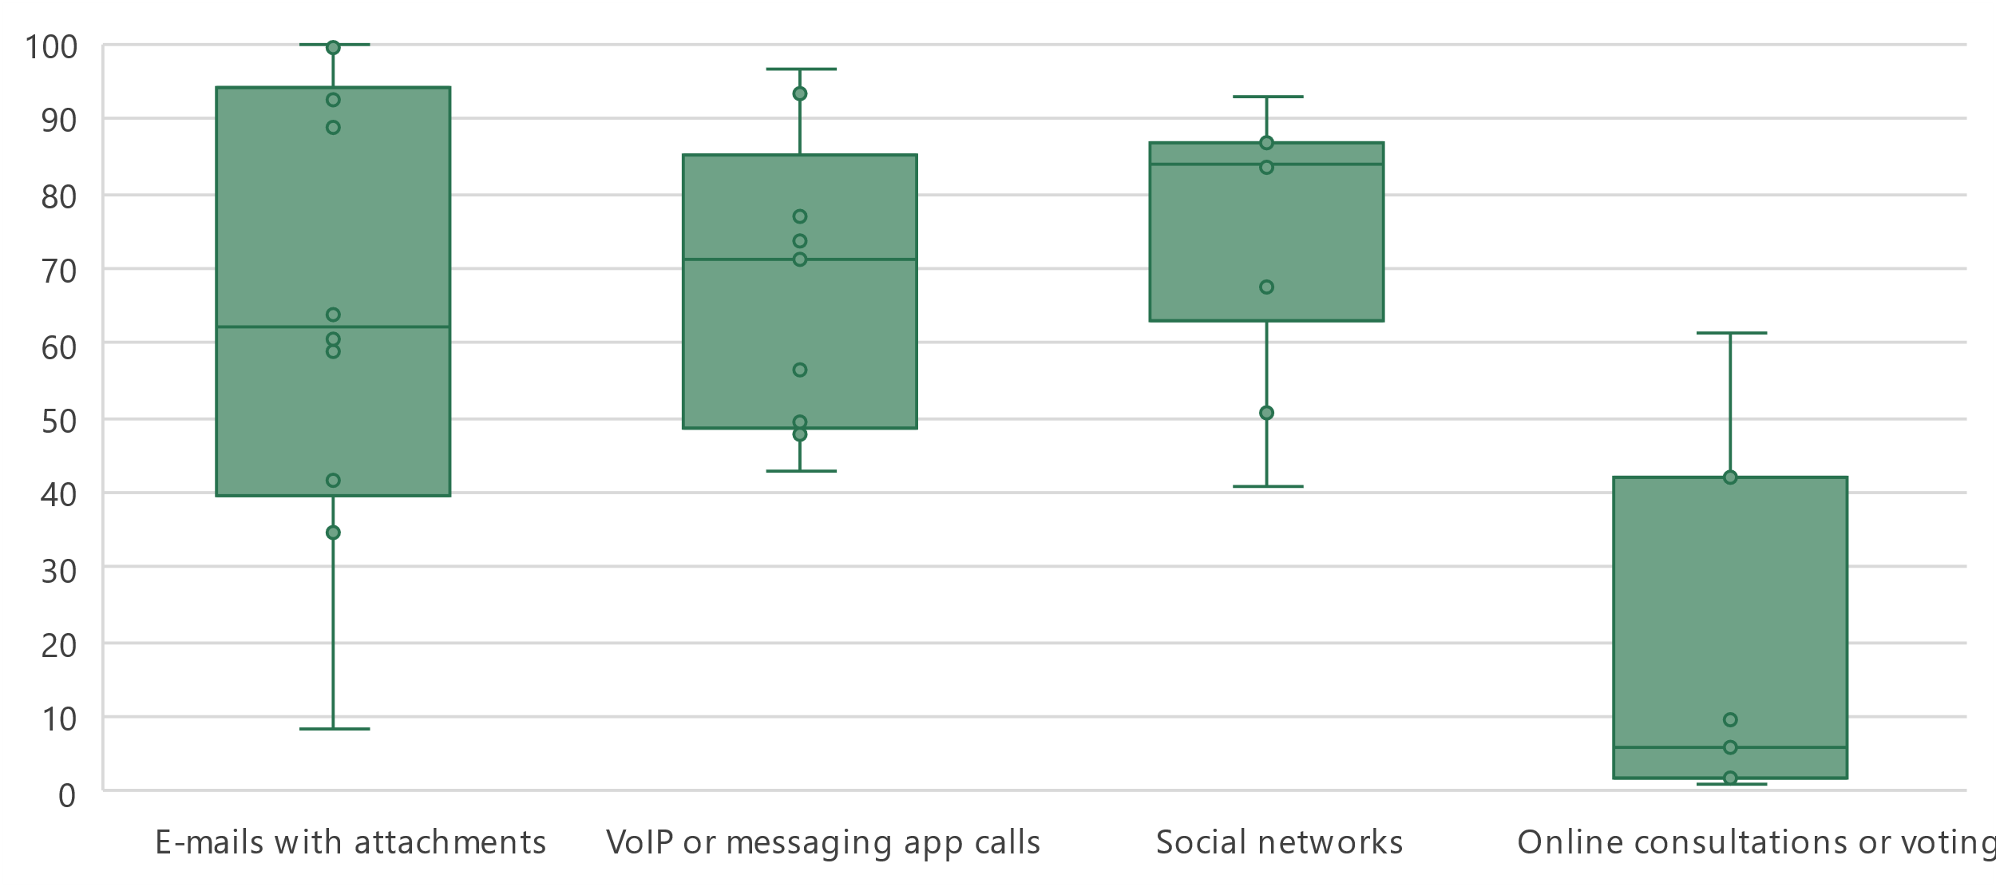

Note: Bars indicate the 25th, median and 75th percentile of all country values. The whiskers (bottom and top lines) indicate individual minimum and maximum values. In-scope age varies between countries. Country data are for 2023 where available but no earlier than 2020. Data availability varies between indicators, ranging from ten countries for *Sending e-mails with attached files* and *Participating in social networks* and seven countries for *Taking part in online consultations or voting to define civic or political issues.* Detailed information – including complete indicator names – is available [here](https://www.itu.int/en/ITU-D/Statistics/Documents/facts/rpm_arb_pub_2025_data.xlsx).

Source: ITU

The medians for communication and collaboration were much higher than for information and data literacy, ranging from 62 to 84 per cent. The one exception was taking part in online consultations or voting to define civic or political issues, which had a median of only 6 per cent.

Percentage of Internet users with digital content creation skills, latest year available

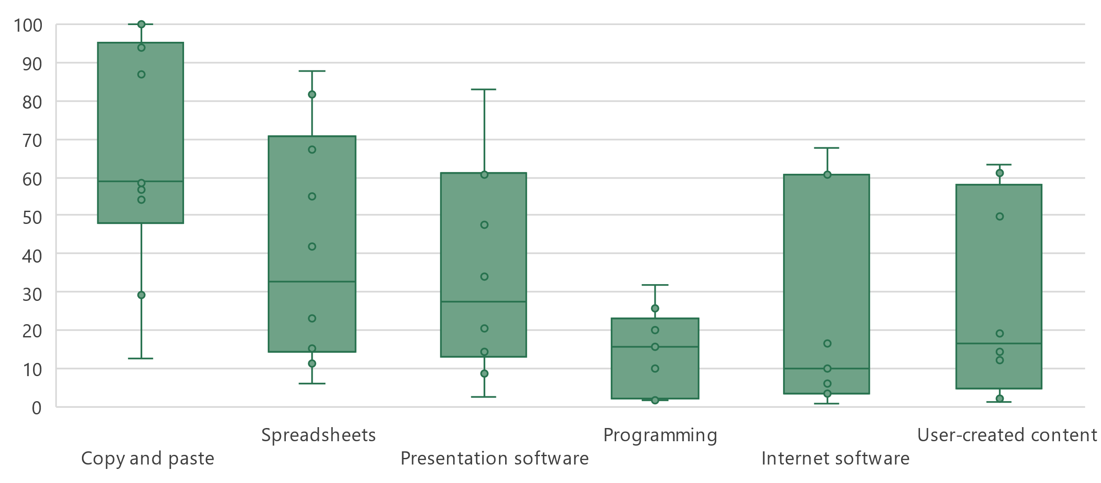

Note: Bars indicate the 25th, median and 75th percentile of all country values. The whiskers indicate individual minimum and maximum values. In-scope age varies between countries. Country data are for 2023 where available but no earlier than 2020. Data availability varies among indicators, ranging from seven countries for *Using software run over the Internet for editing text documents, spreadsheets or presentations* to nine countries for *Writing a computer program using a programming language* and ten countries for all other indicators*.* Detailed information – including complete indicator names – is available [here](https://www.itu.int/en/ITU-D/Statistics/Documents/facts/rpm_arb_pub_2025_data.xlsx).

Source: ITU

The digital content creation skill area generally shows relatively low medians for five of the six activities, ranging from 10 to 33 per cent. The exception is using copy and paste tools within a document, which had a median of 59 per cent.

Percentage of Internet users with safety skills, latest year available

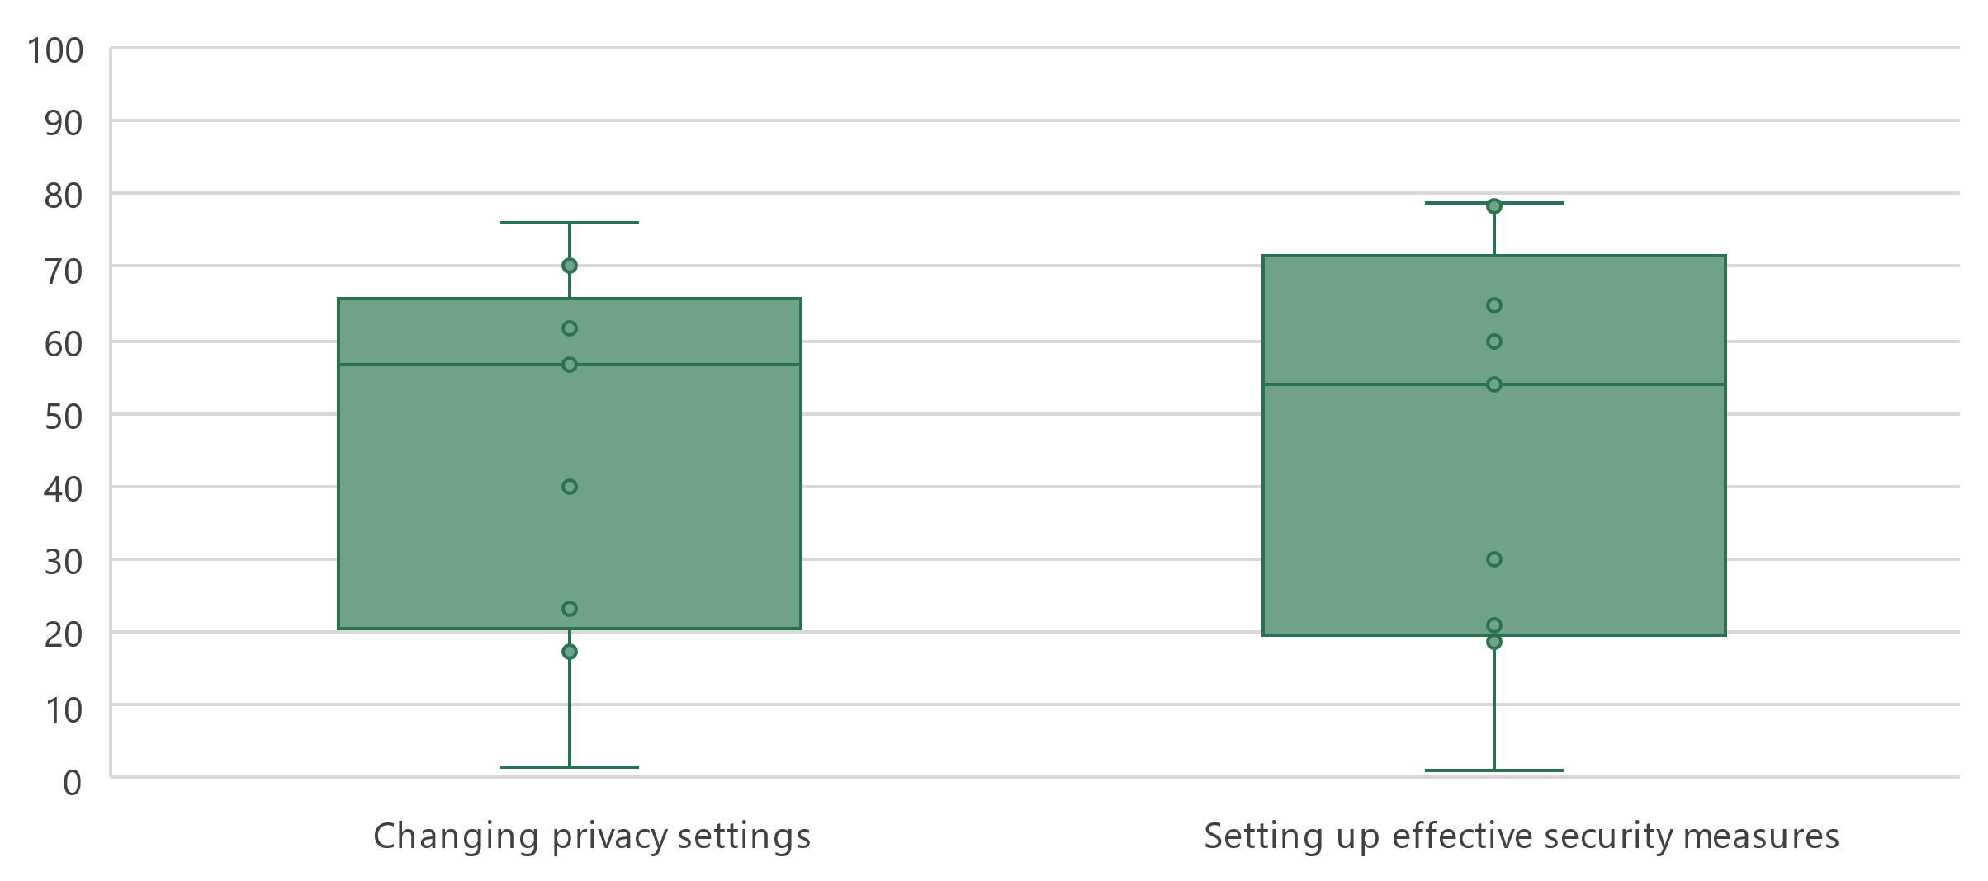

Note: Bars indicate the 25th, median and 75th percentile of all country values. The whiskers (bottom and top lines) indicate individual minimum and maximum values. In-scope age varies between countries. Country data are for 2023 where available but no earlier than 2020. Nine countries provided data for each indicator*.* Detailed information – including complete indicator names – is available [here](https://www.itu.int/en/ITU-D/Statistics/Documents/facts/rpm_arb_pub_2025_data.xlsx).

Source: ITU

The two activities in the safety category showed similar prevalence for countries in the region. The median shares were 57 and 54 per cent for changing privacy settings on one’s device, account or app and setting up effective security measures to protect devices and accounts, respectively.

Percentage of Internet users with problem solving skills, latest year available

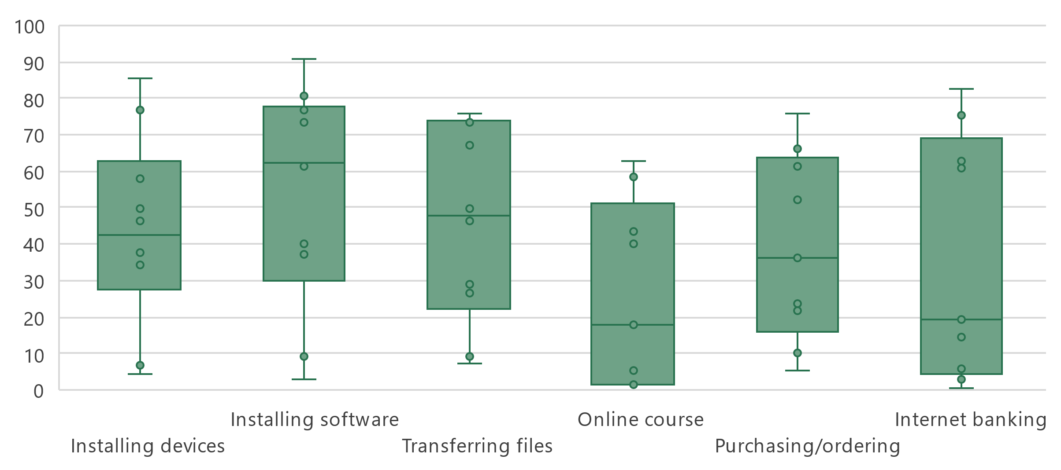

Note: Bars indicate the 25th, median and 75th percentile of all country values. Whiskers indicate minimum and maximum values. In-scope age varies between countries. Country data are for 2023 where available but no earlier than 2020. Data availability varies between nine and ten countries for each indicator*.* Detailed information – including complete indicator names – is available [here](https://www.itu.int/en/ITU-D/Statistics/Documents/facts/rpm_arb_pub_2025_data.xlsx).

Source: ITU

Finally, the medians for activities in the problem-solving skill area vary widely, from 18 per cent for doing an online course to 62 per cent for finding, downloading, installing and configuring software.

Revenues and investment

***The ICT sector is a major driver of the economy***

The telecommunications sector is an important enabler of economic development, with both direct and indirect impacts. While it is harder to capture the indirect contribution, recent data on revenues and investment reveals both the significance of its direct contribution and the existence of significant gaps between countries.

Revenue from all telecommunication services, in USD million and as a % of GDP, latest available year

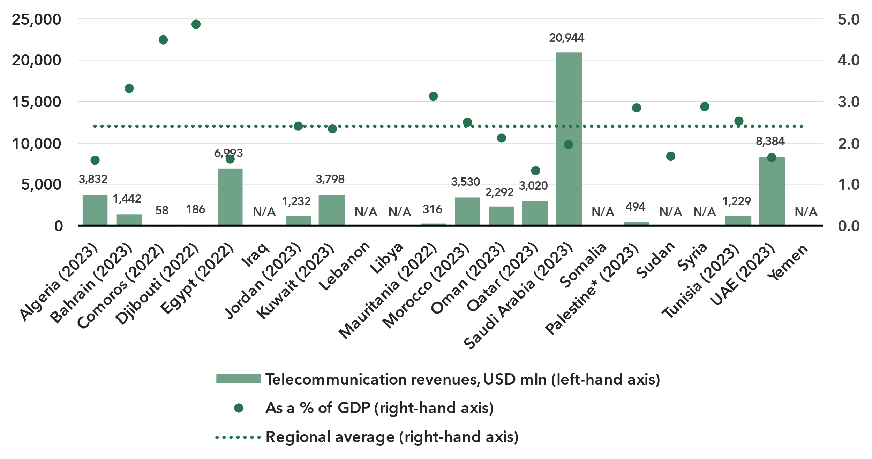Note: Annual average exchange rates applied, last available year values at constant 2023 prices.

Source: ITU, World Bank World Development Indicators

The ICT services sector includes activities providing telecommunications and related service activities, i.e. transmitting voice, data, text, sound and video, over wired, wireless, satellite or other networks.[12] The total retail revenues for the sector in the Arab States region, for the 15 countries that provided data in the last available year since 2021, is estimated at around USD 57.8 billion. This equates to an average of USD 3.9 billion per country, and typically represents 2.4 per cent of a country’s GDP.

Annual investment in telecommunication services, in USD million and as % of GDP

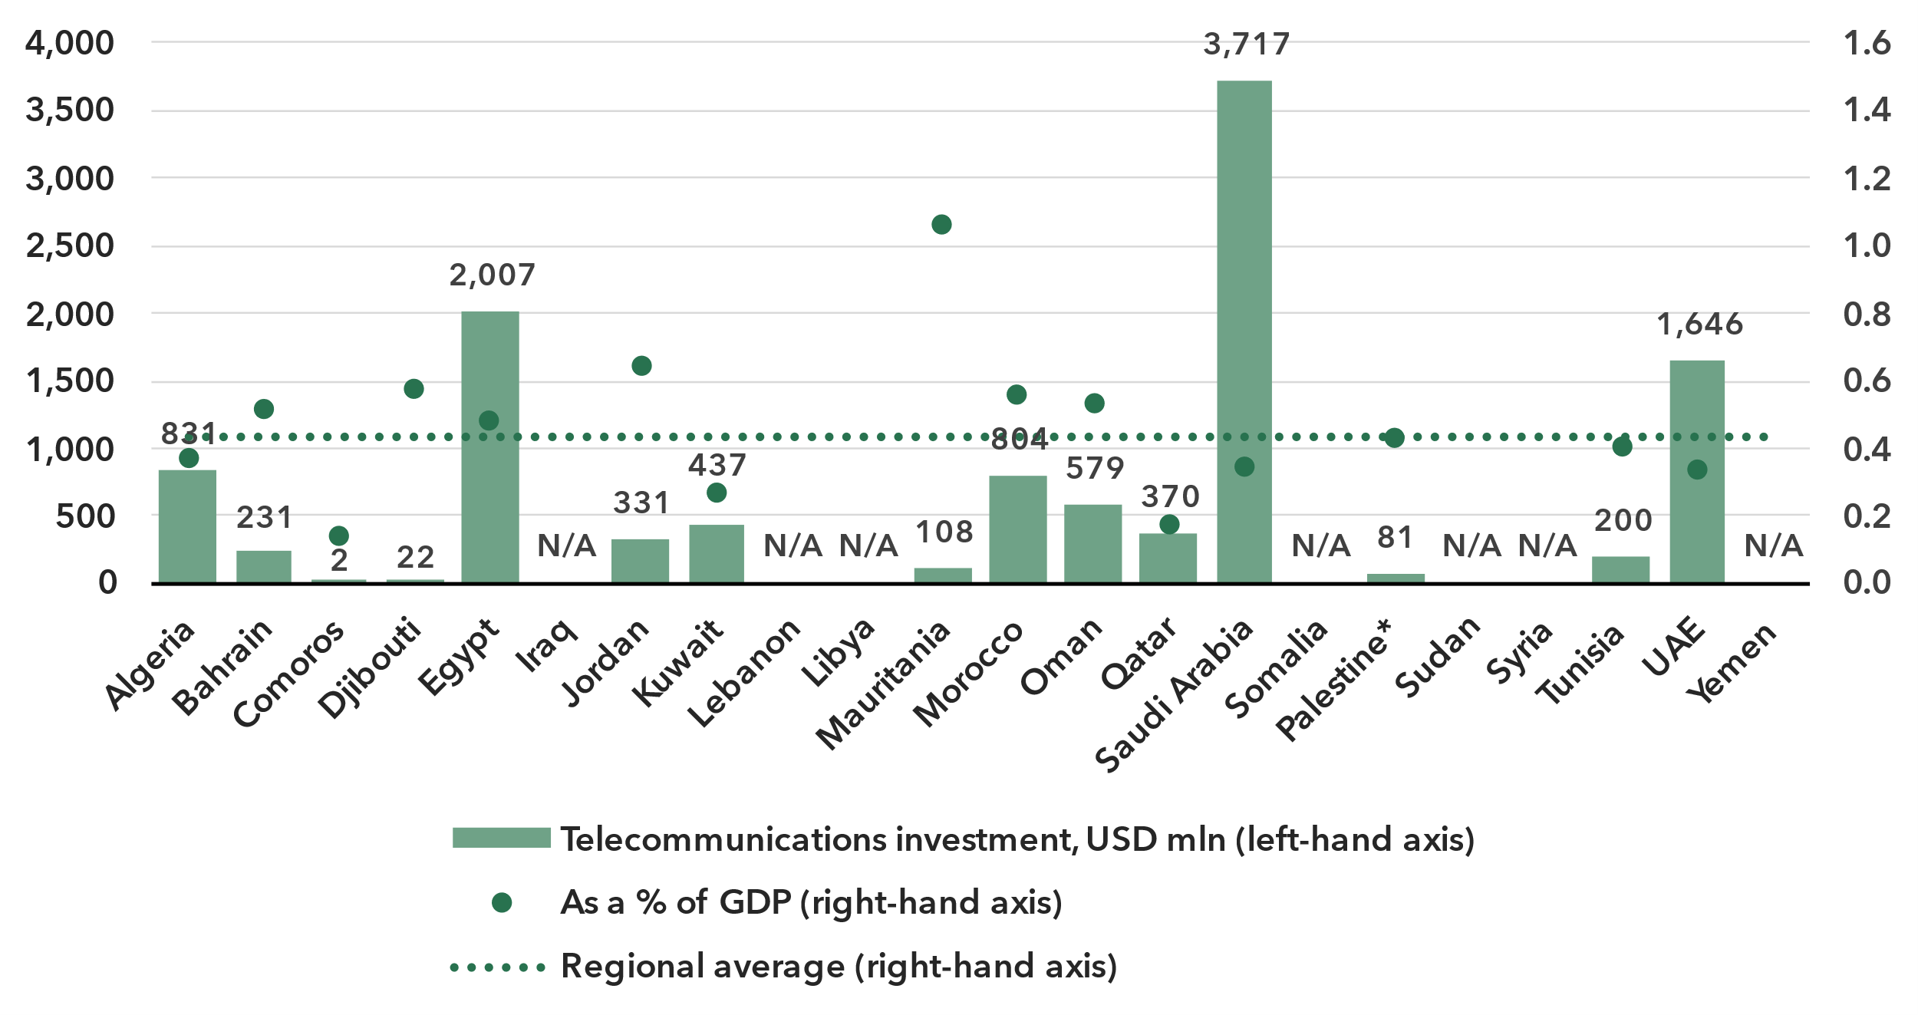Note: Data are a three-year (2021-2023) average of available data points to correct for annual fluctuations and gaps. Investment figures are in constant 2023 US dollars.

Source: ITU, World Bank World Development Indicators

The deployment of new network technologies and the upgrading of existing ones are highly capital-intensive activities. Those countries in the Arab States region for which data was available made annual investments of around US$ 760 million on average – corresponding to a median value of 0.4 per cent of their GDP – in their telecommunication sector over the 2021-2023 period.[13] Investment projects often span multiple years and values fluctuate. Considering moving averages, it can be estimated that the telecommunications sector mobilized over USD 11 billion a year in those countries for which data was available. Investment is unevenly distributed across countries in the region, and both the levels and the per GDP rates of capital expenditure vary significantly. Low levels of investment in countries with mobile network coverage gaps and low mobile and fixed broadband penetration is a particular concern, as it perpetuates digital development divides.

Cybersecurity

***Arab States are increasingly committed to cybersecurity***

Meaningful connectivity requires trustworthy and secure communications. With over 5.5 billion people now online, cybersecurity in the digital economy is no longer an afterthought. Addressing cybersecurity requires a holistic approach encompassing legal, technical, organizational, capacity development, and cooperation issues. Since 2015, the Global Cybersecurity Index (GCI) has tracked countries' performance on these issues, each represented by a pillar of the index, with an aggregate GCI score on a 0-100 scale. The 2024 edition revealed a notable improvement in countries’ commitment to cybersecurity: the average GCI score reached 66, up 14 points from the 2021 edition. The Arab States have mirrored this progression with the same average score of 66 and a gain of 15 points from the previous edition.

Global Cybersecurity Index scores, 2017-2024

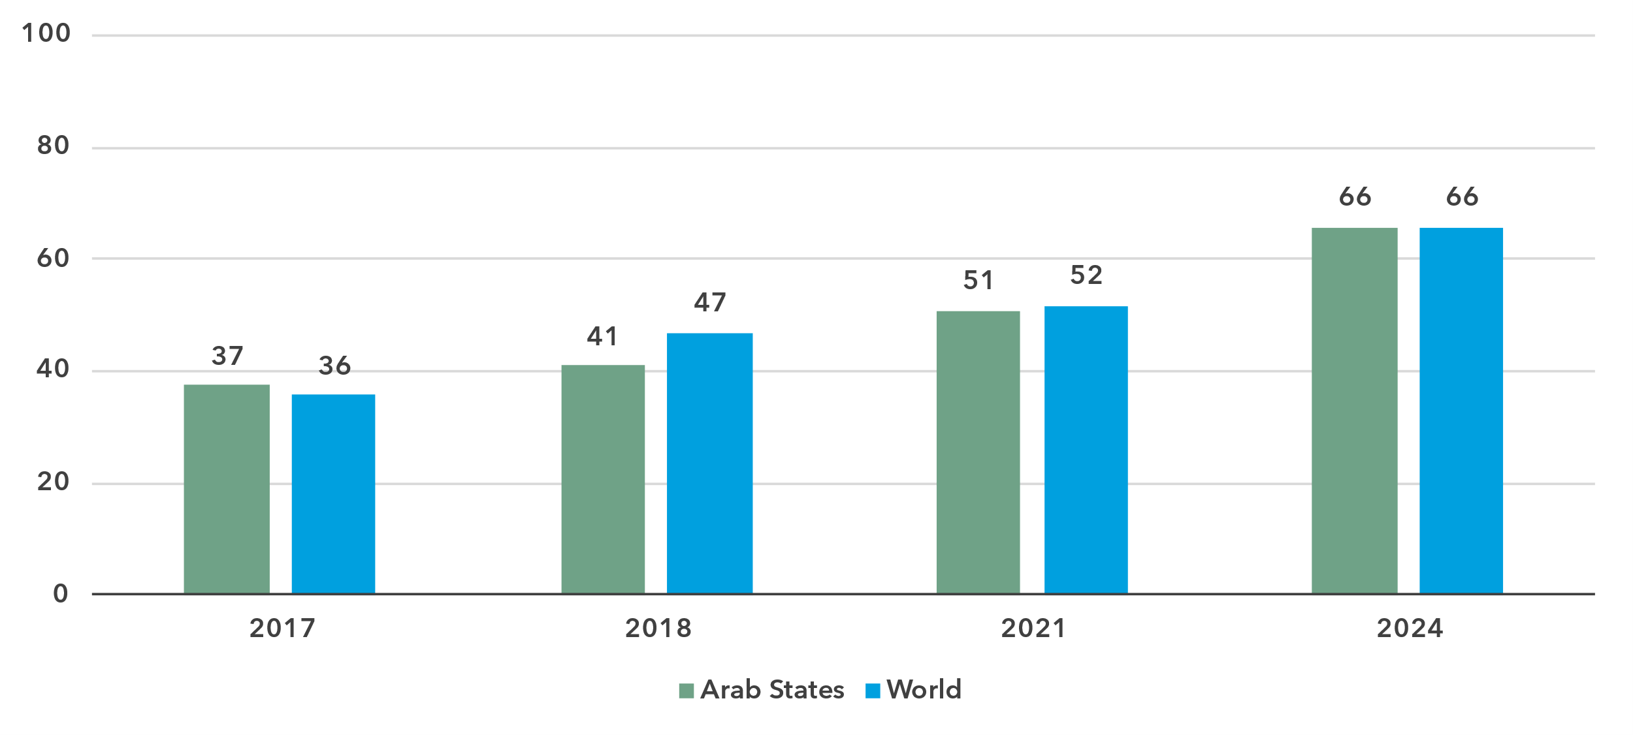Note: Questions and weightings have been updated between editions, in collaboration with the GCI Expert Group, to better measure cybersecurity commitments by countries.

Source: ITU

The performance in the GCI of Arab States is extremely mixed, with a 93-point gap between the region’s best performers, which achieved the maximum score of 100, and the region’s worst performer, Yemen, with a score of 7. All development groups are represented among the top scoring countries in the GCI, indicating that development level is not a reliable predictor of cybersecurity performance. However, the Arab least developed countries (LDCs) are among the worst performers globally. Several Arab economies have made efforts to enhance the quality of their commitments, with extensive auditing, tailored cyber awareness efforts, and a range of educational opportunities. For example, Northern African Arab countries have many legal measures in place but lack measures in other areas.

Global Cybersecurity Index scores, by pillar and overall, 2024

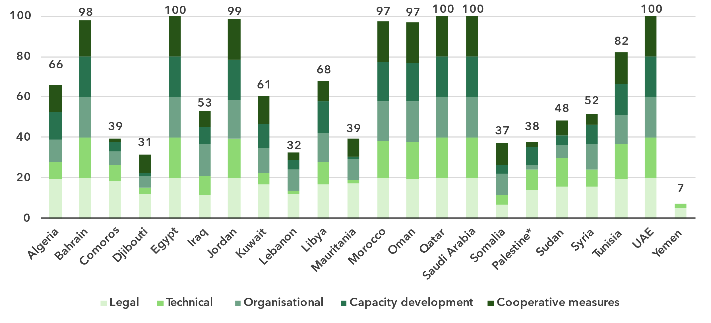* The State of Palestine is not an ITU Member State; the status of the State of Palestine in ITU is the subject of Resolution 99 (Rev. Dubai, 2018) of the ITU Plenipotentiary Conference.

Note: The overall CGI score shown is the sum of the score of the five pillars

Source: ITU

The technical pillar of the GCI assesses the effectiveness of national mechanisms and institutional structures in detecting, preventing, responding to, and mitigating cyberthreats and incidents. Computer incident response teams (CIRTs) are responsible for protection against, detection of, and response to cybersecurity incidents, and can enhance a country’s ability to manage such incidents. Although nearly all countries in the Arab States region have established their national CIRTs, there is a need for increased support, particularly for LDCs. Out of six Arab LDCs, only one has a CIRT in place, with three others in the process of setting one up.

Child online protection (COP) encompasses strategies and initiatives to protect children from harm or exploitation online. This includes ensuring children are using age-appropriate software and filtering tools and educating parents and children about staying safe online. Child online protection is tracked through questions under the legal, organizational, and capacity development pillars. A total of 164 countries reported having legal measures on COP in the GCI 2024, compared to 130 countries in the previous edition. These measures were sometimes part of other rules, regulations, and substantive law, such as on online crime or sexual exploitation. While the Arab States region as a whole stands out with these efforts, Arab LDCs need more targeted support to develop their COP strategies; currently, only one has a COP strategy.

Finally, to meet the demand for cybersecurity professionals, countries are increasingly developing cybersecurity skills within their populations. While the Arab countries have cybersecurity-focused university degrees, there is still room for improvement in secondary schools. Currently, eight countries have a curriculum in place.

E-waste management

As countries strive to harness the benefits of technology to drive economic growth and achieve their national development priorities, the challenge of managing electronic waste has become increasingly urgent. Strengthened e-waste policy and regulatory e-waste management are pivotal for ensuring environmental sustainability, supporting circular economy practices, and advancing progress towards the sustainable development goals (SDGs).

E-waste generated, in millions of kg, 2022

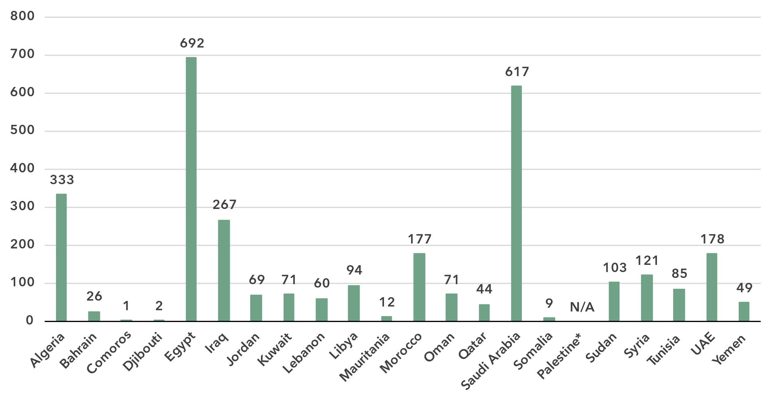

* The State of Palestine is not an ITU Member State; the status of the State of Palestine in ITU is the subject of Resolution 99 (Rev. Dubai, 2018) of the ITU Plenipotentiary Conference.

Source: ITU and UNITAR, [Global E-waste Monitor, 2024](https://www.itu.int/hub/publication/d-gen-e_waste-01-2024/)

The [Global E-waste Monitor 2024](https://www.itu.int/en/ITU-D/Environment/Pages/Publications/The-Global-E-waste-Monitor-2024.aspx) finds that in 2022 the Arab States generated approximately 3 081 million kg of e-waste, representing almost 5 per cent of global e-waste generation (62 billion kg). Again, significant disparities exist across the region. Egypt and Saudi Arabia were the largest contributors, producing 692 million kg and 617 million kg respectively, and together contributed more than 40 per cent of the region’s total e-waste. In contrast, smaller countries like Comoros and Djibouti generated close to 3 million kg of e-waste combined, representing less than 0.1 per cent of the total. This significant variation reflects differences in population size, economic development, and technological adoption across the region.

E-waste per capita generated in kg, 2022

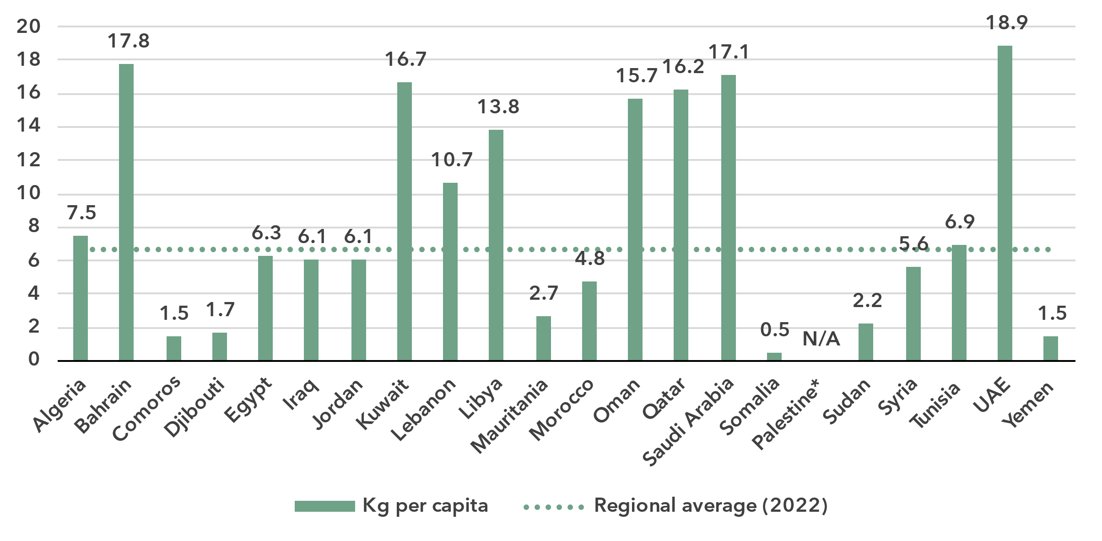

* The State of Palestine is not an ITU Member State; the status of the State of Palestine in ITU is the subject of Resolution 99 (Rev. Dubai, 2018) of the ITU Plenipotentiary Conference.

Source: ITU and UNITAR, [Global E-waste Monitor, 2024](https://www.itu.int/hub/publication/d-gen-e_waste-01-2024/)

The analysis of e-waste trends can be further deepened by examining per capita e-waste generation. The Arab States region as a whole annually generates 6.6 kg of e-waste per capita, less than the global average of 7.8 kg, but, again, disparities between individual countries are stark. Behind the regional average is a diverse landscape, where high-income nations significantly drive up the overall figure. For instance, the United Arab Emirates stands out with the highest per capita figure at 18.9 kg, more than double the global average. Bahrain and Qatar also generate well above-average amounts of e-waste, at 17.8 kg and 16.2 kg per capita respectively, reflecting their economic status and widespread access to advanced digital technologies. In contrast, lower-income nations such as Somalia and Yemen generate significantly less, with e-waste generation of just 0.5 kg and 1.5 kg per capita respectively for those two countries. Meanwhile, mid-range contributors such as Algeria (7.5 kg) and Tunisia (6.9 kg) hover closer to the global average.

Despite these high regional generation rates, only 0.2 per cent (7.3 million kg) of the e-waste generated was documented as properly collected and recycled – well below the global average of 22.3 per cent. Only four countries – Lebanon, Jordan, Qatar, and the United Arab Emirates – reported formal collection and recycling initiatives. Notably, the United Arab Emirates documented having recycled 5.4 million kg of e-waste. In contrast, many countries in the region, including high e-waste generators like Egypt and Saudi Arabia (which together produced over 1 200 million kg), lack significant formal recycling activity.

E-waste policies and regulations in place, 2022

|  |  |  |  |  |
| --- | --- | --- | --- | --- |
|  | **National e-waste legislation/policy or regulation** | **Extended producer responsibility (EPR) framework for e-waste** | **Collection targets** | **Recycling targets** |
| Algeria | No | No | No | No |
| Bahrain | Yes | No | No | No |
| Comoros | No | No | No | No |
| Djibouti | No | No | No | No |
| Egypt | Yes | Yes | No | No |
| Iraq | No | No | No | No |
| Jordan | Yes | No | No | No |
| Kuwait | No | No | No | No |
| Lebanon | No | No | No | No |
| Libya | No | No | No | No |
| Mauritania | No | No | No | No |
| Morocco | No | No | No | No |
| Oman | No | No | No | No |
| Palestine* | N/A | N/A | N/A | N/A |
| Qatar | No | No | No | No |
| Saudi Arabia | No | No | No | No |
| Somalia | No | No | No | No |
| Sudan | No | No | No | No |
| Syria | No | No | No | No |
| Tunisia | No | No | No | No |
| UAE | Yes | Yes | No | No |
| Yemen | No | No | No | No |

* The State of Palestine is not an ITU Member State; the status of the State of Palestine in ITU is the subject of Resolution 99 (Rev. Dubai, 2018) of the ITU Plenipotentiary Conference.

Source: ITU and UNITAR, [Global E-waste Monitor, 2024](https://www.itu.int/hub/publication/d-gen-e_waste-01-2024/)

The lack of comprehensive policies for e-waste management remains a significant challenge in the Arab States, where only a few countries have implemented national e-waste legislation and introduced a framework for extended producer responsibility (EPR). Globally, 42 per cent of countries (81 out of 193) have enacted national e-waste policies, legislation or regulations. In contrast, only four Arab States (Bahrain, Egypt, Jordan, and the United Arab Emirates, i.e. just 18 per cent) have such instruments in place.

Moreover, only two of the countries (Egypt and the United Arab Emirates) have an EPR framework for e-waste, essential for holding producers accountable for the entire lifecycle of their products. This figure is well below the global average, where 67 of the 81 countries with national e-waste policies or legislation have such a framework. The absence of these frameworks across most of the Arab States exacerbates the region’s e-waste challenges, keeping them reliant on informal practices that are harmful to both the environment and public health.

The lack of statutory collection and recycling requirements can significantly impede progress. Countries with a policy or legal instrument that includes collection targets have a collection rate of 35 per cent on average, much higher than the global average of 22 per cent. In contrast, the Arab States, with limited policy, legislation and regulation in place, will face difficulties meeting even modest recycling targets. The region risks missing key opportunities to advance towards a circular economy and reduce its environmental footprint.

Disparities within the region

***Regional averages conceal vast disparities in connectivity among Arab States***

The Arab States are diverse in many respects: income level, with the wealthiest country’s GNI per capita nearly 100 times larger than the poorest; urbanization rate, which ranges from 30 per cent to 100 per cent; and population, which ranges from under one million to over 100 million people.

Given these differences, it can be useful to group the Arab States into clusters, according to their scores on indicators of Internet use, mobile phone ownership, mobile broadband and fixed broadband subscription rates, affordability of entry-level mobile and fixed broadband, and gender equality. This ‘cluster analysis’ yields three distinct groups[14], whose respective members share similar ICT profiles.

The first group, made up of Algeria, Bahrain, Egypt, Kuwait, Libya, Morocco, Oman, Qatar, Saudi Arabia, Tunisia and the United Arab Emirates is characterized by rates of ICT usage and ownership that are well above the world average. Affordability of fixed broadband remains a challenge, however, with the median entry-level price as a share of monthly GNI per capita above the Broadband Commission target of 2 per cent of monthly GNI per capita or lower.

The second group, consisting of Iraq, Jordan, Lebanon and the State of Palestine, also has above-average rates of ICT usage and ownership, but challenges remain on other indicators. Subscription rates are substantially lower than that in the first group, and connectivity is also less affordable – the median entry-level price for both mobile and fixed broadband is above the Broadband Commission target. In addition, the gender gap for Internet use is much wider than in the first group, despite the high levels of overall Internet use.

In contrast to the first two, the next group, consisting of Comoros, Djibouti, Mauritania, Sudan, the Syrian Arab Republic and Yemen, has much lower rates of ICT use and ownership that are far lower than the world average, in addition to low subscription rates and affordability scores. In this group, on average only 39 per cent of the population uses the Internet, less than half the average share for the other two groups, and the data-only mobile broadband plan costs the equivalent of more than five per cent of monthly GNI per capita. The low results for these indicators reflect the development challenges faced by these countries, all but one of which (the Syrian Arab Republic is the exception) are classified as LDCs.

Finally, Somalia – another LDC – does not fall into any of the three groups, due to its low levels of ICT use and ownership, poor gender parity and a lack of affordability of broadband services.

The diversity of these groups of countries underlines the need to design tailored approaches to achieve universal and meaningful connectivity.

Average of key ICT indicators by groups of similar Arab States, 2022

|  |  |  |  |  |
| --- | --- | --- | --- | --- |
|  | Group | | |  |
| **Indicator (units)** | 1  (11 Arab States) | 2  (4 Arab States) | 3  (6 Arab States) | **World average** |
| Share of individuals using the Internet (%) | 90.3 | 87.0 | 38.9 | **63.7** |
| Gender equality - Internet use  (relative gap) | 0.97 | 0.71 | 0.67 | **0.88** |
| Share of individuals owning mobile phones (%) | 95.8 | 81.6 | 59.5 | **77.7** |
| Mobile broadband subscriptions  (per 100 inhabitants) | 125.4 | 55.4 | 43.4 | **85.9** |
| Fixed broadband subscriptions  (per 100 inhabitants) | 15.2 | 9.2 | 1.7 | **17.7** |
| Data-only mobile broadband prices  (as a % of GNI per capita) | 2.8 | 6.6 | 19.2 | **1.5** |
| Fixed broadband prices (as a % of GNI per capita) | 0.8 | 2.8 | 5.3 | **3.2** |

Note: Group averages include unpublished estimates. Group medians shown for data-only mobile broadband and fixed broadband prices as a % of GNI per capita.

Source: ITU

Overview of data availability in the Arab States

Data plays a key role in achieving universal and meaningful connectivity. Reliable and timely data equips policymakers to identify needs, set priorities, design effective interventions, track progress, and measure impact. Investing in data yields substantial returns by enabling better decision-making and more efficient interventions.

The importance of data for the delivery of the Kigali Action Plan was acknowledged by ITU’s Telecommunication Development Advisory Group, which adopted five key performance indicators (KPIs) tracking the extent to which Member States submit timely ICT data to ITU, including KPIs related to the submission of data on skills and on Internet use, disaggregated by location and gender.

The availability and quality of ICT statistics vary widely among the Arab States. Administrative data, typically collected by national regulatory authorities or relevant ministries, is generally accessible. Fifteen of the 22 Arab States have at least 75 per cent of the data available for a core set of 14 administrative ICT indicators covering the 2022-2023 period, and 12 countries have the complete set available.

Percentage availability of selected administrative ICT indicators, 2022-2023

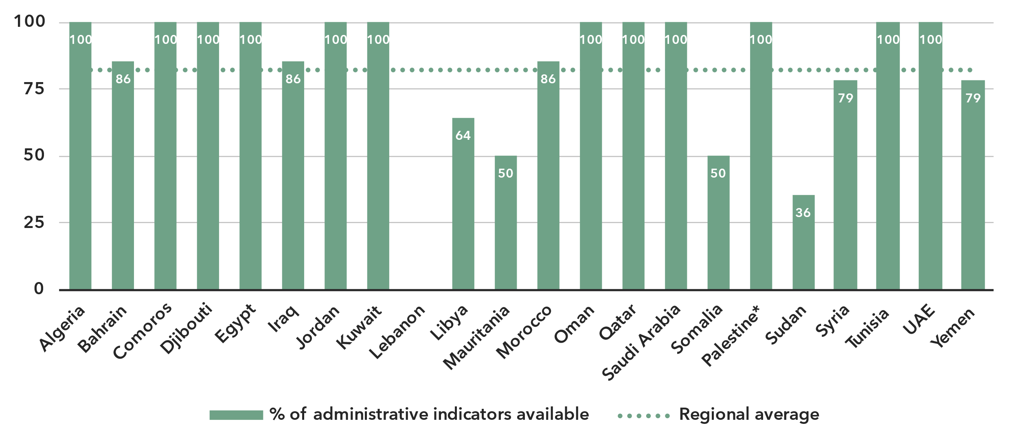* The State of Palestine is not an ITU Member State; the status of the State of Palestine in ITU is the subject of Resolution 99 (Rev. Dubai, 2018) of the ITU Plenipotentiary Conference.

Note: An indicator is considered available if at least one value is available for the period in question. Assessment based on the following set: active mobile broadband subscriptions, fixed broadband subscriptions (total, as well as by speed-tiers: 256 Kbit/s to 2 Mbit/s, 2 Mbit/s to 10 Mbit/s, and above 10 Mbit/s), mobile network coverage indicators by technology (at least 2G, 3G, LTE/WiMAX, 5G), total fixed broadband Internet traffic, mobile broadband Internet traffic within the country, international bandwidth usage, total telecommunication revenues and investment in telecommunication services.

Source: ITU

In contrast, data on ICT access and usage by households and individuals, usually derived from household surveys, remains scarce. Only 11 Arab States have provided at least partial data on ICT household indicators for the period 2022-2023. Six Arab States have never submitted any such data.

Latest year of submission of ICT household survey data, by socio-economic attribute

* The State of Palestine is not an ITU Member State; the status of the State of Palestine in ITU is the subject of Resolution 99 (Rev. Dubai, 2018) of the ITU Plenipotentiary Conference.

Source: ITU

The issue is even more acute for data disaggregated by socio-economic attributes, which is often not available. Egypt is the only country in the Arab States region that has submitted recent data (2022 or more recent) for all six attributes of interest. Seven other countries have submitted recent data for at least one attribute.

Even when data is available, it may suffer from poor sample design, inadequate collection methods, or low response rates. Such shortcomings are likely to yield misleading results and may result in misguided policies. (For example, overestimation of ICT skills could lead policymakers to shift focus away from supporting populations that need training in this area.) Addressing these challenges requires a dual approach targeting both the producers and users of data. Through continuous efforts in capacity building, technical assistance, and advocacy, ITU aims to enhance the availability and quality of ICT data globally.

Part 2. BDT4Impact: Case studies from the Arab States

Record-breaking cyber response trainings, UAE

ITU and the United Arab Emirates Cyber Security Council (CSC) were recognized for record-breaking achievements during cyber response trainings.

[CyberDrills](https://www.itu.int/en/itu-d/cybersecurity/pages/cyberdrills.aspx) simulate cyber-attacks and incidents to test organizations’ cyber capabilities and response, enhancing their cyber resilience. They showcase pioneering strategies and innovations in cybersecurity and highlight the need to improve coordinated responses to address cybersecurity challenges.

Five Guinness World Records were awarded during the 11th Regional Cybersecurity Week, held in October 2023 in Abu Dhabi, United Arab Emirates.

The records were awarded in the following areas:

* Largest CyberDrill competition;
* Most nationalities in a cybersecurity awareness lesson;
* Largest cyber-city threat simulation model;
* Most nationalities in a CyberDrill competition;
* Largest cyber-city threat simulation model (devices).

The two organizations continued to break records at the Global CyberDrill 2024, held during Gulf Information Security Expo and Conference (GISEC) Global 2024 in April 2024 in Dubai, United Arab Emirates, achieving an additional three Guinness World Records for:

* The most nationalities in a gamified cybersecurity training;
* The most nationalities in an Internet of Things (IoT) awareness lesson;
* The largest Internet of Things (IoT) awareness lesson.

Transforming government services, Djibouti

As part of ongoing efforts to build a digitally empowered future, key stakeholders in Djibouti met in 2024 to chart implementation roadmaps and showcase prototypes of digital solutions for e-Cabinet and e-Construction Permit services.

The e-Cabinet initiative is expected to improve decision-making, transparency and efficiency in government operations. The digitization of construction permits, through e-Construction Permit services, will streamline the permit issuance process, making it more transparent and encouraging investment in infrastructure.

In Djibouti, [GovStack](https://www.govstack.global/) – an initiative founded by ITU, the Ministry of Foreign Affairs of the Republic of Estonia, the German agency for international cooperation GIZ and the Digital Impact Alliance (DIAL) – focuses on three main themes: developing digital government strategies and roadmaps for their implementation; designing use cases for e-government services; and building capacity.

The government of Djibouti is using the GovStack building blocks approach to advance its digital transformation efforts and revolutionize its governance and service delivery systems.

Enhancing the growth and reach of start-ups in the Arab States

Entrepreneurs in the Arab States region are benefiting from new opportunities to establish connections and expand into other countries in the region.

An important tool for this was a soft-landing programme that came out of a project called “Assistance to Arab Technoparks and Incubators Network”, an initiative of the [Arab Innovation and Entrepreneurship Network (AIEN)](https://www.itu.int/itu-d/sites/digital-impact-unlocked/arab-innovation-and-entrepreneurship-network-aien-promotes-cooperation-and-the-sharing-of-cross-expertise-between-start-ups/).

The programme supported the international growth and expansion of both early-stage start-ups and established small and medium enterprises (SMEs). It gave them a platform to explore business ecosystems and networks in various Arab countries, helping them compare business models across borders and create opportunities for partnerships. It supported start-ups with legal and business advice from partnering incubators, which played a crucial role in structuring and guiding the entrepreneurs through their expansion phase.

The soft-landing programme stands as a pioneering initiative in pan-Arab cooperation, setting the stage for delivering these essential services to start-ups across the region.

Building capacity and developing specialized trainer skills, Jordan

The Telecommunications Regulatory Commission of Jordan conducted a [train-the-trainer event](https://academy.itu.int/training-courses/full-catalogue/training-trainers-quality-services-training-programme-qostp-and-spectrum-management-training-program) in Amman for telecom engineers, managers and other personnel engaged in spectrum management and quality of service (QoS) work. It equipped participants with the knowledge and skills needed to effectively bridge knowledge gaps in QoS and spectrum management and advance and deliver effective training in their national contexts.

Quality of service is increasingly becoming an important regulatory issue, closely linked to consumer rights and consumer protection. As for spectrum management, for it to be effective and efficient several variables of a political, economic and technical nature need to be taken into consideration. Specialized training professionals need access to high-quality training materials to help them build necessary human and institutional capacity in these two key areas.

The training event dealt with key topics on measuring and monitoring advanced networks and understanding QoS measurements and policies. It also covered spectrum management and spectrum monitoring, including legal and regulatory aspects, and the relevance of economic and market tools for spectrum management.

Preparing national emergency telecommunication plans in the Arab States

Ensuring the flow of timely information before, during and after a disaster is critical for effective decision-making, as well as for rapid response during emergencies.

The ITU Regional Office for the Arab States provided assistance to Djibouti, Comoros, Iraq and Somalia to develop and implement [national emergency telecommunications plans](https://www.itu.int/en/ITU-D/Emergency-Telecommunications/Pages/NETPs.aspx) (NETPs). The plans were finalized and presented to the countries during national NETP workshops.

Throughout the NETP development process, a series of action items to create, enhance and update national emergency plans were shared,as well as recommendations to improve international cooperation and actions to create resilient telecommunication services. The need to develop early warning systems was also emphasized.

In Comoros, the workshop focused on emergency response, knowledge sharing, and collaboration to strengthen emergency telecommunication capabilities.

NETPs set out a strategy to enable and ensure communications availability during the disaster mitigation, preparedness, response and recovery phases, by promoting coordination across all levels of government, between public and private organizations, and within communities at risk.

The development of NETPs allows countries to prepare an effective and efficient framework for deploying emergency communications under each phase of disaster risk management– and put it in place.

Partner2Connect implementation for impact, Egypt   
Egypt’s Decent Life initiative is delivering long-lasting benefits to rural communities and transforming lives through digital transformation.

Through a coordinated approach, integrating key public services such as housing, infrastructure and education, it accelerates rural development and strengthens overall resilience and sustainability in rural communities.

Teachers’ educational programmes have improved thanks to speedy Internet connections and digital capacity building opportunities. Local women have new employment opportunities, allowing them to financially support their families while simultaneously empowering them within their community.

The initiative is implemented through four pillars:

1. Building a fibre infrastructure network to connect the unconnected and enable a digitally transformed society;
2. Developing mobile network towers infrastructure for resilient mobile broadband coverage to enable access to Internet data and voice services;
3. Strengthening post offices to enable digital and financial inclusion;
4. Promoting digital literacy to empower communities through ICT capacity-building programmes and raising awareness of the benefits of today’s digital economy.

The initiative springs from a Partner2Connect pledge by the Ministry of Communications and Information Technology of Egypt to develop the telecom infrastructure of over 4 500 rural villages.

Annex: Data resources

To ensure up-to-date information, optimize space, and enhance readability, all data presented in this document are available for download as Excel files:

* [Country-level data](https://www.itu.int/en/ITU-D/Statistics/Documents/facts/rpm_arb_pub_2025_data.xlsx) organized by tabs corresponding to the sections of this document (URL: https://www.itu.int/en/ITU-D/Statistics/Documents/facts/rpm_arb_pub_2025_data.xlsx). Country level data were extracted from the [ITU DataHub](https://datahub.itu.int/) on 30 November 2024, reflecting the July 2024 data release.
* [Regional and global estimates](https://www.itu.int/en/ITU-D/Statistics/Documents/facts/ITU_regional_global_Key_ICT_indicator_aggregates_Nov_2024.xlsx), as compiled for [*Facts and Figures 2024*](https://www.itu.int/itu-d/reports/statistics/facts-figures-2024/)  
  (URL: https://www.itu.int/en/ITU-D/Statistics/Documents/facts/  
  ITU_regional_global_Key_ICT_indicator_aggregates_Nov_2024.xlsx).

________________

1. The ITU Arab States region (hereinafter Arab States) covers the following 22 economies: Algeria, Bahrain, Comoros, Djibouti, Egypt, Iraq, Jordan, Kuwait, Lebanon, Libya, Mauritania, Morocco, Oman, Qatar, Saudi Arabia, Somalia, State of Palestine, Sudan, Syrian Arab Republic, Tunisia, United Arab Emirates, and Yemen.
2. ITU, ICT Regulatory Tracker, [gen5.digital](https://gen5.digital/).
3. ITU, G5 Benchmark 2023, [gen5.digital](https://gen5.digital/).
4. Idem
5. Idem
6. ITU, Global Digital Regulatory Outlook, 2023.
7. ITU, Benchmark of fifth-generation collaborative digital regulation 2023: Global and regional trends.
8. In this document, for figures reporting economy-level data, all economies are shown, in alphabetical order. Data points are shown for the year 2020 or later. Where none is available, it is so marked (“N/A”). In addition, a marker shows the data point for the year 2018, if available. Data are extracted from the [ITU DataHub](https://datahub.itu.int/) on 30 November 2024, based on the data release of end July 2024. Since country-level data are available for the year 2023 at best, for comparison purposes, the regional average for the year 2023 is reported as well, as published in [Facts and Figures 2024](https://www.itu.int/itu-d/reports/statistics/facts-figures-2024/). To save space in these figures, short names are used for the State of Palestine (Palestine), the Syrian Arab Republic (Syria) and the United Arab Emirates (UAE).
9. The gender parity score is calculated as the proportion of women who use the Internet divided by the proportion of men who use the Internet. A value less than one indicates that men are more likely to use the Internet than women, while a value greater than one indicates the opposite. Gender parity is considered achieved if the value lies between 0.98 and 1.02.
10. Due to the lack of data, it is not possible to compute estimates for Internet use by gender by country. Estimates are available only at the regional level.
11. The State of Palestine is not an ITU Member State; the status of the State of Palestine in ITU is the subject of Resolution 99 (Rev. Dubai, 2018) of the ITU Plenipotentiary Conference.
12. For a complete definition, see ISIC Rev. 4 class 61.
13. Investment statistics collected by ITU refer to acquiring or upgrading property (including tangible assets such as plants and non-tangible assets such as computer software) and networks. Expenditure on research and development, annual fees for operating licences and the use of radio spectrum, and investment in telecommunication software or equipment for internal use are excluded.
14. Somalia is not included in the three groups due to substantial differences in connectivity with others in the region.